**Green Analytical chemistry**

**Dr.M.Shravanthi**

**Assistant Prof, Department of Chemistry, University College for Women (Telangana Mahila Viswavidyalayam), koti, Hyderabad.**

**Abstract**

Green analytical chemistry (GAC) plays a pivotal role in promoting sustainability by minimizing the environmental impact of chemical analysis processes. Traditional analytical methods often involve the use of hazardous reagents, generate significant waste, and consume considerable energy. GAC seeks to address these issues through the development and application of more environmentally friendly techniques. By utilizing safer solvents, reducing reagent quantities, and implementing energy-efficient processes, GAC not only reduces the ecological footprint of chemical analyses but also enhances safety for laboratory personnel. Additionally, GAC supports the principles of green chemistry by promoting the design of inherently safer chemicals and processes from the outset. As industries and regulatory bodies increasingly emphasize sustainability, GAC offers a crucial framework for achieving these goals, ensuring that analytical practices contribute to, rather than detract from, global environmental health and resource conservation. The integration of GAC is essential for advancing scientific research and industrial practices towards a more sustainable future.

Keywords:Hazrdous reagents,energy efficient,sustainability,resource conservation

**1.Introduction**

Green chemistry is an emerging field that aims to create sustainable and safer future through various innovative scientific approaches[1]. By integrating green principles into various sectors, one can minimize the generation of hazardous wastes,thus can achieve significant changes in environmental protection and human health. Green chemistry principles can be applied to Green Analytical chemistry(GAC). The stratagies and analytical methods involving in sample – pretreatment are utmost important[2]. The main principles are to replace the toxic reagents and to automate methods, making it possible to reduce the amounts dramatically the amounts of reagents consumed and wastes generated, so reducing or avoiding side effects of analytical methods.With the advances in technology, focus is shifting to develop new techniques and methods for analysis which may not be environmental friendly. Furthermore, utmost importance is given to design methods that increase the efficiency rate while minimize pollution and harm.This is where Green Analytical chemistry plays a key role in assessing environmental samples containing analytes at low level concentation. Green analytical techniques aim to minimize the environmental impact of analytical processes by reducing the use of hazardous chemicals, energy, and resources while maintainig high anlaytical performance[3].These techniques prioritize sustainability and effiency,addressing the need for environmental protection alongside technological advancement.

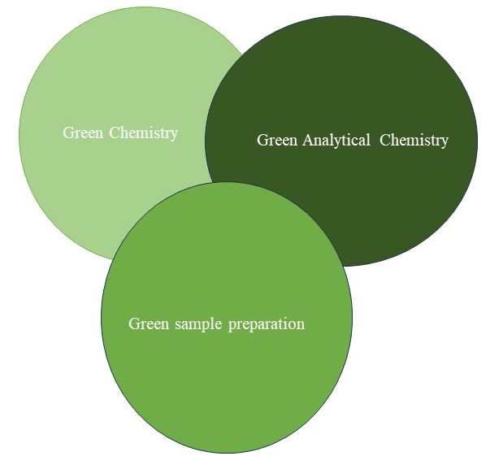

Green Analytical Chemistry (GAC) principles inclusion in the field of analytical chemistry by Anastas (Anastas and Warner, 1998) has impacted the analysts to advance an environmentally benign method that is safe to analyst and environment. The twelve principles portrayed for GAC were derived from green chemistry and modified according to the need of the analytical chemistry.

Paul Anastas and John Warner in 1998 formulated Twelve principles of Green chemistry is a frame work for designing chemical processes that are more environmentally benign[4,5,6].

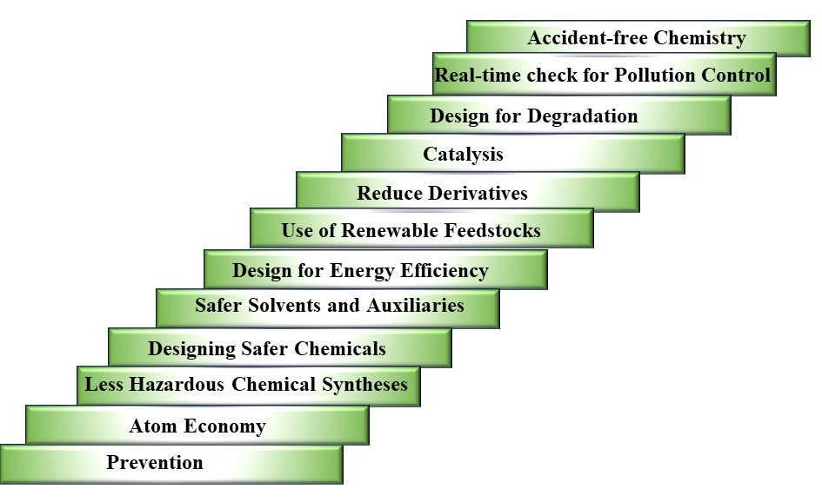

ANALYTICAL FIGURES OF MERIT:

Figures of merit are analytical parameters used for evaluating the performance of a [calibration method](https://www.sciencedirect.com/topics/chemistry/instrument-calibration)[7].

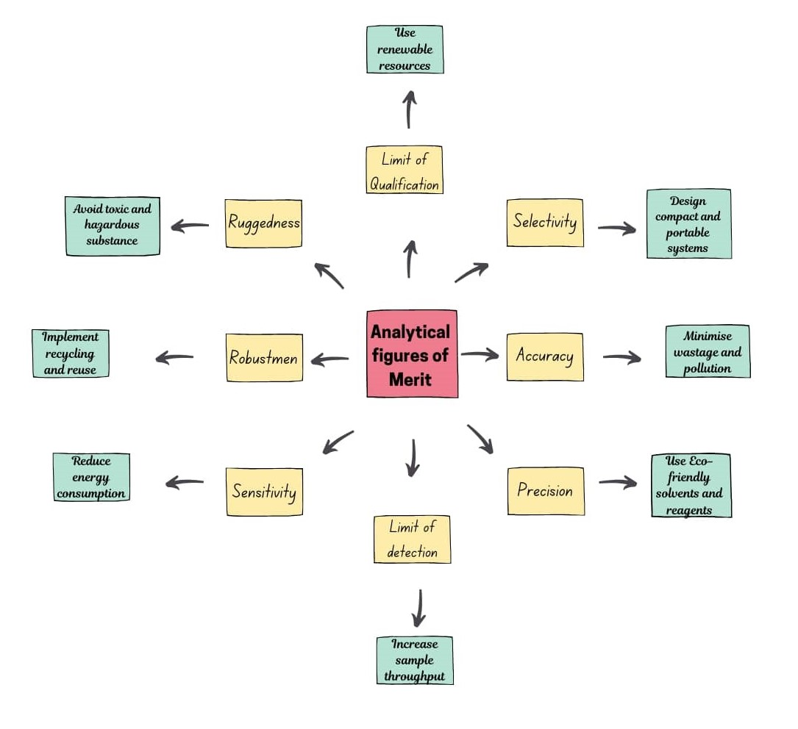

**2.Comparision between Green analytical methods Vs Regular analytical techniques**

Green analytical techniques aim to minimize environmental impact while maintaining the efficiency and accuracy of traditional methods. Greener sample pretreatment techniques aim to reduce the environmental impact of preparing samples for analysis. These methods focus on minimizing the use of harmful chemicals, reducing waste, and improving energy efficiency[8,9]. Here's a comparison of green analytical techniques with their regular counterparts:

### **1.Solid-Phase Microextraction (SPME)** Vs **Liquid-Liquid Extraction (LLE)**

**Green method (SPME)**

* + **Method**: SPME is a solvent-free extraction method that uses a fiber coated with an extracting phase to concentrate analytes from a sample.
  + **Advantage**: Reduces or eliminates the need for organic solvents, produces minimal waste, and is relatively simple and efficient.

**Regular Method(LLE)**

* + **Method**: Uses large volumes of organic solvents to extract analytes.
  + **Drawbacks**: High solvent consumption, generates significant waste.

**2.Microwave-Assisted Extraction (MAE)** Vs **Soxhlet Extraction**

**Green method (MAE)**

* + **Method**: MAE uses microwave energy to heat the sample and solvent, accelerating the extraction process.
  + **Advantage**: Reduces extraction time and solvent usage, increases efficiency, and can be used with water or other environmentally friendly solvents.

**Regular Method(Soxhlet Extraction)**

* **Method**: Uses continuous solvent extraction over several hours.
* **Drawbacks**: Time-consuming, high solvent consumption.

**3.Supercritical Fluid Extraction (SFE)** Vs **Conventional Solvent Extraction**

**Green method(SFE)**

* + **Method**: SFE uses supercritical fluids, often carbon dioxide, to extract analytes from samples.
  + **Advantage**: Uses non-toxic and recyclable supercritical CO2, reduces solvent use, and provides efficient extraction.

**Regular Method**

* + **Description**: Utilizes organic solvents at high volumes.
  + **Drawbacks**: Toxicity, environmental hazards, high waste.

**4.Pressurized Liquid Extraction (PLE)** **Vs** **Traditional Solvent Extraction**

**Green method (PLE)**

* + **Method**: PLE, also known as accelerated solvent extraction (ASE), uses high pressure and temperature to extract analytes with minimal solvent.
  + **Advantage**: Reduces solvent consumption and extraction time, increases extraction efficiency, and can be automated.

**Regular Method(Traditional Solvent Extraction)**

* + **Method**: Involves large volumes of solvents and long extraction times.
  + **Drawbacks**: High solvent and energy use.

**5.Ionic Liquid-Based Extraction** **Vs Organic Solvent Extraction**

**Green method(Ionic Liquid-Based Extraction)**

* + **Method**: Ionic liquids are used as green solvents for extraction due to their low volatility and tunable properties.
  + **Advantage**: Reduces volatile organic compound (VOC) emissions, allows for customizable extraction conditions, and can be reused.

**Regular Method(Organic Solvent Extraction)**

* + **Method**: Relies on volatile organic solvents.
  + **Drawbacks**: High VOC emissions, hazardous waste.

### **6.Ultrasound-Assisted Extraction (UAE) vs. Conventional Heating Extraction**

**Green method (UAE)**

* + **Method**: UAE uses ultrasonic waves to enhance the extraction process by breaking down cell walls and increasing solvent penetration.
  + **Advantage**: Reduces extraction time and solvent use, is energy-efficient, and can be used with water or other green solvents.

**Regular Method (Conventional Heating Extraction)**:

* + **Method**: Involves prolonged heating of samples and solvents.
  + **Drawbacks**: Time-consuming, higher energy and solvent use.

**7.Magnetic Solid-Phase Extraction (MSPE)** **Vs** **Conventional Solid-Phase Extraction (SPE)**

**Green method (MSPE):**

* **Method**: MSPE uses magnetic nanoparticles as adsorbents
* **Advantage**: Minimizes solvent use, is easily separable using a magnetic field.

**Regular Method (SPE):**

* **Method**: Uses solid adsorbents in cartridges.
* **Drawbacks**: Higher solvent use, disposal issues.

**8.Cloud Point Extraction (CPE)** **Vs** **Liquid Liquid Extraction(LLE)**

**Green method** **(CPE)**:

**Method**: Uses nonionic surfactants to extract analytes .

**Advantage**: Minimal organic solvents usage, provides efficient extraction.

**Regular Method (LLE)**:

**Method**: LLE Uses significant volumes of organic solvents.

**Drawbacks**: High solvent usage, hazardous waste generation.

By adopting these green analytical techniques, laboratories can significantly reduce their environmental footprint while maintaining high standards of accuracy and reliability in their analyses.

1. **Trends and Concepts in greening sample treament:**

with the aim to establish greener analytical methodologies the green sample treatment principles were deduced [10].

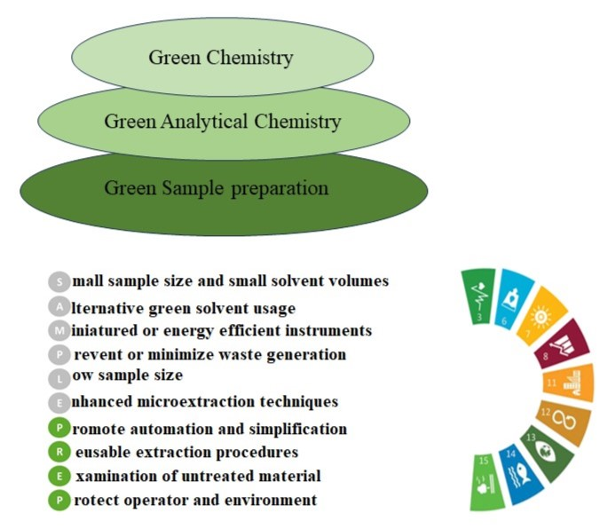

**4. Applications of Green Analytical techniques:**

1. **Supercritical Fluid Chromatography (SFC)**:
   * Utilizes supercritical CO₂ instead of traditional organic solvents, significantly reducing the use of harmful chemicals.
   * Example: Separation of pharmaceutical compounds, natural products, and complex mixtures.
2. **Solid-Phase Microextraction (SPME)**:
   * A solvent-free extraction technique using a coated fiber to adsorb analytes from samples.
   * Example: Analysis of volatile organic compounds (VOCs) in environmental samples and flavors in food.
3. **Microwave-Assisted Extraction (MAE)**:
   * Reduces extraction time and solvent use by applying microwave energy to heat samples.
   * Example: Extraction of polyphenols from plant materials for antioxidant analysis.
4. **Ultrasound-Assisted Extraction (UAE)**:
   * Uses ultrasonic waves to enhance the extraction process, reducing the need for organic solvents and shortening extraction times.
   * Example: Extraction of essential oils from botanical samples.
5. **Portable and Handheld Spectroscopy Devices**:
   * Minimize the need for sample transportation and reduce energy consumption.
   * Example: Handheld X-ray fluorescence (XRF) analyzers for metal content determination in soil samples.
6. **Direct Analysis Techniques**:
   * Techniques like X-ray fluorescence (XRF) and Raman spectroscopy often require little to no sample preparation.
   * Example: In-situ analysis of mineral composition in geological samples.
7. **Electrochemical Sensors**:
   * Provide rapid, sensitive, and selective detection with minimal reagent consumption.
   * Example: Glucose sensors for blood sugar monitoring.
8. **Ionic Liquids as Green Solvents**:
   * Used as solvents in electrochemical applications, replacing volatile organic compounds (VOCs).
   * Example: Ionic liquids as electrolytes in batteries and capacitors for analytical applications.
9. **Biocatalysis**:
   * Uses enzymes as catalysts in analytical reactions, offering high specificity and reducing the need for hazardous chemicals.
   * Example: Enzyme-linked immunosorbent assay (ELISA) for protein quantification.
10. **Photocatalysis**:
    * Utilizes light to drive chemical reactions, reducing the need for thermal energy and harsh reagents.
    * Example: Degradation of pollutants in water using TiO₂ nanoparticles under UV light.
11. **Ambient Ionization Techniques in Mass Spectrometry**:
    * Techniques like Direct Analysis in Real Time (DART) and Desorption Electrospray Ionization (DESI) allow for direct sampling and analysis without extensive sample preparation.
    * Example: Rapid screening of pharmaceuticals and illicit drugs on surfaces.
12. **Microfluidics and Lab-on-a-Chip Devices**:
    * Integrate multiple analytical processes on a single chip, significantly reducing sample and reagent volumes, waste, and energy consumption.
    * Example: Point-of-care diagnostic devices for rapid medical testing.
13. **Supercritical Fluid Extraction (SFE)**:
    * Uses supercritical CO₂ for extraction instead of organic solvents, making the process safer and more environmentally friendly.
    * Example: Extraction of caffeine from coffee beans and essential oils from plants.
14. **Green Solvents**:
    * Utilization of non-volatile and recyclable solvents like supercritical fluids, ionic liquids, and deep eutectic solvents.
    * Example: Use of supercritical CO₂ for the extraction of natural products in food and pharmaceuticals.
15. **Sustainable Instrumentation and Automation**:
    * Energy-efficient instruments and automated systems that optimize reagent and sample use.
    * Example: Automated titration systems that minimize reagent waste and improve accuracy.

**5.Quantitative and Qualitative applications:**

**1.Metal Content Determination in Soil by Handheld XRF Analyzer :**

The contamination levels of a industrial site which is suspected of having elevated levels of heavy metals such as lead (Pb), arsenic (As), and cadmium (Cd) due to past industrial activities[11,12].

**Procedure:**

1. **Field Sampling**:
   * Soil samples are collected from various locations across the site, including suspected contamination hotspots and background areas.
2. **XRF Analysis**:
   * The handheld XRF analyzer is calibrated using certified reference materials to ensure accuracy.
   * The device is then used to analyze each soil sample directly in the field. The probe is placed in contact with the soil surface, and the analyzer emits X-rays to induce fluorescence.
   * The emitted fluorescent X-rays are detected and analyzed by the device, which identifies and quantifies the metal content in the sample.
3. **Data Interpretation**:
   * Results are displayed on the device's screen within seconds, providing concentrations of metals such as Pb, As, and Cd in parts per million (ppm).
   * Data is recorded and mapped to visualize contamination levels across the site.

**2.Food and Pharmaceuticals assay by Supercritical fluid extraction :**

1. **Extraction of Caffeine from Coffee Beans**:
   * **Process**: Coffee beans are exposed to supercritical CO₂ under controlled temperature and pressure. The CO₂ selectively dissolves caffeine, which is then separated from the beans. The caffeine-laden CO₂ is depressurized to separate the caffeine[13].
   * **Benefits**: Produces decaffeinated coffee without the use of harsh organic solvents, preserving the flavor and quality of the coffee.
2. **Extraction of Essential Oils from Plants**:
   * **Process**: Plant materials (e.g., flowers, leaves, roots) are subjected to supercritical CO₂. The CO₂ extracts essential oils, which are then collected by reducing the pressure.
   * **Benefits**: Yields pure essential oils without solvent residues, retaining their aromatic and therapeutic properties. Commonly used for lavender, peppermint, and rosemary oils.
3. **Extraction of Omega-3 Fatty Acids from Fish Oil**:
   * **Process**: Fish oil is treated with supercritical CO₂ to extract omega-3 fatty acids such as EPA and DHA. The CO₂ selectively dissolves these fatty acids, which are then recovered by depressurization.
   * **Benefits**: Produces high-purity omega-3 supplements without contaminants, enhancing their nutritional value and safety.
4. **Extraction of Curcumin from Turmeric**:
   * **Process**: Turmeric powder is exposed to supercritical CO₂, extracting curcumin, a bioactive compound with anti-inflammatory and antioxidant properties.
   * **Benefits**: Yields a high-purity curcumin extract, free from residual solvents, suitable for use in dietary supplements and pharmaceuticals.
5. **Extraction of Flavonoids from Citrus Peels**:
   * **Process**: Citrus peels are treated with supercritical CO₂ to extract flavonoids, which are compounds with antioxidant and anti-inflammatory properties.
   * **Benefits**: Produces high-quality extracts for use in nutraceuticals and functional foods, preserving the bioactivity of the flavonoids.

**3**. **Pollutant Degradation Using TiO₂ Nanoparticles**

**Procedure:**

1. **Preparation of TiO₂ Suspension**:
   * TiO₂ nanoparticles are dispersed in water to form a suspension. The concentration of TiO₂ is optimized based on the specific pollutants and their concentrations[14].
2. **Exposure to UV Light**:
   * The polluted water is passed through a reactor where it is exposed to UV light (either from UV lamps or direct sunlight) in the presence of the TiO₂ suspension.
   * The UV light activates the TiO₂ nanoparticles, generating electron-hole pairs and subsequent reactive oxygen species.
3. **Degradation of Pollutants**:
   * The reactive oxygen species attack and degrade the organic pollutants in the water. Complex molecules are broken down into simpler, non-toxic substances.
   * The process continues until the pollutants are fully mineralized.
4. **Post-treatment**:
   * After photocatalytic treatment, the water is filtered to remove any residual TiO₂ nanoparticles.
   * The purified water is then subjected to further quality checks before being released or reused.

In conclusion, Green Analytical Chemistry is a crucial approach for modern laboratories aiming to achieve sustainable and responsible chemical analysis. By integrating GAC principles, laboratories can contribute to environmental conservation, enhance efficiency, and comply with regulatory standards.

**References:**

1.Wanisa Abdussalam Mohammeda, Amna Qasem Alia, Asma O.Errayes, Chem. Methodol., 2020,4, 408.

2.Tang S.Y., Bourne R.A., Smith R.L., Poliakoff M. Green Chem., 2008, 10,268.

3.S. Irem Kaya, Ahmet Cetinkaya , Sibel A. Ozkan,TrEAC., 2022,  [33](https://www.sciencedirect.com/journal/trends-in-environmental-analytical-chemistry/vol/33/suppl/C), 00157.

4.Anastas P., Eghbali, N., Chem. Soc. Rev., 2010, 39,301.

5. Tang S.L., Smith R.L., Poliakoff M., Green Chem., 2005, 7,761.

6. Kanaka Parvathi Kannaiah , Hemanth Kumar Chanduluru., [J. Clean.Prod](https://www.sciencedirect.com/journal/journal-of-cleaner-production), 2023, [428](https://www.sciencedirect.com/journal/journal-of-cleaner-production/vol/428/suppl/C), 139297.

7.Hai-Long Wu, Ru-Qin Yu., [Data. Hand. Sci. Tech](https://www.sciencedirect.com/bookseries/data-handling-in-science-and-technology), 2015.

8. [Bibhu Prasad Nanda](https://analyticalsciencejournals.onlinelibrary.wiley.com/authored-by/Nanda/Bibhu+Prasad), [Arshdeep Chopra](https://analyticalsciencejournals.onlinelibrary.wiley.com/authored-by/Chopra/Arshdeep), [Yogindra Kumari](https://analyticalsciencejournals.onlinelibrary.wiley.com/authored-by/Kumari/Yogindra), [Raj Kumar Narang](https://analyticalsciencejournals.onlinelibrary.wiley.com/authored-by/Narang/Raj+Kumar), [Rohit Bhatia](https://analyticalsciencejournals.onlinelibrary.wiley.com/authored-by/Bhatia/Rohit).,SSC Plus,2024,4.

9. Angela I. Lopez-Lorente, Francisco Pena-Pereira , Stig Pedersen-Bjergaard , Vania G. Zuin, Sibel A. Ozkan , Elefteria Psillakis.,[TrAC](https://www.sciencedirect.com/journal/trac-trends-in-analytical-chemistry) , 2022, 148,116530.

10. Sibiya NP, Rathilal S, Tetteh ET,Molecules. 2021,26,698.

11.Song, X.; Huang, X,. Adv. Sample Prep. 2022, 2, 100019.

12. Rouessac F, Rouessac A. Chemical Analysis: Modern Instrumentation Methods and Techniques. 2nd ed. New Jersey, USA, Wiley, 2007.

13. lgaz S, Sat IG, and Polat A., Journal of Food Science and Technology, 2018, 55,4, 1407.

14. S.P. Goutama, G. Saxena, V. Singh, A.K. Yadav, R.N. Bharagava, K.B. Thapa,Chem. Eng. J., 2018, 336.