Chapter 5
Advanced Technologies for Efficient Packaging Processes

Introduction:
The term "packaging" refers to the method that keeps containment of pharmaceutical product from the time of production in a unit till its use.[1]
Pharmaceutical packaging is necessary for pharmaceutical products because it preserves the stability and integrity of the dosage form, which demonstrates the product's efficacy.
The fundamental idea behind all definitions of packing is the packaged item's safety and protection during transit so that it can be easily used by customers.
Therefore, packaging is both a technology and a science that deals with the understanding of the machinery used to pack the product as well as the study of the materials and procedures used to pack it. [2]
Packaging and package design play a critical role in the production, distribution, and storage of pharmaceutical products. This is the case because an inadequate or malfunctioning packing system may cause a drug to become unstable, which could have harmful or unfavorable effects on the patient. When handling, storing, and transporting materials, packaging plays a crucial role.
However well a product is formulated, a drug may become completely ineffective or even toxic if the container reacts with the contents.[3]

Types of packaging systems
Primary packaging: Primary packaging systems package ingredients or sub-constituents that come into direct touch with the product and impact its shelf life (i.e., those who wrap the product initially). It consists of prefilled syringes, ampoules, vials (used for parenteral medicines), etc.

Secondary packaging: Secondary packaging, which is used to bundle the primary packages together, is present outside of the primary packaging. Among the secondary packing systems are boxes, shipping containers, and cartons.
Tertiary packaging: A tertiary packing method is utilized in bulk handling. It has edge protection, a barrel, and other things. [2]
Types of packaging material used for pharmaceuticals.
Following materials are used: -
- Paper and board
- Glass
- Rubber
- Metal
- Plastic. [3]

Advanced Technologies for Efficient Packaging Processes
As technology continues to evolve, the pharmaceutical industry has seen significant improvements in the design and functionality of packaging. New materials and technologies have been developed to ensure that medicines remain safe and effective throughout their lifecycle, from production to administration.
One of the most significant advancements in pharmaceutical packaging is the use of smart packaging. These packages are equipped with sensors that can monitor environmental conditions such as temperature, humidity, and light exposure. This technology ensures that medicines are stored and transported under the optimal conditions, reducing the risk of damage and degradation.
Another area of innovation is in the development of child-resistant packaging. This packaging is designed to prevent accidental ingestion of medication by children, ensuring their safety. In addition, packaging that is easier for the elderly or those with mobility issues to open has been developed, making it easier for patients to take their medication independently.
These innovations not only benefit patients but also offer significant advantages for the pharmaceutical industry. Improved packaging can reduce costs associated with product recalls and returns due to packaging-related issues. It can also help to increase patient adherence to medication, ultimately leading to better health outcomes. [4]
Cypaks’ advanced medication monitoring and report card
Patients can interact with medical providers via printed technology thanks to this cutting-edge packaging technology. When a tablet is taken out of its blister pack, this keeps track of the time and information that it was taken. This enables patients to record and publish their comments regarding side effects and the effectiveness of treatment. With the use of this technology, patient-doctor interfaces to determine the optimal course of therapy could reach new heights. The best uses for sensor-based packaging designs are in clinical trials. This aids in the development of new drugs by determining if they are ineffective or are just not being taken correctly.
Cypak uses its cutting-edge drug technology to target the clinical trials industry.
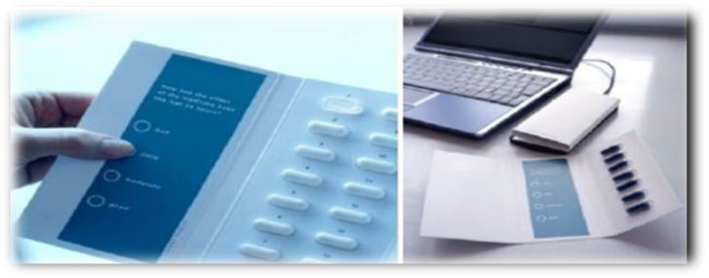
Figure 1: Cypak's advanced medication monitoring and report card systems.

Burgopak’s sliding cr blister pack
At the Pharmapack Paris show, Burgopak Healthcare and Technology took home the "Most Innovative Child Resistant Packaging Design" prize. The patient must simultaneously pull the end tab and press two buttons, one on each side of the Burgopak CR Slider pack, in order for it to open. When the pack opens, the blister is placed inside a plastic tray on one side, and patient information is presented in the form of an easily readable booklet on the other. The patient only needs to slide the end tab back into the pack to reengage the CR lock after they have accessed the medication. Elderly people and others with limited dexterity can utilize the pack more easily because it is CR and doesn't require the use of more durable CR blister foils.
The blister pack and leaflets are coordinated with the outer box, which ensures the product is never separated from its packaging.
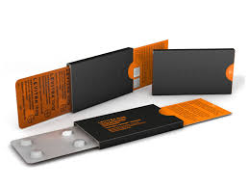
Figure 2: Burgopak's sliding cr blister pack

The Silenor® Patient Starter Kit features
When opened, the unique carton design resembles a bedroom with a bed and nightstand. A seven-count unit dose carded blister that may be removed from the design for mobility and convenience is included in the design. In order to facilitate patient adherence, the design of the bed carton includes a literature pocket that holds the medication guide, the prescription discount card for the Sleep-SaverTM Program, and a multi-panel color leaflet that includes information on how to take Silenor®, a description of its side effects, enrollment instructions that include a website and toll-free number, and more about treating insomnia.[3]

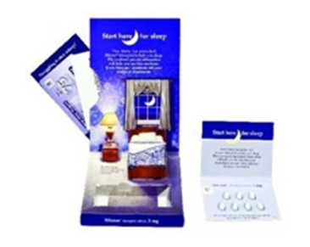
Figure 3: The Silenor® Patient Starter Kit features
Stora Enso – Pharma DDSi Wireless
This system uses conductive ink on a blister inlay made of carton board and connects it to a cellular module that is within the package.
• Pill removal is monitored, and data can be automatically transferred via GSM or GPRS cellular networks to an electronic database..
• The system may send phone calls and text messages to patients, healthcare providers, and even family members.
• A doctor can easily follow a patient's drug intake using the packaging data.
Such cutting-edge mobile technology may be especially useful for patients with Alzheimer's and other neurological disorders, who may need family members and caregivers to be more involved in their care. While patient non-compliance remains a persistent problem for the pharmaceutical sector, creative thinkers in packaging are producing an almost limitless number of ideas. To assist blind and illiterate patients with safely taking their medications, voice and sound-based packaging solutions have also been developed. A greater percentage of patients should start to realize the whole advantages of the medications that the pharmaceutical industry offers as a result of this variety of concepts changing the way pharmaceutical products are packaged and presented.[5]

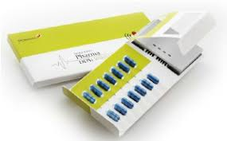
Figure 4: Stora Enso - Pharma DDSi Wireless

Novartis Pharmaceutical Corporation’s - Shellpak
30 days of treatment are provided by ShellpakTM in a calendarized unit-dose blister package. The tablets are arranged with color-coded days and weeks to help with medication compliance. Reminders for refilling the prescription are also included in the pack. The 170mm ShellpakTM exterior, a unique child-resistant package design, houses the 30-day blister. There are labels on the front and rear of the stiff plastic design. The patient's prescription label and an affixed prescription insert are to be placed in the designated space on the rear label. An enlarged content booklet label with a picture of the pill is located on the front of the pack. Patients can get help with dosing instructions, join the BP Success Zone Program guides, which include the website and toll-free number, and further regulatory information on multiple pages found on the front label. Diovan HCT® ShellpakTM is available in four different combinations of strengths. To guarantee that the patient receives the recommended dosage, each strength combination has a different color (Brown, Blue, Purple, or Red) and a picture of the special tablet design for each strength. [6]

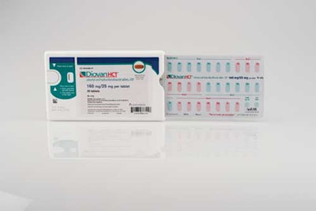

Figure 5: The Diovan HCT® Shellpak™
Eco – Friendly Pharma Packaging
A package's accessibility or safety cannot be compromised because of environmental factors. Novel ideas for pharmaceutical packaging are starting to surface that take environmental issues into account without compromising packaging advancements achieved in the last ten years.
Ecoslide-RX Sustainable compliance Packaging
The Ecoslide - RX ecological compliance packaging was introduced by Folding Box Company and Legacy Pharmaceutical The Ecoslide - RX ecological compliance packaging was introduced by Folding Box Company and Legacy Pharmaceutical Packaging.
With unbleached paperboard and a clay-coated surface to hold blister packaging with the least amount of non-sustainable film and foil, the pack is constructed entirely of recycled materials.
The slide package doesn't require heat sealing during the production process, which lowers costs and energy consumption while still meeting all current standards for child resistance and senior accessible.

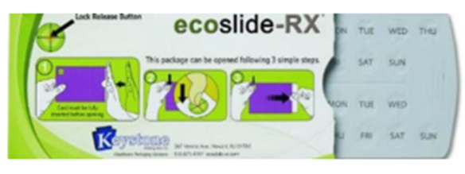
Figure 6: Ecoslide-RX sustainable compliance packaging

Prefilled Syringes
Benefits and motivating factors for prefilled nsyringes
Syringe self-filling can be a laborious procedure that is not only sluggish but also prone to spills and inaccurate dosing. Prefilled syringes made it easier and more accurate to administer medications on oneself. Prefilled syringe usage is rising, but it's not only because consumers generally want more convenient, user-friendly items; pharmaceutical companies are actively pushing this trend due to increased safety and fewer medication overfills. [3]
Packaging against counterfeiting
10% of all medications in the US are counterfeit, according to the FDA. The EU considers that 1% to 3% of medications. The most recent innovations include near field communication (NFC) tags, laser surface authentication packaging that can be identified by a unique code, and fluorescent labeling.
For example, since October 2011, Indian pharmaceutical companies have been shipping their products to international markets with a mandatory sport barcode on the exterior of the packaging.
There are several facets to understanding and simplifying the supply chain for fake pharmaceuticals. The Product-Based tracking methodology, which uses high-tech systems to detect counterfeit drugs on the market, is likely the one that is more often used by pharmaceutical businesses globally today.
These technologies include bar codes, RFID, holographic, and tamper-evident packaging.
It is true that a security feature on packaging elements does not guarantee the genuineness of the contents, which could have been substituted or adulterated. Security device alone do not reduce counterfeits, but are designed to make them easier to detect.[3]
Classification of Anti-Counterfeit Technologies Overt (Visible) Features:
The purpose of overt features is to allow end users to confirm a pack's validity. Typically, these characteristics are highly noticeable and costly or challenging to duplicate.
The lists of overt features are follows:
Holograms:
Optically VariableDevices (OVD):
Colour ShiftingSecurity Inks and Films
Security Graphics
Sequential ProductNumbering
On-Product Marking

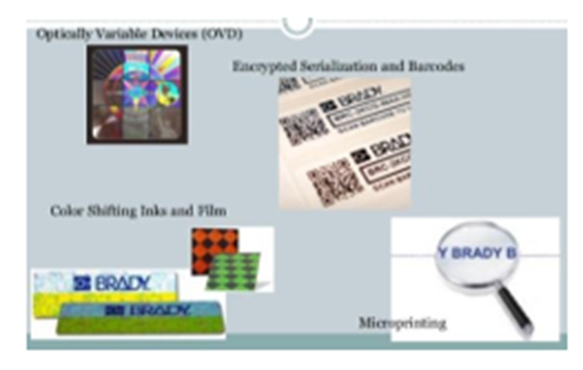
Figure 7: Overt (Visible) Features
Covert (Hidden) Features
A covert feature is meant to help the owner of the brand recognize products that are counterfeit.Its existence will remain unknown to the general population, because they lack the resources to confirm it. More covert features will lose some of their security benefit if they are breached or made public.
The list of Covert features includes: -
- Invisible Printing
- Embedded Image
- Digital Watermarks
- Hidden marks and printing
- Laser coding
- Substrates
- Anti-copy and Anti-scan design
- Odour
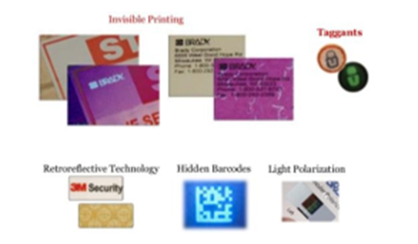
Figure 8: Covert (Hidden) Features
Forensic markers:
There is a wide range of high technology solutions which require laboratory testing or dedicated filed test kits to scientifically prove authenticity of the products. The list includes:
- Chemical Taggants
- Biological Taggants
- DNA Taggants
- Isotoperatios
- Micro-taggants
Serialization/Track and Trace technologies
Applications for Track and Trace are being developed for the pharmaceutical industry. These entail giving each stock item a distinct identity during manufacturing, which is carried with it along the supply chain until it is consumed.
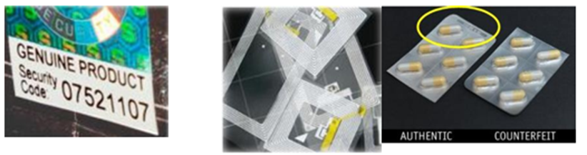

Figure 9: Serialization Track/trace Technology, RFID, Topography - Authentic & Counterfeit product
Tamper Resistant Packaging
One of the main factors taken into account when developing pharmaceutical product packaging is the need for tamper-resistant packaging.
A package that features an indicator of entry, which, if it is absent, can reasonably be expected to give consumers obvious proof that tampering has taken place, is said to be tamper-resistant.
The tamper-resistant package variants listed below have been approved by the FDA:
Bubble pack, Blister packaging, Strip package, and film wrappers Bands and shrink seals Plastic bags, paper, and oil Aerosol containers; breakable caps; bottle seals; tape sealing. [2]
Advancement in Pharmaceutical Packaging
The Talking Packaging
There are two developments in talking packaging at this moment. The German company Wipak Walsrode GmbH developed the "TalkPack" system, which requires a specialized scanning pen but can be seamlessly integrated into any printed image on any kind of packaging. A recent innovation by the VTT Technical Research Centre of Finland allows users to download text, audio, or web page product information to their mobile phone through tags with NFC (Near Field Communication) based technology. The information may then be played back on the device.

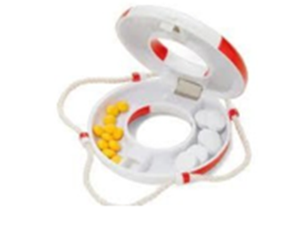
Figure 10: Talk Pack-Wipac
In order to provide the consumer with information about the manufacturer, brand, shelf life, and other details, a unique pen-shaped reader is utilized to retrieve the stored information, replay it as audio files, and make speech, music, or other sounds audible. Talk Pack doesn't need microchips or RFID. Using a unique varnish, the dot code is simply printed over text and images. Every kind of package and printing technology can be utilized with this technique. Dispensing caps, also known as functional caps, are used to contain liquid or dry supplements apart from the water that the user releases to create vitamin or energy drinks, occasionally even therapeutic drinks. Using a distributed cap, anything from medications to nutraceuticals may be packaged and dosed correctly.
Recent changesw and development in Inhalers (MID, pMID, DPI, nebulizers)
Because of worries about the harmful effects of chlorofluorocarbons (CFCs) on the ozone layer, hydrofluoroalkane (HFA) propellant has replaced them. CFC MDIs will not be sold in the US after 2008, according to a decision made by the US Food and Drug Administration (FDA). The need to employ HFA propellants created difficulties in re-designing the formulation, actuators, and valves as well as in carrying out clinical studies.The elastomeric parts of the measuring valves that are currently in use are typically incompatible with certain surfactants and HFA propellants.
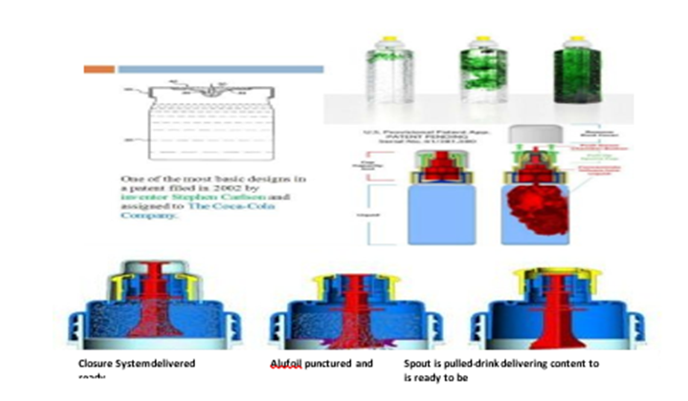

Figure 11: Dispensing cap
DPI devices fall into two categories: single-unit dose inhalers (AerolizerTM, Novartis; HandihalerTM, Boehringer Ingelheim) that load each dose into the device prior to use, and multidose reservoir inhalers (Turbuhaler TM or Flexhaler TM, AstraZeneca; Twisthaler TM, Schering-Plough) that preload a large quantity of medication into the device. Multiunitdose inhalers (DiskusTM, GlaxoSmithKline) contain many single doses that are separately sealed and released upon device activation. The Flexhaler, Diskus, and Twisthaler all contain dose indicators, but the Aerolizer employs discrete single-dose capsules. The FDA published guidelines advising manufacturers to integrate, however pMDIs lack an independent way to track how many doses are still in the device.
Diskus Inhaler Technique
At the 15th annual Allergy & Asthma Day Capitol Hill on Thurs., device inventors and manufacturers were recognized with the AANMA's inaugural new technology award. A dry powder inhaler with a 60-dose capacity is called a DISKUS®. It has an integrated counter so you can always check how many doses are left in it. The first dry powder inhaler that combines a long-acting bronchodilator and an inhaled corticosteroid in one device eases the treatment of asthma.
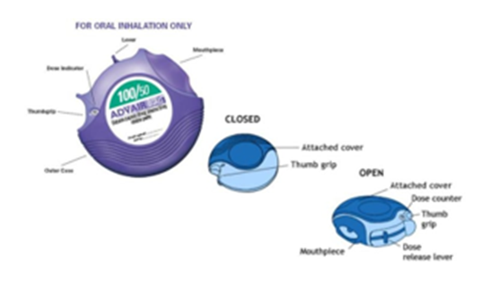

Figure 12: Diskus Inhaler
Recent Technical Advancements in Parenteral packaging Blow-Fill-Seal Technology
Due to its unparalleled flexibility in container design, overall product quality, product output, and low operating costs, this method—which was developed in Europe in the 1930s and brought to the US in the 1960s—has become the go-to approach for aseptic packaging of pharmaceutical and healthcare items.
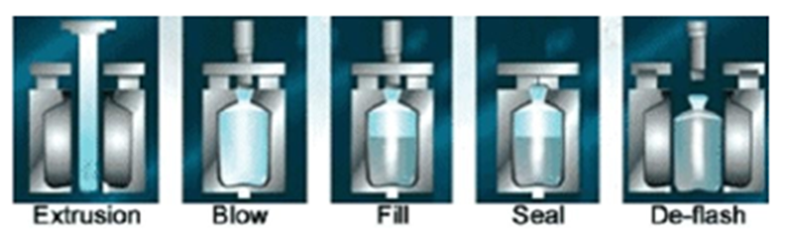
Figure 13: Blow fills seal process

Blow Fill Seal Vs. Convectional Aseptic Processing
Uninterrupted Sequence
• It requires fewer parts to build the package.
• It is more affordable than traditional aseptic processing.
• It creates a single, aseptically filled container with an integrated safety seal.
There are two types of blow-fill-seal packaging:
1]The Micro Dose package 2] TheTwist- Tip vial

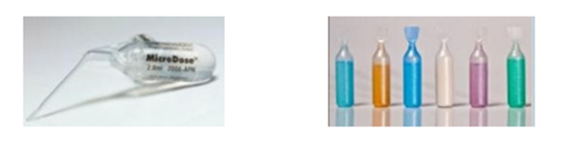

Figure 14: (a) Micro Dose Package (b) The Twist Tip Vial
These packages are made using a modified blow- fill-seal process. One of the more recent advancements in blow-fill-seal technology is the abilityto insert sterilepackaging components into the container to make it a multi use container.
Design of Syreen Prefilled Syringe
The market for syringes is even beginning to embrace environmental consciousness. It uses cyclic olefin polymer (COP) in place of glass. Considering that the COP design creates its own outer shell, this material has completely permitted secondary packaging. The packed syringes' clip-in feature avoids the requirement for cardboard packaging materials.
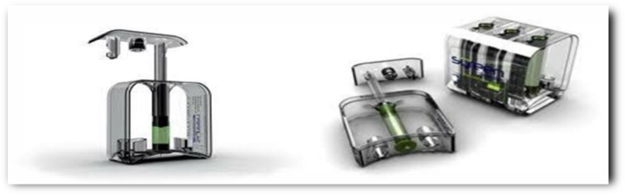

Figure 1: Syreen Prefilled Syringe Design.
Pharmaceutical Packaging Robotics: An Overview
Automation of manual processes, including loading cartoners, horizontal form fill seal machines, or blister machines, is often achieved by robotics. Increased speed, efficiency, and overall equipment effectiveness (OEE) are benefits in these situations. Reduced expenses, fewer injuries, and the elimination of rework are possible additional benefits. robots with remarkable precision and consistency. With features like vision and line tracking, they can track the movement of continuous motion machines to maintain production pace and check product placement. They are available around-the-clock.
Generally speaking, robotic cells have a far smaller footprint than conventional kinds of packaging machinery. These cells also provide a large work envelope, which enables the installed equipment to manage several packaging lines. The foot print of a typical robotic loading assembly, or collation system, is less than 3' x 3'. Even a two cell palletizer, which is usually a big robotic packaging equipment, takes up less floor space than 12' by 10'. Robotic packing lines can save space in addition to having a small footprint by utilizing a single robotic cell for several tasks, which removes the need for extra equipment. For instance, it is possible to design a robotic case packing and palletizing cell that minimizes the amount of equipment and space needed by loading products into cases and then placing the filled cases on a pallet. [3]

Smart Packaging
By 2024, smart packaging is anticipated to have grown to a projected value of $26.7 billion. These days, a wide range of products, including food and medications, are packaged smartly. Benefits of smart packaging for patients and pharmaceutical supply chain management:
• Enhance patient compliance/adherence
• Confirm authenticity
• Support tracking
• Anti-counterfeiting
• Addiction prevention efforts
• Protect shelf life
Types of smart packaging:
- Active packaging: This pharmaceutical packaging technology enhances safety and aids in the display of quality information. It may be able to detect the product's quality, the interior packaging, or the shipping environment. Technology like oxygen scavengers, desiccants, color-changing inks, microwave susceptors, odor absorbers/emitters, etc. are included in it. Some instances are: When tampered with freeze ink is exposed to temperatures below -10°C, it turns blue instead of clear. When Tamper Heat ink is subjected to temperatures above 65°C, it turns from grey to orange (or grey to pink).
- Intelligent packaging: This is more interactive and offers a method for delivering, storing, and/or receiving information from the Internet, the Cloud, printed electronics, cellphones, Near-Field Communication, Radio Frequency Identification, and QR codes. A few instances include
  - Pharmaceutical packaging with NFC tags: NFC is a clever approach to provide patients with interactive information on their cellphones, such a video about dosage.
  - Packaging embedded with sensor: Microchip sensors are used to record data for precise dosage and dose monitoring. For instance, a built-in sensor will capture data every time a patient takes a medication out of its package and send it to the cloud. This makes it possible for doctors to keep track of the times and frequency of tablet intake. Calendar-enabled closure technologies are combined with basic metered dosage systems to track and count pills as they are administered and transmit the data to a smartphone. [6]

References
- https://www.scribd.com/presentation/571354874/Recent-Advances-in-Pharmaceutical-Packaging-Technology.
- Systematic Review Pharmacy Recent Trends in Pharmaceutical Packaging 2022; 13(8): 522-526 A multifaceted review journal in the field of pharmacy Review Article 52.
- Ashwin S. Chouhan, (2023), New Methods and Technology of Pharmaceutical Packaging in the Future, J. Pharmaceutics and Pharmacology Research, 6(3); DOI:10.31579/2693-7247/124
- https://www.linkedin.com/pulse/technology-innovation-pharmaceutical-packaging-lokhande-l-i-o-n-
- https://www.wjahr.com/admin/assets/article_issue/24102020/1604140712.pdf.
- S.Wasim Raja. et al. (2012) Int J of Ad Biomed & Pharm Res. 1(1): 29-39.

