MAGNETOMOTIVE ULTRASOUND: AN EMERGING MOLECULAR IMAGING MODALITY
¹PRATAP SINGH, ² MAMTA VERMA, ³RAUSHAN KUMAR
1.M.Sc. Research fellow
E-mail: pratapsinghbhadoriya719@gmail.com; Contact no. +919587000973
2.Assistant professor, Department of Radiological and Imaging Techniques, College of Paramedical Sciences, Teerthanker Mahaveer University, Moradabad
E-mail: mamtav.paramedical@tmu.ac.in; Contact no. +918604122725
3. Assistant professor, Department of Radiological and Imaging Techniques, College of Paramedical Sciences, Teerthanker Mahaveer University, Moradabad
E-mail: raushank.paramedical@tmu.ac.in; Contact no. +918882010542
Abstract
Magnetomotive ultrasound (MMUS) is a new emerging technique that uses superparamagnetic nanoparticles of iron oxide (SPIONs) as the primary contrast agent. Several potential advantages and drawbacks of MRI and ultrasound leads to the new approach as a hybrid imaging technique. MMUS can detect displacement of these nanoparticles and its distribution throughout the body without causing toxicity to the body. While use of time-varying magnetic field, excitations can be observed within the sub-micrometre range by ultrasound, which gives subsequent results in animal studies. Several in vivo examinations have been demonstrated on human tissues as well in recently published studies, which shows its potential as a hybrid imaging technique. As a result, much earlier diagnosis is possible which allows effective therapy planning. The goal of ongoing work is to evolve a merged real-time implementation in clinical field, which can make MMUS a strong potential nominee for molecular ultrasonography technique. This chapter has covered various proposed configurations of this modality, as well as developments and futuristic approaches.
Keywords: Magnetic nanoparticles; Molecular imaging; Ultrasound; Hybrid imaging
Introduction
The evolution of molecular imaging is considered one of the intriguing trends in field of medical imaging, which emphasize the molecular foundation of disease over anatomical changes or variations. As a result, much earlier diagnosis is possible which allows effective therapy planning. In clinical routine, PET (Positron Emitting Tomography) and SPECT (Single Photon Emission Computed Tomography) are utilized for molecular examinations that use radioactive tracers and ionizing radiation, which expose patients and staff. Both of these modalities provide images with confined spatial resolution and need other modalities like CT and MRI for anatomical details, known as Hybrid Imaging.
Magnetic particle imaging of magnetic tracers in animal research findings have been disclosed with significant results, while use of sub-micrometre sized instead of micrometre sized bubbles to increase permeability in extravascular targets leads to a new approach of combining these modalities as a hybrid system, where motion of magnetic nanomaterials induced from magnetic field can be examined as real time visualization by using ultrasound machine.
Magnetomotive ultrasound is an evolving technique that is a form of molecular ultrasonography imaging that uses SPIONs as the primary contrast agent. Magnets produce an extrinsic magnetic field, which induces motion in nanoparticles. This motion is detected by the ultrasound using spectral or temporal examination of echo data.

OPERATING PRINCIPLE
Nanoparticles are injected into a specific volume of tissue. A time-varying extrinsic magnetic field is then applied to the preferred tissue volume. The nanoparticles will be laid out in motion when they respond to the attractive force of an extrinsic magnetic field. When this field begins to fade, particles will likely to reach their starting stage. The suggested multimodal imaging system can detect displacement and its distribution throughout the body. (Fig.1).
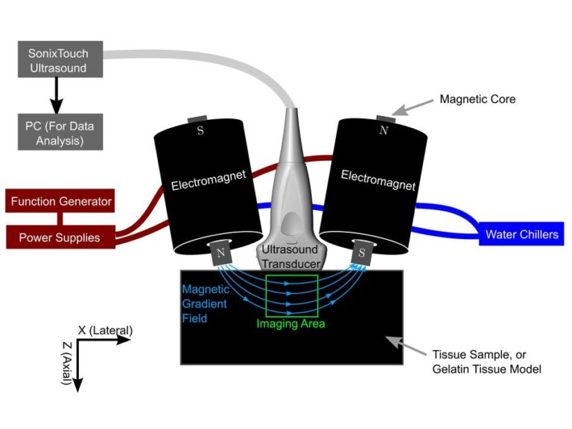
Fig.1: Operating principle of MMUS
MAGNETIC CONTRAST COMPOUNDS
It is a critical element of the magnetomotive ultrasound system that needs to move in reaction to the extrinsic magnetic field for the detection. Few desirable features should be there like initiation of displacement as a response, non-toxic and should reach their desirable site.
Magnetic iron oxide nanomaterials, which is superparamagnetic in nature (SPION) are the most repeatedly used nanoparticles for MMUS imaging that can be detected in extravascular targets without causing toxicity to the body. It is an approved MRI contrast agent and is frequently used in medical imaging procedures.
In vivo, agglomeration can be prevented by biocompatible coatings, which stabilize them. SPION can be used in variety of applications with optimum coating. Alternatively, dextran-coated iron oxide nanoparticles (Feridex I.V.) can also be used. It is considered safe because the rate of allergic reactions is very low and does not induce serious adverse effects.
For better biodistribution of nanoparticles, it needs to reach intended site effectively. The biodistribution depends on size, ability to cross barriers, coating, ability of biological or chemical reaction and route of administration as well.
There are several advantages of superparamagnetic nanoparticles such as zero remnant magnetization and high susceptibility to detect induced motion. Due to zero remnant magnetization, particles attain stability because it never experiences attraction in absence of magnetic field. Additionally, smaller volume of contrast can be detected due to high susceptibility.
Multifunctionality of magnetic contrast substances have been reported in visualisation of disease process with the use specific disease associated ligands, antibodies or similar entities in conjunction with nanoparticles. Nanoparticles can carry these coated particles simultaneously. Hence it can be utilized for treatment by carrying pharmaceutical agents. Thus, nanoparticles can be employed for double purpose as a contrast agent particle useful for diagnosis and therapy.
ROUTE OF ADMINISTRATION
SUBCUTANEOUS INJECTION: The nanoparticles enter the reticuloendothelial system through lymph nodes, and iron oxide particles are converted into serum ferritin. The persistent time and their position are dependent on the dimension of particle, as smaller particles have greater mobility than large particles. It will be ended up by availability of serum ferritin by undergoing metabolism of iron oxide.
INTRAVENOUS INJECTION: The biodistribution is dependent upon the size of nanoparticles and the surface chemistry of the coating. Small-sized particles likely to be more permeable in endothelial and cancerous tissue more effectively than large-sized particles. Smaller particles having a size below 10 nm are mainly removed by renal excretion. While larger particles of size >200 nm are filtered by the spleen. Generally, particles having long circulation time are preferred for molecular study due to more probability to interacting with binding sites.
INDIRECT ADMINISTRATION: It can be performed by the injection of iron-loaded platelets into the blood streams. Although it has not yet clinically tested in vivo by MMUS, only a phantom study has been conducted.

TISSUE RESPONSE
Biological tissues exhibit viscoelasticity, which signify that there is a non-linear relationship between force and displacement. The tissue will exhibit recoil mechanism after the initiated displacement which will be influenced setup parameters and the characteristic of local tissue itself.
The tissue movement shows resonance behaviour, and its response is frequency-dependent. The maximum induced displacement is varied according to the material-dependent optimum frequency (Fig.2).
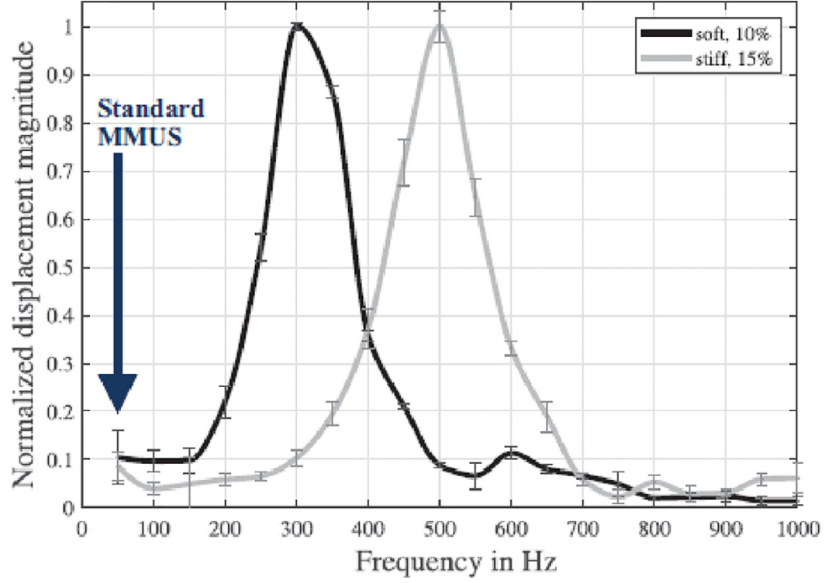
Fig.2: Tissue response¹
It has been depicted from Fig.2 that the frequency response of 300 bloom gelation at 10% and 15% is different, and as a result, a lower concentration (10%) produces softer gel.

GENERATION OF MAGNETIC FIELD
It is a fundamental component of the MMUS system, generally less than 1 tesla which produces a displacement force. The magnetic field can be produced in continuous or pulsed form. Continuous excitation is considered beneficial in terms of sensitivity and signal-to-noise ratio because signals is present only for a fractional portion of time during acquisition by a pulsed imaging system.
Different configurations of magnetic field source and ultrasound have been reported, in which both can be exercised from the same or reverse side. A variety of designs have been recommended in which electromagnets were used as MMUS magnetic field generators in the configuration of simple solenoids with an iron core.
In majority of the studies conducted, the body is placed between the electromagnet and transducer (Fig.3.a). But this configuration is not reliable in terms of inducing magneto motion because of larger extent throughout the patient’s body because displacement of particle is high around close to surface due to high flux intensity and gradient. Alternatively, the second coil can be inclined in favour of first (Fig.3.b). This setup can support an imaging range of 5 cm, when performed in anti-parallel form. Operating in anti-parallel creates a large axial gradient strength across the symmetry axis.
Other variants have been depicted in Fig.3.c and 3.d, where the magnetization coil can be positioned around the ultrasonic transducer and on the corresponding side of the transducer, respectively.
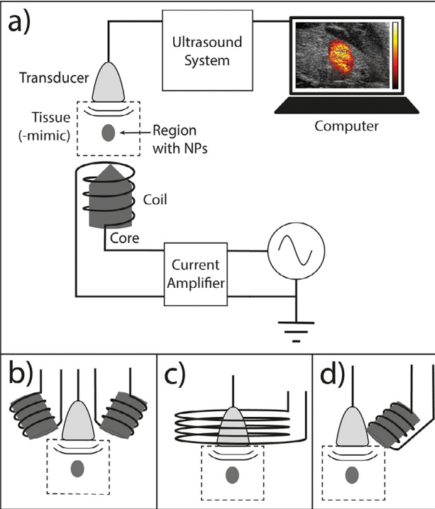
Fig.3: Configuration of magnetic field source¹
In a most recent study, a new patented MMUS probe device was constructed by employing rotating permanent magnet in order to acquire signals from human tissue (Fig.4).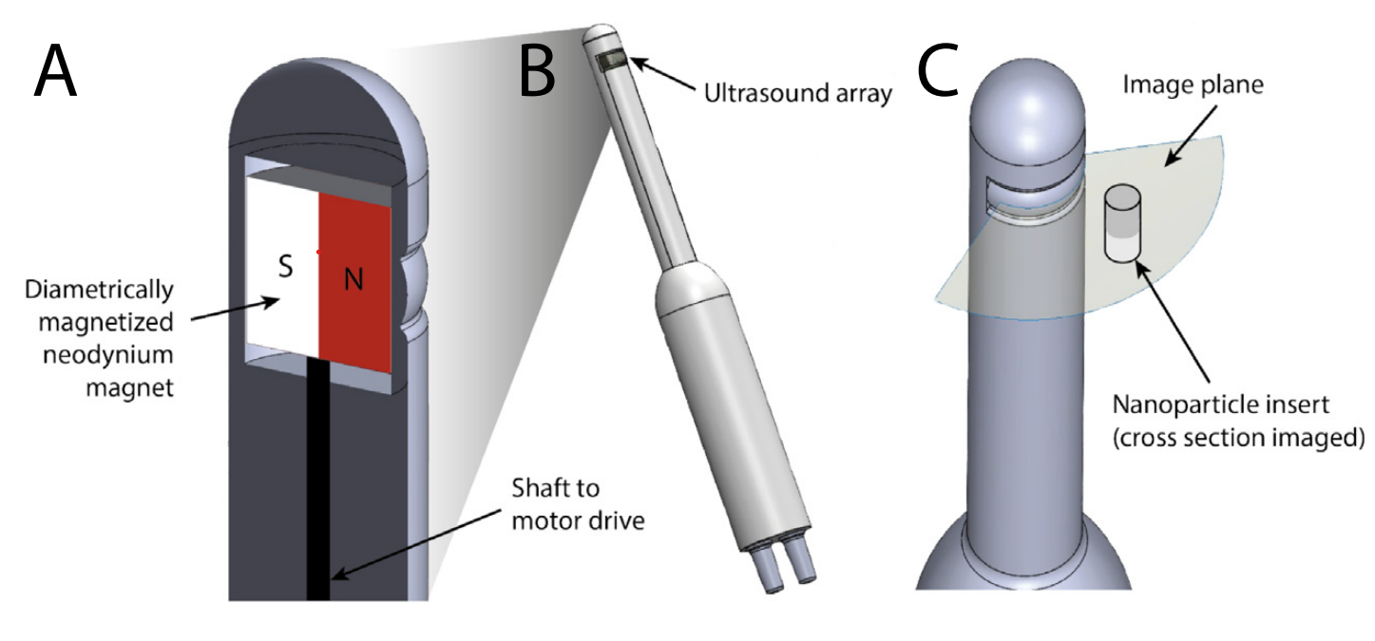

Fig.4: MMUS probe configuration. (A): Permanent magnet rotating on their rotatory axis. (B) Induced movements can be observed by ultrasound array at an imaging plane perpendicular to the rotatory axis of permanent magnets ²
ULTRASOUND ACQUISITION
Temporal resolution should be optimum to observe the initiated motion, which is directly related to frame (pulse) repetition rate. The Nyquist-Shannon sampling theorem states that in order to identify harmonic oscillations, the sample frequency must be at least twice the movement frequency.
For unipolar modulation (f_{m}), sampling frequency should be 2f_{m} because movement frequency is same as field frequency. While for bipolar modulation, sampling frequency should be 4f_{m}.
High frame rates are essential when utilizing impulse excitation since a lower frame rate would not be proficient to detect particle movement. While using the harmonic magnetic field excitation, extending the acquisition time can improve the image quality by increasing signal-to-noise ratio. But it can induce motion artefact and produce local heat deposition due to energy loss in electromagnet.

SIGNAL PROCESSING
The magnetomotion induced by sinusoidal magnetic input can be detected in the range of cm/s. Difficulty in producing a strong magnetic field at deeper imaging depths and the existence of magnetic materials in minute volume generate small magnetomotion within the sub-micrometre range. The identification of this small axial displacement can be difficult, but it may be detected by using the phase difference in the succeeding RF. To detect lateral displacement, it requires more complicated signal processing. So only axial movements have been studied by MMUS so far.
For the transmitting frequency spectrum of 7.5–21 MHz, only axial displacement is considered. Several studies have discussed the direct approach to extracting the induced movements based on excitation frequency. These methods can eradicate unwanted and out-of-phase movements by using a simple phase filter. Thus, specific range of frequency can be recorded. This is possible by using quadrature demodulation (phase sensitive demodulation) technique or Discrete Fourier Transform (DFT) methods.
The resultant signals can be presented on a grayscale image separately after processing. The online implementation and automation of this modality algorithm could obtain images 1.2 seconds later. Studies have shown a further reduction in processing time after integration with the imaging units.
CONCLUSION
In several in vivo trials, MMUS has been validated, which indicate its potential as a multimodal imaging technique. Although this approach is still in a developing stage, it is considered a promising contender for molecular ultrasonography imaging.
To attain clinical implementation, a variety of technological advancements have been suggested, as follows:
- Advancement in magnetic configuration: Achieving a potent magnetic field amplitude will cost for the high weight and size of magnets. The integration of an electromagnetic coil and a permanent magnet can reduce size and heaviness of the devices. Addition of permanent magnet can also increase magnetic gradient and allows imaging at better or extended depth. Several other advantages are low heat production and do not necessarily to be powered by high current. Some configurations that imaged object by placing them between magnets and ultrasonic probe can results in allowance of limited area to be examined. So, it would be beneficial to mount electromagnets and ultrasound probe.
- Doping: Properties like saturation magnetization and magnetic susceptibility can be enhanced by doping the core of nanoparticles which can enables molecular level study of extravasated targets effectively. Additionally, it increases sensitivity and reduces contrast doses.
- Advancement in signal processing: A constant magnetic stimulation can lead to increased detectability, and improved frequency discrimination can be possible by sliding windowing.
- Elastographic examination: There is a prospect of development of elastographic examination with MMUS as particle motion is relying on viscoelasticity that can be affected by numerous pathologies. Detailed study and understanding about particle motion related to specific pathologies is needed to evolve these methods.
The goal of ongoing work is to evolve a merged real-time implementation, which can make MMUS a strong potential contender for molecular ultrasonography imaging. As a result, it can compete with existed medical practices and eradicate the necessity to use ionizing radiation with comparable spatial image resolution and sensitivity.

References:
1. | Sjöstrand S, Evertsson M, Jansson T. Magnetomotive ultrasound imaging systems: Basic principles and first applications. Ultrasound Med Biol. 2020;46(10):2636–50.
2. | Jansson T, Jansson L, Mousavi A, Persson L, Angenete E. Detection of magnetomotive ultrasound signals  from human tissue. Nanomedicine. 2023;47(102621):102621.

