Title: **Diabetic Retinopathy & its Management by Micronutrition**

**Authors: Prof. Prasenjit Das,** Assistant Professor, Department of Optometry, Dr. B. C. Roy Academy of Professional Courses, Durgapur, West Bengal.

**Abstract:** Diabetes is a chronic condition resulting from either insufficient insulin production by the pancreas or ineffective use of insulin by the body. Insulin is the hormone responsible for regulating blood sugar. If diabetes is left untreated, it can lead to hyperglycemia (high blood sugar), which over time can cause significant damage to various body systems, including blood vessels and nerves. Untreated diabetes can damage our kidneys, eyes, nerves, and other organs due to elevated blood sugar brought on by polygenic sickness. High blood sugar brought on by diabetes is the cause of diabetic retinopathy (DR). The portion of our retina that senses light and transmits messages to our brain via the optic nerve might become damaged over time if blood sugar levels are too high. So it is very important to treat & control diabetes as early as possible. Micronutrients have a big impact on managing and preventing DR. Research suggests that eating a Mediterranean diet and consuming dietary vitamins A, B, C, D, and E can help prevent DR, but consuming a higher number of calories has been linked to an increased risk of developing diabetic retinopathy (DR).

**Keywords:-** Diabetes mellitus, Diabetic Retinopathy (DR), Anti-VEGF, Micronutrients

**Introduction:-**

Diabetes mellitus is a disorder of macromolecule metabolism characterized by the body's reduced ability to respond to insulin and regulate blood sugar (glucose) levels effectively.(Editors of Encyclopaedia Britannica. 2024) May be a chronic condition that develops when the duct gland can no longer generate endocrine or when the body is unable to utilise the endocrine that it does create. Endocrine may be an endocrine produced by the duct gland that functions as a kind of key to allow aldohexose from the food we frequently eat to enter the body's cells and provide energy by passing through the bloodstream. All foods high in macromolecules are converted by the blood into aldohexose. Endocrinology facilitates aldohexose uptake by cells.(International Diabetes Federation, 2020). The endocrine system helps transport blood sugar into cells for storage or use as energy. In diabetes, the body either doesn't produce enough insulin or doesn't use it effectively. If untreated, the resulting high blood sugar can damage the kidneys, eyes, nerves, and other organs. (Kumar.R et al 2020)

This century, diabetes, or more accurately diabetes mellitus, is rife with epidemics. Over the last ten years, the incidence of diabetes has increased by 50% (Danaei, G. et al,2011). Despite diabetes being one of the oldest known diseases, with historical records from ancient civilizations like Egypt, Persia, and India, the current epidemic is quite unexpected. (Forbes, J. M., & Cooper, M. E., 2013). According to the World Health Organisation, 347 million individuals globally—or 9.5% of the adult population—had diabetes in 2008. (Kumar.R et al 2020). Estimates indicate that the prevalence of diabetes is rising quickly & that by 2030, the population may nearly double. Although it can occur anywhere in the world, wealthier nations have higher rates of diabetes mellitus.However, Asia, the Middle East (Butler, D. 2012), and Africa are predicted to experience the most growth in incidence in the near future; by 2030, it is estimated that diabetes will have increased in these regions by around 50% (Shaw, J. E et al, 2010).

**Types of diabetes:-**

There are two primary types of diabetes: Type 1 and Type 2. However, diabetes can also occur during pregnancy and in other situations, such as exposure to certain drugs or chemicals, genetic disorders, endocrine diseases, insulin receptor issues, and pancreatic exocrine disease.(American Diabetes Association. 1997).

Hyperglycemia resulting from either relative or chronic insulin deficiency is the clinical hallmark of diabetes (Mathis, D.et al, 2001).

**Type 1 (one) Diabetes:-**

Hyperglycemia in type 1 diabetes results from a complex disease process involving both genetic and environmental factors that trigger an autoimmune response. The exact mechanisms of this autoimmune reaction are not yet fully understood (Davies, J. L.et al 1994). Although some individuals retain a high level of residual C-peptide synthesis, type 1 diabetes generally requires lifelong reliance on external insulin. This necessity arises due to the autoimmune destruction of pancreatic cells within the islets of Langerhans (Keenan, H. A.et al, 2010). Given that the prevalence of type 1 diabetes is rising in westernised nations, it is regarded as a "disease of wealth" (Harjutsalo, V. et al,2008).

**Type 2 (Two) Diabetes:-**

About 85% of diabetes cases are type 2 diabetes, which bears the greatest burden of the disease. In this form of diabetes, the decline in insulin secretion from pancreatic islets may be preceded by increased insulin production and resistance in peripheral tissues like skeletal muscle, liver, and adipose tissue, which have distinct requirements for glucose uptake and metabolism. Nonetheless, there is growing consensus that the ultimate step leading to hyperglycemia in the majority of patients is a relative decrease in insulin secretion (Kang, Y. S.,et al 2010).

**Complications:-**

Diabetes is linked to several problems.Diabetic ketoacidosis resulting from abnormally elevated blood sugar levels is one of the acute metabolic disorders linked to death.low blood glucose levels (hypoglycemia) and coma as a result of elevated glucose concentrations (hyperglycemia). This analysis will concentrate on the long-term vascular problems of diabetes, which are perhaps the disease's most destructive effect. These issues are extensive and primarily caused by persistently elevated blood glucose levels, which damage blood vessels (angiopathy) (Figure I).

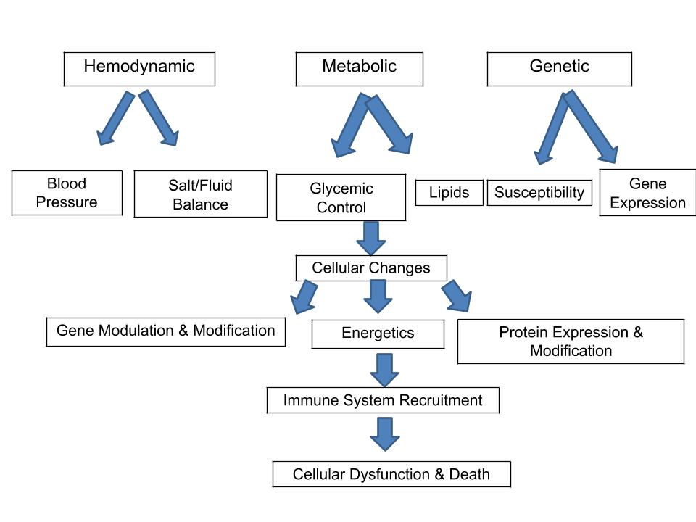

(Diagrammatic representation illustrating the primary factors contributing to complications in diabetes.)

Complications associated with diabetes include macrovascular disease, arising from arterial damage, and microvascular disease, resulting from small blood vessel damage.

Microvascular complications encompass conditions such as nephropathy (kidney disease), retinopathy (eye disease), and neuropathy (nerve damage). Macrovascular complications include cerebrovascular accidents (strokes) and accelerated cardiovascular disease leading to heart attacks (myocardial infarctions).Diabetes related myocardial dysfunction also seems to be, at least partially, independent of atherosclerosis, however the exact cause is yet unknown. Among the other long-term effects of diabetes include depression, (Nouwen, A. et al 2011).

**Diabetic Retinopathy:-**

A significant microvascular consequence of diabetes mellitus is diabetic retinopathy, which damages the retinal capillaries and, if untreated, results in blindness or vision loss (International Diabetes Federation & The Fred Hollows Foundation, 2015). As a further problem, diabetic macular edema can potentially develop at any point in its progression and thicken the retina's macular area, which can cause significant vision loss (International Federation on Ageing, International Agency for the Prevention of Blindness, & International Diabetes Federation. 2016). Due to the increasing prevalence of diabetes and an aging population, diabetic retinopathy has become a leading cause of blindness among the working-age population in the Western world. It is estimated to be responsible for approximately 2.4 million cases of blindness globally (Prokofyeva, E., & Zrenner, E. 2012), of which 15% – 17% occur in the US & Europe and 3% – 7% in Southeast Asia & the Western Pacific (Resnikoff, S.et al 2004). Understanding the causes of diabetic retinopathy is crucial because, in addition to its threat to vision, research shows it is associated with a higher risk of cardiovascular events and overall mortality (Kramer, C. K.,et al. 2011). Diabetic retinopathy significantly negatively impacts the quality of life (Coyne, K. S., et al 2004, Federation, I. D. 2017).

**Pathogenesis of Diabetic retinopathy:-**

Diabetic retinopathy is a microvascular disease of the retina. It involves modifications to the blood's rheological characteristics as well as the vascular wall. When these conditions come together, capillary occlusion occurs, which causes retinal ischemia and leaking that can be seen angiographically. The basilar membrane thickening and the loss of pericytes and endothelial cells are common histological alterations. Pathognomonic microaneurysms are characterized by outward ballooning of the capillary wall. (Figure II)

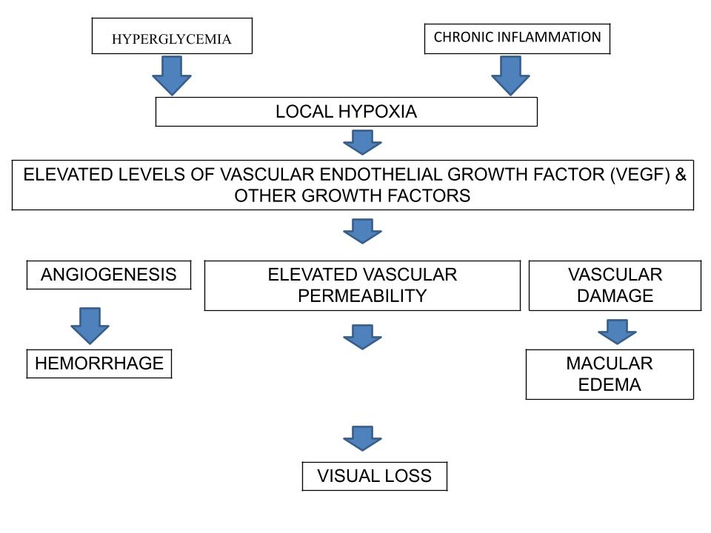

(An illustration of the pathophysiological flow chart for diabetic retinopathy)

In terms of the blood's rheological characteristics, the following elements result in reduced fibrinolysis and increased blood viscosity (Hamilton AMP,et al 1996):

* Reduced erythrocyte deformability,
* Increased platelet aggregation,
* Increased levels of fibrinogen and α2-globulin,
* Decreased levels of serum albumin.

Several biochemical signaling processes contribute to diabetic retinopathy. Elevated protein kinase C activity and protein glycosylation produce advanced glycation end products (AGEs), leading to neovascularization in the eye, increased vascular permeability, and breakdown of the inner blood-retina barrier via vascular endothelial growth factor (VEGF). AGEs mediate various diabetes complications, including vasoconstriction, inflammatory vessel wall changes, and atheromatous plaque formation, affecting endothelial cells and macrophages. AGEs are ingested through food and produced endogenously in greater quantities due to hyperglycemia. The current therapy strategy, which involves intravitreous injection of glucocorticoids, targets alterations in the inflammatory vascular wall (Jonas, J. B. 2007).

**Classification of diabetic retinopathy:-**

Diabetic retinopathy comes in two varieties:-

1. **Non-proliferative diabetic retinopathy (NPDR**):- The condition in its early stages, known as NPDR, are characterised by minimal or nonexistent symptoms. The blood arteries in the retina weaken in NPDR, allowing microscopic bulges known as microanuerysms to emerge from their walls. The macula may expand as a result of fluid leakage from the microanuerysms into the retina. (Kumar, K. S.,et al 2012)
2. **Proliferative diabetic retinopathy (PDR)**:- The disease's more severe variant is called PDR. At this point, circulation issues lead to oxygen deprivation in the retina. As a result, the vitreous, may start to fill with new, delicate blood vessels in the retina. Vision may be obscured by blood leaking into the vitreous from the new blood vessel. Glaucoma development and retinal detachment as a result of scar tissue formation are other PDR consequences. The eye condition known as glaucoma is characterised by increasing optic nerve damage. Excessively high intraocular pressure is the cause of nerve injury in proliferative diabetic retinopathy patients. PDR can result in blindness or significant visual loss if treatment is not received. (Kumar, K. S.,et al 2012)

**Symptoms of diabetic retinopathy:-**

Diabetic retinopathy symptoms can worsen over time and consist of:

* Blurred vision
* Fluctuating vision
* Dark threads or spots floating in vision (floaters)
* Scotoma
* Loss of eyesight
* Trouble interpreting colour
* Diabetic retinopathy typically affects both eyes.

**Medical care for retinopathy caused by diabetes:-**

Laser photocoagulation, both focused and grid, is used to treat diffuse and clinical diabetic macular edoema. A 50% reduction in the probability of blindness was seen after focal laser photocoagulation of microaneurysms and leakage (Rosenstock, J.,et al 2009). Retinal oxygenation is increased by focal laser photocoagulation because it improves oxygen diffusion from choroidal veins. Additionally, endothelial cells and retinal capillaries' pigment are stimulated by focal laser photocoagulation (Nentwich, M. M. & Ulbig, M. W. 2015). Because grid laser photocoagulation has a worse functional prognosis, intravitreal anti-vascular endothelial growth factor (anti-VEGF) therapy should be used instead (Bhagat, N.,et al 2009). Because of its connection to the breakdown of the blood-retinal barrier, vascular endothelial growth factor has been linked to retinal edema and leakage (Qaum, T.,et al 2001). Anti-VEGF medications can be administered intravitreously, allowing for a modest systematic exposure that must be repeated, especially in patients with center-involving diabetic macular edoema. With an average of four injections in the second year and no more than seven injections in the first, intravitreal anti-VEGF therapy is safe. (Stefanini, F. R., et al 2014)

**Nutritional role in the treatment of diabetic retinopathy:-**

**Vitamin A & Carotenoids:-** Retinal, another name for vitamin A, is a class of fat-soluble retinoids that comes from animals and is necessary for cells to divide and grow, the immune system to operate, and eyesight. The pigment in the eye termed rhodopsin is photosensitive and contains vitamin A. Zeaxanthin and lutein are plant-derived, water-soluble carotenoids that readily pass through the blood-brain and blood-retina barriers (Mohn, E. S., et al 2017). They function as potent antioxidants that stabilise cell membranes & guard against oxidative stress when concentrated in the macula. Brazionisa et al. found that, like AMD, greater levels of lutein and zeaxanthin were associated with a considerably lower risk of developing diabetic kidney disease. (Brazionis, L., et al 2008).

**Vitamins in Group B: -** Vitamin B1, also known as thiamine, is an effective scavenger of free radicals that regulates intracellular glucose and prevents the activation of the polyol pathway, which is triggered by high intracellular glucose levels. (Okai, Y.,et al 2007) It is hypothesised that DR in rats and humans is caused by hyperglycemia-induced disruption of the polyol pathway (Dagher, Z., et al 2004). The vascular endothelium is shielded from harm by high serum thiamine levels against advanced end products of glycation. Large daily thiamine dosages (50–100 mg) supplements are safe and effective for treating and preventing end-organ damage, such as diabetic nephropathy and DR (Shi, C., et al 2020).

**Vitamin C:-** Vitamin C that is soluble in water is crucial for the renewal of other antioxidants including glutathione and vitamin E (Vitamin, D.National Institutes of Health 2020). In patients with primary hypertension, it lowers blood pressure (Guan, Y., Dai, P., & Wang, H. 2020). Studies on diabetic patients and animals have demonstrated that oral vitamin C reduces capillary endothelial dysfunction (Thosar, S. S et al 2015). Proliferative DR patients are more likely to develop diabetic macular edema and have a ten fold decreased ascorbate concentration in the vitreous humour (Park, S. W.,et al 2019). When combined with statins, vitamin C reduces nonproliferative DR more than statins alone can (dose-dependently) (Gurreri, A., et al2019).

**Vitamin D:-** Regarding insulin sensitivity, release, inflammation reduction and vascular stiffness, the right dosage of vitamin D is essential (Shi, C., et al 2020). Recent research has demonstrated that DR risk and severity can be decreased by maintaining an optimal vitamin D level (Long, M., et al 2017).The activity of the pancreatic cells is influenced by vitamin D (Rashidi, B., et al 2017).

**Vitamin E:-** Supplementing with Blood pressure is lowered by vitamin E somewhat, particularly the systolic pressure (Shi, C., et al 2020). A Joslin Institute study found that vitamin E administration at a daily dose of 1800 IU enhanced retinal blood flow in people with T1DM who had had the condition for less than ten years (Bursell, S. E.et al 1999). After vitamin E therapy, oxidative stress, which is increased in diabetic retinopathy is decreased (Chatziralli, I. P.,et al 2017). When vitamin C is taken along with vitamin E, the benefits seem to be much greater (Stoyanovsky, D. A.,et al 1995 ).

**Zinc:-** Zinc is an essential cofactor for immune system function, DNA synthesis, protein and glucose metabolism, and cell division. Chronic pathogenic diseases like diabetes, metabolic syndrome, microvascular problems associated with diabetes, and diabetic retinopathy are known to worsen with a zinc shortage (Miao, X.,et al 2013). Low serum zinc levels are linked to hypertension, longer duration of diabetes, elevated HbA1c, and microcirculatory issues. The length and severity of DR cause a progressive decrease in the serum's zinc level (Luo, Y. Y.,et al 2015).

**Conclusion:-** To sum up, micronutrients can play a significant role in both DR prevention and management. Research indicates that dietary Vitamin A, B,C,D,E and a dietary Mediterranean help defend against DR, whereas a greater calorie consumption has been linked to an increased risk of DR. These results may help medical professionals counsel diabetic individuals who could experience DR by providing evidence-based dietary advice. To better inform therapeutic guidelines, however, it may be necessary to examine the impact of other important dietary components on DR, such as proteins, fatty acids, antioxidants, alcohol, and popular beverages.

**Reference:-**

* American Diabetes Association. (1997). Clinical practice recommendations 1997. *Diabetes Care, 20*(Suppl 1), S1–S70
* Bhagat, N., Grigorian, R. A., Tutela, A., & Zarbin, M. A. (2009). Diabetic macular edema: pathogenesis and treatment. *Survey of ophthalmology*, *54*(1), 1-32.
* Brazionis, L., Rowley, K., Itsiopoulos, C., & O'Dea, K. (2008). Plasma carotenoids and diabetic retinopathy. *British Journal of Nutrition*, *101*(2), 270-277.
* Bursell, S. E., Clermont, A. C., Aiello, L. P., Aiello, L. M., Schlossman, D. K., Feener, E. P., ... & King, G. L. (1999). High-dose vitamin E supplementation normalizes retinal blood flow and creatinine clearance in patients with type 1 diabetes. *Diabetes care*, *22*(8), 1245-1251.
* Butler, D. (2012). The soaring incidence of diabetes is driving the United Arab Emirates' science ambitions. *Nature*, 482(7385), 276-277. https://doi.org/10.1038/482276a
* Chatziralli, I. P., Theodossiadis, G., Dimitriadis, P., Charalambidis, M., Agorastos, A., Migkos, Z., ... & Keryttopoulos, P. (2017). The effect of vitamin E on oxidative stress indicated by serum malondialdehyde in insulin-dependent type 2 diabetes mellitus patients with retinopathy. *The open ophthalmology journal*, *11*, 51.
* Coyne, K. S., Margolis, M. K., Kennedy-Martin, T., Baker, T. M., Klein, R., Paul, M. D., & Revicki, D. A. (2004). The impact of diabetic retinopathy: perspectives from patient focus groups. *Family practice*, *21*(4), 447-453.
* Dagher, Z., Park, Y. S., Asnaghi, V., Hoehn, T., Gerhardinger, C., & Lorenzi, M. (2004). Studies of rat and human retinas predict a role for the polyol pathway in human diabetic retinopathy. *Diabetes*, *53*(9), 2404-2411.
* Danaei, G., Finucane, M. M., Lu, Y., Singh, G. M., Cowan, M. J., Paciorek, C. J., ... & Ezzati, M. (2011). National, regional, and global trends in fasting plasma glucose and diabetes prevalence since 1980: systematic analysis of health examination surveys and epidemiological studies with 370 country-years and 2· 7 million participants. *The lancet*, *378*(9785), 31-40.
* Davies, J. L., Kawaguchi, Y., Bennett, S. T., Copeman, J. B., Cordell, H. J., Pritchard, L. E., ... & Todd, J. A. (1994). A genome-wide search for human type 1 diabetes susceptibility genes. *Nature*, *371*(6493), 130-136.
* Editors of Encyclopaedia Britannica. (2024, July 2). *Diabetes mellitus*. Encyclopaedia Britannica.<https://www.britannica.com/science/diabetes-mellitus>
* Federation, I. D. (2017). IDF diabetes atlas 8th edition. *International diabetes federation*, 905-911.
* Forbes, J. M., & Cooper, M. E. (2013). Mechanisms of diabetic complications. *Physiological reviews*, *93*(1), 137-188.
* Guan, Y., Dai, P., & Wang, H. (2020). Effects of vitamin C supplementation on essential hypertension: A systematic review and meta-analysis. *Medicine*, *99*(8), e19274.
* Gurreri, A., Pazzaglia, A., & Schiavi, C. (2019). Role of statins and ascorbic acid in the natural history of diabetic retinopathy: a new, affordable therapy?. *Ophthalmic Surgery, Lasers and Imaging Retina*, *50*(S1), S23-S27.
* Hamilton AMP, Ulbig MW, Polkinghome P: Management of diabetic retinopathy. London, BMJ Publishing Group, 1996.
* Harjutsalo, V., Sjöberg, L., & Tuomilehto, J. (2008). Time trends in the incidence of type 1 diabetes in Finnish children: a cohort study. *The Lancet*, *371*(9626), 1777-1782.
* International Diabetes Federation, & The Fred Hollows Foundation. (2015). *Diabetes eye health: A guide for health care professionals*. Brussels, Belgium.
* International Diabetes Federation. (2020, March 26). About IDF. International Diabetes Federation. <https://www.idf.org/who-we-are/about-idf.html>
* International Federation on Ageing, International Agency for the Prevention of Blindness, & International Diabetes Federation. (2016). *The Diabetic Retinopathy Barometer Report: Global Findings*. 11-10-2017.
* Jonas, J. B. (2007). Intravitreal triamcinolone acetonide for diabetic retinopathy. *Diabetic Retinopathy*, *39*, 96-110.
* Kang, Y. S., Lee, M. H., Song, H. K., Ko, G. J., Kwon, O. S., Lim, T. K., ... & Cha, D. R. (2010). CCR2 antagonism improves insulin resistance, lipid metabolism, and diabetic nephropathy in type 2 diabetic mice. *Kidney international*, *78*(9), 883-894.
* Keenan, H. A., Sun, J. K., Levine, J., Doria, A., Aiello, L. P., Eisenbarth, G., ... & King, G. L. (2010). Residual insulin production and pancreatic β-cell turnover after 50 years of diabetes: Joslin Medalist Study. *Diabetes*, *59*(11), 2846-2853.
* Kramer, C. K., Rodrigues, T. C., Canani, L. H., Gross, J. L., & Azevedo, M. J. (2011). Diabetic retinopathy predicts all-cause mortality and cardiovascular events in both type 1 and 2 diabetes: meta-analysis of observational studies. *Diabetes care*, *34*(5), 1238-1244.
* Kumar, K. S., Bhowmik, D., Harish, G., Duraivel, S., & Kumar, B. P. (2012). Diabetic retinopathy-symptoms, causes, risk factors and treatment. *The Pharma Innovation*, *1*(8).
* Kumar.R, Saha, Purabi, Kumar,Yogendra, Sahana,Soumitra (2020, October). A review on diabetes mellitus: Type 1 & Type 2. *World Journal of Pharmacy and Pharmaceutical Sciences*. https://doi.org/10.20959/wjpps202010-17336
* Long, M., Wang, C., & Liu, D. (2017). Glycated hemoglobin A1C and vitamin D and their association with diabetic retinopathy severity. *Nutrition & diabetes*, *7*(6), e281-e281.
* Luo, Y. Y., Zhao, J., Han, X. Y., Zhou, X. H., Wu, J., & Ji, L. N. (2015). Relationship between serum zinc level and microvascular complications in patients with type 2 diabetes. *Chinese medical journal*, *128*(24), 3276-3282.
* Mathis, D., Vence, L., & Benoist, C. (2001). β-Cell death during progression to diabetes. *Nature*, *414*(6865), 792-798.
* Miao, X., Sun, W., Miao, L., Fu, Y., Wang, Y., Su, G., & Liu, Q. (2013). Zinc and diabetic retinopathy. *Journal of diabetes research*, *2013*(1), 425854.
* Mohn, E. S., Erdman Jr, J. W., Kuchan, M. J., Neuringer, M., & Johnson, E. J. (2017). Lutein accumulates in subcellular membranes of brain regions in adult rhesus macaques: Relationship to DHA oxidation products. *PLoS One*, *12*(10), e0186767.
* Nentwich, M. M., & Ulbig, M. W. (2015). Diabetic retinopathy-ocular complications of diabetes mellitus. *World journal of diabetes*, *6*(3), 489.
* Nouwen, A., Nefs, G., Caramlau, I., Connock, M., Winkley, K., Lloyd, C. E., ... & European Depression in Diabetes (EDID) Research Consortium. (2011). Prevalence of depression in individuals with impaired glucose metabolism or undiagnosed diabetes: a systematic review and meta-analysis of the European Depression in Diabetes (EDID) Research Consortium. *Diabetes care*, *34*(3), 752-762.
* Okai, Y., Higashi-Okai, K., Sato, E. F., Konaka, R., & Inoue, M. (2007). Potent radical-scavenging activities of thiamin and thiamin diphosphate. *Journal of clinical biochemistry and nutrition*, *40*(1), 42-48.
* Park, S. W., Ghim, W., Oh, S., Kim, Y., Park, U. C., Kang, J., & Yu, H. G. (2019). Association of vitreous vitamin C depletion with diabetic macular ischemia in proliferative diabetic retinopathy. *PLoS One*, *14*(6), e0218433.
* Prokofyeva, E., & Zrenner, E. (2012). Epidemiology of major eye diseases leading to blindness in Europe: a literature review. *Ophthalmic research*, *47*(4), 171-188.
* Qaum, T., Xu, Q., Joussen, A. M., Clemens, M. W., Qin, W., Miyamoto, K., ... & Adamis, A. P. (2001). VEGF-initiated blood–retinal barrier breakdown in early diabetes. *Investigative ophthalmology & visual science*, *42*(10), 2408-2413.
* Rashidi, B., Hoseini, Z., Sahebkar, A., & Mirzaei, H. (2017). Anti‐atherosclerotic effects of vitamins D and E in suppression of atherogenesis. *Journal of cellular physiology*, *232*(11), 2968-2976.
* Resnikoff, S., Pascolini, D., Etya'Ale, D., Kocur, I., Pararajasegaram, R., Pokharel, G. P., & Mariotti, S. P. (2004). Global data on visual impairment in the year 2002. *Bulletin of the world health organization*, *82*(11), 844-851.
* Rosenstock, J., Fonseca, V., McGill, J. B., Riddle, M., Hallé, J. P., Hramiak, I., ... & Davis, M. (2009). Similar progression of diabetic retinopathy with insulin glargine and neutral protamine Hagedorn (NPH) insulin in patients with type 2 diabetes: a long-term, randomised, open-label study. *Diabetologia*, *52*, 1778-1788.
* Shaw, J. E., Sicree, R. A., & Zimmet, P. Z. (2010). Global estimates of the prevalence of diabetes for 2010 and 2030. *Diabetes research and clinical practice*, *87*(1), 4-14.
* Shi, C., Wang, P., Airen, S., Brown, C., Liu, Z., Townsend, J. H., ... & Jiang, H. (2020). Nutritional and medical food therapies for diabetic retinopathy. *Eye and Vision*, *7*, 1-16.
* Stefanini, F. R., Badaró, E., Falabella, P., Koss, M., Farah, M. E., & Maia, M. (2014). Anti‐VEGF for the management of diabetic macular edema. *Journal of immunology research*, *2014*(1), 632307.
* Stoyanovsky, D. A., Goldman, R., Darrow, R. M., Organisciak, D. T., & Kagan, V. E. (1995). Endogenous ascorbate regenerates vitamin E in the retina directly and in combination with exogenous dihydrolipoic acid. *Current eye research*, *14*(3), 181-189.
* Thosar, S. S., Bielko, S. L., Wiggins, C. S., Klaunig, J. E., Mather, K. J., & Wallace, J. P. (2015). Antioxidant vitamin C prevents decline in endothelial function during sitting. *Medical science monitor: international medical journal of experimental and clinical research*, *21*, 1015.
* Vitamin, D. (2020). Health Professional Fact Sheet. *National Institutes of Health*.