Indole (Synthetic/Natural)asPotential antidiabetic agent
Gagandeep¹, DivyaDhawal Bhandari², and Suman Lata³*
¹Lyallpur Khalsa College of technical campus school of pharmacy jalandhar-144001
²University institute of Pharmaceutical Sciences, Panjab University, Chandigarh-160014
^{3*}Amar Shaheed Baba AjitSingh JujharSingh Memorial College of Pharmacy, Bela (Ropar)-140111
Abstract
Indole-containing drugs have emerged as promising candidates in the pursuit of effective antidiabetic agents. Diabetes mellitus is a common metabolic disease that requires novel approaches to treatment. Indole compounds have a variety of pharmacological effects that are consistent with the complex pathophysiology of diabetes. The potential of medications containing indole as antidiabetic medicines is thoroughly included in this chapter, which also clarifies the structural variety, therapeutic implications, and methods of action of these medications. Indole derivatives possess many methods of antidiabetic effect, such as regulation of glucose metabolism, insulin sensitization, and preservation of pancreatic β-cells. Furthermore, because of their structural adaptability, specific alterations may be made to maximise pharmacological activity and minimise off-target effects.This chapter provides a thorough overview of current research discoveries and clinical advancements, highlighting indole-based drugs that show promise for the control of diabetes through preclinical and clinical investigations. It also highlights the need for greater research to realise the full therapeutic potential of indole-containing medications by talking about the opportunities and difficulties involved in moving these medications from the bench to the patient's side. This chapter seeks to encourage further research in this crucial field of drug discovery by combining the most recent findings and expertise to help readers gain a better grasp of indole-containing medications as effective antidiabetic medicines.
Keywords: Indole, diabetes mellitus, antidiabetic

- INTRODUCTION
Diabetes mellitus is a severe worldwide health concern that requires effective pharmacotherapeutic strategies for the management of hyperglycemia and related consequences. Because of their diverse biological actions and structural versatility, indole-based compounds have become attractive candidates in the search for new antidiabetic drugs . Indole, with the formula C8H7N, is a bicyclic compound with derivatives that have a variety of biological uses in medicinal chemistry. Its structure includes benzene fused with pyrrole moiety. By reducing oxindole, as proposed by Adolf Von Baeyer in 1866, indole was created.
In the field of medicine, pharmaceutical medicines based on indole have important pharmacological properties include antiviral, antibacterial, antimalarial, and anti-leishmanialproperties,antitubercular, antifungal, antioxidant, and anti-human immunodeficiency virus or HIV. One important structural chemical that clarifies as an affluent scaffold is indole. Evans et al. proposed and described the indole scaffolds that function as ligands intended for receptor diversity. The unique property of indole and its derivatives, which mimics the structure of proteins and binds inversely to enzymes, presents a wealth of opportunities for the discovery of novel medications with a mode of action that spreads. The USA has declared a number of medications on the market that include indole to be the "Best Retail." We attempted to condense recent developments in the moiety with a range of biological and therapeutic activity in the field of healthcare into one overview.
Indole is a desirable target for drug development since it provides a basic scaffold for the production of several bioactive compounds due to its benzene ring fused to pyrrole ring structure.
- STRUCTURAL ACTIVITY RELATIONSHIP AND MECHANISM OF ACTION
We talk about the SAR based on these chemicals' antioxidant and antidiabetic properties as well as modifications to their chemical structures. The heterocyclic ring and substituents of the compounds affected their different levels of activity are given in Fig. 1.
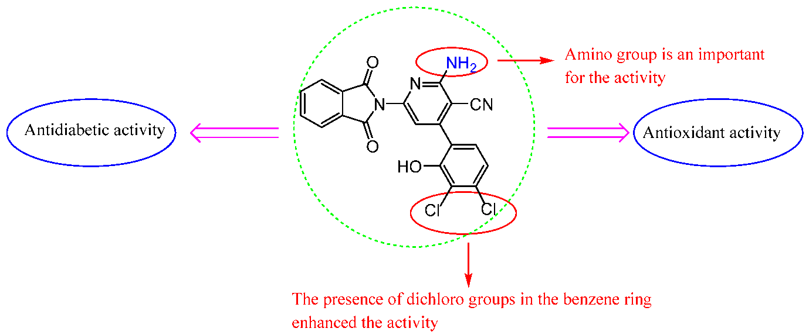
Fig No.1: SAR STUDIES OF INDOLE
Substituents on the Indole Ring:
- Alkyl Substituents: The effectiveness and selectivity of antidiabetic action can be affected by the presence of alkyl groups at various locations on the indole ring. For instance, substituents methyl and ethyl at particular locations may improve metabolic stability or receptor affinity.
- Halogen Substituents: Fluorine, chlorine, and bromine are examples of halogen substituents that can modify the lipophilicity and metabolic stability of indole medicines, hence influencing their pharmacokinetic characteristics and antidiabetic agent effectiveness.
Substitution of Functions Groups:
- Carbonyl Group: Indole derivatives that have a carbonyl group—ketone or ester—may be more bioavailable and have better metabolic stability. These functional groups have the ability to engage through hydrogen bonding with target receptors or glucose metabolism-related enzymes.
- Amino Groups: Indole derivatives with amino groups at particular locations may show superior effects on decreasing glucose levels by increasing receptor affinity and cellular absorption.
Ring Substitution Patterns:
- Ortho vs. Meta vs. Para Substitution: The binding affinity and selectivity for target receptors implicated in glucose control are impacted by the spatial arrangement of substituents on the indole ring, which also affects steric hindrance and electronic effects.
- Disubstitution vs. Monosubstitution: It has been suggested that over-substitution may impede advantageous interactions with target proteins since mono-substituted indole derivatives frequently exhibit optimum activity in comparison to disubstituted analogues.
Using Heterocyclic Substituents in Ring Fusion:
- Polycyclic Compositions: Benzothiazole and indoline moieties are examples of indole compounds with fused ring systems that show increased activity by enhancing molecular stiffness and supplying more binding contacts.
- Heteroatom Substituents: The electrical characteristics and hydrogen bonding capacity of the indole ring or its fused rings can be changed by adding heteroatoms (such as nitrogen or sulphur), which can increase the antidiabetic drugs' potency and selectivity.
Mechanisms of Action:The antidiabetic properties of indole-based compounds are mediated by many pathways, including as increased insulin sensitivity, gluconeogenesis suppression, AMP-activated protein kinase (AMPK) activation, and anti-inflammatory actions as given in Fig. 2.
GSK-3, or Glycogen Synthase Kinase, Inhibitors: By enhancing insulin sensitivity and maintaining beta-cell function, indole compounds that target GSK-3 have demonstrated promise as antidiabetic drugs.
Opponents of the Peroxisome Proliferator-Activated Receptor (PPAR): Insulin-sensitizing effects are shown by indole-based PPAR agonists, which show promise in the management of type 2 diabetes.
DPP-4, or dipeptidyl peptidase IV, DPP-4 inhibitors, such as certain indole compounds, improve glycemic control and glucose-dependent insulin secretion.

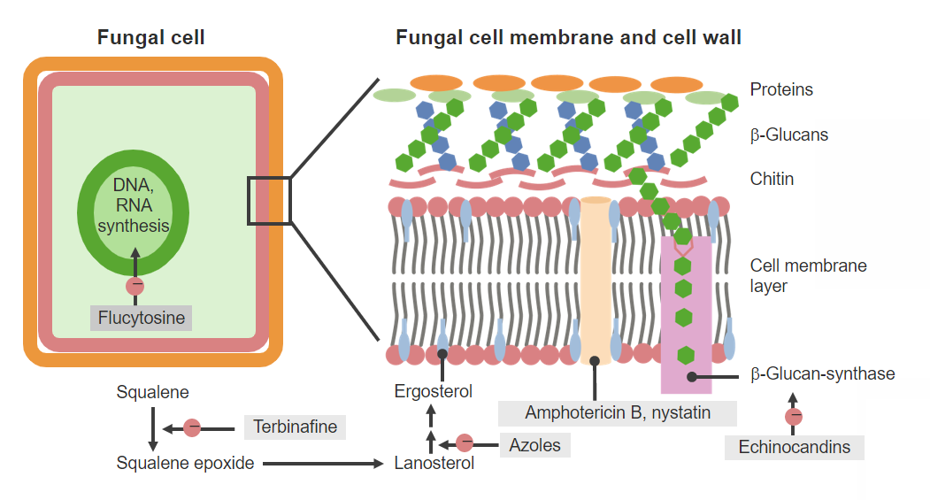
Fig. 2 : Mechanism of Action of Antifungal Drugs

- INDOLE DRUGS AS POTENTIAL ANTIDIABETIC AGENTS
A number of marketed available drugs contain indole nucleus have proved their potential among with metformin, an antidiabetic formulation has indole nucleus. Metformin is a key component in the treatment of type 2 diabetes, having an indole moiety in its structure despite not being a traditional indole molecule.Indoles are thought to have the following main benefits when it comes to possible antidiabetic agents (Fig. 3):
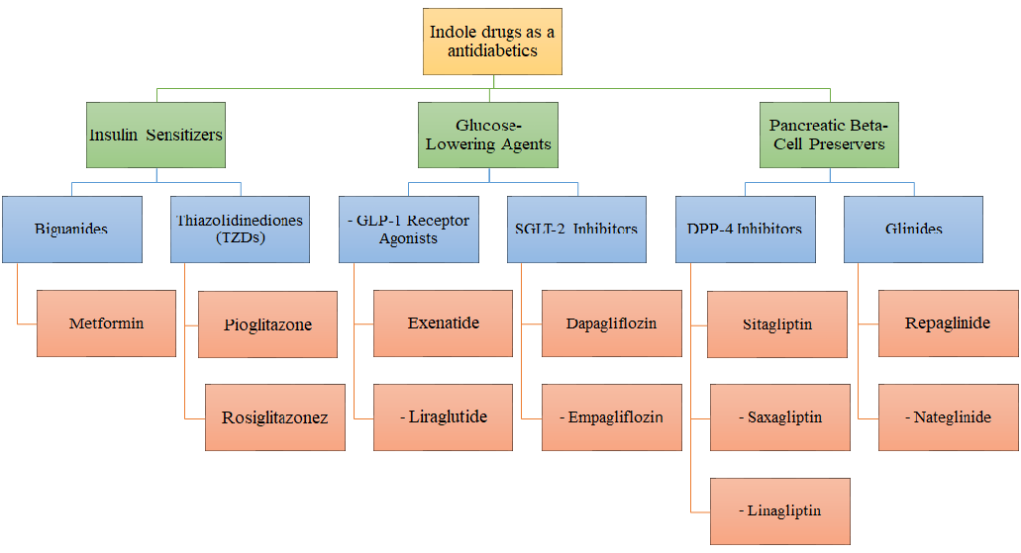
Fig.3: Anti-diabetic potential of Indoles
Insulin Sensitizing Effects:
- Biguanides: Metformin, the first-line treatment for type 2 diabetes, is a member of this family. Metformin decreases hepatic glucose synthesis, increases peripheral tissue insulin sensitivity and improves glucose absorption .
- Thiazolidinediones (TZDs): Medications that are derivatives of TZDs include pioglitazone and rosiglitazone. They improve insulin sensitivity in skeletal muscle, the liver, and adipose tissue via activating PPAR-gamma receptors.
Glucose-Lowering Properties:
- SGLT-2 Inhibitors: Drugs such as dapagliflozin and empagliflozin belong to this class. They inhibit renal glucose reabsorption, leading to increased urinary glucose excretion and lower blood glucose levels .
- GLP-1 Receptor Agonists: Exenatide and liraglutide are examples of GLP-1 receptor agonists. They stimulate insulin secretion in a glucose-dependent manner, suppress glucagon secretion, and slow gastric emptying, resulting in improved glycemiccontrol
Protection of Beta-Cells
- DPP-4 Inhibitors: Sitagliptin, saxagliptin, and linagliptin are DPP-4 inhibitors. They prolong the action of endogenous GLP-1 and GIP hormones by inhibiting their degradation, thereby increasing insulin secretion and suppressing glucagon release.
- Glinides: Repaglinide and nateglinide belong to this class. They stimulate rapid but short-lived insulin secretion from pancreatic beta cells, particularly after meals, helping to control postprandial glucose spikes.
Anti-inflammatory and Antioxidant Effects: Oxidative stress and chronic low-grade inflammation are linked to the aetiology of diabetes and its consequences. Anti-inflammatory and antioxidant characteristics of indole medicines may help reduce insulin resistance
Modulation of Metabolic Pathways: Derivatives of indoles have the ability to modify a number of metabolic pathways related to the metabolism of fats and carbohydrates. One of the ways that indole medicines work to prevent diabetes is by activating AMP-activated protein kinase (AMPK) and regulating peroxisome proliferator-activated receptors (PPARs) .
Structural variety: The ability to generate and optimise antidiabetic medicines with better potency and selectivity is made possible by the structural variety of indole compounds. Researchers can customise indole-based medications to target certain pathways implicated in diabetes mellitus by experimenting with various substituents, functional groups, and structural alterations.

IV. CONCLUSION
A broad class of molecules with potential anti-diabetic effects are indole-based compounds. These compounds present new opportunities for the development of novel therapeutics for diabetes mellitus because they target multiple pathways involved in glucose metabolism and insulin action. Indole or its heterocyclic derivatives open up various pathways for researchers to explore other biological activites also.
V. REFERENCES
- Thanikachalam PV, Maurya RK, Garg V, Monga V. An insight into the medicinal perspective of synthetic analogs of indole: A review. Eur J Med Chem2019;180:562-612.
- Diss LB, Robinson SD, Wu Y, Fidalgo S, Yeoman MS, Patel BA. Age-related changes in melatonin release in the murine distal colon. ACS ChemNeurosci2013;4:879-87.
- Patil SA, Patil R, Miller D. Indole molecules as inhibitors of tubulin polymerization: Potential new anticancer agents. Future Med Chem2012;4:2085-115.
- Higdon JV, Delage B, Williams DE, Dashwood RH. Cruciferous vegetables and human cancer risk: Epidemiologic evidence and mechanistic basis. Pharmacol Res 2007;55:224-36. 16. Rogan EG. The natural chemopreventive compound indole-3- carbinol: State of the science. In Vivo 2006;20:221-8
- Welsch ME, Snyder SA, Stockwell BR. Privileged scaffolds for library design and drug discovery. CurrOpinChemBiol2010;14:347-61
- American Diabetes Association. "Pharmacologic Approaches to Glycemic Treatment: Standards of Medical Care in Diabetes." Diabetes Care, 20XX, XX(Suppl 1), S111-S116.
- Defronzo, R. et al. "Pioglitazone for Diabetes Prevention in Impaired Glucose Tolerance." New England Journal of Medicine, 2011, 364(12), 1104-1115.
- Zinman, B. et al. "Empagliflozin, Cardiovascular Outcomes, and Mortality in Type 2 Diabetes." New England Journal of Medicine, 2015, 373(22), 2117-2128.
- Nauck, M. et al."Incretin-based Therapies: Viewpoints on the Way to Consensus." Diabetes Care, 2013, 36(Suppl 2), S524-S531.
- Drucker, D. "The Biology of Incretin Hormones." Cell Metabolism, 2006, 3(3), 153-165.
- Holst, J. et al. "Repaglinide: A Prandial Glucose Regulator." Drugs, 1998, 55(1), 31-37.
- Patel, N. et al. "Indole-Based GSK-3 Inhibitors: Potential Antidiabetic Agents." European Journal of Medicinal Chemistry, 2.
- Lee, C. et al. "Indole Compounds as AMPK Activators: Potential for Diabetes Therapy." Current Medicinal Chemistry, 20

