CHAPTER TITLE

CARDIOVASCULAR SYSTEM
Ms. Sejal M. Khuman¹, Ms. Jeshika B. Patel² Ms. Morvi M. Raval³, MS. Saloni S. Desai⁴

Ms. Sejal M. Khuman¹
M.Pharm,
Assistant Professor
Rofel Shri G. Bilakhia College of Pharmacy,
Rajju Shroff Rofel University, Vapi

Ms. Jeshika B. Patel²
M.Pharm,
Assistant Professor
Rofel Shri G. Bilakhia College of Pharmacy,
Rajju Shroff Rofel University, Vapi

Ms. Morvi M. Raval³
M.Pharm, Ph.D*
Assistant Professor
School of Pharmacy
Dr. Subhash University, Junagadh

MS. Saloni S. Desai⁴
M.Pharm, , Ph.D*
Assistant Professor
Rofel Shri G. Bilakhia College of Pharmacy,
Rajju Shroff Rofel University, Vapi

Topic covered

- INTRODUCTION
- HEART ANATOMY
  - Structure and function of heart
    - General introduction
    - Heart layers
    - Heart’s chamber
    - Valves of heart
    - Function of heart
- Heart circulation vessels
- Blood circulation
- Conduction system of heart
- Cardiac Cycle
- Conclusion

ABSTRACT

All bodily parts get their blood supply and drainage from the cardiovascular system. In general, the cardiovascular system consists of the heart, venous and arterial systems, as well as a vast network of microscopic capillaries. The heart is a muscle pump with a hollow structure that moves blood through a system of blood arteries. Blood is transported by arteries from the heart to the body's tissues. Blood is drawn from the body's tissues and returned to the heart via veins. The tiniest blood vessels, called capillaries, join the venous and arterial systems. Furthermore, blood arteries can be classified according to the part of the body they supply (or drain).Pulmonary circulation refers to blood vessels that connect to the lungs, and coronary circulation refers to blood vessels that supply blood to the heart muscle itself. This chapter give information about hearts anatomy and physiology.

INTRODUCTION ^{[1,2]}

Humans have an organ system called the circulatory system, which employs vessels to transport blood to and from each part of the body, supplying tissues with nutrients and oxygen, and removing waste products like CO2.The heart muscle pumps blood through a closed tubular system. The pulmonary and systemic circuits are composed of venous, capillary, and arterial components.

The main task of the heart is to pump blood into and out of arteries in all sections of the body like a muscular pump. This blood is transported throughout the body at high pressure and speed via the thick walls of the arteries, which are composed of both elastic fibrous tissue and muscle cells.

Heart anatomy

The cardiovascular system can be compared to a network of large and small blood-carrying plumbing tubes and a pump that's containing one-way valves

Structure and Functions of Heart
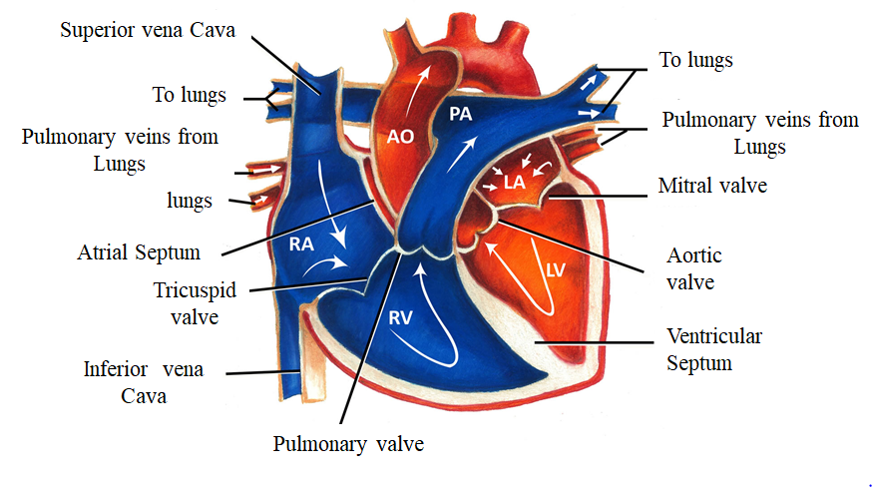
Structure of heart^{[3]}
- The typical adult human heart is approximately the size of a closed fist..
- With an average mass of 250g for adult females and 300g for adult males, At its widest point, it measures around 12 cm (5 in.) in length, 9 cm (3.5 in.) in width, and 6 cm (2.5 in.) in thickness.
- It is located in the mediastinum, an anatomical area that connects the lungs, the first rib to the diaphragm, and the sternum to the vertebral column. The heart's mass is located around two thirds to the left of the body's midline. Four chambers make up the heart. The two inferior pumping chambers are called ventricles, while the two superior receiving chambers are called atria (entrance halls or chambers).

- The pericardium^{[3,4]}

  - The pericardium is the membrane that envelops and shields the heart.
  - The heart is restricted to its location in the mediastinum, yet it still has adequate space to move around to contract rapidly and forcibly.
  - ➢ The fibrous pericardium and the serous pericardium are the two fundamental components of the pericardium. Tough, elastic, thick, uneven connective tissue makes consists the superficial fibrous pericardium.
  - The fibrous pericardium provides protection and keeps the heart from overstretching. A thinner, more sensitive membrane known as the deeper serous pericardium surrounds the heart in a double layer. The outer parietal layer of the serous pericardium is fused to the fibrous pericardium. One of the layers of the heart wall is the epicardium, or inner visceral layer of the serous pericardium, which firmly attaches to the surface of the heart.
  - There is a small layer of lubricating serous fluid between the parietal and visceral layers of the serous pericardium. As the heart beats, a substance minimises friction between the layers of the serous pericardium and is referred to as pericardial fluid. The few millilitres of pericardial fluid are stored in the pericardial cavity.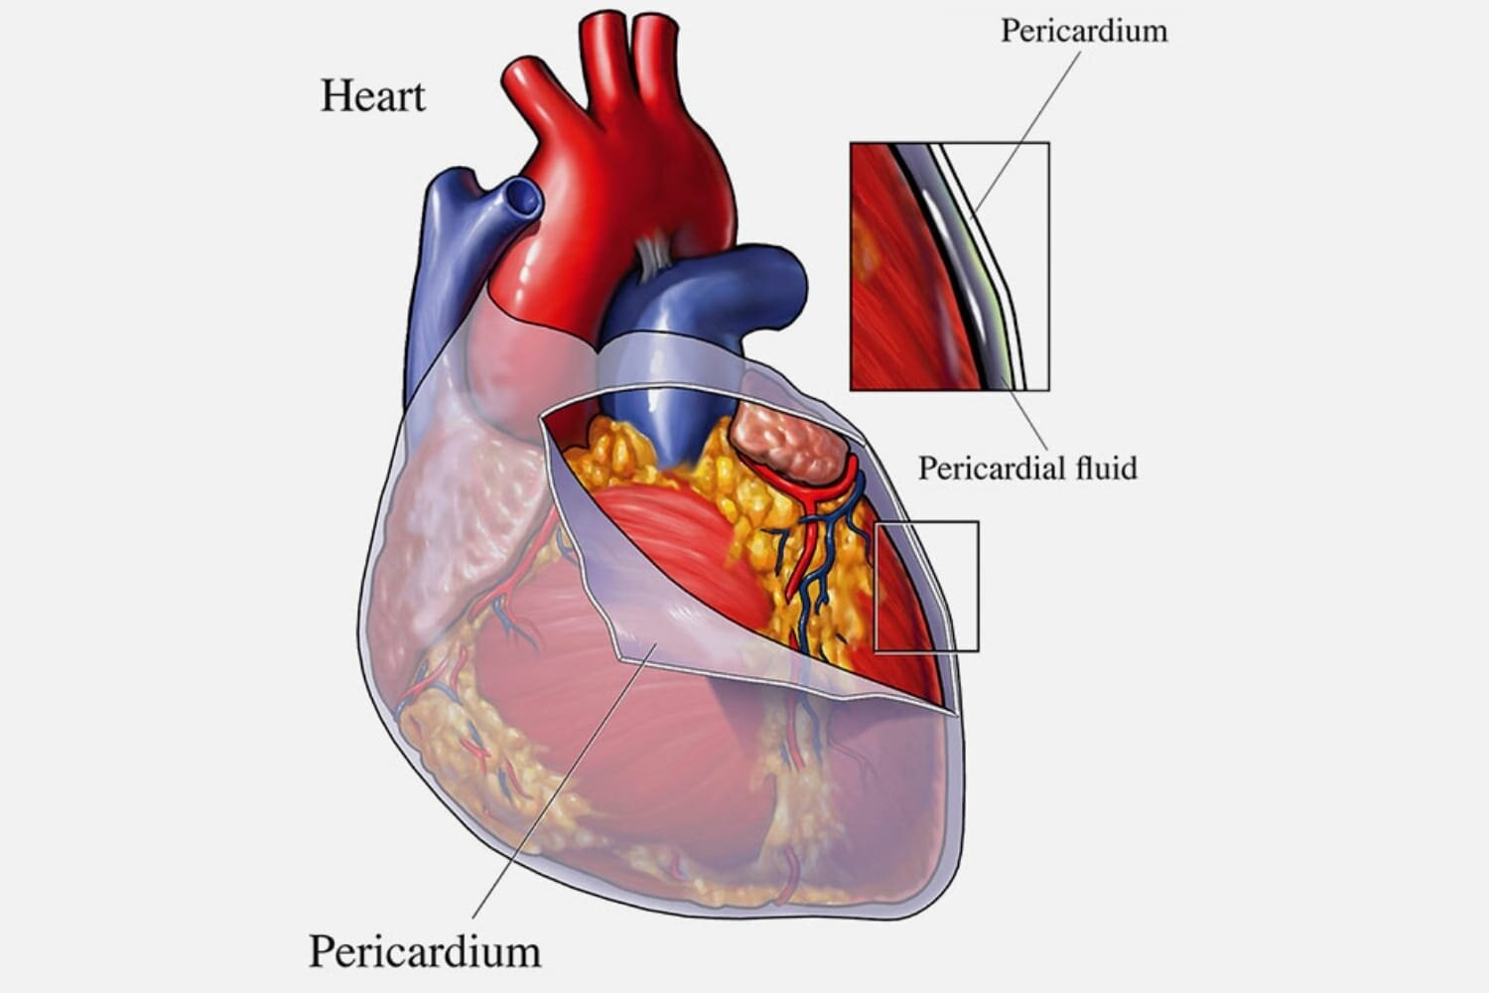

Heart’s pericardium^{[5]}
Heart layers^{[3,4]}

The three layers that collectively make up the heart muscle are as follows:

- The epicardium (external layer)
- The myocardium (middle layer), and
- The endocardium (inner layer)

  - The epicardium (external layer)
- The outermost epicardium, the thin, transparent outer layer of the heart wall, is also called the visceral layer of the serous pericardium.
- It gives the the heart's exterior a smooth, sticky texture and is made up of mesothelium and delicate connective tissue.

  - The myocardium (center layer)
- The center myocardium, which is cardiovascular muscle tissue, makes
up around 95% of the heart and is liable for its pumping activity. The cardiac muscle fibers swirl diagonally around the heart in bundles

  - The endocardium (inner layer)
- Consists of a thin layer of endothelium and a minimal covering of tissue that is fibrous.
- Its primary function is to provide a smooth lining for the heart chambers and to cover the heart valves.
- Additionally, the endocardium is seamlessly connected to the endothelial lining of the major blood vessels connected to the heart, ensuring minimal surface friction.

Heart’s Chambers ^{[3,4]}

The heart is separated by septa into two halves, namely the right and left halves. Every half is further divided into two chambers: the ventricles, which pump blood to the lungs and the rest of the body, are separated by the interventricular septum, while the upper chambers, called atria, are separated by the interatrial septum. The atria receive blood from various parts of the body (called receiving chambers) and transfer it to the ventricles.

The right atrium, also known as the right superior part of the heart, is a chamber with thin walls that receives blood from all tissues except the lungs. The right atrium is the exit point for three veins: the coronary sinus, both the superior and inferior vena cavae, and bringing blood from the upper and lower parts of the body and draining blood from the heart itself. Blood then flows from the right atrium to the right ventricle. The right ventricle, located in the right inferior part of the heart, is responsible for pumping blood to the lungs through the pulmonary artery.

On the other hand, the left atrium, situated in the left superior part of the heart, is slightly smaller than the right atrium and has a thicker wall. It receives oxygenated blood from the lungs through the four pulmonary veins. Blood enters the left ventricle from the left atrium. Three times as thick as the walls of the right ventricle, the left ventricle is located in the left inferior section of the heart. All internal parts—aside from the lungs—are supplied with blood that is aggressively pumped through the aorta from this chamber.

Valves of heart^{[4]}
The valves of the heart respond to changes in pressure by opening and closing. As the heart contracts and relaxes, these valves play a crucial role in maintaining the unidirectional flow of blood. They open to allow blood to pass through and then close to prevent any backward flow.

Atrioventricular Valves (AV valves)

AV valves, namely the tricuspid and bicuspid valves, are referred to as atrioventricular valves due to their positioning between an atrium and a ventricle. During the relaxation of the ventricles, the papillary muscles and chordae tendineae also relax, allowing blood to flow from the higher pressure in the atria to the lower pressure in the ventricles via the open AV valves.

Semilunar Valves

The semilunar valves, namely the aortic and pulmonary valves, derive their name from their structure, It has three cusps formed like a crescent moon. These valves are essential for allowing blood to be ejected from the heart into the arteries and stopping it from returning to the ventricles. The pressure inside the chambers steadily rises as the ventricles compress. The blood can then be discharged from the ventricles into the pulmonary trunk and aorta when the pressure inside the ventricles is greater than the pressure inside the arteries, causing the semilunar valves to open.

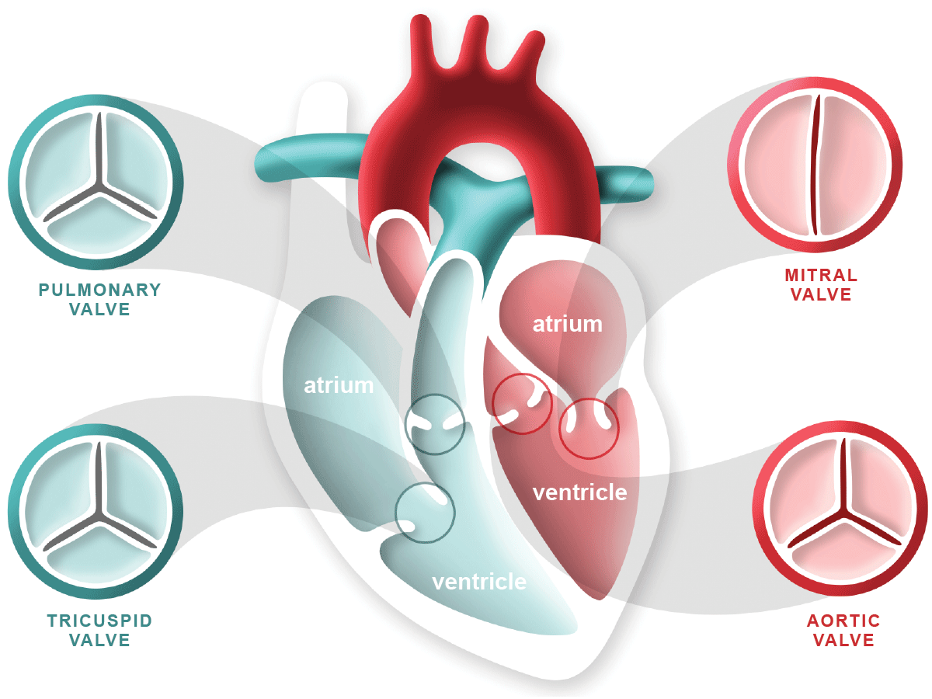

Valves of heart^{[6]}

Blood Vessels^{[7]}
The whole cardiac circulation can go forward thanks to the big blood arteries.
- The superior and inferior vena cava carry blood from the body's veins that has lost oxygen to the heart. The pulmonary trunk is then used to pump this blood. The right and left pulmonary arteries, which carry blood to the lungs, split off from the pulmonary trunk. Carbon dioxide is expelled and oxygen is taken up in the lungs. The four pulmonary veins then carry the oxygenated blood back to the left side of the heart. The aorta receives the blood from the heart and develops into systemic arteries, which supply oxygen-rich blood to every area of the body.

Heart function
- Blood supply management - Blood flow is matched to the shifting metabolic requirements of the tissues during rest, exercise, and changes in body position via variations in the heart's contraction force and rhythm.

- blood pressure production The level of blood pressure is created by heart contractions and is necessary for blood to move through blood vessels.

- Ensuring unidirectional blood supply. The heart's valves ensure that blood only flows through the heart and blood vessels in one direction.

- Blood transmission: By keeping the pulmonary and systemic circulations apart, the heart guarantees that oxygen-rich blood reaches the tissues..

Heart Circulation Vessels^{[7]}

The heart's blood does not nourish the myocardium, despite the blood flowing through its chambers virtually constantly.

• Coronary arteries. At the junction of the ventricles and atria, the atrioventricular groove—also referred to as the coronary sulcus—is where the arteries that supply the heart emerge from the lowest point of the aorta and surround the heart. These arteries constrict when the ventricle contracts and expand when the heart relaxes.

• Cardiac veins. A number of cardiac veins drain the myocardium, and these veins empty into the coronary sinus, an enlarged conduit located on the back of the heart.

Blood vessels

Within the blood vessels, which together constitute the so-called vascular system, a closed transport system, blood flows.

- Arteries- Blood is forced out of the heart through the main arteries as it beats.

- Arterioles- After there, it enters arteries that get progressively smaller until entering arterioles, which supply the tissues' capillary beds.

- Veins- Venules, which empty into veins and ultimately into the large veins that enter the heart, drain the capillary beds.

- Tunics- The blood vessel walls are covered in three layers, or tunics, with the exception of the tiny capillaries.

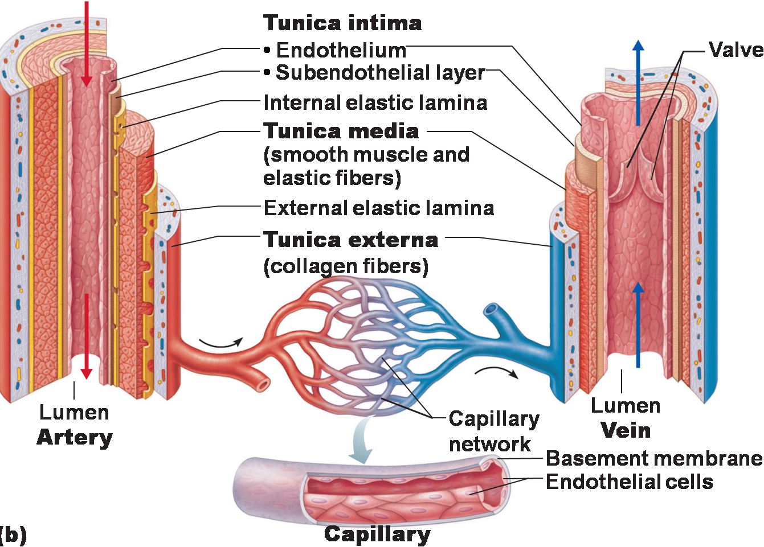

Artery, vein and capillary ^{[8]}
- Tunica intima. A thin layer of endothelium lying on a foundation membrane, the The lumen, or interior, of the tunica intima is lined. veins and reduces friction as blood passes through it.

- Media Tunica. The thick middle coat, or tunica media, is primarily made up of elastic fibers and smooth muscle that can contract or dilate to change blood pressure.

- External tunica. The primary purpose of the outermost tunic, known as the tunica externa, which is primarily made of fibrous connective tissue, is to support and shield the vessels.

Blood circulation ^{[4]}

- In the circulation that occurs after birth, the heart functions by pumping blood enters the pulmonary and systemic circulations, two separate closed pathways..

- Smaller diameter arterioles are produced by the arteries in systemic tissues, and these arterioles eventually grow into huge networks of systemic capillaries.

- These capillaries' thin walls allow for the exchange of gases and nutrients. In the process, blood absorbs carbon dioxide (CO2) and excludes oxygen (O2). Blood normally passes via one capillary and then into a systemic venule..

- These venules exit the tissues with deoxygenated (low oxygen) blood and unite to produce bigger systemic veins. The blood eventually flows back to the right atrium.
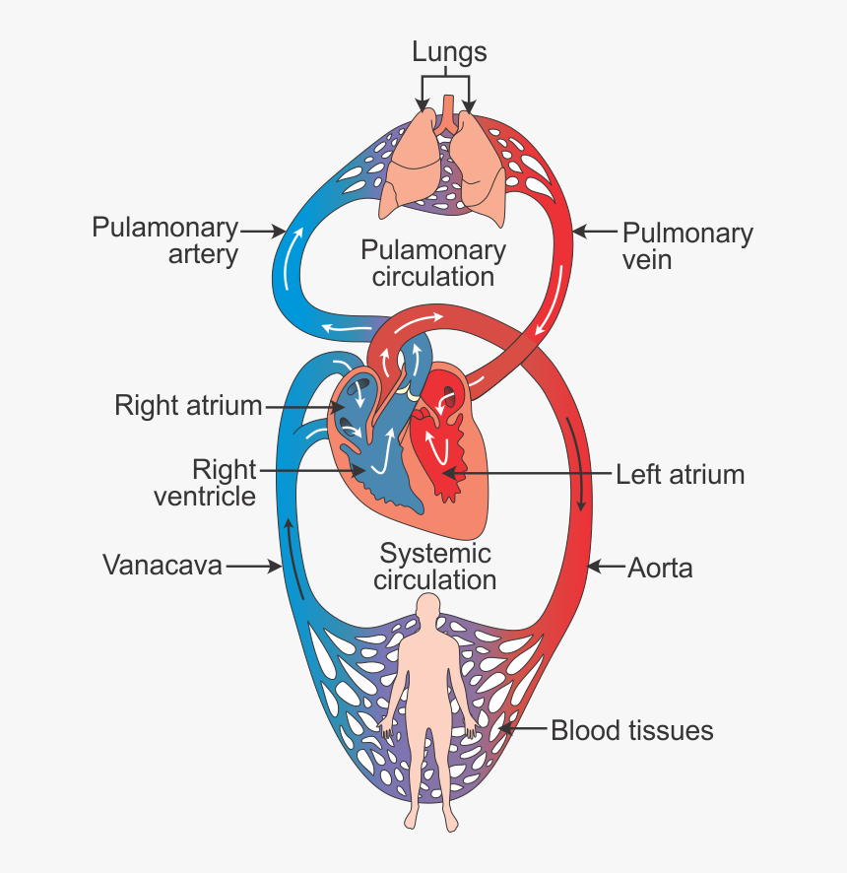
Blood circulation pathway ^{[9]}

The coronary or cardiac circulation is the name given to the complex network of blood arteries that the heart uses to supply nutrition to the myocardium. The ascending aorta is the source of these coronary arteries, which surround the heart in a circle that resembles a crown surrounding the head.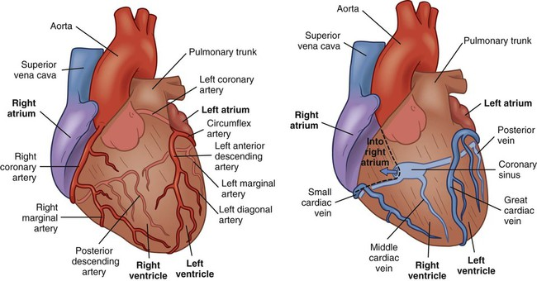
Coronary artery and coronary vein^{[11]}

Conduction system of the heart^{[10]}
- The conducting system of the heart is made up of conducting fibres and cardiac muscle cells, not nerve tissue. These structures are made to quickly initiate impulses and transport them throughout the heart.
- They initiate the normal cardiac cycle and guide the constrictions of the heart chambers.
Both the ventricles and the two atria contract simultaneously, but atrial compression occurs first. The heart's preprogrammed musical pounding is provided by the guiding framework. The events in the circulatory cycle should be organized in a way that allows the ability of the heart to pump effectively and the simultaneous functioning of the fundamental respiratory and aspiratory courses.
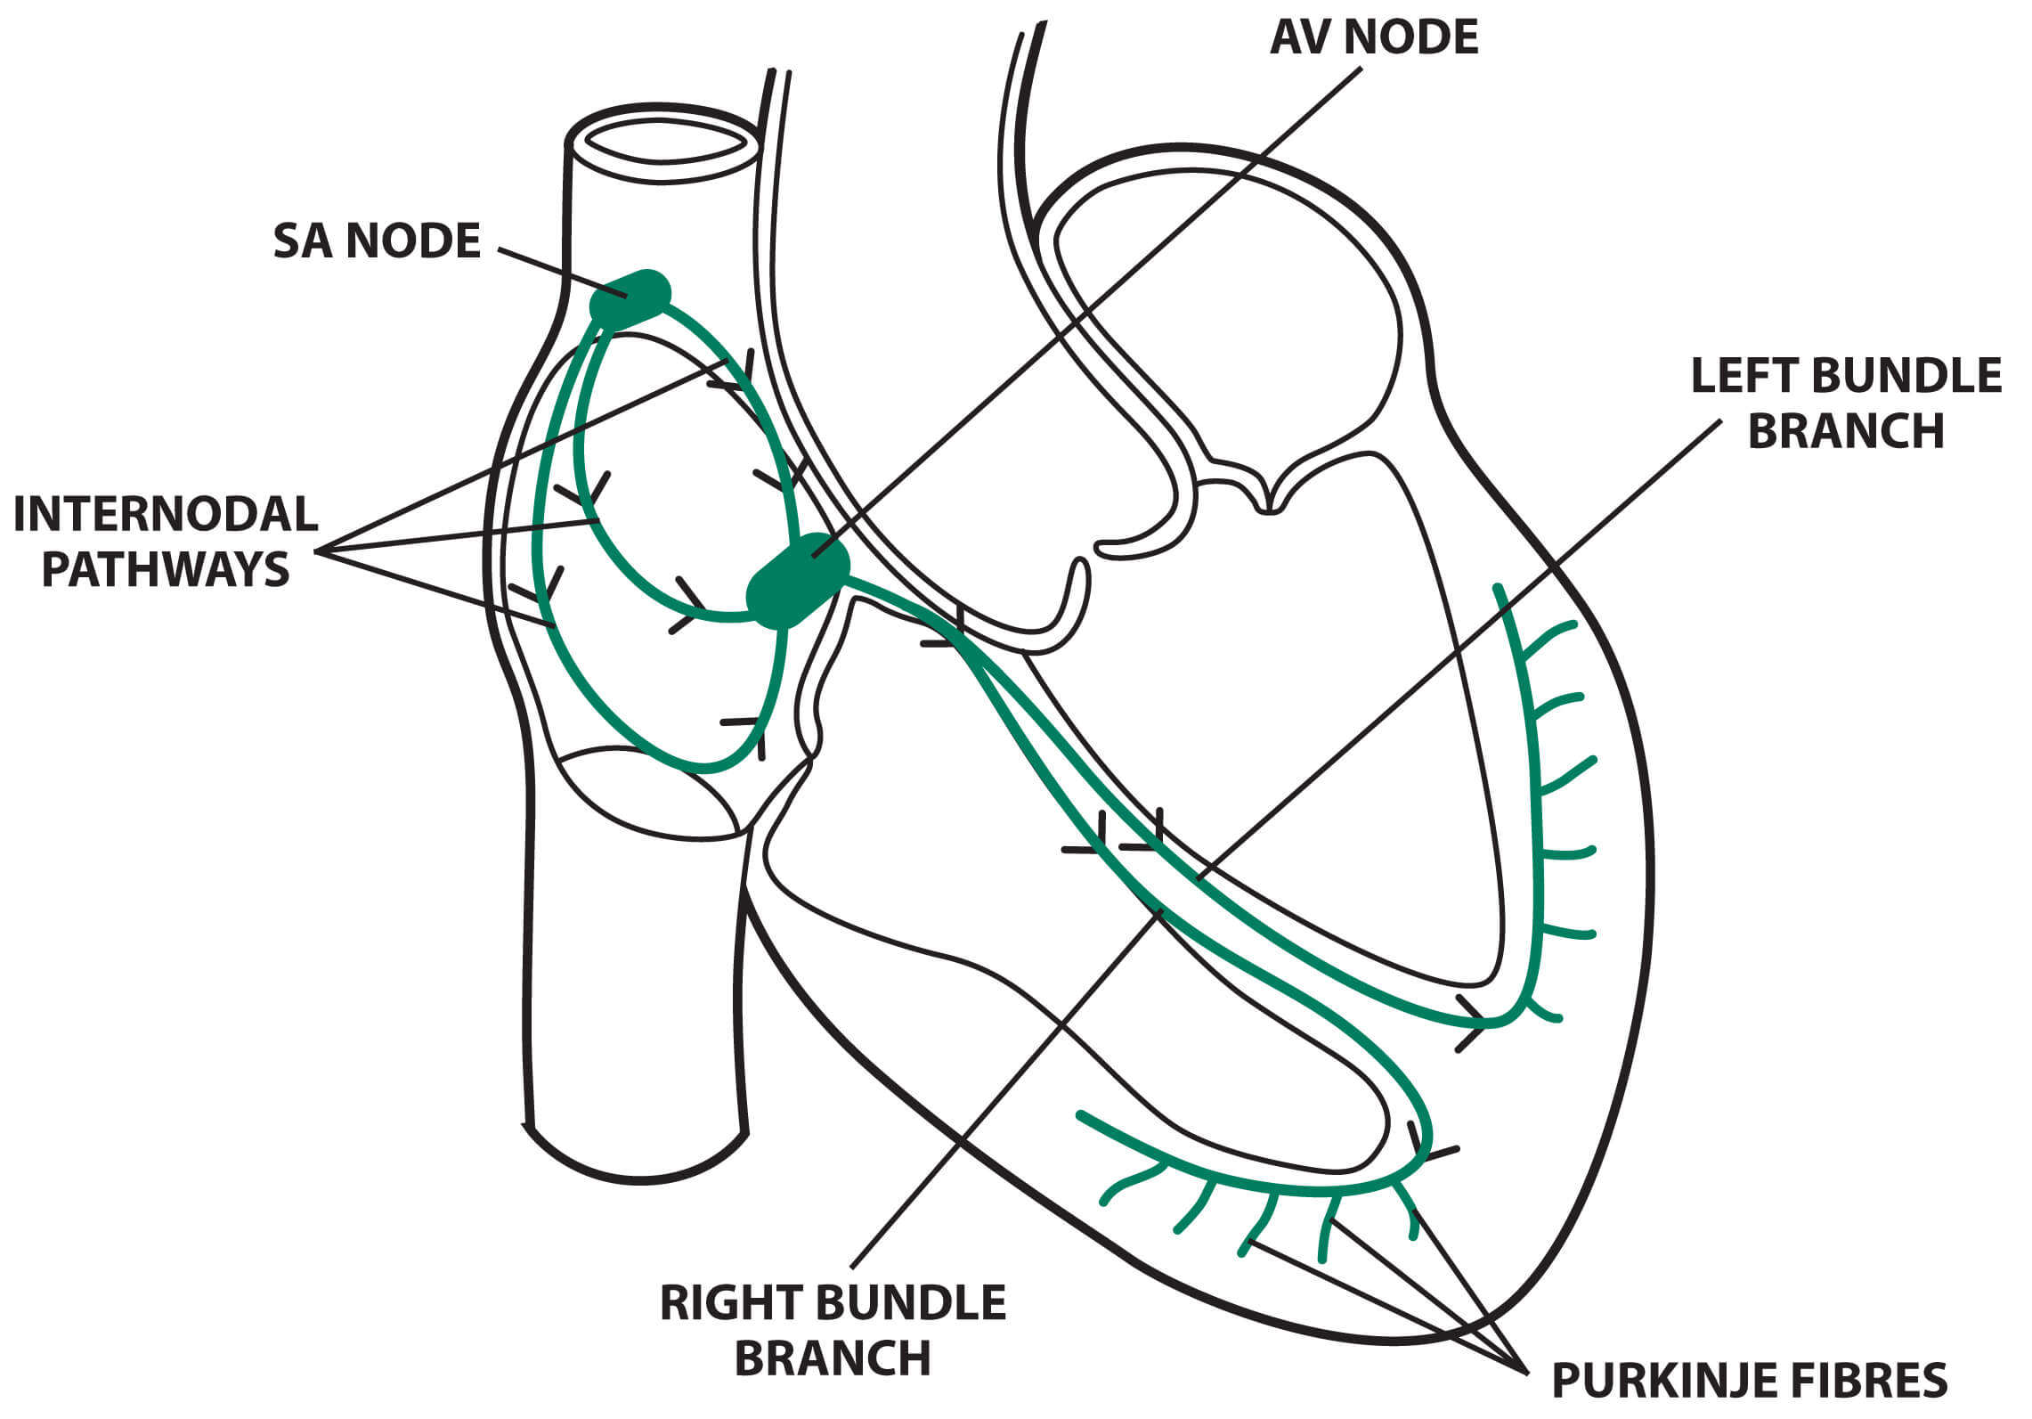

Conduction system of heart^{[13]}

SA node

The spindle-shaped Sinoatrial (SA) node is composed of densely packed cells inside a fibrous tissue matrix. It is thick, ranging in length from 10 to 20 mm, and it tends to narrow caudally toward the inferior vena cava (IVC).

The SA node is located at the side of the right atrial sulcus terminals, less than 1 mm from the epicardial surface, where the right atrium (RA) and the anteromedial portion of the superior vena cava (SVC) meet.

In 55–60% of hearts, the vein supplying the sinus node splits off from the right coronary artery, while in 40–45% of hearts, it branches from the left anterior descending artery. The artery covers the SVC–RA junction in a clockwise or anticlockwise manner before it reaches the Node.

The SA node is heavily innervated by postganglionic adrenergic & cholinergic nerve endings.

By activating muscarinic and beta-adrenergic receptors, neurotransmitters affect the rate of discharge from the SA node. The SA node contains subtypes of beta1 and beta2 adrenoceptors. The beta-adrenergic and muscarinic cholinergic receptors in the human SA node are more than three times thicker than those in the surrounding atrial tissue.

Intra-atrial and internodal conduction

Anatomic evidence shows the presence of 3 Intra-atrial Route: (1) anterior internodal pathway, (2) center internodal route and (3) posterior internodal route .

The front interatrial band, also known as the Bachmann group, is reached by the anterior internodal route, which begins at the first border of the node known as SA and bends anteriorly around the SVC. The front internodal channel of this band enters the prominent edge of the AV node and continues to the left artery (LA). Large muscle group known as the Bachmann bundle appears to be in charge of the cardiovascular drive, particularly from the RA to the LA.

The center internodal pathway starts at the prevalent and back edges of the sinus node, makes a trip behind the SVC to the peak of the interatrial septum, and plummets in the interatrial septum to the predominant edge of the AV node.

The posterior portion of the AV node is joined by the back internodal parcel, which begins at the back edge of the sinus node and proceeds into the interatrial septum over the coronary sinus, around the SVC posteriorly, and down the crista terminalis to the eustachian edge.

Since these collections of internodal tissue don't appear to be histologically distinct tracts, it is appropriate to refer to them as internodal atrial myocardium rather than lots.

AV Node

The atrioventricular (AV) node’s smaller section is a shallow structure situated right above the tricuspid valve’s septal lobe, anterior to the coronary sinus ostium, and slightly below the RA endocardium. At its peak, the tricuspid valve forms a triangle with the Todaro tendon, which extends from the central fibrous body into the atrial septum and continues with the eustachian valve.

In 85–90% of human hearts, the blood circulatory supply to the AV node begins at the posterior crossing point of the AV and interventricular channels (core),a branch of the right coronary artery. A portion of the left branch of the coronary artery provides the AV nodal supply channel in an excess of 10-15% of hearts. The AV node's lower strands may show signs of spontaneous impulse generation. The AV node's main function is to control the atrial impulses that are sent to the ventricles in order to coordinate the contraction of the ventricles and the atrium.\

The Conduction System pathway
The conduction system operates in a methodical manner by:

- SA node. The sinoatrial node starts the depolarization wave.

- Myocardium atrial. The atrial myocardium is then successively passed through by the wave.

- AV node. After reaching the AV node, the depolarization wave causes the atria to constrict.

- AV bundle. The AV bundle is then quickly traversed by it.

- Purkinje fibres and bundle branches. After that, the wave travels through the branches of the bundle on the left and right until arriving at the Purkinje fibers in the ventricular walls, where it causes a contraction that forces blood out of the heart.

Cardiac Cycle ^{[12,14]}

The sequence of events that take place from the start of one heartbeat to the start of the next is known as the cardiac cycle. The heart is made up of two sequentially operating pumps..

The right atrium and right ventricle make up the first pump, which sends blood to the lungs for gas exchange (taking in oxygen and exchanging carbon dioxide). The left atrium and left ventricle make up the second pump, which circulates blood to all other bodily tissues. This process is referred to as systemic circulation. There are valves in the heart's chambers that restrict blood flow to one direction. Located among the right and left ventricles are the tricuspid valve, the mitral valve between the left and right ventricles, the pulmonary valve between the right and left ventricles, and the aortic valve among both ventricles and the aortic artery, which provides oxygenated blood to the body's tissues. The opening and closing of these valves is managed by pressure differentials.

The diastole and systole are the two phases of the heart's beat, just like a pump. During systole, the right ventricle contracts to push deoxygenated blood into the lungs for oxygenation, while the left ventricle narrows to pump oxygenated blood into the entire systemic circulation.

The pulmonary and aortic valves open during this procedure, whereas their bicuspid and tricuspid atrioventricular valves close. Blood can enter the pulmonary artery when the pulmonary valve opens as a result of the right ventricle contracting and increasing pressure. In order to pump blood into the circulation, the left ventricle contracts simultaneously, raising pressure and opening the aortic valve. The ventricles relax during diastole, which lowers the pressure. resulting in the opening of the pulmonary valve, which opens the pulmonary artery to blood flow. In order to pump blood into the circulation, the left ventricle contracts simultaneously, raising pressure and opening the aortic valve. The ventricles relax during diastole, which lowers the pressure. The ventricles can fill with blood from the atria thanks to this relaxation, which also causes the tricuspid and mitral valves to open.

There are three separate phases that make up the systole. All valves close during the initial stage of contraction, which is referred to as isovolumetric contraction. The ventricles contract during this period, which raises the pressure. There is an 8 mmHg pressure increase in the right ventricle and an 80 mmHg pressure increase in the left ventricle. As a result, the aortic and pulmonary valves open, respectively. The second phase, referred known as maximum ventricular ejection fraction, is characterized by the ejection of blood volume at a high pressure. Blood is expelled into the systemic circulation as well as the pulmonary circulation, with pressures as high as 120 mmHg. Reduced ventricular ejection rate refers to the third and last stage. The pressure and velocity of the ejection are reduced during this phase. The aortic and pulmonary valves collapse when the pressure and velocity steadily drop.

There are four main phases of diastole. The ventricles relax during the first phase, which is referred to as isovolumetric relaxation, and the internal blood volume remains constant. All valves are closed for the duration of this phase, which is between 0.03 and 0.06 seconds. The tricuspid and mitral valves open during the second phase, known as fast diastolic filling, allowing the ventricles to fill with blood. There is a small pressure rise throughout this filling procedure, about 5 mmHg. A slower blood flow from the atria to the ventricles is the characteristics of the third phase, which is sometimes referred to as sluggish diastolic filling. The ventricles' internal pressure has somewhat increased as a result. The last stage, known as atrial contraction, is when the atria contract, raising the pressure inside the ventricles. By doing this, the ventricles get ready for systole to begin.

In the right atrium, the pressure rises by 4-6 mmHg and in the left atrium, by 7-8 mmHg during atrial contraction. It is noteworthy that atrial contraction is not necessary for about 70% of the blood volume to travel straight from the atria to the ventricles. Merely 25% of the increase in ventricular volume is attributed to contraction of the atria. For this reason, the atria are also known as a priming pump. The heart pumps 300–400% more blood than the body requires, therefore it may still work without this additional 25%.

The ventricles fill up with 110 to 120 ml of blood during diastole, the rest phase of the cardiac cycle. The last diastolic volume is the name given to this particular volume. On the other hand, this volume drops by about 70 ml during the cardiac cycle's contraction phase, or systole; this is referred to as systolic output. The final systolic volume is the amount of volume left in each ventricle, which can be anywhere between 40 and 50 ml. The ejection fraction, which is usually 60%, is the percentage of the diastolic volume that is ejected. Thus, an increase in systolic output is caused by a rise in final diastolic volume and a drop in final systolic volume. The volume of blood the heart pumps out in a minute is known as cardiac output.

CONCLUSION

Every part of our body receives life-sustaining blood pumping from the heart, a function made possible by the sophisticated and complex circulatory system. This system is a network of fluids, organs, and vessels that work together to carry nutrition and oxygen throughout our bodies. This guide covers the interesting anatomy and physiology of the circulatory system, covering everything from the four chambers of the heart to the complex sequence of events that make up the cardiac cycle.The blood carries waste materials out of the body and carries nutrients and oxygen to the cells. For cells to continuously obtain oxygen and nutrients, the heart cycle and cardiovascular system must function harmoniously. Blood pressure is a crucial indicator of cardiovascular health that is regulated by a number of factors, including blood volume, peripheral resistance, and cardiac output. Comprehending these crucial elements can aid medical practitioners in accurately diagnosing and treating cardiovascular disorders.

REFERENCE
  - Melanie A. Greeley and Stephanie J. White-Hunt, “Cardiovascular System.” Elsevier Inc. 2016, PP-423-437.
  - J.D. Humphrey and A.D. McCulloch, “The Cardiovascular System - Anatomy, Physiology and Cell Biology.” Springer-Verlag Wien, 2003, PP-.1-2.
  - Anatomy Of Heart, December 2023, https://healthjade.com/purpose-heart-valves
  - Human cardiovascular system -- Britannica Online Encyclopedia
  - Pericardium Of Heart, December 2023, https://heartvein.com/heart-disease/conditions/pericarditis
  - HEART VALVES, DECEMBER 2023, https://www.heartfoundation.org.nz/your-heart/heart-conditions/heart-valve-disease
  - Jan Hendrik van Weerd and Vincent M. Christoffels, “The formation and function of the cardiac conduction system.” The Company of Biologists Ltd ,Development, 2016, 143, 197-210.
  - Artery, Vein And Capilary,December 2023, https://www.pinterest.ca/pin/168885054751453242/
  - Blood Circulation Pathway,December 2023, https://www.toppr.com/ask/question/explain-double-circulation-in-human/
  - Conduction system of heart,january 2023, https://emedicine.medscape.com/article/1922987-overview?form=fpf
  - Coronary Artery And Veins, December 2023, https://nursekey.com/nursing-assessment-cardiovascular-system/
  - Vanessa Novaes Barros, “The heart cycle: review.” MOJ Womens Health. 2019, 8(1):66‒69.
  - Conduction System Of Heart, January 2024, https://www.medicalexamprep.co.uk/the-basics-of-ecg-interpretation-part-2-rate-rhythm-and-axis/cardiac-conduction-system-5/

