Chapter 05

Implants and Osmotic Pumps in Drug Delivery: An Overview of Mechanisms, Advantages, and Drawbacks

G Parimala Gandhi ¹, Jailani. S. ², Dr. Gita Chaurasia ³, Manoj Gangadhar Shinde ^{4,*}

¹ Associate Professor, Department of ECE, R R Institute of Technology, Bangalore-90
² Research Scholar, Dept. of Pharmacy, Faculty of Engineering & Technology (FEAT), Annamalai University, Chidambaram-608002. Tamilnadu.
³ Assistant professor, Siddhant College of Pharmacy, Sudumbare, Pune, Maharashtra
⁴ K. K. Wagh College of Pharmacy Nashik, Affiliated to Dr. Babasheb Technology University (D BATU) Lonere, Raigad

*Corresponding Author:
Manoj Gangadhar Shinde
K. K. Wagh College of Pharmacy Nashik, Affiliated to Dr. Babasheb Technology University (D BATU) Lonere, Raigad

ABSTRACT
The drug delivery sector has experienced notable progress through the introduction of implants and osmotic pumps as novel techniques for regulated and prolonged release of medicinal substances. This overview delves into the mechanics that underlie these technologies, providing insight into their unique benefits and possible limitations. Implants, which can range from basic containers to advanced bioengineered instruments, provide accurate manipulation of drug delivery by utilizing a variety of materials and designs. The review explores the processes that control the release of drugs from implants, with a particular focus on the significance of parameters such as biocompatibility, degradation rates, and release kinetics. Osmotic pump’s function based on the principle of osmosis to facilitate the administration of medication. This portion of the review explains the osmotic pumping mechanism and its significance in attaining controlled release patterns. Osmotic pumps have become prominent because they can maintain a consistent level of medication, eliminating the need for frequent doses and improving patient adherence. The benefits of these technologies go beyond regulated release and encompass targeted therapy, less side effects, and enhanced patient outcomes. Nevertheless, it is crucial to thoroughly analyze the disadvantages linked to these systems, including the risk of implant rejection, restricted drug compatibility, and the intricate nature of pump designs. The purpose of this book chapter abstract is to offer researchers, doctors, and pharmaceutical professionals a thorough comprehension of the mechanisms, benefits, and limitations of implants and osmotic pumps in the field of drug administration. This overview aims to provide future research directions and contribute to the improvement of drug delivery techniques for better treatment effectiveness by summarizing the existing knowledge.

KEYWORDS: Implants, PAVA, Osmatic, Standardization, Control release system

Background Study: The landscape of drug delivery systems has evolved significantly in recent years, with a growing emphasis on precision, efficiency, and patient compliance. Traditional oral and parenteral routes often face challenges related to fluctuating drug levels, adverse effects, and the need for frequent administrations. In response to these challenges, implants and osmotic pumps have emerged as promising alternatives, offering controlled and sustained release of therapeutic agents.

Implants: Implantable drug delivery systems encompass a diverse array of devices, from simple reservoirs to advanced, programmable devices. These implants are designed to be placed directly within or beneath the skin, enabling localized and targeted delivery of pharmaceuticals. The mechanisms governing drug release from implants involve a careful interplay of factors such as the choice of materials, design considerations, and the physiological environment. Understanding the intricate mechanisms behind implantable drug delivery is crucial for optimizing release kinetics, ensuring biocompatibility, and minimizing the risk of adverse reactions.

Osmotic Pumps: Osmotic pumps, operating on the principle of osmosis, represent another innovative approach to controlled drug delivery. These pumps utilize osmotic pressure to drive the release of drugs at a consistent rate, offering a continuous and predictable pharmacokinetic profile. The osmotic pump technology has garnered attention for its ability to maintain therapeutic concentrations over extended periods, reducing the frequency of administrations and enhancing patient adherence. Exploring the underlying osmotic pumping mechanisms is essential for comprehending the nuances of this delivery method and its applications in diverse therapeutic scenarios.

Rationale for the Study: The rationale for conducting a comprehensive overview of implants and osmotic pumps in drug delivery lies in the need to bridge existing knowledge gaps and provide a consolidated understanding of these cutting-edge technologies. Researchers, healthcare professionals, and pharmaceutical experts require a thorough exploration of the mechanisms, advantages, and drawbacks associated with these delivery systems to inform their decision-making processes. By elucidating the scientific principles behind implants and osmotic pumps, the study aims to empower practitioners to make informed choices in tailoring drug delivery strategies for specific therapeutic needs. Furthermore, understanding the advantages and drawbacks of these technologies is pivotal for advancing research, addressing challenges, and steering the development of next-generation drug delivery systems toward improved patient outcomes and enhanced clinical efficacy. Overall, this study contributes to the foundational knowledge required for the continual evolution of drug delivery methodologies and their integration into mainstream medical practices.

RECENT ADVANCEMENTS IN THE FIELDS OF FOLLOWING: The last decade has witnessed remarkable progress in the fields of implants and osmotic pumps, redefining the landscape of drug delivery systems. This overview explores the cutting-edge advancements in these technologies, focusing on mechanisms, advantages, and drawbacks.

1. Implants

- Bioresponsive Implants: Recent breakthroughs have seen the development of bioresponsive implants that adapt drug release to physiological changes. These implants utilize sensors to detect variations in biomarkers, triggering tailored release profiles for personalized and adaptive therapy.

- 3D Printing Technology: The integration of 3D printing techniques has revolutionized implant design and fabrication. This approach allows for intricate structures, precise drug loading, and customized shapes, enhancing implant performance and biocompatibility.

- Smart Implants with Connectivity: Implants equipped with wireless connectivity and sensors enable real-time monitoring and remote adjustments. This innovation enhances the ability to fine-tune drug delivery parameters based on patient-specific needs, fostering a new era of intelligent therapeutic interventions.

2. Osmotic Pumps:

- Miniaturization and Microfluidics: Advances in microfluidic technologies have led to the miniaturization of osmotic pumps, enabling more compact and portable devices. This is particularly significant for wearable applications, providing patients with greater flexibility and convenience.

- Biodegradable Materials: Integration of biodegradable materials in osmotic pump design addresses concerns related to device removal. Recent advancements focus on developing pumps that gradually degrade after drug release, minimizing the need for secondary procedures.

- Combination Devices: The emergence of combination devices that integrate osmotic pumps with other drug delivery modalities, such as sensors or biosensors, opens avenues for multifunctional therapeutic approaches. These devices aim to provide a holistic solution, combining controlled release with real-time monitoring.

3. Cross-Cutting Advancements:

- Nanotechnology Integration: Both implantable devices and osmotic pumps have benefited from the integration of nanotechnology. Nanoparticles and nanomaterials facilitate targeted drug delivery, enhance drug solubility, and contribute to more efficient therapeutic outcomes.

- Artificial Intelligence (AI) Optimization: Recent strides in AI have been leveraged to optimize drug release profiles based on complex datasets. AI algorithms analyze patient-specific parameters, therapeutic responses, and real-time data to refine and predict optimal drug delivery patterns.

KEY QUESTIONS: The exploration of "Implants and Osmotic Pumps in Drug Delivery: An Overview of Mechanisms, Advantages, and Drawbacks" prompts several key questions to guide the investigation and analysis of these drug delivery systems. The following are key questions that the overview seeks to address:

- Mechanisms:

  - How do implantable drug delivery systems operate at the molecular and physiological levels?

  - What are the key design considerations influencing drug release mechanisms from implants?

  - How does the osmotic pumping mechanism work in osmotic pumps, and what factors influence its efficacy?

- Advantages:

  - In what ways do implants offer advantages over traditional drug delivery methods in terms of precision and targeted therapy?

  - What specific patient populations benefit most from the sustained release profiles provided by osmotic pumps?

  - How do these technologies enhance patient compliance and overall treatment outcomes?

- Drawbacks:

  - What are the potential drawbacks and limitations associated with the use of implantable drug delivery systems?

  - How does the complexity of osmotic pump designs impact their practical application, and what challenges arise from this complexity?

  - What are the risks of adverse reactions or complications related to long-term use of implants or osmotic pumps?

- Recent Advancements:

  - What recent breakthroughs have been made in the development of bioresponsive implants, and how do they improve therapeutic outcomes?

  - How has 3D printing technology contributed to the evolution of implant design and fabrication?

  - In what ways have advancements in microfluidics influenced the miniaturization and portability of osmotic pumps?

- Integrative Approaches:

  - How is nanotechnology being integrated into both implants and osmotic pumps to enhance drug delivery precision?

  - What role does artificial intelligence play in optimizing drug release profiles and improving the overall efficiency of these systems?

  - How are combination devices that integrate osmotic pumps with other technologies being developed for multifunctional therapeutic applications?

- INTRODUCTION
The investigation of cutting-edge technology in drug delivery, particularly implants and osmotic pumps, is crucial in the field of medical science to attain accurate and regulated release of therapeutic agents for optimal treatment results with minimal adverse effects. This comprehensive study explores the mechanics, benefits, and constraints of several popular drug delivery systems. Implants entail the introduction of devices or substances into the body to provide prolonged drug delivery, assuring consistent and regulated release, hence minimizing the requirement for regular doses. Osmotic pumps employ osmotic pressure to deliver drugs in a controlled manner, ensuring a consistent and predictable release mechanism. The topic covers both the functional processes of implants and osmotic pumps, as well as the possible advantages they offer in patient care, such as increased adherence, decreased adverse effects, and enhanced therapeutic effectiveness. Nevertheless, the overview rigorously evaluates the accompanying disadvantages, including possible complications, device-related problems, and difficulties in building universally applicable solutions. The objective is to offer a well-rounded and perceptive analysis of the described drug delivery techniques, emphasizing their capacity to transform medical therapy while recognizing underlying difficulties and constraints. Experts anticipate significant progress in the precision and targeted distribution of pharmaceuticals in the near future, as the field of drug delivery continues to evolve. The objective of this progress is to surpass the various biological barriers that pharmaceutical molecules encounter, including binding to plasma proteins, traversing gastrointestinal membranes, being eliminated by the lymphatic system, experiencing first-pass hepatic effects, and crossing the blood-brain barrier. Implantable drug delivery devices are considered to be more effective than traditional oral or intravenous methods for addressing these concerns. Implantable drug delivery devices possess a notable advantage in surmounting biological obstacles, as they are not encumbered by the same limitations as oral and intravenous administration. Subcutaneous implanted drug delivery devices enable the repetitive insertion of needles into the body to administer drugs and fluids directly into the bloodstream. They can be administered using large-gauge needles or implanted subcutaneously through minor surgical incisions. This advanced drug delivery system offers two possible advantages: targeted distribution of treatment prescriptions and reduced patient-driven dose frequency. Implantable drug delivery devices are currently utilized in diverse therapeutic domains, including contraception, cancer treatment, dental problems, and others. The growing assortment of implants accessible in the market is indicative of the active participation of multiple firms in their development [2].
1.1 Advantages of an Inflatable Medication Delivery System
The advantages of an implanted drug delivery device are as follows:
a) Convenience: Methods such as repeated injections or continuous intravenous infusions can efficiently sustain the drug's concentration in the bloodstream for extended durations. Nevertheless, patients receiving this treatment must frequently go the hospital for continual medical monitoring. The condition is worsened by short-acting drugs because they necessitate several injections or a higher rate of drug infusion to sustain a therapeutically effective level of the drug. However, patients receiving implantation therapy can obtain their medication outside of the hospital with limited supervision from medical specialists. When comparing implanted therapy to indwelling catheter-based infusion systems, there is also a reduction in the occurrence of infection-related problems.
b) Enhanced Drug Delivery: The drug effectively bypasses metabolic or biological barriers, minimizing any hindrance, whether at a local or systemic level. This is beneficial for drugs that are absorbed in the liver and gastrointestinal system before being distributed throughout the body. Adherence: Reducing or eliminating the amount of medication that patients need to take themselves can lead to a substantial enhancement in patient compliance. Although certain implants may require periodic replacement, the patient's involvement in the medication delivery process is significantly reduced compared to other methods of distribution.
c) The potential for controlled release: Implants offers zero-order controlled release kinetics, which effectively minimize the occurrence of toxicity and infectiousness peaks and valleys associated with standard therapy. (b) Facilitates the reduction in dosage frequency. (c) Enhances patients' compliance. Potential for Intermittent Release: Advanced programmable pumps enable the controlled release of medication at certain intervals in response to several inputs, such as cardiac rhythm, metabolic needs, and the pulsatile release of multiple peptides and proteins.
d) Flexibility: Implants offer a range of options in terms of flexibility, encompassing several aspects such as materials, manufacturing techniques, levels of medicine loading, release rates, and other factors. They facilitate the controlled dissemination of both lipophilic and hydrophilic medicines.
1.1 Drawbacks of Implantable Drug Delivery Systems
The limitations of implanted medicine delivery systems are as follows:
a) Invasive: In specific circumstances, a substantial surgical intervention is required for implantation, resulting in the creation of scars at the implantation site and causing discomfort. Moreover, the installation of the equipment necessitates highly skilled experts.
b) Conclusion: The treatment requires the surgical removal of non-biodegradable polymeric implants from the body.
c) Risk of Device Failure: In the event of any malfunction of the device during the patient's therapy, it is necessary to surgically extract it from their body.
d) Restricted to Potent Medications: Typically, little implants are employed to alleviate patient discomfort. Consequently, the majority of implants are only compatible with potent treatments because they have limited capacity for drug loading. Possible Adverse Drug Reactions: Severe adverse reactions may occur due to dose dumping at the implant site [3-6].
1.1 Advantages of the implantable drug delivery system
The implanted medicine delivery device has several advantages.
a) Ease of use: Continuous intravenous infusions or frequent injections can be used to maintain a consistent and effective drug concentration in the bloodstream over an extended period of time. Conversely, typical therapies may require multiple hospital visits for medical monitoring. Implant therapies offer a reduced risk of infection-related issues and allow patients to receive medication outside of the hospital with less medical care, as opposed to catheter-based infusion systems.
b) Improved Drug Delivery: By circumventing or minimally impeding metabolic or biological barriers, the technique enables the targeted administration of drugs, either locally or across the body. This is particularly beneficial for drugs that undergo absorption in the liver and gastrointestinal tract before being distributed throughout the body. While certain implants may require periodic refilling, patient adherence can significantly improve due to reduced or eliminated patient-administered dosing.
c) Controlled Release Potential: Implants can help eliminate the occurrence of toxic peaks and ineffectual periods commonly associated with traditional therapy by providing zero-order controlled release kinetics. Moreover, this characteristic reduces the frequency of administrations and enhances patient adherence. In addition, implants equipped with programmable pumps allow for intermittent release of medication based on metabolic needs, cardiac rhythm, or pulsatile release of proteins and peptides.
d) Implants provide many flexibilities, such as the ability to adjust materials, production procedures, level of medication loading, and rate of drug release. They facilitate the regulated delivery of both lipophilic and hydrophilic medicines.
1.2 Drawbacks of Implantable Drug Delivery Systems
Here are a few disadvantages of the implanted medicine delivery system:
a) Occupation: Implantation may require significant surgical intervention, resulting in discomfort and visible marks at the point of insertion. Professionals with adequate training are essential for the implantation procedure.
b) Termination: Upon completion of the treatment, non-biodegradable polymeric implants must be surgically extracted from the body.
c) Device Failure Risk: In the event of a malfunction in the implanted device during therapy, surgical removal from the patient's body may be necessary.
d) Restricted to Potent treatments: Implants are typically minuscule, so constraining their loading capacity and rendering them suitable solely for potent treatments, owing to the necessity of minimizing patient discomfort. Administering a large amount of medication at the insertion site can lead to serious negative reactions [3-6].
1.3 Classification of Implantable Drug Delivery Systems
The categorization of implantable drug delivery systems includes non-degradable systems, such as membrane-enclosed reservoirs and matrix-controlled devices. Although membrane-enclosed reservoirs and matrix-controlled systems are the most common, there are also several other non-degradable implant variations available for commercial use. The matrix materials used in these systems typically comprise polymers that have undergone extensive preclinical and clinical assessment. Polymers such as silicones, urethanes, acrylates, copolymers of acrylates, vinylidenefluoride, and polyethylene vinyl acetate (PAVA) are often utilized elastomers [7-10]. The medication is usually evenly distributed throughout the polymeric matrix in passive monolithic implants, which make up the majority of non-degradable implants [11]. Conversely, reservoir-type systems consist of a condensed drug core enclosed by a permeable membrane that cannot be broken down. The membrane's permeability and thickness regulate the drug's diffusion into the body [12]. Norplant is an example of an early and extensively developed implantable reservoir that does not degrade with time. Norplant, a contraceptive method, was created and patented by the Population Council in 1980. It was marketed worldwide in 1983 and obtained approval from the US Food and Drug Administration (FDA) in December 1990. The marketing of the product began in the United States in February 1991 [13]. This contraceptive device consists of six slender and pliable silicone capsules, each containing 36 mg of the hormone levonorgestrel. When inserted subcutaneously, usually on the inner side, as seen in Figure 1.
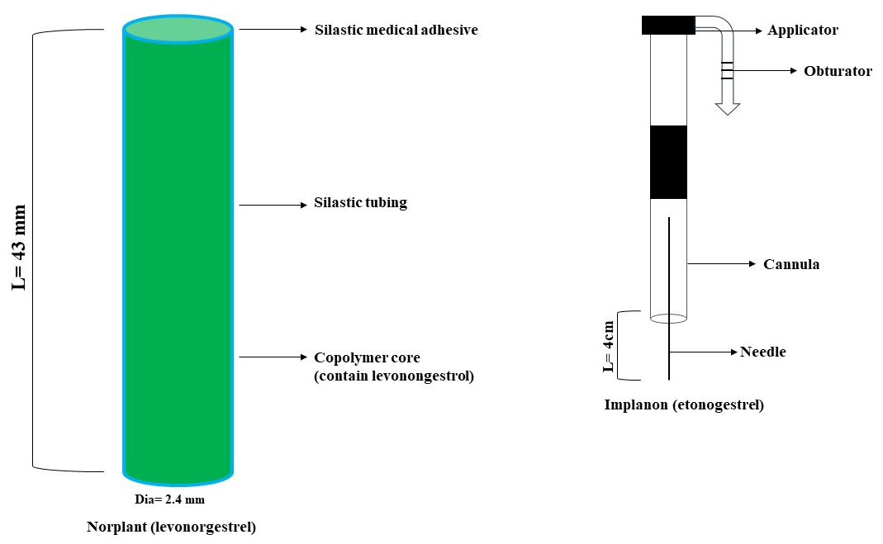
Figure 1: Non-biodegradable implants (A) Norplant and (B) Implanon
Female users often choose to have Norplant, a contraceptive implant, placed in their upper arm [14]. This implant is specifically engineered to offer contraceptive protection for a duration of 5 years and has achieved extensive global recognition, as demonstrated by its authorization in 60 countries. Although Norplant discontinued its marketing efforts in the United States in 2002, it is nevertheless accessible in other nations and has been effectively utilized by more than 60 million women [15]. In 2006, Implanon, another contraceptive implant that has been authorized by the FDA, was launched in the United States [16]. The Implanon is a contraceptive implant that consists of a single rod measuring 4 cm in length and 2 mm in breadth. It has a PAVA core (reservoir) that holds 68 mg of etonogestrel. The medicine is gradually delivered over a span of 3 years, with the rate of release being regulated by a PEVA membrane that covers the rod [17,18]. The duration of pregnancy prevention can be prolonged beyond the initial 3 years by promptly removing and replacing the implant. Implanon, which offers a more convenient subcutaneous insertion and removal process compared to Norplant, has been widely embraced by both patients and healthcare practitioners [19].
1.4 The process by which drugs are released from non-degradable polymeric matrices:
Varies between reservoir systems and matrix-type devices. Reservoir systems maintain a consistent rate of release, regardless of the concentration gradient. The probable cause for this is the thickness and permeability of the rate-controlling polymeric membrane, which may result in achieving zero-order release kinetics. In reservoir systems, the medication is released across the membrane due to a steady pushing force. This assumes that the drug concentration within the reservoir continuously reaches a balance with the inner surface of the membrane [20]. Conversely, drug release in matrix-type devices is primarily influenced by the concentration gradient and is facilitated by diffusion distances and the extent of swelling. Typically, drug delivery systems that are not prone to erosion and are regulated by diffusion are most efficient for medicines weighing 1000 Dalton or less [21] (see Figure 2).
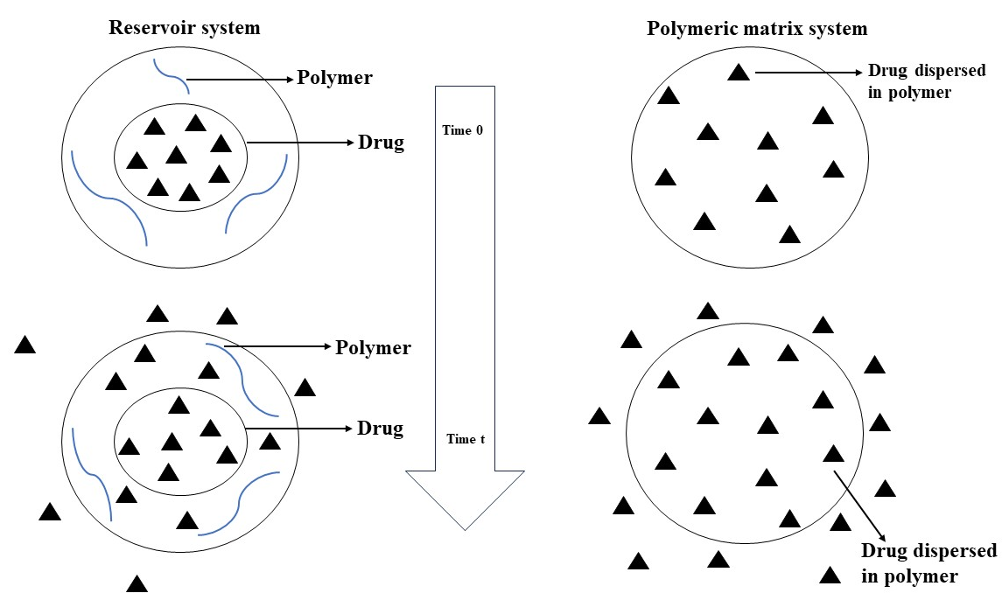
Figure 2: Cross sectional view of idealized reservoir system and matrix system, showing diffusion of drug across the polymer.
1.5 Biodegradable implants are highly favored compared to non-degradable technologies. These systems utilize inert polymers in their construction, and these polymers are ultimately assimilated or expelled by the body. This obviates the necessity for surgical extraction subsequent to treatment, hence enhancing patient receptiveness and adherence [22,23]. Nevertheless, the process of creating biodegradable systems is more intricate than that of non-degradable ones, since it necessitates the careful examination of multiple aspects. The degradation kinetics of the polymer (in vivo) must stay consistent in order to guarantee continuous medication release. Body pH or temperature fluctuations might temporarily impact the pace of deterioration. The erosion is diminished when the surface area of the implant is decreased. Hence, it is imperative to take into account any alterations in the configuration of the drug delivery system throughout the process of formulation design. Geometric structures that maintain a consistent surface area over time, like a flattened slab shape without any erosion at the edges, can exhibit a zero-order release kinetic profile [24,25]. Certain manufacturers have developed systems featuring a bioerodible inert core coat and an active drug matrix in order to reduce alterations in surface area during erosion. An issue associated with bioerodible systems is that the rate of drug diffusion may be slower than the pace at which the system gets bioeroded. The chemical composition of the polymeric component utilized in the formulation has a significant impact on the diffusion of medicines, particularly those with limited therapeutic ranges or those designed for prolonged release [26]. Presently, there are two distinct categories of biodegradable delivery systems. The first system is a reservoir system, which shares similarities with non-degradable reservoir systems in terms of structure and the process of drug release. These systems comprise an outer polymeric membrane that undergoes degradation at a slower pace than the anticipated rate of drug diffusion, ensuring complete drug release prior to membrane degradation. The second category is a monolithic system, in which the medicine is evenly distributed within a polymer and gradually breaks down inside the body through biological mechanisms at a regulated pace. Commonly used biodegradable polymers comprise polyglycolic acid, polyactic acid, polyaspartic acid, and polycaprolactone. Studies have also examined the use of ethyl vinyl acetate copolymer matrices for delivering macromolecular medicines such as insulin [27].
1.6 Implantable drug delivery devices
a) Regulated Drug Administration Transdermal patches consist of hollow micro needles composed of a biocompatible polymer that are used to administer medications beneath the skin. These patches provide benefits such as painlessness, continuous distribution of dose without requiring patient cooperation, and safeguarding medicines against degradation in the gastrointestinal tract [28].
b) Polymer Implants: These implants consist of biodegradable polymers that are infused with medicinal molecules. The polymer undergoes degradation upon contact with bodily fluids, resulting in the release of the medication. Modifying the characteristics of the polymers can maximize the pace of breakdown and, as a result, the release of drugs. Widely utilized polymer compounds comprise Polyglycolic acid (PGA), Polyethane, and their amalgamations [29].
c) Bioadhesives: Bioadhesives, commonly composed of polymer hydrogels, establish connections with biological surfaces. Similar to polymer implants, they are filled with medications and gradually release them when they come into contact with bodily fluids. Hydrogels, which are polymer networks that swell in water, can be engineered to react to changes in their chemical or physical surroundings. As an illustration, they undergo a transformation into a more condensed and tightly packed arrangement when exposed to temperatures ranging from 35-40 °C. This change occurs as a result of a shift in the equilibrium between solution and hydrophobic forces [29].
d) Microencapsulation: This technique entails enveloping medication molecules with substances that delay absorption, so ensuring their viability until they reach the desired location. Microencapsulation techniques encompass the utilization of polymer microspheres, liposomes, and nanoparticles [30].
e) Diffusion Chamber: Debiotech Inc. manufactures a diffusion chamber that contains pharmaceuticals and is sealed with a semi-permeable membrane. Although these reservoirs have the capacity to administer a significant number of medications, they are typically not utilized for extended periods of drug administration [31] (see Figure 3).
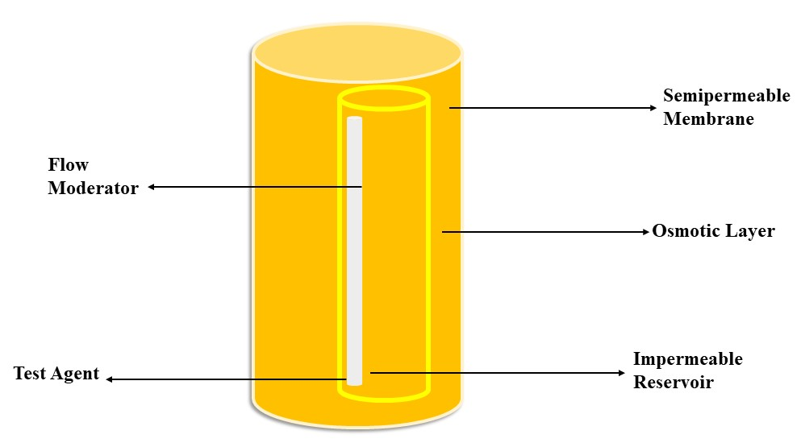
Figure 3: Schematic of an Alzet mini-osmotic pump (shown in partial section)
a) Implantable Pump Systems: In order to properly administer many pharmaceuticals, it is necessary to have external control over the dosage. This is a difficult feature to achieve with both biodegradable and non-degradable delivery systems. Pump systems have demonstrated their indispensability in such situations by offering the required accuracy and remote management. These methods provide multiple benefits, including as circumventing the gastrointestinal tract, obviating the necessity for repetitive injections, and enabling quicker release rates in comparison to diffusion-limited systems. Due to progress in microelectronics since the 1970s, it has been possible to provide remote control over delivery rates or incorporate implantable sensors for feedback-controlled medication delivery. Implantable pumps utilize osmosis, propellant-driven fluids, or electromechanical drives as the main mechanisms to create pressure gradients, which in turn allow for regulated medication delivery [32].
b) Osmotic pumps: Several forms of medication utilize a difference in osmotic pressure to facilitate regulated release of drugs from a storage compartment [33]. This device contains a drug reservoir that is enclosed by a semi-permeable casing, commonly made of a cellulose ester membrane. The enclosure is filled with NaCl or another appropriate osmotic substance. The semi-permeable membrane permits the movement of water while preventing the passage of the medication. The fluid containing water that exists within living organisms and fills the enclosure accumulates enough pressure caused by osmosis, which propels the medication through a small opening. The pace of release is regulated by the size of the opening. The medicine is often enclosed within a pliable impermeable membrane that contracts due to the rising hydrostatic pressure. The numbers 34 and 35 are enclosed in square brackets.
1.7 Utilization of Implantable Drug Delivery System for Therapeutic Purposes
a) Cancer: Implantable drug delivery systems demonstrate substantial promise in the safe and efficient administration of chemotherapeutic medications to affected areas, while minimizing adverse effects. There are various types of implants available on the market for treating brain, prostate, and bladder cancer, as evidenced by examples [36,37]. The Gliadel wafer is an approved example of an initial implanted brain cancer treatment that administers chemotherapy directly to the tumor location. Another example is the Zoladex biodegradable implanted rod, which administers goserelin acetate for the treatment of prostate cancer [38].
b) Ocular Therapy: Prolonged ocular medication delivery has been investigated using many types of implantable systems, including membrane-controlled devices, implantable silicone devices, and implantable infusion systems [39,40]. Ocusert is an instance of a membrane-controlled system that consists of pilocarpine base and alginic acid enclosed in a drug reservoir. This reservoir is covered by an ethylene-vinyl acetate membrane, which controls the rate at which the medication is released. This device delivers an initial surge of pilocarpine followed by a constant release at a rate of 20-40 micrograms per hour for a duration of one week. While Ocusert is generally well-tolerated by adults, it is not as suitable for geriatric patients who often have a greater therapeutic requirement [41].
c) Contraception: The FDA has recently granted approval for the marketing of Norplant, a sub-dermal implant specifically intended for the extended release of levonorgestrel, a contraceptive drug. Norplant is composed of six silicone membrane capsules, with each capsule holding 36 mg of levonorgestrel. These capsules are inserted sub-dermally in a fan-shaped pattern on the inner side of either the upper arm or forearm using a single trocar entry point. These capsules provide a total of 70 micrograms per day (in vivo) over the course of the first 100 days. After that, there is a gradual drop in the delivery rate, reaching 30 micrograms per day at around 800 days. This rate is then maintained for a period of five years. Additional polymer-based systems under investigation for contraception encompass a vaginal ring composed of silicon rubber, which is employed for a duration of 3-6 months and requires a one-week interval for removal each month during menstruation. Another option is Progestasert, an intrauterine device that releases medication and is constructed from ethylene-vinyl acetate copolymer, providing contraceptive effects for a year. Furthermore, injectable microspheres or rods made from biodegradable polymers are also being explored [42].
d) Dental Application: Polymeric implants have been assessed for use in many dental applications, such as the extended local delivery of fluoride, antibacterial agents, and antibiotics. As an illustration, stannous fluoride was used into several dental cements to provide a continuous release of fluoride. Another application was distributing it within a hydroxyethyl methacrylate and methyl methacrylate copolymer hydrogel, which was then coated with an outer layer of the same copolymer in varying ratios. This coating served as a factor that controlled the rate at which the drug was released. The devices, measuring around 8 mm in length and containing 42 mg of fluoride, were affixed to the outside surface of the upper first molar. They released a daily dose of 0.5 mg of fluoride for a duration of 30 days [43-45].
1.8 Outlook for the Future
Presently, there is ongoing considerable research being conducted in the domain of implanted medication delivery devices. Although there has been progress, there is still a significant amount of work required, particularly in the fields of biodegradable and biocompatible materials, drug release kinetics, and further improvement of current systems, before they can be widely utilized. Scientists are hopeful that they may develop many of these technologies to reach ideal zero-order release kinetics profiles in living organisms for lengthy durations, enabling sustained usage. A significant number of these drugs are made from proteins and peptides, which exhibit instability when administered orally. Advancements in prolonged-release drug delivery systems enable the continuous and consistent administration of medication over an extended period, hence removing the requirement for several doses. In the future, it is expected that improvements in new implanted systems would lead to lower costs in drug treatments, enhanced therapeutic efficacy, and better patient adherence [46,47].
1.9 Osmotic delivery systems are a type of drug delivery system that utilize osmosis to release drugs at a controlled rate.
Osmotic delivery systems have a long and notable past, with early investigations tracing back to 1748. A major advancement took place in 1877 when the measurement of osmotic pressure was quantitatively established. The Rose-Nelson osmotic pump, invented by Australian pharmacologists in 1955, was the first implantable osmotic pump. The Higuchi-Leeper osmotic pump was introduced in 1973 as a result of changes made by Higuchi and Leeper [48]. There is a significant market for osmotic pump systems, as evidenced by the granting of numerous patents for these items. The Alza Corporation obtained a patent for oral osmotic pumps, often known as gastrointestinal treatment systems like the EOP, in 1976. The osmotic bursting drug delivery system was initially created in 1979 and subsequently enhanced in 1982 by the incorporation of a hydrogel layer that may expand when exposed to fluid, resulting in the acquisition of an additional patent [50,51]. The development of push-pull osmotic pumps for combination therapy began in 1984. In 1985, the use of mechanically drilled orifices was eliminated, leading to the creation of the controlled-porosity osmotic pump system. This system was patented the following year [52-54]. The development facilitated the utilization of liquid pharmacological substances in osmotic systems, resulting in the acquisition of a patent in 1995. Within these devices, agents are contained within a capsule that includes a distribution port and an osmogen layer, all of which are surrounded by a semi-permeable membrane [55]. The concept of drug administration using a capsule with an asymmetric membrane, which relies on osmotic pressure, was first described in 1999 [56]. A new formulation has been developed that uses an ionic-driven pump. This pump relies on osmotic pressure caused by the concentration of ions, which is directly related to the pace at which the medicine is released. This breakthrough has the benefit of accurately predicting the pace at which a medicine is released, which will make it easier to make improvements to ionic osmotic pumps in the future.
Table 1. Advantages and disadvantages of osmotic delivery systems
S.No. | Advantages | Disadvantages
 | A zero-order rate of drug release is attained following the administration of the system as intended, which is preceded by an initial period known as the lag phase [57]. | There may be a chance of dose dumping, which could lead to a higher than necessary concentration of the medication in the blood and perhaps be harmful [58].
 | When necessary, a customized version that functions as a delayed or pulsed-type drug delivery system can be created utilizing this technology [59]. | A hypersensitivity reaction could occur if the patient has a hypersensitive immune system.
 | Drug release in an osmotic system is controlled by osmotic pressure, which means it is not influenced by hydrodynamic or physiological variables specific to the stomach area, such as pH [61]. | It is challenging to maintain this system's integrity and the necessary consistency [60].
 | When this technique is used, there is a strong association between in vitro dissolution and in vivo bioavailability [62]. | When there is an issue or subpar performance in the coating process, there may be a chance of film flaws. The size of the orifice through which the drug is given is a crucial step that directly affects the efficacy of the drug delivery system [63, 64].
 | In order to produce a therapeutic impact for an extended length of time, these systems enable sustained drug release and accomplish a steady-state and uniform drug concentration in the blood [65]. | It is difficult to remove or recover any toxicity or poisoning from the bodily system [65].

2.0 Fundamental Elements of Osmotic Pump Systems
2.1 Medication
The osmotic pump method is particularly useful for specific circumstances when not every medicine is capable of delivering a lasting response. Drugs that are recommended for long-term treatment and have a biological half-life between 1 and 6 hours are ideal for osmotic systems. Individuals with either shorter or longer half-lives are less appropriate. In addition, the medicine should possess strong potency and exhibit moderate solubility, avoiding both high solubility and very low solubility [66].
2.2 Osmotic Agent
Osmotic substances, referred to as osmogens or osmogents, induce osmotic pressure inside the osmotic delivery system. These agents increase the rate at which medications with low solubility are released by causing a significant difference in osmotic pressure inside the system. Typical osmotic agents consist of lactose, fructose, sorbitol, sodium chloride, citric acid, potassium chloride, sucrose, xylitol, and mannitol, either alone or in combinations [69].
2.3 Definition of Semipermeable Membrane
The semipermeable membrane in osmotic systems must exhibit selectivity in allowing the passage of water exclusively, while remaining impermeable to solutes. Cellulose acetate is the predominant polymer utilized in the formulation of osmotic pumps, available in various grades with differing levels of acetyl concentration. Additional examples of polymers encompass cellulose esters, cellulose acetate butyrate, and cellulose ethers such as ethyl cellulose [73-75]. When evaluating the material, it is crucial to examine its biocompatibility, wet strength, and water permeability capacity [76].
2.4 Wicking Agent: A substance used to facilitate the movement of liquid through a material by reducing surface tension and increasing capillary action.
Wicking agents facilitate the absorption of water into the porous structure of the delivery system, resulting in the formation of channels with increased surface area. These agents, regardless of whether they are capable of swelling or not, enhance the migration of solvent towards the core of the device. Some examples of substances are sodium lauryl sulfate, polyvinylpyrrolidone, and colloidal silicon dioxide [78].
2.5 Agents that create pores
Pore-forming substances facilitate the creation of a microporous membrane or walls containing micro-sized pores, which are released during operation. Pore-forming substances can include alkaline metal salts, alkaline earth metals, and polysaccharides [81-82].
2.6 Solvents for Coating
Coating solvents transport polymers and additives that are distributed or dissolved to the surface of the substrate. Polymeric solutions [83-84] are prepared using inert solvents, which can be either organic or inorganic, such as methanol, cyclohexane, methylene chloride, isopropyl alcohol, and water.
2.7 Classification of Osmotic Drug Delivery Systems
Figure. 4 illustrates the classification of osmotic systems according to the active ingredient, design, and intended usage.

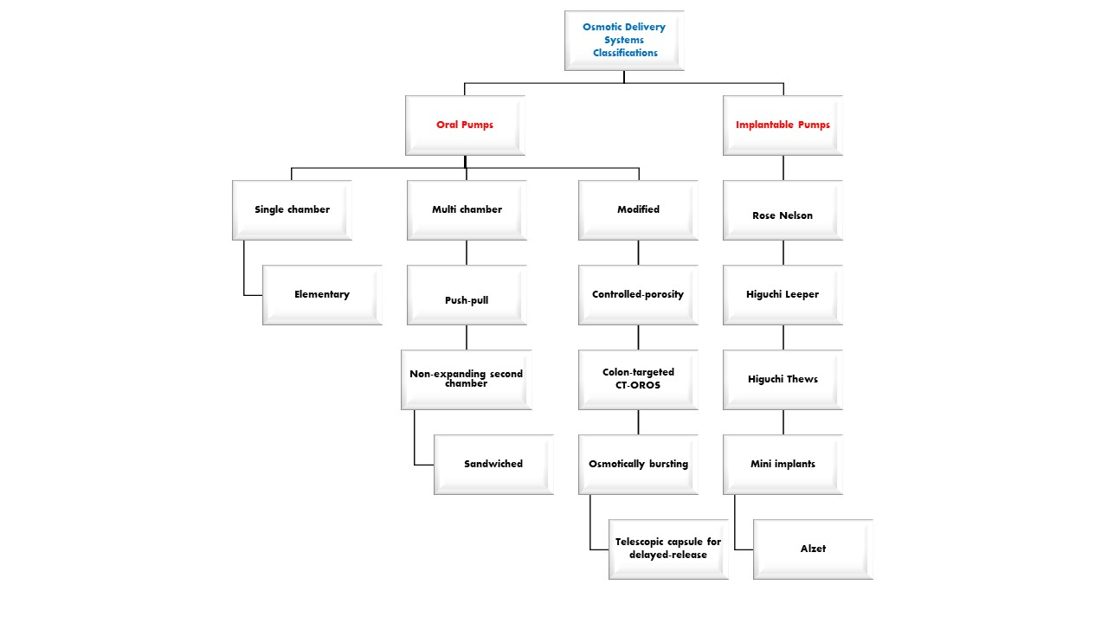
Figure 4: Classification of osmotic delivery systems

2.8. Systems that can be implanted in the body

2.8.1. The Rose-Nelson Pump

The initial implantable osmotic method pump, seen in Figure 2, was documented in 1955 by Rose and Nelson, physiologists from Australia. The pump was specifically engineered to administer medications directly into the gastrointestinal tracts of livestock, including sheep and cattle [85]. An elastic diaphragm, containing a portion of surplus salt, is enclosed by a semi-permeable barrier and a water chamber. The two compartments are divided by a semi-permeable barrier. This results in a disparity in gradient and osmotic pressure, causing water to flow towards the salt chamber from its own chamber. When water flows into the salt chamber, the size of the salt chamber grows. This causes the diaphragm to expand, which in turn leads to the medicine being pumped. The medication is subsequently expelled from the device [86].

The Rose-Nelson Pump, an implantable osmotic method pump, was first introduced in 1955 by Australian physiologists Rose and Nelson. It is represented in Figure 5. This pump was initially created for delivering drugs into the gastrointestinal tract of animals like sheep and cattle. It consisted of a semi-permeable wall and a water chamber that included an elastic diaphragm containing surplus salt. The two chambers were divided by a semi-permeable barrier, creating a gradient and difference in osmotic pressure. As a result, water flowed towards the salt chamber, leading to an expansion in its volume. The enlargement of the salt chamber caused the stretching of the diaphragm, leading to the pumping of drugs. The medication was subsequently discharged from the device [86].

Figure 5: The Rose–Nelson pump

2.8.2 The Higuchi–Leeper Pump

In the 1970s, Alza Corporation created the Higuchi-Leeper pump, which was designed to be a more efficient version of the Rose-Nelson pump [87]. The pump is represented in Figure 3. The Higuchi-Leeper pump stands out in its design by not including a water chamber. Alternatively, the device utilizes water from its immediate surroundings to activate itself [88]. This alteration offers a significant benefit by enabling the storage of prepared and drug-loaded pumps for a duration of up to one month [89].

2.8.3 The Higuchi–Theeuwes Pump

In addition, during the 1970s, Higuchi and Theeuwes created a pump that utilized an outer casing made of a firm semi-permeable membrane (shown in Figure 6). This pump exhibits resemblances to the Rose-Nelson pump, as the medication is placed into the device prior to its utilization [90]. The medication release rate from the device is dependent on the permeability of the outer membrane, which follows a predetermined time course determined by the salt [91].

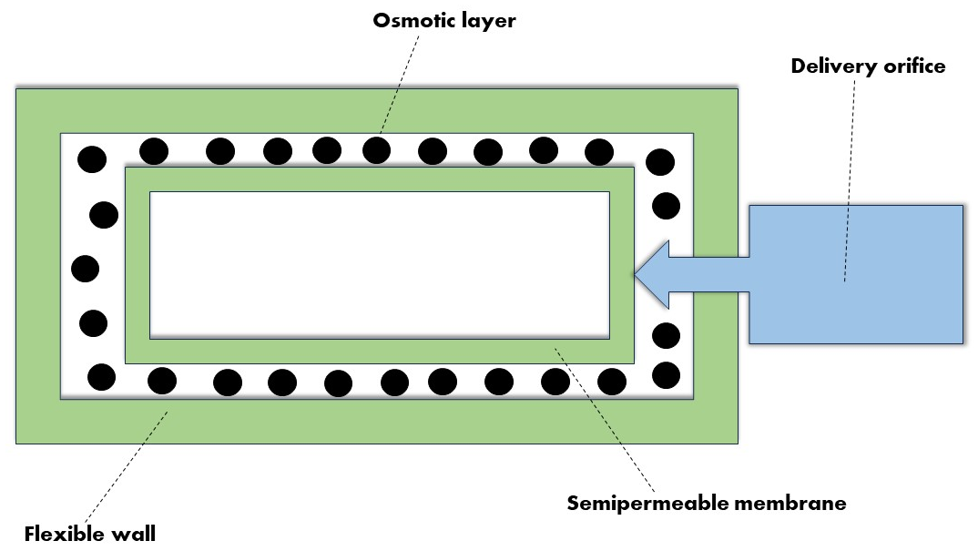

Figure 6: The Higuchi–Theeuwes pump

CONCLUSION
In conclusion, implants and osmotic pumps represent pivotal advancements in drug delivery, offering precise control and sustained release for improved patient outcomes. While showcasing sophisticated mechanisms and significant advantages such as targeted therapy, challenges like biocompatibility issues and design complexities persist. Looking ahead, the integration of AI, 3D printing, and smart connectivity holds promise for personalized drug delivery. The future demands ongoing research to address limitations and refine these technologies, ensuring a refined, effective, and patient-centric era of therapeutic interventions.

FUTURE SCOPE: The exploration of "Implants and Osmotic Pumps in Drug Delivery: An Overview of Mechanisms, Advantages, and Drawbacks" opens avenues for exciting future developments in the field of drug delivery. The following areas present key opportunities for future research and innovation:

1. Enhanced Biocompatibility:
Future research should focus on refining materials and designs to improve the biocompatibility of implants. Strategies to mitigate the risk of rejection and promote seamless integration with the body will be critical for expanding the application of implantable drug delivery systems.

2. Smart and Adaptive Drug Delivery:
The integration of artificial intelligence (AI) and machine learning can pave the way for smart and adaptive drug delivery systems. Developing algorithms that respond to real-time patient data, adapting drug release profiles based on individual needs, will be a transformative direction in personalized medicine.

3. Minimization of Design Complexities:
Addressing the complexities associated with the design and removal of osmotic pumps is an ongoing challenge. Future research should seek simplified yet efficient designs, with a particular focus on the development of minimally invasive removal procedures to enhance patient safety and comfort.

4. Nanotechnology Advancements:
Continued exploration of nanotechnology in drug delivery systems holds great promise. Research should delve into the use of nanoparticles for targeted delivery, improving drug solubility, and minimizing side effects. The integration of nanomaterials can further enhance the precision and efficiency of both implants and osmotic pumps.

5. Patient-Centric Monitoring and Connectivity:
The integration of smart connectivity into drug delivery systems allows for real-time monitoring and patient engagement. Future developments may involve wearable technologies that provide patients and healthcare providers with instant feedback, fostering a more collaborative and informed approach to treatment.

6. Combination Devices and Therapies:
Future research may focus on the development of combination devices that integrate implants or osmotic pumps with other therapeutic modalities, such as biosensors or imaging technologies. This holistic approach could revolutionize treatment strategies for complex medical conditions.

7. Regulatory Frameworks and Standardization:
As these advanced drug delivery systems become more prevalent, there is a need for standardized regulatory frameworks. Future efforts should aim at establishing clear guidelines to ensure the safety, efficacy, and consistent performance of implantable devices and osmotic pumps.

In summary, the future scope of "Implants and Osmotic Pumps in Drug Delivery" lies in a multidimensional approach, combining technological innovation, biocompatibility improvements, and personalized medicine. As research progresses in these areas, the field is poised to witness transformative changes, ultimately leading to more effective, patient-friendly, and widely adopted therapeutic interventions.

REFERENCES

  - W.A Check. New drugs and drug-delivery systems in the year 2000. AM J Hosp Pharm 1984; 41:1536-47.
  - Chien Yie W. Novel drug delivery systems. Marcel Dekker Inc 1982; 1:1-816.
  - Abhinandan AA, Vikas RA, Pallavi SJ and Rajshekhar MC. Formulation and Evaluation of Novel Biodegradable Sustain Released Matrix Implant of Gentamicin Sulphate. Res J Pharm Biol Chem Sci 2018; 9:451-463.
  - Chien Yie W. Novel drug delivery systems, Marcel Dekker Inc 1992.
  - Seaton’s MF and Salminen L. Ocular Inserts for topical Delivery. Adv Drug del Rev 1995; 16:95- 106.
  - Rhar RK and Vyas SP. Targeted and controlled drug delivery novel Carrier Systems. CBS Publisher and distributions 2002.
  - Maartje JLC, Mintsje DB, vanderhulst RR and Jan Willem CT. Two Hundreds case of ASIA syndrome following silicone implants: a Comparative study of 30 years and a review of current literature. Immunol Res 2016; 65:120-128.
  - De Witt D, Finley M, Lawin LDD, Finley MM and Laurie R. A blends comprising ethylene-vinyl acetate copolymer and poly (alkyl (meth) acrylates or poly (aromatic (meth) acry lates): Implantable medical device; permit stents releasing the bioactive agent over Time in vivo; provide clear coats, durability, biocompatibility, and release Kinetics: drug delivery device. US Patent Application 2005.
  - Nunes-Pereira J, Ribeiro S, Ribeiro C, Gombak CJ, Gama FM and et al. Poly (vinylidene fluoride) and copolymers as Porous membranes for tissue engineering applications. Polym Testing 2015; 44,234-241.
  - Shastri VP. Non degradable biocompatible polymers in medicine: past, present and future. Curr Pharm Biotechnol 2003; 4:331-337.
  - Martinez-Rus F, Ferreiroa A, Bartolome JF and Pradies G. Fracture resistance of crowns cemented on titanium and zirconia implant Abutments: a comparison of monolithic versus manually veneered all- Ceramic systems. Int J Oral Maxillofacial Implants 2012; 27:1448-1455.
  - Spice handler J. Demographic and Programmatic Consequences of Contraceptive Innovations. Springer 1989.
  - Rademacher KH, Vahdat HL, Dorflinger L, Owen DH and Steiner MJ. Global introduction of a lowcost contraceptive implant. Critical Issues in Reproductive Health. Springer 2014; 285-306.
  - Glasier A. Implantable contraceptives for women: effectiveness, discontinuation rates, returns of fertility, and outcome of pregnancies. Contraception 2002; 65:29-37.
  - Johansson ED. The return of the pharmaceutical industry to the Market of contraception. Steroids 2000; 65:709-711.
  - Bennink HJ. The pharmacokinetics and pharmacodynamic of Implanon, a single-rod etonogestrel contraceptive implant. Eur J Contracept Reprod Health Care 2000; 5:12-20.
  - Zheng SR, Zheng HM, Qian SZ, Sang GW and Kaper RF. A Randomized multicenter study comparing the efficacy and bleeding pattern of a single-rod (Implanon®) and a six-capsule (Norplant®) hormonal Contraceptive implant. Contraception 1999; 60:1-8.
  - Mascarenhas L, van Beek A, Bennink HC and Newton J. Twenty-Four-month comparison of apolipoproteins A-1, A-II, and B in contraceptive Implant users (Norplant® and Implanon®) in Birmingham, United Kingdom. Contraception 1998; 58:215-219.
  - Fu Y and Kao WJ. Drug release kinetics and transport mechanisms of nonde- gradable and degradable polymeric delivery systems. Expert Opin Drug Deliv 2010; 7:429-444.
  - Siepmann J and Siepmann F. Modeling of diffusion-controlled drug. Deliv J Control Rel 2012; 161:351-362.
  - Claes L and Ignatius A. Development of new, biodegradable Implants. Chirurq 2002; 73:990- 996.
  - Tian H, Tang Z, Zhuang X, Chen X and Jing X. Biodegradable Synthetic polymers: preparation, fictionalization and biomedical Application. Prog Polym Sci 2012; 37:237-280.
  - Lance KD, Good SD, Mendes TS, Ishikiriyama M, Chew P and et al. In vitro and in vivo sustained zero-order delivery of rapamycin (sirolimus) from a biodegradable intraocular device sustained Zero-order delivery of rapamycin. Invest Ophthalmol Visual Sci 2015; 56:7331-7337.
  - Wu DQ and Chu CC. Biodegradable hydrophobic Hydrophilic hybrid hydro- gels: swelling behavior and controlled Drug release. J Biomater Sci Polym Ed 2008; 19:411-429.
  - Jiang T, Petersen RR, Call G, Ofek G, GAO J and et al. Development of chondroitin sulfate encapsulated PLGA microsphere Delivery systems with control- label multiple burst releases for treating Osteoarthritis. J Biomed Mater Res B Appl Biomater 2011; 97:355-363.
  - Rahimi M, Mobedi H and Behnamghader A. In situ-forming PLGA Implants loaded with leuprolide acetate/β-cyclodextrin complexes: Mathematical modeling and degradation. J Microencapsul 2016; 33:355-364.
  - Ranade VV. Hollinger Mannifred a Drug Delivery system Boca Raston, fla. CRC press 1996.
  - Mathiowitz E and chickering DM. Bioadhesives drug Delivery system fundamental novel approaches and development. Marcel Dekker 1999.
  - Allababidi S and shah JC. Efficacy and Pharmacokinetics of site–specific Cefazolin delivery using Biodegradable implants in the prevention of post-operative wound infection. Pharm Res 1998; 325-333.
  - Banker Rw. In control release of biologically active agent. John Wiley and sons 1987.
  - Brissova M, Lacik I, Power AC, Anilkumar AV and Wang T. Control and Measurement of permeability for Design of microcapsule cell delivery system. J Biomed Mater Res 1998; 39:61-70.
  - Theeuwes F and Yum SI. Principles of the design and operation of generic osmotic pumps for the delivery of semisolid or liquid drug formulations. Ann Biomed Eng 1976; 4:343-53.
  - Gong W, Liu Y, Mei DY, Yang M and Mei XG. Preparation, release and Pharmacokinetics of resperidone elementary osmatic pump system. Drug Dev Ind Pharm 2015; 41:464-469.
  - Pan H, Jing H, Yang X, Pan W and Chen T. Synchronized and Controlled Release of metformin hydrochloride/gilpizipde form elementary Osmotic Delivery. Drug Dev Ind Pharm 2016; 43:1- 35.
  - Barros AA, Browne S, Oliveira C, Lima E, Healy KE and et al. Drug- eluting biodegradable uretheral stent: New approach for Urothelial tumors of upper urinary tract cancer. Int J pharm 2016; 513:227-237.
  - Exner AA and Saidal GM. Drug- eluting polymer implants in cancer Therapy. Expert opin Drug Deliv 2008; 5:775-788.
  - Goldspiel BR and Koler DR. Goserelin acetate implant: a depot Luteinizing hormone- releasing hormone analog for advanced prostate cancer. Annual pharmacotherapy 1991; 25:769-804.
  - Barar J, Aghanejad A, Fathi M and Omidi Y. Advanced drug delivery and targeting technologies for the ocular diseases. Bioimpacts 2016; 6:49- 67.
  - Yasukawa T, Ogura Y, Kimura H, Sakurai E and Tabata, Y. Drug Delivery form ocular implants. Expert Opin Drug Deliv 2006; 3:261-273.
  - Karthikeyan D, Bhowmick M, Pandey VP, Nanhakumar J, Sengottuvelu S and et al. The concept of ocular insert as drug Delivery systems: an overview. Asian J Pharm 2014; 192-200.
  - Jain NK. Advanced in controlled and novel Drug Delivery. CBS Publication and Distributors 2005; 219-223.
  - Koka S. The implant- mucosal interface and its role in the long-term Success of end osseous oral implants: A review of the literature. Int J prosthodontics 1998; 2:421-432.
  - Sennerby L and roos J. Surgical determinants Of Clinical success of Osseo integrated oral implants: A Review of the literate. Int J prosthodontics; 1998; 2:408-410.
  - Rahman A, Konstantina D, Samuel Z, Rashid S, Solakoglu O and et al. Immediate placement and immediate proviousionalization of ITI Implants in Maxillary Non–restorable single teeth. A prelim rep 2004; 13:66-71.
  - Gupta PK, Hung CT and perrier DG. Quantition of the release of Doxorubicin from Colloidal Dosage forms using Dynamic Dialysis. J Pharm Sci 1987; 76:141-145.
  - Robinson DH and Sanpath S. Release Kintics of Tobramycin Sulphate from Polymethyl–metha– acrylates Implants. Drug Dev Ind Phram 1989; 15:2339-2357.
  - Vyas SP and Khar RK. Controlled Drug Delivery Concepts and Advances. Vallabh Prakashan 2008; 473-474.
- Patel, K.N.; Mehta, T.A. A review on oral osmotically driven systems. Int. J. Pharm. Pharm. Sci. 2013, 5, 1005–1013.

- Farooqi, S.; Yousuf, R.I.; Shoaib, M.H.; Ahmed, K.; Ansar, S.; Husain, T. Quality by Design (QbD)-Based Numerical and Graphical Optimization Technique for the Development of Osmotic Pump Controlled-Release Metoclopramide HCl Tablets. Drug Des. Dev. Ther. 2020, 14, 5217. [CrossRef]
- Prajapati, H.M.; Prajapati, S.T.; Patel, C.N. A review on recent innovation in osmotically controlled drug delivery system. Int. J. Pharm. Res. Bio-Sci. 2012, 1, 158–194.
- Cortese, R.; Theeuwes, F. Osmotic Device with Hydrogel Driving Member. U.S. Patent no 4327725, 4 May 1982.
- Malaterre, V.; Ogorka, J.; Loggia, N.; Gurny, R.J.I. Approach to design push–pull osmotic pumps. Int. J. Pharm. 2009, 376, 56–62. [CrossRef] [PubMed]
- Gundu, R.; Pekamwar, S.; Shelke, S.; Kulkarni, D.; Shep, S. Development, optimization and pharmacokinetic evaluation of biphasic extended-release osmotic drug delivery system of trospium chloride for promising application in treatment of overactive bladder. Future J. Pharm. Sci. 2021, 7, 1–20. [CrossRef]
- Kumaravelrajan, R.; Narayanan, N.; Suba, V.J.L. Development and evaluation of controlled porosity osmotic pump for Nifedipine and Metoprolol combination. Lipids Health Dis. 2011, 10, 51. [CrossRef]
- Wong, P.S.; Theeuwes, F.; Barclay, B.L.; Dealey, M.H. Osmotic Dosage System for Liquid Drug Delivery. U.S. Patent no 5413572, 9 May 1995.
- Flavia, L.; Keckeis, V. Advances in drug delivery systems: Work in progress still needed? Int. J. Pharm. 2020, 590, 119912.
- Rastogi, S.; Vaya, N.; Mishra, B.J.E. Osmotic pump: A novel concept in rate controlled oral drug delivery. East. Pharm. 1995, 38, 79.
- Verma, R.; Mishra, B.; Garg, S. Osmotically controlled oral drug delivery. Drug Dev. Ind. Pharm. 2000, 26, 695–708. [CrossRef]
- Farheen, F.; Bharadwaj, S. A review on osmotically regulated systems. PharmaTutor 2014, 2, 51–64.
- Udawant, S.J.W. A review: Osmotic drug delivery system. World J. Pharm. Res. 2015, 4, 1787–1801.
- Santus, G.; Baker, R.W. Osmotic drug delivery: A review of the patent literature. J. Control. Release 1995, 35, 1–21. [CrossRef]
- Siddique, W.; Zaman, M.; Sarfraz, R.M.; Butt, M.H.; Rehman, A.U.; Fassih, N.; Albadrani, G.M.; Bayram, R.; Alfaifi, M.Y.; Abdel-Daim, M.M. The Development of Eletriptan Hydrobromide Immediate Release Buccal Films Using Central Composite Rotatable Design: An In Vivo and In Vitro Approach. Polymers 2022, 14, 3981. [CrossRef] [PubMed].
- Patel, H.; Parikh, V.P. An overview of osmotic drug delivery system: An update review. Int. J. Bioassays 2017, 6, 5426–5436. [CrossRef]
- Malaterre, V.; Ogorka, J.; Loggia, N.; Gurny, R.J. Oral osmotically driven systems: 30 years of development and clinical use. Eur. J. Pharm. Biopharm. 2009, 73, 311–323. [CrossRef]
- Babu, A.; Ratna, P.R.V. Controlled-porosity osmotic pump tablets—An overview. Asian J. Pharm. Res. Health Care 2010, 2, 1.
- Singla, D.; Hari Kumar, S.; Nirmala, G.J. Osmotic pump drug delivery: A novel approach. Int. J. Res. Pharm. Chem. 2012, 2, 661–670.
- Okimoto, K.; Rajewski, R.A.; Stella, V.J. Release of testosterone from an osmotic pump tablet utilizing (SBE) 7m-β-cyclodextrin as both a solubilizing and an osmotic pump agent. J. Control. Release 1999, 58, 29–38. [CrossRef]
- Herrlich, S.; Spieth, S.; Messner, S.; Zengerle, R. Osmotic micropumps for drug delivery. Adv. Drug Deliv. Rev. 2012, 64, 1617–1627. [CrossRef] [PubMed]
- Jerzewski, R.L.; Chien, Y.W. Osmotic drug delivery. In Treatise on Controlled Drug Delivery; CRC Press: Boca Raton, FL, USA, 2017; pp. 225–253.
- Banerjee, A.; Verma, P.R.P.; Gore, S. Controlled porosity solubility modulated osmotic pump tablets of Gliclazide. AAPS PharmSciTech 2015, 16, 554–568. [CrossRef] [PubMed]
- Siew, A. Controlling drug release through osmotic systems. Pharm. Technol. 2013, 37, 32–35.
- Lindstedt, B.; Ragnarsson, G.; Hjärtstam, J. Osmotic pumping as a release mechanism for membrane-coated drug formulations. J. Control. Release 1989, 56, 261–268. [CrossRef]
- Makhija, S.N.; Vavia, P.R. Controlled porosity osmotic pump-based controlled release systems of pseudoephedrine: I. Cellulose acetate as a semipermeable membrane. J. Control. Release 2003, 89, 5–18. [CrossRef]
- Seminoff, L.A.; Zentner, G.M. Cellulosic Coating. European Patent no 0425023A2, 23 October 1989.
- Ahmed, K.; Shoaib, M.H.; Yousuf, R.I.; Qazi, F.; Anwer, S.; Nasiri, M.I.; Mahmood, Z.A. Use of Opadry® CA—A cellulose acetate/polyethylene glycol system for rate-controlled osmotic drug delivery of highly soluble antispastic agent Eperisone HCl. Adv. Polym. Technol. 2018, 37, 2730–2742. [CrossRef]
- Sanap, S.L.; Savkare, A.D. Controlled porosity osmotic pump: A review. Int. J. Pharm. Res. Dev. 2014, 5, 70–80.
- Markovsky, E.; Baabur-Cohen, H.; Eldar-Boock, A.; Omer, L.; Tiram, G.; Ferber, S.; Ofek, P.; Polyak, D.; Scomparin, A.; SatchiFainaro, R. Administration, distribution, metabolism and elimination of polymer therapeutics. J. Control. Release 2012, 161, 446–460. [CrossRef] [PubMed]
- Rudnic, E.M.; Burnside, B.A.; Flanner, H.H.; Wassink, S.E.; Couch, R.A.; Pinkett, J.E. Osmotic Drug Delivery System. U.S. Patent no 6110498, 29 August 2000.
- Ghosh, T.; Ghosh, A.J. Drug delivery through osmotic systems—An overview. J. Appl. Pharm. Sci. 2011, 1, 38–49.
- Mathur, M.; Mishra, R. A review on osmotic pump drug delivery system. Pharma Sci. Monit. 2016, 7, 453.
- Zentner, G.M.; Rork, G.S.; Himmelstein, K. The controlled porosity osmotic pump. J. Control. Release 1985, 1, 269–282. [CrossRef]
- Thulasiramaraju, T.; Reddy, S.R.; Patnaik, N.A.; Kumar, K.S. Osmotic drug delivery system: A promising drug delivery Technology. AJRC 2013, 1, 7–22.
- Verma, R.K.; Krishna, D.M.; Garg, S.J. Formulation aspects in the development of osmotically controlled oral drug delivery systems. J. Control. Release 2002, 79, 7–27. [CrossRef]
- Singh, K.; Walia, M.K.; Agarwal, G.; Harikumar, S.J. Osmotic pump drug delivery system: A noval approach. J. Drug Deliv. Ther. 2013, 3, 156–162. [CrossRef]
- Rose, S.; Nelson, J. A continuous long-term injector. Aust. J. Exp. Biol. Med. Sci. 1955, 33, 415–419. [CrossRef]

- Gohel, M.; Parikh, R.; Shah, N. Osmotic Drug Delivery: An Update. World J. Pharm. Res. 2009, 7, 1–7.

- Higuchi, T.; Leeper, H. Osmotic Dispenser. U.S. Patent no 3995631, 7 December 1976.

- Higuchi, T. Osmotic Dispenser with Collapsible Supply Container. U.S. Patent no 3732865, 15 May 1973.

- Umamaheswari, A. Formulation and Evaluation of Controlled Porosity Osmotic Tablets of Lornoxicam. Ph.D. Thesis, College of Pharmacy, Madras Medical College, Chennai, India, 2012.

- Theeuwes, F.; Yum, S. Principles of the design and operation of generic osmotic pumps for the delivery of semisolid or liquid drug formulations. Ann. Biomed. Eng. 1976, 4, 343–353. [CrossRef]

- Theeuwes, F. Osmotic System for Delivering Selected Beneficial agents Having Varying Degrees of Solubility. U.S. Patnet no 4111201, 5 September 1978.

