Chapter 3: Viral Assay
A. Cultivation of virus:
Virus cultivation refers to the process of growing viruses in controlled laboratory conditions to study their biology, behaviour, and interaction with host cells. Cultivating viruses is essential for various purposes, including research, vaccine development, diagnostic testing, and the production of viral vectors for gene therapy. As viruses rely on host cells for replication, they cannot be cultivated on inert culture media. Three methods are utilized for virus cultivation:
1. Animal inoculation- The earliest method used to cultivate viruses causing human diseases involved inoculating them into human volunteers. Reed and colleagues (1900) pioneered this approach in their research on yellow fever. Subsequently, Theiler (1903) introduced the use of white mice, expanding the possibilities of animal inoculation, which remains a cornerstone in virology. Infant mice, particularly susceptible to coxsackie and arboviruses, serve as valuable hosts for viruses that may not grow in other systems. Mice, guinea pigs, and rabbits serve roles in both attenuating virus strains and assessing vaccines. For instance, the foot and mouth disease virus vaccine underwent initial testing in guinea pigs before progressing to trials in cattle and pigs. Mice can be inoculated via various routes (Figure 8), including intracerebral, subcutaneous, intraperitoneal, or intranasal. Other animals like guinea pigs, rabbits, and ferrets are also utilized in specific situations. Virus growth in inoculated animals can be indicated by death, disease manifestations, or visible lesions. Sometimes, multiple blind passages are required before detecting evidence of viral growth. Animal inoculation has drawbacks, such as interference from existing immunity and the potential for latent viral infections in animals. However, it remains crucial for studying pathogenesis, immune responses, epidemiology, and oncogenesis.

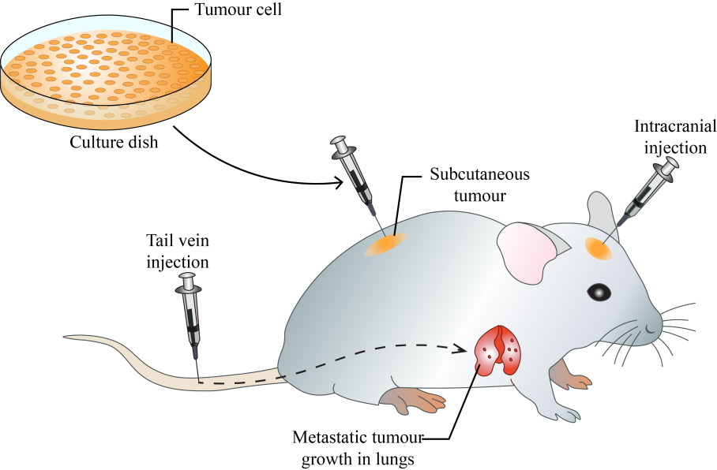
Figure 8: Animal inoculation
2. Embryonated eggs- Embryonated egg cultivation (Figure 9), pioneered by Goodpasture in 1931 and further developed by Burnet, is a method used to propagate viruses by introducing them into fertilized bird eggs, typically chicken eggs. The process involves delicately drilling a small hole into the eggshell to inoculate the virus without harming the developing embryo. Once inoculated, the eggs are sealed and placed in an incubator under controlled conditions. As the embryo develops, the virus infects various embryonic tissues, leading to viral replication and propagation. Depending on the route of inoculation, such as the chorioallantoic membrane (CAM), allantoic cavity, amniotic sac, or yolk sac, different viruses can be cultured. For example, inoculating on the chorioallantoic membrane produces visible lesions, aiding in the assay of pock-forming viruses like variola or vaccinia.
Embryonated eggs offer an ideal environment for virus cultivation due to their rich nutrients, growth factors, and supportive membrane system. This method provides a cost-effective means of producing large quantities of virus for research, diagnostics, and vaccine development. Notably, it is particularly effective for rapidly growing viruses like influenza.
However, there are limitations to this technique, including the need for specialized equipment and expertise, as well as ethical considerations regarding the use of animal embryos. Despite these challenges, embryonated egg cultivation remains a valuable tool in virology for studying viral pathogenesis, tropism, and host immune responses, as well as for producing vaccines like those for yellow fever (17D strain) and rabies (Flury strain).
Duck eggs, being larger and having a longer incubation period compared to hen's eggs, offer a superior yield of rabies virus. Consequently, they were employed in the production of the inactivated non-neural rabies vaccine.

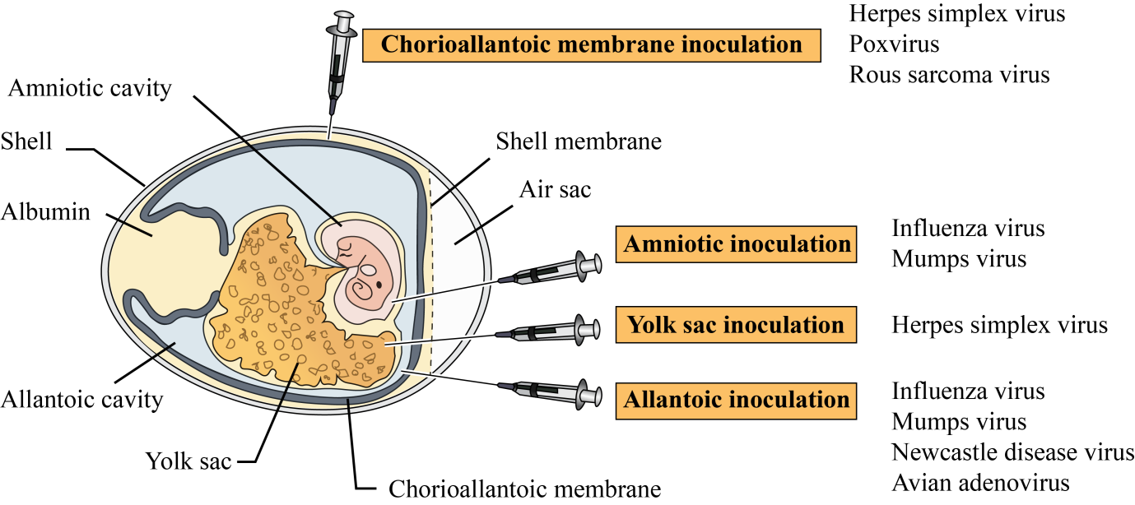

Figure 9: Virus cultivation in embryonated egg
3. Virus tissue culture- Virus tissue culture, a pivotal technique in virology, involves growing viruses in lab-grown living cells from various sources. This method has transformed virology research, facilitating the exploration of virus-host interactions, viral pathogenesis, and the development of vaccines and antiviral drugs. Initially, bacterial contamination posed a significant challenge to tissue culture until antibiotics became available for prevention. The breakthrough came with Enders, Weller, and Robbins in 1949, demonstrating that poliovirus, previously thought strictly neurotropic, could thrive in non-neural tissue cultures. Since then, nearly all human viruses have been successfully cultivated using tissue culture methods.
a) Organ culture- Virus organ culture involves the cultivation of small fragments of organs in laboratory conditions to study virus-host interactions and isolate viruses that target specific tissues. These cultures can maintain the original architecture and function of the organs for extended periods, making them valuable tools for virology research. The process begins with the collection of tissue samples from the desired organ, which are then dissected into small fragments. These fragments are placed into a culture medium containing nutrients, growth factors, and other necessary components to support cell viability and growth.
The culture is incubated at a suitable temperature and environment to mimic physiological conditions. However, virus organ culture also has limitations. It requires specialized equipment and expertise for tissue dissection and maintenance. Moreover, the availability of human organ tissues for culture is limited, often necessitating the use of animal models, which may not fully recapitulate human physiology. Examples are- tracheal ring organ cultures for studying respiratory viruses such as coronaviruses, brain organ cultures to study neurotropic viruses like herpes simplex virus or Zika virus.
b) Explant culture- Small pieces of minced tissue can be cultured as "explants," either embedded in plasma clots or grown in suspension. Explant culture preserves the structural and functional integrity of the original tissue. Adenoid tissue explant cultures can be utilized for isolating adenoviruses. Brain explant cultures can be infected with neurotropic viruses to investigate neuronal infection and associated pathology. Similarly, respiratory explant cultures can be used to study viruses that target the respiratory tract, such as influenza or respiratory syncytial virus (RSV). The lifespan of explant cultures is limited, as the cells eventually senesce or undergo apoptosis over time.
c) Cell culture- Ross Harrison achieved successful cell culture (Table 5,6 and 7) for the first time in 1907, while in 1885, Roux was the first to maintain embryonic chick cells in a cell culture. This method is commonly used to culture viruses, involving the dissociation of tissues into individual cells through enzymatic action, like trypsin, and mechanical agitation. After washing and counting, the cells are suspended in a growth medium containing essential amino acids, vitamins, salts, glucose, and a buffering system with 5% carbon dioxide. Fetal calf serum (5%), antibiotics, and phenol red are often added to prevent contamination and monitor cell health. Cultures are typically incubated for 24-48 hours in containers where cells adhere to the surface and form a monolayer (Figure 10) within a week. These cultures can be incubated stationary or rolled in special drums for aeration. They are classified based on origin, chromosomal features, and maintenance capacity.
Table 5: Types of cell cultures
Cell culture types | Definition | Examples | Usage
Primary cell cultures | Cultures consist of cells freshly isolated from the body. Capable of only limited growth in culture  and cannot be maintained in serial culture. | monkey kidney, human embryonic kidney, human amnion, and chick embryo cell cultures. | Primary cell cultures are valuable for isolating viruses and cultivating them for vaccine production.
Diploid cell strains (finite culture) | Cells retain the original diploid chromosome number during limited serial subcultivation before undergoing senescence. | Derived from human fibroblasts | They are susceptible to various human viruses and are crucial for isolating fastidious pathogens and producing viral vaccines.
Continuous cell lines | These cells can be cultivated indefinitely  and can be maintained by serial subcultivation.  They can be stored (-70⁰C) for future use. | Derived from cancer cells - HeLa, HEp-2, and KB cell lines | Some, like vero cells, are authorized for vaccine production, such as rabies vaccines. Viral growth in infected tissues is often detected by the presence of inclusions.

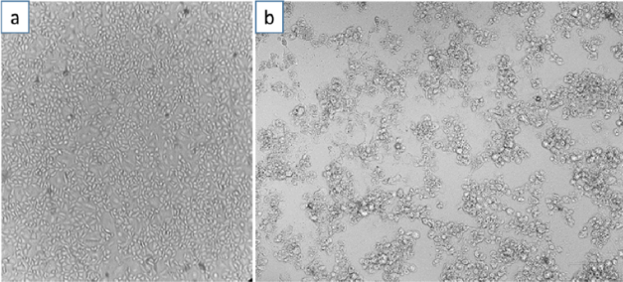
Figure 10: Vero cell culture- a) Normal vero cell monolayer b) Infected vero cells with SARS CoV-2 showing CPE (Nugroho et al., 2023)
Table 6: Cell lies infected by viruses
Cell culture types | Examples | Origin | Cell line infected by virus
Primary cell cultures | RhMK | Rhesus monkey kidney cell culture | adenovirus, coxsackie B, simian virus 40, polio virus (virus propagation in inactivated Polio vaccine), influenza, vaccinia (smallpox vaccine)
 | HAEpiC | Human amniotic epithelial cell culture | rubella, herpes simplex virus (HSV), cytomegalovirus, adenovirus, influenza
 | CEF | Chick embryo fibroblast cell culture | Avian Leukosis Virus, Avian Influenza, Newcastle Disease Virus, Infectious Bronchitis Virus
Diploid cell strains | Wl-38 | Human embryonic lung cell strain | poliomyelitis, measles, mumps, rubella, varicella (chicken pox), herpes zoster, adenovirus, rabies and Hepatitis A  3
 | HL-8 | Rhesus embryo cell strain | Simian T-lymphotropic virus, Herpes B, Simian Virus 40 (SV40), Simian immunodeficiency virus
Continuous cell lines | Hela | Human carcinoma of cervix cell line | rhino virus, human papillomavirus (HPV), HIV, HSV
 | HEp-2 | Human epithelioma of larynx cell line | Human parainfluenza, Coxsackie, Polio, Respiratory syncytial virus (RSV), Adenovirus, HSV, HPV
 | KB | Human carcinoma of nasopharynx cell line | Measles, Epstein–Barr virus, HPV 16 & 18, Influenza, Rhino virus, RSV
 | McCoy | Human synovial carcinoma cell line | Human herpesvirus 8 (HHV 8), HSV, Cytomegalovirus, HSV 1 & 2, Enteroviruses, Varicella-zoster virus (VZV)
 | Detroit 6 | Sternal marrow cell line | Influenza, Parainfluenza, Enteroviruses, Adeno-associated virus, Parvo B-19
 | Chang C/I/L/K | Human conjunctiva (C) Intestine (I), Liver (L) and Kidney (K) cell lines | Mumps, Swine influenza, Adenovirus, Poliovirus
 | Vero | Vervet monkey kidney cell line | Dengue, Zika, Ebola, Measles, Mumps, Yellow fever, SARS-CoV-2 (Vero E6)
 | BHK-21 | Baby hamster kidney cell line | Adenovirus 25, HSV, Vaccinia, Chikungunya, Reovirus, Foot and mouth disease virus, Japanese encephalitis, Semliki forest virus (Togavirus), Rift valley fever virus (Bunyavirus)
 | MDCK | Madin-Darby canine kidney | Influenza virus (isolation and vaccine production), Canine parvovirus, Canine distemper virus
Table 7: Detection of virus growth
Detection assay | Assay procedure
Cytopathic Effect (CPE)- | Many viruses induce morphological changes in cultured cells, known as cytopathic effects (CPE). These changes, such as cell rounding (polio), syncytium formation (retroviruses, paramyxoviruses), or granular clumping (adenoviruses-grape like cluster), can be observed microscopically and aid in identifying the infecting virus. Different viruses produce characteristic CPE, facilitating the presumptive identification of virus isolates
Metabolic Inhibition- | Virus growth in cell cultures can inhibit cellular metabolism, leading to a lack of acid production in the culture medium. This metabolic inhibition can be detected by changes in the color of the indicator (e.g., phenol red) incorporated into the medium
Hemadsorption- | Hemagglutinating viruses, such as influenza and parainfluenza viruses, can cause erythrocytes (red blood cells) to adhere to the surface of infected cells in culture. This phenomenon, known as hemadsorption, indicates viral replication within the culture
Interference- | The growth of a non-cytopathogenic virus in cell culture can be assessed by challenging the culture with a known cytopathogenic virus. If the first virus inhibits the infection by the second virus, it suggests interference between the two viruses. For example, certain strains of influenza virus can inhibit the replication of other influenza virus strains or unrelated viruses.
Transformation- | Oncogenic viruses can induce cell transformation, leading to the loss of contact inhibition and the formation of piled-up growth patterns resembling microtumors
Immunofluorescence- | Virus-infected cells can be stained with fluorescent conjugated antiserum specific to viral antigens. Examination under a UV microscope allows for the visualization of virus antigens, providing early detection of viral infection and finding wide application in diagnostic virology

Cell culture media- The culture medium stands as a pivotal component in the culture environment, furnishing essential nutrients, growth factors, and hormones vital for cell growth, while also regulating pH and osmotic pressure. Initially, cell culture experiments relied on natural media extracted from tissue or body fluids. However, the demand for standardized, high-quality media prompted the development of defined media. Serum, a key component, supplies growth factors, adhesion factors, hormones, lipids and minerals essential for cell culture. Despite its benefits, serum poses challenges such as cost, variability, and potential contamination. Commonly used media are-DMEM (Dulbecco’s Modified Eagle’s Medium), RPMI (Roswell Park Memorial Institute), GMEM (Glasgow’s Modified Eagle’s Medium) and EMEM (Eagle’s Minimal Essential Medium).
Media can be categorized into three types:
a. Basal media- Supplemented with amino acids, vitamins, salts, and glucose, require additional serum.
b. Reduced-serum media- enriched with nutrients and animal-derived factors, decrease serum dependency.
c. Serum-free media- substitute serum with appropriate nutritional and hormonal formulations, providing selectivity for specific cell types. This method offers flexibility in tailoring the medium to suit various cell cultures.
Additionally, maintaining optimal pH, CO₂ levels, and temperature is crucial for cell growth. Most mammalian cell lines thrive at pH 7.4, with some exceptions (some transformed cell lines). CO₂ concentration influences medium pH and is vital for buffering cells against pH fluctuations. Temperature settings vary depending on cell origin, with most human and mammalian cell lines cultured at 36°C to 37°C. Insect, avian, and cold-blooded animal cell lines have distinct temperature requirements.
Subculture- Subculture, also known as passaging or splitting, refers to the process of transferring cells from one culture vessel to another to maintain their growth and proliferation. This procedure is essential for preventing overcrowding of cells, replenishing nutrients, and ensuring the longevity of the cell line.
Cell growth in culture typically follows a standard pattern, starting with a lag phase after seeding, followed by exponential growth known as the log phase. However, growth eventually slows down as cells reach confluence in adherent cultures or surpass the medium's capacity in suspension cultures. To maintain optimal growth, cells should be subcultured or passaged when they cover the plate or exceed the medium's capacity. This ensures cells remain at an optimal density for continued growth, maximizing the number of healthy cells available for experiments.
Cryopreservation- Cryopreservation involves preserving biological samples at ultra-low temperatures to maintain their viability for long-term storage. Freezing media, also known as cryoprotective agents or cryopreservation solutions, play a crucial role in this process by protecting cells from damage during freezing and thawing. These solutions typically consist of a combination of cryoprotectants, buffers, and other additives that help maintain cell integrity and viability. The composition of freezing media varies depending on the type of cells being preserved and the specific requirements of the cryopreservation protocol. Common components of freezing media include:
- Cryoprotectants- These are chemicals that help prevent the formation of ice crystals within cells during freezing. Common cryoprotectants include dimethyl sulfoxide (DMSO), glycerol, and ethylene glycol.
- Buffers: Buffers help maintain the pH of the solution, ensuring optimal conditions for cell survival. Phosphate-buffered saline (PBS) and HEPES are commonly used buffers in freezing media.
- Serum or protein supplements: Addition of serum (preferably fetal bovine serum) or proteins such as albumin can provide additional protection to cells during freezing and thawing.
- Antioxidants: Antioxidants such as vitamin E or beta-mercaptoethanol may be included in freezing media to protect cells from oxidative damage.
- Sugars: Sugars like sucrose or trehalose may be added to freezing media to help stabilize cell membranes during freezing.
- Freezing media are carefully formulated to minimize cell damage and maximize cell survival during the cryopreservation process, allowing for long-term storage of biological samples at ultra-low temperatures.
B. Microscopy-visualization of virus:
1. Light microscopy- Light microscopes utilize visible light within the range of 400–700 nm wavelengths to visualize objects. While they are generally not capable of magnifying viruses due to their small size, some of the largest known viruses, such as Mimivirus, Pithovirus, Megavirus, and Pandoravirus, can be observed using light microscopy when infecting amoebas. Light microscopy remains valuable for detecting virally induced changes in infected cells. For instance, Negri bodies (inclusion bodies) found in neurons infected with rabies. The analysis of CPE through light microscopy is a standard diagnostic technique, where changes in cellular morphology, such as swelling, shrinking, and syncytium formation, are assessed. The timeframe for observing CPE varies depending on the virus, ranging from 24 hours for herpes simplex to 10–30 days for cytomegalovirus. The duration of CPE incubation serves as an important characteristic for viral identification and characterization.
2. Immunofluorescence microscopy- The assay employs fluorescence microscopy to detect viruses within infected cells. This method utilizes specific antibodies tagged with fluorophores, such as fluorescein, which bind to viral antigens within the cell. When exposed to excitation light, the fluorophores emit fluorescence, allowing visualization of infected cells under the microscope. This technique offers high sensitivity and specificity, enabling the detection of viral particles and infected cells with high precision. Additionally, fluorescence microscopy can facilitate the study of viral replication dynamics, host-virus interactions, and the effects of antiviral agents on viral propagation. Direct and indirect immunofluorescence microscopy are techniques used to detect specific antigens in biological samples.
In direct immunofluorescence (Figure 11) microscopy, fluorescently labeled antibodies directly bind to the target antigen in the sample. This results in immediate visualization of the antigen-antibody complex under the microscope. On the other hand, indirect immunofluorescence (Figure 11) microscopy involves two steps. First, unlabeled primary antibodies bind to the target antigen. Then, fluorescently labeled secondary antibodies, which recognize the primary antibodies, are added to the sample. This secondary antibody amplifies the signal, making the antigen-antibody complex easier to detect under the microscope.

Fluorophore

Anti mouse antibody
Fluorophore

Virus specific antibody (murin Mab)
Virus specific antibody

Viral antigen
Viral antigen

Indirect
Direct

Figure 11: Types of immunofluorescence

3. Electron microscopy- During 1930s, German physicist, Ernst Ruska, achieved a major breakthrough in virology with the introduction of electron microscopy (EM)., that enabled the visualization of individual viruses for the first time. Unlike traditional light microscopy, EM utilizes an electron beam and electromagnets to achieve exceptional resolution and magnification, up to approximately 10,000,000 times.
Despite its remarkable capabilities, EM has notable drawbacks. Samples prepared for EM are typically fixed and processed, rendering them dead and subject to significant damage from the electron beam, which interacts with organic matter. Nevertheless, EM unveiled the basic structures and crystalline nature of viruses, establishing itself as a fundamental tool in virology. One technique employed in EM, known as negative staining, involves coating virus particles with heavy metals to create a detailed surface representation while preserving structural integrity. However, this method provides limited insight into internal structures.
EM has long served as a valuable means of directly detecting viruses in various biological samples, such as body fluids, stools, and histopathologic specimens, through visual counting of viral particles. Nevertheless, its effectiveness relies on the presence of a high virion count in samples and demands significant technical expertise from operators.

C. Assay of infectivity (quantitative assay):
An assay of infectivity is a laboratory technique used to measure the ability of a virus or other infectious agent to infect cells or organisms.
1. TCID50 assay- TCID50 (Tissue Culture Infectious Dose 50) assay is a endpoint dilution method used in virology to determine the concentration of a virus sample that is capable of infecting 50% of the inoculated cell cultures. This assay is particularly useful for quantifying the infectious titer of viruses that can replicate in cell culture.
To perform the TCID50 assay, the virus stock is serially diluted and each dilution is inoculated onto multiple wells of a cell culture plate. After an incubation period, typically several days, the cultures are examined for evidence of viral infection, such as cytopathic effects (CPE) or specific staining patterns. The dilution at which 50% of the cultures show signs of infection are then calculated using statistical methods such as the Reed-Muench method.
While endpoint dilution assays are primarily conducted in cell cultures, they can also be performed in animals, with results reported as Infectious Dose 50% (ID50) or Lethal Dose 50% (LD50) if death is the endpoint. It's important to note that virus titers are relative values, contingent upon the type of cells or animals utilized for the assay.
2. Plaque assay- The plaque assay (Figure 12), a widely used and esteemed quantitative virus assay, involves infecting a cell monolayer with various dilutions of a lytic virus. After infection, an overlay medium (eg: agarose) is added to prevent viral spread, allowing plaques (zones of cell death) to form due to viral replication. Plaque development typically takes 2-14 days, depending on the virus and host cells. Plaques are manually counted after staining with neutral red or crystal violet, and the viral titer is calculated in terms of plaque forming units (PFU) per milliliter (PFU/ml), assuming each plaque represents one infective virus particle. This assay, introduced by Dulbecco in 1952, confines viral spread to the vicinity of infected cells, allowing visible plaques to indicate infectivity. Some viruses, such as herpesvirus, can form plaques without an agar overlay, while oncogenic viruses can be enumerated using the transformation assay, which detects cell transformation indicative of micro-tumors.

100µl
100µl
100µl
100µl
10µl
No virus
Serial dilution

10⁻⁷
10⁻⁶
10⁻⁵
10⁻⁴
10⁻³
Virus stock

10µl
10µl
10µl
Mix virus dilution with cells, plate and overlay cells with agarose

10⁻⁷
10⁻⁶
10⁻⁵

Remove agarose layer, stain cells to visualize plaques in the monolayer

No plaques
Numerous plaques
2 plaques
7 plaques

Figure 12: Plaque assay
3. Focus Forming Assays (FFAs)- These are adaptations of plaque assays employing antibody-based staining to identify infected cells. Unlike plaque assays, FFAs detect both lytic and non-lytic viruses with greater sensitivity and faster incubation times. However, FFAs require specific antibodies and only detect viral protein subunits, not infectious virions. Results are reported as focus forming units (FFU) per milliliter (FFU/ml).
4. Serum neutralization test (SNT)- The serum neutralization test (Figure 13) is a laboratory technique used to measure the presence of neutralizing antibodies in a serum sample against a specific virus. In this test, the serum sample is serially diluted and mixed with a fixed amount of virus. The mixture is then added to susceptible cells in culture. If neutralizing antibodies are present in the serum, they will bind to the virus and prevent it from infecting the cells. The highest dilution of serum that prevents virus infection is determined as the neutralizing titer. This test is valuable in assessing immunity to viral infections and evaluating the effectiveness of vaccines.

Virus (50 plaques per 100μl).

90 mins. Incubation (37⁰C)

Inocula was removed gently from the wells
Heat inactivated serum (4 fold dilution)

Overlay agar medium added to wells
Incubate at 37⁰ C in 5% CO₂ for 5 to 6 days
Cells
Stain with 1% Amido stain, washed and counted

Figure 13: SNT assay
D. Serological assay:
1. Hemagglutination assay- Hemagglutinin is a crucial protein found on the envelope of various viruses such as arboviruses, influenza, and parainfluenza subtypes. Its primary function is to bind to red blood cells (RBCs), causing them to clump together and form a lattice-like structure known as agglutinated cells. In the hemagglutination assay (Figure 14), different dilutions of the virus are mixed with RBCs, and the samples are observed for the presence of agglutinated cells.
Figure 14: Haemagglutination assay
Hemagglutination inhibition assay- The assay is used to assess the levels of specific antibodies present in serum samples. When antibodies are present in sufficient concentrations, they interfere with the attachment of the virus to the RBCs, preventing the formation of agglutinated cells. This inhibition of hemagglutination indicates the presence of neutralizing antibodies in the serum.
2. Enzyme-Linked Immunosorbent Assay (ELISA)- ELISA serves as a pivotal tool for detecting antibodies produced in response to infections or viral antigens in serum samples. It assesses the presence and concentration of specific antibodies, which can persist in the bloodstream long after the infection has resolved. Therefore, a positive ELISA result indicates patient immunity resulting from prior exposure to the virus, reinfection, or a reactivation state, rather than active infection. ELISAs are indispensable for epidemiological studies as they enable the analysis of disease prevalence in different populations over time.
The ELISA procedure involves immobilizing a viral antigen or antibody against the pathogen onto the surface of a microplate well. When serological samples containing viral antibodies or specific viral proteins are added to the well, they recognize and bind to the immobilized molecules. Subsequently, specific labeled antibodies recognize the bound molecules of interest often involving enzymes such as horseradish peroxidase (HRP) or alkaline phosphatase (AP) for signal amplification and generate a detectable signal, such as colorimetric, chemiluminescent, or fluorescent, which is measured by a microplate reader. The intensity of the signal corresponds to the amount of specific antigen or antibody present in the sample. ELISAs can be of different types (Figure 15)-
- Direct ELISA- Direct ELISA detects antigens directly by immobilizing specific antibodies on a microplate, allowing antigen binding and subsequent detection with enzyme-conjugated secondary antibodies, providing a rapid and sensitive method for antigen detection.
- Indirect ELISA-Indirect ELISAs involve a two-step process, where a non-labeled primary antibody binds to the antigen or viral antibody, followed by recognition by a labeled secondary antibody.
- Sandwich ELISA- Sandwich ELISA involves capturing the target antigen between two specific antibodies: one immobilized on the surface and the other enzyme-conjugated, enabling highly sensitive and specific detection of antigens in complex samples.
- Competitive ELISA- ELISAs can be conducted in a competitive manner to measure antigen concentration by detecting signal interference. In this approach, the sample antigen competes with a reference antigen for binding to a specific labeled antibody, leading to a weaker signal proportional to the amount of antigen in the sample.

Substrate
Substrate
Substrate
Substrate
Substrate
Inhibitor ag
Secondary ab conjugate
Enzyme

Capture ab
Primary ab conjugate
Antigen
Direct Indirect Direct sandwich Indirect sandwich Competitive
Figure 15: Types of ELISAs
3. Homogenous assay: Homogeneous assays offer an alternative approach to traditional heterogeneous ELISAs, eliminating the need for washing steps to reduce background interference and detect bound complexes. This means there's no requirement for separating unbound components from the well, simplifying the assay procedure to a straightforward add-and-read protocol. This streamlined process minimizes handling steps and operation time, making homogeneous assays ideal for automation-supported screening applications. Examples of homogeneous virus assays include fluorescence polarization immunoassays, various Time-Resolved Fluorescence (TRF) and Time-Resolved Fluorescence Resonance Energy Transfer (TR-FRET) based assays.
4. Fluorescent antibody assay (Immunofluorescence)- The fluorescent antibody assay, also known as immunofluorescence assay (IFA), is a technique used to detect and localize specific antigens (usually viral proteins) in cells or tissues using fluorescently labeled antibodies. The steps involved are-
- Antigen Detection- The first step involves fixing and permeabilizing the cells or tissue samples to allow access for the antibodies. Then, the samples are incubated with a primary antibody that specifically binds to the target viral antigen.
- Primary Antibody Binding- If the target viral antigen is present in the sample, the primary antibody will bind to it, forming an antigen-antibody complex.
- Fluorescent Labeling- After washing away unbound primary antibodies, the samples are incubated with a secondary antibody conjugated to a fluorescent dye. This secondary antibody recognizes and binds to the primary antibody, forming a sandwich complex.
- Visualization- When exposed to light of the appropriate wavelength, the fluorescent dye emits fluorescent light, allowing visualization of the location of the viral antigen within the sample. This can be observed under a fluorescence microscope.

There are two types of fluorescent antibody assays used in virology (Figure 16)-

- Direct Immunofluorescence Assay (DFA)-In DFA, a single fluorescently labeled antibody directly binds to the specific viral antigen present in the sample. This method is relatively simple and rapid, but it requires high-affinity antibodies and may lack sensitivity compared to other techniques.
- Indirect Immunofluorescence Assay (IFA)-In IFA, a primary antibody binds to the viral antigen, and then a secondary antibody conjugated to a fluorescent dye binds to the primary antibody. This amplifies the signal and enhances sensitivity, allowing for the detection of low levels of viral antigens.

Fluorophore/Enzyme

Secondary Ab
Fluorophore/Enzyme

Primary Ab
Primary Ab

Antigen
Antigen
Slides
Slides
Indirect
Direct

Figure 16: Immunofluorescence assay
E. Molecular assay:
NAAT- Nucleic Acid Amplification techniques (NAATs) revolutionize viral infection diagnosis, offering heightened sensitivity, rapidity, and reliability. By targeting and amplifying specific viral genome regions, NAATs can detect viral presence even before the appearance of antigens or antibodies in the bloodstream. The process involves DNA/RNA extraction, purification, and quality testing, often measured by absorbance using a spectrometer-based microplate reader. Fluorescence intensity methods like Hoechst or PicoGreen provide increased sensitivity by distinguishing between double-stranded and single-stranded nucleic acids. There are several types of molecular assays used for detecting and studying viruses-
Polymerase Chain Reaction (PCR)- PCR is a technique (Figure 17) used to amplify specific regions of DNA or RNA. It is highly sensitive and can detect even small amounts of viral genetic material. Variations of PCR include quantitative PCR (qPCR) for quantifying viral load and nested PCR for increased specificity.
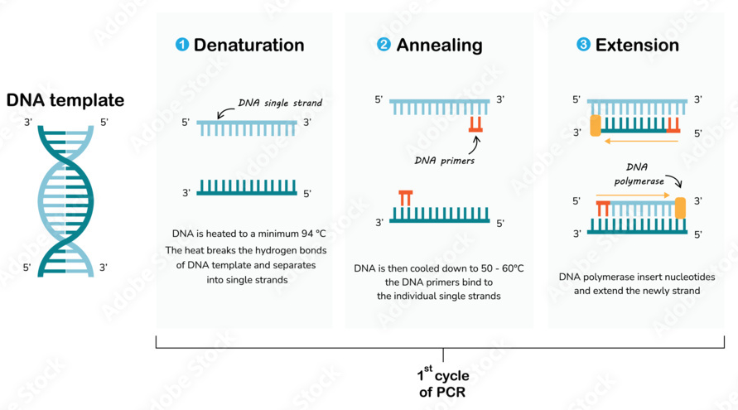

Figure 17: PCR assay

Reverse Transcription Polymerase Chain Reaction (RT-PCR)- RT-PCR is used to detect RNA viruses by first converting RNA into complementary DNA (cDNA) using reverse transcriptase enzyme. The cDNA is then amplified using PCR.
Real-time PCR- Real-time PCR (Figure 18) with TaqMan probes is a molecular biology technique that combines PCR amplification with real-time fluorescence detection using TaqMan probes. These probes are oligonucleotide sequences containing a fluorescent reporter dye and a quencher molecule. During PCR amplification, the TaqMan probe anneals to the target sequence, and when the polymerase extends the primer, it cleaves the probe, separating the reporter dye from the quencher molecule. This results in an increase in fluorescence intensity, which is monitored in real-time and correlates with the amount of target nucleic acid present in the sample. TaqMan-based real-time PCR offers high specificity, sensitivity, and quantitative capabilities for the detection and measurement of specific DNA or RNA sequences.

Quencher
Fluorophore
Forward PCR primer
TaqMan probe
5´
3´
5´
3´
Reverse PCR primer

Amplification assay
Polymerization

Fluorescence
Probe displacement and cleavage

Fluorescence

Cleavage product
PCR product

Figure 18: Real time TaqMan PCR
Nucleic Acid Sequencing- Sequencing techniques are used to determine the exact order of nucleotides in a viral genome. This allows for the identification of specific viral strains and mutations.
Nucleic Acid Hybridization- This technique involves the use of complementary nucleic acid probes to detect specific viral sequences. It can be used for both qualitative and quantitative analysis of viral nucleic acids.
Loop-mediated Isothermal Amplification (LAMP)- LAMP is a method for amplifying DNA under isothermal conditions. It is rapid and can be performed at a single temperature, making it suitable for point-of-care testing.
Next Generation Sequencing (NGS)- NGS technologies enable high-throughput sequencing of nucleic acids, allowing for the analysis of entire viral genomes and the identification of novel viral strains.
In situ Hybridization- This technique allows for the visualization of viral nucleic acids within cells or tissues. It is commonly used for studying viral tropism and localization in infected tissues.

F. Flowcytometry:
Flowcytometry is a powerful technique used to analyze the physical and chemical characteristics of cells or particles suspended in a fluid. It involves passing a suspension of cells or particles through a laser beam, where various properties such as size, granularity, and fluorescence are measured. Each cell or particle passing through the laser beam generates signals that are collected by detectors, allowing for the characterization of individual cells or particles within the sample. The movement of sheath fluid propels the particles, confining them to the center of the sample core. This phenomenon is termed hydrodynamic focusing. Flow cytometry (Figure 19) is widely used in immunology, cancer research, microbiology, and many other fields for cell counting, sorting, and biomarker analysis.
A flow cytometer comprises three primary systems: fluidics, optics, and electronics.
- The fluidics system conveys particles in a stream to the laser beam for examination.
- The optics system includes lasers that illuminate the particles in the sample stream and optical filters that direct the resulting light signals to the appropriate detectors.
- The electronics system converts the detected light signals into electronic signals that are compatible with computer processing. In instruments equipped with a sorting capability, the electronics system can also initiate sorting decisions to charge and deflect particles.

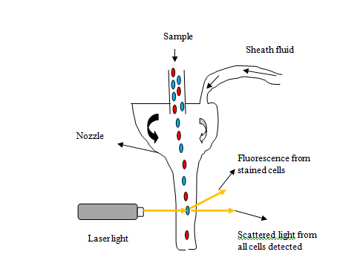
Figure 19: Flowcytometry assay

Virus purification:
Viruses cultivated in cell cultures undergo various processes for purification, quantification, imaging, and biochemical analysis. The initial virus concentration determines the ease of purification, with higher concentrations facilitating separation from cell debris and media components. Cytopathic viruses are found amidst cell debris and media, while cell-associated viruses require gentle lysis to release them. Low-speed centrifugation (~5000×g) is employed to pellet cell debris, leaving virions in the supernatant. Subsequent high-speed centrifugation (~30,000–100,000×g) isolates the virus, followed by optional purification through density gradient centrifugation using substances like sucrose or glycerol. This gradient separates sample components based on buoyant density, enabling finer separation and visible band formation for virus collection.

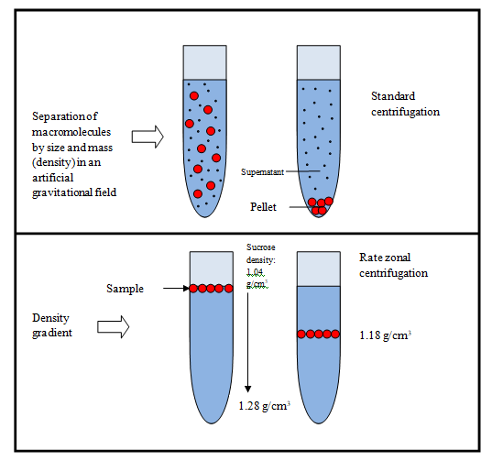
Figure 20: Purification of virus (Centrifugation)

Reference:
Nugroho, H.A., Agustiyanti, D.F., Angelina, M., Ningrum, R.A., Rahmani, S., Wisnuwardhani, P.H., 2023. Biosafety protocol verification to inactivate Indonesian isolate SARS CoV-2 using formaldehyde. Presented at the PROCEEDINGS OF THE 9TH INTERNATIONAL SYMPOSIUM ON INNOVATIVE BIOPRODUCTION INDONESIA ON BIOTECHNOLOGY AND BIOENGINEERING 2022: Strengthening Bioeconomy through Applied Biotechnology, Bioengineering, and Biodiversity, Bogor, Indonesia, p. 080002. https://doi.org/10.1063/5.0183716
Payne, S., 2017. Methods to Study Viruses. Viruses 37–52. https://doi.org/10.1016/B978-0-12-803109-4.00004-0
Wadell, G., 1983. Cultivation of viruses, in: Textbook of Medical Virology. Elsevier, pp. 38–44. https://doi.org/10.1016/B978-0-407-00253-1.50010-4

