Chapter 5
Advanced Technologies for Efficient Packaging Processes

Introduction:
The term "packaging" refers to the method that keeps containment of pharmaceutical product from the time of production in a unit till its use.[1]
Pharmaceutical packaging is necessary for pharmaceutical products because it preserves the stability and integrity of the dosage form, which demonstrates the product's efficacy.
The fundamental idea behind all definitions of packing is the packaged item's safety and protection during transit so that it can be easily used by customers.
Therefore, packaging is the pair of a science and a technology that involves the study of materials and techniques as well as the understanding of the machinery used to pack the product.[2]
Packaging and package design play a prominent role in the manufacturing, distribution and storage of medicaments. This is the case because an inadequate or malfunctioning packing system may cause a drug to become unstable, which could have harmful or unfavourable effects on the patient. When handling, storing, and transporting materials, packaging plays a crucial role.
Regardless of how perfectly a product is made, if the container reacts with the contents, a drug could become poisonous or utterly ineffective. [3]

Types of packaging systems.
Primary packaging: Primary packaging systems package ingredients or sub-constituents that come into direct touch with the product and impact its shelf life (i.e., those who wrap the product initially). It consists of prefilled syringes, vials, ampoules (used for parenteral drugs), etc.
Secondary packaging: It is used to bundle the primary packages together, it is present outside of the primary packaging. Among the secondary packing systems are boxes, shipping containers, and cartons.
Tertiary packaging: A tertiary packing method is utilized in bulk handling. It has edge protection, a barrel, and other things. [2]
Types of packaging material used for pharmaceuticals. Following materials are used: -
- Paper and board
- Glass
- Rubber
- Metal
- Plastic. [3]

Advanced Technologies for Efficient Packaging Processes
As technology continues to evolve, the pharmaceutical industry has seen significant improvements in the design and functionality of packaging. New materials and technologies have been developed to ensure that medicines remain safe and effective throughout their lifecycle, from production to administration.
One of the most significant advancements in pharmaceutical packaging is the use of smart packaging. These packages are equipped with sensors that can monitor environmental conditions
Like temperature, humidity, and light exposure. This technology ensures that medicines are stored and transported under the optimal conditions, reducing the risk of damage and degradation.
Another area of innovation is in the development of child-resistant packaging. This packaging is designed to prevent accidental ingestion of medication by children, ensuring their safety. In addition, packaging that is easier for the elderly or those with mobility issues to open has been developed, making it easier for patients to take their medication independently.
These innovations not only benefit patients but also offer significant advantages for the pharmaceutical industry. Improved packaging can reduce costs associated with product recalls and returns due to packaging-related issues. It can also help to increase patient adherence to medication, ultimately leading to better health outcomes. [4]

Cypaks’ advanced medication monitoring and report card
Patients can interact with medical providers via printed technology thanks to this cutting- edge packaging technology. When a tablet is taken out of its blister pack, this keeps track of the time and information that it was taken. This enables patients to record and publish their comments regarding side effects and the effectiveness of treatment. With the use of this technology, patient-doctor interfaces to determine the optimal course of therapy could reach new heights. Clinical trials are the ideal applications for sensor-based package solutions. This helps in the creation of new drugs by determining if they are ineffective or are just not being taken correctly. Cypak uses its cutting-edge drug technology to target the clinical trials industry.
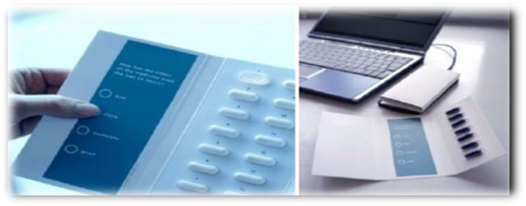
Figure 1: Cypak's advanced medication monitoring and report card systems.
Burgopak’s sliding cr blister pack
At the Pharmapack Paris show, Burgopak Healthcare and Technology took home the "Most Innovative Child Resistant Packaging Design" prize. The patient must simultaneously pull the end tab and press two buttons, one on each side of the Burgopak CR Slider pack, in order for it to open. When the pack opens, the blister is placed inside a plastic tray on one side, and patient information is presented in the form of an easily readable booklet on the other. The patient only needs to slide the end tab back into the pack to reengage the CR lock after they have accessed the medication. Elderly people and others with limited dexterity can utilize the pack more easily because it is CR and doesn't require the use of more durable CR blister foils.
The leaflets and blister pack interrelate in conjunction with the outer box, which guarantees that the product is which ensures the product is never separated from its packaging material.
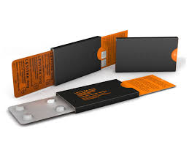

Figure 2: Burgopak's sliding cr blister pack

The Silenor® Patient Starter Kit features
When opened, the unique carton design resembles a bedroom with a bed and nightstand. A seven-count unit dose carded blister that may be removed from the design for mobility and convenience is included in the design. In order to facilitate patient adherence, the arrangment of the bed carton includes a literature pocket that contains the medication guide, the prescription discount card for the Sleep- SaverTM Program, and a multi-panel color leaflet that includes instructions on how to use Silenor®, a list of its side effects, enrollment instructions that include a website and toll-free number, and more about treating insomnia.[3]
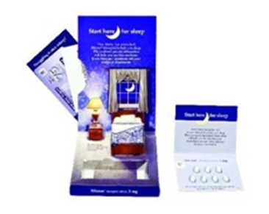

Figure 3: The Silenor® Patient Starter Kit features
Stora Enso – Pharma DDSi Wireless
This system uses conductive ink on a blister inlay made of carton board and connects it to a cellular module that is within the package.
• Pill removal is monitored, and data can be automatically transferred via GSM or GPRS cellular networks to an electronic database.
• The system may send telephone calls and SMS to patients, health professional, and family members also.
• A doctor can easily follow a patient's drug intake using the packaging data.
Such cutting-edge mobile technology may be especially useful for patients with Alzheimer's and other neurological disorders, who may need family members and caregivers to be more involved in their care. While patient non-compliance remains a persistent problem for the pharmaceutical sector, creative thinkers in packaging are producing an almost limitless number of ideas. To assist blind and illiterate patients with safely taking their medications, voice and sound-based packaging solutions have also been developed. A greater percentage of patients should start to realize the whole advantages of the medications that the pharmaceutical industry offers as a result of this variety of concepts changing the way pharmaceutical products are packaged and presented.[5]

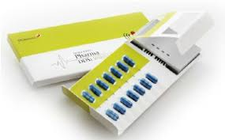

Figure 4: Stora Enso - Pharma DDSi Wireless
Novartis Pharmaceutical Corporation’s - Shellpak
30 days of treatment are provided by ShellpakTM in a calendarized unit-dose blister package. The tablets are arranged with color-coded days and weeks to help with medication compliance. Reminders for refilling the prescription are also included in the pack. The 170mm ShellpakTM exterior, a unique child-resistant package design, houses the 30-day blister. There are labels on the front and rear of the stiff plastic design. The patient's prescription label and an affixed prescription insert are to be placed in the designated space on the rear label. An enlarged content booklet label with a picture of the pill is located on the front of the pack. Patients can get help with dosing instructions, join the BP Success Zone Program guides, which include the website and toll-free number, and further regulatory information on multiple pages found on the front label. Diovan HCT® ShellpakTM is available in four different combinations of strengths. To guarantee that the patient receives the recommended dosage, each strength combination has a different color (Brown, Blue, Purple, or Red) and a picture of the special tablet design for each strength. [6]

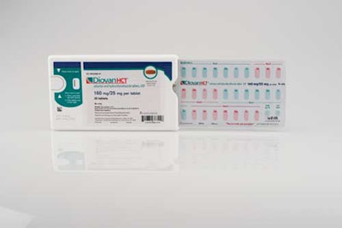
Figure 5: The Diovan HCT® Shellpak™

Eco – Friendly Pharma Packaging
A package's accessibility or safety cannot be compromised because of environmental factors. Novel ideas for pharmaceutical packaging are starting to surface that take environmental issues into account without compromising packaging advancements achieved in the last ten years.
Ecoslide-RX Sustainable compliance Packaging
The Ecoslide - RX ecological compliance packaging was introduced by Folding Box Company and Legacy Pharmaceutical. The Ecoslide - RX ecological compliance packaging was introduced by Folding Box Company and Legacy Pharmaceutical Packaging.
With unbleached paperboard and a clay-coated surface to hold blister packaging with the least amount of non-sustainable film and foil, the pack is constructed entirely of recycled materials.
The slide package does not requisite thermo sealing during the production process, which lowers expenses and energy consumption while still meeting all current standards for child resistance and senior accessible.
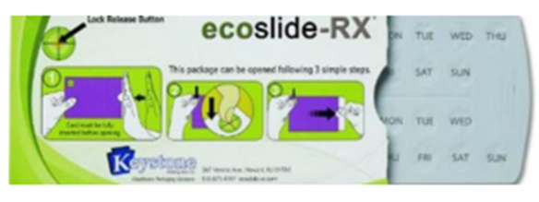

Figure 6: Ecoslide-RX sustainable compliance packaging
Prefilled Syringes
Advantages and driving forces behind prefilled syringes.

Syringe self-filling can be a laborious procedure that is not only sluggish but also prone to spills and inaccurate dosing. Prefilled syringes made it easier and more accurate to administer medications on oneself. Prefilled syringe usage is rising, but it's not only because consumers generally want more convenient, user-friendly items; pharmaceutical companies are actively pushing this trend due to increased safety and fewer medication overfills. [3]

Packaging against counterfeiting
10% of all medications in the US are counterfeit, according to the FDA. The EU considers that 1% to 3% of medications. The most recent innovations include near field communication (NFC) tags, with laser surface authentication packaging system that can be uniquely coded and labelled fluorescently for identification.
For example, since October 2011, Indian pharmaceutical companies have been shipping their products to international markets with a mandatory sport barcode on the exterior of the packaging.
There are several facets to understanding and simplifying the supply chain for fake pharmaceuticals. The Product-Based tracking methodology, which uses high-tech systems to detect counterfeit drugs on the market, is likely the one that is more often used by pharmaceutical businesses globally today.
These technologies include bar codes, RFID, holographic, and tamper-evident packaging.
Yes, a security feature on packaging components does not ensure the genuineness of the inner contents, which may have been adulterated or substituted. Counterfeits are not reduced by security device alone, but are planned to make them easier to detect. [3]
Classification of Anti-Counterfeit Technologies Overt (visible) features.
The purpose of visible features is to allow end users to confirm the validity of a packet. Typically, these characteristics are highly noticeable and costly or challenging to duplicate.
The lists of overt features are follows:
- Pearlescent inks
- Water marks
- Holograms
- Colour shifting security Inks
- Sequential product numbering
- Optically Variable Devices (OVD)
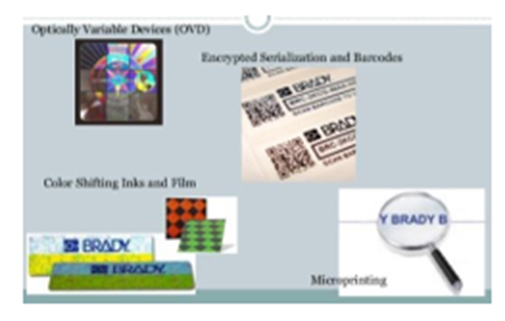
Figure 7: Various Overt Features
Advantages of Overt features
- No device is required for the authentication process.
- Light response angle.
- Immediate verification.
- Predictable, repeated behavior.
- Either persistent or non-existent.
- Secure as a layer or on its own.[7]

Covert Features (Hidden Features)
The covert features are prepared to help the owner of the brand to recognize counterfeit products.
Its existence will remain unknown to the general population, because they lack the resources to confirm it. More covert features will lose some of their security benefit if they are breached or made public.
The list of Covert features includes: -
- Radio Frequency Identification Device (RFID).
- Biometric fingerprints.
- Anti-copy and Anti-scan design.
- Hidden marks and printing.
- Digital Watermarks.
- Embedded Image.
- Invisible Printing.
- Laser coding.
- Substrates.
- Odour.

Figure 8: Covert features
Forensic markers:
The only way forensic markers differ from covert technologies is in the way they verify authenticity through the use of scientific techniques such as field test equipment and lab testing. [2]
The list includes:
- Isotoperatios
- Biological Taggants
- Micro-taggants
- Chemical Taggants
- DNA Taggants
Serialization/Track and Trace technologies
In order to identify and trace pharmaceuticals across the whole supply chain, pharmaceutical serialization involves giving each package a unique serial number. In order to enable Track and Trace from the manufacturing cycle to the end user, information such as the product origin, expiration date, and batch number could be detected and correlated with the serial number. For producers, parallel distributors, importers, warehouses, third-party logistics companies, hospitals, and pharmacies, pharmaceutical serialization and traceability helps harmonize and standardize operational procedures, creating a synchronized workflow.[2]

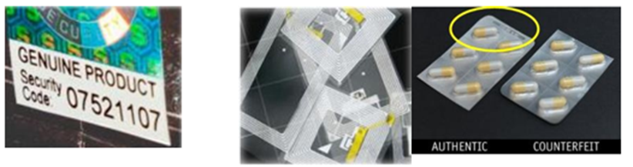

Figure 9: Track and Trace technologies (Sterilisation) RFID, Topography, Authentic and Counterfeit products.
Child – Resistant Packaging
Poison Prevention Packaging (PPP), also known as child-resistant (CR) packaging, is a term used to describe packaging that provides adults with easy access to the contents while making it difficult for children under five to access them. [8]

Table 1. Types of CR Drug-packaging Technologies That Are Employed Worldwide Right Now
Class | Features of children
Type A | Hand Strength | The tablet inside the blister pack cannot be removed without applying significant pressure.
Type B | Hand Length | The tray could not be removed from the carton unless two hooks at the top were pressed simultaneously.
Type C | Literacy | The blister pack covered in a paper or plastic film laminate. The package's surface bears instructions on how to peel off.
Type D | Ability to use tools | The heat-sealed pouch requires scissors to open.
Type E | Ability to perform multiple actions | The bottle that requires simultaneous pushing down and turning of the cap in order to be opened.

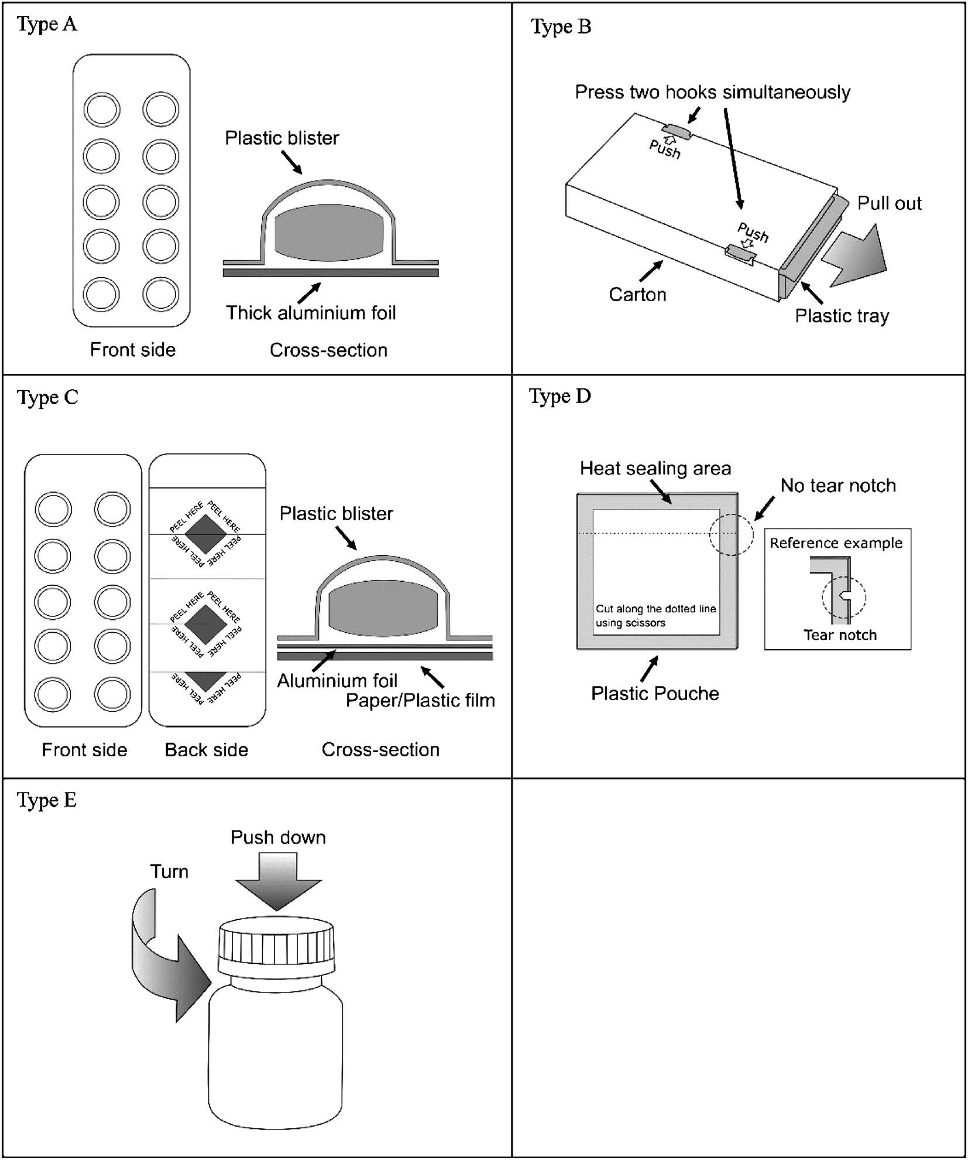

Figure 10: The Standard Schematics for Every Class of CR Drug-packaging Technology

Technology known as CR packaging prevents children from having easy access to items like lighters and medications that could be dangerous if misused. According to the Poison Preventive Packaging Act, CR packaging must stop at least 85% of infants between the ages of 42 and 51 months from opening medication packaging in less than five minutes. [9]

Tamper Resistant packaging
One of the main factors taken into account when developing pharmaceutical product packaging is the need for tamper-resistant packaging.
A package that features an indicator of entry, which, if it is absent, is logically anticipated to give customers obvious proof that tampering has taken place, is said to be tamper-resistant.
The tamper-resistant package variants listed below have been approved by the FDA:
Bubble pack, Blister packaging, Strip package, and film wrappers Bands and shrink seals Plastic bags, paper, and oil Aerosol containers; breakable caps; bottle seals; tape sealing. [2]
Progress in Pharmacopackaging.
Talking” Packaging: The revolution in consumer experience.
There are currently two advancements in talking packaging.

The German company Wipak Walsrod GmbH in Germany developed the ‘Talk Pack’ system. Which requires a specialized scanning pen but can be seamlessly integrated into any printed image on any type of packaging. Through tags with NFC (Near Field Communication) based technology, consumers can now download text, audio, or web page product information to their mobile phone. This breakthrough was made recently by the VTT Technical Research Centre of Finland. The gadget may then be used to play back the information.

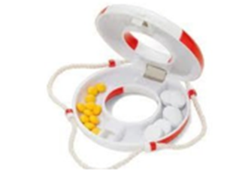

Figure 11: Wipac-Talk Pack
In order to provide the consumer with information about the manufacturer, brand, shelf life, and other details, to access the stored information, play it back as audio files, and audibly produce music, speech or other sounds, a special pen-shaped reader is used. Talk Pack doesn't need microchips or RFID. Using a unique varnish, the dot code is simply printed over text and images. Every kind of package and printing technology can be utilized with this technique. Dispensing caps, also known as functional caps, are used to contain liquid or dry supplements apart from the water that the user releases to create vitamin or energy drinks, occasionally even therapeutic drinks. Using a distributed cap, anything from medications to nutraceuticals may be packaged and dosed correctly.
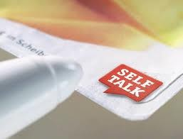
Figure 12: Talk pack- wipe pen reader Figure 13: NFC = enable Mobile phone
Current developments and modifications to inhalers (MID, pMID, DPI, nebulizers)
Because of worries about the harmful effects of chlorofluorocarbons (CFCs) on the ozone layer, hydrofluoroalkane (HFA) propellant has replaced them. CFC MDIs will not be sold in the US after 2008, according to a decision made by the US Food and Drug Administration. The need to employ HFA propellants created difficulties in re-designing the formulation, actuators, and valves as well as in carrying out clinical studies. The elastomeric parts of the measuring valves that are currently in use are typically incompatible with certain surfactants and HFA propellants.
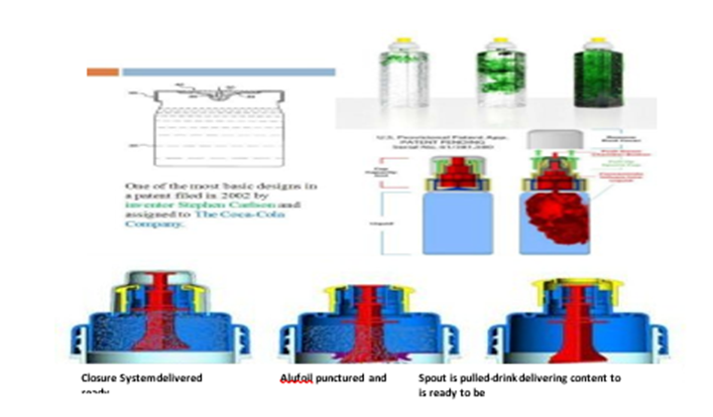

Figure 14: Dispensing cap
DPI devices fall into two categories: single-unit dose inhalers (AerolizerTM, Novartis; HandihalerTM, Boehringer Ingelheim) that load each dose into the device prior to use, and multidose reservoir inhalers (Turbuhaler TM or Flexhaler TM, AstraZeneca; Twisthaler TM, Schering-Plough) that preload a large quantity of medication into the device. Multiunitdose inhalers (DiskusTM, GlaxoSmithKline) contain many single doses that are separately sealed and released upon device activation. The Flexhaler, Diskus, and Twisthaler all contain dose indicators, but the Aerolizer employs discrete single-dose capsules. The FDA published guidelines advising manufacturers to integrate, however pMDIs lack an independent way to track how many doses are still in the device.
Diskus Inhaler Technique
At the 15th annual Allergy & Asthama Day Capitol Hill. device inventors and manufacturers were recognized with the AANMA's inaugural new technology award. A dry powder inhaler with a
60-dose capacity is called a DISKUS®. You can constantly check the amount of dosages remaining in it thanks to its embedded counter. Asthma treatment is made easier with the first
dry powder inhaler that combines an inhaled corticosteroid and a long-acting bronchodilator in one device.
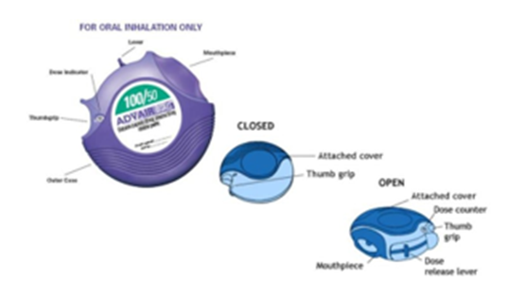

Figure15: Diskus Inhaler

Current Technological Developments in Blow-Fill-Seal Parenteral Packaging
This method, which was developed in Europe in the 1930s and brought to the US in the 1960s, has become the standard for aseptic packaging of pharmaceutical and healthcare items due to its unmatched flexibility in container design, product output, overall product quality, and low operating costs.
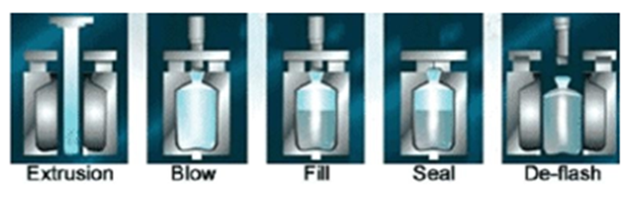
Figure 16: Blow fill seal process.

Comparing Convectional Aseptic Processing with Blow Fill Seal
Sequence Without Interruptions
• It requires fewer parts to build the package.
• It is more affordable than traditional aseptic processing.
• It creates a single, aseptically filled container with an integrated safety seal.
Blow-fill-seal packaging comes in two varieties:

1] The Micro Dose Package 2] The Twist Tip vial
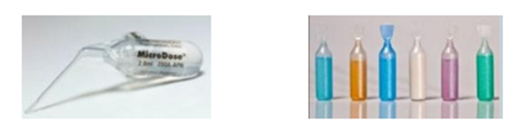
Figure 17: (a) Micro dosage pack (b) The Twist Tip Vial
A modified blow-fill-seal method is used to create these packages. Inserting sterile packaging components into the container to convert it to a multi-use container is one of the more recent developments in blow-fill-seal technology.
Design of Syreen Prefilled Syringe.
The market for syringes is even beginning to embrace environmental consciousness. It uses cyclic olefin polymer (COP) in place of glass. Considering that the COP design creates its own outer shell, this material has completely permitted secondary packaging. The packed syringes' clip-in feature avoids the requirement for cardboard packaging materials. [10]
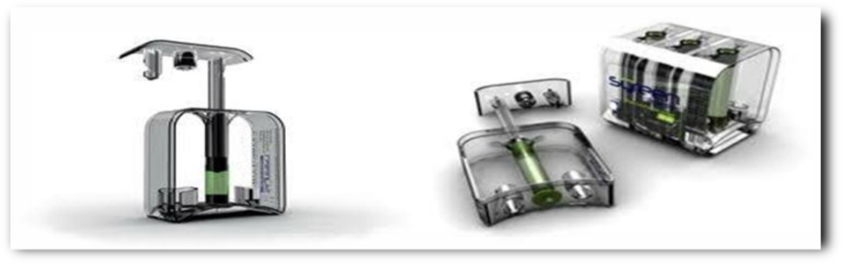
Figure 18: Syreen Prefilled Syringe Design.
Plasma Impulse Chemical Vapor Deposition (PICVD)
Schott invented plasma impulse chemical vapor deposition (PICVD) over a decade ago. For the mass production of optical coatings on glass components (such as infrared reflective coatings and cold light mirrors), it was the first CVD-based coating technology. In recent years, three distinct functional coatings have been deposited on plastics using a modified PICVD process. One technology-PICVD-provides the anti-scratch, anti-reflective, and easily-cleanable layers. [11]
Despite being created by Schott Glass, Plasma Impedance Chemical Vapor Deposition has proven successful in coating large glass items like syringes, ampoules, and pharmaceutical vials.
It was very successful in adapting the original PICVD process and coating a variety of plastics with bonded, uniform coatings, such as SiO2 and TiO2 oxide coatings that resemble glass (e.g., PC, PP, PET, HDPE, COC and PMMA). As a result, plastic can now possess all of glass's positive attributes. It is now feasible to create antiscratch and antireflective coatings for plastic lenses and display covers, but a PICVD coating blocks the passage of gas in plastic packaging, making it impossible for released carbon dioxide to escape and oxygen to enter. As a result, the contents' shelf life is extended without affecting their flavour. [12]

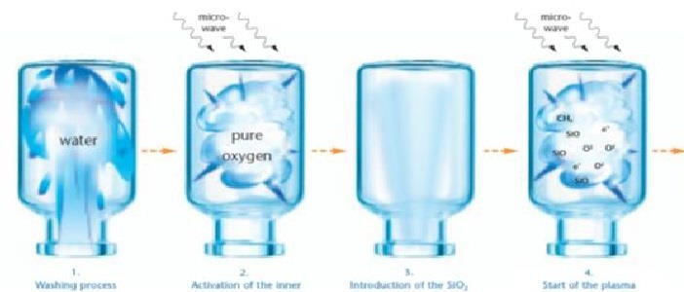

Figure 19: (PICVD) Plasma Impulse Chemical Vapour Deposition

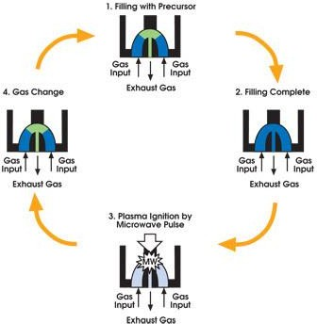

Figure 20: Process of PICVD

Pharmaceutical Packaging Robotics: An Overview
Automation of manual processes, including loading cartoners, horizontal form fill seal machines, or blister machines, is often achieved by robotics. In these circumstances, there are advantages in terms of increased efficiency, speed and overall equipment effectiveness (OEE). Reduced expenses, fewer injuries, and the elimination of rework are possible additional benefits. robots with remarkable precision and consistency. With features like vision and line tracking, they can track the movement of continuous motion machines to maintain production pace and check product placement. They are available around-the-clock.
Generally speaking, robotic cells have a far smaller footprint than conventional kinds of packaging machinery. These cells also provide a large work envelope, which enables the installed equipment to manage several packaging lines. The foot print of a typical robotic loading assembly, or collation system, is less than 3’ x 3’. Even a two cell palletizer, which is usually a big robotic equipment for packaging,
is smaller than 12' by 10' in terms of floor area. Robotic packing lines can save space in addition to having a small footprint by utilizing a single robotic cell for several tasks, which removes the need for extra equipment. For instance, it is possible to design a robotic case packaging and palletizing cell that minimizes the amount of equipment and space needed by loading products into cases and then placing the filled cases on a pallet. [3]
Smart Packaging
By 2024, smart packaging is anticipated to have grown to a projected value of $26.7 billion. These days, a wide range of products, including food and medications, are packaged smartly. Benefits of smart packaging for patients and pharmaceutical supply chain management:
• Enhance patient compliance/adherence
• Confirm authenticity
• Support tracking
• Anti-counterfeiting
• Addiction prevention efforts
• Protect shelf life

Types of smart packaging:
- Active packaging: This pharmaceutical packaging technology enhances safety and aids in the display of quality information. It may be able to detect the product's quality, the interior packaging, or the shipping environment. Technology like oxygen scavengers, desiccants, color-changing inks, microwave susceptors, odor absorbers/emitters, etc. are included in it. Some instances are: When tampered with freeze ink is exposed to temperatures below -10°C, it turns blue instead of clear. When Tamper Heat ink is subjected to temperatures above 65°C, it turns from grey to orange (or grey to pink).
- Intelligent packaging: This is more interactive and offers a method for delivering, storing, and/or receiving information from the Internet, the Cloud, printed electronics, cellphones, Near-Field Communication, Radio Frequency Identification, and QR codes. A few instances include
  - Pharmaceutical packaging with NFC tags: NFC is a clever approach to provide patients with interactive information on their cellphones, such a video about dosage.
  - Packaging embedded with sensor: Microchip sensors are used to record data for precise dosage and dose monitoring. For instance, a built-in sensor will capture data every time a patient takes a medication out of its package and send it to the cloud. This makes it possible for doctors to keep track of the times and frequency of tablet intake. Calendar-enabled closure technologies are combined with basic metered dosage systems to track and count pills as they are administered and transmit the data to a smartphone. [6]

Security through digitilisation.
Digitization is the process of transforming data into a format that can be easily accessed by computers, regardless of one's location. Digital technology is being used by the pharmaceutical packaging industry to introduce effective supply chain tracking and fight counterfeiting.

3.1 Anti-counterfeiting apps.
Anti-counterfeiting apps allow users to determine whether a medication is real or fake by just scanning it. Using optical character recognition (OCR), for instance, the Drugsafe app-which took home the Big Data award at the 2018 Microsoft Imagine Cup—verifies the legitimacy of medications using data from the Azure Cosmos database. [13]

References
- https://www.scribd.com/presentation/571354874/Recent-Advances-in-Pharmaceutical-Packaging-Technology.
- Gahtori. A.U., (2022). Recent Trends in Pharmaceutical Packaging. Systematic Review Pharmacy; 13(8): 522-526, 52 doi: 10.31858/0975-8453.13.8.522-526.
- Ashwin S. Chouhan, (2023). New Methods and Technology of Pharmaceutical Packaging in the Future, J. Pharmaceutics and Pharmacology Research, 6(3). doi:10.31579/2693-7247/124
- https://www.linkedin.com/pulse/technology-innovation-pharmaceutical-packaging-lokhande-l-i-o-n-
- https://www.wjahr.com/admin/assets/article_issue/24102020/1604140712.pdf.
- S.Wasim Raja. et al. (2012). Innovations in pharmaceutical packaging – an update. Int J of Ad Biomed & Pharm Res. 1(1): 29-39.
- Vig. Rakesh, (2007). PLACE conference, www.tappiplace.org

- Lockhart, H., Paine, F.A. (1996). Child-resistant packaging. In: Packaging of Pharmaceuticals and Healthcare Products. Springer, Boston, MA. https://doi.org/10.1007/978-1-4615-2125-9_8

Masaru Mizoguchi, Go Miura, and Fumiyoshi Ojima. Study of Child-resistant Packaging Technologies to Prevent Children from Accidental Ingestion of Drugs in Japan (2018). The Pharmaceutical Society of Japan.138(08) 1103- 1110.
- Chordiya. S.V and Garge. B.M (2019). Innovative packaging of medicines. Int J Aesthet Health Rejuvenation; 2(4): 72-6.
- Zadbuke. N., Sahi. S., Gulecha. B., Padalkar.A and Thube. M (2013). Recent trends and future of pharmaceutical packaging technology. Journal of pharmacy & BioAllied Sciences. 5(2): 98–110. doi: 10.4103/0975-7406.111820
- Kulkarni. K.M., Mane. S., Kondaver. M.S and Magdum (2020) S. A Review On Current Trends In Pharmaceutical Packaging. Indo Am. J. P. Sci, 07(07). 952-959.
- https://www.europeanpharmaceuticalreview.com/article/107961/packaging-security-trends-in-the-pharmaceutical-industry

.

