Reilluminating Wireless Horizons: Exploring Complete Information Transmission through Visible Light
Gagandeep Kaur¹, Varsha Gupta², Neetu Settia³, Shivani Duggal^{4,} Monica Bhutani⁵
^{1,2,3,4} Guru Tegh Bahadur Institute of Engineering, New Delhi
⁵Bharati Vidyapeeth’s College of Engineering, New Delhi
Abstract. Over the decades, radio waves have been the leading source for data transmission. Wi-Fi (Wireless-fidelity), Infrared, Bluetooth, and Zigbee are examples of wireless communication that require radio waves for information transmission. Despite the extensive adoption of these technologies, exploring new methods for wireless and efficient data transmission has become an utmost priority. One of the solutions to this problem is Light Fidelity (Li-Fi), which uses light instead of electromagnetic waves as a medium. Li-Fi, an example of visible light communication (VLC), operates via a light-emitting diode to transfer data by flickering them at a very high speed, which cannot be notifiable to the eye. This paper implements the VLC system using readily available electronic components like Arduino and LED. In this paper, we have researched the domains of wireless communication and emphasize a novel approach to transmitting data by harnessing visible light. Our study focuses on the concept of light-based information transfer, which takes advantage of the properties of visible light to send data wirelessly. By using existing lighting infrastructure, such as LED bulbs, we aim to amplify the capacity and efficiency of wireless networks while reducing interference.
Through extensive research and experimentation, we have provided insight into the feasibility and practicality of utilizing visible light as a means for information transmission. We analyze the advantages offered by light-based data transfer, including its ability to provide higher bandwidth, greater security, and immunity against electromagnetic interference. Moreover, we examine various connectivity solutions by comparing into the lumens of various light sources namely Standard bulb, Halogen, CFL and LED operating at energy of 40 W.
The results obtained highlight the nature of visible light communication (VLC) systems and their potential to revolutionize wireless networks. We also address the applications and limitations associated with VLC.

Keywords: Light Fidelity (Li-Fi), Visible Light Communication (VLC), Access Points (APs), Information transmission, Light-based data transfer, Wireless networks, Connectivity solutions
- Introduction
With the progression of the Internet of Things (IoT), the demand for internet has increased considerably. Smart devices like Smartphones, smart watches, smart tv’s, smart lighting systems have become indispensable in common man’s livelihood. Due to constant processing and sensing abilities of these smart devices, the user needs to be continuously connected to the internet and cloud. This has led to Wi-Fi Spectrum Crunch which has risen due to everlasting demand of radio waves dedicated to Wi Fi for the internet. Consequently, the present architecture is not sufficient for wireless communication [7], [8].
Visible Light Communication (VLC) [9], [10] presents an effective substitute to the prevailing concern of Wi-Fi spectrum. VLC take into consideration frequencies which are higher than radio waves enabling wireless communications at rapid speed. Additionally, the popularity and accessibility of LEDs, has enabled new horizons for optical communication [11], [12]. Lastly, the growing research in the visible light have revealed Li-Fi technology [13].
Li-Fi (Light Fidelity) uses optical light for high-speed optical wireless communication. LED (Light Emitting Diode) is made to blink rapidly to transmit information hence enabling digital communication by varying the intensity of LED. This technology has widespread use in the areas where the application of Wi-Fi (Wireless Fidelity) is prohibited. Additionally, it eliminates hazardous health effects due to exposure of radio waves. The data transmission using Light is more secure and cannot be hacked easily. The utilization of light as a means of communication to transmit information has been termed as Li-Fi (Light - Fidelity) by Harald Hass at the University of Edinburgh [3]. Just like Wi-Fi technology, Li Fi also transmits the data wirelessly but at much higher speed and lesser time span. By replacing incandescent bulbs with LEDs, which possess electronic properties, Li-Fi has the potential to expand Internet and transform the telecommunication field.
Wi-Fi offers wireless data coverage within premises, while Li-Fi is well-suited for providing high-density wireless data coverage within specific areas and minimizing radio interference. Unlike traditional wireless communication, Li-Fi utilizes light for data transmission instead of radio waves.[2]. The speed of data transmission is about 15Mbps, though it is aimed to improve up to 100 Mbps by 2025. Li-Fi can be achieved by fitting a small microchip to every possible illumination device [5], thereby combining two basic functionalities: illumination and wireless data transmission [20]. This technology solves the most important concerns faced in wireless communication i.e capacity, cost, efficiency, and security. VLC is a vital fragment of 6G [36] and its ultra-speed transmission will collaborate with supplementary communication approaches to benefit our everyday livelihoods [14]. The application of the LED lights for VLC as a short-range information transferor may be sustainable compared to the RF-based mobile systems [15].APs (Access Points)might be deployed worldwide for eco-friendly and even brighter future. LiFi has certain problems such as path loss, sensitivity to obstructions and Non-line-of-sight (NLOS) [22] [29].

This paper provides an insight into the design and construct a data transmission system that transmits data effectively via Li-Fi technology using off the shelf electronic components. The key objectives of this paper are:
i. To give the brief introduction to the VLC
ii. To design and construct the hardware implementation of the transmitter’s microcontroller unit using Arduino.
ii. To design and construct the receiver’s microcontroller unit using a photodiode and display it using LCD.
iii. To Implement the Arduino code on the PC (Transmitter & Receiver) to enable text data processing.
- Visible Light Communication (VLC)
Visible light communication (VLC) is a type of data transmission, which exploits optical spectrum in the range of 400 THz to 800THz. VLC is a section of ocular wireless communications technology. The technology applies neon lamps to send out signals at 10kbs, or LEDs for up to 500Mbps [8]. By making use of twinkling of visible spectrum components like LEDs for Transmission, it is feasible to send out numerous diversify features speedy [17-19] and securely at any place, such as delivering sound particulars by a notice or acquire thorough congestion particulars with illumination of traffic lights.
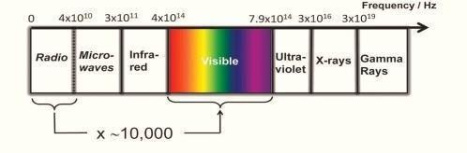
Fig. 1.: Visible light and RF frequencies at the electromagnetic spectrum.
One of VLC’s attributes is giving full bandwidth as described in Figure 1.

  - Light Fidelity (Li-Fi)
Li-Fi is an emerging technology for short-range mobile communication systems; ideally applicable for transmission of data via light using LEDs [23]. Li-Fi makes use of visible light, an underutilized segment of the electromagnetic EM spectrum as opposed to the radio frequency segment. Data can be encoded in light to transmit separate strings of 1s and 0s by modulating the speed at which the LEDs blink on and off. The rapid blinking of LED is imperceptible to human eye, making the output appear constant. Advances techniques, such as employing an array of LEDs, allows parallel data communication hence enabling higher data rates for Li Fi. Additionally, using combinations of red, green, and blue LEDs can alter the light frequency to encode different data channels.
  - Comparison of data rates of various light sources
This section provides a detailed insight into the lumens of various light sources namely Standard bulb, Halogen, CFL and LED operating at energy of 40 W. It is observed that LED light source depicted the maximum power saving while it was least for standard bulb. LED has rapid switching speed [30] and hence is most suitable of Li fi communication.

Bulb Type  (40W ) | Brightness  (Lumens) | Rated life | Power Savings | Efficiency
Standard | 400+ | 1 Year | - | Least
Halogen | 700+ | 1-3 Year | Upto30% | Moderate
CFL | 2000+ | 6-10 Year | Upto 75% | More than Halogen
LED | 3000+ | 15-25 Years | Upto 80% | Most

  - Application of Li Fi
Li-Fi works as a safer alternative when radio waves pose a threat to security or safety of equipment and people. This light-based technology excels in fields like airplanes, hospitals, and power plants where electromagnetic interference creates a major issue. Wi-Fi falls short due to its reliance on radio waves which makes Li-Fi ideal for such sensitive locations since it uses just light waves. A few of its potential applications are listed below:
- Education Institutions: Use of traditional Wi-Fi technology for internet access at educational institutions and companies has been replaced since the inception of Li-Fi as a powerful tool for data transfer [32]. It not only promises ultra-fast data transfer but evolutionary leap in speed and connectivity.
- Medical Field: Wi-Fi is prohibited in operating theatres (OT) as Electromagnetic Interference could potentially disrupt critical medical equipment like monitors and be hazardous to patient’s health [31]. Li-Fi allows access to the internet and eliminates the risk of equipment being hampered in the Operating Theatres. Not only it ensures safe data transmission but is also efficient in conducting robotic surgery and other automated procedures.
- In Flight connectivity: while using Wi-Fi there are lots of interference with navigation Systems instead of this Li-Fi provides in flight connectivity without any interference with navigation systems [33]
- Underwater usage: Due to Limited ranges cumbersome cables are replaced by high powered light sources, which Transmit data wirelessly deeper to explore underwater world [16] [25].
- Vehicular –VLC: V-VLC communication system can assist from the vast existing spectrum and the freely accessible LED based lighting systems of new cars [24]

  - Key Features of Li Fi

Li-Fi is a rapidly evolving technology which used light emitted waves thus offering several advantages as compared to traditional Wi-Fi. Some of these advantages include:
- Energy Efficiency: Energy utilization in the process can be curtailed with the help of LED display which is easily accessible in homes, offices, hospitals, shopping malls etc. Thus, the insignificant power requirement is there for the communication of data, it is well organized focus on both costs and energy optimization [34].
- Transmission Rate: Li-fi gives high data proximity i.e. more than one Giga bit per second, with a combination of very low interference, high-intensity output with high bandwidth [26].
- Accessibility: Li-Fi offers internet access wherever there is a light source available which make it so much more accessible than Wi-Fi. Light source is available everywhere from our houses and offices to airplanes and this makes Li-Fi potentially near ubiquitous for data transmission [21].
- Low Cost and secure Solution: Li-Fi uses simpler and easy to maintain components and it requires minimal power consumption since it works on light energy which makes it cost efficient [35].
- Futuristic scope of Li-Fi technology. Widespread usage and adoption of LED’s in our day-to-day life paves a way for embedding Li-Fi technology in our environment [27].
  - Drawbacks of Li-Fi
Major drawbacks of Light-Fidelity are:
- Dependence on Light: Since Li-Fi requires continuous light to work so its usage is limited to areas with a light source.
- Line -Of-Sight: Data transmission is only possible when proper line-of-sight is available.
- Effect of Obstructions: Opaque articles can cause hindrance to data transmission.
- Light Sensitivity: The speed by which data is transmitted depends on the type of light used. It varies for natural light, sunlight or electrically generated light.
- Limited Range: It has shorter range as compared to Wi-Fi.
- High Installation Cost
- Li-Fi Communication System
The transmitter part of VLC is shown in Fig2, input is given with the help of keypad which is processed by the switching control unit (Arduino) .Arduino converts the information into binary pulses which are transmitted with the help of LED Light source. Via blinking of LED to the receiver side.
Switching Control Unit
Visible Light
Transmitter
Transmitted
Pulses
Input
Data
Fig. 2. VLC Transmitter Section

In the receiver section, with the help of sensor( LDR Photodiode), binary pulses from the transmitter side are converted into electrical signal, Arduino receives these pulses and converts it into actual data and which is displayed on LCD display.

Received
Data
Photodiode
Receiver
Filtration and
Amplification
LCD
Display

Fig 3 . VLC Receiver Section

Figure 4 shows the interconnection of the hardware components for data transmission. using single microcontroller (Arduino board) .

  - Components of VLC System
For the implementation of the VLC system, the hardware section consists of the components listed in the table 1.
Table 1. Hardware Section containing
Name of the devices/ Component used | Description
Arduino Uno  LDR Module | Arduino is an open-source platform used for building electronics projects. Arduino consists of both a physical programmable circuit board (often referred to as a microcontroller) and a piece of software, or IDE (Integrated Development Environment) that runs on your computer, used to write and upload computer code to the physical board.  There is a one-sensor module that is used to measure light intensity as well as to detect the presence of light. when light falls on the module the output becomes HIGH and out of the module goes to low as light is absent.
Jumper Wires | Jumper wires are used to provide a connection between the LDR module, and Arduino, and with other components, there is no need for soldering. Different colors of jumper wires help to identify the point where the wire is connected.
Breadboard | A slim malleable board used to grip electronic elements (diode, transistors, capacitor, resistors, chips, etc.) that are uptight with each other. Utilized to grow a sample of electronic circuits, breadboards can be employed for upcoming jobs.  Instead of using PCB a breadboard (its name is bread because of its physical structure which is similar to bread sometimes called a protoboard)
LCD  Display | LCD is a leveled console exposed to view, it uses liquid instead of cathode ray. It uses a combination of two states of matter solid and liquid both together to make the visible image. LCD screen works by blocking the light rather than emitting the light.
LED | A semiconductor device that emits light when current flows through it or when voltage is applied is known as a Light light-emitting diode (LED).
Switches | Switches allow to connect dozens of devices

The concluded information conveyance system is such away a microcontroller (Arduino board) is utilized to encrypt, decrypt, and provide power to the sender and recipient circuits.
After the workout of the resistor values and design in the sender and recipient circuit, entire elements of the circuit were put on a prototype board meticulously accompanied by jumper wires, and for point-to-point continuity test was done by using the multimeter. So that make sure correct experimentation of the system and circumvent its susceptibility to errors, the sender and recipient circuits were assembled on a single protoboard and the LED and LDR were adjacent to each other as depicted in below image 4.
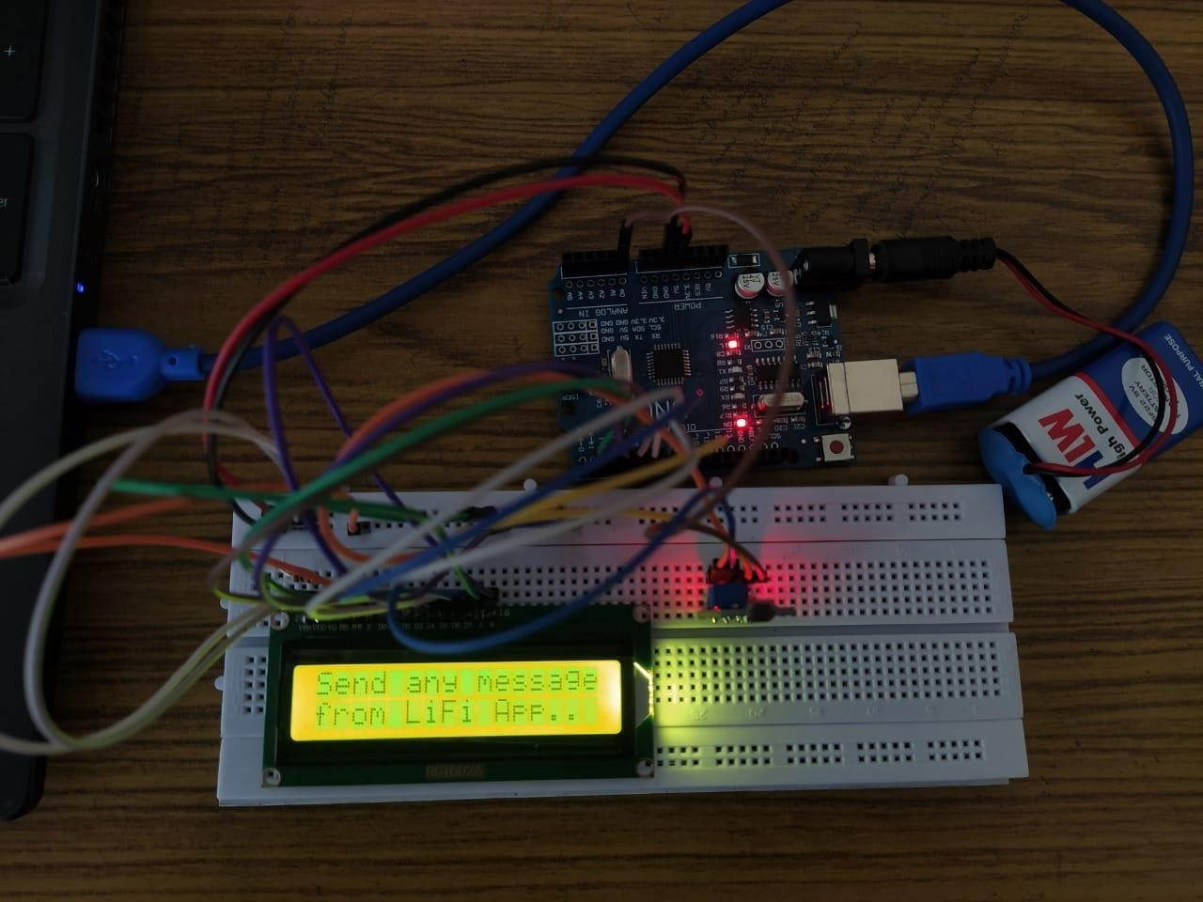
Fig. 4. Hardware Implementation of VLC System
  - Hardware Implementation of VLC System
The hardware employment of the VLC system is composed of the subsequent different chunks:
- Information wrapping and ciphering: This is achieved by the Arduino attached to the sender circuit. It transforms the content into bits and dispatches consecutively as a small or High-voltage signal.
- Apparatus control;
- Transmission co-exists;
- Communication Decipher: This is achieved by using the photo-sensor that transforms the luminance signal to a correspondent signal of different magnitudes and then proceeds it to the circuit that amplifies the signal, known as an amplifier.
- Error handling: This is brought out by the circuit that is mapped out to maintain a constant output signal level (AGC: Automatic Gain Controller), which is just after the photodiode. It makes sure that a “0” is different from a “1” bit.

Every time a user wishes to dispatch information to a second user, the subsequent order will be followed:
- At first, note the serial port number at the PC where the uno board is attached.

- After completion of uploading the sketch, the serial monitor of Arduino is opened and the text to be dispatched is typed in the text box of the serial monitor of Arduino.

- The network module will safeguard it and indicate the pass on the signal over the LED.

- The Arduino attached to the collecting computer will gather the string from the medium i.e. the photosensor, and have it to the heart of the accepting computer.

- The arrived content is then put on view utilizing a 16*2 LCD console.
- Conclusion
This paper has interrogated the theories, applications, and restrictions of Visible Light Communication and designed a hardware for complete information transmission system to send data from a desktop to a display screen. The information passed on to the system has been assembled and tested, which manifests adequate performance. The assembled VLC Light-based data transfer system is cheaper and satisfies the vital object of this research and the inclusion of a Li-Fi medium using currently available electronic devices.
In conclusion, our research focuses on more efficient and reliable wireless communication by examining complete information transmission through visible light. Through further advancements, this emerging technology could bridge the wide gap between increasing demands for internet connectivity and existing wireless network. Through this paper we have demonstrated a VLC (Li-Fi) prototype based on the principle of Li- Fi and bears the declaration of the benefits of Li-Fi over Wi-Fi. The structure assembled does not have many restrictions as well. The Li-Fi specimen sketch does not hold up multi-user access. The speed attained with this specimen is eleven thousand five hundred twenty bits per second only which is not of the elevated sequence of Gigabits per second. As well, the well-known specimen is unidirectional. Consequently, it is dedicated to broadcast ground. The constraint of this complete task can be eliminated by using top-quality devices.

References
- Saranya, M., et al. "Data Transfer Using Lifi." NVEO-NATURAL VOLATILES & ESSENTIAL OILS Journal| NVEO (2021): 3282-3302.
- Rekha, R., et al. "Li-Fi based data and audio communication." Int. J. Eng. Res. Technol 8.5 (2019): 558-561.
- Saranya, M., et al. "Data Transfer Using Lifi." NVEO-NATURAL VOLATILES & ESSENTIAL OILS Journal| NVEO (2021): 3282-3302.
- Harshitha, K., et al. "Li-Fi (Light Fidelity)-the future technology in wireless communication." Int. J. Softw. Eng. Soft Comput 6 (2016): 49-51.
- Shahuraj Sable., et al. “Data Transfers using LED with LiFi Visible Light” IJARSCT (May 2023)
- J Pierre De Vries, Ljiljana Simic, Andreas Achtzehn, Marina Petrova, and Petri Mähönen. The wi-fi “congestion crisis”: Regulatory ´ criteria for assessing spectrum congestion claims. Telecommunications Policy, 38(8):838–850, 2014.
- Charles Baylis, Matthew Fellows, Lawrence Cohen, and Robert J Marks II. Solving the spectrum crisis: Intelligent, reconfigurable microwave transmitter amplifiers for cognitive radar. IEEE Microwave Magazine, 15(5):94–107, 2014.
- Harald Haas. High-speed wireless networking using visible light. SPIE Newsroom, 2013.
- Christian Pohlmann. Visible light communication. In Seminar Kommunikationsstandards in der Medizintechnik, pages 1–14, 2010.
- Harald Haas. Visible light communication. In Optical Fiber Communication Conference. Optical Society of America, 2015.
- Shinichiro Haruyama. Visible light communication using sustainable led lights. In ITU Kaleidoscope: Building Sustainable Communities (K-2013), 2013 Proceedings of, pages 1–6. IEEE, 2013.
- Yuanquan Wang, Yiguang Wang, Nan Chi, Jianjun Yu, and Huiliang Shang. Demonstration of 575-mb/s downlink and 225-mb/s uplink bi-directional scm-wdm visible light communication using rgb led and phosphor-based led. Optics express, 21(1):1203–1208, 2013.
- Dobroslav Tsonev, Stefan Videv, and Harald Haas. Light fidelity (li-fi): towards all-optical networking. In SPIE OPTO, pages 900702– 900702. International Society for Optics and Photonics, 2013.
- Chi, Nan, Yingjun Zhou, Yiran Wei, and Fangchen Hu. "Visible light communication in 6G: Advances, challenges, and prospects." IEEE Vehicular Technology Magazine 15, no. 4 (2020): 93-102.
- Teixeira, Lucas, Felipe Loose, Carlos Henrique Barriquello, Vitalio Alfonso Reguera, Marco Antônio Dalla Costa, and J. Marcos Alonso. "On energy efficiency of visible light communication systems." IEEE Journal of Emerging and Selected Topics in Power Electronics 9, no. 5 (2021): 6396-6407.
- I. Rust and H. H. Asada, ―A dual-use visible light approach to integrated communication and localization of underwater robots with application to non-destructive nuclear reactor inspection,‖ in Proc. IEEE Int. Conf. Robot. Autom. pp. 2445–2450., 2012
- Rajagopal, S., Roberts, R.D., Sang-Kyu Lim, "IEEE 802.15.7 visible light communication: modulation schemes and dimming support", IEEE Communications Magazine, Volume 50, Issue 3, pp. 72 - 82, March 2012
- E. Monteiro and S. Hranilovic, ―Constellation design for colorshift keying using interior point methods,‖ in Proc. IEEE GLOBECOM Workshops, pp. 1224–1228. 2012.
- G. Cossu, A. M. Khalid, P. Choudhury, R. Corsini, and E. Ciaramella, ―Long distance indoor high speed visible light communication system basedonRGBLEDs,‖ in Proc.AsiaCommun.Photon. Conf. pp. 1–3., 2012.
- Z. Jia, “A visible light communication based hybrid positioning method for wireless sensor networks,‖ in Proc. Int. Conf. Intell. Syst. Design Eng. Appl., , pp. 1367–1370,2012.
- Wu, Xiping, Majid Safari, and Harald Haas. "Access point selection for hybrid Li-Fi and Wi-Fi networks." IEEE Transactions on Communications 65, no. 12 (2017): 5375-5385.
- Alfattani, Safwan. "Review of LiFi technology and its future applications." Journal of Optical Communications 42, no. 1 (2021): 121-132.
- Matheus, Luiz Eduardo Mendes, Alex Borges Vieira, Luiz FM Vieira, Marcos AM Vieira, and Omprakash Gnawali. "Visible light communication: concepts, applications and challenges." IEEE Communications Surveys & Tutorials 21, no. 4 (2019): 3204-3237.
- Memedi, Agon, and Falko Dressler. "Vehicular visible light communications: A survey." IEEE Communications Surveys & Tutorials 23, no. 1 (2020): 161-181.
- Seetharaman, R., M. Tharun, SS Sreeja Mole, and K. Anandan. "Application of Li-Fi technique in underwater communication." Materials Today: Proceedings 51 (2022): 2249-2253.
- Aldarkazaly, Zahraa Tareq, Manal Fadhil Younus, and Zainab Salim Alwan. "Data transmission using Li-Fi technique." Advance Science Technology 29, no. 3 (2020): 7367-7382.
- Agarwal, Arun, Chandan Mohanta, and Gourav Misra. "Li-Fi Technology: Principle, Future Scope, Challenges and Applications." American Journal of Electrical and Electronic Engineering 10, no. 1 (2022): 1-5.
- Chen, Cheng, Dushyantha A. Basnayaka, Ardimas Andi Purwita, Xiping Wu, and Harald Haas. "Wireless infrared-based LiFi uplink transmission with link blockage and random device orientation." IEEE Transactions on Communications 69, no. 2 (2020): 1175-1188.
- Mana, Sreelal Maravanchery, Peter Hellwig, Jonas Hilt, Pablo Wilke Berenguer, and Volker Jungnickel. "Experiments in non-line-of-sight Li-Fi channels." In 2019 Global LIFI Congress (GLC), pp. 1-6. IEEE, 2019.
- Sharma, Mithun, and Shilpi Sharma. "Light Fidelity (Li-Fi) overview and investigation into connection speed." Engineering Management in Production and Services 13, no. 1 (2021): 63-73.
- Sudha, S., D. Indumathy, A. Lavanya, M. Nishanthi, D. Merline Sheeba, and V. Anand. "Patient monitoring in the hospital management using Li-Fi." In 2016 IEEE Technological Innovations in ICT for Agriculture and Rural Development (TIAR), pp. 93-96. IEEE, 2016.
- Apoorv, Shubhendu, Sudharshan Kumar Bhowmick, and E. Annadevi. "Implementation of Li-Fi Technology in Classrooms." In IOP Conference Series: Materials Science and Engineering, vol. 590, no. 1, p. 012044. IOP Publishing, 2019.
- Chanti, Yerrolla, Bandi Bhaskar, and Nagendar Yamsani. "Li-Fi Technology Utilized In Leveraged To Power In Aviation System Entertainment Through Wireless Communication." Journal Of Mechanics Of Continua And Mathematical Sciences 15, no. 6 (2020): 2454-7190.
- Damerdash, Anwaar M., Doaa Abdelhameed, Mokhtar Aly, Emad M. Ahmed, and Mohamed A. Ahmed. "Energy efficiency assessment of power electronic drivers and LED lamps in Li-Fi communication systems." Energy Reports 7 (2021): 7648-7662.
- Hussein, Yaseein Soubhi, and Amresh Chetty Annan. "Li-Fi technology: High data transmission securely." In Journal of Physics: Conference Series, vol. 1228, no. 1, p. 012069. IOP Publishing, 2019.
- Katz, Marcos, and Iqrar Ahmed. "Opportunities and challenges for visible light communications in 6G." 2020 2nd 6G wireless summit (6G SUMMIT) (2020): 1-5.

