Review of Artificial Intelligence based concept of Automated planning

Prof. Daljeet Kaur

Department of Computer Science & Engineering

Gyan Ganga College of Technology

Jabalpur (MP), India

daljeetkaur@ggct.co.in

ABSTRACT

Along with toy obstacles, planners are now able to tackle real-world problems thanks to new developments in computational planning. However, applying computerized planners to real-world problems is far from simple. On the one hand, there is a challenge in precisely defining action models for planning.. Conversely, off-the-shelf planners fall short in many sectors in terms of scaling up and producing good solutions. Planners can use domain-specific control knowledge in these troublesome domains to increase the pace and quality of their solutions. On the other hand, control knowledge definition by hand is highly challenging. This research examines state-of-the-art machine learning methods for automatically defining planning knowledge. It is arranged in accordance with the learning process's objective: automated planning definition

Keywords— Information, Data Science, Data Analytics.

# INTRODUCTION

Artificial intelligence (AI) has emerged to relieve humans of repetitive duties at work that necessitate human competencies for successful completion. Scientists are no different; in order to expedite their discoveries, they too require strong computational approaches. In this regard, launching a new study frequently entails a thorough examination of pertinent scientific literature in order to comprehend the background and identify pertinent studies dealing with the same or a related issue. In addition, it takes time to search through, filter through, and extract relevant material from a large collection of articles. If this is done without guidance or experience, it is possible to overlook significant contributions. Finding a series of steps to achieve one or more objectives is the process of planning. Computation is used in automated planning to help human operators make decisions or to control automated systems. When it comes to handling the intricacy of managing resource-intensive systems, automated planning exhibits considerable promise. In the area of automated planning, various techniques have been developed that can be applied to determine the best course of action given objectives and a set of circumstances. But on their own, planning algorithms are fragile since circumstances can alter after a plan is created. The majority were created with the assumption of a controlled and predictable environment [1]. Domains that engage with the outside world are even more complex because of this

We now are a part of the Fourth Industrial Revolution, or 4IR, a technological era. Because of this revolution's greater interconnection and intelligent automation, it is anticipated that industries, technology, societal norms, and procedures will all change quickly. This revolution affects almost every industry in every country and is bringing about a considerable degree of change at a non-linear rate that has never been witnessed before. Its effects extend to all disciplines, industries, and economies. Three key words The ability to monitor, analyze, and report—also known as self-awareness—as well as automation, which reduces human interaction in operations, intelligent computing, which can make conclusions or useful knowledge from data, and smart computing, which can monitor, analyze, and report—have become essential design elements in the modern world principles.

The creation of intelligent computers capable of doing activities that conventionally need human intelligence is the aim of the broad field of computer science known as artificial intelligence (AI). Stated differently, its objective is to provide computers with intelligence like to that of humans by allowing them to learn and think like computers do via computer programs or machine learning. From a philosophical standpoint, artificial intelligence (AI) holds the potential to help individuals live more fulfilled lives with less effort and to manage the large network of interconnected people, corporations, states, and nations in a way that is beneficial to everybody. Thus, the primary goal of artificial intelligence is to enable computers and other devices to do cognitive activities like   
When it comes to AI, planning is the of affairs, determining the desired result, and formulating a plan that outlines the necessary actions to reach that goal. It can be utilized in robots, video games, logistics, and the medical field, among other industries.

As figure 1 illustrates, there are various forms of AI planning, each appropriate for a certain circumstance. Popular varieties of AI planning include:

• Classical Planning: In this kind of planning, a sequence of steps is designed to achieve a goal in a prearranged environment. Everything is taken to be unchanging and predictable.

• Hierarchical planning: Planning becomes more efficient when big challenges are broken down into smaller ones using hierarchical planning. It is necessary to create a hierarchy of plans, where higher-level plans oversee the implementation of lower-level plans.

• Temporal Planning: Future planning takes into account time constraints and the interdependencies between tasks. It does this by accounting for job length, which guarantees that the plan may be implemented within a given time frame.

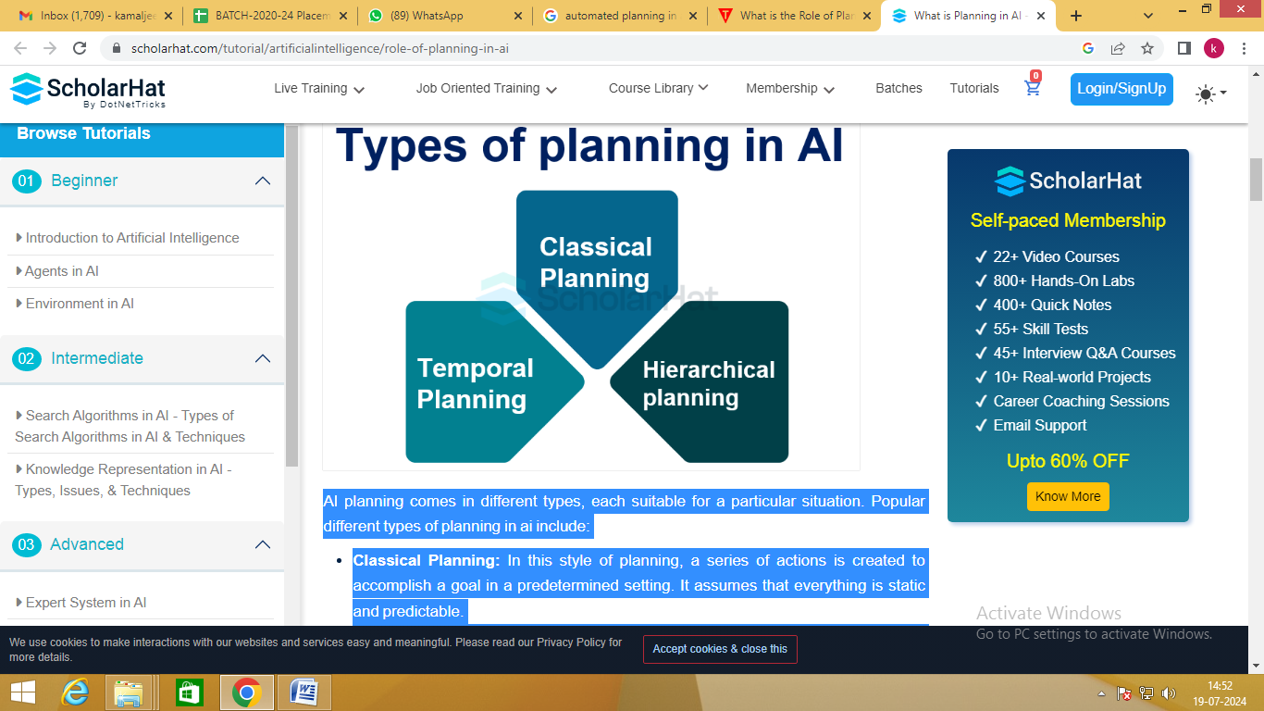

Fig.1 Types of planning

**Components of planning system in AI**

AI planning Systems are made up of several crucial parts that cooperate to create effective plans. These AI planning system components are as follows:

• Representation: Representation is the term used to describe the way the planning problem is represented. It is necessary to specify the state space, actions, goals, and constraints.

• Search: The To find a set of instructions that will take you to your destination, the search component searches the entire state space. Numerous search techniques, including depth-first and A* searches, can be employed to find the best plans.

• Heuristics: Heuristics help focus search efforts and determine the cost and value of different courses of action. They facilitate the identification of potential routes and improve the efficiency of the planning procedure.

**Benefits of AI Planning**

Artificial intelligence planning has many benefits that increase the effectiveness and efficiency of AI systems. Among the principal advantages are:

• Allocation of Resources: AI planning enables the optimal distribution of resources, guaranteeing their efficient utilization in achieving the intended goals.

• Better Decision-Making: AI planning helps with educated decision-making by accounting for a range of factors and constraints. It aids AI systems in weighing multiple options and selecting the optimal course of action.   
  
• Automation of Complex Tasks: Complex tasks that would need a lot of human labor are automated by AI planning. It enables AI systems to oversee intricate processes and enhance them for superior outcomes.

**Applications of AI Planning**

AI planning's versatility and effectiveness are demonstrated by the wide range of fields in which it is applied. Among the noteworthy applications are:   
• Robotics: Planning is essential for autonomous robots to be able to operate, traverse their environment, and accomplish tasks.  
• Gaming: Because AI planning empowers virtual characters to make deliberate decisions and create challenging and captivating gameplay settings, it is crucial to the gaming industry.   
  
• Logistics: AI planning is frequently used in logistics to optimize schedules, routes, and resource allocation to accomplish successful supply chain management.   
• Healthcare: By scheduling patients, assigning resources, and organizing treatments, AI planning helps the

sector improve the efficacy and quality of healthcare services.

**Challenges in AI Planning**

Despite all of AI planning's benefits, there are still a lot of problems to be fixed. Common difficulties consist of:   
• Complexity: Planning can be challenging in complex domains because of the large state space, numerous potential actions, and interdependencies between them.  
• Uncertainty: Overcoming uncertainty is one of the main obstacles in AI planning. The outcomes of actions may not always be known in advance, so the planning system must be prepared to handle these unclear circumstances.   
• Scalability: As planning issues get larger and more complicated, scalability becomes a major obstacle. Planning systems are necessary for the efficient handling of large-scale concerns.

**Strategies for Mastering AI Planning**

To become an expert at AI planning, you must implement techniques that enhance your planning skills. Here are some tactics to consider:

• Domain Knowledge: Acquire as much knowledge as possible regarding the planning domain. Knowing the intricacies and constraints of the field can help you formulate more effective solutions.

• Algorithm Selection: The appropriate planning algorithm must be selected for the specific problem at hand. Because different algorithms have different advantages and disadvantages, selecting the optimal algorithm can significantly affect the planning process.   
  
• Iterative improvement: Planning is an iterative process, and progress is necessary. Evaluate the success of plans, identify areas for development, and make any required adjustments to the planning system.

**Tools and Techniques for AI Planning**

AI planning can be aided by a variety of planning-supportive techniques and tools. Commonly employed methods and resources include:

• Automatic planners: STRIPS and PDDL are two programs that provide a framework for defining planning problems. They are examples of programs that automatically generate plans.  
• Constraint Programming: Complex planning problems with a range of restrictions can be modeled and resolved with the powerful technique of constraint programming.

• Machine Learning: By Reinforcement learning is the process of improving plans based on feedback and past experiences is a machine learning technology that may be used to improve planning.

**Best Practices of AI Planning**

The following significant elements are included in best practices for AI planning:   
• A clear formulation of the problem: Indicate your objectives, limitations, and intended outcomes clearly.  
• The best possible portrayal Provide a suitable illustration of the planning realm.   
• Algorithm selection: Select planning algorithms that balance optimality and complexity.   
• Iterative improvement: Review and enhance the planning process on a regular basis.   
• Uncertainty management: Use techniques to address uncertainty, such as probabilistic modeling.   
• Making use of human expertise: Get input from others and use it to ensure that your goals align with theirs.

• Benchmarking and evaluation: Monitor performance over time and compare it to relevant metrics.   
• Cooperation: Promote collaborative planning by including relevant partners.   
• Scalability: To successfully address large challenges, design planning systems with scalability in mind.

• Quick response time:

The corporate community has quickly realized AI's promise. Its acceptance has grown quickly and yearly. AI has the ability to bring about revolutionary change as its capabilities grow at an unparalleled rate. Artificial intelligence (AI) technology are being used to automate jobs, analyze massive amounts of data, improve consumer experiences, refine decision-making processes, and open up new avenues for efficiency and growth..

Companies that have already made investments in AI technology typically plan to spend more in the ensuing years. By 2022, 52% of respondents who were currently employing AI reported that the technology accounted for more than 5% of their digital expenditure, up from 40% in 2018. It appears that those who employ AI in some way find it valuable enough to keep investing in it and even raise the percentage of their budget that goes toward it. This seems to be solid evidence in favor of the claim that AI has enormous financial benefits. Artificial Intelligence (AI) has numerous applications, including virtual assistants, natural language processing (NLP), computer vision, and machine learning (ML), and data analysis and insights.

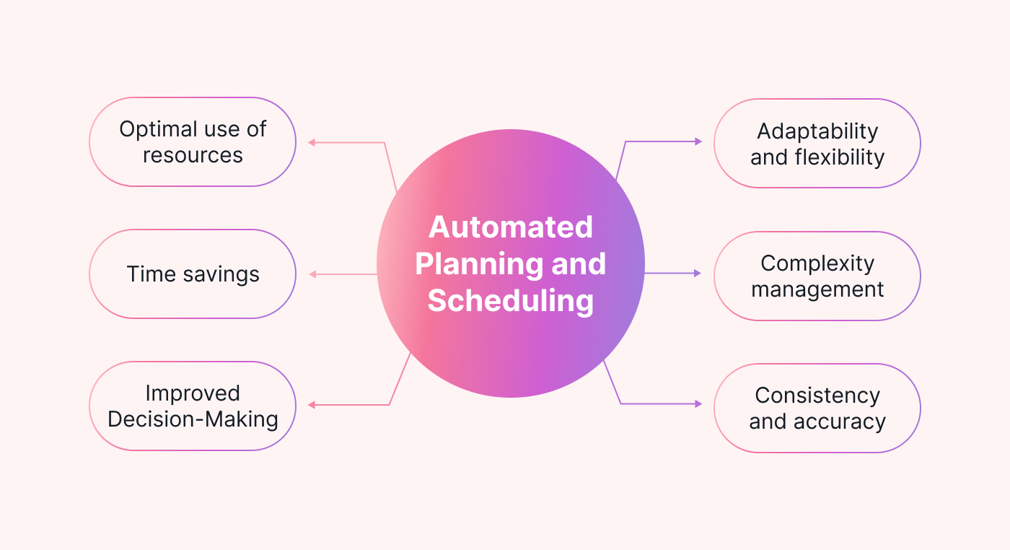

**Figure-2** Automated Planning and Scheduling

# RELATED WORK

The goal of Srihari Maruthi et al. [1] is to outline potential research avenues and offer insights on the current state of AI's automatic scheduling and planning. New approaches to machine learning for automatically defining planning knowledge are reviewed by Sergio Jimenez et al. [2]. It has been arranged in accordance with the learning process's objectives, which are the automatic definition of planning control knowledge and planning action models. The goal of Tan Yigitcanlar et al.,[3] is to increase our knowledge of the connections between the major artificial intelligence (AI) technologies (n = 15) and their major urban planning and development application sectors (n = 16). In order to achieve this, this study looks at how the general public views artificial intelligence (AI) technologies and the ways in which they are applied in the creation and planning of cities. The objective of Fouad Amer, S.M.ASCE et al. [6] is to investigate the main problems that have so far prevented automated planning systems and methodologies from being widely used and scaled up. The following knowledge gaps were found after a thorough analysis of the formalization of knowledge, scope quantification and techniques for planning, scheduling, and optimizing the schedule, as well as project defining procedures. A general formal framework capable of modeling domains, plans, and objectives for automated planning is presented by Alessandro Cimatti et al. [7]. The chapter also covers potential upcoming research problems and the most recent methods in the field. The primary goal of Ilche Georgievski et al.'s [8] classification of the literature is to make those features easier to understand. After that, we conduct a thorough examination of the literature to identify potential roadblocks in ubiquitous computing planning. Matias Rojas et al.[9] contribute to the body of literature in two ways. First, we propose a novel partial-order plan monitoring strategy that is better suited for application in educational settings. Second, we show how plan-derived feedback could promote reflection on collaborative problem-solving in the context of a multi-agent exercise. A new hierarchical approach to requirement analysis of challenges in automated planning is the goal of Javier Martinez Silva et al. [10].

# CASE STUDY OF ARTIFICAL INTELLIGENCE

The field of Automated planning and scheduling, or AI planning, is the branch of artificial intelligence that deals with the realization of strategies or action sequences, typically for execution by intelligent agents, autonomous robots, and unmanned vehicles. Unlike classical control and classification problems, these difficulties feature intricate solutions that require multifaceted optimization. Planning is closely related to decision theory. In contexts where models are available and well-known, offline planning can be done. Before putting into practice, alternatives might be found and evaluated. Online strategy change is often required in uncertain and dynamic environments. Models and policies must be changed. Usually, the repetitive trial-and-error processes observed in artificial intelligence are used to find solutions. These include reinforcement learning, combinatorial optimization, and artificial intelligence that deals with the realization of strategies or action sequences, usually for execution by intelligent agents, autonomous robots, and unmanned vehicles, is known as automated planning and scheduling, or simply AI planning. In contrast to traditional control and classification issues, these challenges have complicated solutions that need to be found and improved in multiple dimensions. Decision theory is also connected to planning. Offline planning is possible in environments that are well-known and have models available. Alternatives can be identified and assessed before implementing. Online strategy revision is frequently necessary in contexts that are dynamic and uncertain. Policies and models need to be modified. Typically, solutions rely on the iterative trial-and-error procedures seen in artificial intelligence. Among these are combinatorial optimization, reinforcement learning, and dynamic programming. languages employed

Self-driving automobile technology is one of the most interesting uses of AI's automatic scheduling and planning tools. Planning and scheduling done automatically is a crucial piece of technology that will allow self-driving cars to function safely and effectively. These vehicles have the potential to completely transform transportation. Additional possible uses for AI's automatic scheduling and planning include: Package delivery drones that operate on their own; hospital and assisted living robots; intelligent traffic control systems There are many advantages to automated scheduling and planning. We can free up human time and resources for other duties and even improve our lives by automating the planning and scheduling process.

Artificial intelligence (AI) planning and forecasting is the application of AI to create independent, scientific predictions about the future. AI planning systems forecast future developments for a wide range of industries, including manufacturing, sales, healthcare, and financial services, using time series data. A burgeoning field of study and application in computer science and artificial intelligence (AI) is automated planning. The following are some relevant publications and noteworthy advancements in automated planning: as depicted in picture 3.

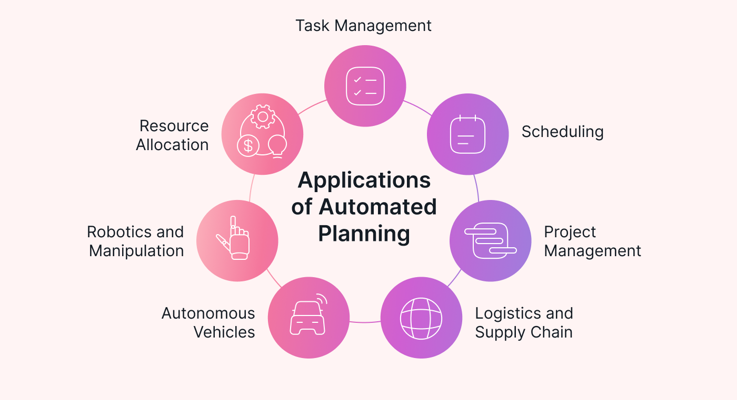

**Figure-3** Application of Automated Planning

1. STRIPS (the problem solver from Stanford Research Institute): STRIPS, a formalism for modeling planning problems using states, actions, and goals, was developed in the late 1960s. It established the groundwork for further automated planning research.

2. The standard language PDDL (Planning Domain Definition Language) can be used to describe planning domains and issues. Planning domains and challenges can be described using PDDL (Planning Domain Definition Language), which is a standard language that enables practitioners and scholars to communicate and codify planning activities. It is now a commonly accepted benchmark in the planning industry.

3. Classical Planning: This method of planning is based on deterministic settings with predictable results for activities. Various algorithms, such as heuristic search, graph-based planners (like Graphplan), and A* search, have been created to identify the best or almost best plans.

4. Temporal Planning: Adding time limits and temporal linkages between actions, temporal planning goes beyond classical planning. Plans that adhere to temporal constraints are created using strategies like constraint-based reasoning and temporal logic.

5. Hierarchical Planning: By breaking down high-level objectives into smaller, more manageable subgoals, hierarchical planning enables the organization of actions into hierarchical structures for more effective planning.   
  
6. Planning under Uncertainty: Planning under uncertainty refers to situations in which decisions may be made based on probabilities or in which only a portion of the world's state is known. In these situations, methods like partially perceptible The two types of Markov decision processes are Markov decision processes (MDPs) and POMDPs. employed.  
  
7. Robotics Applications: Autonomous robots need automated planning to carry out activities including navigation, manipulation, and work scheduling. It lets robots to program actions to accomplish objectives in unpredictable and changing surroundings.

8. Real-time Planning: This refers to situations in which plans must be made and promptly modified in response to fresh information or conditions that change. In these situations, strategies like preplanning and online planning are used.

9. Integrated Task and Motion Planning: In order to empower robots to carry out intricate activities involving both symbolic reasoning and actual physical contact with the environment, this field focuses on fusing low-level motion planning combined with high-level task planning.

10. Multi-Agent Planning: This technique involves arranging the activities of several independent agents in order to maximize group performance or accomplish shared objectives. It entails dealing with issues including agent coordination, bargaining, and communication.  
  
  
These fields reflect current research initiatives aiming at improving automated planning systems' capacities and making them more reliable, flexible, and effective in resolving real-world issues in a variety of fields.

### **Understanding Various Types of Artificial Intelligence**

Artificial intelligence's (AI) primary objectives are to comprehend and perform intelligent tasks, such as reasoning, picking up new abilities, and adapting to unfamiliar circumstances and challenges. Therefore, simulating a range of issues and tasks associated with human intellect is the primary focus of artificial intelligence (AI), a field of study and engineering. However, because real-world scenarios and data are dynamic and diverse, developing a viable AI model is a challenging task. Therefore, to fully understand the idea of AI's power—as shown in Fig. 1—we look into a variety of AI applications, including analytical, functional, interactive, textual, and visual—to address a range of issues in the Fourth Industrial Revolution of today. We define the parameters for each category in the• **Analytical AI**: Analytics is the general term for the process of finding, deciphering, and conveying significant data patterns. Analytical AI thus seeks to support data-driven decision-making by identifying novel insights, patterns, correlations, or dependencies in data. As a result, it becomes a fundamental component of AI in the context of modern business intelligence, capable of offering insights to an organization and producing ideas or recommendations via its analytical processing power. An analytical AI model can be created using a variety of machine learning and deep learning techniques to address a specific real-world issue. For example, a data-driven analytical model can be used to evaluate business risk.

• Functional AI: Functional AI is similar to analytical AI in that it looks for patterns and dependencies in large volumes of data. On the other hand, functional AI accomplishes tasks rather than making recommendations. A working AI model could be useful for robots and Internet of Things applications, for example, to make fast choices.   
  
• Interactive artificial intelligence (AI): This kind of AI typically enables the automation of efficient and interactive communication, which is widely utilized in many aspects of daily life, particularly in the commercial sector. For example, an interactive AI model could be useful in the creation of intelligent personal assistants and chatbots. An interactive AI model can be made using a variety of techniques, such as AI heuristic search, frequent pattern mining, machine learning, and reasoning.   
  
• Textual AI: This is also known as natural language processing or text analytics, and it provides businesses with tools like text recognition, voice-to-text conversion, machine translation, and content production. For instance, a company may use textual AI to support its corporate knowledge base internally and provide relevant services, such answering consumer questions.

### As was previously noted, all forms of AI are capable of providing solutions for a variety of real-world problems. To provide solutions that take into account the target applications, however, a range of AI techniques and their combinations—briefly covered in "Potential AI techniques"—such as machine learning, deep learning, advanced analytics, knowledge discovery, reasoning, searching, and relevant others—can be employed. Since most real-world problems require advanced analytics to deliver an intelligent and clever solution in line with today's needs, analytical AI that leverages machine learning (ML) and deep learning (DL) approaches can be crucial in the field of AI-powered computing and systems. The Relation of AI with ML and DL

Artificial intelligence (AI), machine learning (ML), and deep learning (DL) are the three well-known terminology that are used these days to describe intelligent systems or software. Where machine learning and deep learning fit in the context of artificial intelligence is depicted in Fig. 2. DL is a subset of ML, which is a subset of AI, as Fig. 2 illustrates. Machine learning (ML) automates the process of creating analytical models by learning from data or experience, whereas artificial intellect (AI) typically combines cognition and human behavior into computers or systems. Deep learning also refers to data-driven learning methods that use multi-layer neural networks and processing for computation. The deep learning approach's use of the word "Deep" refers to the idea of several levels or stages that data processing goes through..

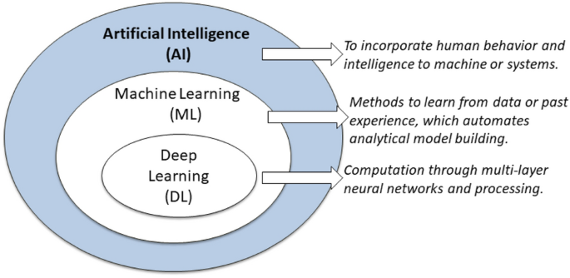

Our lives are already centered around artificial intelligence and machine learning, and these fields will undoubtedly remain significant in the foreseeable future. They improve commonplace technologies, revolutionize whole sectors, spur creativity, resolve challenging issues, and enable customisation. Our world will change as AI and ML develop, creating new opportunities and radically altering the ways in which we communicate, work, and live. If we want to take advantage of all the many advantages that today's technology has to offer and stay ahead of the rapidly changing world, we must embrace contemporary technology and recognize its potential.   
Planning is the process of determining a set of actions to do in order to accomplish one or more goals. Automated planning performs computational operations to

# ARTIFICAL INTELLIGENCE APPROACHES

AI's automated planning component is crucial. Using automated planning, a collection of methods that, from a given starting point, will result in a given outcome are created. This branch of AI is essential for problems related to manufacturing, logistics, robotics, gaming, and self-controlled systems.

By accomplishing the objective of a decision-processing technique that can function in a world that is continuously changing, automated planning is a means of generating effective and efficient judgments in complex systems. The essay explores the fundamentals of automated planning as well as its workings, uses, and obstacles.

The Essence of Automated Planning

Automated planning, sometimes known as AI planning or just planning, is based on traditional control and decision-making theories. Fundamentally, it represents the act of identifying an objective and methodically arranging the actions necessary to reach it within specific limitations.

Techniques in Automated Planning

Important Elements of Automated Planning:

• Domain Model: Defines environmental regulations and the effects of actions in relation to them. Understanding how actions change the state of the universe requires an understanding of this paradigm.   
  
• Planner: After processing incoming data (the aim and the current state), the algorithmic core creates a plan, or a set of steps leading to the objective.   
• Executor: carries out the plan, usually with the flexibility to quickly adjust to unforeseen changes in the environment.   
  
• Monitor: Provides input to the planner and facilitates dynamic re-planning as necessary by keeping an eye on the execution and surroundings.   
  
Two main categories can be used to group automated planning techniques: deterministic and non-deterministic.   
1. Deterministic planning is appropriate for static or highly regulated environments because it implies a predictable environment in which every action has a definite outcome.**Application of Automated Planning in AI**

There are numerous fields in which planning systems are used in the real world:   
• Robotics: These algorithms facilitate the movement of autonomous devices as they perform tasks in ever-changing environments.  
• Logistics: Planning is necessary for automated systems to determine the most efficient routes and delivery timetables.   
  
• Manufacturing: They can also be employed in sectors where the goal is to reduce time wastage by optimizing production processes.   
• AI in games: Planning software has improved the behavior of non-player characters (NPCs), making them more intelligent and active in the virtual environment.

# CONCLUSION

* **Automated planning is a fundamental component of AI's knowledge representation and reasoning, allowing machines to solve a wide range of difficult issues and reach sufficient conclusions on their own. To be more precise, when used correctly, AI systems can try to solve a wide range of issues by leveraging the principles of modeling languages, domain-independent planning, strong algorithms, and appropriate deployment strategies. Additionally, we can see that this field of research and development is constantly progressing, indicating that the potential uses and capacities of automated planning will only grow, promoting innovation in a variety of industries. Automated planning is a fundamental component of AI's knowledge representation and reasoning, allowing robots to tackle a wide range of difficult tasks independently and makeenough**

##### REFERENCES

[1]. Srihari Maruthi et al. " Automated Planning and Scheduling in AI: Studying automated planning and scheduling techniques for efficient decision-making in artificial intelligence", [Vol. 2 No. 2 (2022): African Journal of Artificial Intelligence and Sustainable Development](https://africansciencegroup.com/index.php/AJAISD/issue/view/4).

[2]. [Sergio Jimenez](https://www.researchgate.net/scientific-contributions/Sergio-Jimenez-71057107?_tp=eyJjb250ZXh0Ijp7ImZpcnN0UGFnZSI6InB1YmxpY2F0aW9uIiwicGFnZSI6InB1YmxpY2F0aW9uIn19) et al. "A review of machine learning for automated planning", DOI:[10.1017/S026988891200001X](http://dx.doi.org/10.1017/S026988891200001X), December 2012 The Knowledge Engineering Review 27(04)

[3]  Tan Yigitcanlar et al.,"Artificial Intelligence Technologies and Related Urban Planning and Development Concepts: How Are They Perceived and Utilized in Australia?", *J. Open Innov. Technol. Mark. Complex.* 2020, *6*(4), 187; <https://doi.org/10.3390/joitmc6040187>

[4] [Erez Karpas](https://www.annualreviews.org/search?value1=Erez+Karpas&option1=author&noRedirect=true) et al. "Automated Planning for Robotics", Vol. 3:417-439 (Volume publication date May 2020) <https://doi.org/10.1146/annurev-control-082619-100135>

[5] [Andrea Marrella](https://link.springer.com/article/10.1007/s13740-018-0096-0#auth-Andrea-Marrella-Aff1), "Automated Planning for Business Process Management",  [Journal on Data Semantics](https://link.springer.com/journal/13740), Volume 8, pages 79–98, (2019).

[6]  [Fouad Amer, S.M.ASCE](https://ascelibrary.org/doi/abs/10.1061/%28ASCE%29CO.1943-7862.0002093#con1) et al. "Automated Methods and Systems for Construction Planning and Scheduling: Critical Review of Three Decades of Research", Journal of Construction Engineering and Management, Volume 147, Issue <https://doi.org/10.1061/(ASCE)CO.1943-7862.0002093>.

**[**7] Alessandro Cimatti, et al. "Automated Planning",[Foundations of Artificial Intelligence](https://www.sciencedirect.com/bookseries/foundations-of-artificial-intelligence), [Volume 3](https://www.sciencedirect.com/bookseries/foundations-of-artificial-intelligence/vol/3/suppl/C), 2008, Pages 841-867, <https://doi.org/10.1016/S1574-6526(07)03022-2>.

[8] [Ilche Georgievski](https://dl.acm.org/doi/abs/10.1145/3004294), et al.," Automated Planning for Ubiquitous Computing", [ACM Computing Surveys (CSUR), Volume 49, Issue 4](https://dl.acm.org/toc/csur/2017/49/4), Article No.: 63, Pages 1 - 46, <https://doi.org/10.1145/3004294>

[9] [Matias Rojas](https://link.springer.com/article/10.1007/s40593-022-00321-2#auth-Matias-Rojas-Aff1-Aff2) et al. , "Using Automated Planning to Provide Feedback during Collaborative Problem-Solving", Volume 33, pages 1057–1091, (2023), Published: 01 December 2022.

[10] Javier Martinez Silva et al., "A new hierarchical approach to requirement analysis of problems in automated planning",Engineering Application of AI, [Volume 81](https://www.sciencedirect.com/journal/engineering-applications-of-artificial-intelligence/vol/81/suppl/C), May 2019, Pages 373-386, <https://doi.org/10.1016/j.engappai.2019.02.019>