**Biotechnological Advances in Fish Genetics: Implications for Vaccine Development Against Aquatic Pathogens**

**Dr. Bireshwar Bera**

**Associate Professor, Department of Zoology,**

**St. Joseph’s College, North Point, Darjeeling,**

**West Bengal, India**

[***bireshwar.sjc@gmail.com***](mailto:bireshwar.sjc@gmail.com)

**Abstract**

The advancements in biotechnology concerning fish genetics are fundamentally transforming the methodologies employed in disease management within aquaculture, particularly through the innovation of specialized vaccines aimed at combating aquatic pathogens. As the global aquaculture sector continues to grow, the persistent threat of infectious diseases undermines both productivity and sustainability, culminating in annual financial losses that surpass $10 billion. State-of-the-art genetic technologies such as CRISPR/Cas9, Zinc Finger Nucleases (ZFNs), and TALENs have facilitated precise genomic alterations that enhance both disease resistance and growth characteristics in cultivated fish species. These innovations have propelled the advancement of vaccination strategies—transitioning from conventional inactivated and live-attenuated vaccines to contemporary nucleic acid-based immunizations. This paper examines the historical development, current utilizations, and prospective implications of genetic interventions on vaccine efficacy. Furthermore, ethical considerations and regulatory frameworks are analyzed, underscoring the necessity for public transparency and equitable accessibility, particularly within developing regions. The amalgamation of genetic innovation with effective immunoprophylaxis represents a promising avenue toward the establishment of more sustainable and resilient aquaculture systems.

Keywords: Aquaculture biotechnology, fish genetics, CRISPR/Cas9, aquatic vaccines, genetic engineering, disease resistance

**1. Introduction**

Recent advancements in fish genetics through biotechnology have significantly enhanced vaccine development against infectious diseases in aquaculture—a sector facing escalating challenges due to intensified farming practices. As global demand for aquaculture products grows, so too does the incidence of disease outbreaks, which are exacerbated under high-density farming conditions. These outbreaks contribute to substantial economic losses, estimated to exceed **$10 billion annually**, primarily from diseases such as Viral Nervous Necrosis and vibriosis (1, 2).

The introduction of precise gene-editing tools, particularly **CRISPR/Cas9**, has marked a transformative shift in the field. These technologies enable targeted genomic modifications to enhance traits such as disease resistance and growth rates (3, 4). In tandem with gene-editing, the development of advanced vaccines—including live-attenuated, inactivated, and nucleic acid-based formulations—has shown promise in eliciting robust immune responses across a range of aquaculture species (5, 6). This paradigm shift from antibiotic reliance to preventive immunization represents a major step toward more sustainable aquaculture practices (2, 5).

However, the application of biotechnology in aquaculture raises critical **ethical and regulatory** concerns. The use of genetically modified organisms (GMOs) in fish farming continues to provoke debate surrounding environmental safety, food security, and consumer acceptance. Public perception often equates biotechnology with elevated risk, underscoring the need for **transparent risk communication** and robust regulatory oversight (7, 8). Moreover, the ethical implications of genetic alteration—especially when involving food production—necessitate inclusive dialogue among scientists, policymakers, and the broader public to ensure responsible and equitable implementation (9).

Looking ahead, the continued integration of biotechnological tools in aquaculture is poised to redefine vaccine development, bolster fish health, and advance global food security. Future strategies should prioritize the enhancement of vaccine efficacy, address accessibility challenges in developing regions, and consider societal and regulatory concerns. By aligning innovation with ethical and practical considerations, the full potential of genetic technologies in mitigating aquatic disease can be realized (5, 8, 10).

**2. Historical Context**

The application of biotechnology in aquaculture has undergone a substantial transformation, evolving from traditional breeding methods to sophisticated genetic interventions. Initially, fish farming practices relied heavily on **selective breeding** and improved husbandry to enhance growth and health outcomes. However, as disease prevalence escalated—especially under high-density rearing conditions—these conventional methods proved insufficient, prompting the need for **innovative genetic solutions** (1, 3).

The late 20th century marked a critical turning point with the emergence of **genetic modification technologies**, which enabled scientists to introduce and manipulate genetic traits in fish. These advances opened new avenues for enhancing disease resistance and improving productivity (3, 8). Molecular tools such as **CRISPR/Cas9** have since propelled the field forward, allowing for **precise genome editing** to induce beneficial traits—such as sterility, accelerated growth, and increased immunity to specific pathogens (3, 4).

These technological breakthroughs have not only provided new strategies for managing disease outbreaks but have also intensified discourse around **biosafety, ethical implications**, and regulatory frameworks in aquaculture (9, 10). The advent of gene editing technologies underscores the dual trajectory of innovation and scrutiny—highlighting the need for continued research and ethical oversight.

Historical developments in aquaculture biotechnology illustrate a clear trajectory: one that aligns scientific advancement with the urgent demand for **sustainable and resilient fish farming systems**. As the industry grapples with both environmental challenges and global food security imperatives, the role of fish genetics in developing **next-generation vaccines** remains a pivotal focus of ongoing research (11, 12).

**3. Biotechnological Techniques in Fish Genetics**

**A. Overview of Gene Editing Techniques**

Recent advancements in biotechnology have profoundly influenced fish genetics, particularly through the development of sophisticated gene-editing tools. Among the most impactful technologies are **CRISPR/Cas9, Zinc Finger Nucleases (ZFNs),** and **Transcription Activator-Like Effector Nucleases (TALENs)**. Each of these systems provides distinct advantages in modifying genetic sequences with high specificity and efficiency.

**CRISPR/Cas9 Technology**

Discovered in 2012, **CRISPR/Cas9** has revolutionized genetic engineering due to its simplicity, cost-effectiveness, and versatility (3). The system uses a guide RNA (sgRNA) to direct the Cas9 enzyme to specific genomic sites, enabling precise DNA modifications. Its utility extends beyond basic research; in aquaculture, CRISPR has been employed to enhance disease resistance and growth performance in various fish species (13, 14, 15). The availability of full genome sequences for over 70 aquatic species has further accelerated targeted gene interventions, addressing challenges like sterility and pigmentation issues (13).

**Zinc Finger Nucleases (ZFNs)**

ZFNs are engineered proteins composed of zinc-finger DNA-binding domains fused with the Fok I endonuclease. By inducing site-specific double-stranded breaks, they promote gene disruption or repair via non-homologous end joining (NHEJ) (3). While offering high precision, ZFNs are associated with off-target effects and are more complex to design. Nonetheless, they have demonstrated success in both model organisms like zebrafish and mammalian cells, making them valuable tools for aquatic genetic research (16).

**Transcription Activator-Like Effector Nucleases (TALENs)**

Derived from Xanthomonas bacteria, TALENs function by binding to targeted DNA sequences and generating precise cuts. Although they are highly specific, TALENs are often considered more labor-intensive and costly compared to CRISPR/Cas9 (3, 13). Despite these challenges, TALENs have been effectively applied in gene editing across several aquatic species, contributing to the resolution of complex genetic traits (16).

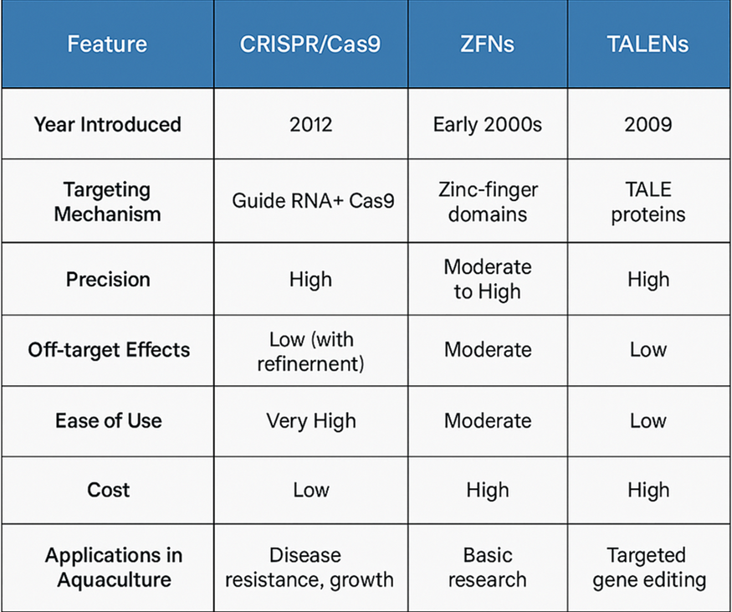

**[Infographic: Comparison of Gene Editing Technologies in Aquatic Genetics]**

**B. Applications in Aquaculture**

The integration of gene-editing technologies into aquaculture has yielded substantial improvements in fish health, productivity, and resilience. These interventions address longstanding industry challenges, particularly the management of infectious diseases.

**Genetic Modification for Disease Resistance**

Targeted editing of immune-related genes has emerged as a promising strategy to bolster disease resistance in fish. For instance, CRISPR/Cas9 can be used to modify genes that influence innate and adaptive immune responses, reducing the need for antibiotics and enhancing survivability under high-density farming conditions (14, 15, 17).

**Enhanced Growth and Performance Traits**

Beyond immunity, gene-editing tools are also applied to enhance growth by altering genes involved in hormone regulation—a research focus since the early 1980s (13). Faster-growing fish not only improve production efficiency but also reduce resource use and environmental impact.

**Toward Integrated Vaccine Platforms**

Looking forward, biotechnology is expected to support the development of **comprehensive vaccine design platforms.** These systems would integrate omics data—genomics, transcriptomics, and immunoproteomics—to better understand immune mechanisms such as memory response, tolerance, and mucosal immunity. This foundational knowledge will inform the design of next-generation vaccines and optimize disease control strategies in aquaculture (5, 18).

**4. Aquatic Pathogens**

Aquatic pathogens—comprising viruses, bacteria, and parasites—pose a significant threat to the global aquaculture industry. As fish farming operations expand and intensify, disease outbreaks have become increasingly common, particularly under conditions of overcrowding and environmental stress. These pathogens not only endanger fish health but also jeopardize the economic and ecological stability of aquaculture systems.

Estimates suggest that **annual economic losses** due to aquatic diseases exceed **$10 billion globally**, with major contributors including **Viral Nervous Necrosis (VNN), vibriosis,** and **pasteurellosis** (1, 2). These diseases have led to high mortality rates in economically important species such as Atlantic salmon, European sea bass, and gilthead sea bream.

| **Disease** | **Estimated Loss (USD)** |
| --- | --- |
| Viral Nervous Necrosis (VNN) | $3.2 Billion |
| Vibriosis | $2.1 Billion |
| Pasteurellosis | $1.5 Billion |
| Others | ~$3.2 Billion |
| **Total** | **> $10 Billion** |

**Estimated Annual Economic Losses from Major Aquatic Diseases**

**Economic and Ecological Impacts**

The rapid transmission of aquatic diseases not only leads to direct financial losses for fish farmers but also causes **broader ecological harm**. When pathogens spread from farmed to wild populations, they disrupt native ecosystems and threaten biodiversity (19). Moreover, the widespread use of **antibiotics and chemical treatments** to manage disease outbreaks has contributed to environmental pollution and the **emergence of antimicrobial resistance (AMR)**—a growing concern in both veterinary and human health sectors (2).

The compounding effects of these challenges necessitate a shift from reactive to preventive disease management strategies, such as vaccine development and genetic enhancement for resistance. By addressing pathogens at the genetic and immunological levels, aquaculture can move toward more sustainable and responsible practices.

**5. Vaccine Development and Immunoprophylaxis**

As the threat of waterborne diseases continues to grow, **vaccination** has become a central strategy in protecting farmed fish populations. Unlike antibiotics, which treat infections after they occur, vaccines offer a **preventive approach**, triggering immune responses that equip fish to resist future exposures. This not only improves animal welfare but also reduces antimicrobial residues in seafood, aligning with global public health and sustainability goals (2, 5).

**Research on Immune Responses in Fish**

Recent immunological research has revealed **species-specific pathways** that determine how fish respond to vaccines. For instance, DNA vaccines—when paired with suitable adjuvants—can significantly enhance immune gene expression and cytokine responses in fish like grouper and flounder (5). These findings have deepened our understanding of fish immunology and informed the design of more effective vaccines.

Mechanistic studies have also shown that fish exhibit both **mucosal and systemic immunity**, depending on the vaccine type and administration method. While intraperitoneal injections typically induce a systemic immune response, immersion or oral delivery may stimulate mucosal defenses. These delivery routes must be tailored to both the pathogen and host species to maximize protection.

**Types of Aquatic Vaccines**

Vaccines for aquatic species can be categorized based on **pathogen type** (bacterial, viral, or parasitic), **antigen formulation** (monovalent or multivalent), and **manufacturing approach** (live-attenuated, inactivated, or genetically engineered).

**Live-Attenuated and Inactivated Vaccines**

Live-attenuated vaccines utilize weakened pathogens to elicit robust immunity, while inactivated vaccines use killed organisms. The latter are considered safer and are commonly administered via intraperitoneal injection. However, efficacy can vary due to strain differences and host variability (5). Despite these limitations, both vaccine types have played a foundational role in aquatic immunoprophylaxis since the first fish vaccine—targeting *Aeromonas salmonicida*—was introduced in 1942.

**Nucleic Acid Vaccines**

DNA and RNA-based vaccines represent a **next-generation approach** in aquatic vaccinology. These formulations deliver genetic instructions that prompt host cells to produce pathogen-specific antigens, stimulating targeted immune responses. Nucleic acid vaccines offer advantages such as **long-lasting immunity, safety,** and **rapid scalability** (5, 20). Approved examples include DNA vaccines against Infectious Hematopoietic Necrosis Virus (IHNV) and Salmon Pancreatic Disease Virus (SPDV), underscoring their growing relevance (6).

**Immunological Mechanisms and Safety Considerations**

The success of a vaccine depends on its ability to activate both **humoral and cellular immunity**. For instance, injected vaccines can stimulate IgM antibodies in mucosal tissues, while muscle injections often trigger systemic immune responses. Nevertheless, tolerance and unintended immune suppression are risks, particularly for DNA vaccines, where **plasmid integration into the host genome** remains a theoretical concern (6).

**Future Directions**

The future of aquatic vaccine development lies in **genetic engineering and multi-omics integration**. Custom-designed vaccines can be tailored to target specific pathogens, host species, and even environmental conditions. However, significant gaps remain—particularly in vaccines for parasitic and fungal infections, which are currently underrepresented in commercial offerings (5).

To address this, multivalent vaccine platforms, improved adjuvant systems, and predictive models using AI and genomic data are expected to drive the next wave of innovation.

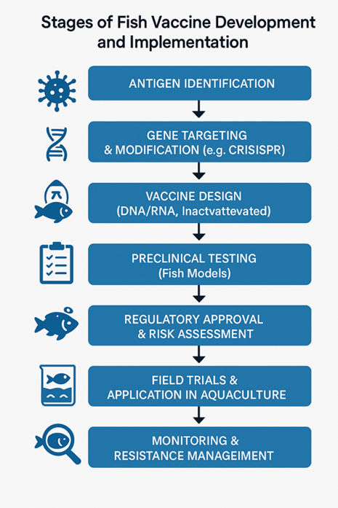

**[Flowchart: Stages of Fish Vaccine Development and Implementation]**

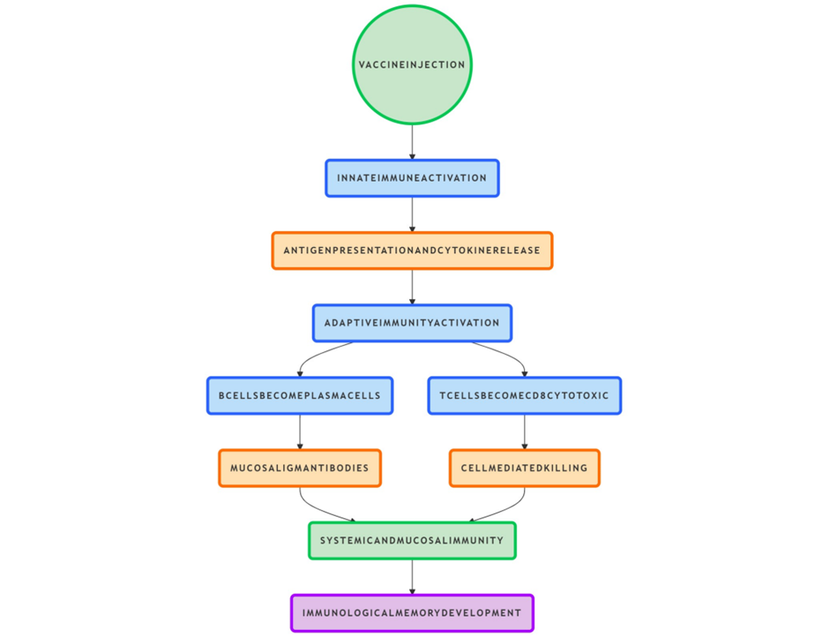

**[Diagram: Immune Pathways Activated in Fish Post-Vaccination]**

**6. Implications of Genetic Advances on Vaccine Efficacy**

Recent breakthroughs in genetic engineering and molecular biology have significantly influenced both the design and effectiveness of vaccines in aquaculture. These innovations have enabled the development of **targeted, species-specific vaccines** that offer improved immune protection for farmed fish, thereby transforming health management strategies across the industry.

**Improved Vaccine Design through Genomic Insights**

Advances in **functional genomics** have empowered researchers to identify critical antigens—molecules capable of triggering immune responses—which serve as the foundation for modern vaccine design. Tools such as **genomics, transcriptomics, proteomics, and metabolomics** (collectively referred to as "multi-omics") have provided detailed insights into host-pathogen interactions, enabling the rational selection of high-priority vaccine targets (21).

This data-driven approach not only enhances the **specificity and efficacy** of vaccines but also reduces the likelihood of adverse effects, thereby contributing to both **safer formulations and streamlined regulatory approval processes**.

**Advanced Methods for Evaluating Vaccine Efficacy**

Historically, vaccine efficacy in aquaculture was primarily assessed through survival rates following pathogen challenge. Today, **high-resolution techniques** such as **flow cytometry, multi-omics profiling,** and **monoclonal antibody assays** are used to evaluate immunogenicity at the molecular and cellular levels. These tools allow researchers to assess vaccine-induced gene expression, protein synthesis, and immune cell activation in a more **quantitative and mechanistic** manner (5, 11).

This transition from empirical to analytical evaluation not only strengthens vaccine research but also provides **predictive markers of immune protection**, which are crucial for developing effective vaccination protocols in diverse aquaculture settings.

**Genetically Engineered Vaccines**

The use of **recombinant DNA technologies** has enabled the creation of vaccines that express specific antigens in host organisms. These genetically engineered vaccines are designed to stimulate **precise and robust immune responses** without introducing infectious agents, thereby minimizing biosecurity risks (22).

Although development costs and production timelines remain challenges, the potential to create **multivalent vaccines**—which can protect against multiple pathogens simultaneously—offers a promising avenue for reducing disease burden in aquaculture (5, 23).

**Selective Breeding and Genetic Resistance**

In parallel with vaccine innovation, genetic tools are being employed to support **selective breeding programs** that enhance natural disease resistance in aquaculture species. By identifying and amplifying **genetic markers associated with immunity**, breeders can produce more resilient fish populations over successive generations (2).

This integrative approach—combining **vaccination with genomic selection**—not only enhances fish health but also reduces dependency on pharmaceuticals, thereby contributing to **ecological sustainability and long-term industry resilience**.

**7. Regulatory and Ethical Considerations**

As genetic technologies gain prominence in aquaculture—particularly in vaccine development and disease resistance—**ethical concerns and regulatory** oversight have become central to ensuring their responsible application. Public skepticism surrounding biotechnology, especially genetically modified organisms (GMOs), underscores the need for a transparent, inclusive, and ethically grounded approach to innovation.

**Risk Perception and Public Acceptance**

Studies show that the public often perceives biotechnology in food systems as riskier than experts do, with concerns centered on **food safety, environmental impacts, and moral** **acceptability** (7). These perceptions are shaped by a complex mix of cultural values, media influence, and institutional trust.

Effective risk communication must therefore go beyond technical assessments. It should actively engage stakeholders—including consumers, farmers, regulators, and ethicists—in **dialogue about the purpose, benefits, and potential risks** of gene-editing and vaccine technologies in aquaculture.

**Environmental and Health Risk Assessment**

Genetic engineering in aquaculture is primarily aimed at enhancing traits such as growth rate, sterility, and disease resistance—not producing toxins or harmful byproducts (8). Nonetheless, potential ecological consequences—such as the **unintended release of genetically modified fish into natural ecosystems**—warrant cautious and thorough evaluation.

The U.S. National Research Council (USNRC) and similar international bodies recommend assessing multiple variables: the nature of the genetic modification, the biology of the modified species, and the characteristics of the release environment (8). These risk assessments must consider long-term, cumulative impacts and integrate both **quantitative science and societal values**.

**Regulatory Frameworks and Global Disparities**

International regulatory frameworks, such as the European Union’s REACH (Registration, Evaluation, Authorisation, and Restriction of Chemicals), establish high standards for health and environmental safety. However, **regulatory disparities between regions** can lead to unequal access to biotechnologies, particularly in developing countries where aquaculture is rapidly expanding but infrastructure for oversight may be limited.

To address these challenges, a **globally coordinated regulatory effort** is needed—one that harmonizes safety standards while promoting **equitable access to safe, effective genetic technologies**.

**Ethical Implications of Genetic Modification**

The ethical debate surrounding genetic engineering in aquaculture extends beyond safety and risk. It raises fundamental questions about **human intervention in nature,** the **ownership of genetic resources,** and **benefit-sharing with indigenous and local communities** (8, 9).

Bioprospecting—the commercialization of genetic traits sourced from traditional knowledge—can exacerbate inequalities if not managed fairly. Ethical governance must therefore ensure that communities contributing genetic resources receive **adequate recognition and compensation**.

Additionally, consumer attitudes toward genetically modified fish are often shaped less by science than by **perceived transparency and trust** in regulatory institutions (24). Retailers and food service providers increasingly respond to these concerns through product labeling and certification, reflecting the need for **trust-building and accountability** throughout the aquaculture value chain.

**8. Future Directions**

As biotechnology continues to evolve, its application in aquaculture—particularly in vaccine development—holds vast potential to reshape the industry. Future advancements will be guided not only by technological innovation but also by **practical, ethical, and geopolitical considerations** that ensure sustainable and equitable implementation.

**Toward Integrated Vaccine Design Platforms**

A major goal in future aquaculture health management is the development of **comprehensive platforms** for studying and designing vaccines. These platforms will integrate **molecular tools, immune profiling, and computational modeling** to enable precise understanding of fish immune responses—spanning innate, adaptive, and trained immunity. Such systems will allow researchers to evaluate **pathogen-specific defense mechanisms**, immunological memory, and tolerogenic responses in different aquaculture species (5, 18).

This deeper understanding of fish immunology will lay the groundwork for **rational vaccine design**, enhancing both efficacy and safety.

**Enhancing Vaccine Efficacy with Genetic Engineering**

Emerging vaccine technologies—particularly **genetically engineered and multivalent vaccines**—are poised to provide broad-spectrum protection against multiple pathogens. Gene-based approaches have already shown success against diseases like viral hemorrhagic septicemia in rainbow trout, demonstrating the feasibility of **genome-informed immunoprophylaxis** (10).

Going forward, integrating CRISPR-driven antigen discovery with next-generation sequencing and synthetic biology will open avenues for **custom vaccine development** tailored to species, environments, and local disease burdens.

**Systematic Research and Regulatory Alignment**

To realize the full potential of biotechnological vaccines, the **entire development pipeline must be optimized**—from laboratory research and clinical validation to regulatory approval and field deployment. Key priorities include:

* Enhancing the effectiveness of adjuvants and immunostimulants.
* Establishing **standardized disease monitoring systems.**
* Expanding the use of **validated animal models** for vaccine testing.
* Streamlining compliance with **regional and international biosafety regulations** (5, 18).

This systematic approach will ensure that novel vaccines are not only effective but also **accessible and applicable in real-world aquaculture systems**.

**Addressing Inequities in Developing Countries**

A critical challenge moving forward is the **unequal access to biotechnological innovations**, particularly in low- and middle-income countries where aquaculture is expanding rapidly. Cost, infrastructure, and regulatory barriers often prevent the adoption of advanced vaccines in these regions.

Future efforts must focus on developing **affordable, scalable, and locally adaptable technologies** that meet the specific needs of these aquaculture systems. By doing so, biotechnology can become a tool for **global food security and economic empowerment**, rather than deepening existing inequalities (8, 10).

**Ethical Innovation and Public Engagement**

Finally, as gene-editing and vaccine technologies continue to advance, **ethical frameworks and public engagement** will be essential for building trust. Educational initiatives, stakeholder dialogues, and transparent regulatory practices must accompany scientific innovation to ensure **informed consent, social acceptance, and environmental stewardship** (25, 26).

The future of aquaculture lies in harnessing genetic technologies not just for production gains, but for the creation of **a resilient, responsible, and inclusive global food system**.

**References**

1. Fraslin, C., Quillet, E., Rochat, T., Dechamp, N., Bernardet, J., Collet, B., Lallias, D., & Boudinot, P. (2020). Combining Multiple Approaches and Models to Dissect the Genetic Architecture of Resistance to Infections in Fish. Frontiers in Genetics, 11, 540967. <https://doi.org/10.3389/fgene.2020.00677>
2. Gutási, A., Hammer, S. E., El-Matbouli, M., & Saleh, M. (2023). Review: Recent Applications of Gene Editing in Fish Species and Aquatic Medicine. *Animals*, *13*(7), 1250. <https://doi.org/10.3390/ani13071250>
3. Devin M. Bartley FAO Fisheries Department, Rome, Italy. Genetically modified organisms in aquaculture. <https://www.fao.org/4/y5929e/y5929e09.htm>
4. RESEARCH AND DEVELOPMENT OF APPROPRIATE GENETIC BIOTECHNOLOGIES FOR THE FISHERY SECTOR IN DEVELOPING COUNTRIES. <https://www.fao.org/4/y0422e/y0422e11.htm>
5. Fish Farming (Oct 17,2024). How Biotechnology is Transforming Fish Farming: Key Innovations and Ethical Considerations. <https://worldwideaquaculture.com/how-biotechnology-is-transforming-fish-farming-key-innovations-and-ethical-considerations/>
6. Bedekar, M., Kole, S. & Gayatri, T. (2019). Biotechnological approaches to fish vaccine. 10.1016/B978-0-12-816352-8.00017-5.
7. Mweemba, H., Mutoloki, S., & Evensen, Ø. (2015). An Overview of Challenges Limiting the Design of Protective Mucosal Vaccines for Finfish. Frontiers in Immunology, 6, 152449. <https://doi.org/10.3389/fimmu.2015.00542>
8. Sciuto S, Colli L, Fabris A, Pastorino P, Stoppani N, Esposito G, Prearo M, Esposito G, Ajmone-Marsan P, Acutis PL, Colussi S. 2022. What Can Genetics Do for the Control of Infectious Diseases in Aquaculture? Animals (Basel). 12(17) :2176. doi: 10.3390/ani12172176. PMID: 36077896; PMCID: PMC9454762.
9. Aquaculture, 2024. The Genetic Frontier: How Transgenic Fish Are Revolutionizing Aquaculture Published 11/11/2024. * By Maharshi Limbola and Arya Singh. <https://aquaculturemag.com/2024/11/11/the-genetic-frontier-how-transgenic-fish-are-revolutionizing-aquaculture/>
10. Fjalestad, K T., Gjedrem T,. & Bjarne G. (1993). Genetic-Improvement of Disease Resistance in Fish - an Overview. Aquaculture. 111. 65-74. 10.1016/0044-8486(93)90025-T. https://www.researchgate.net/publication/223387780_Genetic-Improvement_of_Disease_Resistance_in_Fish_-_an_Overview
11. Yang Z, Fu G, Lee M, Yeo S, Gen Hua Yue GH.2025. Genes for editing to improve economic traits in aquaculture fish species, Aquaculture and Fisheries,10(1),1-18, <https://doi.org/10.1016/j.aaf.2024.05.005>.
12. Myhr, A. I., & Dalmo, R. A. (2005). Introduction of genetic engineering in aquaculture: Ecological and ethical implications for science and governance. *Aquaculture*, *250*(3-4), 542-554. https://doi.org/10.1016/j.aquaculture.2004.12.032
13. Zhu, M., Sumana, S. L., Abdullateef, M. M., Falayi, O. C., Shui, Y., Zhang, C., Zhu, J., & Su, S. (2024). CRISPR/Cas9 Technology for Enhancing Desirable Traits of Fish Species in Aquaculture. International Journal of Molecular Sciences, 25(17), 9299. https://doi.org/10.3390/ijms25179299
14. Marnis, H., & Syahputra, K. (2025). Advancing fish disease research through CRISPR-Cas genome editing: Recent developments and future perspectives. Fish & Shellfish Immunology, 160, 110220. <https://doi.org/10.1016/j.fsi.2025.110220>
15. Griot, R., Allal, F., Phocas, F., Morvezen, R., Haffray, P., François, Y., Morin, T., Bestin, A., Bruant, J., Cariou, S., Peyrou, B., Brunier, J., & Vandeputte, M. (2021). Optimization of Genomic Selection to Improve Disease Resistance in Two Marine Fishes, the European Sea Bass (Dicentrarchus labrax) and the Gilthead Sea Bream (Sparus aurata). *Frontiers in Genetics*, *12*, 665920. <https://doi.org/10.3389/fgene.2021.665920>
16. Irshath AA, Rajan AP, Vimal S, Prabhakaran VS, Ganesan R. 2023.Bacterial Pathogenesis in Various Fish Diseases: Recent Advances and Specific Challenges in Vaccine Development. Vaccines (Basel). 11(2):470. doi: 10.3390/vaccines11020470. PMID: 36851346; PMCID: PMC9968037
17. Du, Y., Hu, X., Miao, L., & Chen, J. (2022). Current status and development prospects of aquatic vaccines. Frontiers in Immunology, 13, 1040336. https://doi.org/10.3389/fimmu.2022.1040336
18. Umar BM. & Elezuo, K O. (2024). Review Paper on Recent Advances of Biotechnology Application to Aquaculture Development. International Journal of Innovative Science and Research Technology. 9. 737-743. 10.38124/ijisrt/IJISRT24JUN514.
19. Mondal, H. & Thomas, J.2022. A review on the recent advances and application of vaccines against fish pathogens in aquaculture. Aquacult Int 30, 1971–2000 (2022). <https://doi.org/10.1007/s10499-022-00884-w>
20. CRISPR AQUACULTURE: HOW CAS9 IS PAVING THE WAY FOR SUSTAINABLE AQUATIC FARMING. [https://ersgenomics.com/wp-content/uploads /2023/02/Aquaculture.pdf](https://ersgenomics.com/wp-content/uploads%20/2023/02/Aquaculture.pdf)
21. Joseph A (2023) The Role of Genetically Modified Organisms in Aquaculture for Sustainable Seafood Production. Advac Genet Eng. 12:247. <https://www.longdom.org/open-access/the-role-of-genetically-modified-organisms-in-aquaculture-for-sustainable-seafood-production-104426.html>
22. Furgurson J, Loschin N, Butoto E, Abugu M, Gillespie CJ, Brown R, Ferraro G, Speicher N, Stokes R, Budnick A, Geist K, Alirigia R, Andrews A, Mainello A. 2023. Seizing the policy moment in crop biotech regulation: an interdisciplinary response to the Executive Order on biotechnology. Front Bioeng Biotechnol. 2023 Aug 7;11:1241537. doi: 10.3389/fbioe.2023.1241537.PMID: 37609116; PMCID: PMC10441231.
23. Su, H., Yakovlev, I. A., Van Eerde, A., Su, J., & Clarke, J. L. (2021). Plant-Produced Vaccines: Future Applications in Aquaculture. Frontiers in Plant Science, 12, 718775. <https://doi.org/10.3389/fpls.2021.718775>
24. Hallman WK. June 2000. Consumer Concerns About Biotechnology: International Perspectives. https://foodpolicy.rutgers.edu/docs/pubs/2000_Consumer_Concerns_About_Biotechnology_International_Perspectives.pdf
25. Ma J, Bruce TJ, Jones EM, Cain KD. 2019.A Review of Fish Vaccine Development Strategies: Conventional Methods and Modern Biotechnological Approaches. Microorganisms. 2019 Nov 16;7(11):569. doi: 10.3390/microorganisms7110569. PMID: 31744151; PMCID: PMC6920890.
26. Yáñez, J. M., Houston, R. D., & Newman, S. (2014). Genetics and genomics of disease resistance in salmonid species. Frontiers in Genetics, 5, 120437. <https://doi.org/10.3389/fgene.2014.00415>