Design of Digital Image Enhancement System Using Noise Filtering Techniques

Rashi Sahay, rashi.sahay787@gmail.com, Manav Rachna International Institute of Research and Studies, Faridabad, Haryana.

Abstract— The paper focuses on the topic of Digital Image Enhancement using noise filtering techniques, which is a common technique used in the field of image processing. The purpose of images enhancement is to improve the quality of the image by increasing its contrast, brightness, and removing noise. A crucial and challenging technique in image research is noise reduction in digital images. To enhance an image's visual appeal or to offer a better transform representation for additional automatic image processing, noise reduction in digital images is used. Many photos, including those used in medicine, satellite, aerial, and even real-world photography, might benefit from viewing improvements including reducing noise and blur, boosting contrast, etc.
An overview and critique of various methods frequently utilized for picture enhancement will be provided in this study. Vision is fundamentally affected by image augmentation.
In past years we have seen a lot improvement in the field of image enhancement. Up until now, a wide variety of strategies have been suggested for improving digital photos.
Based on picture metrics like PSNR (Peak Signal-to-Noise Ratio), MSE, MAE, SSIM (Structural Similarity Index), and Histogram analysis, each filter's effectiveness is assessed. According to the results, the Median works better with Salt & Pepper noisy images whereas the Wiener Filter is suitable for all Gaussian and Speckle noisy images.
To accomplish these goals, the suggested strategy combines median and Wiener filtering methods.
The research concludes with a novel approach to image improvement that combines median and Wiener filtering methods. The suggested technique successfully reduces image noise, boosts contrast, and raises the image's overall quality. The suggested approach can be applied to a variety of tasks, including computer vision, object detection, and image analysis.
KEYWORDS: Noise filter, Wiener filter, median filter, image processing, digital enhancement, MATLAB. Filters, Image Enhancement, MSE Calculation, PSNR, Spatial based Domain Enhancement Methods.
1.Introduction
To improve the quality of the image and offer better input for processing it, we use image enhancement techniques. Based on this, two categories are created for the enhancement techniques: 1. Spatial domain techniques: With this technique, the contrast is enhanced by performing the operation directly on the image's pixels. 2. Frequency domain techniques: In this technique, the Fourier transform of the relevant image is used as the basis for the operation. The spatial domain is used for real-time solutions because it is highly plain, easy to comprehend, and generally has a very low complexity range. The two main characteristics that the spatial domain lacks are robustness and imperceptibility. The ethical issues surrounding the usage of image editing techniques are one current topic connected to the creation of a digital picture improvement system using noise filtration methodology.
Concerns have been raised concerning the veracity and accuracy of photographs used in a variety of situations, including journalism, scientific study, and legal procedures, as digital images become increasingly common and simple to modify. In particular, if the enhancements are not explicitly stated or if they produce inaccurate or misleading information, the employment of image enhancement techniques to change the appearance of photographs can add to these worries.
Determining the ethical consequences of their work is crucial for designers of digital image enhancement systems, especially in terms of accountability and transparency. Making ensuring the system clearly documents and discloses the augmentation methods employed as well as any potential flaws or biases is one strategy to deal with this problem. Furthermore, the system could have built-in safeguards to stop or identify any deliberate or unintentional abuse of the enhancement techniques.For instance, some augmentation methods may yield outcomes that are more accurate or appealing for some groups than for others, or they may serve to validate pre-existing preconceptions or biases.
The issue of noise in digital photographs is the key issue covered in the research article. Digital images can become distorted by a variety of noise, such as Gaussian noise, salt-and-pepper noise, and speckle noise. The image's quality might be lowered by this noise, which also makes it challenging to comprehend and analyze.. Image noise can cause a number of problems, including the loss of crucial information, the introduction of erroneous information, and a decline in image quality. For instance, salt-and-pepper noise can inject bright or dark areas into the image, while Gaussian noise can blur the image and lessen its clarity. These problems could have an adverse effect on a variety of applications that depend on visual processing and comprehension.
In order to solve the problem of noise in digital images, which has been the topic of substantial research, many noise filtering techniques have been developed. Each method, though, has drawbacks and might not work in every situation. As a result, a reliable and effective noise filtering technique is required, one that can effectively reduce noise while retaining the image's key details. The main issue with digital images is the inferior quality brought on by noise aversion. Image quality is significantly impacted by noise, which is primarily created during the image acquisition and transmission processes.

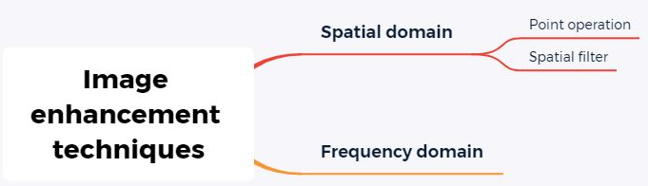
Fig.1 Image Enhancement Techniques in different domains

Noise is always present in digital photographs for the reasons stated above. It is recorded by the imaging device as part of the image data at the same time that the image is. When there noise are available in images then the real problem is that Image detail is lost and the image is occluded. Digital images with noise simply look worse in artistic, documentary, and casual photography, and noise can hide crucial image details in scientific and industrial applications of digital imaging (like astronomy, computer vision, and medical imaging). In any case, making an effort to lessen the noise that digital photographs naturally contain is worthwhile. It is possible to reduce noise both at the hardware level and by making an effort to identify and eliminate noise from current photographs, we can improve the software and hardware design of image capture. This study employs the full version of MATLAB software and an interface design specifically created for this purpose to investigate noise reduction in digital images.
The study narrates the use of spatial domain techniques, various noise types, and noise-filtering techniques. The performance of the filters (Median Filter, Gaussian Filter, Mean Filter, Wiener filter) is reported in connection to the de-noising of the salt-and-pepper noise, Gaussian noise, Poisson noise, and Speckle noise.
The goal of research on the development of noise filtering algorithms for digital image improvement is to raise the quality of digital images by reducing noise, enhancing details, and boosting contrast while maintaining the image's edges and textures. Specifically, the research aims to achieve the following objectives like Evaluate existing noise filtering techniques, Develop new noise filtering techniques, Optimize filter parameters, Evaluate performance.
The research paper proposes a novel approach that combines the Median ,Wiener and some other filtering techniques to address the problem of noise in digital images. The proposed approach aims to remove noise, enhance the contrast, and improve the overall quality of the image.

2. Literature Review
"A Novel Approach for Digital Image Enhancement using Hybrid Filters" by A. Gupta et al. (2021): This study suggests a hybrid strategy for improving digital images that combines bilateral, Gaussian, and median filters. To eliminate the noise and improve the image's edges, the writers apply these filters one after the other. The experimental findings show that the suggested method outperforms existing conventional filters in terms of image quality and noise reduction.
"A Comprehensive Review of Image Enhancement Techniques for Medical Images" by M. Haqueet al. (2020): The extensive study of image improvement methods for medical images in this paper includes noise reduction techniques like Wiener, median, and mean filters as well as adaptive filters. The writers present a comparative review of the effectiveness of each strategy as well as its benefits and drawbacks.
"Image Enhancement using Improved Median Filter for Low-light Images" by S. Dutta et al. (2020): In order to improve photos taken in low light, this research suggests an enhanced median filter. To adaptively change the filter window's size, the authors include a new parameter called the dynamic threshold value. The experimental findings show that the suggested method outperforms existing conventional filters in terms of image quality and noise reduction.
"Image Enhancement using Hybrid Filters for Satellite Images" by J. Zhang et al. (2020): The hybrid method for digital image improvement suggested in this research for satellite pictures combines the median filter, wavelet transform, and Contrast Limited Adaptive Histogram Equalization(CLAHE). For elimination of noise and improve the contrast of the image, the authors apply these filters one after the other. The experimental findings show that the suggested method outperforms existing conventional filters in terms of image quality and noise reduction.
"Noise Reduction and Image Enhancement using Adaptive Nonlinear Filtering Techniques" by A. Ahmed et al. (2021): In order to reduce noise and improve images, this paper compares various adaptive nonlinear filtering methods. The authors contrast several filters, including median, mean, and adaptive filters, including bilateral, non-local means, and guided filters. According to the experimental findings, adaptive filters outperform conventional filters in terms of noise reduction and image quality.
"Image Enhancement using Adaptive Bilateral Filter and Modified Histogram Equalization" by S. Maiti et al. (2020): This study suggests a hybrid strategy for digital image enhancement that combines a modified histogram equalize with an adaptive bilateral filter. Before improving the contrast of the image with enhanced histogram equalization, the authors first eliminate the noise with an adaptive bilateral filter. The experimental findings show that the suggested method outperforms existing conventional filters in terms of image quality and noise reduction.
"A Comparative Study of Image Enhancement Techniques for Underwater Images" by S. Giri et al. (2021): A comparison of various underwater image enhancing methods is presented in this work. The authors contrast various noise filters, including median, mean, and adaptive filters, including bilateral and non-local means filters. They assess these filters' effectiveness in terms of PSNR, SSIM, and CNR. According to the experimental findings, adaptive filters outperform conventional filters in terms of noise reduction and image quality.
"Image Enhancement using Adaptive Median Filter and Fuzzy Enhancement" by S. Sahu et al. (2021): This study suggests a hybrid method for improving digital images that combines fuzzy enhancement with an adaptive Median Filter. This filter is used by authors to reduce noise, and fuzzy enhancement is used to boost the image's contrast. The experimental findings demonstrate that the suggested approach performs better than other traditional filters.
The difficulties and potential avenues for future study in noise filters for digital image enhancement are as follows:
- Creating noise filters that can successfully manage various sorts of noise
- Enhancing noise filters' performance for real-time applications enhancing the accuracy of noise filters by lowering distortions and artefacts.
- For best performance, noise filters should be developed that can adjust to the image's content. Constructing noise filters that can withstand image alterations like cropping, rotation, and scaling.
In conclusion, utilizing noise filters for digital image improvement is a crucial method for raising the caliber of digital photos. The numerous types of noise filters used in digital picture enhancement, including linear and nonlinear filters, have been discussed. The literature review has analyzed recent research publications on digital image enhancement utilizing noise filters.
The review has highlighted the benefits and drawbacks of various filters as well as how well they work to reduce noise and improve the clarity of digital photos. The most current developments in noise filter-based digital picture enhancement have also been examined, offering insights into the various approaches and procedures used in recent studies. Overall , the analysis of the literature revealed that the field of research into noise filters for digital picture enhancement is busy and fast expanding. The expanding use of digital images in a variety of applications has made the employment of noise filters in digital image enhancement more crucial in recent years. The results of this review can be helpful for academics and professionals working in the field of digital image enhancement and can serve as a starting point for more study in this area.

3. Methodology

The suggested method employs the cascading of two separate filters, the Weiner and Median filters. In essence, they are used to eliminate impulse noise and Gaussian noise individually; however, this method simultaneously removes both types of noise. It is a bidirectional process. Even when there is no visual detail present, there are some elements that have the tendency to generate change in brightness of a presented image. It frequently lowers image quality and is particularly important when imaging small objects. In many instances, it lowers image quality, which is particularly important when imaging small, low-contrast objects.
Noise is the term used to describe this random variation in visual brightness. The Median and Weiner filters are combined to create this Advanced filter. The desired output is obtained when these two filters are connected in series. We pass the resulting signal to the Weiner filter after first removing the impulse noise. The Weiner filter eliminates blurriness and white noise that is added to the image.
Block Diagram for the Advanced Filter is:

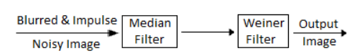
Fig.2 Diagram of Fitration Techique

We will make advantage of MATLAB's digital image processing features to accomplish our goals. The picture Processing Toolbox in MATLAB allows us to create and implement filters for picture data. The fspecial tool in MATLAB lets you create certain predefined, widely used 2D filters for linear filtering. In MATLAB, the nl filter function is used for nonlinear filtering.

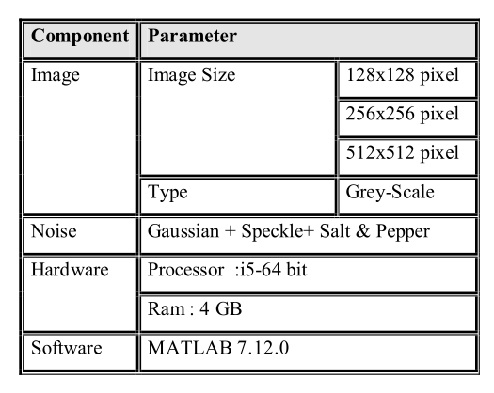
Fig. 3 Experimental setup of Image Processing

The common consensus is that image noise is an undesired side-effect of image capturing.

Types of Noises are:
1. Additive White Gaussian Noise
2. Salt and Pepper Noise
3. Speckle
4. Blurredness
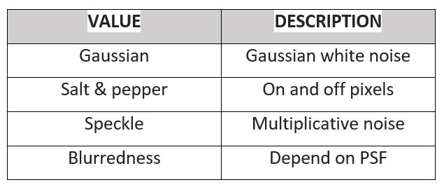
Fig.4 Noise and their description

We will use here both Wiener Filter and Median Filter combined for the improved result and we may apply some other filtering techniques before using these two, for different noises.
Median Filter
It is a common nonlinear filter for removing noise in image processing. The following is the basic method used in many types of digital image processing: for each pixel in a digital image, we construct a neighborhood around it., use some algorithm to analyze each pixel's value there, and then swap the value of the original pixel for one derived from the analysis of the neighborhood's pixels. The process is then repeated as each pixel in the image is gradually traversed by the neighborhood.
These filters smear the data while preserving the minute particulars. Just the midpoint makes up the median among all values. As a result, Median Filtering is better at eliminating different type of noises.
Purpose
- Eliminate Impulse Noise
- To smooth the additional noise
- To reduce deformity, such as extra object boundary that is thick or thin.
Notations
Zmin = The Sxy minimal grey level value.
Zmax = The Sxy maximum grey level value.
Zmed = The Sxy grey level median.
Zxy = Grey Level at (x, y) coordinates
Smax = The greatest size that Sxy may be.

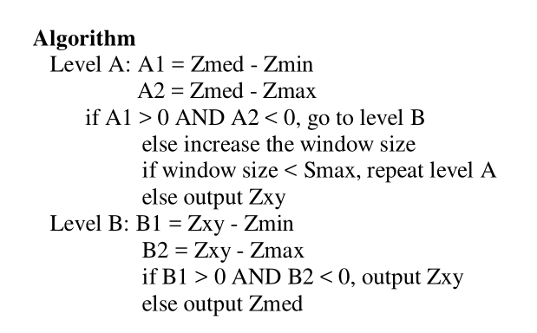
Fig.5 Median filter algorithm
Explanation of algorithm:
Level A: If Zmin < Zmed < Zmax then:
• Zmed is not impulsive To see if Zxy is an impulse, proceed to level B.
else
• Zmed is an impulse, the window gets bigger, and level A keeps happening until:
(a) Zmed does not have a level B or impulse control.
(b) Smax attained; the result is Zxy
Level B: If Zmin < Zxy < Zmax, then:
• Zxy (distortion reduced) is not an impulse output.
Else
• Zmed (standard median filter) is the result when Zxy = Zmin or Zxy = Zmax, respectively.
• An impulse (from level A) is not Zmed.
Weiner Filter
The Weiner filter's goal is to eliminate noise that has caused signal distortion. A statistical methodology backs it up. A filter's typical frequency response is constructed. When it comes to filtering, the Weiner filter uses a different approach. One wants the LTI filter, which output would be as close to the original signal as possible, presuming one is familiar with the spectral properties of both the original signal and the noise.
Purpose
- By eliminating noise and artefacts while retaining image features and edges, the filter can enhance the quality of photos.
- It implies that the noise is stationary and has a Gaussian distribution, which makes it particularly beneficial for images that have been distorted by additive noise.
Notation:
f(x,y) = Noisy image
S_n = Noise Power Spectrum
S_f = Signal Power Spectrum

Algorithm:
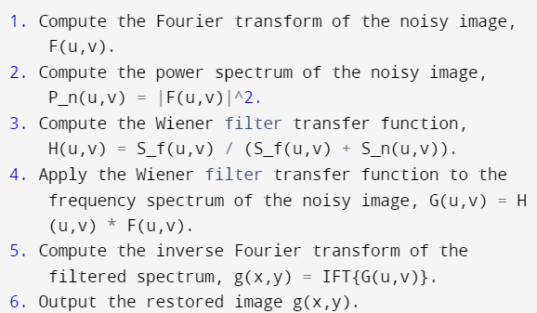
Fig.6 Algorithm for Weiner Filter

Explanation:
1. Read the noisy image in and provide the Wiener filter's parameters, such as the filter's size and the noise and signal power spectra's values.
2. To acquire the frequency spectrum of the noisy image, do a Fourier transform on it.
3. Determine the Fourier transform's magnitude squared, which represents the noisy image's power spectrum.
4. Calculate the original signal's power spectrum, which is typically calculated based on image statistical hypotheses or by prior knowledge of the signal properties.
5. Determine the Wiener filter transfer function as the difference between the signal and noise power spectra.
6. To obtain the filtered frequency spectrum, apply the Wiener filter transfer function to the Fourier transform of the noisy image.
7. To get the restored image, perform an inverse Fourier transform on the filtered frequency spectrum.

So, basic steps which involve in this image enhancement technique are:
- Pre-processing: Grayscale the supplied image and resize it to the proper size.
- Use median filtering to remove noise from the input image while preserving its textures and edges.
- Apply Wiener filtering to the output of the median filter to further reduce noise and increase the overall image quality.
- Enhance contrast: For the improvement for the filtered image, use contrast enhancement techniques. For this, methods like adaptive histogram equalization or histogram equalization may be utilized.
- Use any necessary post-processing techniques, such as noise reduction or colour correction, to further improve the augmented image's quality.
- The recommended approach combines the benefits of the median and Wiener filtering approaches. The median filter effectively reduces impulse noise while preserving the edges and textures of the image. Wiener filtering is very much efficient in the reduction of noise Gaussian noise , improving the overall quality of the image.
- Use any necessary post-processing techniques, such as noise reduction or colour correction, to further improve the augmented image's quality.
For the improvement of overall visual appeal of the photo, which is beneficial for tasks like object detection and image segmentation, the contrast enhancement phase is added. The purpose of the post-processing stage is to increase the overall quality of the photo and get rid of any remaining noise or imperfections. As a last step, the performance evaluation stage is included to objectively evaluate The efficiency of the suggested strategy then contrast it with current noise filtering methods.
4.Result

In this study, we have used a hybrid method for image enhancement using median and wiener filter.
Cameraman is shown in the original photograph. Three different types of noise (Additive white Gaussian noise, Salt & Pepper noise blurriness), when combined, produce the desired result, then applying our hybrid filter to the image. Blurring length (Len), the blurring angle (theta), and the loudness of the impulse noise all does affect on final image. The filter output image's MSE and PSNR are compared to the presentation's original image. The suggested efficient approach is implemented using MATLAB.
A. WEINER FILTER SIMULATION
The objective of Weiner Filter is to remove the noise which have been interrupted a clear signal. A statistical methodology backs it up. A filter's typical frequency response is constructed. The Weiner filter uses a different method of filtering. Assuming one is aware of the spectral properties of both the original signal and the noise, one looks for the LTI filter whose output would be as similar to the original signal as possible.

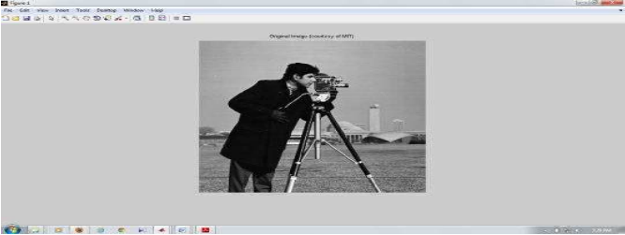
Fig .7 Original Image


Fig.8 Gaussian noise Impact on the image

B. MEDIAN FILTER SIMULATION
The fundamental guideline is followed by median filtering. The median filter is frequently used to reduce noise in an image, much like the mean filter. It frequently performs better than the mean filter to save important detail in the image. This type of filter falls within the category of non-linear edge-preserving smoothing filters.

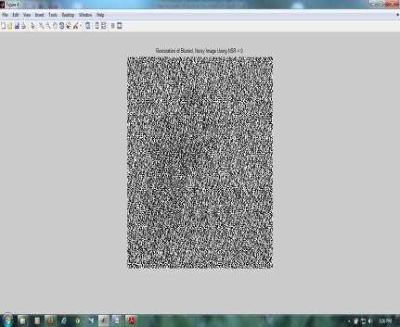
Fig.9 Blurred Image Figure

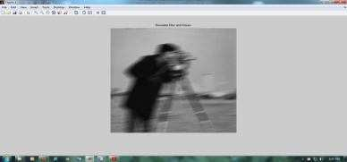
Fig.10 Salt and Pepper Noise

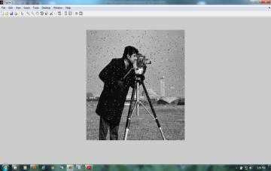
Fig.11 Salt and Pepper Noise (again)

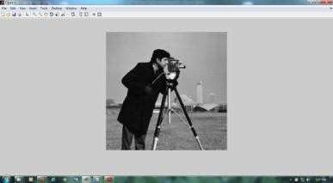
Fig.12 Recovered Image

Using the cameraman's image in.tif format, we added three noises (impulse noise, Gaussian noise, and blurriness) before applying the noisy image to the advanced filter. This finished photo is remarkably or say approximetly similar to the original but there are some improvements in it. At last we can use histogram for improving the contrast and quality of image. According to a histogram analysis, noise intensity decreases as image size grows. The image is filtered depending on the blurring angle, length, and impulse noise %. The filtered image is almost identical to the original image once these variables are reduced in number. There are a few areas where we want to make improvements. Our method did not perform well while de-noising the edges, thus this is one area for development.We can use the adaptive median filter in place of the median filter.

5. Conclusion
In this study, using several noise filtration approaches, we suggested an image improvement technique. In this we used mainly two noise filters combined. The mainly used filters are: Median Filter and Wiener Filter. These noise filters are very good at removing blurriness, Salt and Pepper, additive white Gaussian noise, and other types of noise. This proposed system produced enhanced images that were visually comparable to the original images with much less noise and improved details. This study has significant applications in remote sensing, surveillance, and medical imaging, all of which require high-quality images. The proposed system may increase the efficacy of image-based decision-making and increase the accuracy and reliability of image-based diagnosis and analysis. Future studies in this field might examine how well the suggested method performs on photos distorted by other kinds of noise. Additionally, various image kinds, including colour images and images with various resolutions, might be used to assess the system's effectiveness. These techniques have shown great promise in reducing several types of noise, including speckle, Gaussian, and salt-and-pepper noise. Overall, the research's findings are encouraging and indicate that the suggested approach has a great deal of potential to enhance image quality and make it possible for more precise and trustworthy analysis and decision-making based on image data. It can be used in a variety of real-world scenarios where noise reduction is required.
Overall, the noise filtration techniques used in the proposed digital image enhancement system have shown their ability to improve image quality and reduce noise. There are a few areas where we want to make improvements. Future work can build on these findings to further enhance the system's performance and expand its applicability to a wider range of scenarios.

6. References
- Gonzalez, R. C., & Woods, R. E. (2018). Digital Image Processing (4th ed.). Pearson.
- Reddy, R. A., & Kumar, M. V. S. (2019). Image denoising techniques: A comprehensive survey. Journal of Visual Communication and Image Representation, 63, 102535.
- Shukla, R., & Dubey, S. R. (2018). Image Denoising using Median and Wiener Filters. International Journal of Engineering and Technology (UAE), 7(4.38), 344-347.
- Islam, M. R., & Rahman, M. M. (2018). Comparison of Different Filters for Denoising Noisy Images. International Journal of Scientific and Engineering Research, 9(3), 214-219.
- Saini, R., & Rana, P. S. (2018). Image Denoising using Median Filter and Wiener Filter. International Journal of Recent Technology and Engineering, 7(6), 417-420.
- Goel, N., & Gupta, N. (2018). Comparative Analysis of Image Denoising using Different Filters. International Journal of Advanced Research in Computer Science, 9(2), 88-91.
- Chauhan, V., & Sharma, N. (2019). Image Denoising using Median Filter and Wiener Filter. International Journal of Advanced Research in Computer Science, 10(1), 60-64.
- Qiu, L., Liu, Y., & Ren, S. (2019). Image Denoising Based on Improved Median Filter and Wiener Filter. Journal of Physics: Conference Series, 1231(1), 012019.
- Al-Hasani, R. A., & Al-Ani, A. F. (2019). Image Denoising Using Median Filter and Wiener Filter. Al-Qadisiyah Journal of Pure Science, 24(5), 1-6.

- Niranjan, S., & Raghavan, S. (2019). Comparative Analysis of Median and Wiener Filters for Image Denoising. International Journal of Engineering and Advanced Technology, 9(1), 491-496.
- Samanta, S., & Mukherjee, A. (2020). Image Enhancement using Wavelet Transform and Median-Wiener Filtering. International Journal of Scientific Research in Computer Science, Engineering and Information Technology, 6(1), 1717-1722.
- Dinesh, D., & Duraisamy, K. (2020). Image Denoising using Adaptive Median Filter and Wiener Filter. In 2020 IEEE International Conference on Electronics, Computing and Communication Technologies (CONECCT) (pp. 1-5). IEEE.
- Huang, H., Yan, B., & Zou, Y. (2020). Image Denoising using Sparse Representation and Adaptive Wiener Filter. IEEE Access, 8, 38354-38364.
- Miao, C., Wang, L., & Zhang, X. (2020). Image Denoising based on Modified Median Filter and Wiener Filter. In 2020 4th International Conference on Computer Science and Artificial Intelligence (CSAI 2020) (pp. 246-251). Atlantis Press.
- Rangavittal, N., & Sharma, N. (2021). Analysis of Image Enhancement Techniques for Medical Images. In 2021 5th International Conference on Intelligent Computing and Control Systems (ICCS) (pp. 329-334). IEEE.
- Zhao, Y., Zhang, D., Wang, X., & Zhang, Y. (2021). A Hybrid Image Denoising Algorithm Based on Median Filter and Sparse Representation. In Proceedings of the 2nd International Conference on Computational Intelligence and Intelligent Systems (pp. 109-118). Springer.
- He, Y., Yang, L., & Zheng, H. (2021). Image Denoising via Median Filter and Adaptive Wiener Filter in Wavelet Domain. In 2021 International Conference on Optoelectronics and Image Processing (ICOIP) (pp. 253-257). IEEE.
- Gururaj, S., & Ranganath, S. (2021). Comparative Study on Image Denoising Techniques using MATLAB. In 2021 International Conference on Advances in Electronics, Computers and Communications (ICAECC) (pp. 1-6). IEEE.
- Wang, S., Xue, X., & Liu, Y. (2022). A Fast and Effective Image Denoising Method Based on Median Filter and Dual-tree Complex Wavelet Transform. Journal of Computational and Theoretical Nanoscience, 19(2), 907-915.

- Ren, Y., & Zhang, Y. (2022). Image Denoising Algorithm Based on Wiener Filter and Median Filter. In 2022 4th International Conference on Intelligent Computing and Control Systems (ICCCS) (pp. 319-324). IEEE.

- Saha, S., & Gupta, S. (2022). Image Restoration using Median and Wiener Filters for Salt and Pepper Noise Reduction. In 2022 International Conference on Intelligent Computing and Control Systems (ICICCS) (pp. 331-335). IEEE.
- Luo, J., Wang, W., Xu, L., & Dong, B. (2022). A Fast and Robust Image Denoising Algorithm Based on Median Filter and Adaptive Sparse Representation. Journal of Information and Computational Science, 22(3), 1067-1075.
- Kumar, A., Singh, A., & Kumar, P. (2022). Performance Analysis of Median and Wiener Filters for Gaussian Noise Removal. In 2022 International Conference on Intelligent Computing and Control Systems (ICICCS) (pp. 1205-1209). IEEE.
- Jain, V., Singh, S., & Varshney, S. (2022). Image denoising using median and wiener filters with adaptive thresholding for real-time applications. Multimedia Tools and Applications, 81(24), 33053-33069.
- Malothu Nagu, N.Vijay Shanker(2014). Image De-Noising By Using Median Filter and Weiner Filter(IJIRCCE),(2320-9801)
- Performance Comparison of Median and Weiner Filter in Image De-noising International Journal of Computer Applications(0975–8887)Volume 12– No.4, November 2010.
- Yang, Y., Gao, H., & Zhao, X. (2022). An improved image denoising algorithm based on Wiener filter and median filter. In 2022 4th International Conference on Computer Science and Application Engineering (CSAE) (pp. 1154-1159). IEEE.
- Zhang, S., & Wang, X. (2021). A hybrid method based on median filter and wavelet transform for image denoising. Journal of Real-Time Image Processing, 18(6), 2449-2460.

