**Nutraceutical formulation with antioxidant activity**

Sakshi Khapre, Anita Wanjari

Department of Rasashastra and Bhaishajya Kalpana, MGACHRC, Salod (H), DMIHER, Wardha - 442001, Maharashtra, India

**Corresponding author**: Dr. Anita Wanjari

Professor, Department of Rasashastra and Bhaishajya Kalpana, MGACHRC, Salod (H), DMIHER, Wardha - 442001, Maharashtra, India

Email: [anitawanjari7@gmail.com](mailto:anitawanjari7@gmail.com)

Tel: 91-9970251129

**Abstract:**

**Introduction:** Nutraceuticals provide substantial health advantages by bridging the gap between pharmaceuticals and nutrition. Ayurveda offers a natural remedy with its rich history of using dietary supplements like *Rasayana*. An Ayurvedic nutraceutical called *"Ojolyte syrup"* is developed in this study to address the demands of contemporary living and provide a natural substitute for artificial energy drinks.

**Materials and Methods:** *Ojolyte syrup* was prepared using traditional Ayurvedic methods like *Mantha* and *Sharkara Kalpana*, blending fruits like dates, pomegranate, Indian gooseberry, etc. with rock salt and rock sugar. Analytical studies included organoleptic, physicochemical (LOD, specific gravity, ash, extractive values, pH, Brix), and modern analyses (DPPH scavenging, palatability).

**Results and Discussion:** The syrup exhibited desirable organoleptic properties and complied with Ayurvedic standards. Physicochemical analysis confirmed its stability and composition. Notably, it demonstrated significant antioxidant activity (DPPH scavenging) and high consumer palatability, validating its potential as an electrolyte-rich, natural health supplement, even for post-chemotherapy recovery.

**Conclusion:** Ojolyte syrup effectively combines traditional Ayurvedic wisdom with modern science, creating a safe, effective and palatable nutraceutical. Its antioxidant properties and nutrient profile highlight its promise in promoting holistic health and well-being.

**Key words:** Antioxidant Activity, Ayurvedic Nutraceutical, Electrolytes, Ojolyte Syrup, Palatability

**Introduction:**

Stephen De Felice first used the terms Nutraceuticals from nutrition and pharmaceuticals in 1989. It is characterised as a food or part of food that has health or medicinal benefits, such as aiding in the prevention or cure of diseases.[1]

The appropriate amounts of vitamins, proteins, lipids, carbohydrates, minerals and other nutrients are present in nutraceuticals. Nutraceuticals are food products that offer health and medical benefits, such as disease prevention and treatment, in order to promote good health. Nutraceuticals can be used to maintain the integrity and functionality of the body or to enhance health, delay the ageing process, avoid chronic diseases and prolong life. They are regarded as healthy sources for preventing serious illnesses like diabetes, cancer, Alzheimer's disease and allergic reactions. Nutraceuticals can be classified as pharmaceutics, functional foods, medicinal foods or dietary supplements.

The best solution for these nutraceuticals is Ayurveda. The ancient Indian medical practice of Ayurveda emphasises the significance of diet and nourishment in achieving and sustaining optimal health. The *Rasayana* of Ayurveda are dietary supplements said to boost immunity, aid in wound healing and extend life. Ayurveda has been using nutritional supplements for well over five thousand years. Ayurvedic nutraceuticals are dietary supplements and health boosters made from a wide variety of organic ingredients like plants, minerals and even animal products. When taken correctly, these nutraceuticals can be an effective and safe alternative or supplement to conventional medical care.[2]

Ayurvedic nutraceuticals boost digestive power, which in turn promotes proper nutrition.[3]

The concept of *Ajasrik rasayana* is food products that can be consumed on daily basis for protection of both internal and external stress induced factors and thus improve quality of life.[4]

Ayurvedic pharmaceutics’ aim and objectives are to prepare various formulations of herbo-mineral and herbal compounds in different forms. Several fundamental principles are to be taken into consideration in order to maintain the medicine's potency for a long time, ease of administration and quick action.

Use of traditional herbal medicines is well known and usually considered as safe and effective. Herbal medicine has always been based on traditional knowledge, since ancient times. It needs to be processed and changed into an appropriate pharmaceutical form, which can be accomplish by the knowledge of Ayurvedic pharmaceutics*.*

Several drug processing techniques that can transform drugs into a variety of forms or formulations in order to enhance their effects are discussed in this field of study. It also sheds light on how different compounds can be modified to suit the demands of patients.

Decoction is not readily accepted in modern life style because of its short shelf life, large dose, unpalatability and daily preparation. Preservatives can be added to extend its shelf life, but their safety has not yet been thoroughly investigated.[5] One of the decoction’smodifications is syrup. Syruppreparations are the concentrated solutions of sucrose obtained in syrup consistency. These preparations are not mentioned in the Ayurvedic classics. Yadavji Trikamjiintroduced these preparations into Ayurvedic pharmaceuticals in the 20th century. Syrup prevents oxidation by being partially hydrolysed into reducing sugars. Syrup's high osmotic pressure stops bacteria, fungi and mould from growing, which delays decomposition. Syrupis palatable and it completely masks undesirable taste and odour of the drugs.[6]

Dates *(Phoenix dactylifera),* pomegranate *(Punica granatum),* black raisin *(Vitis vinifera),* kokum *(Garcinia cambogia),* tamarind *(Tamarindus indica),* Indian gooseberry *(*Emblica officinalis)*,* nutgrass *(Cyperus scariosus),* rock salt; all these ingredients are rich in minerals and having antioxidant properties.

Antioxidants are natural compounds that shields cells from oxidative damage, preventing oxidative stress caused by excessive free radical production, which harms vital biological elements like proteins, lipids and DNA. Antioxidants stabilize free radicals, prevent cell damage, and reduce oxidative stress, promoting overall health.[7]

Electrolytes are essential for life functioning, generating and maintaining electrical neutrality in cells. Imbalanced electrolytes can disrupt bodily functions and cause life-threatening complications.[8]

Part of food product development and the launching of new products in the market require some measure of whether the products are liked or not by the appropriate consumers. In food science, probably the most used scale over the last 60 years has been the 9-point hedonic scale. The scale comprises a series of nine verbal categories ranging from ‘dislike extremely’ to ‘like extremely’ and is described as such in various sensory texts. For subsequent quantitative and statistical analysis, the verbal categories are generally assigned numerical values, ranging from ‘like extremely’ as ‘9’ to ‘dislike extremely’ as ‘1’.

**Sports Medicine**

Nowadays, as sports and fitness are on rise and so the sports industry; Sports Ayurveda is one of the emerging fields in Ayurveda. *Ojolyte* syrup contains dates *(Phoenix dactylifera),* pomegranate *(Punica granatum),* black raisin *(Vitis vinifera),* kokum *(Garcinia cambogia),* tamarind *(Tamarindus indica),* Indian gooseberry *(*Emblica officinalis)*,* nutgrass *(Cyperus scariosus),* rock salt which are rich in minerals and antioxidant. Therefore, it quenches thirst, replenish electrolytes and acts as energy drink.

As *Ojolyte* syrup is fruity in taste, it can replace other unpalatable supplements present in the market and can be prescribe to all age group (from pediatric to geriatric). Most of the ingredients taken aresour in taste. Hence, it can be given in morning sickness. *Ojolyte* syrup can also be preferred for antenatal to postnatal period.

The effectiveness of Ayurvedic preparations using dates as a component has been demonstrated in numerous clinical studies. The mean hangover score, blood levels of alcohol, and acetaldehyde were all significantly reduced by an herbal remedy that included Date powder as one of the constituents. This result showed the potential of this herbal formulation as a novel herbal formulation for the prevention of hangover symptoms and the treatment of acute and chronic alcoholic liver disorders.[9]

*Ojolyte* syrup can be given to the post-chemotherapy patients as it contains electrolytes which are imbalanced in them and also has antioxidants which reduces oxidative stress in cancer patients. There are many formulations of herbal origin available in the market. Research work also available on single drugs such as dates, Indian gooseberry, pomegranate, raisins, etc. to test the efficacy of antioxidant. But there is no any research work available on combination of drugs which are used as herbal syrup.

Nowadays, most of the energy drinks which are available in market contains synthetic sweeteners, artificial colors, preservatives, added flavor and extract instead of the herb which may be carcinogenic and has very less nutritive values. For stimulation, caffeine is also added. [10] In Ojolyte syrup no artificial agents are added. Whole fruit is used. Rock salt is added for electrolytes and rock sugar is added as preservative.[11]

**Materials and methods:**

The herbs and salt were procured from a pharmaceutical unit of Mahatma Gandhi Ayurveda College Hospital and Research Centre (MGACHRC), Wardha. Pharmaceutical preparations *(Ojolyte syrup)* and their analysis were carried out at the pharmaceutical unit of MGACHRC.

**Preparation of *Mantha (as per Sha. Ma. Kha. 3)***

All the raw drugs are washed thoroughly and cut into pieces and seeds were removed. All the drugs are taken together in a clean stainless-steel utensil. 28 parts (4 parts of total drug quantity) of water is added. It is left undisturbed for 2 to 4 hours to soak the drug. Later the mixture is churned well until the cold water turn warm by vigorous churning. The liquid is filtered through a clean cloth. The filtrate gained is polyherbal *Mantha.*

**Preparation of herbal syrup (*Sharkara kalpana*)**

Polyherbal *Mantha* is taken in clean vessel. 70 to 80% of rock sugar is added into the polyherbal *Mantha*. Boil it over mild heat until the liquid attains syrup consistency (1-2 thread consistency). It is filtered to get rid of any impurities present in sugar. The syrup is filled in sterile amber colored bottles. Bottles are stored in dry, cool and dark place.

The same method of preparation of Mantha and syrup is applied for all 4 batches.

**Table 1: Ingredients, part and quantity used for the preparation of Ojolyte syrup**

|  |  |  |  |  |  |  |  |
| --- | --- | --- | --- | --- | --- | --- | --- |
| **Sr. no.** | **Ingredients** | **Scientific Name** | **Part to be used** | **Proportion**  **Syrup 1** | **Proportion**  **Syrup 2** | **Proportion**  **Syrup 3** | **Proportion**  **Syrup 4**  **(*Ojolyte* syrup)** |
| 1. | Date  *(Kharjura)* | *Phoenix dactylifera* Linn. | Fruit | 2 parts | 1 part | 1.5 parts | 4 parts |
| 2. | Pomegranate  *(Dadima)* | *Punica granatum* Linn. | Fruit | 1 part | 1 part | 1.5 parts | 1 part |
| 3. | Raisin  *(Draksha)* | *Vitis vinifera* Linn. | Fruit | 2 parts | 4 parts | 2.5 parts | 1 part |
| 4. | Kokum  *(Vrukshamla)* | *Garcinia cambogia* Linn. | Fruit | 1 part | 1 part | 1 part | 1 part |
| 5. | Tamarind  *(Amlika)* | *Tamarindus indica* Linn. | Fruit | 1 part | 1 part | 1 part | 1 part |
| 6. | Indian gooseberry  *(Amalaki)* | Emblica officinalis Gaertn. | Fruit | 2 parts | 1 part | 1.5 parts | 1 part |
| 7. | Grassnut  *(Nagarmotha)* | *Cyperus scariosus* | Rhisomes | 1/4 part | 1/4 part | 1/4 part | 1/4 part |
| 8. | Rock salt  *(Saindhava)* | *-* | - | 1/8 part | 1/8 part | 1/8 part | 1/8 part |
| 9. | Rock sugar  *(Sharkara)* | *Saccharum officinarum Linn.* | - | 75% | 75% | 75% | 75% |

**Analytical study**

Following Study Parameters are used for Analytical study:

**Organoleptic Characters:**

1. Sound
2. Texture
3. Colour
4. Taste
5. Odour

**Physio-Chemical Analysis:**

1. LOD at 105˚C
2. Specific gravity
3. Total ash value
4. Water soluble ash value
5. Acid insoluble ash value
6. Alcohol soluble extractive value
7. Water soluble extractive value
8. pH test
9. Brix value

**Modern sophisticated analysis:**

1. DPPH scavenging activity
2. Palatability test

**Scavenging effect on DPPH**

The free radical scavenging capacity of the methanolic extracts will be determine using DPPH method. It will be measured by a decrease in absorbance at 516 nm of a solution of coloured DPPH in methanol brought about by the sample. A stock solution of DPPH (1.3 mg/mL in methanol) will be prepared. The concentration of methanolic extracts solution will be 10 mg/10 mL. From this solution, 1mL will be taken in test tubes and diluted with the same solvent up to 10 mL. This is stock solution. From stock solution 0.10, 0.15, 0.25, 0.50, and 0.60 mL will be taken in different test tubes, whose concentration will be 10, 15, 25, 50, and 60 μg/mL, respectively. A total of 24 milligrams of DPPH were dissolved in 100 mL of methanol for making the stock solution. Filtration of DPPH stock solution using methanol yielded a usable mixture with an absorbance of around 0.973 at 517 nm. [12] In a test tube, 3 mL DPPH workable solutions were combined with five different concentrations of extract. 3 mL of solution containing DPPH in methanol is often given as a standard. After that, the tubes were kept in complete darkness for 30 min. The absorbance was therefore determined at 517 nm using a spectrophotometer (Systronics UV–Visible Spectrophotometer 2201). % scavenging of the DPPH free radical will be measured using the following equation:

% of antioxidant activity= [(Ac−As) ÷Ac] × 100

% of antioxidant activity= [(Ac−As) ÷Ac] × 100

where: Ac—Control reaction absorbance;

As—Testing specimen absorbance. [13]

**Palatability test:**

For checking the palatability, Hedonic scale was used. The samples (syrup Ⅰ, Ⅱ, Ⅲ, Ⅳ) were given to 35 people for tasting and their responses were collected using google forms.

**Results and Discussion:**

**Organoleptic characters:**

Organoleptic characters were the same in all the 4 batches.

|  |  |  |
| --- | --- | --- |
| **Sr. No.** | **Organoleptic characters** | **Ojolyte syrup** |
| 1. | Sound | No sound |
| 2. | Texture | Sticky |
| 3. | Colour | Brown |
| 4. | Taste | Sweet, sour and astringent |
| 5. | Smell | Characteristic |

**Physio-Chemical Analysis:**

**LOD at 105˚C:**

|  |  |  |
| --- | --- | --- |
| **Sr. No.** | **Samples** | **LOD at 105˚C (%)** |
| 1. | Dates | 53.31 |
| 2. | Raisin | 54.87 |
| 3. | Pomegranate | 88.56 |
| 4. | Indian gooseberry | 49.2 |
| 5. | Tamarind | 53.91 |
| 6. | Kokum | 52 |
| 7. | Grassnut | 8.6 |
| 8. | *Ojolyte* syrup | 47.69 |

**Specific gravity:**

|  |  |  |
| --- | --- | --- |
| **Sr. No.** | **Samples** | **Specific gravity (w/v)** |
| 1. | Pomegranate juice | 1.0710 |
| 2. | *Ojolyte* syrup | 1.1079 |

**Total ash:**

|  |  |  |
| --- | --- | --- |
| **Sr. No.** | **Samples** | **Total ash value (%)** |
| 1. | Dates | 1.945 |
| 2. | Raisin | 1.385 |
| 3. | Pomegranate | 0.28 |
| 4. | Indian gooseberry | 3.05 |
| 5. | Tamarind | 2.81 |
| 6. | Kokum | 2.41 |
| 7. | Grassnut | 2.58 |
| 8. | Rock salt | 2.83 |
| 9. | Rock sugar | 0.74 |
| 10. | *Ojolyte* syrup | 0.76 |

**Water soluble ash:**

|  |  |  |
| --- | --- | --- |
| **Sr. No.** | **Samples** | **Water soluble ash value (%)** |
| 1. | Dates | 0.59 |
| 2. | Raisin | 0.34 |
| 3. | Pomegranate | 0.04 |
| 4. | Indian gooseberry | 2 |
| 5. | Tamarind | 1.2 |
| 6. | Kokum | 0.74 |
| 7. | Grassnut | 1.18 |
| 8. | Rock salt | 0.83 |
| 9. | Rock sugar | 0.5 |
| 10. | *Ojolyte* syrup | 0.088 |

**Acid insoluble ash:**

|  |  |  |
| --- | --- | --- |
| **Sr. No.** | **Samples** | **Acid insoluble ash value (%)** |
| 1. | Dates | 0.152 |
| 2. | Raisin | 0.098 |
| 3. | Pomegranate | 0.01 |
| 4. | Indian gooseberry | 0.55 |
| 5. | Tamarind | 0.34 |
| 6. | Kokum | 0.05 |
| 7. | Grassnut | 0.635 |
| 8. | Rock salt | 0.42 |
| 9. | Rock sugar | 0.3 |
| 10. | *Ojolyte* syrup | 0.106 |

**Alcohol soluble extractive:**

|  |  |  |
| --- | --- | --- |
| **Sr. No.** | **Samples** | **Alcohol soluble extractive value (%)** |
| 1. | Dates | 49 |
| 2. | Raisin | 35 |
| 3. | Pomegranate | 36.3 |
| 4. | Indian gooseberry | 33.5 |
| 5. | Tamarind | 34.8 |
| 6. | Kokum | 46.62 |
| 7. | Grassnut | 85.93 |
| 8. | Rock salt | 2.6 |
| 9. | Rock sugar | 3 |

**Water soluble extractive:**

|  |  |  |
| --- | --- | --- |
| **Sr. No.** | **Samples** | **Water soluble extractive value (%)** |
| 1. | Dates | 57.8 |
| 2. | Raisin | 62.4 |
| 3. | Pomegranate | 78.1 |
| 4. | Indian gooseberry | 42 |
| 5. | Tamarind | 60 |
| 6. | Kokum | 45 |
| 7. | Grassnut | 9.2 |
| 8. | Rock salt | 86.6 |
| 9. | Rock sugar | 90.8 |

**pH test:**

|  |  |  |
| --- | --- | --- |
| **Sr. No.** | **Samples** | **pH** |
| 1. | Dates | 5.53 |
| 2. | Raisin | 5.18 |
| 3. | Pomegranate | 3.56 |
| 4. | Indian gooseberry | 3.87 |
| 5. | Tamarind | 3.78 |
| 6. | Kokum | 3.57 |
| 7. | Grassnut | 5.53 |
| 8. | Rock salt | 7.07 |
| 9. | Rock sugar | 7.24 |
| 10. | *Ojolyte* syrup | 4.50 |

**Brix value:**

|  |  |  |
| --- | --- | --- |
| **Sr. No.** | **Samples** | **Brix˚** |
| 1. | *Ojolyte* syrup | 76 |

**Modern sophisticated analysis:**

**DPPH scavenging activity:**

**Palatability test:**

**Table No. Hedonic Scale for syrup 1 (n=35)**

|  |  |  |  |  |  |  |  |  |  |
| --- | --- | --- | --- | --- | --- | --- | --- | --- | --- |
| **Dislike extremely** | **Dislike very much** | **Dislike moderately** | **Dislike slightly** | **Neither like nor dislike** | **Like slightly** | **Like Moderately** | **Like very much** | **Like extremely** | **Total** |
| 00 | 00 | 01 | 00 | 07 | 16 | 07 | 01 | 03 | 35 |

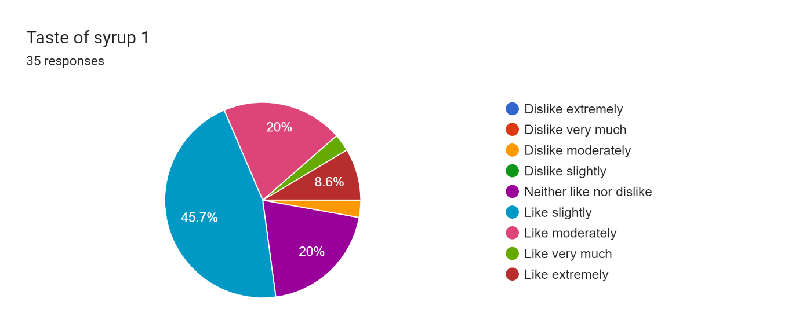

**Table No. Hedonic Scale for syrup 2 (n=35)**

|  |  |  |  |  |  |  |  |  |  |
| --- | --- | --- | --- | --- | --- | --- | --- | --- | --- |
| **Dislike extremely** | **Dislike very much** | **Dislike moderately** | **Dislike slightly** | **Neither like nor dislike** | **Like slightly** | **Like Moderately** | **Like very much** | **Like extremely** | **Total** |
| 01 | 00 | 02 | 06 | 10 | 07 | 08 | 01 | 00 | 35 |

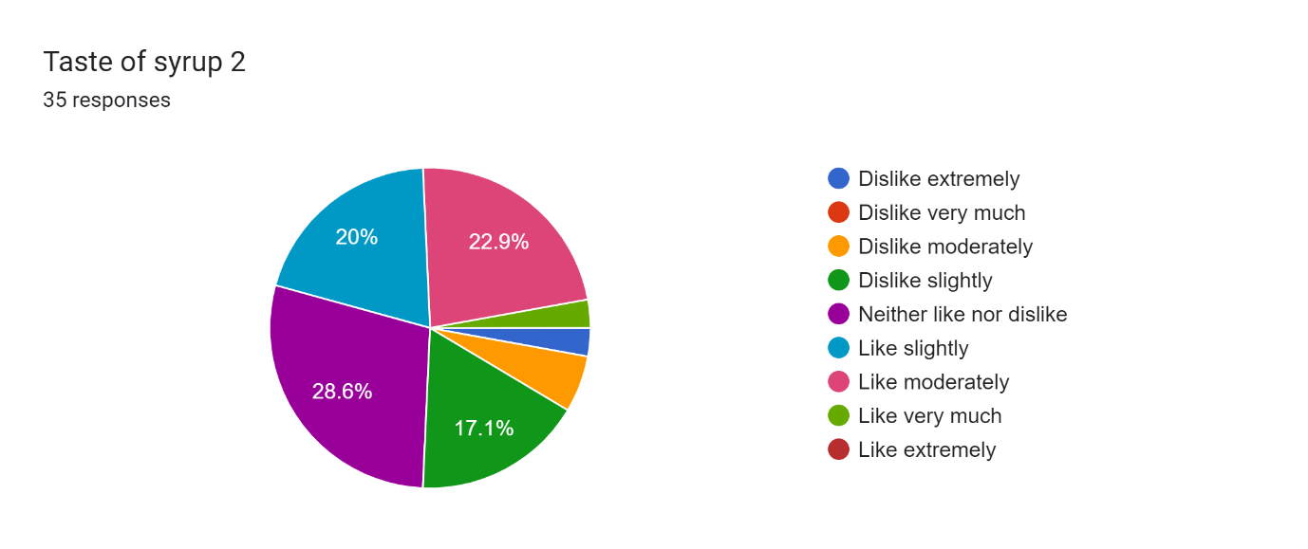

**Table No. Hedonic Scale for syrup 3 (n=35)**

|  |  |  |  |  |  |  |  |  |  |
| --- | --- | --- | --- | --- | --- | --- | --- | --- | --- |
| **Dislike extremely** | **Dislike very much** | **Dislike moderately** | **Dislike slightly** | **Neither like nor dislike** | **Like slightly** | **Like Moderately** | **Like very much** | **Like extremely** | **Total** |
| 01 | 01 | 01 | 03 | 08 | 15 | 04 | 01 | 01 | 35 |

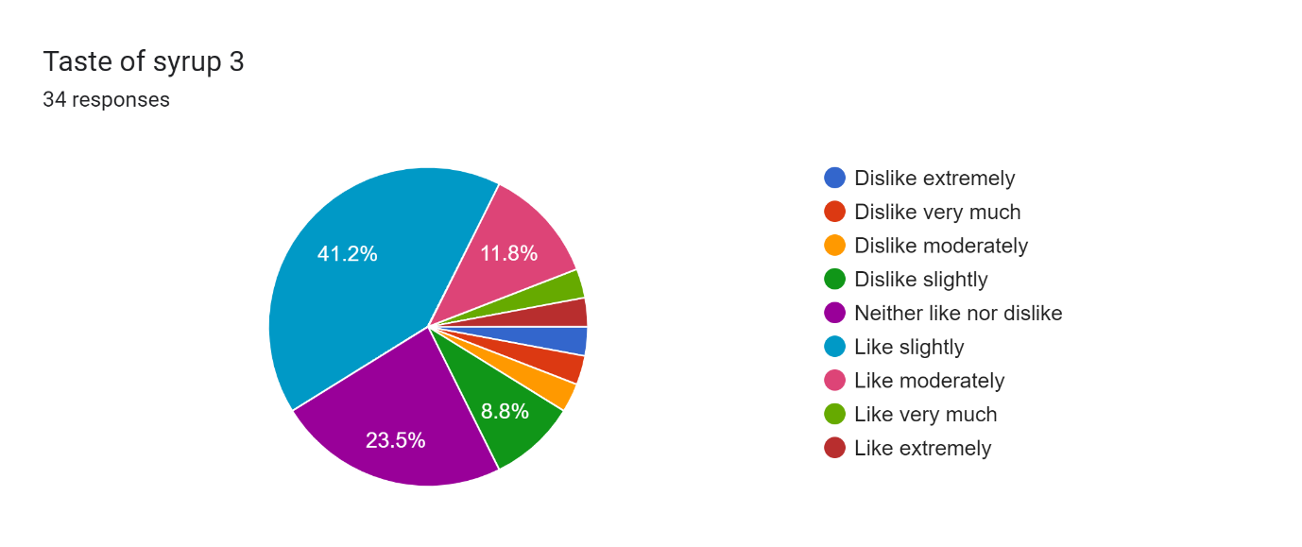

**Table No. Hedonic Scale for syrup 4 (n=35)**

|  |  |  |  |  |  |  |  |  |  |
| --- | --- | --- | --- | --- | --- | --- | --- | --- | --- |
| **Dislike extremely** | **Dislike very much** | **Dislike moderately** | **Dislike slightly** | **Neither like nor dislike** | **Like slightly** | **Like Moderately** | **Like very much** | **Like extremely** | **Total** |
| 00 | 00 | 00 | 00 | 01 | 02 | 03 | 08 | 21 | 35 |

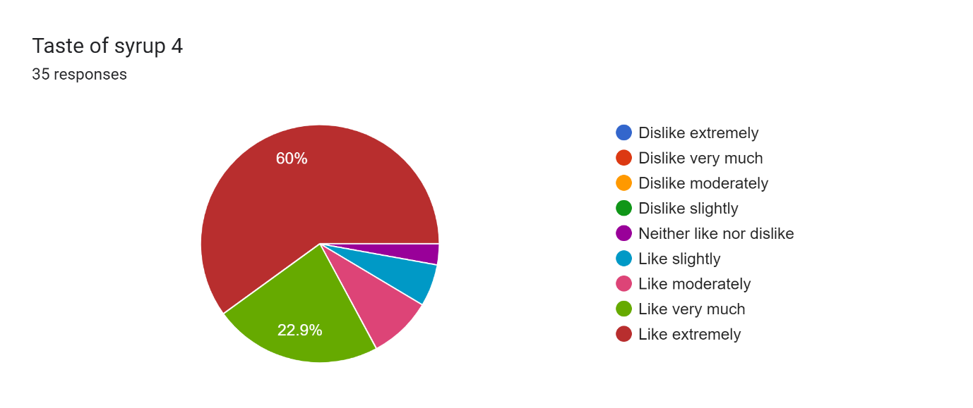

**Discussion:**

**Drug review:**

Date *(Phoenix dactylifera)* is a well-known fruit in relation of its multipurpose use such as blood purifier, diuretic, aphrodisiac, anti-inflammatory, promotes strength and bulk. Dateisknown for its sweetness and high fibre content, vitamins (especially B-complex), and minerals (like potassium and magnesium) it provides energy and supports digestive health [14]. Raisins *(Vitis vinifera)* are rich in vitamins, minerals and polyphenols, supporting heart health and antioxidant functions [15]. Pomegranate seeds *(Punica granatum)* are rich in antioxidants, vitamins (C and K), and minerals (potassium). Pomegranate contributes to cardiovascular health, has anti-inflammatory properties, and helps in managing oxidative stress. Indian gooseberry *(Emblica officinalis)* is renowned for its high vitamin C content, antioxidant and minerals (like calcium and iron). It boosts immunity, enhances skin health, supports liver function, and aids in digestion [16]. Tamarind *(Tamarindus indica)* contributes tartness and digestive properties due to its high fibre and antioxidant content. Kokumis used for its digestive benefits and potential in weight management. *Nagarmotha* *(Cyperus rotundus)* supports digestion and has anti-inflammatory properties [17].Rock salt provides essential minerals like sodium, potassium, calcium and magnesium, crucial for electrolyte balance, hydration and nerve function.

*Ojolyte* syrup is a polyherbal formulation of substances known for their nutritional and therapeutic qualities that is based on Ayurvedic principles. To promote health advantages in a synergistic way, the following herbs have been included: Dates *(Phoenix dactylifera),* pomegranate *(Punica granatum),* black raisin *(Vitis vinifera),* kokum *(Garcinia cambogia),* tamarind *(Tamarindus indica),* Indian gooseberry *(Emblica officinalis), Nagarmotha (Cyperus scariosus),* and Rock salt. The selection of these ingredients is based on Ayurveda, which uses them to promote antioxidant activity, improve electrolyte balance and promote general well-being.

Rock sugar is added as a preservative and sweetener, improving palatability and prolonging shelf life. *Ojolyte* syrup sets itself apart with its natural approach from conventional synthetic energy drinks, which usually contains artificial flavours and additives.

**Pharmaceutical study:**

*Ojolyte* syrup is prepared by the method described in Ayurveda. First, the herbs are prepared by washing, chopping and soaking in water. The mixture is extensively churned to extract the active ingredients (*Mantha kalpana*). After adding the rock sugar and boiling it to a syrup consistency (*Sharkara Kalpana*). This procedure ensures the retention of therapeutic properties while enhancing flavour and convenience of use.

**Analytical study:**

This analytical study aims to evaluate the quality and efficacy of the finished products. The Analytical studies encompassing organoleptic characteristics measuring loss on drying, Specific gravity, Total ash, Water soluble ash, Acid insoluble ash, Alcohol soluble extractive, Water soluble extractive, pH test, Brix value, Additionally, specific analysis using DPPH scavenging activity and palatability test were also conducted.

**Organoleptic Characters**: *Ojolyte* syrup exhibits characteristic features such as a sticky texture, brown colour and a taste profile described as sweet, sour and astringent. These sensory attributes which align with its herbal composition.

**Physio-Chemical Analysis**: Physio-chemical analysis of *Ojolyte* syrup involves a thorough evaluation of multiple factors to ensure its quality, stability and fulfilling Ayurvedic standards.

LOD values for individual herbs and the final syrup indicate low moisture content. LOD value of *Ojolyte* syrup is 47.69% ensuring stability and preventing microbial growth during storage. The density of the syrup is reflected in its specific gravity, which also affects viscosity, dosing precision, and overall quality. With a specific gravity of 1.1079 w/v, *Ojolyte* syrup demonstrated a viscosity and density that were ideal for convenient administration and optimal therapeutic effect. The total ash value, water soluble ash value and acid insoluble ash value of *Ojolyte* syrup is 0.76%, 0.088% and 0.106% respectively. Water soluble extractive value determines the amount of soluble active compounds in water, essential for assessing the herbal extraction process and therapeutic efficacy. Water soluble extractive value of *Ojolyte* syrup is 90.8% which indicates high solubility of active ingredients, ensuring effective bioactivity and absorption in the body. Alcohol soluble extractive value measures the quantity of active constituents soluble in alcohol, indicative of the presence of bioactive compounds like polyphenols and alkaloids. Alcohol soluble extractive value of *Ojolyte* syrup is 3% which demonstrates the extraction efficiency and concentration of beneficial phytochemicals, contributing to its therapeutic potential. pH value of *Ojolyte* syrup is 4.50 ensures optimal acidity level for palatability and efficacy, aligning with physiological conditions for better absorption and therapeutic action. Brix value evaluates the sugar concentration in the syrup, affecting taste, preservation, and compliance with formulation standards. Brix˚ of *Ojolyte* syrup is 76 indicates the sugar content derived from natural sources like rock sugar, enhancing palatability without compromising on health benefits.

The physio-chemical analysis of *Ojolyte* syrup confirms its compliance with Ayurvedic pharmacopeial standards, ensuring safety, efficacy, and quality. These parameters collectively validate the syrup’s stability, nutritional value, and therapeutic potential, supporting its use in promoting overall health, managing specific health conditions, and enhancing well-being. Analysis of single drugs and syrup shows synergistic effect.

**Modern Sophisticated Analysis**: The free radical DPPH is a quick, easy, and affordable method to test a compound's antioxidant capabilities. It is widely used to evaluate a compound's ability to function as a hydrogen supplier and free-radical scavenger. The DPPH test depends on the elimination of DPPH, a stabilized free radical. DPPH is indeed a dark-coloured crystalline compound composed of free-radical particles that are stable. In particular, it is a widely used antioxidant test and a well-known radical. Once, reduced and transformed into DPPH-H, the DPPH radical has a dark purple hue in solution, but when reduced as well as transformed into DPPH-H, it turns colourless or light yellow [18]. Several extractions of plants have been shown to neutralize DPPH radical scavenging activity, in vitro [19].

The DPPH test is used to estimate antioxidant activity based on the process through which antioxidants limit lipid oxidation, resulting in DPPH free-radical scavenging and therefore determining free-radical scavenging potential. As the analysis takes just a few minutes, this technique has been widely used. The DPPH free radical has a UV–vis absorbance peak of 515 nm, is extremely stable and reacts with hydrogen chemicals. The method relies on antioxidants scavenging DPPH, which, after a reduction process, decolorizes the DPPH methanol solution. This test measures the antioxidant's ability to reduce the DPPH radical [20].

The DPPH (1,1-diphenyl-2-picryl hydrazyl) scavenging activity test assess the antioxidant potential of *Ojolyte* syrup. This test demonstrated significant antioxidant activity, crucial for neutralizing free radicals and reducing oxidative stress, thereby supporting overall health.

Additionally, a palatability test using the Hedonic scale indicated high acceptability among participants, highlighting the syrup's pleasant taste and consumer appeal across different age groups.

**Conclusion:**

*Ojolyte* syrup exemplifies the integration of traditional Ayurvedic knowledge with modern analytical methods to create a potent and palatable nutraceutical formulation. Its formulation and preparation adhere strictly to Ayurvedic principles, ensuring safety, efficacy, and broad applicability across various health conditions. The syrup's significant antioxidant activity and nutrient-rich composition make it a promising natural alternative in promoting holistic health, supporting digestive function, enhancing immunity, and maintaining overall well-being.

Future research avenues may include clinical trials to further validate the therapeutic efficacy of *Ojolyte* syrup in specific health conditions such as post-chemotherapy recovery or as a daily health supplement. Further optimization in formulation techniques and packaging could enhance accessibility and usability in diverse healthcare settings. Comparative studies with synthetic energy drinks could provide insights into the relative advantages of natural versus synthetic formulations in promoting overall health and well-being, making the way for broader acceptance and integration of Ayurvedic nutraceuticals in modern healthcare practices.

**References:**

1. Brower V. Nutraceuticals, Poised for a healthy slice of; healthcare market, Nat Biotechnol,1998,Page No.728-731
2. Patil AR. Nutraceuticals and Ayurveda: The Intersection of Traditional Medicine and Modern Science. Nanotechnology Applications in Medicinal Plants and their Bionanocomposites: An Ayurvedic Approach. 2024 May 2:396.
3. Deshmukh KS. Ksheerpaka Kalpana-Nutraceutical in Ayurveda. Int Ayurveda Publ. 2017;2(5):657-64.
4. Vd. Yadavji Trikamji Acharya & Narayanram Acharya, Sushrut Samhita, Choukhamba Prakashan,5th edition, 1992, Page No.498-499
5. Kutty DM. *A Comparative Pharmaceutico-Analytical and Invitro Study of Simhasyadi Kwatha and Its Modified Form as Sharkara WSR to Organisms Causing Respiratory Tract Infections* (Doctoral dissertation, Rajiv Gandhi University of Health Sciences (India)).
6. Angadi Ravindra. A textbook of Bhaishajya Kalpana Vijnana, new revised edition 2022, Varanasi, Chaukhamba Surbharati Prakashan, Page no. 147.
7. Pham-Huy, L. A., He, H., & Pham-Huy, C. (2008). Free radicals, antioxidants in disease and health. International journal of biomedical science: IJBS, 4(2), 89–96.
8. Shrimanker, I.; Bhattarai, S. Electrolytes. In StatPearls;StatPearls Publishing: Treasure Island, FL, 2023.
9. Shanmugapriya M, Patwardhan K. 27 Uses of Date Palm in Ayurveda. Dates: production, processing, food, and medicinal values. 2012 Apr 20;20:377.
10. Weihrauch MR, Diehl V. Artificial sweeteners—do they bear a carcinogenic risk?. Annals of Oncology. 2004 Oct 1;15(10):1460-5.
11. Oplatowska-Stachowiak M, Elliott CT. Food colors: Existing and emerging food safety concerns. Critical reviews in food science and nutrition. 2017 Feb 11;57(3):524-48.
12. Nariya PB, Bhalodia NR, Shukla VJ, Acharya R, Nariya MB. In vitro evaluation of antioxidant activity of Cordia dichotoma (Forst f.) bark. AYU (An International Quarterly Journal of Research in Ayurveda). 2013 Jan 1;34(1):124-8.
13. Baliyan S, Mukherjee R, Priyadarshini A, Vibhuti A, Gupta A, Pandey RP, Chang CM. Determination of antioxidants by DPPH radical scavenging activity and quantitative phytochemical analysis of Ficus religiosa. Molecules. 2022 Feb 16;27(4):1326.
14. Valko, M.; Leibfritz, D.; Moncol, J.; Cronin, M.T.; Mazur, M.; Telser, J. Free radicals and antioxidants in normal physiological functions and human disease. *Int. J. Biochem. Cell Biol.* 2007, *39*, 44–84.
15. SANTOSH N, KHATAVAKAR DM. THERAPUTIC EEFECTS OF AYURVEDA FRUITS.
16. RG R, Eapen J. COMPARATIVE PHYTOCHEMICAL ANALYSIS OF FRUIT OF DRAKSHA (VITISVINIFERA LINN) AND KAASHMARI (GMELINAARBOREA ROXB).
17. Jain A, Garg N. Therapeutic and medicinal uses of amalaki: A review. World J Pharm Res. 2017;6(02):512-24.
18. Sridhar, K.; Charles, A.L. In vitro antioxidant activity of Kyoho grape extracts in DPPH and ABTS assays: Estimation methods for EC50 using advanced statistical programs. *Food Chem.* **2019**, *275*, 41–49.
19. Aini, F.; Maritsa, H.; Riany, H. Antioxidant activity of nipahendophytic fungi (*Nypha fruticans* Wurmb) from Tanjung JabungTimur Jambi. *J. Biota* **2019**, *5*, 104–109.
20. Kirkinezosa, I.G.; Morae, C.T. Reactive oxygen species and mitochondrial diseases. *Cell Dev. Biol.* **2001**, *12*, 449–457.