**Chapter - 12**

**Case Studies and Best Practice**

**Introduction**

Climate change has a huge impact on health making it a health crisis. Health systems are key to both stopping and dealing with these effects. Climate change already affects health in many ways. It changes how diseases spread through vector borne illnesses, messes up food supplies, and causes death and sickness from more extreme weather. To address this, we need to bring green practices into primary care and link them with top-notch treatment.*(1)*

Hospitals and clinics around the world harm the environment a lot in rich countries. In recent years, health care has released 2.7 billion tons of CO2 or similar gases. This is 5.2% of all the world's emissions making the problem worse. In England, the NHS alone makes up 4% of the country's total carbon output (NHS England and NHS Improvement 2020).

According to estimates, approximately 50 % of the carbon footprint of general practice in the UK is related to the prescription of pharmaceuticals. However, new data from Australia indicates that diagnostic imaging and pathology tests account for 9% of the carbon footprint of healthcare. Clinical and instructions procedures account for the majority of health care emissions. On World Health Day 2008, Margaret Chan, the director general of the World Health Organization, estimated that malaria, diarrhoea, and infectious diseases would lead to more fatalities globally due to climate change. In a more recent study, the UCL-Lancet Commission termed climate change "the biggest threat to global health in the 21st century" and emphasised the even more likely effects of armed conflict over productive land and population disorientation. Therefore, it could be suggested that the medical community has an exemption to lead the effort to tackle climate change. In addition, the health sector will inevitably be compelled to lower its emissions as a result of international commitments and regional carbon reduction rules.*(1)*

A low-carbon health service will employ:

* the lowest carbon technologies
* be more efficient at preventing sickness
* facilitate people greater autonomy regarding their health
* be leaner in its development and delivery*(1)*

**Sustainability in quality improvement framework (SusQI)**

The “SusQI” framework is an approach for incorporating sustainability concerns into conventional healthcare quality improvement procedures, assessing quality not just on the basis of medical outcomes but also on the "triple bottom line"—the impact on the environment, society, and economy. It involves altering the way we provide services, promoting health, increasing preventive, practicing corporate social responsibility, and developing more sustainable care models. By lowering avoidable healthcare activity, enhancing service safety, efficacy, and efficiency also enhances the triple bottom line.*(2)*

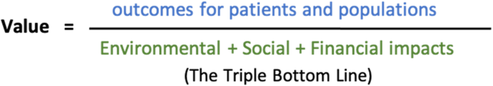

Figure12. 1 Sustainable value in healthcare (2)

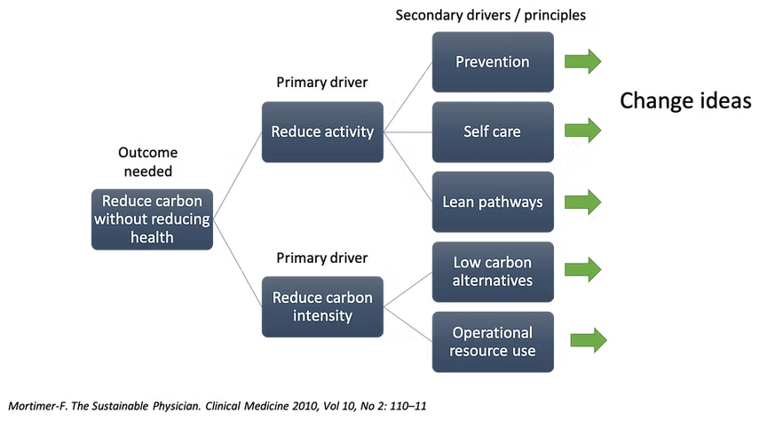

Figure 12.2 Applying sustainable clinical practice principles in quality improvement.(3)

**Principle of sustainable clinical practice**

Sustainable clinical practice is based on four principles outlined through the Campaign for Greener Healthcare.

* **prevention of illness** - Specialties are encouraged to address the economic, social, and environmental influences of health—the root causes of disease—both in individual patient treatment and via broader advocacy. The environmental co-benefits of healthy lifestyles, such as the reductions in carbon emissions and improving air quality.(*1*)
* **patient self-care** - Empowering many individuals to take an active role in managing their own health and treatment could halt the advancement of the disease and prevent consequences. Additionally, knowledgeable patients can help clinical teams cooperate more efficiently to avoid misinterpretation or duplication.*(1)*
* **lean service delivery -** Promoting medical judgment in the choice and focus of therapies will reduce low-value activities and the environmental effects they cause. Specialties can help with this by defining specific patient routes alongside providing precise, fact-based advice. By integrating patient, staff, and laboratory sample information with information from online records, email, and the phone, trip emissions can be decreased even in situations when clinical input is highly valued. *(1)*
* **low carbon alternatives -** This study focused on sustainable medication prescriptions, covering non-pharmacological alternatives, systematic medical follow-ups, start packages, medical waste disposal, and selecting the least damaging alternatives, as well as healthcare supplies, equipment, fabrics, and technologies. Other significant pharmacological suggestions included prescribing dry powder inhalers in place of metered dosage inhalers to minimize needless greenhouse gas emissions and avoiding medications like fluoroquinolones due to their innate resistance.*(1)*

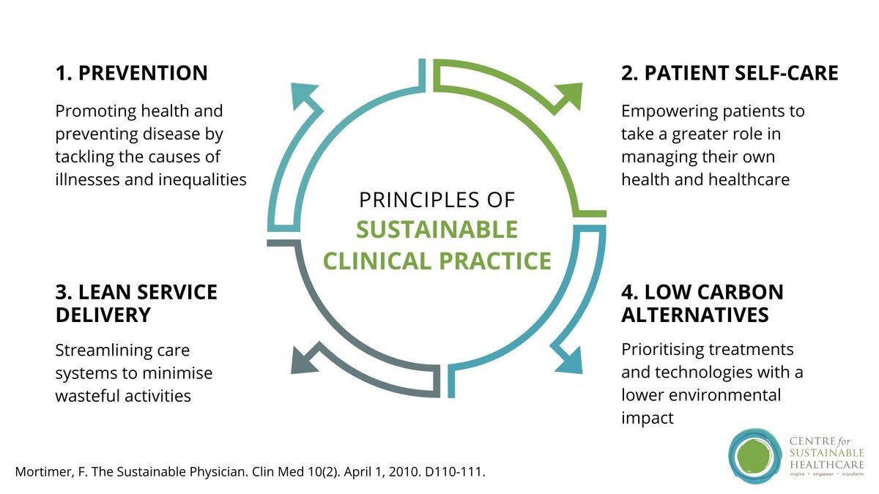

Figure 12.3 Principles of sustainable clinical practice.

Methods for minimizing the healthcare field's carbon footprint concentrate on lowering the carbon intensity of services or the sheer amount of healthcare that is required. Health promotion, illness prevention, assisted self-management, lean, efficient routes, low-carbon alternatives like "greener" respirators and anaesthetics, and waste and procurement issues are a few of these. Enhancing social fairness, access to healthcare, employee and supplier safety and welfare, and focus on social determinants of health are some strategies for social sustainability in the healthcare industry.*(1)*

**Benefits of SusQI**

* Enhancements in patient and group clinical outcomes
* Reduction in greenhouse gas emissions from the provision of wellness services
* Emphasize enhancing the social value of offering services.
* Eliminating or reducing the financial burden of providing healthcare.
* Enabling patients the tools to deal with their climate-related issues
* Empowering employees to increase workplace satisfaction and effect good change. *(2)*

**Primary care within a sustainable HealthCare system**

The foundation of the healthcare system is strong primary care, which is characterized as incorporated, all-encompassing first-contact care. This relates to a more efficient health system. There is substantial research of the benefits of effective primary care systems. Strong primary care has been linked to decreased mortality, enhanced population health outcomes, and more affordable expenses for healthcare, as demonstrated by systematic literature examinations.*(4)*

In responsibility for care coordination, the general practitioner is the gatekeeper. Structured chronic illness management, persistent data-driven quality improvement through computerized drug prescription decision support, and capitation-based reimbursement per registered patient are the program's primary components. Long-term health results were supposed to be improved by the program. (strong and sus pH).*(4)*

**Case study: sustainable use of prescribing and medicine**

Approximately 25% of NHS carbon emissions result from pharmaceuticals. Most of these emissions (20%) occur from the production, acquisition, transportation, and usage of medications, with inhalers accounting for 3% and anesthetic gases contributing 2% of the remaining 5%.*(5)*

It is anticipated that the growing and aging global population would raise the importance and consumption of medicines, which are essential to society. However, increasing consumption of medications also increases exposure to the environment, that affects the ecosystem and has a negative long-term impact on our health, such as through antibiotic resistance and reproductive anomalies.

Alarmingly drugs and their metabolites pose a risk to ecosystems and public health through damage to the environment. For both pharmaceutical companies and environmental regulatory authorities, antimicrobial resistance is a significant concern. This resistance is evident in environmental samples of extended range beta lactamase and carbapenemase-producing bacteria caused by pharmaceutical pollution.

In addition to addressing these pressing public health concerns, medications and the regulation of pharmaceutical manufacturing serve a crucial role in preserving and improving health in general. The all over the world clinical pharmacology community needs to come collaboratively and take action to make sure that the creation, production, distribution, and use of medications have a carbon footprint that is sustainable, do not adversely affect the environment, and promote treatment equity. A number of pharmaceutical companies have made significant investments in R&D to explore novel solutions, and the pharmaceutical industry should be praised for its ambitious objectives and time frames for net zero emissions. In clinical practice, customized drugs and medication optimization are developing "culture-shift" areas that will inevitably benefit patients and eventually save money*(5)*.

**Case study: Sustainable practice in radiological imaging**

The increasing requirement for medical imaging services enhances the ecological impact of medical imaging departments (MID) in addition to arising workload.

The economic pillar of medical imaging is predicated on an evaluation of the suitability of all radiological procedures since medical imaging is founded on the interconnection of radiation protection principles, such as the justification principle, "value-based radiology," and sustainability.

The healthcare industry uses a lot of energy and water and generates a wide variety of waste, making it a high resource consumer and waste generator. Heating, air conditioning, ventilation, laundry, food services, and informatics systems are the primary sources of energy usage. MID has an important contribution to the environmental impact of healthcare systems. There are several things that may be accomplished, such reducing energy, water, recovery and recycling of contrast agents’ iodine and gadolinium from waste and patients and waste production while improving recycling, utilizing biodegradable materials, and encouraging healthy habits like attending medical imaging conferences virtually.

A compelling reason to embrace and uphold technology in an environmentally conscious way as new eco-friendly technologies can lessen their negative effects on the environment. Instead of relying on entirely replacements, which can be more resource-intensive and have a significant environmental impact, the maintenance strategy should take into account the possibility of future equipment upgrades. Enhancing radiographers' expertise in environmental sustainability may encourage radiology departments to adopt a more sustainable culture.   
The respondents had an extensive knowledge of environmental sustainability concerns. For instance, they acknowledged that they already implement mitigation measures by turning off equipment at the conclusion of their shift and that energy consumption is an important indicator of environmental effect in radiology. By lowering expenses and enhancing patient safety, these programs can also reduce their negative effects on the environment and bring radiology practices into line with global sustainability objectives.*(6)*

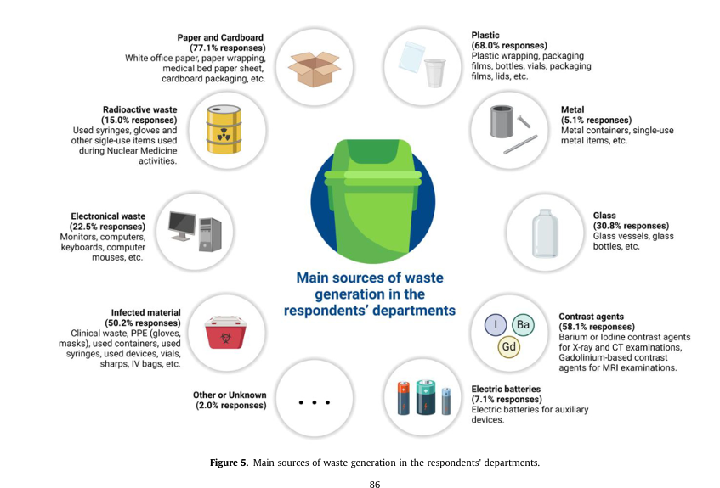

Figure 12. main sources of waste generation in the respondent’s departments(7)

**Case study: Reusable medical textiles in operating theatres**

Reusable alternatives should be used to substitute resource-intensive single-use medical equipment, such as disposable medical textiles, in order to mitigate the environmental effect of healthcare.

To ensure an in-depth comprehension of the complex variables influencing circular medical textile systems, undertake qualitative interviews with important stakeholders such as OT personnel, suppliers, procurement companies, laundry service providers, and subject matter experts. Single-use surgical components, such as disposable gowns and drapes, are a major source of the ecological footprint of operations performed by NHS OTs.

We suggest three interventions that can help with the transition to reusable medical textiles:

* the proactive engagement of infection control specialists to reassure occupational therapy professionals and establish the safety of reusable medical textiles
* the provision of education concerning the environmental impact of reusable versus disposable textiles
* the requirement of reforming supply chains and acquisition processes to comply with the NHS's net-zero emissions imperative.*(8*)

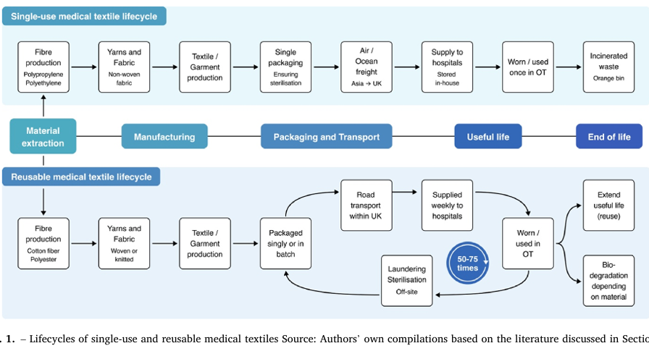

Figure 12.Llifecycles of single-use and reusable medical textiles sources(8)

The study that identifies possible facilitators and obstacles for the adoption of reusable medical textiles in healthcare is then examined in light of the underutilization of these devices in OTs. These include:

(1) an increased awareness of the significant environmental impact of disposables

(2) the relative costs of purchasing reusables and disposables

(3) the differences in performance between reusables and disposables

(4) healthcare personnel's perceptions

(5) the medical textile supply chain structures

(6) the healthcare industry's ability to launder and sterilize

The adoption of reusable medical textiles, which are responsible for 14–31% of medical waste, has been mainly encouraged by the sustainability mandate since the NHS set the lofty goal to achieve Net Zero emissions by 2040.*(8*)

**Case study: Green practice operating theatres**

In order to advance global health and the health of the environment, the health sector should set an example by becoming greener and leaving a smaller ecological impact. This a study discusses the effects of volatile anaesthetic’s, nitrous oxide (N2O), intravenous drug waste, single-use devices, and the energy usage of HVAC (heating, ventilation, and air conditioning) systems on the environment.*(9)*

**Volatile anesthetic agents** - The aim of the 1987 Montreal Protocol was to gradually replace the use of chlorofluorocarbons with hydrofluorocarbons worldwide. Because of medical need, neither protocol limited the use of volatile anaesthetic’s, despite the fact that anaesthetic gases are hydrofluorocarbons (desflurane, sevoflurane) and chlorofluorocarbons (isoflurane). In 2014, 3 million tons of CO2 were released as hydrofluorocarbon and chlorofluorocarbon anesthetic gases, with desflurane contributing to 80% of the emissions.GWP100 (global warming potential) estimates for desflurane are significantly greater than those of sevoflurane and isoflurane, which are both widely used drugs.*(9)*

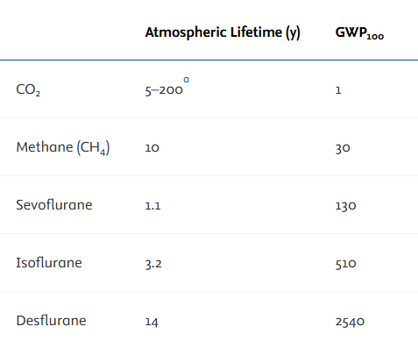

Figure 12. Atmospheric lifetime and global warming potential of volatile anesthetic’s compared with other known greenhouse gases(9)

**Restore waste anesthesia gas** - In general, scavenged waste anesthetic gas (WAG) is released straight from the hospital's roof. However, a number of technologies are being developed to capture WAG before to its release into the environment, with the ultimate objective of destroying, storing, or purifying and reusing it. In this method activated charcoal use for adsorption of the volatile WAG*.(9)*

**Case study: COVID- 19 pandemic impact greening of nosocomial environment**

The COVID-19 outbreak has caused a huge impact in the worldwide need for N95 respirators and surgical masks. This has led to shortages, costs in the billions, and tons of medical trash. If every healthcare worker used a new N95 respirator daily, we'd need 3.29 billion of them, spend $2.83 billion, and create 37.22 million kg of waste. Using respirators, you can sterile and reuse, with filters cleaned by H2O2 vapor, would cut costs to $831 million and make 1.58 million kg of waste. Decontamination and reusing masks could help us use fewer N95 respirators and surgical masks, reduce expenses, and make less trash.*(9)*

**Case study: a forensic ward service user-led quality improvement project**

A 16-bed male forensic rehabilitation unit team performed a quality-improvement effort directed by service users between May 2022 and May 2023. Instead, then treating acute disease, the program supports the rehabilitation of those returning to the community after experiencing a mental health crisis. The investigation found that single-use cutlery strains hospital waste management systems and contributes to plastic pollution, which is a worldwide concern for healthcare systems. Within a year, the team's project aimed to lower the consumption of single-use plates, glasses, and silverware by 80%. Plans to customize the plates and cups were in the works, but the ward's strict safety requirements made this impossible. Service users were often reminded to bring their non-disposable dishes and silverware to meals. Every day, a service user was tasked with gathering and cleaning the reusable goods in order to promote personal accountability.

Among the difficulties the project faced was the loss of utensils which required more purchases. Eventually, though, the service users adjusted, and the practice of bringing and cleaning reusable goods became standard procedure. This development demonstrated the potential for behaviour modification as well as the advantages of regular reinforcement. From an average of £173 per month at baseline (May 2022) to £79 per month by the end of testing in May 2023, the ward's monthly ordering expenses for single-use cups, cutlery, and plates decreased by 54% over the trial.*(10)*

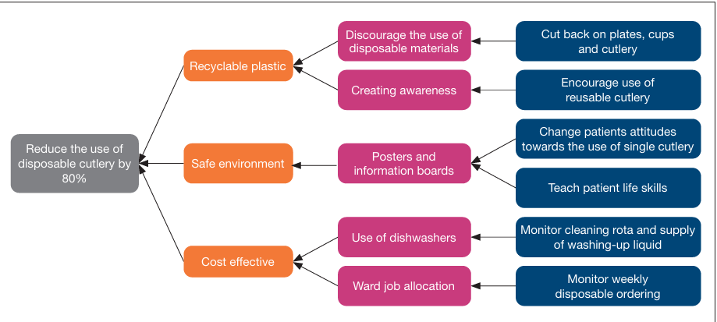

Figure12. Flow chart of disposable cutlery quality improvement project carried out on a male forensic rehabilitation ward(10)

**Sustainable medical waste management**

Green healthcare refers to an additional evaluation for healthcare providers and organizations, which includes integrating sustainable practices into the provision of medical care. The absence of structure in hospitals regarding disposal of waste is one of the primary obstacles. Compared to other sorts of waste, waste generated during health care activities have the highest potential risk of infection and harm. According to scientific research, as compared to household garbage, 75–90% of the waste created in hospital nosocomial is risk-free.

According to the World Health Organization (WHO), the most frequently encountered issues with healthcare waste include a lack of economic and human resources, a lack of waste administration and disposal systems, a lack of training in proper waste management, ignorance of the health risks associated with the waste, and a lack of attention to the issue.

* advised strategies to ensure appropriate waste segregation and minimize the amount of trash generated.
* the implementation of procedures and plans that progressively develop waste removal, destruction, and segregation processes with the goal to eventually meet global standards.
* The introduction of safe and sustainable methods for handling hazardous medical waste (such as autoclaving, microwaves, chemical treatment, etc.) rather to burning medical trash.
* expanding awareness of secure procedures and the hazards associated with medical waste.
* employing sustainable and safe organizational approaches will protect employees from hazards at work such as gathering, managing, storing, transporting, processing, or getting rid of garbage.*(11)*

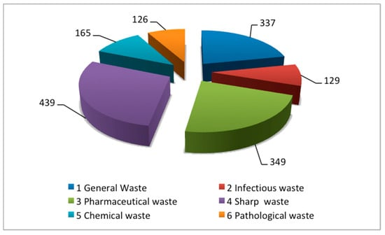

Figure12. Production rate (Kg/day) of different waste fractions for all hospitals in Swat District, Pakistan(12)

**References**

1. Mortimer F. The sustainable physician. Clinical Medicine. 2010 Apr;10(2):110–1.

2. Clery P, d’Arch Smith S, Marsden O, Leedham-Green K. Sustainability in quality improvement (SusQI): a case-study in undergraduate medical education. BMC Med Educ. 2021 Dec;21(1):425.

3. Monsell A, Krzanowski J, Page L, Cuthbert S, Harvey G. What mental health professionals and organisations should do to address climate change. BJPsych Bull. 2021 Aug;45(4):215–21.

4. Sawicki OA, Mueller A, Klaaßen-Mielke R, Glushan A, Gerlach FM, Beyer M, et al. Strong and sustainable primary healthcare is associated with a lower risk of hospitalization in high risk patients. Sci Rep. 2021 Feb 23;11(1):4349.

5. Adeyeye E, New BJM, Chen F, Kulkarni S, Fisk M, Coleman JJ. Sustainable medicines use in clinical practice: A clinical pharmacological view on eco‐pharmaco‐stewardship. Brit J Clinical Pharma. 2022 Jul;88(7):3023–9.

6. Ghotra SS, Champendal M, Flaction L, Ribeiro RT, Sá Dos Reis C. Approaches to reduce medical imaging departments’ environmental impact: A scoping review. Radiography. 2024 Jun;30:108–16.

7. Roletto A, Catania D, Rainford L, Savio A, Zanardo M, Bonfitto GR, et al. Sustainable radiology departments: A European survey to explore radiographers’ perceptions of environmental and energy sustainability issues. Radiography. 2024 Jun;30:81–90.

8. Der Klink MV, Demirel P. Implementing reusable medical textiles in NHS operating theatres: Barriers and enablers. Journal of Cleaner Production. 2025 Feb;491:144852.

9. Gordon D. Sustainability in the Operating Room. Anesthesiology Clinics. 2020 Sep;38(3):679–92.

10. McAllister S, Brown J, Chitewe A, Frasquilho F, Hodgkinson S, Lomax P, et al. Towards environmentally sustainable healthcare: using quality improvement to deliver a net zero NHS. British Journal of Healthcare Management. 2024 Aug 2;30(8):1–16.

11. Lee SM, Lee D. Effective Medical Waste Management for Sustainable Green Healthcare. IJERPH. 2022 Nov 10;19(22):14820.

12. Ahmad R, Liu G, Santagata R, Casazza M, Xue J, Khan K, et al. LCA of Hospital Solid Waste Treatment Alternatives in a Developing Country: The Case of District Swat, Pakistan. Sustainability. 2019 Jun 26;11(13):3501.