**Late-Time Cosmic Acceleration in Modified Gravity Models**

Bal Krishna Yadav*1, Atanu Nag1 and Pooja2

1Department of Physics, School of Sciences, IFTM University, Moradabad-244102

2Research Scholar, Department of Physics, School of Sciences, IFTM University, Moradabad-244102

* balkrishnalko@gmail.com

**Abstract:** Some mysterious form of the energy, known as dark energy, is responsible for this cosmic acceleration. This chapter discusses thoroughly different cosmological models which can describe the observed evolution of the universe along with their detailed comparative features. These models include different modified gravity models like *f*(*R*) gravity, scalar-tensor theories, Gauss-Bonnet gravity and Braneworld models. At the local scales (galactic scale), we do not need any modification in general theory of relativity. So, we consider the mechanisms in which the effect of modification vanishes.

**1. Introduction**

There exists an uncertainty among the cosmological models that may consistently describe the observed evolution of the universe. Over the past century, the observational knowledge about the universe has been mainly acquired through electromagnetic waves (from γ-rays to radio waves), as signals carrying messages about the sources and the inter-galactic medium to our earth-based or space-based detectors of electromagnetic waves. Cosmic Microwave Background Radiation (CMBR) anisotropies gave us information about the early universe when it was about 3,80,000 years old [1]. Interestingly, another revolution came with the Gravitational Waves (GWs) [2, 3], discovered in 2015, and we got excited to think about using their characteristics to be able to fix this indeterminacy among cosmological models. Immediately after the generation of GWs, it propagates freely in the early universe. So, it carries information about its generation processes. GWs provide information about the state of the universe at different epochs. This is done at energy scales which are inaccessible by any other means. At present, the Lambda Cold Dark Matter (ΛCDM) model, also treated as the standard model of the universe, is the widely accepted model largely explaining the evolution of the universe. Of course, while the cosmological constant Lambda, once put by Einstein himself into his equations of General Relativity (GR) for some historical reasons, is the simplest candidate of the *dark energy* [4] to explain the present accelerated expansion of the universe, its large value (in comparison to the energy density of the dark energy) is a serious problem, among several others. Therefore, scientists, attempted to explore the alternative theories of gravity, especially *f*(*R*) theories, in contrast to the so called standard approach to gravitation based on GR. The ongoing fervent research activity across the world in this field, There are several observational evidences to confirm current accelerated expansion phase of the universe [5-7]. Some mysterious form of the energy, known as dark energy, is responsible for this cosmic acceleration. From the observation of the galaxy rotation curves and other observations, it is found that there exists some unknown form of the matter in the galaxies [8-12]. It is known as the *dark matter*. There are several authors, who studied the dark matter problem in alternative gravity theories in references [13-16]. We have many approaches to explain the nature of dark energy. These approaches, broadly classified into (i) modified matter and (ii) modified gravity models can be obtained by the modification of the Einstein’s general theory of relativity (GTR). The Lagrangian of the Einstein-Hilbert (E-H) action in GTR is modified in two different ways. In modified gravity models, the gravitational part of the E-H action is changed. A new form the matter component is added in the matter part of the action in case of modified matter models [17-23]. Quintessence, k-essence and phantom dark energy models are different modified matter models. In this chapter we will describe the modified gravity models in order to explain the cosmic acceleration.

**2. Modified gravity models**

The quantization of the gravity is studied in modified gravity models. A lot of research in these models has been done in order to explain the inflation and present accelerated expansion of the universe. In modified gravity models, the geometrical part of the E-H action is modified in different ways. There are many gravity models in this group like *f*(*R*) gravity, scalar-tensor theories, Braneworld models, Gauss-Bonnet gravity model and Horndeski model etc [24-35]. In this chapter, we will discuss the different modified gravity models briefly. We do not have a cosmologically viable *f*(*R*) model till now. Therefore, we want to constrain these models by using the direct detection of GWs. It will improve in our present understanding of the laws of gravity. With the help of GWs we can probe the energy scales far beyond the reach of the presently available observational probes of the universe which are based on electromagnetic emission. Since GWs are detected recently in 2015, cosmological theories are not so much probed using GWs as a tool [36-39]. Unified gravity models are used to explain the dark energy and dark matter problems by a single scalar field [40, 41].

The scalar field equation of motion is similar to that of the damped harmonic oscillator [42-43]. The solution of this equation is obtained from the action-angle formalism [44-48]. It is found that the scalar field particle mass depends upon the energy density of the non-relativistic matter. These particles are known as “scalaron”. From this analysis we found that scalar field may behave as the non-relativistic matter, radiation and dark energy also. Further, the conformal transformation from the physical frame (Jordan frame) to the Einstein frame provides a scenario of two (apparently distinct) formulations of f(R) gravity theory. It is still not clear whether these two formulations are fundamentally equivalent or not [49], even though their mathematical equivalence at the level of classical action is more convincing than the physical one [50, 51]. Authors have addressed the problem of mathematical equivalence at quantum scales [52]. Anyways, as it remains today, this equivalence is a controversial topic that may show a path to deeper physics.

**2.1 *f*(*R*) gravity models**

These are the simplest form of the modified gravity models. In these models, the Ricci scalar (*R*) is replaced by its function. The 4-dimensional action of the *f*(*R*) gravity models is given as

 (1)

where . *f*(*R*) is a general function of *R*, *g* is the determinant of the metric tensor  and  is the action of the matter fields. There are two formalisms to derive the field equations from the action (1). These are (i) metric formalism and (ii) Palatini formalism.

In metric formalism, we consider the usual relation between  and Christoffel symbol. Taking the variation of the action (1) w.r.t. the metric  gives

 (2)

*F*(*R*) represents the first derivative of *f*(*R*) w.r.t. *R*,  represents covariant derivative and  represents the energy-momentum tensor of the matter. The trace of the field equation (2) is:

 (3)

where *T* represents the trace of .

The dynamics of the *f*(*R*) gravity models can be studied by assuming a dynamic, homogeneous and isotropic universe. The line element to describe the homogeneous and isotropic space-time, known as the Friedmann-Lemaitre-Robertson-Walker (FLRW) space-time, is defined as



where *a*(*t*) is the cosmic time t dependent scale factor.

is defined as



where the values of *K*, called as the spatial curvature, is $-$ 1, 0, +1 respectively for open, flat and closed geometries. describes the 3-dimensional space in spherical polar coordinates, with their usual symbols. Here, we consider the spatially flat FLRW space-time in which the Ricci scalar *R* is



where *H* and  respectively represent the Hubble parameter and its time derivative. For equations (2) and (3), by using components of flat FLRW space-time metric, we get



and 

Here  and  respectively stands for the energy densities corresponding to matter and radiation. An overdot represents the time derivative. We have discussed about a general *f*(*R*) gravity model till now.

In the Palatini approach, we consider  and christoffel symbols as independent quantities. The field equations in this formalism is given as

 (4)

Ricci tensor in Palatini formalism is different than that in the metric formalism. The trace of the field equation (3) is given as

 (5)

***2.1.1 Conformal transformation and scalar field in f(R) gravity models***

We consider that the *F*(*R*) is equivalent to a scalar field and the trace of the field equation represents the motion of the scalar field. In *f*(*R*) gravity, scalar field is defined as the conformal transformation of the space-time metric in the Jordan frame to that of the Einstein frame. For the conformal transformation of the space-time metric from the Jordan to the Einstein frame we can use the following equation:

 (6)

where  and  respectively represents the space-time metric in the Einstein and Jordan frame.  is the conformal factor. Here we consider the quantities in Einstein frame with a tilde symbol. The Ricci scalar in both frames are related as

 (7)

where  (8)

represents the partial derivative.

 (9)

where 

In the Einstein frame, equation (9) can be modified as

 (10)

where  is the determinant of . Considering the conformal factor  as

 (11)

and a scalar field *ϕ* defined as

 (12)

The action (10) becomes

 (13)

where 

This scalar field results from the modification in the gravitational part of the Einstein’s GTR.

The variation of the action, as given by equation (13), w.r.t. scalar field gives the field equation:

 (14)

where  and . is the D’Alembertian operator in the Einstein frame.

Equation (14) represents the equation of motion of the scalar field. We can rewrite the equation (14) as

 (15)

where 

The *scalaron* mass () has been calculated for

 (16)

type models [53]. Here  is a constant and  is a model parameter having constant values. It is found that  depends on the energy density of the non-relativistic matter.

Figure 1 shows the variation of  with  for the energy density of matter *ρ* = 4 10-42 (GeV)4 at the galactic scale.

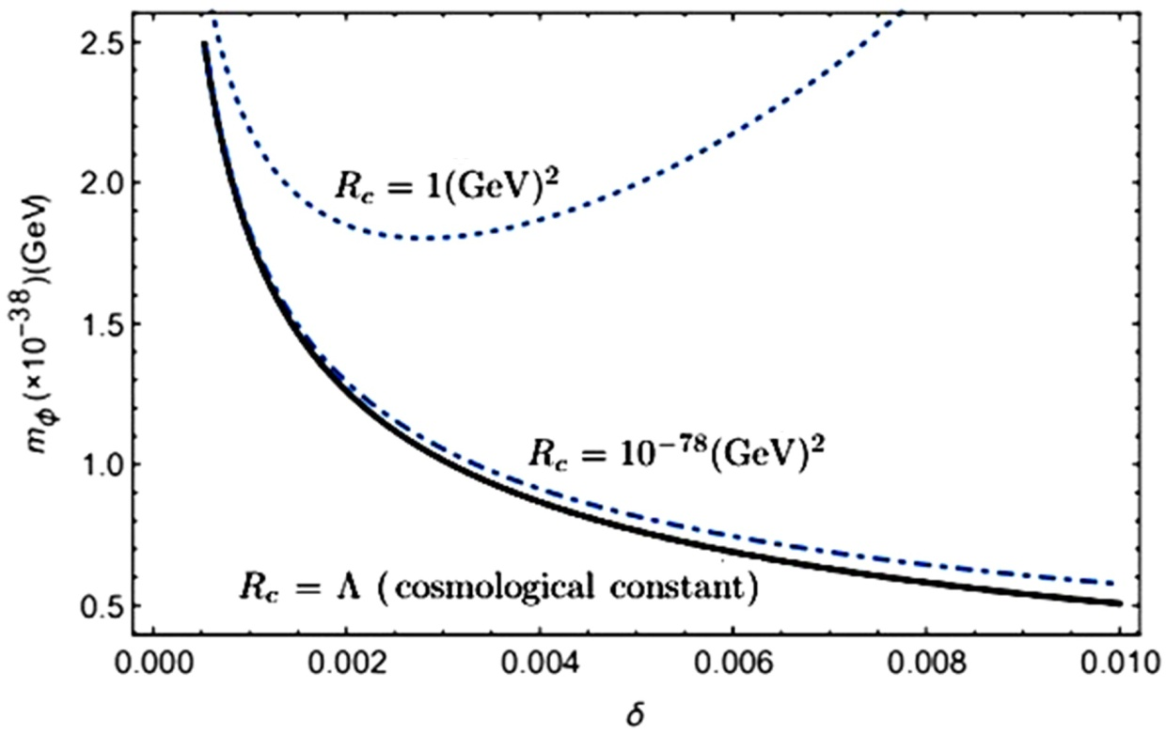

Figure 1. Variation of  with  for *ρ* = 4 10-42 (GeV)4 at the galactic scale [53].

Figure 2 shows the variation of  with *ρ* for *Rc* = Λ.

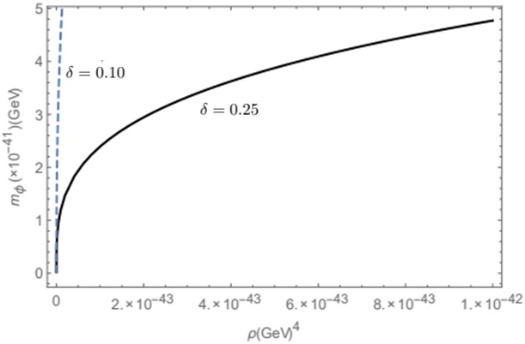

Figure 2. Variation of  with *ρ* for *Rc* = Λ for *δ* = 0.10 and *δ* = 0.25 [53].

Figure 3 illustrates the variation of  with *ρ*.

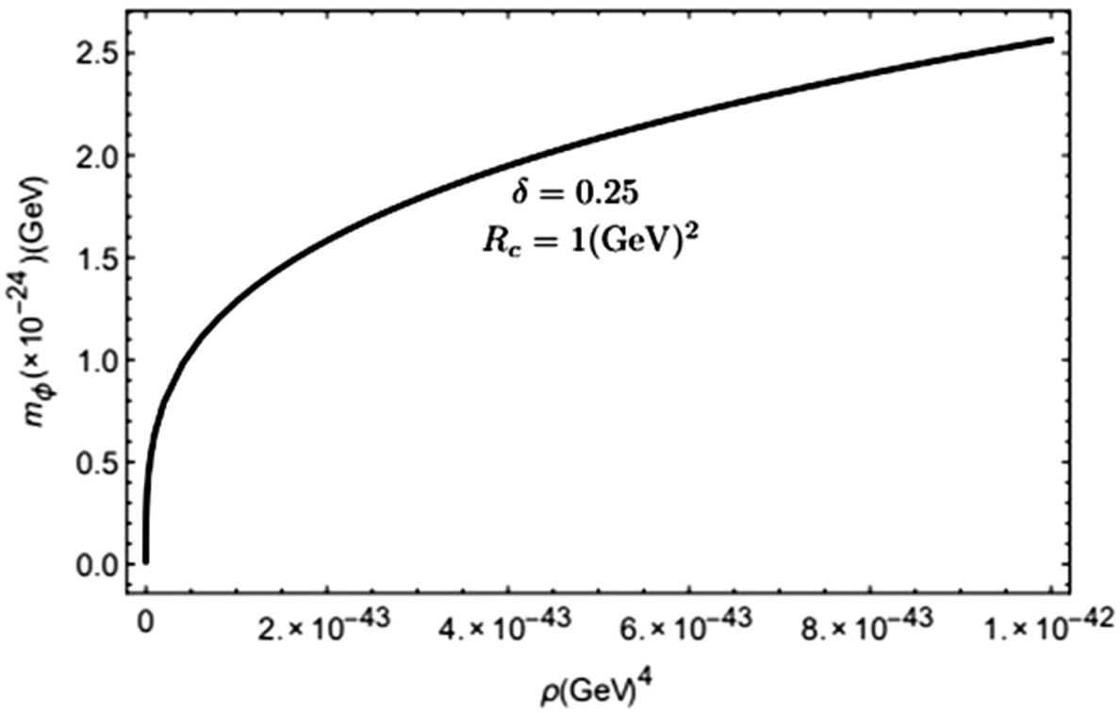

Figure 3. Variation of  with *ρ* for *δ* = 0.25 and for *Rc* = 1 (GeV)2 [53].

Figure 4 gives the variation of the equation of state (*w*) with the energy density () of scalar field. It is found that *w* is zero at and becomes positive at higher densities.

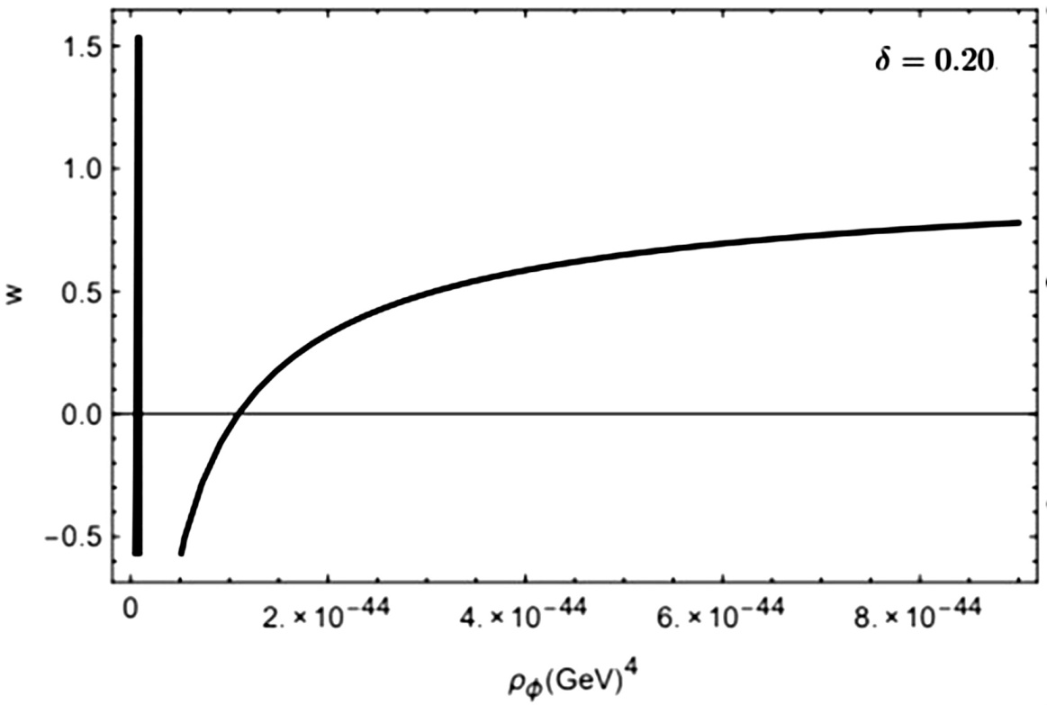

Figure 4. Variation of the *w* with of scalar field for *δ* = 0.20 [53].

Investigation of *w* for a power-law model of *f*(*R*) establishes that it varies with the energy density of non-relativistic matter. From this analysis we found that scalar field may behave as the non-relativistic matter, radiation and dark energy also.

**2.2 Scalar-tensor theories**

In the scalar-tensor theories, the action can be defined as:

 (17)

where  and  represents the scalar field and the action of the matter fields. is a function of  whereas *f* is a function of the scalar field  and *R*. Here, we have chosen units for which. Now, similar to the case of *f*(*R*) gravity, we consider the conformal transformation of the space-time metric from the Jordan to the Einstein frame. Here, the conformal factor is given as:

 (18)

Let us consider the model

 (19)

Under the conformal transformation, action (17) of scalar tensor theories becomes

 (20)

in the Einstein frame. Here we have defined a new scalar field  given as

 (21)

The potential of the new scalar field is given by

 (22)

**2.3 Gauss Bonnet Dark energy models**

We have taken a general function of *R* in the Lagrangian of the *f*(*R*) gravity models. In scalar-tensor theories we consider a function of the Ricci scalar and a scalar field. It is also possible to choose a combination of Ricci tensors () and Riemann tensors () in the Lagrangian. In these models a Gauss-Bonnet term is coupled with the scalar field. The action of Gauss Bonnet models is given by

 (23)

where

 (24)

**2.4 Braneworld models**

In these models, we consider that the particles are in 3-dimensional brane, embedded in a 5-dimensional bulk space-time.

 (25)

where  represents the space-time metric in the 5- dimensional bulk and represents the metric in brane. Other symbols;

 (26)

where Planck masses in 5- and 4-dimensions are respectively denoted as and .

**3. Comparison of the different modified gravity models**

Table 1 gives a comparative study among the different modified gravity models by focusing on their main characteristic features.

**Table 1.** Comparison of the different modified gravity models

|  |  |  |  |
| --- | --- | --- | --- |
| **Sl.**  **No.** | **Modified gravity models** | **Features of the different models** | **References** |
| 1. | *f*(*R*) gravity | 4-dimensional gravity theory, Lagrangian is only a function of the *R* (Ricci scalar) | *f*(*R*) gravity models are studied by authors of references [24-27]. |
| 2. | Scalar-tensor theories | Lagrangian is a function of scalar field and *R* | These theories are given in references [28, 29] |
| 3. | Gauss-Bonnet gravity models | Lagrangian is a function of *R*, ,  and scalar field | Different Gauss-Bonnet models are discussed in references [30, 31]. |
| 4. | Braneworld models | Lagrangian is a function of the *R* and extra dimensions are considered. | These models are studied in the references [32, 33]. |

**4. Conclusions**

This chapter discusses on the different modified gravity theories (*f*(*R*) gravity, scalar-tensor theories, Gauss-Bonnet gravity and Braneworld models) in which dark energy and dark matter problems are explained by modifying the E-H action of GTR. To study the gravity at quantum scales, we modify the E-H action and replace the Ricci scalar by a function of Ricci scalar *R*. We do not have a suitable *f*(*R*) gravity model to explain the whole cosmic evolution. Similarly other modified gravity models faces different problems. At the local scales (galactic scale), we do not need any modification in GTR. So, we consider the mechanisms in which the effect of modification vanishes. Some of the important aspects of this study are:

* Scalar-tensor theories are more general theories of gravity. In these models, scalar field and metric tensor are the gravity mediators. Brans-Dicke theory is an example of these theories.
* *f*(*R*) gravity model can be obtained as a special case of the scalar-tensor theories if we consider and .
* In high density regions, the mass of the scalar field increases and the motion of the scalar field seize and effect of the modification is weared off. Similarly, there are other screening mechanisms, which are used to vanish the modification of gravity.
* In Braneworld models, late-time cosmic acceleration happens due to large extra dimensions.
* A scalar field, Ricci tensor, Ricci scalar and Riemann tensor is considered in the Gauss-Bonnet model.

**References**

1. D. N. Spergel et al., Astrophys. J. Suppl. 148, 97 (2003).
2. B. P. Abbott et al., Phys. Rev. Lett. 116 (6), 061102 (2016).
3. B. P.Abbott et al. Phys. Rev. Lett. 119, 161101 (2017).
4. M. Kunz and D. Sapone, Phys. Rev. Lett. 98, 121301 (2007).
5. A. G. Riess et al., (Supernova Search Team Collaboration), Astron. J. 116, 1009 (1998).
6. B. Schmidt et al., Astrophys. J. 507, 46 (1998).
7. S. Perlmutter et al., Astrophys. J. 517, 565 (1999).
8. V. C. Rubin, W. K. Ford and N. Thonnard, Astrophys. J. 238, 471 (1980).
9. A. Borriello and P. Salucci, Mon. Not. R. Astron. Soc. 323, 285 (2001).
10. V. K. Sharma and M. M. Verma, Eur. Phys. J. C (EPJC).
11. V. K. Sharma, B. K. Yadav and M. M. Verma, Eur. Phys. J. C (EPJC), 81, 109, (2021).
12. V. K. Sharma, B. K. Yadav and M. M. Verma, Eur. Phys. J. C (EPJC), 80, 619, (2020).
13. C. G. Boehmer, T. Harko and F. S. N. Lobo, Astropart. Phys. 29, 386 (2008)
14. T. Katsuragawa and S. Matsuzaki, Phys. Rev. D 95, 044040 (2017).
15. R. Zaregonbadi, M. Farhoudi and N. Riazi, Phys. Rev. D 94, 0840052 (2016).
16. S. Nojiri and S. D. Odintsov, Proceedings, 17th Workshop on General Rel- ativity and Gravitation in Japan (JGRG17): Nagoya, Japan, December 3-7, 2007, 03, (2008).
17. T. Katsuragawa, T. Nakamura, T. Ikeda and S. Capozziello, Phys. Rev. D 99, 124050 (2019).
18. A. Goldstein et al., Astrophys. J. 848, L14 (2017).
19. S. M. Carroll, Living Rev. Relativ. 4, 1 (2001).
20. P. J. E. Peebles and B. Ratra, Rev. Mod. Phys. 75, 559-606 (2003).
21. R. R. Caldwell, R. Dave, and P. J. Steinhardt, Phys. Rev. Lett. 80, 1582 (1998).
22. T. Chiba, T. Okabe, and M. Yamaguchi, Phys. Rev. D 62, 023511 (2000).
23. R. R. Caldwell, Phys. Lett. B 545, 23 (2002).
24. S. Capozziello, Int. J. Mod. Phys. D 11, 483 (2002).
25. A. A. Starobinski, Phys. Lett. B 91, 99(1980).
26. A. D. Felice and S. Tsuzikawa, Living Rev. Relativity 13, 3, (2010).
27. L. Amendola, R. Gannouji, D. Polarski and S. Tsujikawa, Phys. Rev. D 75, 083504 (2007).
28. L. Amendola, Phys. Rev. D 60, 043501 (1999).
29. N. Bartolo and M. Pietroni, Phys. Rev. D 61, 023518 (2000).
30. S. Noziri, S. D. Odintsov and M. Sasaki, Phys. Rev. D 71, 123509 (2005).
31. G. Calcagni, S. Tsujikawa and M. Sami, Class. Quant. Grav. 22, 3977 (2005).
32. G. R. Dvali, G. Gabadadze and M. Porrati, Phys. Lett. B 485, 208 (2000).
33. V. Sahni and Y. Shtanov, JCAP 0311, 014 (2003).
34. S. Nojiri and S. D. Odintsov, Phys. Rept. 505, 59 (2011).
35. A. K. Sharma and M. M. Verma, Astrophys. J. (ApJ), 926 (1), 29, (2022).
36. P. Creminelli and F. Vernizzi, Phys. Rev. Lett. 119, 251302 (2017).
37. C. P. L. Berry and J. R. Gair, Phys. Rev. D 83, 104022 (2011).
38. P. I. Dyadina, J. Exp. Theor. Phys. 135, 333 (2022).
39. H. R. Kausar, L. Philippoz and P. Jetzer, Phys. Rev. D 93, 124071 (2016).
40. V. Sahni and L. Wang, Phys. Rev. D 62, 103517 (2000).
41. S. S. Mishra, V. Sahni and Y. Shtanov JCAP 06, 045 (2017).
42. M. S. Turner, Phys. Rev. D 28, 1243 (1983).
43. M. M. Verma and B. K. Yadav, Int. J. Mod. Phys. D 27, 1850002 (2018).
44. E. Masso, F. Rota and G. Zsembinszki, Phys. Rev. D 72, 084007 (2005).
45. S. Dutta and R. J. Scherrer, Phys. Rev. D 78, 083512 (2008).
46. B. K. Yadav and M. M. Verma, Int. J. Mod. Phys. D 26, 1750183 (2017).
47. H. Goldstein, Classical Mechanics.
48. L. D. Landau and E. M. Lifshitz, Mechanics (Butterworth- Heinemann, Oxford, UK, 1976).
49. V. Faraoni and E. Gunzig, Int. J. Theor. Phys. 38, 217 (1999).
50. D. N. Vollick, Class. Quant. Grav. 21, 3813 (2004).
51. S. Capozziello et. al, Phys. Lett. B 689, 117 (2010).
52. A. Y. Kamenshchik and C. F. Steinwachs, Phys. Rev. D 91, 084033 (2015).
53. B. K. Yadav and M. M. Verma JCAP 10, 052(2019).