Chapter 19
Emerging Pathogens and Novel Diagnostic Challenges
Abubakar Yaro^{1, 2, 3*}

*Corresponding author

Abubakar Yaro
AHRO Center for Academic Research
Email: Abubakar_yarogh@yahoo.com

Abstract

COVID-19 caused by SARS-CoV-2 which caused one of the most devastating pandemic of our generation has shown that the threat of emerging and re-emerging pathogens is real. Globalization had turn the world into a global village where an individual can travel across continents within few days. This has therefore increased the risk of the rapid transmission of pathogens across the globe. Emerging and re-emerging pathogens are associated with risk factors including climate change, antimicrobial resistance, and international travels. Detection and identification of these emerging pathogens is important in managing outbreaks. Currently, there are two main tools used in detecting and identifying infectious agents: traditional and molecular-based assays. This chapter will be reviewing these techniques and discuss some of the challenges associated with these platforms.

Key words: Emerging, pathogens, reemerging, diagnostic, challenges, traditional approach, molecular-based, assay, mutation

Introduction

Since the beginning of human life, humans and pathogenic agents have had “race of life” in which the battle for survival has been the hallmark. These can be attributed to rapid evolution of these microbes and their ability to adapt that have led to bacteria, viruses, and parasites becoming more resistant to human defence mechanism. Some zoonotic pathogens are able to “jump” from animals to humans to become major human pathogens (1). The human immunodeficiency virus (HIV), the causative agent of acquired immunodeficiency syndrome (AIDS) is known to have jumped from nonhuman primate (2). In recent time, one of the most deadly pandemic to have emerged was from bats and pangolins (3). Based on prediction, the World Health Organization has placeholder name for the next epidemic or pandemic and placed priority for research and development (https://web.archive.org/web/20200301083134/http://origin.who.int/blueprint/priority-diseases/en/).
Human evolution has played significant role in the evolution of microbes; with some pathogens becoming more virulent over the course of human history where the make-up of human genome of has been affected by evolution. For example, when human malaria parasite has been found to possess lesser ability to infect an individual who have globin gene alleles that result in their red blood cells becoming unfit host for intracellular pathogens. Furthermore, most of the human immune system make-up may have evolved overtime to prevent pathogenic agents from embracing human cellular machinery that promotes microbial gene expression and replication (4). However, it should be added that human benefits from the presence of non-pathogenic microbes.
Increased sophistication in human behaviour in addition to our capability of changing our natural environment has increased the possibility of the emergence and re-emergence of pathogens. Modern human activities have increased pathogen transmission e.g. air travel. The 2002 SARS epidemic was linked with air travel which started in Guangdong in China and spread to more than 29 countries with a reported 8422 cases with an associated 916 fatalities (5). In addition, Ebola virus is suggested to reside in bats as natural hosts from which virus is transmitted to human resulting in Ebola Virus Disease (EVD)
Antimicrobial agents, vaccines, effective disease control programs, and improved sanitation activities are some of the human activities that have led to decrease in the emergence of novel pathogenic agents. As we face uncertainty with regards to the next pandemic, it must be stated that population growth and urbanization are among the major risk factors that will facilitate the emergence of novel pathogenic diseases. As outlined by the United Report ( https://www.unfpa.org/sowp-2021) , it was estimated between 2008 and 2025, more than half of the global population will be staying in the urban areas. It was further estimated by 2050,, about 6 billion people of the total predicted 9.2 billion global population will be living in urban areas. With this come increased burden on resources such as clean water and natural habitat which can lead to higher temperature due to global warning that allows mosquitoes that carry disease pathogens to new areas. By our expansionist policy, humans try to expand to forest areas resulting in increased contract between human and wildlife resulting in human infections that were earlier unknown leading to the emergence of novel human pathogens with ability to cause disease. Furthermore, increased livestock production to meet the global demand may facilitate the emergence of new and re-emerging zoonotic diseases (1). Table 1 outlines some of the risk factors associated with the emergence of infectious pathogens.

Table 1: Risk Factors associated with emergence of infectious pathogens
Modern human factors including demographic, environmental, and behavioural are risk factors that favour spread of infectious pathogens include:
- Global travel
- Globalization of food supply and centralized food processing of food
- Population growth and increased urbanization as well as crowding
- Population movements as a result of civil wars, famines and other manmade or natural disasters
- Deforestation, irrigation, and reforestation programs that changes the habitats of disease carrying insects and animals
- Increased human contact with rainforests and other wilderness habitats that are reservoirs of insects, and animals that harbour unknown infectious pathogens
- Increased use of antimicrobial agents that facilitate the emergence of drug resistance strains
- Deteriorating public health infrastructure that impact control of diseases
- Climate changes
- Lack of political will to initiate disease control projects
- Release of pathogenic agents by terrorists intentionally.

Emerging and re-emerging pathogens are therefore major threat to international health globally. During the COVID-19 pandemic, the impact of this pandemic pathogen was felt across all facet of human life as the world was completely shut down which lead to significant direct and indirect costs. This motivated our interest in identifying some challenges that will be encountered when diagnosing emerging and re-emerging pathogens.
This chapter present an overview of advances in diagnostic methods for emerging and reemerging pathogens that are currently under development or under investigation, focusing on emerging viral pathogens, emerging bacterial pathogens, and emerging parasitic pathogens.

Emerging and re-emerging pathogens

Over the course of human history, epidemics and pandemics associated with infectious diseases have been reported with COVID-19 been the latest pandemic to plague the world. Earlier in the past, the world experienced a number of devastating epidemic and pandemics, including the plague of the mid-1300s, influenza in the early 1900s with led to more than 20 millions, and HIV/AIDS of which an estimated 39.9 million people were living with the virus at the end of 2023 (6,7). Other pathogens such as Mycobacterium tuberculosis and human malaria parasites are also burden due to the continuous emergence of resistant strains. Several new human pathogenic agents have been described. In the past, the World Health Organization and Centers for Disease Control and Prevention reported of more than fifty new or newly identified human pathogens in the past fifty years (6). However, new pathogens are being discovered at rapid rate. In 2019, the novel severe acute respiratory syndrome-coronavirus (SARS-CoV) was reported (8). Between December 2018 and May 2021, another virus, Langya virus was discovered in China after five people were diagnosed to have been infected by the virus (9, 10). What makes this virus interesting is, it belongs to the family Paramyxoviridae under the genus Henipavirus which was predicted by this author to be potential agent of the next pandemic. Researchers based at King’s and Guy’s and St Thomas also discovered new bacteria they named Variovorax Durovernensis which was isolated from prosthetic aortic graft of a shepherd. This was the first time Variovorax sp has been reported in human (11)

Table 2 Emerging and re-emerging pathogens causing diseases in humans (selected example
Year of discovery  2001  2002  2015  2019  2023  2025 | Agent  Human metapneumovirus  Severe Acute Respiratory Syndrome Coronavirus (SARS-CoV-1)  Zika Viurs  Severe Acute Respiratory Coronavirus (SARS-19)  Novel Brucella  Camp Hill virus | Disease in Human  Bronchiolitis, pneumonia  Pneumonia, bronchiolitis  Myalgia, lymphopenia, abnormal chest radiography results  Pneumonia, bronchiolitis  Rash, Headache, join pain, Myalgia, and conjunctivitis. Microcephaly and other congenital abnormalities  Myalgia, encephalitis with confusion, seizures, and coma  Asthenia, lower back, hepatomegaly | Reference  12  13  8  15  16  14

Emerging and re-emerging pathogens causes or previously known pathogens that have attained additional virulence traits and those that starts spreading in unaffected areas. Emerging and re-emerging pathogens can be classified into five groups: zoonotic- and vector-borne pathogens, drug-resistant pathogens, food-borne and water-borne pathogens, chronic infections that are due to infective pathogens and pathogens that are transmitted via blood transfusion and blood products.
Below are brief summaries of some pathogens who have gained status as emerging and re-emerging pathogens based on these categorization.

Vector-borne pathogen: Humanity has been plagued by vector-borne infectious agents for long time and these have been associated with high impact on public health systems across the globe. For example malaria and dengue continue to pose public health burden with the developing countries heavily affected. It must be stated that some vector-borne infectious agents have more significance than other. For example pathogens such as malaria, Chikungunya virus, Crimean-Congo hemorrhagic virus, dengue fever virus, West Nile fever virus, Rift Valley fever virus, Yellow fever virus and Zika virus are known mosquito-borne pathogens that continue pose significant public health burdens. Below is brief description of some emerging and re-emerging vector-borne pathogens.
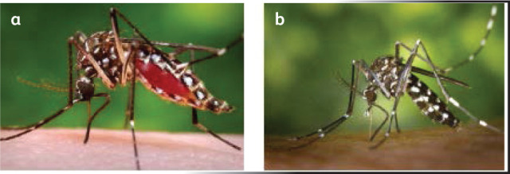
Figure 1: Aedes mosquitoes. Sources: Centers for Disease Control and Prevention. (a) Aedes aegypti mosquito and (b) Aedes albopictus mosquito

Zika virus (ZIKV)
ZIKV is a mosquito-borne Flavivirus that belong to the family Flaviviridae. It is an emerging virus consisting of positive single-stranded (ss) RNA virus that encodes a polyprotein precursor. It was first described in 1947 in Uganda from a rhesus monkey then later isolated from humans in South East Asia. Sporadic cases of ZIKV disease was reported until 2007 when ZIKV infection increased unexpectedly. It initially began in Micronesia, then spread to the Pacific Ocean Island then finally reaching the South of America in 2015 (17). No clear reason was ascertain as to why the unexpected emergence of this virus but certain suggestions were made. Several factors may be associated with the emergence of arboviruses including climate change which have an impact on vector distribution, viral mutation which results in the virus acquiring additional virulence and changes in the behaviour of the arthropod which leads to higher host-pathogen interactions; for example autochthonous transmission of ZIKV in Brazil from Pacific region was associated with two major events that were held in 2014: World cup and the World sprint (18). There are 3 lineages of ZIKV: the Africa, Asian, and Brazilian strains; with research suggesting that the African lineage is more virulent. There have been three major outbreaks of ZIKV infections. The Yap Island outbreak and sporadic cases reported in Southeast Asia from the late 2000s to mid-2010s; the French Polynesia outbreak and transmission in the Pacific Islands in the early 2010s; and the Brazil outbreak and transmission in the Americas in 2015-2016. It was declared a “public health emergency of international concern” by the WHO in 2016 (19, 20).

Dengue Fever
Dengue fever is caused by the Flaviviridae family belonging to the Flavivirus genus. It is transmitted via mosquito bite (figure 1) and found mostly in the tropical and subtropical areas (20). It is associated with asymptomatic manifestation to severe clinical manifestations which in certain cases results to multi-organ failures. In recent times, cases of incidence of dengue have increased exponentially with an estimated 100 to 400 million new infections occurring every year (21, 23). The Centers for Disease Control and Prevention estimated that there were more than 5 million new cases in more than 80 countries across the world with most cases reported in the Americas (3 million suspected and confirmed cases (24) while the several Africa countries including Angola, Mali, etc also reported of dengue outbreaks (25)
Dengue was first described in the 19th century in the Caribbean islands then from there the suggested was it was introduced to the New World from Africa as a result of slavery (21). From there, dengue passed through several timelines with the severity of the infection changing to more severe form. Dengue is regarded as emerging and re-emerging pathogen because increased urbanization, climate change and global warming, the ability of the mosquito vector adapting to new environments thereby resulting in its transmission to previously unaffected regions (22, 23). Dengue outbreak has been reported in areas where previously there have been no cases such as Europe (23). This has been associated with temperature rise where mosquitoes are able to survive and breed in areas where previously it was too cool for them to survive. For example it was reported that three confirmed cases occurred in France which was attributed to increased trend of global warming and high international travel rate which likely led to infection in warm weather (26).
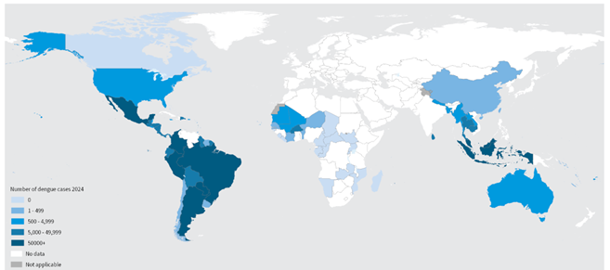Figure 2: Burden of Dengue from 103 countries in the WHO global dengue surveillance system as of 30 April 2024 (Source: WHO)
Chikungunya Virus (CHIKV)
CHIKV is another mosquito-borne pathogen that is gaining international public health concern due to its re-emerging ability and transmission in new areas thereby causing outbreaks with resultant high morbidity rate and potential long-term debilitating effects. It belong to the family Togaviridae of the genus Alphavirus. It was first reported in Tanzania in 1952 where it was referred to as “disease that bends up the joints” and has since spread to every continent except the Antarctica. Over the past decades, CHIKV has spread across the tropical and subtropical regions to temperate areas (Figure 3) with more than 97 outbreaks reported from 45 countries thereby gaining the status of a pathogen of emerging public health concern (27, 28). Since the start of 2025, and as of March, it was reported that about 80,000 new cases of CHIKV infections and 49 CHIKV-assocated deaths have been reported from 14 countries with cases reported from the Americas, Asia and Africa. However, no autochthonous cases have been reported in Europe in 2025, although 13,000 cases have been reported in the French region of Reunion (29, 30). Because of the serious risk associated with CHIKV on human, it was listed on WHO list of emerging pathogens with potential of causing future pandemic (31).

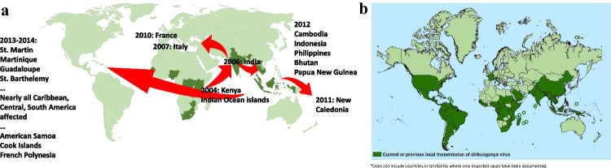
Figure 3: Spread of CHIKV with the dark green showing local spread as of 2004 in Kenya which subsequently spread across different areas (A) while the dark areas in B showed local transmission of the virus across the Americas (Source: 27)

Malaria
Malaria a mosquito-borne infection that is caused by 5 genera of Plasmodium (P): P falciparum, P vivas, P ovale, P malariae and P knowlesi. It is transmitted by Anopheles mosquito. (32). According to the WHO, as of 2023 263 million cases of malaria were reported while 597,000 malaria-associated mortalities were reported (33). Human malaria infection is now one of the most important re-emerging infectious diseases in the world which has been worsened by the continuous emergency of drug resistant strains to most malaria drugs including Artesunate Combination Therapy (ACT) (34, 35, 36). With climate change becoming a global burden, malaria might continue to be re-emerging pathogen.
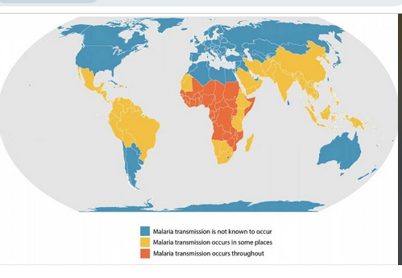
Figure 4: Incidence of malaria around the world (Source: WHO, 2023)

Zoonotic-borne Pathogens
Zoonotic infections are “Infections in animals that are transmitted to humans” According to the “Asia Pacific Strategy for emerging diseases: 2010” document, about 60% of the emerging human infectious diseases are zoonosis in nature with about 70% originating wildlife species (37). Factors such as urbanization, climate change, and international travel have been linked with the emergence and re-emergence as well distributions of zoonotic pathogens. Emerging zoonotic pathogen are considered as newly identified, newly evolved, or occurred in the past but is showing an increase incidence or transmission to new geographical regions , host, or vector. In most cases, human are affected because of close contract with animals who act as reservoirs for this emerging and re-emerging pathogens (38).
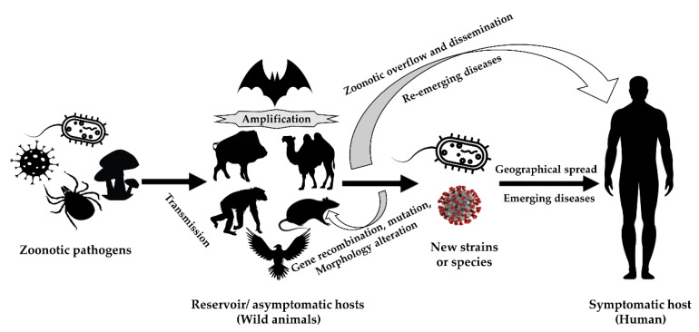
Figure 5: Role of wild animals in the process zoonosis (Source: 39)

Coronavirus disease 2019 (COVID-19)
COVID-19 is caused by severe acute respiratory syndrome coronavirus (SARS-CoV). It is associated with one of the most devastating pandemics in recent times. It was first reported to the WHO on 31 December 2019. On 12 January 2020, the WHO designated it as a novel coronavirus before later renaming it as severe acute respiratory syndrome coronavirus-2 (SARS-CoV-2). Om 11 March 2020, the WHO declared it as a global pandemic due to the rapid transmission of the virus to several countries (40). By 10 November 2024, over 776.8 million confirmed cases and over 7 million confirmed mortalities were reported to the WHO across 234 countries; with majority of COVID-19 linked deaths occurring in 2020, 2021, and 2022(41). COVID-19 is no doubt one of the deadliest pandemic to confront humanity. Data based on virological, epidemiological, and ecological indices established that the virus emerged directly or indirectly from β-coronavirus in the group sarbecovirus which naturally infects pangolins and bats. Before discussing factors that led to the emergence COVID-19, we must cast our mind back to the past. In 2004, the previously unknown coronavirus SARS-CoV emerged initially in China before spreading to about 27 countries. It nearly caused a pandemic and killed 813 out of the 8809 people infected before it was controlled. In 2012, another previously unknown coronavirus, Middle East respiratory syndrome coronavirus (MERS) which was closely related to SARS-CoV emerged in Saudi Arabia and was associated with high fatality in humans. However, MERS did not transmit efficiently between humans so the outbreak was localised to the Middle East where the host, dromedary camel exist with high number. Another novel coronavirus from bat was reported. This α-coronavirus also emerged from China and caused novel epizootic infection among pigs. It was named swine acute diarrhoea syndrome coronavirus (SADS-CoV). Before the outbreak of COVID-19, scientists have been raising alarm over the potential of a coronavirus outbreak due to large animal reservoirs for coronaviruses that spread across the globe. Bats, which are the known reservoir for coronaviruses are distributed globally with study reporting that bats are not only the evolutionary reservoirs of coronavirus but of the ecological drives of coronavirus diversity (3, 42). It has been suggested that animal and human interactions is the major risk factor for the emergence of novel coronaviruses ; including bat tourism, human consumption of wildlife bats and other supply chain, wet market, urbanization and land governance practices and environmental disruption. Furthermore, mutation which has led to the emergence of the virus into several genera such as alpha, beta, delta, deltacron, and omicron is fuelling the transmission of the virus around the globe. Risk mapping studies coupled with virological evaluation has shown that there risk of more coronavirus outbreaks remains high (Figure 5) (3, 42).
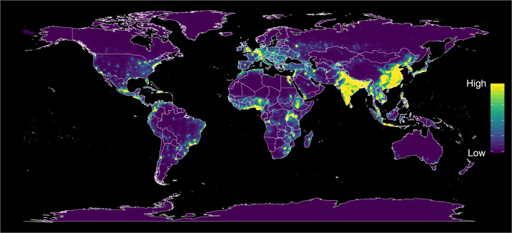
Figure 6: Predicted global hotspots for the emergence coronavirus diseases, with permission from (Source: 42)

Influenza Viruses (flu)
Flu is distributed globally and influenza viruses are pathogens of both human and animal. There are four major types of influenza; A, B, C and D. Based on antigenicity of hemagglutinin (HA) and neuraminidase (NA) proteins, influenza viruses are categorised into different subtypes. 16 HA subtypes and 9 NA subtypes have been reported in avian species. Human influenza is associated with annual epidemics which causes highly contagious respiratory infection that can result in severe disease and life threatening complications among high-risk individuals. Periodically, new human influenza virus strain evolves from animals that are transmitted rapidly within humans who do not have pre-existing immunity (43, 44). The emergence of novel influenza strains is due to antigenic drift (mutation) and antigenic shift (reassortment of the viral segmented genome). The world has experienced four major pandemic linked with influenza: the “1918-19 Spanish flu”, the “1957 Asia flu”, the “1968 Hong Kong flu” and the “2009 Swine flu” with the Spanish flue been one of the most devastating pandemic ever experienced which is reported to have cause approximately 500 million infections and almost 100 million-associated mortalities around the world (43). Occasionally, humans are zoonotically infected by animal influenza viruses (avian and swine flu). HA subtypes H5, H7 and H9 subtype are highly pathogenic among poultry which cause severe burden for the world’s poultry business. For example between January 2005 and November 2022, H5 subtype caused 8534 outbreaks with 389 million associated deaths of poultry around the globe (44). H7 viruses have also been causing outbreaks among domestic poultry. Between 2005 and 2022, highly pathogenic H7 subtypes were linked with 106 outbreaks and more than 33 million associated poultry deaths across the globe. Novel influenza viruses keeps emerging with 2020 -2023 panzootic outbreaks caused by H5N1 (HPAI) ( Figure 5) which lead to high economic losses, several geographic regions affected, and high number of species and individuals animals affected (45). This is of great concern as it indicates that there is change in the ability of influenza viruses in terms of host range and disease severity.

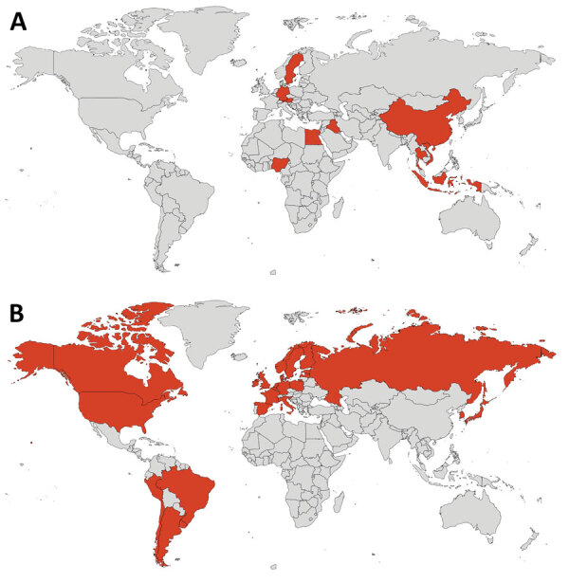
Figure 7: Geographical areas of mammal species affected by H5N1 in the past waves of infection, A. 2003-2019 outbreaks and B. 2020-2023 outbreaks (Source: 44)

Drug-resistant Pathogens
Drug resistant pathogens contribute to the spread of emerging and re-emerging pathogens. By acquiring mechanism of resisting drugs, there pathogens become difficult to treat thereby increasing the risk of transmission. Acquisition of resistant to drug contribute to the re-emergence of pathogens over time. Below is brief summary of two important pathogens which ability to resist drugs keeps fuelling their emergence over time

Drug Resistant gonorrhoea
Gonorrhoea is a sexually transmitted infection that is cause by Neisseria gonorrhoea which is high morbidity and has impact on global socioeconomic indices. Control of gonorrhoeal infection depends on prevention, appropriate diagnostic techniques and effective antibiotic therapy (46). However, antibiotic resistant gonorrhoea cases are on the increase with antimicrobial resistance (AMR) strains reported for almost all drugs used in the treatment of gonorrhoea, with emergence of extensively drug- resistant gonorrhoea emerging in France, Japan, and Spain (46,47). The recommended extended-spectrum cephalosporins (ESCs), ceftriaxone, and cefixime which are the first-line drug available are becoming treatment failures as a result of the development of resistance (46). In addition, azithromycin resistance has spread across the globe. Due to the rising cases of drug resistant gonorrhoea, the WHO has listed it as a high-priority pathogen (48).

HIV/AIDS
HIV is a typical emerging and re-emerging pathogen. First described in 1981, it is the cause of Acquired Immunodeficiency Syndrome (AIDS) (figure 6). There are two strains: HIV-1 and HIV-2; with HIV -1 being highly pathogenic and associated with pandemic while HIV-2 is less pathogenic. (49). Furthermore, multiple subtypes have been described as M,N, O, and P which were attributed to human to human transmission. Subtype M which is the most prevalent is further subtypes into A, B, and C with being the most prevalent globally. Many years later, HIV/AIDS is still a global public health burden with about 39 million people living with the virus while more than 35 million have died from AIDS (50). The HIV/AIDS pandemic is facilitated by diversity and drug resistance.

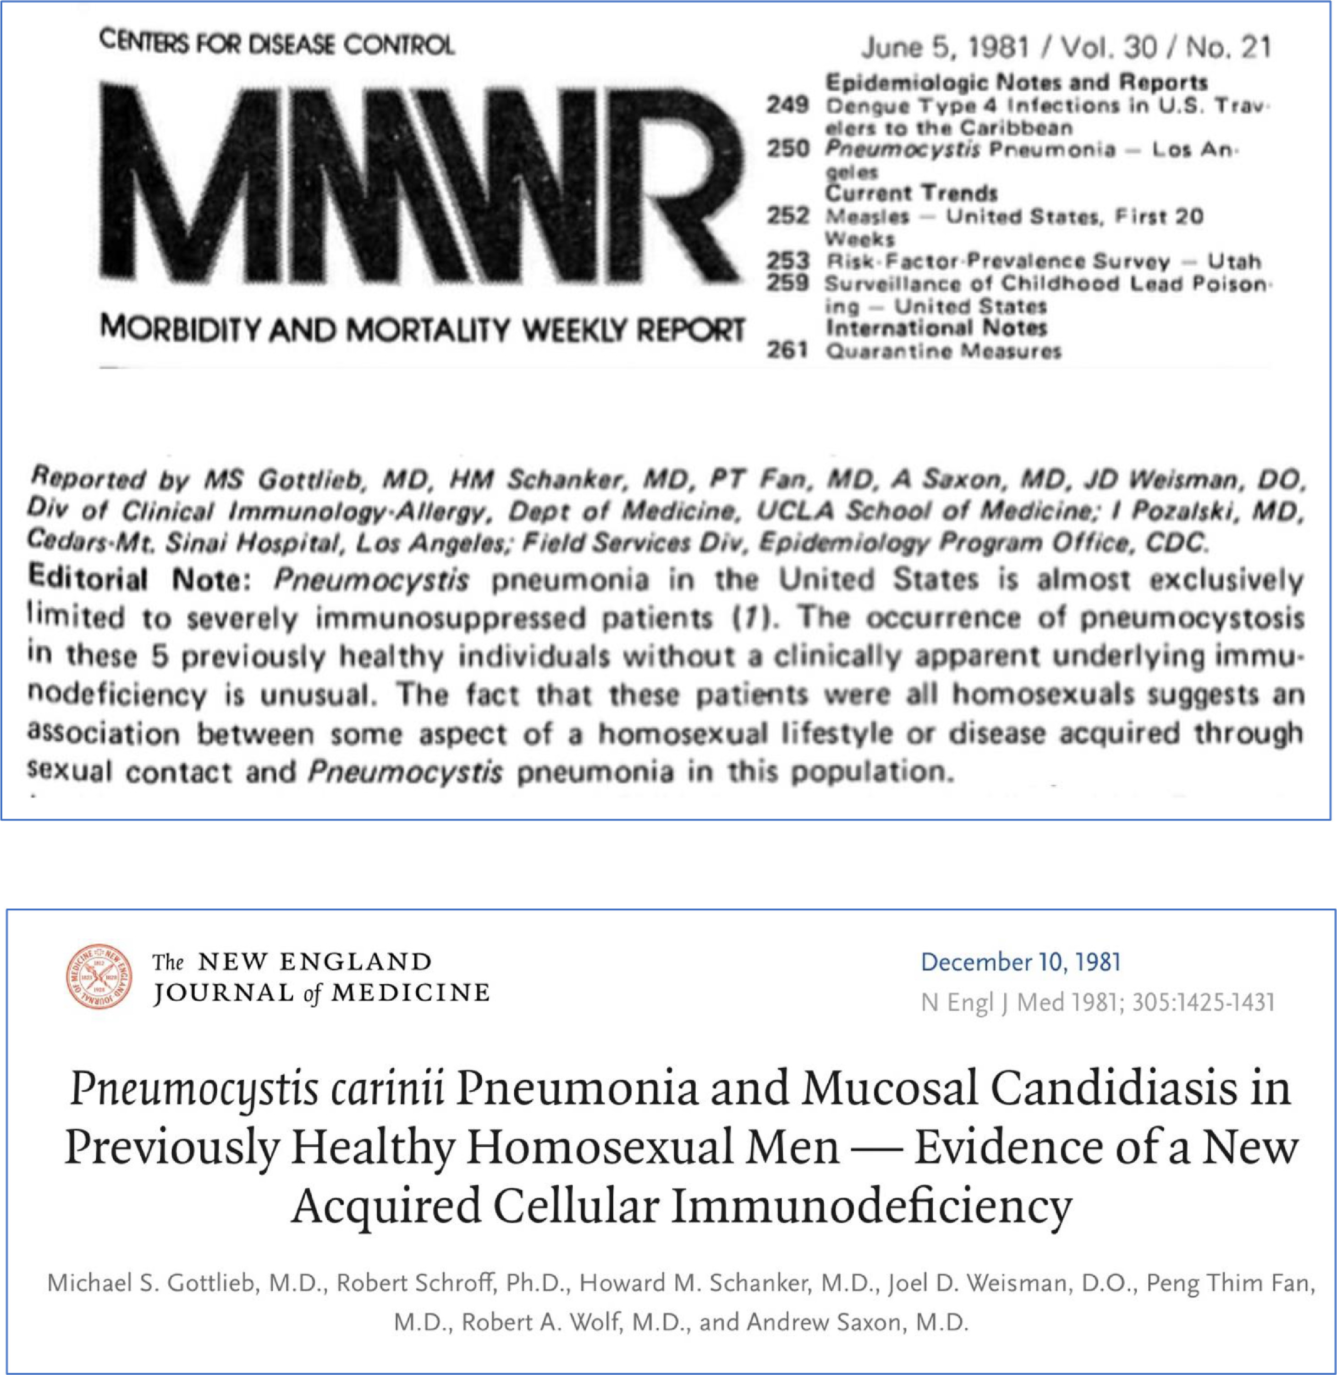
Figure 8: How the world initially reported and descriptions of HIV/AIDS
HIV posses several intrinsic mechanisms that facilitates the emergence of subtypes. The reverse transcriptase of the virus is known to lack proofreading activity. This result in mutation rate of about 3.4 x 10⁻⁵ mutation per base every replication cycle. Because the genome of the virus is estimated to be around 10⁴ base pair in length, the viral reproduction baseline rate is about 10¹⁰ virion every day. This means about millions of viral variants are produced every day in infected individual. Further HIV recombination can result in viral diversity and when an individual is co-infected with two different strains, they can multiply in the same cell resulting in the emergence of new viral strains (51). With HIV drug-resistance, resistance strains can spread from one individual to another. This can therefore affect viral response to cART in the infected individual even though the he/she has ever used cART.

Mycobacterium (M) tuberculosis
M tuberculosis is an old disease and regarded as one of the important emerging and re-emerging bacterial pathogens. In addition, M bovis is now becoming a causative agent of tuberculosis in humans (52). It has been suggested that human and TB might have co-existed more than 40,000 years ago (53). It is still one of the important public health issues because it one of the leading infectious diseases that is associated with high death globally, with recent data showing it second to the recent COVID-19 pandemic in terms of mortality. In the 2024 report by the WHO, it was reported that about 8.2 million new cases of TB was reported in 2023 from 7.5 million in 2022 (54). Factors such as ecological, environmental, demographical, the continuous burden of anti-drug resistance, mobility, and the global impact of HIV facilitates the emergence of TB infection across the globe which poses significant international public health threat (52).

Rationale for Effective Diagnostic Approaches for Emerging and Re-emerging Pathogens

Efficient and timely diagnosis of emerging and re-emerging pathogens is essential for managing these pathogens especially during pandemics as was experienced during COIVID-19. This will fasten the rapid diagnosis of novel pathogen, accelerate the implementation of measures consisting of therapeutic and control strategies. This will help address the issues of transmission and disruption of the society. In order to use a specific diagnostic approach, the following aims should be taking into consideration: the initial diagnosis of the pathogen, evaluation of the prognosis, and the impact of therapeutic intervention

Diagnostic Approaches

In emerging and re-emerging outbreaks, both the researchers and clinicians depend on traditional and molecular techniques for identification and characterization of the novel or emerging/re-emerging pathogen (s). Below is a description of the diagnostic approaches and challenges encountered when they are utilized in managing emerging and re-emerging pathogens

Traditional Diagnostic Approach: COVID-19 as case
As outlined earlier, timely diagnosis of emerging and re-merging pathogens is an essential strategy that will help prevent the transmission of that pathogen (s). During the COVID-19 pandemic, rapid diagnosis was key to the management strategies. Protein-based diagnosis was utilized. In this method, the protein, glycans or antibodies that are unique to the virus is detected. This test is based on the antigen-antibody reaction where antigen or antibody from patients reacts with antigen or antibody from the test kit. Using protein-based tests such as antigen-antibody tests are rapid, does not require expert knowledge or skills, and it is easily available (55). Different kits have been designed for use as antigen-based tests. Most of the kits are based on detecting spike protein that is unique to SARS-CoV-2. Antigen-based method has high sensitivity which reduces with each day passing by. A study showed that the high sensitivity was 80% in the first seven days of infection which reduced to 76% in the following week and by the third week, it has reduced to 19% in comparison to molecular technique. On the other hand, antibody-based method had contrary course with regards to sensitivity in that during the early phase of the infection, it had only 26.8% sensitivity which by the two weeks of infection had increased to 76% (55, 56). One important aspect of antigen-based test is the viruses can be detected as soon as the defence mechanism has been elicited. In a non-outbreak scenario, antibody-based test is used in patients who have recovered (55). A study by Schnurra et al comparing the diagnostic sensitivity of SARS-CoV-2 nucleoprotein and glycoprotein-based antibody tests reported that sensitivity of antigen-based test was highest during the 1st week of the infection as a result of high viral loads during this period (57). Table 3 summarizes some of the used immunoassays used for diagnosing SARS-CoV-19.

Table 3 Summary some protein-based kits used for detecting coronavirus (Sources: FDA & EU)
Company | Test | Technology
Abbott Laboratories | Affinity I SARS-CoV-2 IgG | CMIA
Abbott Laboratories | Architect SARS-CoV-2 IgG | CMIA
Beckman Coulter, Inc | Access SARS-CoV-2 IgG | Automated CLIA
Babson Diagnostics, Inc | Diagnostic aC19G1 | CLIA
Siemens Healthcare Diagnostic Inc | ADVIA Centaur SARS-CoV-2 Total (COV2T) | Automated Semi-Quantitative CMIA
SNIBE Diagnostic | MAGLUM 2019-nCoV IgM/IgG | Automated CLIA
Roche Diagnostic | Elecsys Anti-SARS-CoV-2 | ECLIA

Using antibodies result in rapid and simple procedure with high sensitivity. IgM is the first line of defence mechanism so by using antibodies, many emerging and re-emerging pathogens can be detected. Although antibody-based tests are widely acceptable, they have some challenges. They are effective between 5 and 10 days after the symptoms have manifested (55, 58).In addition, several diagnostic tools such as antigen-based test, RT-PCR, etc are utilized; of which lateral flow immunoassay is the most opted for as it posses acceptable sensitivity and specificity of about 87% and 91%, respectively (59).However, it also has its own challenges with false negative occurring frequently because of various factors such as multiple steps procedure, unreasonable immobilization, etc. A meta-analysis study by Zhang et al evaluated the false positive profile of IgG-mediated kit that used RIAT concluded that 57% of the total patients returned false-positive results. The patients were actually suffering from common cold pneumonia associated with coronavirus (60).

Antibody-based tests detect IgG and IgM which fluctuates during infections and have been shown to have diagnostic rationale in several studies. The IgM levels increases during the 1st week of infection post-exposure to the virus. However, IgG also start to increase from the 2nd week and this last for longer period. IgM may also decrease. IgA also appears within four and ten days after the infection. This means the levels of IgM, IgG, and IgA can be used as markers of infections, respectively (61). A rapid immunoassay kits evaluated the levels of IgG and IgM in blood samples and found that there was improved specificity and sensitivity (62).

Serological-based assays are promising. However they have some limitations including lack of harmony across various platforms, autoantibodies, cross-reactivity, anti-antigen antibodies, differences in antibody kinetics, labour intense, poor substrate, inconsistent pipetting and washing, background noise, reagent contamination, and hook effect. Taking ELISA as example, the challenges including issue of cross-reactivity where non-target molecules found in the sample can bind to antibody thereby resulting in false positive or negative results. In the diagnosis of ZIKV infections one of the main challenges using ELISA is the rate of high cross-reactivity between the flaviviruses which can result in false positive (75). A systematic study by Endale et al found high cross-reaction between DENV and other flaviviruses, with the highest cross-reaction reported with yellow fever virus. In addition, cross-reaction was higher in IgG assay in comparison to IgM. This means in interpreting serological assays in regions where more than one flavivirus exist, cross-reactivity should be taking into consideration (76). However this result was inconsistent with study by Steinhagen et al who reported that there was no cross-reactivity in a NS1-based ELISA assay used in their study (75). Also background noise also leads to generation of false-positive signals. In ELISA immunoassay, background noise can be due to the quality of samples. Among the causes of background noise are detergents and protein which can interfere with the binding affinity of the antibodies or enzyme substrate. Minimising background noise would help in reducing misdiagnosis. A study by Moritz et al suggested that by subtracting serum-specific background noise (SSBN) via utilizing non-coated ELISA wells and control, SSBN was normalized resulting in reduction of frequency of false-positive. Normalizing the SSBN is a novel protocol that will reduce the frequency of false-positive (77) and background noise should be considered as negative. Contamination of regents is another major cause of false-positive result. As reported by Kroidl et al in Tanzania, lipoarabinomannan which is part of the cell wall of mycobacteria can be found in urine of patients infected with TB. However, under field condition, false-positive results was obtained as a result of contamination with contaminants such as dust, stool, and soul; although contamination of blood and other pathogens such as fungi and bacteria do not have any effect (78).Finally, “hook effect” (inhibition) is another important factor which is caused by complement interference. To address this inhibition, several interventions have been recommended including used of ethylenediaminetetraacetic acid. In addition use of heat treatment and diluting serum can reduce the effect of inhibition (79).

Serological-based assay are crucial platform for rapid diagnosis of emerging and re-emerging pathogens especially during pandemics. To improve their efficiency, sensitivity, specificity, and consistency, there is the need to consider the assay format, how samples are prepared and the data should be analyzed accurately.

Molecular Diagnostic Approaches for emerging and re-emerging pathogens
The introduction of molecular techniques has improved diagnosis of infectious diseases especially emerging and re-emerging pathogens especially when dealing with pathogens that cannot be cultivated or are difficult to be isolated in clinical laboratories (63). Traditional-based diagnostic methods were used in the past for the primary detection and identification of emerging and re-emerging infectious agents; including microscopy, cell culture, serological testing, immunochemistry, etc. In detection and identification of these pathogens, the use of molecular techniques such as polymerase chain reaction (PCR) which consist of amplifying the target, probe hybridization, and nucleic acid sequencing are the most unique techniques used for detection and characterizing these pathogens. In the identification of then novel hepatitis C virus (HCV), molecular technique was used. Initially, hepatitis A and B viruses were discovered but in cases of posttransfusion hepatitis, another pathogen then termed non-A and non-B hepatitis were linked with this condition. In 1989, plasma that was obtained from chimpanzee was prilled, nucleic acid extracted then cDNA was synthesized using random primers and RT. Further evaluation recognized a RNA-encoded clone which expressed antigen that cross-reacted with antibodies from individuals that were infected. After, the complete genome of the agent was described and the novel pathogen which was closely associated to flavivirus was determined as HCV (64). Another example of utilization of molecular methodology is the identification and characterization of SARS-CoV, a then novel coronavirus that emerged in southern part of China the late 2002 and then transmitted to more than thirty-seven countries across 5 continents. It affected 8273 individuals with associated 775 mortalities. The utilization of PCR, cloning, and sequencing led to the detection and identification of the novel pathogens within a short time after the report of the first case (64, 65, 66). Furthermore, PCR was used in the identification and characterization of Bartonella infection from solid organ transplant recipients, differentiating Lyme spirochetes and the emerging pathogens Anaplasma phagocytophilum and Babesia microti, and a novel phlebovirus within the Bunyaviridea family classified as SFTS bunyavirus which is associated with thrombocytopenia syndrome (SFTS). This was achieved using next-generation sequencing (NGS) (67, 68, 69).

One important utilizations of molecular techniques is molecular epidemiology which is very essential in the initial identification of emerging and re-emerging pathogens. These techniques preferred methods for definite characterization of novel strains of emerging pathogens and sequence variations. This means molecular data are widely utilized for molecular epidemiological and phylogenic evaluations , and comparison of the sequences to enable specific identification of genetically diverse strains or sequences which can be used to investigate these pathogens ( including origin and transmission) (64). These are important for mounting preventive and tracking of these pathogens (emerging and re-emerging) during outbreaks. Furthermore, understanding the sequence variations is essential in the development of effective diagnostic assays and designing efficacious treatment interventions. Finally, molecular epidemiological evaluation is important for public health surveillance (64).

In the clinical laboratories, accurate and rapid diagnosis of novel pathogens which have emerging and re-emerging capability is very important. Many techniques are used for clinical diagnosis and identification of emerging pathogens. These include microscopy, cell culture and serology. But these techniques have some limitations although they are routinely regarded as “gold standard”. For example, cell culture is mostly used as gold standard for diagnosing emerging obligate bacteria like Rickettsia which is disadvantaged by the requirement of a biological safety level 3 (BSL-3). This makes the diagnosis difficult for many clinical laboratories. In addition, with cell culture, the turnaround time takes approximately between seven and ten days. Such prolonged time means the results obtained from this test is not relevant because therapeutic intervention is required at the early phase of an infection.

Secondly, serological-based assays such as ELISA and immunoflourescence assay as explained earlier depend on antigen-antibody interaction. However, low sensitivity at the early phase of the infection when specific antibodies are required for the antigen-antibody interaction is low; potential false-positive as a result of cross-reaction; and diagnosis of acute infection using IgG serology lacking standardization are some of the limitation associated with serology-based assays for diagnosis of emerging pathogens within the clinical diagnostic laboratories (64).

Molecular approaches such PCR and next generation sequence (NGS) are therefore routinely employed for the diagnosis and identification of several emerging and re-emerging infectious agents. These molecular approaches includes genotyping and subtyping approach utilized for prognosis of disease and identifying drug resistance mutations, quantitative approach, and nucleic acid assays. Typical examples of using molecular emerging pathogens are HIV and HCV which are used routinely to monitor viral load and emergency of drug-resistant mutants. Many guidelines have been developed that are accepted for HIV and HCV molecular diagnosis. For example, detection of HCV RNA is a diagnostic marker of current HCV infection not IgG. Furthermore, HCV RNA identifications are routinely used in the clinical laboratories (70). Furthermore, genotyping is assay is routinely used and it is important for predicting effective therapeutic strategies and monitoring drug-resistance in HCV infection (71). Molecular assays have been routinely used for other emerging and re-emerging pathogens including virulent Leptospira (72), Vibrio alginolyticus (73), HIV, DENV, and ZIKV (74). Overtime, these molecular techniques have been optimized and new technologies have been introduced as discussed below. These techniques have high sensitivity and repeatability.

During the COVID-19 pandemic, RT-PCR and nucleic acid hybridization were the main techniques used. In RT-PCR, viral RNA was extracted from clinical samples which is converted to cDNA then amplified, The DNA amplification is closely observed in real-time utilizing a fluorescent dye or combined quencher molecule and sequence DNA probe that is labelled with fluorescent molecular (Figure 9) (79). The selected viral regions to be used as target in RT-PCR are very essential; for example, the E gene has been shown to have the highest sensitivity. RT-PCR is a quantitative platform that quantifies the pathogen (s) without requiring calibration curves; PCR inhibitors are used that can affect the efficiency of this technique. To address this, the digital PCR was introduced that have higher analytical sensitivity because the process divides the samples which result in less competition between the targets during amplification process. It also high multiplexing ability in comparison to quantitative PCR. However, is has a complex workflow and also requires expensive laboratory equipments. It also requires longer time and highly skilled staffs which increases the cost (79). A study found that digital PCR was superior for the clinical diagnosis of COVID-19 virus in comparison to RT-PCR because it reduces the rate of false-negative (80)

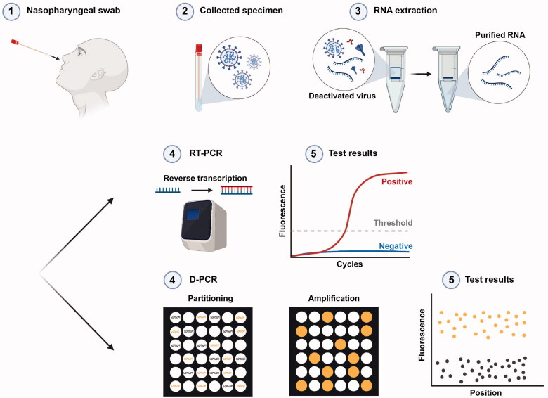
Figure 9: Work flow of RT-PCR and digital PCR used in COVID-19 (Source: 79)

Other molecular assays have also shown promise in diagnosis and identification of emerging and re-emerging pathogens such as isothermal nucleic acid amplification assay where the target is amplified at constant temperature thereby removing the requirement for expensive laboratory thermal cycle equipment. The reverse transcription loop-mediated isothermal amplification (RT-LAMP) permits the identification of target of interest by utilizing 4 to 6 primers that are designed specifically to bind the target. By targeting and amplifying distinct sequence, it is highly selective. It was used in the diagnosis of MERS-CoV and SARSD-CoV (81). A study concluded that this platform is a powerful tool for identification and monitoring of infectious agents which can be utilized for emerging and re-emerging pathogens (82). Other isothermal amplification based approach includes transcription-mediated amplification and circle amplification (80).

Clustered Regularly Interspaced Short Palindromic Repeats (CRISPR) –based assays have been introduced that recognized specific sequence of a target. CRISPR was initially described in Escherichia coli and it is recognized as a useful system for editing genes. Currently different versions of CRISPR based on use of RNA-guided, RNA-targeting enzymes including CRISPR-Cas12a and CRISPR-Cas13a have been introduced. A platform that is based on amplifying the target sequence (DNA or RNA) then followed by Cas13-mediated identification utilizing colorimetric and fluorescent information called Specific High Sensitivity Enzymatic Reporter UnLOCKing (SHERLOCK) has been introduced that aid in the rapid diagnosis of infective agents from clinical samples (80). Patchsung et al found that SHERLOCK has 100% specificity and 96% sensitivity in a study in Thailand while the platform was consistent with result obtained for quantitative PCR (82, 83).

Nucleic acid microarray assays is another promising tool that can be used in emerging and re-emerging pathogens outbreaks. This platform merges powerful nucleic acid amplification plus high throughput screening novelty of microarray technology. It can therefore be used in the detection of different emerging and re-emerging pathogens with high sensitivity and specificity. This platform can be used for detecting these pathogens by utilizing reverse transcription then followed by labelling with specific probes. It is then uploaded onto microarray wells that are covered with oligonucleotide which can give signal when the pathogen nucleic acid is present (Figure 10). One of the challenges of microarray-based assay is the high cost which can be an obstacle for its use especially in the developing world. However, non-fluorescent microarray technique is less expensive and has similar sensitivity to RT-PCR. It is therefore an ideal tool for identification of emerging pathogens (80).

Finally NGS has led to advances across different of medical research. It permits through characterization and evaluation of genetic material of a pathogen. The advantage of NGS is that it can screen and identify infectious agents even when researchers do not have prior knowledge of the pathogen. Untargeted sequencing of full genome of a pathogen in a sample (Shotgun metagenomics) can improve the infective agents that could not be detected by RT-PCR such as mutant strains (84). NGS-based assay has great promise in research involve emerging and re-emerging pathogens but the huge amount of data that is generated is a challenge; meaning there is the need to acquire advanced data storage and processing equipment. This will limit its usefulness during an outbreak. NGS-based assay is therefore be expensive in comparison to other molecular-based assay. It requires complicated preparation of samples and developing library protocols that require highly skilled workers. In addition, with regards to time, NGS cannot compete with other molecular-based assay as it requires more than 18 hours to perform only the sequence (85,86).

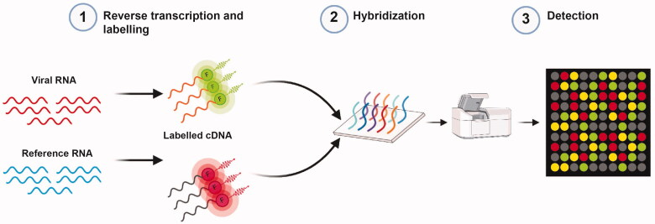
Figure 10: Workflow of microarray (Source: 79)

Despite their usefulness, molecular assays in the detection and identification of emerging pathogens, they have their own limitations. These approaches have a challenge of time constraints. Although approach such as PCR gives fast result, the preparation of the sample during the preparatory phase is challenging factor. There are available many commercial kits that facilitate rapid isolation of nucleic acid but they are associated with higher cost. This can be a challenge for developing countries. There is also the need for expensive machines but this was addressed through the introduction of a more integrated technique called point of care (POC). These POCs were very useful during COVID-19 pandemic (74).

Conclusion
Molecular assays have brought hope for rapid diagnosis and identification of emerging and re-emerging pathogens. The current advances with the integration of POC in routine clinical laboratories will further facilitate the diagnostic process of emerging and re-merging pathogen during outbreaks. The COVID-19 pandemic has thought us that these pathogens are real threat to humanity. Therefore novel technologies are needed that would facilitate the detection and identification of emerging and re-emerging infectious agents. Recent advances in molecular epidemiology have facilitated diseases surveillance. COVID-19 is a typical example when the pandemic started in Wuhan, China; due to utilization of molecular techniques, the genome of the virus was released within a short time. All hands should be on deck; from international partners to national laboratories and individual stakeholders to increase funding that would play critical role during outbreaks. Molecular-based assays should be the mainstream diagnostic tools which would be effective in emerging and re-emerging infections research. However, the traditional methods of diagnostic should not be disregarded but they must be optimized and integrated alongside molecular-based assays.

References
- Levitt AM, Khan AS, Hughes WG (2012): Emerging and re-emerging pathogens and diseases, Infectious Diseases; 21: 56-69. DOI: 10.1016/B978-0-323-04579-7.00004-6
- Gao F, Bailes E, Roberson DL (1999): Origin of HIV-1 in the chimpanzee Pan troglodytes, Nature; 397: 436-441. DOI: 10.1038/17130
- Morens DM, Breman JG, et al (2020): The origins of COVID-19 and why it matters, Am J Trop Med Hyg; 103: 955-959. DOI: 10.4269/ajtmh.20-0849
- John B, et al (2003): Thalassemia and malaria: New insights into an old problem, Proceedings of the Association Physicians, 111: 278-282. DOI: 10.1046/j.1525-1381.1999.99235.x
- Cherry JD, Krogstad P (2004): SARS: The first pandemic of the 21st century, Pediatr Res; 56: 1-5. DOI: 10.1203/01.PDR.0000129184.87042.FC
- Fledmann H, Czub M, et al (2002): Emerging and re-emerging infectious diseases, Med Microbiol Immunol; 191: 63-74
- Kobayashi N (2018): Impact of emerging, re-emerging and zoonotic viral infectious diseases, in a Virologist’s perspective, Open Virol J; 12: 131-133.
- Paraskevis D, Kostaki EG, et al (2020): Full-genome evolutionary analysis of the novel corona virus (2019-nCoV) rejects the hypothesis of emergence as a result of a recent recombination event, Infect Genet Evol; 79: 104212. DOI: 10.1016/j.meegid.2020.104212
- Murugesu JA (2022): Langya virus: how serious is the new pathogen discovered in China, New Scientist; 10
- Chakraborty S, Chandran D, et al (2022): Langya virus, a newly identified Henipavirus in China-zoonotic pathogen causing febrile illness in humans, and its health concerns: Current knowledge and counteracting strategies-correspondence, Int J Surg; 105: 106882. DOI: 10.1016/j.ijsu.2022.106882
- Payne L, Alcolea-Medina A, et al (2024): The first reported case of human infection with Variovorax durovernensis: a novel Variovorax sp. Isolated from the prosthetic aortic graft of a shepherd, Clinical Infection in Practice; 21: 1-5. DOI: 10.1016/j.clinpr.2023.100332
- Van den Hoogen BG, de Jong JC, et al (2001): A newly discovered human pneumovirus isolated from young children with respiratory tract disease, Nat Med; 7: 719-724. DOI: 10.1038/89098
- Peiris JSM, Yuen KY, et al (2003): The severe acute respiratory syndrome, New Engl J of Medicine; 349: 2431-2441. DOI: 10.1056/NEJMra032498
- Parry RH, Yamada K, Hood WR, et al (2025): Henipavirus in Northern Short-Tailed Shrew Alabama, USA, Emerg Infect Dis; 31: 392-394. DOI: 10.3201/eid3102.241155
- Bogoch II, Brady OJ, et al (2016): Anticipating the international spread of Zika virus from Brazil; Lancer; 387: 335-336. DOI: 10.1016/S0140-6736(16)00080-5
- About F, Pastre T, Boutrou M, et al (2023): Novel species of Brucella causing human brucellosis, French Guiana, Emerg Infect Dis; 29: 333-340. DOI: 10.3201/eid2902.220725
- Ferraris P, Yssel Hans, Misse Dorothee (2019): Zika virus infection: an update, Microbes and Infection; 21: 8-9. DOI: 10.1016/j.micinf.2019.04.005
- Zanluca C, De Melo VCA, et al (2015): First report of autochthonous transmission of Zika virus in Brazil, Memorias Do Instituto Oswaldo Cruz; 110: 569-572. DOI: 10.1590/0074-02760150192
- Song B-H, Yun S-Im et al (2017): Zika virus: History, epidemiology, transmission , and clinical presentation, J of Neuroimmunology; 308: P50-64. DOI: 10.1016/j.jneuroim.2017.03.001
- Kularatne SA, Dalugama C (2022): Dengue infection: Global importance, immunopathology and management, Clin Med (Lond); 22: 9-13. DOI: 10.7861/clinmed.2021-0791
- Tsheten T, Clements ACA, et al (2021): Clinical predictors of severe dengue: a systematic review and meta-analysis, Infectious Diseases of Poverty; 10: Article number 123. DOI: 10.1186/s40249-021-00908-2
- Guzman MG, B+Gubler DJ, et al (2016): Dengue infection, Nat Rev Dis Primers; 2:16055. DOI: 10.1038/nrdp.2016.55
- Akinsulie OC, Idris I (2024): Global re-emergence of dengue fever: the need for a rapid response and surveillance, The Microbe; 4: 100107. DOI: 10.1016/j.microb.2024.100107
- Centers for Disease Control and Prevention (2023): Current Year Data on https://www.cdc.gov/dengue/statistics-maps/current-data.html (Accessed on 03/04/2025)
- Pan American Health Organization (2023): As dengue cases increases globally, vector control, community engagement key to prevent spread of the disease on www.paho.org/en/news/3-8-2023-dengue-cases-increase-globally vector-control-community-engagement-key-prevent-spread (Accessed on 03/04/2025)
- Fournet N, Voiry N, et al (2023): A cluster of autochthonous dengue transmission in the Paris region-detection, epidemiology, and control measures, France, October 2023, Euro Surveil; 28: pii-2300641. DOI: /10.2807/1560-7917.ES.2023.28.49.2300641
- Mourad O, Makhani L, Chen LH (2022): Chikungunya: An emerging public health concern, Current Infect Dis; 24: 217-228. DOI: 10.1007/s11908-022-00789-y
- Powers AM, Brault AC, et al (2000): Re-emergence of chikungunya and o’nyong-nyong viruses: evidence for distinct geographical lineages and distant evolutionary relationships, J Gen Virol; 81: 471-479. DOI: 10.1099/0022-1317-81-2-471
- Chikingunya and dengue in Reunion Bulletin of 26 March 2025 on https://www.santepubliquefrance.fr/regions/ocean-indien/documents/bulletin-regional/2025/chikungunya-et-dengue-a-la-reunion.-bulletin-du-26-mars-2025 (Accessed on 03/04/2025)
- Chikungunya worldwide overview, Situation update, March 2025 on https://www.ecdc.europa.eu/en/chikungunya-monthly (Accessed on 03/04/2025)
- Ukoaka BM, Ojesanya OJ, et al (2024): Updated WHO list of emerging pathogens for a potential future pandemic: implications for public health and global preparedness, Infez Med; 32: 463-477. DOI: 10.53854/liim-3204-5
- Kasetsirikul S, Buranapong J, et al (2016): The development of malaria diagnostic techniques: a review of the approaches with focus on dielectrophoretic and magnetophoretic methods, Malar J; 15: 358. DOI: 10.1186/s12936-016-1400-9
- World Malaria report 2024: Addressing inequity in the global malaria response on https://www.who.int/teams/global-malaria-programme/reports/world-malaria-report-2024 (Accessed on 03/04/2025)
- Nair AA, Tripathy KP, Behera PK (2022): Arsesunate Resistance-An emerging threase, J Assoc Physicians India; 70: 11-12. PMID: 35443476
- Balikagala B, Fukudu N, et al (2021) Evidence of Artemisinin-Resistant Malaria in Africa, NEJM; 385: 1163-1171. DOI: 10.1056/NEJMoa2101746
- Nichola J, White FRS (2021): Emergence of Artemisinin-Resistant Plasmodium falciparum in East Africa, NEJM; 385: 1231-1232. DOI: 10.1056/NEJMe2110659
- Rahman MT, Sobur MA, et al (2020): Zoonotic Diseases; Etiology, impact, and control; Microorganisms; 8: 1405. DOI: 10.3390/microorganisms8091405
- Woolhouse ME, Gowtage-Sequeria S (2005): Host range and emerging and reemerging pathogens, Emerg Infect Dis; 11: 1842-1147. DOI: 1 0.3201/eid1112.050997
- Marli C, Michely RB, et al (2020): Emerging and re-emerging human infectious disease: A systematic review of the role of wild animals with a focus on public health; Asian Pacific Journal of Tropical Medicine; 13: 99-106. DOI: 10.4103/1995-7645.277535
- Majumber J, Minko T (2021): Recent development on therapeutic and diagnostic approaches for COVID-19, AAPS J; 23: 14. DOI: 10.1208/s12248-020-00532-2
- COVID-19 epidemiological update-24 December 2024, special edition 174 on https://www.who.int/publications/m/item/covid-19-epidemiological-update---24-december-2024 (Accessed on 03/04/2025)
- Anthony SJ, Johnson CK, et al (2017): Global patterns in coronavirus diversity, Virus Evolution, 3: vex012. DOI: 10.1093/ve/vex012
- Liang Y (2023): Pathogenicity and virulence of influenza, Virulence; 14: 2223057. DOI: 10.1080/21505594.2023.2223057
- Shi J, Zeng X, et al (2022): Alarming situation of emerging H5 and H7 avian influenza and effective control strategies, Emerg Microbes Infect; 12: 2155072. DOI: 10.1080/22221751.2022.2155072
- Plaza PI, Gamarra-Toledo V, et al (2024): Recent changes in patterns of mammal infection with highly pathogenic avian influenza A (H5N1) virus worldwide, Emerg Infect Dis; 30: 444-452. DOI: 10.3201/eid3003.231098
- Unemo M, Nicholas RA (2012): Emergence of multidrug-resistant, extensively drug-resistant and untreatable gonorrhoea, Future Microbiol; 7: 1401-1422. DOI: 10.2217/fmb.12.117
- Camelena F, Merimeche M, et al (2024): Emergence of extensively drug-resistant Neisseria gonorrhoeae, France, 2023, Emerg Infect Dis; 30: 1903-1906. DOI: 10.3201/eid3009.240557
- Raccagni AR, Ranzenigo M, et al (2023): Neisseria gonorrhoea antimicrobial resistance: the future of antibiotic therapy, J Clin Med; 12: 7767. DOI: 10.3390/jcm12247767
- Barin F (2022): HIV/AIDS as a model for emerging infectious disease: Origin, dating, and circumstance of an emblematic epidemiological success, La Presse Medicale; 51: 104128. DOI: 10.1016/j.lpm.2022.104128
- Mahomed S, Pillay K, et al (2025): Clinical trials of broadly neutralizing monoclonal antibodies in people living with HIV-a review, AIDS Research and Therapy; 22: 44. DOI: 10.1186/s12981-025-00734-8
- Taylor BS, Sobieszczyk ME, et al (2009): The challenge of HIV-1 subtype diversity, N Engl J Med; 358: 1590-1602. DOI: 10.1056/NEJMra0706737
- Alexander KA, Pleydell E, et al (2002): Mycobacterium tuberculosis: An emerging disease of free-ranging wildlife, Emerg Infect Dis; 8: 598-601. DOI: 10.3201/eid0806.010358
- Riccardi N, Canetti D, et al (2020): The evolution of a neglected disease: tuberculosis discoveries in the centuries, J Prev med Hyg; 61 (Spply 1): E9-E12. DOI: 10.15167/2421-4248/jpmh2020.61.1s1.1353
- World Health Organization (2024): Global tuberculosis report 2024 on https://www.who.int/publications/i/item/9789240101531 (Accessed on 08/04/2025)
- Chavda VP, Valu DD, et al (2023): Conventional and novel diagnostic tools for the diagnosis of emerging SARS-CoV-2 variants, Vaccines; 11: 374. DOI: 10.3390/vaccines11020374
- Boum Y, Fai KN, et al (2021): Performance and operational feasibility of antigen and antibody rapid diagnostic tests for COVID-19 in symptomatic and asymptomatic patients in Cameroon: A clinical, prospective, diagnostic accuracy study, Lancet Infection Dis; 21: 1089-1096. DOI: 10.1016/S1473-3099(21)00132-8
- Schnurra C, Reiners N, et al (2020): Comparison of the diagnostic sensitivity of SARS-CoV-2 nucleoprotein and glycoprotein-based antibody tests, J Clin Virol; 129: 104544. DOI: 10.1016/j.jcv.2020.104544
- Prazuck T, Colin M, et al (2020): Evaluation of performance of two SARS-CoV-2 rapid IgM-IgG combined antibody tests on capillary whole blood samples from the fingertip, PLoS One; 15: e0237694. DOI: 10.1371/journal.pone.0237694
- Liu G, Tusling JE (2021): Antibody tests and their limitations, ACS Sens; 6: 593-612. DOI: 10.1021/acssensors.0c02621
- Zhang ZI, Hou YL, et al (2021): Diagnostic efficacy of anti-SARS-CoV-2 IgG/IgM test for COVID-19: A meta-analysis, J Med Virol; 93: 366-374. DOI: 10.1002/jmv.26211
- Kevadiya BD, Machhi J, et al (2021): Diagnostics for SARS-CoV-2 infection, Nat Mater; 20: 593-605. DOI: 10.1038/s41563-020-00906-z
- Ai JW, Zhou X, et al (2019): CRISPR-based rapid and ultra-sensitive diagnostic tests for Mycobacterium Tuberculosis, Emerg Microbe Infect; 8:1361-1369. DOI: 10.1080/22221751.2019.1664939
- Okeke IN, Ihekweazzu C (2021): The importance of molecular diagnostic for infectious diseases in low-resource settings, Nat Rev Microbiology; 19: 5470548. DOI: 0.1038/s41579-021-00598-5
- Dong J, Ismail N, Waler DH (2017): Chapter 15-Molecular Testing in Emerging Infectious Diseases, Editor(s): William B. Coleman, Gregory J Tsongalis, Diagnostic Molecular Pathology, Academci Press, Page 179-200. DOI: 10.1016/B978-0-12-800886-7.00015-7
- Huang J-L, Lin H-T, et al (2005): Rapid and sensitive detection of multiple genes from the SARS-Coronavirus using quantitative RT-PCR with dual system, J of Medical Virol; 77: 151-158. DOI: 10.1002/jmv.20432
- Payne B, Bellamy R (2014): Novel respiratory viruses: What should the clinician be alert for? Clinical Medicine; 14 (Suppl 6): s12-s16. DOI: 10.7861/clinmedicine.14-6-s12
- Georgios P, James R, et al (2012): Bartonella henselae infections in solid organ transplant recipients report of 5 cases and review of the literature, Medicine; 91: 111-121. DOI: 10.1097/MD.0b013e31824dc07a
- Kamfai C, Marras SAE, Parveen N (2013): Sensitive multiplex PCR assay to differentiate Lyme spirochetes and emerging pathogens Anaplasma phagocytophilum and Babesia microti; BMC Microbiology; 13: 1-15. DOI : 10.1186/1471-2180-13-295
- Yu X-J, Liang M-F, et al (2011): Fever with thrombocytopenia associated with a novel Bunyavirus in China, New Engl Journal of Medicine; 364: 1523-1532. DOI: 10.1056/NEJMoa1010095
- Yang R, Wei L (2018): Profile of the VERSANT HCV genotype 2.0 assay, Expert Rev Mol Diagn; 18: 995-1004. DOI: 10.1080/14737159.2018.1541740
- Cuypers L, Ceccherini-Silberstein F, et al (2016): Impact of HCV genotype on treatment regimens and drug resistance: a snapshot in time, Rev med Virol; 26: 408-434. DOI: 10.1002/rmv.1895
- Giraud-Gatineau A, Nieves C, et al (2024): Evolutionary insights into the emergence of virulent Leptospira spirochetes, PLoS Pathogen; 20: e1012161. DOI: 10.1371/journal.ppat.1012161
- Huang Z, Li Y, et al (2024): Genome-wide expanding of genetic evolution and potential pathogenicity in Vibrio alginolyticus, Emerg Microbes Infect; 13: 2350164. DOI: 10.1080/22221751.2024.2350164
- Altindis M, Kharaman Kilbas EP (2023): Managing viral emerging infectious diseases via current and future diagnostics, Diagnostics (Basel); 13: 1421. DOI: 10.3390/diagnostics13081421
- Steinhagen K, Probst C, et al (2016): Serodiagnosis of Zika virus (ZIKV) infections by a novel NS1-based ELISA devoid of cross-reactivity with dengue virus antibodies: a multicohort study of assay performance, 2015 to 2016, Euro Surveill; 21: 30426. DOI: 10.2807/1560-7917.ES.2016.21.50.30426
- Endale A, Medhin G, et al (2021): Magnitude of antibody cross-reactivity in medically important mosquito-borne flaviviruses: A systematic review, Infect Drug Resist; 14: 4291-4299. DOI: 10.2147/IDR.S336351
- Mortiz CP, Tholance Y, et al (2019): Reducing the risk of misdiagnosis of indirect ELISA by normalizing serum-specific background noise: The example of detecting anti-FGFR3 autoantibodies, J Immunol Methods; 466: 52-56. DOI: 10.1016/j.jim.2019.01.004
- Kroidl I, Clowes P, et al (2013): Reasons for false-positive lipoarabinomannan ELISA results in a Tanzanian population, Scandinavian J of Infect Dis; 46: 144-148. DOI: 10.3109/00365548.2013.853133
- Habibzadeh P, Mofatteh M, et al (2021): Molecular diagnostic assays for COVID-19: an overview, Crit Rev Clin Lab; 17: 1-20. DOI: 10.1080/10408363.2021.1884640
- Suo T, Liu X, et al (2020): ddPCR: a more accurate tool for SARS-COV-2 detection in low viral load specimens, Emerging Microbes & Infections; 9: 1259-1268. DOI: 10.1080/22221751.2020.1772678
- Notomi T, Okayama H, et al (2000): Loop-mediated isothermal amplification of DNA, Nucleic Acid Research; 28: e63. DOI: 10.1093/nar/28.12.e63
- Yan C, Cui J, et al (2020): Rapid and visual detection of 2019 novel coronavirus (SARS-CoV-2 by a reverse transcription loop-mediated isothermal amplification, Clin Microbiology & Infection,; 26: P773-779. DOI: 10.1016/j.cmi.2020.04.001
- Patchsung M, Jantarug K, et al (2020): Clinical validation of a Cas13-based assay for the detection of SARS-CoV-2 RNA, Nat Biomedical Engineering; 4: 1140-1149. DOI: 0.1038/s41551-020-00603-x
- Quince C, Walker AW, et al (2017): Shotgun metagenomics, from sampling to analysis, Nat Biotechnology; 35: 833-844. DOI: 10.1038/nbt.3935
- Hillmann B, Al-Ghalith GA, et al (2018): Evaluating the information content of shallow shotgun metagenomics, mSystem; 3: e00069-18. DOI: 10.1128/mSystems.00069-18
- Chiu CY, Miller SA (2019): Clinical metagenomics, Nat RFev Genet; 20: 341-355. DOI: 10.1038/s41576-019-0113-7

