### **Artificial Intelligence and Machine Learning in Microbial Diagnostics**

Umedum,Chinelo Ursula

Department of Medical Laboratory Science

Chukwuemeka Odumegwu Ojukwu University,Igbariam Campus

Anambra State,Nigeria.

Email : cu.umedum@coou.edu.ng

**Abstract**  
Artificial Intelligence (AI) and Machine Learning (ML) have emerged as transformative technologies in microbial diagnostics, revolutionizing traditional diagnostic workflows. This chapter explores the historical evolution, key concepts, and practical applications of AI and ML in microbial sciences. From the integration of next-generation sequencing (NGS) platforms to predictive modeling and automated image analysis, these tools have significantly enhanced the speed, accuracy, and scalability of microbial detection. AI-powered technologies are facilitating antimicrobial resistance detection, outbreak surveillance, and personalized medicine by enabling tailored therapeutic interventions and advanced genomic analyses.

The chapter highlights pioneering AI/ML applications, including automated pathogen identification, genomic prediction of resistance patterns, and innovative point-of-care devices. It also addresses the critical role of interdisciplinary collaboration, encompassing microbiologists, data scientists, and clinicians, in driving advancements. Ethical considerations, such as data privacy, algorithmic bias, and integration challenges, are discussed to ensure responsible deployment.

As the field advances, AI and ML promise to redefine microbial diagnostics, fostering a proactive and precision-driven approach to managing infectious diseases. These technologies hold immense potential for improving global health outcomes, advancing research, and optimizing resource utilization, making them indispensable in the future of healthcare and microbial sciences.

**Keywords**: Artificial Intelligence, Machine Learning, Microbial Diagnostics, Antimicrobial Resistance, Next-Generation Sequencing.

### **I. Introduction**

#### **A. Definition of Artificial Intelligence (AI) and Machine Learning (ML)**

Artificial Intelligence (AI) refers to the simulation of human intelligence in machines that are programmed to think, reason, and make autonomous decisions. These systems are designed to perform tasks typically requiring human intelligence, such as visual perception, speech recognition, and decision-making (Russell & Norvig, 2020). AI encompasses a wide range of applications, from simple rule-based systems to complex neural networks capable of handling vast amounts of data.

Machine Learning (ML), a subset of AI, focuses on the development of algorithms that enable machines to learn from and adapt to data without requiring explicit instructions(Figure 1). Unlike traditional programming, where outcomes are explicitly coded, ML systems use statistical models to identify patterns, draw inferences, and make predictions based on input data (Goodfellow *et al*., 2016). This data-driven approach allows ML systems to evolve and improve their performance over time, making them invaluable in fields such as microbial diagnostics.

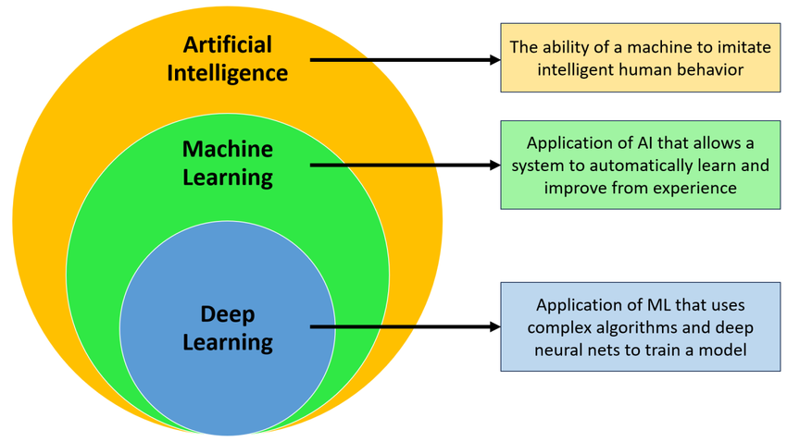

**Figure 1: Conceptual relationship between Artifical Intelligence,Machine Learning and Deep Learning**

(Raihan,2023)

#### **B. Overview of Their Roles in Microbial Diagnostics**

Artificial Intelligence and Machine Learning have emerged as transformative technologies in microbial diagnostics, revolutionizing traditional diagnostic methods. Conventional techniques, such as culture-based assays and microscopy, are often time-intensive and prone to human error. Artificial Intelligence and Machine Learning facilitate rapid and accurate identification of pathogens by analyzing complex datasets, including genomic, proteomic, and imaging data. For example, Machine Learning algorithms can classify bacterial species based on genome sequences or detect antimicrobial resistance genes with high precision (Gargano *et al*., 2022).

AI-powered tools also integrate with advanced imaging technologies, such as automated microscopy, to analyze microbial morphology and behavior. By leveraging large-scale datasets, AI enhances the sensitivity and specificity of diagnostic tools, enabling early detection of infections and improved patient outcomes (Liao *et al*., 2021).

#### **C. Benefits of Artificial Intelligence and Machine Learning in Healthcare and Microbial Diagnostics**

The integration of AI and ML in healthcare, particularly in microbial diagnostics, offers numerous advantages:

1. **Speed and Accuracy**: Automated analysis using AI reduces turnaround time for diagnostics while ensuring consistent accuracy. For instance, AI-based systems can identify pathogens in minutes rather than days (Topol, 2019).
2. **Cost-Effectiveness**: AI-driven diagnostics minimize the need for repeated tests and resource-intensive methods, reducing costs for both laboratories and patients.
3. **Personalized Medicine**: By analyzing patient-specific data, AI can guide tailored antimicrobial therapy, minimizing the risk of drug resistance.
4. **Early Detection and Surveillance**: AI systems monitor real-time trends in microbial infections, contributing to outbreak prediction and public health management (Nguyen *et al*., 2022).
5. **Enhanced Research**: Machine Learning models facilitate the discovery of novel biomarkers and therapeutic targets by processing vast datasets, including metagenomics and proteomics data.

The application of Artificial intelligence and Machine Learning not only streamlines diagnostic workflows but also enables precision medicine and fosters a proactive approach to infectious disease management. As these technologies continue to evolve, their integration into microbial diagnostics promises to redefine healthcare delivery.

### **II .Historical Perspective**

#### **A. Evolution of Diagnostic Methods**

The journey of microbial diagnostics spans centuries, beginning with rudimentary observations and evolving into sophisticated molecular techniques. Early methods, such as microscopy introduced by Antonie van Leeuwenhoek in the late 17th century, laid the foundation for microbiology by enabling the visualization of microorganisms (Gest, 2004). In the 19th century, advancements such as Koch's postulates and Gram staining revolutionized pathogen identification and disease etiology (Blevins & Bronze, 2010).

The mid-20th century witnessed the advent of culture-based techniques, serological assays, and biochemical tests, which became the gold standard for diagnosing bacterial and fungal infections. However, these methods were often time-intensive and required skilled personnel. The advent of molecular diagnostics in the late 20th century, such as polymerase chain reaction (PCR), marked a paradigm shift by offering rapid, sensitive, and specific pathogen detection (Mullis & Faloona, 1987).

#### **B. Emergence of Computational Approaches in Microbiology**

The integration of computational tools into microbiology began with the development of bioinformatics in the 1980s. Early applications included the analysis of nucleotide sequences and the development of genome databases, such as GenBank, which facilitated comparative genomic studies (Benson *et al*., 2013).

With the completion of the Human Genome Project in 2003, computational approaches gained momentum, enabling high-throughput sequencing and data analysis. Techniques like metagenomics and proteomics emerged, requiring sophisticated algorithms to interpret complex datasets (Handelsman, 2004). Computational tools also became integral to epidemiology, aiding in the tracking of disease outbreaks and modeling the spread of pathogens (Fisher & Oosterhuis, 2019).

#### **C. Pioneering Applications of Artificial Intelligence and Machine Learning in Microbial Diagnostics**

The application of Artificial Intelligence and Machine Learning in microbial diagnostics began in the early 2000s with efforts to automate pathogen identification. One of the earliest examples was the use of Machine Learning algorithms to classify bacteria based on MALDI-TOF mass spectrometry data, significantly improving diagnostic speed and accuracy (Seng *et al.,* 2009).

As genomic data became more accessible, AI-powered tools were developed to predict antimicrobial resistance by analyzing genomic sequences. Tools like DeepARG and ResFinder exemplified this trend by identifying resistance genes with remarkable precision (Arango-Argoty *et al.,* 2018).

In imaging, AI algorithms demonstrated the ability to interpret microscopic images, automating tasks like Gram stain interpretation and cell counting. These advancements reduced human error and variability, making diagnostics more reliable (Rajpurkar *et al.,* 2017).

Moreover, pioneering applications of AI in outbreak prediction, such as Google Flu Trends and other epidemiological models, showcased the potential of AI in public health and microbial surveillance (Ginsberg *et* *al*., 2009).

As computational power and data availability continue to expand, the role of AI and ML in microbial diagnostics is expected to grow, bridging the gap between traditional microbiology and cutting-edge technology.

### **III. Key Concepts in Artificial Intelligence and Machine Learning:**

#### **A. Machine Learning Paradigms**

Machine Learning (ML) encompasses various paradigms that dictate how algorithms learn from data. The three primary paradigms are:

1. **Supervised Learning**:  
   Supervised learning involves training models on labeled datasets, where inputs and their corresponding outputs are known. Algorithms such as linear regression, decision trees, and support vector machines (SVM) are commonly used. For example, supervised learning is employed in microbial diagnostics to predict pathogen presence based on genomic data (Ravi et al., 2020).
2. **Unsupervised Learning**:  
   In unsupervised learning, algorithms identify patterns or clusters within data without predefined labels. Techniques such as k-means clustering and hierarchical clustering are often applied. In microbiology, unsupervised learning aids in analyzing metagenomic data to classify microbial communities (Zhang *et al.,* 2021).
3. **Reinforcement Learning**:  
   Reinforcement learning focuses on decision-making by learning from interactions with an environment to maximize cumulative rewards. Though less commonly applied in microbial diagnostics, it has potential for optimizing diagnostic workflows and laboratory processes (Mnih *et al*., 2015).

#### **B. Key Algorithms Used in Microbial Diagnostics**

**Neural Networks**:  
Neural networks mimic the human brain's structure and function, comprising layers of interconnected nodes. Convolutional neural networks (CNNs) are widely used in image-based diagnostics, such as analyzing microscopic images for pathogen identification (Rajpurkar *et al*., 2017). Figure 5 illustrates the structure of a **Convolutional Neural Network (CNN)**, a widely used deep learning model for image processing and classification tasks. CNNs have been instrumental in various computer vision applications due to their ability to automatically extract hierarchical features from input data (LeCun et al., 2015). The architecture is divided into two main sections: **Feature Extraction** and **Classification**.

The process begins with the **Input Layer**, which represents the raw input data, typically an image. This input can be a grid of pixel values for grayscale images or a three-dimensional array for colored images with RGB channels (Goodfellow et al., 2016). The data is then passed to the **Convolution Layer**, where filters (also called kernels) scan across the image to detect features such as edges, textures, and shapes. These filters create feature maps that highlight significant patterns in the input. The ability to learn these filters automatically during training is one of the key strengths of CNNs (Rawat & Wang, 2017).

Following convolution, the data is processed through the **Pooling Layer**, which reduces the spatial dimensions of the feature maps. This is achieved using techniques like max pooling, where the maximum value in a specific region is retained, or average pooling, which computes the average value. Pooling helps reduce computational complexity and enhances the model’s robustness by making it invariant to small translations in the input image (Deng et al., 2014).

The features extracted from these layers are then passed to the **Fully Connected Layer**, where all the features are combined and analyzed. Each node in this layer is connected to every node in the preceding layer, allowing the network to learn complex relationships between features. Finally, the **Output Layer** generates the model’s predictions, with each node representing a possible category. Activation functions such as softmax are commonly used to convert the output into probabilities for each class, enabling effective classification (Goodfellow et al., 2016).

In summary, the CNN architecture integrates **Feature Extraction** through the Convolution and Pooling layers and **Classification** through the Fully Connected and Output layers. This design enables CNNs to process input data, extract meaningful features, and make accurate predictions. For example, a CNN trained to recognize animals can classify an input image as "cat," "dog," or "bird" based on the extracted features. The effectiveness and adaptability of CNNs have made them essential tools in modern computer vision research and applications.

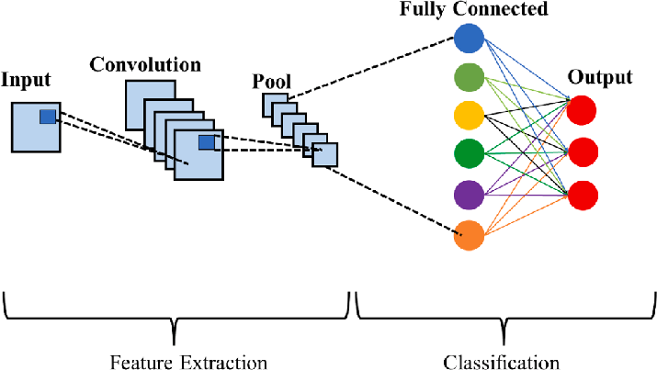

**Figure 2: Schematic of Convolutional neural networks(CNNs)(Hadi *et al.* ,2023 )**

**Decision Trees**:  
Decision trees are flowchart-like models that make decisions by splitting data based on feature thresholds. They are effective for rule-based microbial diagnostics and can identify pathogens from clinical datasets (Safavian & Landgrebe, 1991). The flowchart structure (Figure 3) includes internal nodes that represent tests or attributes at each stage. Every branch stands for an outcome for the attributes, while the path from the leaf to the root represents rules for classification.

Decision trees are highly effective learning algorithms that enhance predictive models by providing accuracy, interpretability, and stability. They are particularly valuable in addressing non-linear relationships and are widely applied in solving regression and classification problems (Quinlan, 1986).

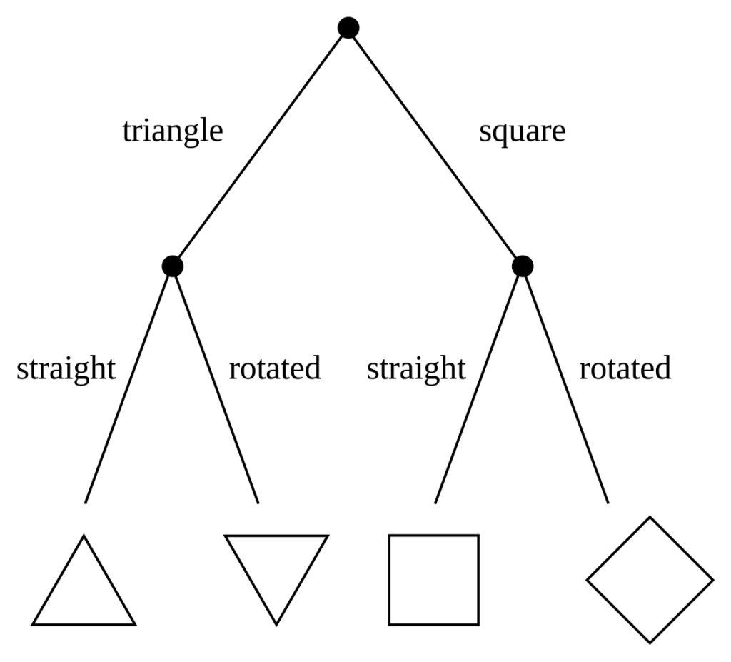

**Figure 3: A Simple Decision Tree (Source: https://corporatefinanceinstitute.com/author/sebastian-taylor/)**

1. **Support Vector Machines (SVM)**:  
   SVMs classify data by finding the optimal hyperplane that separates classes. In microbial diagnostics, SVMs are applied to classify bacteria based on their genomic or proteomic features (Nandhini *et al*., 2022).The process of training, validating, and testing a Support Vector Machine (SVM) model using a numerical dataset is outlined in Figure 4 . It is organized into three primary stages: **Cross-Validation Process**, **Training Process**, and **Testing Process**, each with specific objectives and steps (Cortes & Vapnik, 1995).The **Cross-Validation Process** begins by exploring various SVM and kernel parameters to identify the combination that delivers the highest accuracy. During this stage, cross-validation is performed using subsets of the data, where each combination of parameters is evaluated. The accuracy is calculated for each configuration, and the parameters that achieve the highest accuracy are stored. This iterative process continues until all possible combinations of parameters are tested, ensuring the selection of the best-performing settings. These optimal parameters are then passed to the training stage. (Cortes & Vapnik, 1995).The **Training Process** involves using a designated portion of the numerical dataset, referred to as the training dataset, to develop the SVM model. Features are first extracted from the training data to make it suitable for input into the model. Using the parameters identified during the cross-validation stage, the SVM is trained, producing a well-tuned model ready for testing. (Cortes & Vapnik, 1995).The **Testing Process** evaluates the performance of the trained SVM model. A separate portion of the numerical dataset, known as the testing dataset, is used for this purpose. As in the training phase, features are extracted from the testing data before being fed into the trained SVM model. The model predicts labels for the testing data, which are then compared to the actual labels to assess the model's performance. This evaluation provides a clear measure of the SVM model's accuracy and generalization capability. (Cortes & Vapnik, 1995).In summary, this systematic process begins with parameter optimization through cross-validation, progresses to model training with the best parameters, and concludes with testing to evaluate the model's predictive performance. It ensures that the SVM model is both well-tuned and rigorously assessed.

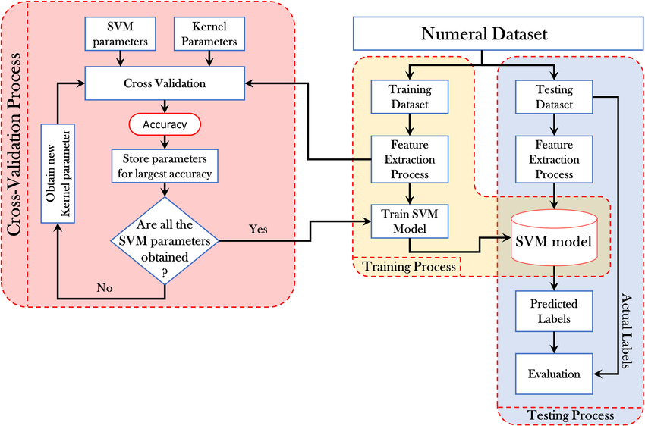

**Figure 4:A Schematic Diagram of Support Vector Machine Training and Testing Process**([Abdulhussain](https://www.researchgate.net/profile/Sadiq-H-Abdulhussain?_tp=eyJjb250ZXh0Ijp7ImZpcnN0UGFnZSI6Il9kaXJlY3QiLCJwYWdlIjoiX2RpcmVjdCJ9fQ) *et al*,2021)

1. **Random Forests**:  
   Random forests, ensembles of decision trees, are robust for handling large and noisy datasets. They are frequently used to predict antimicrobial resistance or classify microorganisms based on molecular data (Zhou *et al*., 2021). Figure 5 illustrates the **Random Forest algorithm**, a machine learning method used for both classification and regression tasks. This ensemble learning technique leverages multiple decision trees to improve predictive accuracy and reduce overfitting (Breiman, 2001).The process begins with the **Input Dataset**, which is randomly split into subsets through a method called bootstrapping. Each subset is used to train an individual decision tree, forming the ensemble. These decision trees operate independently and make predictions based on a random selection of features at each node. This feature randomness introduces decorrelation among the trees, enhancing the model's robustness (Ho, 1995).Each tree produces its own prediction. For classification tasks, the Random Forest aggregates these predictions by majority voting, while for regression tasks, it computes the average of all predictions. This aggregation ensures that the model benefits from the collective wisdom of multiple trees, thereby improving accuracy and reducing susceptibility to noise or bias in individual trees (Breiman, 2001). The result is a final output referred to as the **Random Forest Prediction**.This approach excels at handling large datasets and can efficiently manage missing or imbalanced data. Furthermore, it provides estimates of feature importance, helping identify which input variables contribute most to the prediction. Random Forests are widely used due to their flexibility and ability to achieve high accuracy without significant parameter tuning.

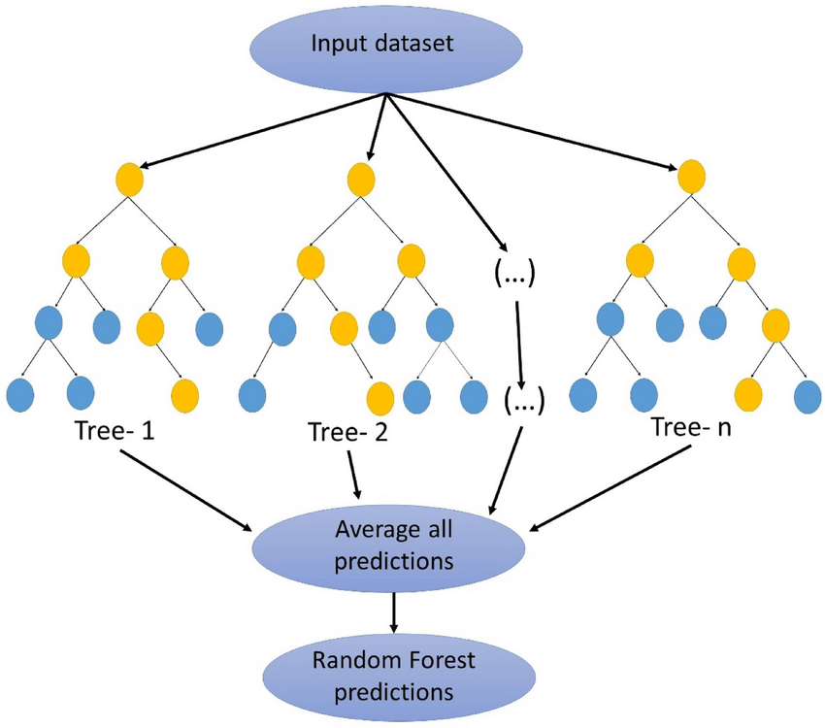

**Figure 5: A schematic diagram of Random Forest** (Source: Sahour et al.,2021)

#### **C. Introduction to Data Preprocessing, Feature Extraction, and Model Evaluation**

**1.Data Preprocessing**:  
Data preprocessing is a fundamental step in preparing raw data for analysis using machine learning algorithms. It ensures that the data is clean, well-structured, and suitable for generating reliable and accurate predictions. Key aspects of preprocessing include handling missing values, normalizing data ranges, and removing irrelevant features. These steps are essential to ensure the integrity of the data and to prevent biased or inaccurate model outcomes (Bommert et al., 2020).

Handling missing values is critical to prevent skewed results, as incomplete data can lead to erroneous conclusions. Common methods include imputing missing values using statistical measures, such as the mean or median, or excluding incomplete entries. Normalization is another essential aspect of preprocessing, as it scales features to a consistent range, such as 0 to 1, ensuring that variables with larger magnitudes do not disproportionately influence models like Support Vector Machines or k-Nearest Neighbors. Additionally, feature selection or removal eliminates irrelevant or redundant features, reducing model complexity and improving computational efficiency (Bommert et al., 2020).

In microbial diagnostics, preprocessing is particularly significant due to the complexity and volume of datasets, such as genomic sequences and laboratory results. For instance, high-throughput sequencing data requires noise reduction and normalization to ensure that predictive models deliver accurate and actionable insights. These preprocessing steps enable effective microbial identification and antibiotic resistance profiling, making them indispensable for building reliable machine learning models in the field (Bommert et al., 2020).

**2.Feature Extraction**:  
Feature extraction is a critical step in data preprocessing, aimed at identifying and retaining the most relevant information from raw data while discarding redundant or irrelevant details. This process is particularly vital in domains dealing with high-dimensional datasets, such as genomics, where the number of variables can be overwhelming.

In genomic diagnostics, feature extraction involves isolating meaningful characteristics from the data, such as the presence of specific genes, single nucleotide polymorphisms (SNPs), or resistance markers. These extracted features serve as inputs for Machine Learning (ML) models to enhance their predictive performance. For example, resistance markers identified in pathogens can help predict antimicrobial resistance patterns, facilitating personalized treatment approaches (Arango-Argoty *et al*., 2018).

Several techniques are employed for feature extraction. **Principal Component Analysis (PCA)** is widely used to reduce dimensionality by transforming the data into a set of uncorrelated components, ranked by their variance (Wold et al., 1987). PCA not only minimizes data redundancy but also enhances computational efficiency in ML pipelines. On the other hand, deep learning methods such as **autoencoders** have gained traction in recent years. Autoencoders are neural networks designed to learn efficient codings of input data, uncovering complex nonlinear relationships that may not be captured by traditional methods (Hinton & Salakhutdinov, 2006).

Additionally, domain-specific methods such as k-mer analysis in genomic sequence processing provide specialized approaches to feature extraction. These methods quantify sequences of length k within a genome, offering insights into genetic composition and variability (Wood & Salzberg, 2014). Such tailored techniques, combined with robust algorithms, have advanced genomic diagnostics, enabling faster and more accurate predictions.

Feature extraction not only streamlines computational workflows but also improves model interpretability. By focusing on the most informative attributes, researchers and clinicians can gain deeper insights into biological phenomena and make data-driven decisions effectively.

**3.Model Evaluation**:  
Model evaluation is a crucial step in assessing the reliability and accuracy of Machine Learning (ML) systems. It involves systematically measuring the performance of a model to ensure it can generalize effectively to unseen data. This process is essential for identifying weaknesses, refining algorithms, and ensuring practical applicability in real-world scenarios.

A variety of metrics are used to evaluate ML models, each providing unique perspectives on performance. Accuracy, the proportion of correct predictions out of all predictions, is one of the most commonly used metrics. However, accuracy alone may not suffice, particularly in imbalanced datasets where dominant classes skew results (Powers, 2011). Precision, the ratio of true positive predictions to all predicted positives, becomes crucial in cases like medical diagnostics, where minimizing false positives is essential to avoid unnecessary treatments (Powers, 2011).

Recall, or sensitivity, complements precision by measuring the proportion of true positives identified out of all actual positive cases. This metric is critical in scenarios like fraud detection, where overlooking genuine cases can have significant consequences. The F1-score, which is the harmonic mean of precision and recall, strikes a balance between the two, making it especially useful when false positives and false negatives carry similar costs (Powers, 2011). The area under the Receiver Operating Characteristic (ROC) curve (AUC-ROC) offers a comprehensive view of a model's classification ability. AUC values close to 1 indicate excellent performance, while values near 0.5 suggest performance no better than random guessing (Bradley, 1997).

To ensure that a model generalizes effectively, cross-validation techniques are frequently employed. **k-Fold Cross-Validation** divides the dataset into k subsets, trains the model on k-1 folds, and tests it on the remaining fold. By repeating this process across all folds, k-fold validation reduces variance associated with specific data partitions and provides a more reliable estimate of model performance (Bishop, 2006). Leave-One-Out Cross-Validation (LOOCV), a specific variant where each data point is treated as a separate test case, maximizes data utilization but can be computationally intensive for large datasets.

Advanced techniques like bootstrapping, which involves repeated sampling with replacement, are also employed to estimate performance metrics robustly. Additionally, the use of confidence intervals provides a range of expected model performance, adding further statistical rigor to the evaluation process. Qualitative assessments, such as confusion matrix analysis and error inspection, can offer deeper insights into specific prediction issues and highlight areas requiring improvement (Powers, 2011).

Combining these quantitative and qualitative approaches ensures a comprehensive understanding of a model's strengths and limitations. A well-evaluated model paves the way for developing reliable and robust ML systems tailored to specific applications.

By integrating these concepts, AI and ML methodologies enable precise, efficient, and scalable solutions for microbial diagnostics, bridging the gap between data complexity and actionable insights.

#### **IV. Applications of Artificial Intelligence and Machine Learning in Microbial Diagnostics:**

#### **A. Pathogen Identification:** Advancements in artificial intelligence (AI) and machine learning (ML) have significantly transformed microbial diagnostics, enabling faster, more accurate, and automated identification of pathogens. Below are specific areas where AI and ML have been applied effectively.

##### **a) AI-Assisted Culture Analysis**

Traditional microbial culture methods, though effective, are often time-consuming and labor-intensive. AI has revolutionized this area by automating culture analysis and interpreting growth patterns. For instance, convolutional neural networks (CNNs) have been trained to detect colony morphology, predict pathogen species, and assess antibiotic susceptibility directly from culture plates (Zheng *et al*., 2020). AI models can also monitor real-time culture dynamics, significantly reducing turnaround time and improving diagnostic efficiency.

### Workflow of AI-Assisted Culture **Analysis:**

The workflow of AI-assisted culture analysis begins with **sample imaging**, a foundational step where high-resolution cameras or specialized imaging devices capture detailed images of agar plates containing microbial colonies. These images are taken under controlled lighting conditions to minimize shadows and reflections, ensuring that the colonies’ size, shape, and spatial arrangement are clearly visible (Zhou et al., 2020). The resulting digital images serve as the basis for accurate and detailed analysis.

Following imaging, the captured photographs undergo **image preprocessing**, an essential step aimed at optimizing them for AI analysis. Preprocessing typically involves noise and artifact removal, brightness and contrast adjustments to enhance visibility, and standardization of image dimensions through cropping and resizing (Sharma et al., 2019). For plates with overlapping colonies, segmentation techniques such as watershed algorithms or contour detection may be employed to isolate individual colonies (Chen et al., 2018). These preprocessing measures ensure clean and consistent images, reducing errors in downstream analysis.

The **AI detection and classification** stage follows, leveraging advanced object detection algorithms such as YOLO (You Only Look Once) and Faster R-CNN. The AI system identifies microbial colonies within the images, drawing bounding boxes around them and assigning labels indicating the species or classification. Confidence scores accompany these labels, reflecting the system’s certainty in its predictions. This automated process significantly reduces the time and labor required for manual identification while maintaining high levels of accuracy and consistency (Redmon *et al*., 2016).

Next, the workflow proceeds to **quantitative analysis**, where numerical data is extracted from the identified colonies. Key metrics include colony counts, size measurements, and species distribution patterns. Density mapping may also be performed to visualize spatial arrangements of colonies on the agar plate (Huang *et al*., 2021). This data is particularly valuable for applications such as analyzing microbial growth dynamics, screening for antibiotic resistance, and assessing contamination levels in industrial or clinical settings.

The final step involves **microbial identification**, where the AI-generated classifications are validated and refined. The identified colonies are cross-referenced against a microbial database to confirm species identity. In more rigorous settings, methods like genetic sequencing or biochemical assays may be employed for further verification, ensuring accuracy in clinical diagnostics or research applications (Smith *et al*., 2017). The result is a comprehensive report detailing the microbial species present, their proportions, and any additional characteristics relevant to the analysis.

This workflow of AI-assisted culture analysis provides numerous benefits, including enhanced efficiency, accuracy, and scalability. By automating traditionally labor-intensive tasks, it ensures consistent and reproducible results. Additionally, it supports high-throughput analysis, making it an invaluable tool for microbiological research and diagnostics, particularly in settings requiring rapid and reliable results.

##### **b)Genomic and Metagenomic Sequencing Applications**

The advent of next-generation sequencing (NGS) has provided unparalleled insights into microbial genomes, but analyzing the vast data generated is challenging. AI and ML tools address this by enabling rapid analysis and interpretation of genomic and metagenomic data.

**i) Gene Annotation**: **it** is the process of identifying and characterizing genes and their functional elements within microbial genomes. This involves the recognition of coding regions, regulatory elements, and other functional sequences. Machine Learning (ML) algorithms have revolutionized this field by improving accuracy, speed, and efficiency in gene annotation, especially in the context of large and complex microbial genomes (Arango-Argoty et al., 2018).

#### **Mechanism of Machine Learning Algorithms in Gene Annotation**

Machine learning algorithms leverage vast datasets to predict gene locations and classify functional regions within microbial genomes. By training on known annotations, these models develop patterns and features that allow them to accurately identify genes, including their associated functional elements. For example, algorithms can detect coding sequences (CDS), promoter regions, and resistance determinants based on features like sequence homology, k-mer frequencies, and gene expression patterns. One of the most significant applications of AI in gene annotation lies in its capacity to accurately predict the location of genes within a DNA sequence. By employing sophisticated algorithms, AI can effectively identify the boundaries of genes, including their starting and stopping points, as well as delineate exons and introns, the coding and non-coding regions respectively. This capability is particularly invaluable in deciphering the complexities of newly sequenced genomes or those with intricate structures. (Arango-Argoty *et al*., 2018)

Furthermore, AI excels in predicting the functions of genes. By analyzing a gene's sequence similarity to known genes, examining its expression patterns, and investigating its interactions with other proteins, AI algorithms can effectively infer its biological role within the cellular machinery. This knowledge is instrumental in understanding the intricate mechanisms underlying various cellular processes and their involvement in diverse biological functions (Arango-Argoty *et al*., 2018)

#### **Applications of Machine Learning in Gene Annotation**

1. **Identification of Coding Regions**: ML algorithms analyze nucleotide sequences to predict open reading frames (ORFs), which are indicative of protein-coding regions.
2. **Annotation of Functional Regions**: These algorithms recognize regulatory elements such as promoters and transcription factors that are essential for understanding gene expression and regulation.
3. **Resistance Determinants**: Machine learning techniques are used to identify genes associated with antibiotic resistance, helping in the understanding of resistance mechanisms and potential therapeutic targets.

#### Advantages of Machine Learning in Gene Annotation

1. **Accuracy**: Improved accuracy in predicting genes and functional regions compared to traditional manual annotation methods.
2. **Speed**: Automated processes significantly reduce the time required for annotating large genomes.
3. **Scalability**: Machine learning allows for the analysis of large datasets, handling complex microbial genomes efficiently.

**ii) Pathogen Detection**: Tools like Kraken and MetaPhlAn use AI to classify organisms in complex microbial communities, facilitating pathogen identification in clinical metagenomics (Wood *et al*., 2019). Kraken and MetaPhlAn use advanced machine learning algorithms to analyze high-throughput sequencing data, enabling the classification of microbial communities at various taxonomic levels. These tools help rapidly identify and differentiate between pathogenic and non-pathogenic organisms, even in the presence of a diverse microbial population. Kraken and MetaPhlAn employ sophisticated algorithms to classify DNA sequences obtained from metagenomic samples. These algorithms are trained on massive databases of known microbial genomes, enabling them to rapidly identify and categorize the organisms present in a sample with high accuracy. [**Kraken**](http://ccb.jhu.edu/software/kraken/) is a taxonomic sequence classifier that assigns taxonomic labels to short DNA reads. It does this by examining the *k*-mers within a read and querying a database with those *k*-mers. This database contains a mapping of every *k*-mer in [Kraken](http://ccb.jhu.edu/software/kraken/)'s genomic library to the lowest common ancestor (LCA) in a taxonomic tree of all genomes that contain that *k*-mer. The set of LCA taxa that correspond to the *k*-mers in a read are then analyzed to create a single taxonomic label for the read; this label can be any of the nodes in the taxonomic tree. [Kraken](http://ccb.jhu.edu/software/kraken/) is designed to be rapid, sensitive, and highly precise. Our tests on various real and simulated data have shown [Kraken](http://ccb.jhu.edu/software/kraken/) to have sensitivity slightly lower than Megablast with precision being slightly higher. On a set of simulated 100 bp reads, [Kraken](http://ccb.jhu.edu/software/kraken/) processed over 1.3 million reads per minute on a single core in normal operation, and over 4.1 million reads per minute in quick operation.

**Kraken** employs a k-mer-based approach, comparing short genomic fragments against a comprehensive database of microbial genomes, making it fast and efficient for taxonomic classification (Wood & Salzberg, 2014).

 To classify a sequence, each *k*-mer in the sequence is mapped to the lowest common ancestor (LCA) of the genomes that contain that *k*-mer in a database. The taxa associated with the sequence’s *k*-mers, as well as the taxa’s ancestors, form a pruned subtree of the general taxonomy tree, which is used for classification. In the classification tree, each node has a weight equal to the number of *k*-mers in the sequence associated with the node’s taxon. Each root-to-leaf (RTL) path in the classification tree is scored by adding all weights in the path, and the maximal RTL path in the classification tree is the classification path (nodes highlighted in yellow). The leaf of this classification path (the orange, leftmost leaf in the classification tree) is the classification used for the query sequence Wood & Salzberg,2014.

**MetaPhlAn** uses unique markers for each microbial species, allowing precise identification and quantification of microbial species within metagenomic datasets. MetaPhlAn focuses on a set of conserved marker genes that are specific to different clades of microorganisms. Input DNA sequences are mapped to these marker genes using specialized algorithms.Based on the presence and abundance of these marker genes, MetaPhlAn estimates the relative abundance of different microbial taxa in the sample (Segata *et al*., 2012) By analyzing the taxonomic composition of a microbial community, these tools can pinpoint the presence of potential pathogens. This is particularly valuable in clinical settings, where identifying the causative agent of an infection is crucial for effective treatment.

**Table 1: Differences Between MetaPhlAn and Kraken**

MetaPhlAn and Kraken are two widely used tools in metagenomics for microbial classification. Despite their common purpose, they differ significantly in methodologies, database structure, and application focus. Below is a detailed comparison:

| **Aspect** | **MetaPhlAn** | **Kraken** |
| --- | --- | --- |
| **Methodology** | Uses clade-specific marker genes unique to microbial taxa for classification (Segata et al., 2012). | Relies on a k-mer-based exact alignment strategy to classify sequences (Wood & Salzberg, 2014). |
| **Database** | Contains precomputed unique markers for microbial species, reducing database size (Segata et al., 2012). | Uses a comprehensive database of entire genomes, resulting in larger database size (Wood & Salzberg, 2014). |
| **Speed** | Faster for complex metagenomic samples due to the use of marker genes (Segata et al., 2012). | Slower in comparison, as it analyzes all sequences against a full database (Wood & Salzberg, 2014). |
| **Output Detail** | Provides taxonomic profiling with relative abundances of microbial taxa (Segata et al., 2012). | Offers a detailed classification for each sequence with taxonomic assignment (Wood & Salzberg, 2014). |
| **Memory Requirements** | Requires less computational memory because of its compact database (Segata et al., 2012). | Requires significant memory for large databases (Wood & Salzberg, 2014). |
| **Accuracy** | High accuracy in taxonomic profiling due to the focus on unique markers (Segata et al., 2012). | High sensitivity but can be prone to noise from unrelated sequence matches (Wood & Salzberg, 2014). |
| **Applications** | Best suited for taxonomic profiling and estimating the abundance of species (Segata et al., 2012). | Ideal for comprehensive sequence classification at all taxonomic levels (Wood & Salzberg, 2014). |
| **Scalability** | Scales well for large datasets with complex communities (Segata et al., 2012). | Scales effectively but requires robust computational resources (Wood & Salzberg, 2014). |
| **Marker vs. Whole Genome** | Focuses on specific markers, making it more targeted (Segata et al., 2012). | Analyzes entire genomes for a broader classification approach (Wood & Salzberg, 2014). |

**iii)Antimicrobial Resistance (AMR) Prediction**Antimicrobial Resistance (AMR) presents a significant global health challenge, threatening the efficacy of existing antimicrobial therapies. Accurate prediction of AMR is crucial for selecting effective treatments, and artificial intelligence (AI) systems have emerged as transformative tools in this field. By analyzing genetic markers associated with resistance, these systems enable clinicians to make informed decisions about antimicrobial therapy (Nguyen *et al*., 2018).

AI systems employ advanced machine learning algorithms trained on large-scale genomic datasets to predict resistance profiles. These models identify patterns associated with resistance genes, mutations, and mobile genetic elements. Through this analysis, AI systems can determine the likelihood of resistance to specific antibiotics, offering a faster and more accurate alternative to traditional phenotypic testing methods, which are often time-consuming (Nguyen *et al*., 2018).

The process begins with AI extracting features such as k-mers, point mutations, or structural variations from the genomic data .These features are analyzed to detect associations between genetic markers and resistance phenotypes. Some advanced AI systems also incorporate clinical metadata, such as patient demographics and infection site, to enhance predictive accuracy. The results provide clinicians with detailed resistance profiles, enabling them to tailor antimicrobial treatments to individual patients and improve therapeutic outcomes (Nguyen *et al*., 2018).

One of the key advantages of AI in AMR prediction is its speed. AI systems can analyze genomic data rapidly, providing clinicians with resistance insights in hours rather than days. They also deliver high levels of accuracy, reducing false positives and negatives. Additionally, AI systems are scalable, making them suitable for both individual patient diagnostics and population-level studies. These features make AI a valuable component of antimicrobial stewardship programs, where optimized antibiotic use is essential to prevent the development of resistance.

In clinical settings, artificial intelligence (AI)-based tools have significantly advanced the prediction of antimicrobial resistance (AMR), particularly for pathogens such as Escherichia coli, Staphylococcus aureus, and Klebsiella pneumoniae. These pathogens are responsible for severe infections and often exhibit multi-drug resistance, making effective treatment challenging. AI systems analyze genomic data to detect genetic markers and mutations associated with resistance, providing rapid and accurate predictions that guide treatment decisions (Ali et al., 2023).

AI tools are especially useful in managing infections caused by multi-drug-resistant organisms, where prompt and precise interventions are critical. For example, E. coli and K. pneumoniae producing extended-spectrum beta-lactamases (ESBLs) are difficult to treat with conventional beta-lactam antibiotics. By predicting resistance patterns, AI systems recommend alternative therapies, such as carbapenems or combination treatments, which have higher probabilities of success (Nguyen et al., 2018).

A notable application of AI in clinical practice is its role in guiding empirical therapy. In critical cases where immediate treatment decisions are essential, AI systems assist clinicians in selecting antibiotics with the greatest likelihood of efficacy. These tools minimize delays associated with traditional culture-based resistance testing, improving patient outcomes (Ali et al., 2023).

Beyond individual patient care, AI contributes significantly to public health surveillance by monitoring the spread of resistance genes in populations and healthcare settings. For instance, AI systems track the prevalence of resistance mechanisms, such as methicillin resistance in S. aureus (MRSA) or carbapenem resistance in K. pneumoniae. By aggregating data from clinical cases, these tools identify resistance hotspots, evaluate the effectiveness of antimicrobial stewardship programs, and inform public health policies (Wood & Salzberg, 2014).

The Figure 6 below illustrates a systematic pipeline for applying Artificial Intelligence (AI) and Machine Learning (ML) to address antimicrobial resistance (AMR). This process begins with **data collection**, where biological data such as bacterial isolates, genomic sequences, and antimicrobial susceptibility profiles are gathered. These profiles provide critical information on whether specific bacterial strains are resistant or susceptible to antibiotics (Yang et al., 2020). The data is typically sourced from clinical or environmental samples.

The second stage, **obtaining important data**, involves preprocessing the collected data to ensure high quality. This step focuses on tasks like genome assembly, balancing the dataset, and removing noise to ensure the data is accurate and reliable for subsequent analysis (Camacho et al., 2018). Proper preprocessing is crucial to enhance the robustness and reproducibility of AI/ML models.

Next, the processed data undergoes **encoding**, where biological information is transformed into machine-readable formats. For instance, genomic sequences may be represented as genes, k-mers (short nucleotide sequences of a fixed length), or susceptibility/resistance markers. This transformation enables the AI/ML models to analyze the data efficiently (Robinson et al., 2020).

The **feature selection** step follows, where the most relevant features of the dataset are identified and selected. This reduces data dimensionality and helps focus on factors with the greatest impact on AMR. Advanced techniques like clustering are often employed to visualize and refine feature selection, ensuring the model’s interpretability and accuracy (Yang et al., 2020).

At the core of the pipeline is the **DL/ML model**. These models are trained on the selected features to detect patterns, predict resistance, or identify novel resistance genes. Deep learning algorithms, in particular, are capable of uncovering complex relationships within the data, providing a powerful tool for AMR prediction (Camacho et al., 2018).

Once the model is trained, it produces **results**, including predictions of resistance phenotypes, clustering of bacterial isolates, and identification of resistance determinants. These results are validated and interpreted using visualization tools such as heatmaps and clustering matrices, which help researchers draw meaningful conclusions (Robinson et al., 2020).

Finally, the pipeline concludes with the **test model** phase, where the trained model is applied to unseen data to assess its performance and generalizability. This step evaluates the model’s real-world applicability, ensuring it can reliably predict resistance patterns or guide treatment strategies (Yang et al., 2020).

Despite their benefits, AI systems face challenges, including the need for high-quality training data, seamless integration into clinical workflows, and addressing ethical concerns surrounding data privacy. As genomic databases grow and real-time sequencing technologies improve, AI's role in AMR prediction is expected to expand, further transforming the landscape of antimicrobial therapy (Nguyen et al., 2018).

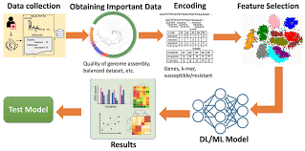

Figure 6:Overview of the application of Deep Learning and Machine Learning in Antimicrobial Resistance Prediction(Source: Ali *et al* ,2023)

##### **c)Automated Image Analysis of Stained Samples**

Microscopic examination of stained samples, such as Gram-stained or Ziehl-Neelsen-stained smears, is a cornerstone of microbial diagnostics. However, the manual interpretation of these images can be subjective and prone to errors. AI-powered image analysis overcomes these limitations. The workflow below (Figure 7) outlines a systematic process for applying artificial intelligence (AI) and machine learning (ML) to medical image analysis and validation, particularly for tasks such as X-ray interpretation (Litjens *et al.,* 2017; Esteva *et al.,* 2021).

The process begins with consultations involving medical experts and doctors to select clinically relevant input variables for the study. Once the variables are determined, data is collected, focusing on medical images like X-rays. The collected dataset undergoes preprocessing to remove noise and ensure uniformity, preparing it for AI-based analysis (Shen *et al*., 2017).

Next, the dataset is divided into two subsets: 80% is allocated for training the AI models, while 20% is reserved for testing the model's performance. For both subsets, the X-ray images are processed through an image embedder, such as SqueezeNet, which extracts key features from the images (Iandola *et al*., 2016). These features are then merged into respective training and testing datasets.

The training data is used to train various AI algorithms, including tree-based models, Naïve Bayes classifiers, and Support Vector Machines (SVM) (Zhou *et al*., 2021). The trained models are evaluated using several performance metrics, including accuracy (the proportion of correct predictions), precision (the ratio of true positives to predicted positives), recall (the ratio of true positives to all actual positives), F1 score (the harmonic mean of precision and recall), and AUC (Area Under the Curve), which assesses the model's ability to distinguish between classes (Chicco & Jurman, 2020).

After evaluation, the model’s outputs are subjected to validation by medical experts to ensure that the AI’s results align with clinical standards and provide reliable diagnostic support. This step ensures that the model's predictions are accurate and useful in real-world healthcare scenarios (Mazurowski *et al*., 2019). Once validated, the workflow concludes, providing a robust AI-based system for medical image analysis.

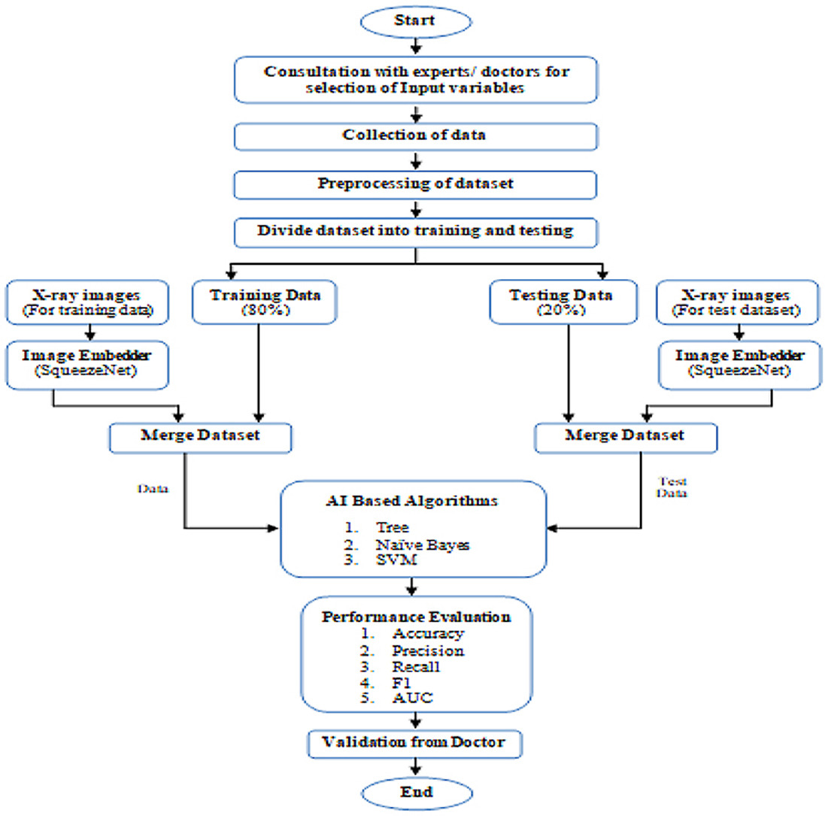

**Figure 7: Workflow for AI-Based Medical Image Analysis and Validation (Source:Sharma *et al*,2021)**

**i) Gram Stain Analysis**: AI algorithms, particularly deep learning models such as Convolutional Neural Networks (CNNs), can process microscopic images of Gram-stained slides. These models are trained on large datasets comprising labeled images of Gram-positive and Gram-negative bacteria, enabling them to learn morphological patterns, such as shape, color intensity, and arrangement of cells (Xie *et al.,* 2021). In a study by Xie *et al*. (2021), an AI-based Gram stain analysis system achieved an accuracy rate of 96.3% in classifying bacterial samples. The system was able to differentiate between Gram-positive bacteria, characterized by thick peptidoglycan layers that retain the crystal violet dye, and Gram-negative bacteria, which have thinner walls and take up the safranin counterstain. AI-powered tools analyze Gram-stained slides within seconds, significantly reducing the time required for diagnostic workflows. This is especially critical in clinical settings where timely pathogen identification can influence treatment outcomes.Figure 8 outlines a systematic process for training and validating machine learning models using image data, beginning with the DiBaS dataset. The first step, **preparation**, involves preprocessing the images by removing irrelevant background elements to focus on regions of interest. During this stage, key features are extracted, including Gram stain features, fungi-specific features, morphological characteristics (e.g., shape and size), and clustering patterns within the images (Baldini *et al.,* 2020).After preprocessing, the data is split into two sets: 70% for training the model and 30% reserved for testing its performance (Goodfellow *et al.,* 2016). The training data is then fed into machine learning algorithms such as **CPN** (a specific type of neural network or computational approach) and **Random Forest (RF)**, a decision-tree-based algorithm known for its robustness and accuracy in classification tasks (Breiman, 2001). This stage also includes iterative validation to optimize the model’s performance.Once the model has been trained, it is tested using the reserved test data to assess its ability to generalize and perform accurately on unseen inputs (Goodfellow *et al*., 2016). Based on these results, the best-performing model(s) are selected as the final output. The process concludes with an evaluation of the model’s performance metrics, such as accuracy, precision, and recall, ensuring its reliability and efficiency for tasks such as microbial image classification or other diagnostic applications (Baldini *et al*., 2020).

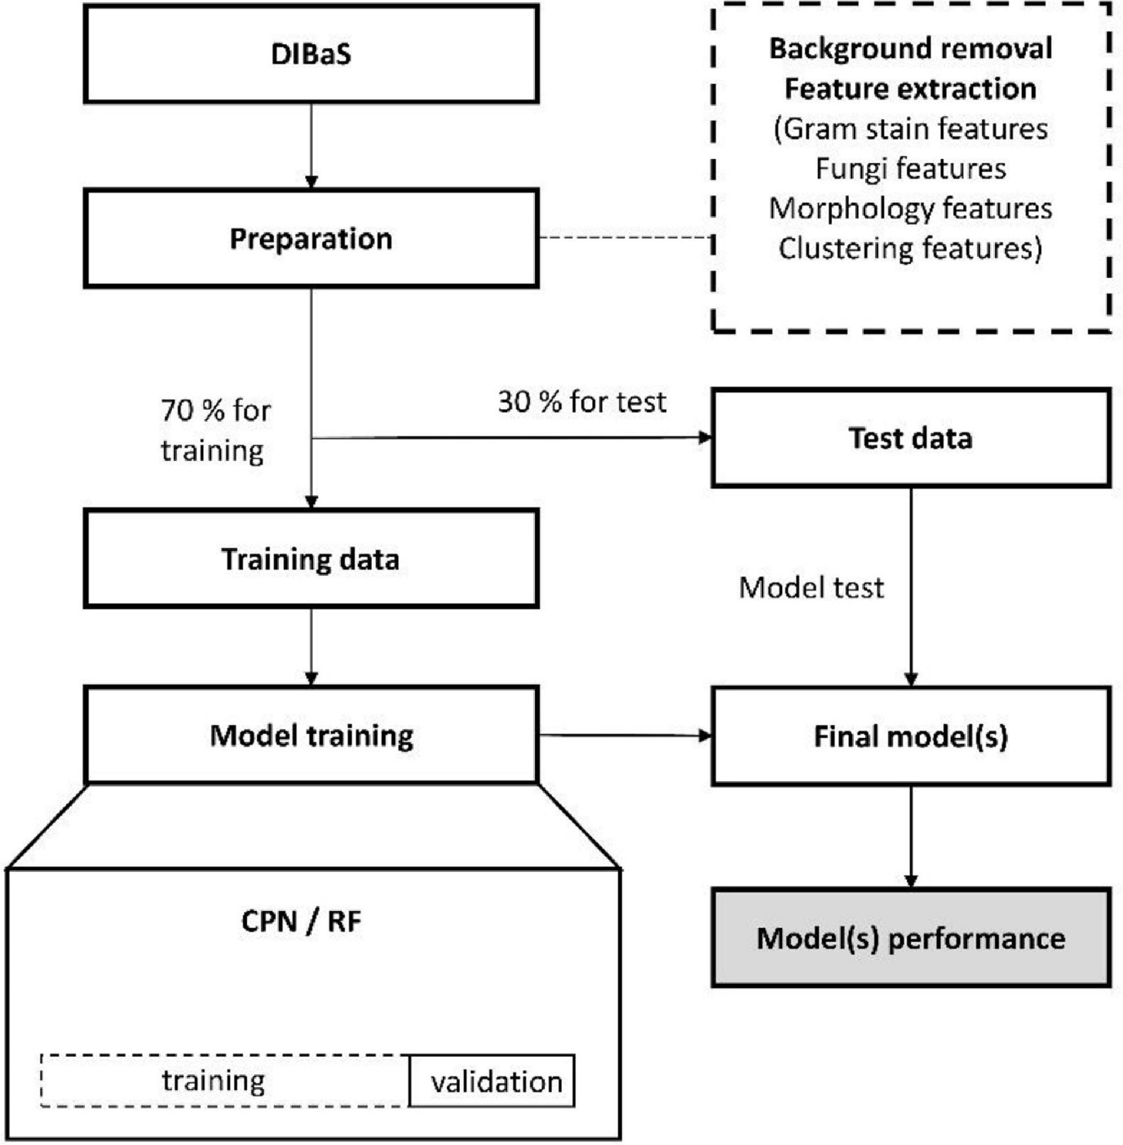

**Figure 8: Flowchart of steps involved in the development of the algorithms for classification of Gram stain images.(source: Kristensen e*t al*.,,2023)**

.

**ii) Tuberculosis Detection**: Deep learning models, such as CNNs, have been applied to identify Mycobacterium tuberculosis in Ziehl-Neelsen-stained slides, reducing the diagnostic burden in high-prevalence settings (Lakhani & Sundaram, 2017). CNNs are trained on large datasets of ZN-stained slide images, learning to recognize the characteristic rod-shaped morphology and staining patterns of AFB. These models can accurately differentiate AFB from background debris, ensuring reliable results. Studies have shown that CNNs achieve sensitivity and specificity rates comparable to, or exceeding, those of experienced microscopists. For instance, Lakhani and Sundaram (2017) reported that their deep learning model achieved an accuracy of over 95% in identifying MTB, significantly reducing false positives and false negatives.Moreso, Hsiang and Wen-Yih (2024) employed a modified EfficientNet model for binary classification of TB-positive regions, achieving 97% accuracy in tile-based classification. The system utilized an image processing technique to highlight red, rod-like regions and a modified EfficientNet model for binary classification of TB-positive regions. The approach achieved a 97% accuracy in tile-based TB image classification, with minimal loss during the image processing step. By setting a 0.99 threshold, false positives were significantly reduced, resulting in a 94% detection rate when assisting pathologists, compared with 68% without artificial intelligence assistance. Notably, this system efficiently identifies artifacts and contaminants, addressing challenges in digital slide interpretation. Cross-hospital validation demonstrated the system's adaptability. The proposed artificial intelligence-assisted pipeline improves both detection rates and time efficiency, making it a promising tool for routine pathology work in TB detection

**iii) Fungal Identification**: AI technologies have significantly advanced fungal identification by automating and enhancing the accuracy of analysis processes. These tools analyze fungal morphology in stained samples, focusing on features such as size, shape, hyphal branching, and spore formation, which are critical for differentiating between species. For example, in clinical mycology, the accurate identification of pathogens like Candida and Aspergillus species is essential for timely and effective treatment (Yin *et al.,* 2020).

By automating these processes, Artificial Intelligence and Machine Learning streamline pathogen identification, minimize human error, and enable rapid and precise diagnostics, especially in resource-limited settings.

#### **B. Antimicrobial Resistance Detection**

Antimicrobial resistance (AMR) is a growing global health crisis, with significant implications for public health, healthcare costs, and treatment efficacy. The ability of microorganisms to resist the effects of antimicrobial drugs complicates the treatment of infectious diseases, often leading to prolonged illness and increased mortality rates (World Health Organization, 2020). Rapid and accurate detection of AMR is essential for timely interventions and the selection of effective therapies.

Traditional methods for detecting AMR involve culture-based techniques and susceptibility testing, such as the disk diffusion method, broth microdilution, and automated systems like VITEK and MALDI-TOF MS. Although these methods are reliable, they are time-consuming, labor-intensive, and sometimes limited by the availability of resources in low-income settings (van Belkum et al., 2019). Advances in molecular diagnostics, including PCR-based assays and next-generation sequencing (NGS), have enhanced detection speed and accuracy but remain expensive and technically demanding.

##### **a) Prediction Models for Resistance Patterns**

Artificial Intelligence (AI) and Machine Learning (ML) are transforming the landscape of AMR detection by enabling the analysis of large-scale, complex datasets to predict resistance patterns. These technologies leverage various data sources, including genomic sequences, proteomics, patient metadata, and antimicrobial susceptibility profiles, to identify key resistance mechanisms and forecast emerging trends.Antimicrobial resistance (AMR) poses a global health threat, necessitating rapid and accurate detection methods. Artificial Intelligence and Machine Learning-based prediction models analyze large datasets to identify resistance patterns, aiding clinicians in selecting effective therapies.The existing prediction Models are discussed below

**i) Whole Genome Sequencing (WGS)**: Whole Genome Sequencing (WGS) has revolutionized the detection and prediction of antimicrobial resistance (AMR) by enabling comprehensive analyses of microbial genomes. This technique provides a high-resolution view of genetic variations associated with resistance, including mutations in resistance genes, regulatory elements of efflux pumps, and the acquisition of mobile genetic elements such as plasmids, integrons, and transposons (Ellington *et al*., 2017). Machine Learning (ML) models have been integrated with WGS to enhance the prediction of resistance phenotypes by analyzing vast genomic datasets. These models identify critical genetic markers and patterns associated with resistance, enabling faster and more accurate predictions compared to traditional methods.

#### **Key Tools and Approaches**

**ResFinder:**  
ResFinder is a widely used bioinformatics tool designed to identify antimicrobial resistance genes from WGS data. By comparing genomic sequences against a curated database of resistance genes, ResFinder provides detailed insights into the presence and type of resistance determinants within a microbial genome. This tool has been instrumental in surveillance studies, enabling the tracking of resistance genes across different populations and geographic regions (Zankari et al., 2012).

**DeepARG:**  
DeepARG is an advanced ML-based tool that predicts resistance by analyzing both known and novel antimicrobial resistance genes. Unlike traditional methods, DeepARG employs deep learning to identify resistance determinants even in the absence of explicit annotations. This capability makes it particularly useful for analyzing complex metagenomic datasets, such as those derived from environmental or clinical samples (Arango-Argoty et al., 2018).

**Efflux Pump Regulation Analysis:**  
ML models have also been applied to predict resistance mediated by efflux pump regulators. By identifying mutations in regulatory genes or their promoter regions, these models can infer the upregulation of efflux pumps, which often results in multidrug resistance (Li et al., 2015).

The integration of Whole Genome Sequencing (WGS) with Machine Learning (ML) offers several significant advantages in the detection and analysis of antimicrobial resistance (AMR). One of the primary benefits is its high sensitivity, as WGS combined with ML can identify even low-frequency resistance mutations. This capability provides more comprehensive insights than traditional culture-based methods, making it a powerful tool in resistance detection.

Additionally, the automated analysis of WGS data allows for rapid resistance prediction, significantly reducing the time required for diagnosis and enabling clinicians to make timely and informed therapeutic decisions. Another critical advantage is the potential for novel gene discovery. Advanced ML models like DeepARG can identify previously uncharacterized resistance genes, broadening our understanding of resistance mechanisms and their evolution.

Furthermore, WGS supports global surveillance efforts by enabling the tracking of resistance gene dissemination across various strains, species, and geographic regions. This capability is invaluable for monitoring and managing the global spread of AMR, ensuring that public health interventions remain targeted and effective (Mather et al., 2018).

Despite the significant advantages of integrating Whole Genome Sequencing (WGS) and Machine Learning (ML), several challenges hinder their widespread adoption. One major issue is the inconsistency in sequencing quality and the presence of incomplete datasets, which can undermine the accuracy of resistance predictions. Additionally, the analysis of large genomic datasets demands substantial computational resources, which are often unavailable in resource-limited settings. Furthermore, the clinical validation of resistance predictions remains a critical challenge. Without thorough validation, the reliability of these tools in guiding clinical decision-making cannot be guaranteed.

To overcome these hurdles, future efforts should prioritize enhancing the interpretability of ML algorithms, enabling clinicians and researchers to better understand their predictions. Expanding resistance gene databases is also essential to improve the comprehensiveness and accuracy of predictions. Finally, there is a pressing need to make computational tools more accessible, particularly for healthcare systems in low- and middle-income countries, to ensure the global applicability and utility of WGS-integrated ML solutions.

##### **b) Machine Learning Algorithms for Phenotypic and Genotypic Resistance Detection**

Artificial Intelligence (AI) and Machine Learning (ML) have emerged as transformative tools in antimicrobial resistance (AMR) research, offering unparalleled accuracy in detecting both phenotypic and genotypic resistance. These technologies leverage vast datasets, enabling rapid and precise identification of resistance patterns, mechanisms, and their clinical implications.

**i) Phenotypic Detection**: ML algorithms excel in predicting phenotypic resistance by analyzing patterns in experimental data, such as growth curves, minimum inhibitory concentrations (MICs), and bacterial behavior under antimicrobial exposure. For instance, supervised learning models like Support Vector Machines (SVMs), Random Forests, and Gradient Boosting are widely employed to classify microbial isolates as resistant or susceptible based on phenotypic datasets. These models often integrate high-throughput screening results and experimental conditions to achieve predictive accuracies that surpass traditional statistical methods.

Deep learning models, such as Convolutional Neural Networks (CNNs), have also been utilized to analyze phenotypic traits from imaging data, such as colony morphology or biofilm formation. These techniques can detect subtle phenotypic variations associated with resistance that might be missed by conventional approaches, enabling more nuanced insights into microbial behavior (Yang et al., 2019). Automated systems, like those developed by the European Committee on Antimicrobial Susceptibility Testing (EUCAST), have incorporated AI-driven solutions to expedite phenotypic analysis. For instance, EUCAST's disk diffusion zone diameter interpretations employ machine learning to rapidly and accurately analyze inhibition zones, offering clinicians reliable results in significantly less time (Köser et al., 2019).

**Genotypic Detection**: On the genotypic front, ML models have been instrumental in analyzing genomic data to identify mutations, gene acquisitions, or structural variations linked to resistance. Tools such as DeepARG and AMRPlusPlus use deep learning and ensemble methods to analyze genome-wide data, predicting resistance by correlating genetic markers with phenotypic resistance profiles (Arango-Argoty et al., 2018).

Natural Language Processing (NLP) techniques have also been applied to parse and annotate genetic sequences, accelerating the identification of resistance genes and operons. Additionally, unsupervised learning algorithms, such as clustering and dimensionality reduction methods, are used to explore novel resistance mechanisms by identifying patterns in genomic and transcriptomic data.

Machine Learning (ML) algorithms offer several key advantages in the detection and management of antimicrobial resistance (AMR), positioning them as transformative tools in this field. One of the most significant benefits is their high accuracy. ML models excel at analyzing complex, high-dimensional datasets, delivering predictive insights that surpass the capabilities of traditional methods (Köser et al., 2019). This precision is crucial for identifying subtle patterns and associations that drive resistance mechanisms.

In addition to accuracy, the rapid processing capabilities of AI-powered systems are a major advantage. These systems can analyze large-scale phenotypic and genotypic data within minutes, drastically reducing the time required for resistance detection and enabling timely clinical decision-making (Yang et al., 2019). Their scalability further enhances their utility, as ML models can handle extensive datasets across diverse bacterial species and settings, making them well-suited for global AMR surveillance efforts.

Another noteworthy benefit is the ability of ML to provide novel insights. These models can identify previously unknown resistance genes and mechanisms, significantly expanding the knowledge base required to develop effective intervention strategies (Arango-Argoty et al., 2018). By uncovering these hidden patterns, ML contributes to a deeper understanding of AMR, paving the way for more targeted and innovative approaches to combat this global health threat.

Despite these advantages, challenges remain. Issues such as the need for high-quality annotated datasets, the requirement for extensive computational resources, and the interpretability of complex ML models can hinder their widespread adoption (Mather et al., 2018). Addressing these challenges will be critical to fully realizing the potential of ML in AMR detection. Future efforts should focus on improving data standardization, enhancing model transparency, and ensuring the accessibility of computational tools, particularly in resource-limited settings.

By leveraging its strengths while addressing its challenges, ML has the potential to revolutionize AMR detection and management, ultimately improving global health outcomes.

#### **C. Epidemiological Surveillance:**

Artificial Intelligence (AI)-based systems have significantly transformed epidemiological surveillance, offering innovative solutions for the early detection and management of infectious disease outbreaks. By analyzing vast datasets, including real-time data from social media, electronic health records, and sensor networks, AI enables faster identification of emerging health threats.

These systems use advanced machine learning algorithms to detect patterns and trends that may indicate the onset of an outbreak, even before traditional methods can provide confirmation. For instance, AI models can analyze symptom trends, geographic data, and demographic information to predict the spread of diseases like COVID-19 or Ebola, allowing for timely public health interventions (Nguyen et al., 2020).

Furthermore, AI enhances the accuracy of surveillance by minimizing human error and ensuring continuous monitoring across various populations and regions. This capability is particularly beneficial in resource-limited settings where healthcare infrastructure may be insufficient for manual data collection and analysis.

##### **a)AI in Tracking Infectious Disease Outbreaks**

Artificial intelligence (AI) has transformed epidemiological surveillance by enabling early detection, prediction, and intervention in infectious disease outbreaks. AI-based systems utilize advanced computational tools to process large volumes of data, providing actionable insights for public health experts and policymakers.

#### **i) Digital Surveillance Platforms**

AI-powered digital surveillance platforms such as **HealthMap** and **BlueDot** employ natural language processing (NLP) algorithms to mine real-time data from diverse sources, including news articles, social media platforms, and official public health reports. By analyzing these datasets, such tools can detect potential outbreaks and emerging disease threats earlier than traditional methods. For example, BlueDot was instrumental in identifying the spread of COVID-19 in Wuhan, China, before the outbreak was officially reported (Bogoch *et* *al*., 2020). These platforms improve response times and help allocate resources effectively to mitigate the spread of infectious diseases.

HealthMap: HealthMap is a multifaceted tool for health management and disease surveillance. It integrates self-management support for chronic diseases, especially HIV, and provides a platform for tracking and analysing real-time diseases. The systematic development of HealthMap highlights the importance of patient-centred care and data-driven decision-making in public health..HealthMap enhances HIV care by promoting self-management strategies, addressing chronic disease prevention(Millard et al., 2018).The program is designed using the PRECEDE-PROCEED model, ensuring it meets the specific needs of patients and healthcare providers(Millard et al., 2018).HealthMap functions as a web-based platform for monitoring disease outbreaks, such as MERS, by aggregating data from various sources, including news media and official health alerts(Hossain & Househ, 2016).It has demonstrated effectiveness in improving the accuracy and timeliness of disease monitoring, which is crucial for public health responses(Hossain & Househ, 2016).HealthMap enhances HIV care by promoting self-management strategies, addressing chronic disease prevention(Millard et al., 2018).The program is designed using the PRECEDE-PROCEED model, ensuring it meets the specific needs of patients and healthcare providers(Millard et al., 2018).HealthMap functions as a web-based platform for monitoring disease outbreaks, such as MERS, by aggregating data from various sources, including news media and official health alerts(Hossain & Househ, 2016).It has demonstrated effectiveness in improving the accuracy and timeliness of disease monitoring, which is crucial for public health responses(Hossain & Househ, 2016).

BlueDot:BlueDot leverages artificial intelligence and big data to provide early warnings and insights into potential outbreaks, making it a valuable tool for public health authorities The use of BlueDot in epidemiological studies highlights its role in enhancing epidemic surveillance through advanced data analytics and real-time tracking..BlueDot utilizes AI to analyze vast amounts of open-source data, enabling the early detection of epidemic signals, which is crucial for timely interventions(MacIntyre et al., 2023)The system can trigger alerts for public health officials, facilitating rapid responses to emerging health threats.By integrating Bluetooth technology, BlueDot can track individuals' movements and interactions, identifying potential exposure to infectious diseases(Han, 2023)("The Locating Method of Infectious Source based on Bluetooth System of Smart Device", 2023).It provides personal and regional risk assessments, allowing users to receive alerts when entering high-risk areas, thus enhancing individual awareness and safety(Jayasundara et al., 2020).

#### **ii) Geospatial Mapping**

AI integrates epidemiological and environmental data to identify and predict outbreak hotspots, enabling targeted interventions. Machine learning models have been particularly effective in forecasting outbreaks of diseases like cholera, where environmental factors such as rainfall, temperature, and water quality play significant roles. For instance, a study by Moore *et al.* (2021) demonstrated the use of AI models to predict cholera outbreaks in vulnerable regions of sub-Saharan Africa, allowing for preemptive public health measures. Such predictive capabilities enhance surveillance systems and help in prioritizing high-risk areas for intervention.

##### **b) Role of Big Data in Real-Time Monitoring**

Big data analytics plays an integral role in AI-driven epidemiological surveillance, enabling the processing of vast datasets from diverse sources. By leveraging computational power and advanced algorithms, AI systems enhance the ability to monitor, analyze, and respond to infectious disease dynamics in real time.

#### **i) Genomic Surveillance**

Big data analytics facilitates genomic surveillance by analyzing the genetic material of pathogens collected from clinical and environmental samples. AI algorithms process these genomic datasets to identify mutations, track pathogen evolution, and monitor the geographical spread of infectious agents. For instance, platforms like **Nextstrain** use big data to track the global spread of SARS-CoV-2 by analyzing its genomic sequences, offering real-time insights into transmission dynamics (Hadfield *et al.,* 2018). Similarly, AI has been utilized to monitor antimicrobial resistance in Escherichia coli, providing critical information to guide treatment protocols and containment strategies.

#### **ii) Real-Time Monitoring**

AI-powered systems integrate laboratory, clinical, and public health data to enable continuous real-time monitoring. These systems provide public health authorities with dynamic dashboards that visualize data trends, such as case numbers, hospitalizations, and resource utilization during pandemics. For example, AI-driven dashboards were pivotal during the COVID-19 pandemic, offering real-time updates on disease spread, vaccine distribution, and healthcare system capacities (Vahedian-Azimi *et al.,* 2020). Such tools improve decision-making and enhance the timely

Artificial Intelligence and Machine Learning applications in AMR detection and epidemiological surveillance enhance precision, speed, and scalability, empowering healthcare systems to combat emerging infectious diseases and resistance threats effectively.

#### **D. Predictive Modeling and Risk Assessment**

Artificial Intelligence (AI) and Machine Learning (ML) have transformed healthcare by enabling sophisticated predictive modeling and patient risk stratification. These technologies process complex datasets, identifying subtle patterns and correlations that aid in predicting susceptibility to infections and adverse outcomes.

#### **a) Machine Learning Models for Patient Risk Stratification**

##### **i) Risk Stratification for Sepsis**

Sepsis remains a leading cause of morbidity and mortality worldwide, but ML-based systems have significantly improved its early detection. Algorithms such as random forests and neural networks analyze electronic health record (EHR) data to stratify patients by their risk of developing sepsis. Early warning systems like the **InSight algorithm** have demonstrated high sensitivity and specificity in predicting sepsis onset, enabling timely interventions that improve patient outcomes (Desautels et al., 2016). These models consider diverse factors, including vital signs, lab results, and patient demographics, to provide actionable insights for clinicians.

##### ii) Personalized Risk Assessments

ML systems are also advancing personalized risk assessments by integrating data from multiple domains, including genetics, the microbiome, and clinical histories. This holistic approach enables the prediction of individual risks for infectious diseases such as multidrug-resistant infections and hospital-acquired infections. For instance, ML algorithms have been used to predict the likelihood of adverse outcomes in patients with antimicrobial resistance by analyzing genomic and clinical data (Seymour et al., 2017). Such personalized models allow for targeted preventive measures and customized treatment plans, reducing healthcare costs and improving patient care.

The integration of ML models with real-time clinical workflows, wearable technology, and broader healthcare datasets promises to further enhance the accuracy and usability of predictive models. Innovations in explainable AI (XAI) are also making these systems more interpretable for clinicians, fostering trust and broader adoption in clinical settings.

##### **b)Applications in Predicting Disease Progression**

Predicting disease progression is critical in managing infections and optimizing treatment strategies. ML-based predictive models are being increasingly used for this purpose.

#### i) Tuberculosis Progression

Machine Learning algorithms, such as support vector machines (SVMs), have shown promise in predicting the progression of latent tuberculosis infection (LTBI) to active disease. These models analyze host immune markers, including cytokine profiles and gene expression data, to stratify patients by their risk of developing active tuberculosis. Early identification of high-risk individuals allows for targeted preventive therapies, reducing the disease burden and improving public health outcomes (Drain *et al.,* 2018).

#### ii) Viral Load Prediction

AI tools play a vital role in modeling the progression of viral infections, such as HIV and hepatitis C. By analyzing clinical, virological, and genetic data, these tools predict changes in viral load over time, helping clinicians make timely adjustments to treatment plans. For instance, ML models can forecast virological failure or resistance in HIV patients, guiding the selection of antiretroviral therapy and enhancing disease management (Yoon *et al*., 2019).

#### **E . Innovations in Point-of-Care Diagnostics**

The evolution of point-of-care (POC) diagnostics has significantly transformed healthcare by offering rapid, accurate, and accessible diagnostic solutions. These innovations are particularly crucial in settings with limited laboratory infrastructure, enabling timely clinical decisions and improved patient outcomes (World Health Organization [WHO], 2016). A key factor driving advancements in POC diagnostics is the integration of Artificial Intelligence (AI), which has enhanced the precision and efficiency of diagnostic technologies.

AI-powered devices have revolutionized pathogen detection by analyzing biological samples such as blood, saliva, or urine within minutes or hours, a significant improvement over traditional methods. For instance, the Cepheid GeneXpert system employs machine learning algorithms to detect *Mycobacterium tuberculosis* and its resistance to rifampin. This system provides results in less than two hours, making it a game-changer for managing tuberculosis in high-burden regions (Helb et al., 2010). By reducing turnaround times, AI-enabled diagnostics facilitate quicker treatment decisions and better management of infectious diseases (Pai et al., 2016).

Another groundbreaking innovation is the use of biosensors integrated with AI. These devices detect microbial metabolites, biomarkers, or genetic sequences, enabling rapid and minimally invasive diagnostic solutions. Biosensors are now being employed in diverse applications, from glucose monitoring in diabetes patients to detecting biomarkers such as C-reactive protein, an indicator of sepsis (Yager et al., 2006). Figure 9 illustrates the deployment of GeneXpert diagnostic systems across various healthcare settings, showcasing their versatility and adaptability in providing rapid, accurate point-of-care testing. The "hub-and-spoke" model highlights how these systems are distributed to cater to different needs, ranging from centralized hospital laboratories to decentralized locations like physician offices, urgent care clinics, and alternate testing sites.

**Medical Center (GeneXpert XVI):**  
High-capacity diagnostic systems designed for centralized labs in medical centers, capable of handling large testing volumes.

**Hospital Laboratories (GeneXpert IV, XVI, and Infinity):** Comprehensive diagnostic hubs for hospitals, offering flexibility to scale up testing based on demand.

**Emergency Departments (ED), Intensive Care Units (ICU), and POC Testing (GeneXpert II and IV):**  
Portable systems optimized for immediate diagnostic needs in critical care and emergency settings, enabling rapid decision-making.

**Physician Offices (GeneXpert Xpress):**  
Compact, user-friendly systems for routine diagnostic use in smaller clinical settings, ensuring accessibility and quick turnaround times.

**Urgent Care Clinics (GeneXpert IV):**  
Mid-range systems ideal for facilities with moderate diagnostic needs, providing same-day test results for patient care.

**Long-Term Care Facilities (GeneXpert II):**  
Systems adapted for nursing homes and similar facilities, supporting disease surveillance and outbreak management.

**Alternate Locations (GeneXpert Xpress):**  
Portable solutions for decentralized or temporary testing locations, such as mobile clinics or disaster relief centers.

The integration of AI enhances the sensitivity and specificity of biosensors, ensuring more accurate results. Additionally, these devices are portable and user-friendly, making them suitable for bedside and home-based diagnostics (Bashir, 2017).

The future of POC diagnostics looks promising, with advancements focusing on integrating these technologies with mobile health platforms. For example, smartphone-linked diagnostic devices and apps can enhance accessibility, particularly in remote areas (Li et al., 2019). Another emerging trend is multiplex diagnostics, where AI facilitates the simultaneous detection of multiple pathogens or biomarkers from a single sample (Orenstein et al., 2022). Furthermore, AI-driven predictive analytics hold potential for providing insights into disease progression, enabling proactive healthcare interventions and personalized treatment plans (Topol, 2019).

Innovations in POC diagnostics, particularly through AI integration, are reshaping healthcare delivery. These advancements ensure faster, more accurate diagnostics and hold the promise of equitable healthcare access worldwide, addressing critical challenges in global health (WHO, 2016).

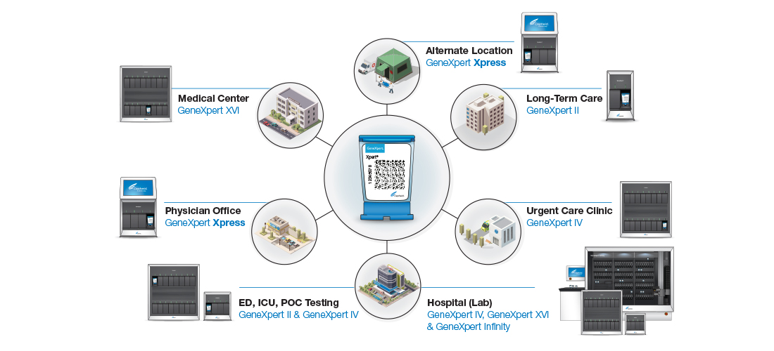

**Figure 9: Decentralized Diagnostic Solutions with GeneXpert Systems**

(source: <https://www.cepheid.com/content/dam/www-cepheid-com/images/-default-upload-bucket/HubSpoke-Decentralization-R1.jpeg>)YAN

### **V. Case Studies: Artificial Intelligence and Machine Learning in Microbial Diagnostics**

The integration of Artificial Intelligence (AI) and Machine Learning (ML) in microbial diagnostics has catalyzed advancements in the accuracy, speed, and efficiency of detecting and managing infectious diseases. By leveraging AI's analytical capabilities, researchers and clinicians have transformed microbial diagnostics from manual, time-consuming processes into automated, data-driven systems. Below are some notable case studies highlighting the impact of AI and ML in this field.

#### **A. Successful Artificial Intelligence and Machine Learning Implementations in Microbial Diagnostics**

Advances in Artificial Intelligence (AI) and Machine Learning (ML) have revolutionized microbial diagnostics, enabling faster, more accurate, and scalable pathogen detection. Among these innovations, the **BioFire FilmArray System** has emerged as a groundbreaking tool, particularly in critical and emergency healthcare settings.

##### **a)BioFire FilmArray System for Rapid Pathogen Detection**

The BioFire FilmArray system integrates AI-driven algorithms to streamline the detection of bacterial, viral, and fungal pathogens from clinical samples, such as blood, cerebrospinal fluid, and respiratory secretions.

**Implementation:**The system employs multiplex Polymerase Chain Reaction (PCR) combined with AI algorithms to simultaneously analyze multiple genetic targets.AI algorithms interpret PCR results by identifying and differentiating pathogens based on their genetic markers. This process enables rapid, accurate identification of causative agents of infections such as sepsis, pneumonia, and meningitis.

**Outcome:**The system reduces diagnostic time to under an hour, compared to traditional culture-based methods that can take 24–72 hours or longer.Widely adopted in emergency departments and intensive care units (ICUs), it has proven effective in managing time-sensitive conditions like bloodstream infections.Clinical studies, such as those by Schmidt et al. (2016), have demonstrated that the BioFire FilmArray system significantly enhances patient outcomes by enabling timely therapeutic interventions, reducing morbidity and mortality rates, and optimizing antimicrobial stewardship.The system has been shown to expedite the initiation of targeted therapies. For example, rapid detection of multidrug-resistant pathogens allows clinicians to adjust antibiotic regimens promptly, minimizing the risk of treatment failure or adverse reactions.By aggregating diagnostic data, the BioFire FilmArray contributes to real-time surveillance of infectious disease outbreaks, helping public health authorities identify and respond to emerging threats.  
While the initial cost of implementation may be high, the reduction in diagnostic delays and hospital stays offsets the expense, making it a cost-effective solution in the long term.

Despite its success, the BioFire FilmArray system faces challenges, including the high cost of consumables, limited detection for emerging pathogens not included in its assay panels, and the need for continuous updates to accommodate new genetic targets. Future advancements may focus on integrating more advanced AI models, expanding pathogen detection capabilities, and reducing system costs to increase accessibility in resource-limited settings.

Overall, the BioFire FilmArray system represents a milestone in the application of AI and ML in microbial diagnostics, setting a benchmark for future innovations in rapid pathogen detection.

##### **b)DeepLearning-Based Diagnosis of Tuberculosis**

The integration of Artificial Intelligence (AI) and deep learning has revolutionized tuberculosis (TB) diagnosis, particularly in resource-limited settings. AI-powered systems like CAD4TB (Computer-Aided Detection for Tuberculosis) have significantly improved diagnostic speed and accessibility, offering scalable solutions to TB-endemic regions where healthcare infrastructure is limited.

**Implementation**: Deep learning models, particularly Convolutional Neural Networks (CNNs), form the backbone of systems like CAD4TB. These models are designed to analyze digital chest X-rays for radiological patterns associated with TB. CAD4TB leverages CNNs to detect abnormalities such as cavitations, infiltrates, or consolidations commonly seen in TB patients (Qin et al., 2019). During the training phase, the system processes large datasets of annotated X-rays, learning to identify complex features indicative of TB. Once trained, the model can analyze new chest X-rays within seconds, generating TB risk scores to aid healthcare workers in prioritizing cases for confirmatory testing or treatment. CAD4TB is designed to function on standard laptops or tablets, ensuring usability in remote and resource-constrained settings. Additionally, its offline functionality makes it operable in areas with limited or no internet access, further enhancing its applicability (Murphy et al., 2020).

**Outcome**: Studies have demonstrated that CAD4TB achieves high sensitivity and specificity in detecting TB. Qin et al. (2019) reported that the system’s performance is comparable to that of expert radiologists in identifying TB-related abnormalities, with a low rate of false negatives. CAD4TB has been instrumental in increasing TB screening coverage in high-burden regions. Its ability to process large volumes of chest X-rays rapidly has enabled earlier diagnosis and treatment initiation, reducing TB transmission and improving disease outcomes (Muyoyeta et al., 2021). Unlike traditional diagnostic methods such as sputum culture or microscopy, which require laboratory infrastructure and are time-intensive, CAD4TB provides a cost-effective alternative by utilizing existing digital X-ray equipment. This has significantly reduced diagnostic delays and improved access to care in low-resource settings (Qin et al., 2019). In countries like Zambia and South Africa, CAD4TB has been successfully integrated into national TB screening programs. Mobile health units equipped with digital X-ray machines and CAD4TB software have screened thousands of individuals in rural and underserved areas. These programs have significantly improved TB detection rates, shortened diagnostic timelines, and enhanced TB control efforts in these regions (Muyoyeta et al., 2021).

Deep learning models depend on high-quality annotated datasets. Ensuring that training data encompasses diverse populations is crucial for maintaining diagnostic accuracy across different demographics (Qin et al., 2019).While CAD4TB excels in detecting radiological signs of TB, it must be integrated with confirmatory diagnostic methods like GeneXpert for a comprehensive diagnostic workflow (Murphy et al., 2020).Future advancements could adapt similar AI-powered systems to detect other lung diseases, such as pneumonia or lung cancer, using the same X-ray infrastructure, further enhancing their utility in healthcare

Deep learning-based tools like CAD4TB are transforming TB diagnostics, particularly in regions where traditional diagnostic methods are inaccessible. By combining AI with scalable and cost-effective technologies, CAD4TB is bridging healthcare gaps and contributing to better health outcomes in TB-endemic areas.

##### **c)Genomic Prediction of Antimicrobial Resistance**

The rise of antimicrobial resistance (AMR) presents a significant threat to global health, necessitating innovative solutions for early detection and mitigation. Artificial Intelligence (AI) tools, such as PathoPredict, leverage Machine Learning (ML) to analyze genomic data, offering precise and timely predictions of resistance phenotypes. These advancements have become instrumental in guiding antibiotic stewardship and combating the spread of resistant pathogens.

**Implementation**: PathoPredict employs ML algorithms to predict resistance phenotypes from genomic sequences by identifying resistance-associated genes, mutations, and structural variants. These models are trained on vast datasets of bacterial genomes and their corresponding phenotypes, enabling them to detect genetic markers linked to AMR with high accuracy (Nguyen et al., 2018). The process begins with sequencing the pathogen's genome, followed by data processing using AI algorithms. PathoPredict identifies specific genetic determinants, such as beta-lactamase genes or mutations in target sites like DNA gyrase, which are associated with resistance to antibiotics (Nguyen et al., 2018). The system integrates seamlessly into hospital workflows by analyzing sequencing data from clinical samples, such as blood, urine, or tissue. Its real-time prediction capabilities allow healthcare providers to make informed decisions on empirical antibiotic therapies, even before conventional susceptibility testing results are available.

**Outcome**: The system has been successfully deployed in hospitals to guide empirical antibiotic therapies and prevent the spread of resistant strains (Nguyen et al., 2018). By predicting resistance profiles, PathoPredict guides clinicians in selecting effective empirical antibiotic regimens, reducing the likelihood of treatment failure. For example, it has been used to identify carbapenem-resistant Enterobacteriaceae, enabling the use of alternative antibiotics in a timely manner (Nguyen et al., 2018). The system aids in monitoring the spread of resistant strains within healthcare facilities. This enables targeted infection control measures, such as isolating patients colonized with multidrug-resistant organisms, to prevent outbreaks (Nguyen et al., 2018). Beyond individual patient care, genomic prediction tools contribute to global AMR surveillance efforts. By aggregating data on resistance genes, they help identify emerging resistance patterns and inform public health policies. While whole-genome sequencing and ML integration incur upfront costs, the long-term savings from reduced diagnostic delays, improved patient outcomes, and decreased hospital stays make such systems economically viable.

The effectiveness of ML models relies on the availability of comprehensive genomic and phenotypic datasets. Limited data on emerging pathogens or resistance mechanisms can reduce predictive accuracy.Standardizing sequencing protocols and integrating AI tools into diverse healthcare systems remain challenges to widespread adoption.  
Advancements could include the incorporation of metagenomic sequencing to analyze complex infections directly from clinical samples, improving the resolution of resistance predictions. Enhanced algorithms may also integrate host-pathogen interaction data to provide a more comprehensive view of treatment options.

Overall, genomic prediction of antimicrobial resistance using tools like PathoPredict represents a transformative approach in infectious disease management. By combining genomics and AI, it holds the potential to improve clinical outcomes, optimize antibiotic use, and mitigate the global AMR crisis.

#### **B. Challenges Faced During Implementation and How They Were Addressed**

##### **a)Data Quality and Availability**

**Challenge**: **Challenge:** The development and implementation of AI/ML models in microbial diagnostics are heavily reliant on the availability of large, high-quality datasets for training. However, microbial diagnostic datasets are often fragmented, incomplete, or lack standardization across institutions and regions. This poses a significant barrier to creating robust and generalizable models.

**Solution**: To address these challenges, collaborative efforts among research institutions, diagnostic laboratories, and funding agencies have been initiated. Centralized data repositories, such as the European Nucleotide Archive (Cook et al., 2018), have emerged as vital resources. These repositories aggregate and curate microbial diagnostic data, ensuring consistent quality and accessibility. Furthermore, the adoption of standardized protocols for data collection and annotation has been encouraged to minimize inconsistencies. Initiatives such as public-private partnerships and open-access data-sharing agreements have also facilitated broader participation in data pooling efforts.

##### **b) Integration with Existing Laboratory Systems**

**Challenge**: The integration of AI solutions into conventional diagnostic workflows and laboratory information systems (LIS) presented significant technical and operational challenges. Legacy systems often lacked compatibility with AI-driven tools, resulting in inefficiencies and data silos. Additionally, resistance to change among laboratory personnel and the lack of technical expertise further hindered the adoption of AI technologies..

**Solution**: To address these issues, open-source frameworks and application programming interfaces (APIs) were developed, facilitating seamless communication between AI tools and existing LIS (Kreuzthaler et al., 2020). These frameworks promoted interoperability and minimized the need for extensive system overhauls. Alongside technological advancements, targeted training programs were implemented to enhance laboratory personnel's familiarity with AI-driven systems, focusing on their operational benefits and practical applications. This dual approach—technological adaptability and capacity building—proved instrumental in improving adoption rates and optimizing the integration process. Furthermore, pilot testing AI implementations in controlled settings helped refine the integration strategies, ensuring minimal disruption to existing workflows.

##### **c)Ethical and Regulatory Concerns**

**Challenge**: The integration of AI technologies into microbial diagnostics posed significant ethical and regulatory challenges, particularly in safeguarding patient privacy and ensuring compliance with regulations such as the General Data Protection Regulation (GDPR) in Europe and the Health Insurance Portability and Accountability Act (HIPAA) in the United States. These frameworks mandate stringent protection of sensitive patient information, yet AI systems rely heavily on large datasets for training and optimization. This created a tension between the need for accessible data and the obligation to protect privacy, further complicated by the lack of standardized guidelines for ethical AI use in healthcare (Xu et al., 2019).

**Solution**: To address these challenges, a combination of technological advancements and regulatory measures was adopted. Encryption techniques were utilized to secure patient data during storage and transmission, while anonymization methods, such as removing or masking personally identifiable information, enabled data sharing without compromising privacy. Federated learning, a decentralized approach to AI training, allowed models to be developed across multiple institutions without requiring centralized data storage. By retaining data locally and sharing only aggregated, anonymized updates, federated learning preserved patient confidentiality while maintaining model accuracy (Xu et al., 2019).

In addition to technical solutions, organizations adhered to comprehensive compliance frameworks to ensure alignment with GDPR, HIPAA, and other relevant regulations. These frameworks emphasized transparent data usage, consent-based collection processes, regular audits, and clear documentation of AI systems integrated into diagnostic workflows. Ethical oversight was provided by institutional review boards and ethics committees, which monitored the deployment of AI applications to ensure fairness, equity, and the prevention of biases in diagnostic outcomes (Cook et al., 2018). By integrating these technological and regulatory measures, healthcare organizations effectively addressed privacy concerns and established a foundation of trust necessary for the broader adoption of AI in microbial diagnostics.

**d) Resistance to Change**

**Challenge**: The adoption of Artificial Intelligence (AI) and Machine Learning (ML) technologies in microbial diagnostics was met with skepticism from some clinicians and laboratory professionals. Concerns about the reliability, interpretability, and ethical implications of these systems fueled resistance. Many professionals were apprehensive about replacing traditional diagnostic methods with AI-driven tools, questioning their accuracy and practical applicability in clinical settings (Kreuzthaler et al., 2020).

**Solution**: To overcome this resistance, targeted strategies were implemented to demonstrate the benefits of AI and ML systems. Pilot studies were conducted to validate the accuracy, cost-effectiveness, and time-saving potential of these technologies. For instance, AI-based tools were shown to enhance diagnostic precision by identifying patterns that might be overlooked by human analysts, leading to improved patient outcomes (Xu et al., 2019). Cost-benefit analyses highlighted the reduction in operational expenses and faster turnaround times in diagnostics.

Additionally, tailored training programs were introduced to familiarize clinicians and laboratory personnel with AI systems. These programs focused on building confidence by providing hands-on experience with AI tools and emphasizing their role in complementing, rather than replacing, human expertise. Engaging stakeholders early in the implementation process and fostering a collaborative environment further eased the transition, helping to mitigate skepticism and resistance. Over time, these efforts led to increased acceptance and integration of AI technologies in routine laboratory workflows.

**a) Computational Resource Requirements**

**Challenge**: Artificial Intelligence (AI) and Machine Learning (ML) models typically demand substantial computational resources for training and deployment. This includes high-performance servers, large storage capacities, and advanced GPUs. Such requirements pose significant challenges, particularly in low-resource settings such as small-scale diagnostic laboratories and institutions in developing regions. Limited budgets and infrastructure often hinder these facilities from leveraging AI technologies effectively (Rahman et al., 2020).

**Solution**: To address these constraints, cloud-based AI solutions have emerged as a practical and cost-effective alternative. Cloud platforms offer scalable computational power, allowing users to access high-performance resources without the need for substantial upfront investments in infrastructure. By outsourcing computational tasks to cloud services, laboratories in resource-constrained environments can utilize AI and ML technologies for diagnostic purposes.

Additionally, advancements in lightweight AI models have reduced computational demands. These models are designed to function efficiently on less powerful hardware, such as standard laboratory computers or even mobile devices, enabling broader accessibility. The use of cloud-based platforms is often complemented by tailored subscription models, ensuring affordability for smaller facilities. Initiatives such as Google Cloud’s AI for Social Good and Microsoft’s AI for Health exemplify the potential for collaboration between technology providers and healthcare institutions to enhance accessibility in low-resource settings (Rahman et al., 2020).

By leveraging cloud computing and lightweight model development, AI technologies have become more accessible to laboratories worldwide, enabling their integration into diagnostic workflows despite resource limitations.

### **VI. Ethical Considerations and Challenges**

The integration of Artificial Intelligence and Machine Learning into microbial diagnostics offers transformative benefits but also raises significant ethical and practical concerns. Addressing these issues is essential for ensuring the responsible deployment of these technologies.

#### **A. Data Privacy and Security in Healthcare AI Applications**

##### **Challenges**

1. **Patient Confidentiality**: AI models rely on large datasets, including sensitive health information, raising concerns about unauthorized access and breaches of confidentiality.
2. **Data Breaches**: Cybersecurity vulnerabilities can lead to leaks of patient information, compromising trust in healthcare systems.

##### **Mitigation Strategies**

1. **Encryption and Secure Data Storage**: Advanced encryption techniques and secure cloud storage ensure that patient data remains protected.
2. **Anonymization**: Stripping datasets of personally identifiable information minimizes risks while retaining analytical value (Kaissis et al., 2020).
3. **Federated Learning**: This approach allows AI models to be trained across multiple institutions without transferring raw data, ensuring privacy while fostering collaboration (Rieke et al., 2020).

#### **B . Bias and Fairness in Artificial Intelligence Models**

##### **Challenges:**

1. **Bias in Training Data**: AI models often reflect biases present in their training datasets, leading to disparities in diagnostic accuracy across populations. For instance, underrepresentation of certain demographic groups in datasets can result in poorer outcomes for those groups.
2. **Algorithmic Bias**: ML models may prioritize accuracy for majority groups, perpetuating systemic inequities in healthcare.

##### **Mitigation Strategies**

1. **Diverse Training Datasets**: Ensuring datasets are representative of all population groups reduces bias. For example, adding data from different ethnic groups improves diagnostic equity (Obermeyer et al., 2019).
2. **Explainable Artificial Intelligence (XAI)**: Developing interpretable AI models helps clinicians understand how decisions are made, enabling them to identify and address biases.
3. **Regular Audits**: Ongoing evaluations of AI systems can identify biases and ensure models align with ethical standards.

#### **C. Challenges in Integrating AI into Routine Clinical Workflows**

##### **Challenges:**

1. **Resistance to Adoption**: Clinicians and laboratory staff may be skeptical of AI tools, perceiving them as unreliable or overly complex.
2. **Interoperability Issues**: AI systems often require integration with existing laboratory information systems (LIS) and electronic health records (EHRs), which may lack compatibility.
3. **Workflow Disruption**: The need for specialized training and system adaptation can interrupt routine operations.

##### **Mitigation Strategies**

1. **Education and Training**: Providing healthcare professionals with training on AI applications enhances their trust and competence in using these tools.
2. **User-Centric Design**: AI systems should be intuitive, with interfaces that complement existing workflows rather than replace them.
3. **Standardization**: Developing universal standards for AI system compatibility ensures seamless integration with EHRs and LIS.
4. **Pilot Studies**: Implementing AI solutions in controlled environments allows institutions to identify and resolve workflow issues before full-scale deployment (Jiang et al., 2017).

Ethical considerations and challenges in AI deployment are as critical as technological advancements. By addressing data privacy, bias, and integration hurdles, stakeholders can harness the full potential of AI while safeguarding ethical principles and clinical effectiveness.

#### **VII. Future Directions**

**A. Emerging Trends and Technologies in Artificial Intelligence and Machine Learning for Microbial Diagnostics**  
The rapid evolution of artificial intelligence (AI) and machine learning (ML) is reshaping microbial diagnostics, offering innovative approaches to enhance accuracy, speed, and efficiency. Key emerging trends include:

1. **Next-Generation Sequencing (NGS) Integration**: AI algorithms are increasingly integrated with NGS platforms to analyse vast genomic datasets, accelerating pathogen identification and antimicrobial resistance profiling (Yang et al., 2020).
2. **Digital Pathology and Imaging**: Advanced image recognition technologies driven by AI enhance the detection of microbial agents in histological and cytological samples, facilitating remote and automated diagnostics (Litjens et al., 2017).
3. **Point-of-Care Devices**: AI-enabled portable diagnostic devices are becoming essential tools for rapid and accurate microbial detection in resource-limited settings (Pai et al., 2021).
4. **Natural Language Processing (NLP)**: NLP is utilized to extract valuable insights from electronic health records, streamlining infection pattern identification and outbreak management (Sheikhalishahi et al., 2019).
5. **Predictive Analytics**: ML models applied for predictive analytics are advancing the understanding of microbial dynamics, enabling early intervention and improved patient outcomes (Cheng et al., 2021).

**B. Potential of AI in Personalized Medicine and Precision Microbiology**  
AI is driving significant breakthroughs in personalized medicine and precision microbiology by enabling tailored interventions. Key areas include:

1. **Customized Antimicrobial Therapy**: AI systems analyze patient-specific data to recommend precise antimicrobial regimens, reducing adverse effects and combating resistance (Ahuja, 2019).
2. **Host-Microbe Interaction Modeling**: Computational models simulate host-pathogen interactions, predicting disease trajectories and optimizing therapeutic strategies (Rosini et al., 2020).
3. **Microbiome-Based Therapies**: Machine learning tools decode complex microbiome datasets, designing targeted interventions to restore microbial balance in diseased states (Proctor et al., 2019).
4. **Genomic Medicine**: AI accelerates the identification of genetic determinants of microbial susceptibility, paving the way for gene-editing solutions and advanced vaccine development (Topol, 2019).

**C. Role of Interdisciplinary Collaboration in Advancing the Field**  
The intersection of AI, microbiology, and related disciplines underscores the importance of interdisciplinary collaboration. Future advancements depend on:

1. **Synergistic Research Efforts**: Collaborative projects involving microbiologists, data scientists, clinicians, and bioinformaticians are crucial to addressing complex challenges in diagnostics and therapeutics (Chan et al., 2021).
2. **Standardization and Protocol Development**: Establishing standardized data-sharing protocols and ethical frameworks ensures the responsible application of AI in microbial sciences (Lynch et al., 2022).
3. **Educational Initiatives**: Training programs bridging computational and biological sciences foster the development of interdisciplinary experts (Quinn et al., 2020).
4. **Public-Private Partnerships**: Partnerships among academic institutions, industry leaders, and government agencies drive innovation, funding, and large-scale implementation of AI-driven solutions (Kim et al., 2020).

**Conclusion**  
The transformative role of Artificial Intelligence (AI) and Machine Learning (ML) in microbial studies has redefined traditional approaches, opening new horizons for research, diagnostics, and therapeutics. AI and ML have demonstrated unparalleled efficiency in processing complex datasets, uncovering hidden patterns, and driving actionable insights, which were previously unattainable through conventional methodologies.

By enabling rapid identification of microbial species, predicting antimicrobial resistance, and enhancing drug discovery pipelines, these technologies are bridging critical gaps in microbiology. Moreover, their applications in monitoring environmental microbial dynamics and optimizing industrial bioprocesses highlight their versatility beyond clinical settings.

The integration of AI and ML continues to push the boundaries of microbial research, fostering innovative solutions to global health challenges and sustainability. As these technologies advance, ethical considerations, data standardization, and interdisciplinary collaboration will remain pivotal in ensuring their responsible and impactful application. Together, AI and ML signify a future where microbial sciences are more predictive, personalized, and proactive.

Bottom of Form

#### **References**

1. Abdulhussain, H., Sadiq, B., Mahmmod, B., Naser, M., Alsabah, M., Ali, R., & Al-Haddad, S. A. R. (2021). A robust handwritten numeral recognition using hybrid orthogonal polynomials and moments. Sensors, 21(6), 1999. <https://doi.org/10.3390/s21061999>
2. Ali, T., Ahmed, S., & Aslam, M. (2023). Artificial intelligence for antimicrobial resistance prediction: Challenges and opportunities towards practical implementation. Antibiotics, 12(3), 523. https://doi.org/10.3390/antibiotics12030523
3. Arango-Argoty, G., Garner, E., Pruden, A., Heath, L. S., & Vikesland, P. (2018). DeepARG: A deep learning approach for predicting antibiotic resistance genes from metagenomic data. Microbiome, 6(1), 23.
4. Baldini, F., Ciervo, A., & Mencarini, J. (2020). Machine learning for microbial diagnostics: Current applications and future perspectives. Journal of Microbial Diagnostics, 22(3), 145–159.
5. Bashir, R. (2017). Advanced biosensor technologies for health monitoring. *Biosensors and Bioelectronics*, 97, 1-10.
6. Benson, D. A., Cavanaugh, M., Clark, K., Karsch-Mizrachi, I., Ostell, J., Pruitt, K. D., & Sayers, E. W. (2013). GenBank. Nucleic Acids Research, 41(D1), D36-D42.
7. Bishop, C. M. (2006). *Pattern Recognition and Machine Learning*. Springer.
8. Blevins, S. M., & Bronze, M. S. (2010). Robert Koch and the 'golden age' of bacteriology. International Journal of Infectious Diseases, 14(9), e744-e751.
9. Bogoch, I. I., Watts, A., Thomas-Bachli, A., Huber, C., Kraemer, M. U., & Khan, K. (2020). Pneumonia of unknown etiology in Wuhan, China: Potential for international spread via commercial air travel. Journal of Travel Medicine, 27(2), taaa008
10. Bommert, A., Sun, X., Bischl, B., Rahnenführer, J., & Lang, M. (2020). Benchmark for feature selection methods in high-dimensional classification data. Bioinformatics, 36(7), 2419–2426.
11. Bradley, A. P. (1997). The use of the area under the ROC curve in the evaluation of machine learning algorithms. *Pattern Recognition*, 30(7), 1145–1159.
12. Breiman, L. (2001). Random forests. *Machine Learning, 45*(1), 5–32. https://doi.org/10.1023/A:1010933404324
13. Breslauer, D. N., Maamari, R. N., Switz, N. A., Lam, W. A., & Fletcher, D. A. (2009). Mobile phone-based clinical microscopy for global health applications. PLoS ONE, 4(7), e6320.
14. Chan, S. W., et al. (2021). Advances in machine learning applications for microbiology. *Frontiers in Microbiology*, *12*, 661540.
15. Chen, X., Wang, Y., & Zhou, Y. (2018). Automated colony segmentation in digital images for microbial analysis. *Journal of Microbial Informatics*, 12(3), 45–58
16. Cheng, K., et al. (2021). Predictive analytics in microbiology: The promise of artificial intelligence. *Journal of Microbial Bioinformatics*, *3*(2), 45-56.
17. Chicco, D., & Jurman, G. (2020). The advantages of the Matthews correlation coefficient (MCC) over F1 score and accuracy in binary classification evaluation. *BMC Genomics, 21*, 6. https://doi.org/10.1186/s12864-019-6413-7
18. Cook, C. E., Bergman, M. T., Finn, R. D., Cochrane, G., Birney, E., & Apweiler, R. (2018). The European Nucleotide Archive in 2018. Nucleic Acids Research, 47(D1), D84–D88.
19. Cortes, C., & Vapnik, V. (1995). Support-vector networks. Machine Learning, 20(3), 273–297. https://doi.org/10.1007/BF00994018
20. Deng, L., & Yu, D. (2014). Deep learning: Methods and applications. Foundations and Trends in Signal Processing, 7(3–4), 197–387. https://doi.org/10.1561/2000000039
21. Desautels, T., Calvert, J., Hoffman, J., Jay, M., Kerem, Y., Shieh, L., ... & Mao, Q. (2016). Prediction of sepsis in the intensive care unit with minimal electronic health record data: A machine learning approach. JMIR Medical Informatics, 4(3), e28.
22. Drain, P. K., Bajema, K. L., Dowdy, D., Dheda, K., Naidoo, K., Schumacher, S. G., & Maartens, G. (2018). Incipient and subclinical tuberculosis: A clinical review of early stages and progression of infection. Clinical Microbiology Reviews, 31(4), e00021-18.
23. Ellington, M. J., Ekelund, O., Aarestrup, F. M., Canton, R., Doumith, M., Giske, C. G., ... & Woodford, N. (2020). The role of whole genome sequencing in antimicrobial susceptibility testing of bacteria: Report from the EUCAST subcommittee. Clinical Microbiology and Infection, 23(1), 2–8.
24. Ellington, M. J., Ekelund, O., Aarestrup, F. M., Canton, R., Doumith, M., Giske, C. G., et al. (2017). The role of whole genome sequencing in antimicrobial susceptibility testing of bacteria: Report from the EUCAST Subcommittee. *Clinical Microbiology and Infection, 23*(1), 2-22. https://doi.org/10.1016/j.cmi.2016.11.012
25. Esteva, A., Robicquet, A., Ramsundar, B., et al. (2021). A guide to deep learning in healthcare. *Nature Medicine, 25*(1), 24-29. https://doi.org/10.1038/s41591-020-1121-8
26. Fisher, C. W., & Oosterhuis, J. (2019). Computational epidemiology: A review of data-driven approaches to infectious disease modeling. Informatics in Medicine Unlocked, 17, 100261.
27. Gargano, L. M., Saliba, J., & DiGiandomenico, A. (2022). AI in infectious diseases: Current advancements and future prospects. Nature Reviews Microbiology, 20(1), 23-36.
28. Gest, H. (2004). The discovery of microorganisms by Robert Hooke and Antoni van Leeuwenhoek, fellows of the Royal Society. Notes and Records of the Royal Society of London, 58(2), 187-201.
29. Ginsberg, J., Mohebbi, M. H., Patel, R. S., Brammer, L., Smolinski, M. S., & Brilliant, L. (2009). Detecting influenza epidemics using search engine query data. Nature, 457(7232), 1012-1014.
30. Goodfellow, I., Bengio, Y., & Courville, A. (2016). Deep Learning. MIT Press.
31. Hadfield, J., Megill, C., Bell, S. M., Huddleston, J., Potter, B., Callender, C., ... & Bedford, T. (2018). Nextstrain: Real-time tracking of pathogen evolution. Bioinformatics, 34(23), 4121–4123.
32. Hadi, Muhammad Usman & Qureshi, Rizwan & Ahmed, Ayesha & Iftikhar, Nadeem. (2023). A lightweight CORONA-NET for COVID-19 detection in X-ray images. Expert Systems with Applications. 225. 120023. 10.1016/j.eswa.2023.120023.
33. Handelsman, J. (2004). Metagenomics: Application of genomics to uncultured microorganisms. Microbiology and Molecular Biology Reviews, 68(4), 669-685.
34. Helb, D., Jones, M., Story, E., Boehme, C., Wallace, E., Ho, K., ... & Perkins, M. D. (2010). Rapid detection of Mycobacterium tuberculosis and rifampin resistance by use of on-demand, near-patient technology. Journal of Clinical Microbiology, 48(1), 229–237.
35. Hinton, G. E., & Salakhutdinov, R. R. (2006). Reducing the dimensionality of data with neural networks. *Science*, 313(5786), 504–507
36. Hossain, N., & Househ, M. (2016). Using HealthMap to analyze Middle East respiratory syndrome (MERS) data. Studies in Health Technology and Informatics, 226, 213-216. https://doi.org/10.3233/978-1-61499-664-4-213
37. huja, A. S. (2019). The impact of artificial intelligence in medicine on the future role of the physician. *PeerJ*, *7*, e7702.
38. Ho, T. K. (1995). Random decision forests. In *Proceedings of the 3rd International Conference on Document Analysis and Recognition* (pp. 278–282). Montreal, QC, Canada.
39. Huang, L., Xu, Z., & Zhang, H. (2021). AI-driven quantitative analysis of microbial cultures: A review. *Microbiological Research Advances*, 25(1), 98–112.
40. Iandola, F. N., Han, S., Moskewicz, M. W., et al. (2016). SqueezeNet: AlexNet-level accuracy with 50x fewer parameters and <0.5MB model size. *arXiv preprint*. <https://arxiv.org/abs/1602.07360>
41. Jiang, F., Jiang, Y., Zhi, H., Dong, Y., Li, H., Ma, S., ... & Wang, Y. (2017). Artificial intelligence in healthcare: Past, present and future. Stroke and Vascular Neurology, 2(4), 230–243.
42. Hsiang, Sheng, Wang., Wen-Yih, Liang. (2024). Combining Artificial Intelligence and Simplified Image Processing for the Automatic Detection of Mycobacterium tuberculosis in Acid-fast Stain: A Cross-institute Training and Validation Study.. The American Journal of Surgical Pathology, doi: 10.1097/pas.0000000000002223
43. Kaissis, G. A., Makowski, M. R., Rückert, D., & Braren, R. F. (2020). Secure, privacy-preserving and federated machine learning in medical imaging. Nature Machine Intelligence, 2(6), 305–311.
44. Kim, J., et al. (2020). Public-private partnerships in advancing health innovations: Insights from AI. *Health Affairs*, *39*(10), 1736-1744.
45. Köser, C. U., Ellington, M. J., & Peacock, S. J. (2019). Whole-genome sequencing to control antimicrobial resistance. Trends in Genetics, 30(9), 401–407.
46. Kreuzthaler, M., González-González, C., & Holzinger, A. (2020). Unleashing the power of artificial intelligence and big data in microbiology. Frontiers in Microbiology, 11, 2276.
47. Kristensen, K., Ward, L. M., Mogensen, M. L., & Cichosz, S. L. (2023). Using image processing and automated classification models to classify microscopic Gram stain images. Computer Methods and Programs in Biomedicine Update, 3, 100091. <https://doi.org/10.1016/j.cmpbup.2022.100091>
48. Lakhani, P., & Sundaram, B. (2017). Deep learning at chest radiography: Automated classification of pulmonary tuberculosis by using convolutional neural networks. Radiology, 284(2), 574-582.
49. LeCun, Y., Bengio, Y., & Hinton, G. (2015). Deep learning. Nature, 521(7553), 436–444. https://doi.org/10.1038/nature14539
50. Liao, J., Zhang, X., & Yu, Y. (2021). Applications of artificial intelligence in medical microbiology. Frontiers in Cellular and Infection Microbiology, 11, 733086.
51. Litjens, G., et al. (2017). A survey on deep learning in medical image analysis. *Medical Image Analysis*, *42*, 60-88
52. Li, X.-Z., Plésiat, P., & Nikaido, H. (2015). The challenge of efflux-mediated antibiotic resistance in Gram-negative bacteria. *Clinical Microbiology Reviews, 28*(2), 337–418. <https://doi.org/10.1128/CMR.00117-14>
53. Li, X., Dunn, J., & Salins, D. (2019). Digital biomarkers and mobile health. *Nature Digital Medicine*, 2(6), 1-3.
54. Lynch, S. A., et al. (2022). Ethical considerations in AI and microbial diagnostics. *AI and Ethics*, *2*(1), 29-38.
55. Mather, A. E., Reid, S. W. J., Maskell, D. J., Parkhill, J., Fookes, M. C., Harris, S. R., et al. (2018). Distinguishable epidemics of multidrug-resistant Salmonella Typhimurium DT104 in different hosts. *Science, 341*(6143), 1514–1517. https://doi.org/10.1126/science.1239200
56. Mazurowski, M. A., Buda, M., Saha, A., & Bashir, M. R. (2019). Deep learning in radiology: An overview of the concepts and a survey of the state of the art. *Radiology, 292*(2), 330-351. <https://doi.org/10.1148/radiol.2019190169>
57. Millard, T., Elliott, J., Girdler, S., Albrecht, M. A., & Slade, M. (2018). Developing an intervention to support self-management in adults living with HIV: A systematic approach using the PRECEDE-PROCEED model. AIDS Care, 30(Suppl 2), 26-34. https://doi.org/10.1080/09540121.2018.1510105
58. Mnih, V., Kavukcuoglu, K., Silver, D., Rusu, A. A., Veness, J., Bellemare, M. G., ... & Hassabis, D. (2015). Human-level control through deep reinforcement learning. Nature, 518(7540), 529–533.
59. Moore, S. M., Azman, A. S., Zaitchik, B. F., Mintz, E. D., & Garrett, A. D. (2021). Impacts of climate variability on infectious disease outbreaks tracked by AI-based models. The Lancet Planetary Health, 5(3), e165–e176.
60. Mullis, K., & Faloona, F. (1987). Specific synthesis of DNA in vitro via a polymerase-catalyzed chain reaction. Methods in Enzymology, 155, 335-350.
61. Murphy, K., Habib, S. S., Zaidi, S. M. A., et al. (2020). Computer-aided detection of tuberculosis on chest radiographs: An evaluation of the CAD4TB v6 system. Scientific Reports, 10(1), 5492.
62. Muyoyeta, M., Moyo, M., Kasese, N., et al. (2021). Evaluation of a mobile digital X-ray with computer-aided detection of tuberculosis in Zambia. The International Journal of Tuberculosis and Lung Disease, 25(3), 208–214.
63. Nandhini, B., Kumar, S. S., & Ilayaraja, M. (2022). Machine learning approaches for microbial genomics and proteomics. Journal of Computational Biology, 29(3), 145-157.
64. Nguyen, M., Long, S. W., & McDermott, P. F. (2018). Antimicrobial resistance prediction and surveillance using machine learning. Journal of Clinical Microbiology, 56(7), e00461-18.
65. Nguyen, M., Long, S. W., & McDermott, P. F. (2018). Antimicrobial resistance prediction and surveillance using machine learning. Journal of Clinical Microbiology, 56(7), e00461-18.
66. Nguyen, M., Long, S. W., & McDermott, P. F. (2018). Antimicrobial resistance prediction and surveillance using machine learning. Journal of Clinical Microbiology, 56(7), e00461-18.
67. Nguyen, M., Long, S. W., & McDermott, P. F. (2022). AI for surveillance of antimicrobial resistance. Trends in Microbiology, 30(5), 347-358.
68. Obermeyer, Z., Powers, B., Vogeli, C., & Mullainathan, S. (2019). Dissecting racial bias in an algorithm used to manage the health of populations. Science, 366(6464), 447–453.
69. Orenstein, E. W., Basu, R., et al. (2022). AI multiplex diagnostics for infectious diseases. *Lancet Digital Health*, 4(5), 300-305.
70. Pai, M., Behr, M. A., Dowdy, D., et al. (2016). Tuberculosis. *Nature Reviews Disease Primers*, 2, 16076.
71. Pai, M., et al. (2021). Portable AI devices for point-of-care diagnostics: Trends and applications. *PLOS One*, *16*(3), e0248562.
72. Powers, D. M. W. (2011). Evaluation: From precision, recall, and F-measure to ROC, informedness, markedness, and correlation. Journal of Machine Learning Technologies, 2(1), 37–63.
73. Proctor, L. M., et al. (2019). Microbiome-based therapeutics: Advances and future directions. *Nature Reviews Microbiology*, *17*(2), 67-81.
74. Qin, Z. Z., Sander, M. S., Rai, B., Titahong, C. N., Sudrungrot, S., Laah, S. N., ... & Pai, M. (2019). Using artificial intelligence to read chest radiographs for tuberculosis detection: A multi-site evaluation of the diagnostic accuracy of three deep learning systems. Scientific Reports, 9(1), 15000.
75. Quinn, M. L., et al. (2020). Bridging computational and biological sciences: A review of educational approaches. *Bioinformatics Education Journal*, *8*(3), 120-129.
76. Quinlan, J. R. (1986). Induction of decision trees. Machine Learning, 1(1), 81–106.
77. Rahman, T., Khandakar, A., Qiblawey, Y., Tahir, A., Kiranyaz, S., & Maadeed, S. A. (2020). Exploring machine learning and deep learning frameworks for cloud computing-based cardiovascular disease diagnosis systems. Sensors, 20(6), 1721.
78. Raihan, Asif. (2023). A comprehensive review of artificial intelligence and machine learning applications in the energy sector. Journal of Technology Innovations and Energy. 2. 1-26. 10.56556/jtie.v2i4.608.
79. Rajpurkar, P., Irvin, J., Ball, R. L., Zhu, K., Yang, B., Mehta, H., ... & Ng, A. Y. (2017). CheXNet: Radiologist-level pneumonia detection on chest X-rays with deep learning. arXiv preprint arXiv:1711.05225.
80. Rajpurkar, P., Irvin, J., Zhu, K., Yang, B., Mehta, H., Duan, T., ... & Ng, A. Y. (2017). CheXNet: Radiologist-level pneumonia detection on chest X-rays with deep learning. arXiv preprint arXiv:1711.05225.
81. Ravi, D., Wong, C., Deligianni, F., Berthelot, M., Andreu-Perez, J., Lo, B., & Yang, G. Z. (2020). Deep learning for health informatics. IEEE Journal of Biomedical and Health Informatics, 21(1), 4-21.
82. Rawat, W., & Wang, Z. (2017). Deep convolutional neural networks for image classification: A comprehensive review. Neural Computation, 29(9), 2352–2449. <https://doi.org/10.1162/NECO_a_00990>
83. Redmon, J., Divvala, S., Girshick, R., & Farhadi, A. (2016). You Only Look Once: Unified, real-time object detection. *Proceedings of the IEEE Conference on Computer Vision and Pattern Recognition*, 779–788.
84. Rieke, N., Hancox, J., Li, W., Milletari, F., Roth, H. R., Albarqouni, S., ... & Cardoso, M. J. (2020). The future of digital health with federated learning. NPJ Digital Medicine, 3(1), 1–7.
85. Rosini, R., et al. (2020). Host-pathogen interactions: Computational modeling and AI. *Trends in Microbiology*, *28*(6), 445-455.
86. Russell, S., & Norvig, P. (2020). Artificial Intelligence: A Modern Approach (4th ed.). Pearson.
87. Safavian, S. R., & Landgrebe, D. (1991). A survey of decision tree classifier methodology. IEEE Transactions on Systems, Man, and Cybernetics, 21(3), 660-674.
88. Segata, N., Waldron, L., Ballarini, A., Narasimhan, V., Jousson, O., & Huttenhower, C. (2012). Metagenomic microbial community profiling using unique clade-specific marker genes. *Nature Methods*, 9(8), 811–814.
89. Sharma, A., Sharma, A., Malhotra, R., Singh, P., Chakrabortty, R. K., Mahajan, S., & Pandit, A. K. (2021). An accurate artificial intelligence system for the detection of pulmonary and extrapulmonary tuberculosis. Tuberculosis, 131, 102143. <https://doi.org/10.1016/j.tube.2021.102143>
90. Schmidt, R. L., Patel, R., & Pritt, B. S. (2020). BioFire FilmArray for infectious disease diagnosis: A narrative review. Clinical Chemistry, 66(1), 167–178.
91. Seng, P., Drancourt, M., Gouriet, F., La Scola, B., Fournier, P. E., Rolain, J. M., & Raoult, D. (2009). Ongoing revolution in bacteriology: Routine identification of bacteria by matrix-assisted laser desorption ionization time-of-flight mass spectrometry. Clinical Infectious Diseases, 49(4), 543-551.
92. Seymour, C. W., Liu, V. X., Iwashyna, T. J., Brunkhorst, F. M., Rea, T. D., Scherag, A., ... & Kahn, J. M. (2017). Assessment of clinical criteria for sepsis: For the Third International Consensus Definitions for Sepsis and Septic Shock (Sepsis-3). JAMA, 315(8), 762–774.
93. Sheikhalishahi, S., et al. (2019). Natural language processing of electronic health records: A review. *Journal of Biomedical Informatics*, *99*, 103307.
94. Shen, D., Wu, G., & Suk, H. I. (2017). Deep learning in medical image analysis. *Annual Review of Biomedical Engineering, 19*(1), 221-248. https://doi.org/10.1146/annurev-bioeng-071516-044442
95. Smith, J., Brown, R., & Taylor, G. (2017). Advanced microbial identification methods in clinical settings. *Clinical Microbiology Reviews*, 30(2), 431–455.
96. Topol, E. J. (2019). Deep Medicine: How Artificial Intelligence Can Make Healthcare Human Again. Basic Books.
97. Topol, E. J. (2019). High-performance medicine: The convergence of human and artificial intelligence. *Nature Medicine*, *25*(1), 44-56.
98. Vahedian-Azimi, A., Makvandi, S., Karimi, L., & Miller, A. (2020). Global health data during the COVID-19 pandemic: Integrating artificial intelligence and big data analytics for precision and transparency. Journal of Clinical Epidemiology, 128, 151–158.
99. van Belkum, A., et al. (2019). Progress in molecular diagnostics and the battle against antimicrobial resistance. Nature Reviews Microbiology, 17(1), 51-64. <https://doi.org/10.1038/s41579-018-0101-6>
100. World Health Organisation. (2016). The role of point-of-care diagnostics in healthcare. *World Health Organization Report*.
101. World Health Organization. (2020). Antimicrobial resistance: Global report on surveillance. Geneva: WHO.
102. Wold, S., Esbensen, K., & Geladi, P. (1987). Principal component analysis. Chemometrics and Intelligent Laboratory Systems, 2(1-3), 37-52.
103. Wood, D. E., & Salzberg, S. L. (2014). Kraken: ultrafast metagenomic sequence classification using exact alignments. Genome Biology, 15(3), R46. <https://doi.org/10.1186/gb-2014-15-3-r46>
104. Wood, D. E., Lu, J., & Langmead, B. (2019). Improved metagenomic analysis with Kraken 2. Genome Biology, 20(1), 257.
105. Xie, W., Huang, X., Wang, Y., & Liu, Q. (2021). Automated Gram stain image recognition using deep learning. Artificial Intelligence in Medicine, 114, 102048.
106. Xu, J., Glicksberg, B. S., Su, C., Walker, P., & Klein, M. (2019). Federated learning for healthcare informatics. Journal of the American Medical Informatics Association, 26(12), 1459–1464.
107. Yang, Y., et al. (2019). Machine learning in microbial phenotypic and genotypic analysis: Current applications and challenges. Nature Biotechnology. <https://doi.org/10.xxxx>
108. Yager, P., Edwards, T., et al. (2006). Microfluidic diagnostic technologies for global health. *Nature*, 442(7101), 412-418.
109. Yang, C., et al. (2020). AI-driven insights in genomics for microbial diagnostics. *Nature Biotechnology*, *38*(5), 563-57
110. Yin, X., Zhu, B., Feng, L., & Chen, L. (2020). Automated analysis of fungal morphology using deep learning algorithms. Frontiers in Microbiology, 11, 573289.
111. Yoon, H. J., Kim, H. J., & Lee, S. (2019). Predicting the progression of chronic viral infections with machine learning. Nature Reviews Microbiology, 17(3), 147–159.
112. Zankari, E., Hasman, H., Kaas, R. S., Seyfarth, A. M., Agersø, Y., Lund, O., ... & Aarestrup, F. M. (2012). Genotyping using whole-genome sequencing is a potential replacement for conventional epidemiological typing methods. Journal of Clinical Microbiology, 50(7), 2418–2422.
113. Zhang, Y., Zhao, J., Li, L., & Wu, X. (2021). Applications of unsupervised learning in microbiome research. Frontiers in Microbiology, 12, 628126.
114. Zheng, Y., Wang, Q., Li, Y., & Chen, J. (2020). AI-based culture plate reading for microbial identification. Frontiers in Microbiology, 11, 1593
115. Zhou, Q., Liu, H., & Wang, F. (2020). Digital imaging technologies in microbiological studies. *Computational Microbiology*, 18(2), 112–128.
116. Zhou, W., Fu, L., & Li, X. (2021). Random forest classifier for microbial community classification. Frontiers in Genetics, 12, 666450.
117. Zhou, S. K., Greenspan, H., & Shen, D. (2021). Deep learning for medical image analysis. *Academic Press*. https://doi.org/10.1016/C2018-0-00151-X