**Exploring the AI, ML, and IoT Landscape: The Future of Intelligent Business**

**Abstract:**

The combination of Artificial Intelligence (AI), Machine Learning (ML), and the Internet of Things (IoT) is transforming how businesses operate, driving innovation and increasing efficiency across industries. AI, which includes technologies such as Natural Language Processing, Computer Vision, and Robotics, simulates human intelligence by performing tasks autonomously. Machine learning (ML), a subset of artificial intelligence, allows systems to learn from data and improve over time, facilitating predictive analytics, customer segmentation, and demand forecasting. IoT connects physical devices to the internet, allowing for real-time data collection and automation in a variety of applications, including supply chain optimisation and smart buildings. The convergence of AI, ML, and IoT creates intelligent business ecosystems that offer real-time analytics, predictive maintenance, and enhanced customer experiences. However, challenges such as data privacy, security, and ethical considerations must be addressed to ensure responsible adoption. As these technologies continue to evolve, future trends such as Edge Computing, AI-driven automation, and Industry 5.0 promise to further transform business landscapes by enabling faster insights, autonomous systems, and human-machine collaboration. Leveraging this synergy will provide organisations a competitive advantage, creating new chances for development and innovation.

**Keywords:** Artificial Intelligence (AI), Machine Learning (ML), Internet of Things (IoT), Business Applications, Intelligent Business, Edge Computing, AI-Driven Automation, Predictive Maintenance, Supply Chain Optimization, Smart Cities, Cybersecurity, Data Privacy, Ethical Considerations.

**1. Introduction to Artificial Intelligence (AI)**

**1.1 Definition and Scope**

Artificial intelligence (AI) is the simulation of human intelligence processes by machines, most notably computer systems. These processes include learning (acquiring information and rules for using it), reasoning (applying rules to arrive at approximate or definite conclusions), and self-correction.

**1.2 AI is broadly categorized into two types:**

**Narrow AI** and **General AI**—are the most common classifications, but there are also other ways to categorize AI based on its capabilities, evolution, and the scope of its intelligence.

* **Narrow AI:** Narrow AI, also known as Weak AI, is designed to perform a specific task or a set of tasks. These systems operate under a limited set of constraints and cannot perform tasks outside their defined scope. Examples include facial recognition software, voice assistants like Siri or Alexa, and recommendation systems used by platforms like Netflix and Amazon. Narrow AI excels in efficiency and accuracy within its domain but lacks general understanding or consciousness.
* **General AI:** General AI, or Strong AI, represents a more advanced concept where machines possess the capability to perform any intellectual task a human can do. This includes understanding, reasoning, problem-solving, and even exhibiting creativity. General AI systems would have the ability to adapt to new situations, make autonomous decisions, and learn from experiences without human intervention. As of now, General AI remains a theoretical concept, with research ongoing to achieve such advancements.

Other AI based Categories are tabulated as follows:

|  |  |  |  |
| --- | --- | --- | --- |
| **AI Type** | **Definition** | **Key Characteristics** | **Societal Status** |
| **Narrow AI (Weak AI)** | AI designed to perform specific tasks or functions. | Specializes in one task, limited to its programmed scope. Examples include facial recognition, recommendation systems. | In use today (e.g., Siri, Google Assistant, etc.) |
| **General AI (Strong AI)** | AI that can perform any intellectual task that a human can do. | Capable of reasoning, learning, and understanding across various domains. | Theoretical, research focus |
| **Reactive Machines** | AI that reacts to specific stimuli without memory or learning. | Operates based on fixed rules or responses to inputs, like Deep Blue. | In use today (e.g., chess-playing AI) |
| **Limited Memory Systems** | AI systems that can learn from historical data for decision-making, but have a limited memory. | Can make decisions based on data but cannot retain long-term experiences. | In use today (e.g., self-driving cars) |
| **Generative AI** | It is considered as Narrow AI, that generates new content or data based on patterns learned from existing data. | Creates new, original outputs such as text, images, music, etc., based on learned data patterns. | Rapidly evolving, widely used in creative industries |

**Table: 1.1:** AI Classification and Types.

**1.3 Key Components of AI**

* **Machine Learning (ML):** Machine Learning is the backbone of modern AI systems. It involves training algorithms on data so they can learn patterns, make predictions, or take actions without being explicitly programmed. There are three main types of ML: supervised learning (uses labelled data), unsupervised learning (analyses unlabelled data), and reinforcement learning (focuses on decision-making through trial and error). Applications include fraud detection, customer segmentation, and personalized recommendations.
* **Natural Language Processing (NLP):** NLP enables machines to understand, interpret, and generate human language. It combines computational linguistics with machine learning to process text or speech. Common NLP applications include language translation, sentiment analysis, and chatbots. Technologies such as OpenAI's GPT models or Google's BERT have advanced the field significantly, enabling machines to perform complex language-related tasks with high accuracy.
* **Computer Vision:** This branch of AI deals with enabling machines to interpret and process visual data from the world around them. Tasks include image recognition, object detection, and video analysis. Examples of applications include facial recognition systems, medical imaging diagnostics, and self-driving car navigation. Computer vision relies on deep learning algorithms such as convolutional neural networks (CNNs) to analyse and process images effectively.
* **Robotics:** Robotics involves designing and programming machines to perform tasks autonomously or semi-autonomously. Advanced robotics integrates AI to enable robots to learn from their environments, adapt to changes, and perform complex operations such as assembly line tasks, exploration of hazardous environments, or assistance in surgeries. Robotics combines mechanical engineering, sensor technologies, and AI to create intelligent systems capable of real-world interaction.

**1.4 AI in Business**

AI is transforming the way businesses operate, enabling faster decision-making, automating repetitive tasks, and offering deep insights into customer behaviour. Some examples include:

* **Chatbots:** Enhancing customer service through instant support.
* **Recommendation Systems:** Personalizing user experiences in e-commerce and entertainment.
* **Fraud Detection:** Identifying anomalies in financial transactions.

**2. Understanding Machine Learning (ML)**

**2.1 Definition and Importance**

Machine Learning is a subset of AI that enables systems to learn and improve from experience without being explicitly programmed. It relies heavily on data to uncover patterns and make predictions or decisions. For businesses, ML provides a pathway to understand customer behaviour is, optimize processes, and predict trends.

**2.2 Types of Machine Learning**

* **Supervised Learning:** Uses labelled data to train models for prediction or classification. In supervised learning, models are trained on labelled datasets, meaning that each training example is paired with an output label. The system learns to predict the label for new data based on the input features. This type is used in applications like spam detection, image recognition, and predictive analytics.
* **Unsupervised Learning:** Works with unlabelled data to discover hidden patterns or groupings. Unsupervised learning deals with unlabelled data. The model tries to find hidden patterns or intrinsic structures in the input data without pre-existing labels. Common techniques include clustering (grouping similar data points) and dimensionality reduction (simplifying data while retaining its structure). Use cases include customer segmentation and anomaly detection.
* **Reinforcement Learning:** Trains models to make decisions by rewarding desirable behaviours. This type involves training models to make sequences of decisions by rewarding desirable behaviour and penalizing undesired ones. The system learns through trial and error to achieve a specific goal. Applications include robotics, gaming, and dynamic pricing strategies.

**2.3 ML Algorithms**

Machine Learning (ML) algorithms provide the foundation for developing predictive and decision-making models. They use mathematical and statistical methods to analyse data, learn patterns, and make inferences or classifications. Some widely used algorithms include:

* **Regression Analysis:** A method used for predicting continuous numerical values based on input variables. For example, forecasting sales or estimating prices.
* **Classification:** Algorithms that categorize data into predefined labels, such as determining whether an email is spam or not.
* **Clustering:** Techniques that group data into clusters based on shared characteristics, often used in market segmentation and anomaly detection.
* **Decision Trees:** A hierarchical model that splits data based on conditions to make decisions or predictions, commonly applied in business analytics and risk assessments.

**2.4 ML in Business: A Deeper Dive**

Machine learning (ML) has become an indispensable tool for businesses across various sectors. Its ability to analyse vast datasets, identify patterns, and make predictions has revolutionized how companies operate and make decisions.

Here's a closer look at some key applications:

1. **Predictive Analytics**

Predictive analytics involves using historical data to forecast future trends and outcomes. ML algorithms excel at this by identifying complex relationships within data that might be missed by human analysts.

**Applications:**

* **Financial forecasting:** Predicting stock market trends, identifying potential risks, and optimizing investment portfolios.
* **Customer churn prediction:** Identifying customers likely to leave a company, allowing proactive retention strategies.
* **Fraud detection:** Identifying suspicious transactions and preventing financial losses.
* **Demand forecasting:** Predicting future product or service demand, optimizing inventory management, and informing production planning.

1. **Customer Segmentation**

Customer segmentation involves grouping customers based on shared characteristics and behaviour. ML algorithms can analyse vast customer data to create more accurate and nuanced segments.

**Applications:**

* **Targeted marketing:** Tailoring marketing campaigns to specific customer groups, increasing conversion rates and ROI.
* **Personalized recommendations:** Recommending products or services based on individual customer preferences, enhancing customer satisfaction.
* **Customer service improvement:** Prioritizing customer support based on customer value and needs, improving overall service quality.

1. **Demand Forecasting**

Demand forecasting is crucial for businesses to optimize inventory, production, and supply chain management. ML algorithms can analyse historical sales data, market trends, and external factors to predict future demand with greater accuracy.

**Applications:**

* **Inventory optimization:** Minimizing inventory costs and preventing stockouts by accurately predicting demand.
* **Production planning:** Optimizing production schedules to meet anticipated demand, reducing waste and improving efficiency.
* **Supply chain management:** Ensuring timely delivery of goods by anticipating demand fluctuations and optimizing logistics.

**3. Introduction to the Internet of Things (IoT)**

**3.1 What is IoT?**

The Internet of Things (IoT) refers to the network of interconnected devices that collect, exchange, and act on data. IoT extends internet connectivity to everyday objects such as thermostats, cars, and industrial equipment.

Figure 1: IoT Processing Pipeline Architecture

**3.2 How IoT Works**

The Internet of Things (IoT) describes the network of interconnected devices embedded with sensors, software, and network connectivity, enabling them to collect and exchange data. IoT works by:

* **Sensors:** Devices that collect data (e.g., temperature, motion, humidity). These are the eyes and ears of the IoT, collecting data about the physical world. They can measure temperature, humidity, motion, light, sound, and much more.
* **Connectivity:** Networks (Wi-Fi, Bluetooth, 5G) transmit the collected data. This is the nervous system of the IoT, enabling communication between devices. Networks like Wi-Fi, Bluetooth, 5G, and cellular allow data to flow seamlessly.
* **Data Processing:** Data is analysed locally or in the cloud. This is the brain of the IoT, where collected data is analysed, patterns are identified, and insights are extracted. This can happen locally on the device or in the cloud.
* **Action:** Insights lead to actions or automation (e.g., turning off lights when no one is present). This is the muscle of the IoT, where insights are translated into real-world actions. This could involve adjusting thermostats, triggering alarms, or controlling other devices.

**3.3 IoT in Business**

The Internet of Things (IoT) is revolutionizing the way businesses operate by connecting physical devices to the internet,enabling real-time data collection and automated decision-making.

Here are some key applications:

* 1. **Supply Chain Optimization**

Supply Chain Optimization leverages IoT by enabling real-time tracking of shipments, monitoring inventory levels, and predicting equipment failures. For instance, IoT sensors on shipping containers provide real-time location data, allowing companies to track shipments in transit, identify potential delays, and optimize routes for faster and more efficient delivery. Sensors in warehouses can monitor inventory levels, trigger automatic reordering when stock is low, and prevent stockouts. Additionally, IoT sensors on equipment can detect potential failures before they occur, allowing for proactive maintenance and minimizing downtime.

Here are some specific examples:

* **Real-time Tracking:** IoT sensors on shipping containers and vehicles provide real-time location data, allowing companies to track shipments in transit, identify potential delays, and optimize routes for faster and more efficient delivery.
* **Inventory Management:** Sensors in warehouses can monitor inventory levels, trigger automatic reordering when stock is low, and prevent stockouts.
* **Predictive Maintenance:** IoT sensors on equipment can detect potential failures before they occur, allowing for proactive maintenance and minimizing downtime.
  1. **Smart Buildings**

Smart Buildings leverage IoT to enhance energy efficiency, optimize maintenance, and improve security. IoT-enabled smart thermostats, lighting systems, and HVAC (Heating, Ventilation, and Air Conditioning) controls optimize energy consumption based on occupancy, weather, and time. Sensors monitor building systems like elevators and HVAC, enabling predictive maintenance and preventing costly breakdowns. Furthermore, IoT devices enhance security by monitoring systems, detecting intrusions, and providing real-time alerts to personnel.

Here are some specific examples:

* **Energy Efficiency:** IoT-enabled smart thermostats, lighting systems, and HVAC controls can optimize energy consumption based on occupancy, weather conditions, and time of day, reducing energy costs and environmental impact.
* **Predictive Maintenance:** Sensors can monitor the condition of building systems, such as elevators and HVAC equipment, allowing for timely maintenance and preventing costly breakdowns.
* **Enhanced Security:** IoT devices can monitor security systems, detect intrusions, and provide real-time alerts to security personnel.
  1. **Connected Products**

Connected products transform customer experiences, open up new revenue streams, and drive product innovation. IoT-enabled products, such as smartwatches and fitness trackers, provide valuable user insights, allowing for personalised services and increased customer satisfaction. Companies can increase revenue by providing connected services like remote monitoring and maintenance for their IoT products. Furthermore, IoT technology enables the creation of innovative new products that have improved functionality and connectivity, such as smart appliances and self-driving cars.

Here are some specific examples:

* **Enhanced Customer Experience:** IoT-enabled products, such as smartwatches and fitness trackers, provide valuable insights into user behaviour and preferences, allowing companies to personalize services and improve customer satisfaction.
* **New Revenue Streams:** Companies can generate new revenue streams by offering connected services, such as remote monitoring and maintenance, for their IoT-enabled products.
* **Product Innovation:** IoT technology can be used to develop innovative new products with enhanced functionality and connectivity, such as smart appliances and self-driving cars.
  + 1. **Industrial Internet of Things (IIoT)**

Through production optimisation, predictive maintenance, and end-to-end supply chain visibility, the Industrial Internet of Things (IIoT) revolutionises manufacturing. Real-time production process monitoring using IoT sensors identifies inefficiencies and optimises operations for higher output and lower expenses. Furthermore, IIoT sensors on industrial machinery anticipate malfunctions, enabling preventative maintenance and reducing downtime. Additionally, IoT technology gives businesses complete supply chain access, from raw materials to final products, allowing them to enhance inventory control and streamline operations.

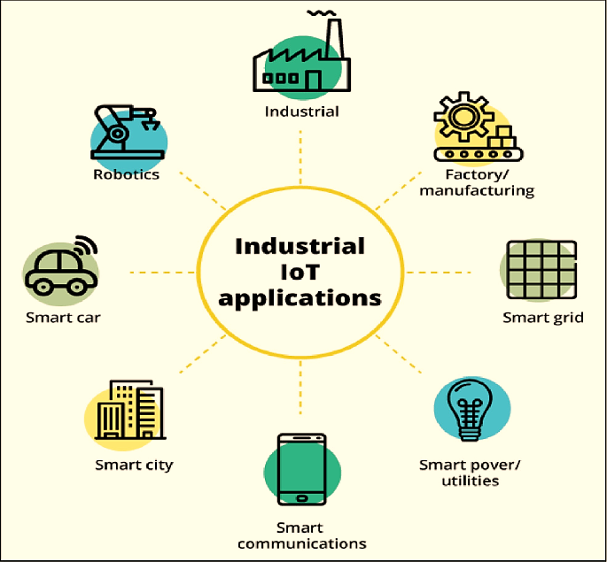

Figure 2: Industrial IoT Ecosystem and Applications

Here are some specific examples:

* **Manufacturing Optimization:** IoT sensors can monitor production processes in real-time, detect inefficiencies, and optimize operations for increased productivity and reduced costs.
* **Predictive Maintenance:** IoT sensors on industrial equipment can predict equipment failures, allowing for proactive maintenance and minimizing downtime.
* **Supply Chain Visibility:** IoT technology can provide end-to-end visibility into the supply chain, from raw materials to finished goods, allowing companies to optimize logistics and improve inventory management.

**4. Intersection of AI, ML, and IoT**

**4.1 How They Work Together**

The convergence of AI, ML, and IoT creates a powerful ecosystem for intelligent business solutions. IoT devices generate vast amounts of data, which ML models analyse to extract actionable insights. AI ensures that these systems adapt and improve over time.

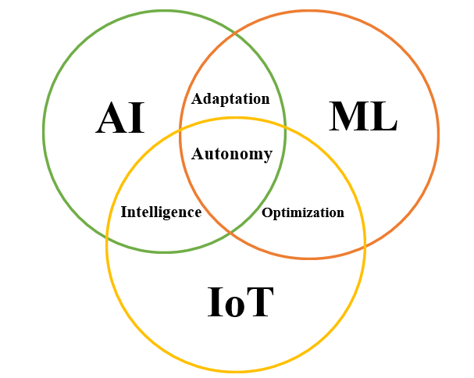

Figure 3: Synergy between Ai, ML and IoT

* + **AI ∩ ML (Adaptation):** Machine Learning algorithms enable AI systems to learn, adapt, and improve over time. In intelligent businesses, this combination is used for deep learning-based predictive analytics and reinforcement learning for dynamic decision-making, such as optimizing supply chain operations or personalizing customer experiences.
  + **AI ∩ IoT (Intelligence):** IoT devices generate massive amounts of data, and AI analyses this data to enable real-time decision-making. Examples include smart home devices that learn user preferences for energy efficiency and industrial robots that autonomously adjust their performance to maximize productivity.
  + **ML ∩ IoT (Optimization):** IoT devices equipped with Machine Learning improve their operational efficiency by learning from data. Examples include predictive maintenance systems in manufacturing and self-driving cars that learn road patterns to enhance safety and performance.
  + **AI ∩ ML ∩ IoT (Autonomy):** When AI, ML, and IoT converge, businesses achieve intelligent, adaptive systems capable of real-time insights and actions. Examples include autonomous vehicles that learn and adapt to new environments and smart factories that optimize production lines with predictive analytics and automated adjustments.

**4.2 Applications in Intelligent Business**

Intelligent business applications leverage the power of AI and IoT to drive innovation and efficiency.

* **Smart Cities:** AI-driven IoT solutions optimize traffic flow, reducing congestion and travel times. Smart grids powered by AI and IoT manage energy consumption more efficiently, minimizing waste and costs.
* **Predictive Maintenance:** IoT sensors gather real-time data from equipment, while AI/ML models analyse this data to predict potential failures. This proactive approach minimizes downtime, reduces maintenance costs, and improves overall equipment lifespan.
* **Real-Time Analytics:** Businesses can leverage AI to analyse IoT data in real-time. This enables faster decision-making, quicker responses to market changes, and improved operational agility. For example, a retail store can use AI to analyse real-time customer traffic data to adjust staffing levels or offer personalized promotions.

**4.3 Case Studies**

* **Amazon:** Amazon's warehouses serve as a testament to the transformative power of AI and IoT. AI-powered robots seamlessly navigate the warehouse floor, automating tasks like picking, packing, and transporting goods. This automation significantly increases efficiency and reduces reliance on manual labour. Furthermore, IoT sensors strategically placed throughout the warehouse monitor inventory levels in real-time, ensuring optimal stock levels and preventing costly stockouts. These real-time insights, combined with AI-driven predictive analytics, allow Amazon to forecast demand accurately, optimizing inventory management and minimizing waste.
* **Tesla:** Tesla's electric vehicles exemplify the seamless integration of IoT and AI. The vehicles themselves are essentially sophisticated computers on wheels, equipped with an array of sensors that constantly gather data on their surroundings. This data is then processed by powerful AI algorithms, enabling features like Autopilot, which allows for semi-autonomous driving. Moreover, Tesla leverages IoT connectivity to deliver over-the-air software updates, continuously improving vehicle performance, adding new features, and enhancing safety. The integration of IoT also facilitates remote diagnostics, allowing Tesla to proactively identify and address potential issues, ensuring optimal vehicle performance and minimizing downtime for owners.

**5. Challenges and Ethical Considerations**

**5.1 The convergence of AI, ML, and IoT**

The convergence of AI, ML, and IoT brings forth a range of challenges. Data privacy, security of IoT devices, and seamless integration of these technologies are key concerns. Addressing these challenges requires a multi-faceted approach that involves collaboration between technologists, policymakers, and ethicists.

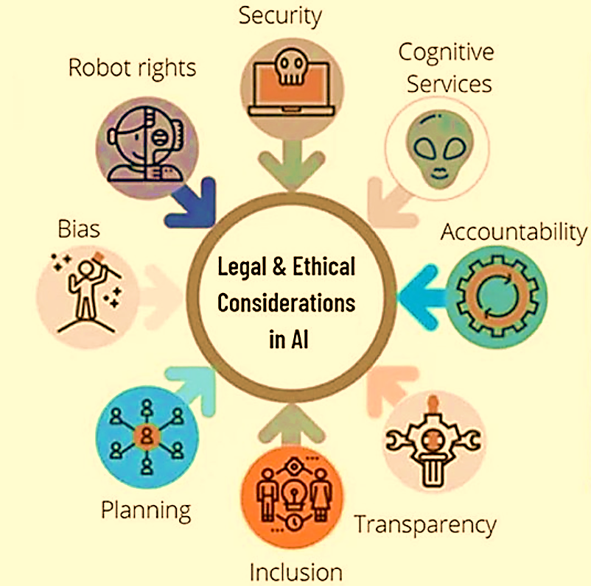

Figure 4: Ethical and Legal Compass for AI Governance

**Challenges**

* 1. **Confidentiality:** Safeguarding proprietary business and customer information against exposure. The collection and utilization of vast amounts of data raise significant privacy concerns. Ensuring the confidentiality and security of sensitive personal information is paramount. Robust data protection measures, including encryption and anonymization techniques, are crucial to safeguard individual privacy.
  2. **Security:** The interconnected nature of IoT devices creates a vast attack surface. Cyberattacks can compromise the security of individual devices, disrupt critical infrastructure, and even compromise personal safety. Robust security measures, including strong authentication, encryption, and regular software updates, are essential to mitigate these risks.
  3. **Liability:** Establishing accountability for AI decisions or failures, particularly in high-stakes scenarios like healthcare or autonomous vehicles. Ensuring data accuracy and precision in AI predictions, as errors can result in financial or reputational losses.
  4. **Integration:** Seamlessly integrating AI, ML, and IoT systems presents a complex technical challenge. Ensuring interoperability between different devices, platforms, and technologies requires well-defined standards and protocols. Additionally, addressing potential compatibility issues and ensuring data flow across different systems is crucial for successful implementation.

**Ethics**

1. **Regulation:** Regulation ensures adherence to industry standards and government policies that guide the ethical deployment of AI. It provides a structured framework to prevent misuse and ensures compliance with laws, particularly in critical domains like healthcare, banking, and public services. By regulating AI implementation, organizations can avoid risks associated with unregulated applications, such as unintended harm, legal penalties, or loss of public trust.
2. **Privacy:** Privacy emphasizes safeguarding user and customer data by complying with global and national data protection laws like GDPR (General Data Protection Regulation) or India's DPDP (Digital Personal Data Protection) Act. Ethical AI systems must prioritize secure handling of sensitive information through encryption, anonymization, and secure access controls. Respecting individual privacy builds user trust and minimizes risks associated with unauthorized data access or breaches.
3. **Bias Mitigation:** Bias mitigation is critical for ensuring fairness in AI algorithms. Ethical AI systems should be designed to reduce discriminatory outcomes based on gender, ethnicity, or socioeconomic status. By implementing bias detection, correction mechanisms, and inclusive training datasets, organizations can avoid perpetuating societal inequalities and ensure just outcomes for all users.
4. **Transparency:** Transparency requires organizations to make AI decision-making processes understandable and accessible to all stakeholders. Explaining how algorithms function, what data they use, and why specific outcomes are reached builds trust and accountability. Transparency is particularly crucial in high-stakes areas such as hiring, credit scoring, or healthcare.
5. **Relevance:** Relevance ensures that AI systems align with organizational goals and societal values while avoiding misuse or unintended consequences. Ethical AI practices involve designing systems that provide meaningful solutions, maintain ethical boundaries, and avoid applications that conflict with public interest or organizational mission.
6. **Planning and Inclusion:** Planning and inclusion emphasize designing AI systems that cater to diverse needs and benefit all stakeholders. Inclusive AI development involves representing varied user groups in data, avoiding exclusionary practices, and ensuring equitable access. Ethical planning ensures that AI systems promote social good, reduce disparities, and support diverse communities.

**5.2 Ethical AI and IoT in Intelligent Business**

Ethical considerations are critical in the development and implementation of AI and IoT technologies. One major concern is the possibility of bias in ML models. If the data used to train these models reflects existing societal biases, the AI systems may reinforce and even amplify these biases, resulting in unfair or discriminatory outcomes.

The widespread adoption of AI and IoT raises concerns about responsible use of these technologies. Unintended consequences of automation, such as job displacement and a loss of human autonomy, must be carefully considered and mitigated. The interconnectedness of IoT devices creates a large attack surface, making them vulnerable to cyberattacks. Security breaches can compromise personal information, disrupt critical infrastructure, and even jeopardise national security.

The ethical considerations surrounding the integration of AI, ML, and IoT centre on fairness, transparency, accountability, and human oversight. Bias in ML models, if not addressed, can perpetuate, and exacerbate existing societal inequalities. Responsible AI use necessitates careful consideration of unintended consequences, such as job displacement and the loss of human autonomy. Above all, ensuring the security of IoT devices is critical for preventing data breaches, protecting privacy, and preserving the integrity of critical infrastructure.

The following are key ethical considerations in the development and deployment of AI and IoT technologies:

* **Bias in ML Models:**

This refers to the situation where AI models, trained on biased data, make unfair or discriminatory decisions. For example, a loan application algorithm trained on historical data might unfairly discriminate against certain demographic groups. This will focus on ensuring fairness in decision-making is crucial to avoid perpetuating existing societal biases and ensuring equal opportunities for all.

* **Responsible AI Usage:**

This emphasizes the need to carefully consider the potential unintended consequences of deploying AI systems. Automation can lead to job displacement, erode human autonomy, and create unforeseen social and economic disruptions. Responsible AI development requires a proactive approach to mitigating these risks.

* **IoT Security:**

This highlights the vulnerabilities of interconnected IoT devices to cyberattacks. Security breaches can compromise personal data, disrupt critical infrastructure (like power grids or transportation systems), and even jeopardize national security.

**6. Future Trends**

The future trends like Edge Computing, AI-Driven Automation, and Industry 5.0 are poised to significantly reshape industries and technology landscapes:

* **Edge Computing and IoT**: As more devices become interconnected, processing data closer to the source reduces latency, optimizes bandwidth usage, and allows for faster decision-making. This is particularly beneficial in environments where real-time data processing is critical, such as autonomous vehicles, smart cities, and industrial automation systems.
* **AI-Driven Automation**: With the continued advancements in AI, automation will move beyond simple task execution to more complex decision-making processes. AI can enable self-regulating systems that monitor their own performance, make adjustments, and adapt to changing conditions with minimal human intervention. This leads to more efficient operations, particularly in manufacturing, logistics, and even healthcare.
* **Industry 5.0**: Unlike the focus of Industry 4.0 on automation and digitalization, Industry 5.0 emphasizes the collaboration between humans and machines. It’s about enhancing creativity, innovation, and the human experience through AI, robotics, and advanced technologies. Human workers will collaborate with robots and AI systems in more nuanced and productive ways, enabling industries to deliver more personalized and innovative solutions.

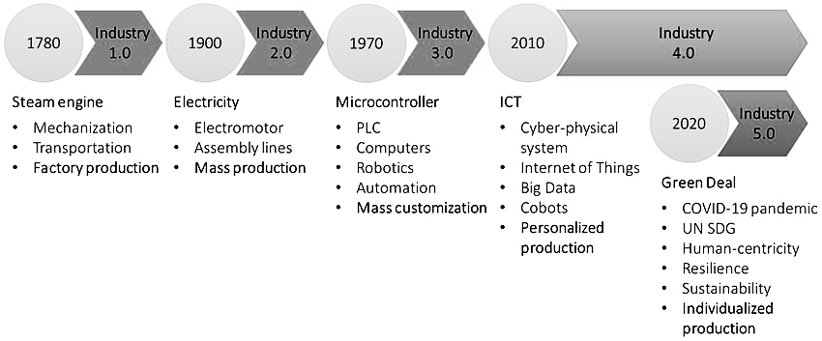

**Figure 5:** The Evolution of Industrial Revolutions: From Industry 1.0 to Industry 5.0

The Evolution of industrial revolutions, from Industry 1.0 to Industry 5.0. Industry 1.0 (1780) saw the introduction of steam engines, which allowed for advances in industrial output and transportation. Electricity, electromotors, and assembly lines were introduced during Industry 2.0 (1900), paving the way for mass manufacturing. Industry 3.0 (1970) introduced microcontrollers, computers, robots, and automation, emphasising mass customisation. Industry 4.0 (2010) combines ICT, cyber-physical systems, IoT, big data, and cobots to enable personalised production. Finally, the COVID-19 pandemic, UN Sustainable Development Goals, and the Green Deal have impacted Industry 5.0 (2020), which emphasises human-centricity, resilience, sustainability, and individualised manufacturing.

**Summary**

By leveraging the synergies between AI, ML, and IoT, businesses can unlock unprecedented opportunities for growth, efficiency, and innovation. This ecosystem drives operational excellence and ensures a competitive edge in the ever-evolving market landscape. This chapter explores the integration of Artificial Intelligence (AI), Machine Learning (ML), and the Internet of Things (IoT) in driving intelligent business solutions. AI simulates human intelligence, with components like ML for learning patterns, Natural Language Processing (NLP) for language understanding, and Computer Vision for visual data interpretation. ML, a subset of AI, offers supervised, unsupervised, and reinforcement learning techniques to uncover insights and make predictions. IoT connects devices to collect, process, and act on data, enabling applications like smart buildings and supply chain optimization. The convergence of AI, ML, and IoT fosters innovations such as predictive maintenance, real-time analytics, and enhanced customer experiences, creating a transformative impact across industries while addressing challenges like data privacy and ethical use.