**AI-Aware Cybersecurity Policies and Regulations**

Yash Kumar Singh1, Hitesh Sharma2, Prabhav Katoch3, Bhupinder Kaur4,AvneetKaur5,Poonam Kukana6

1Computer Science Engineering, Chandigarh University, India, [21BCS5116@cuchd.in](mailto:21BCS5116@cuchd.in)

2Computer Science Engineering, Chandigarh University, India, [21BCS5090@cuchd.in](mailto:21BCS5090@cuchd.in)

3Computer Science Engineering, Chandigarh University, India, [21BCS5179@cuchd.in](mailto:21BCS5090@cuchd.in)

4Computer Science Engineering, Chandigarh University, India, erbhupinderkaur@gmail.com

5Computer Science Engineering, Chandigarh University, India, avibhathal@gmail.com

6Computer Science Engineering, Chandigarh University, India, [poonam.e18526@cumail.in](mailto:poonam.e18526@cumail.in)

**Abstract:** Artificial Intelligence (AI) is rapidly reshaping cybersecurity by enabling faster threat detection, automated response, and predictive defense mechanisms. However, its integration also introduces new risks. Cybercriminals now exploit AI to launch sophisticated phishing attacks, create adaptive malware, and evade detection through adversarial techniques. Additionally, the opaque nature of AI models raises concerns about trust, interpretability, and accountability. This chapter explores the dual role of AI in cybersecurity—both as a powerful defense tool and a potential threat vector. It highlights recent advances, real-world risks, and ethical challenges, emphasizing the need for transparent AI development, strong governance, and resilient systems to ensure secure digital infrastructures.

**Keywords:** Artificial Intelligence (AI), Cybersecurity, Threat detection, Phishing attacks, Adaptive malware, AI opacity, Transparent AI development, Digital infrastructure security.

**9.1 Introduction**

The rapid evolution of artificial intelligence (AI) technologies has transformed nearly every sector of society—from finance and healthcare to transportation and defense. While AI offers immense potential to enhance cybersecurity by automating threat detection, improving response times, and managing large datasets, it also introduces novel risks and vulnerabilities. Sophisticated AI models can be weaponized for malicious purposes, such as deepfake generation, automated cyberattacks, and evasion of traditional security mechanisms. These emerging threats demand a shift in how cybersecurity is governed and enforced.

Traditional cybersecurity policies, often reactive and static, struggle to keep pace with the dynamic and autonomous nature of AI systems. As a result, there is a growing need for **AI-aware cybersecurity regulations**—legal, ethical, and technical frameworks that recognize the dual-use nature of AI and proactively address the unique challenges it poses. These frameworks must not only mitigate AI-driven threats but also ensure the safe, transparent, and accountable deployment of AI in cybersecurity itself.

In an era of increasing digital dependence, cybersecurity has become a critical pillar for safeguarding information, infrastructure, and user trust. The complexity and frequency of cyber threats have escalated significantly, rendering traditional security approaches insufficient. In response, the cybersecurity industry has embraced artificial intelligence (AI) as a transformative solution, capable of enhancing threat detection, automating responses, and proactively identifying vulnerabilities. AI-powered tools are now able to analyze vast amounts of data in real time, recognize patterns of malicious behavior, and even predict future attacks before they occur.

However, while AI introduces powerful capabilities, it also creates new risks and challenges that cannot be overlooked. Malicious actors are exploiting the same technology to design more sophisticated attacks, such as AI-generated phishing emails, deepfake impersonations, and intelligent malware that can evade detection. Furthermore, the reliance on black-box AI models raises concerns about transparency, accountability, and ethical use. As organizations increasingly integrate AI into their cybersecurity strategies, they must also contend with issues such as data privacy, bias in machine learning algorithms, and adversarial attacks that manipulate AI models themselves.

This dual nature of AI—acting as both a defense mechanism and a potential threat vector—necessitates a deeper understanding of its role in modern cybersecurity. This chapter aims to explore the benefits and drawbacks of AI-driven security solutions, examine the emerging risks associated with AI in the hands of attackers, and highlight the critical need for governance, regulation, and responsible innovation. As the digital world becomes more interconnected and intelligent, securing AI systems and understanding their vulnerabilities is not just a technical challenge but a strategic imperative.

**9.2 Importance of Cybersecurity**

The rising scale, sophistication, and speed of cyberattacks have made traditional security methods increasingly inadequate. In this evolving threat landscape, AI-driven cybersecurity has emerged as a crucial advancement for modern defense systems. AI enables security platforms to process and analyze vast amounts of data in real time, identifying threats, vulnerabilities, and anomalies that would be difficult or impossible for human analysts to detect manually.

One of the most significant advantages of AI is its ability to learn and adapt. Machine learning algorithms continuously improve as they encounter new data, allowing systems to detect previously unknown threats, also known as zero-day attacks. AI also enhances threat prediction by recognizing patterns and anticipating malicious behavior before damage occurs, making it a proactive defense rather than a reactive one.

Moreover, AI improves the efficiency of cybersecurity operations by automating routine tasks such as log analysis, threat classification, and response execution. This automation not only reduces the burden on human security teams but also speeds up response times, which is critical during active attacks.

In today’s hyper-connected digital world—where data breaches, ransomware, and phishing attacks are daily threats—AI-driven cybersecurity offers a scalable, intelligent, and dynamic approach to protection. As cyber threats continue to evolve, the integration of AI is not just an enhancement but a necessity for ensuring digital resilience and maintaining trust in digital systems.

Cybersecurity policies and regulations are critical for safeguarding digital infrastructure, protecting sensitive data, and ensuring the resilience of governments, businesses, and individuals in the face of cyber threats. As technology continues to evolve, so do the tactics of malicious actors—making clear, enforceable rules essential for managing risk, defining responsibilities, and establishing standards for security practices.

These policies help:

* **Prevent data breaches** by setting minimum security requirements.
* **Ensure accountability** by defining legal consequences for negligence or cybercrime.
* **Promote trust** among users, consumers, and stakeholders in digital systems.
* **Support national security** by protecting critical infrastructure from cyberattacks.
* **Enable global cooperation** through harmonized standards and information sharing.

In a world increasingly dependent on interconnected digital systems, robust cybersecurity policies are no longer optional—they are foundational to both economic stability and societal well-being.

**9.3 Risks and Challenges of Cybersecurity**

* **Adversarial Attacks**: Cybercriminals can exploit AI vulnerabilities to manipulate systems, evading detection and causing harm.
* **Lack of Transparency**: The "black box" nature of AI models makes it difficult to understand decision-making processes, affecting trust and accountability.
* **Bias in AI Models**: AI systems may inherit biases from training data, leading to skewed or unfair security responses.
* **Resource-Intensive**: AI-powered security solutions often require significant computational resources, making them costly and difficult to scale.
* **Evolving Threat Landscape**: As AI advances, cybercriminals adapt their tactics, leading to an ongoing arms race between defense and attack strategies.
* **False Positives/Negatives:** AI systems may generate incorrect alerts or miss critical threats, leading to either unnecessary actions or undetected breaches.
* **Ethical Concerns:** The use of AI in cybersecurity raises questions about privacy, surveillance, and the potential for misuse in monitoring or controlling individuals.
* **Dependence on Data Quality:** AI models heavily rely on high-quality, diverse data. Inaccurate or insufficient data can lead to flawed predictions and reduced effectiveness in detecting threats.

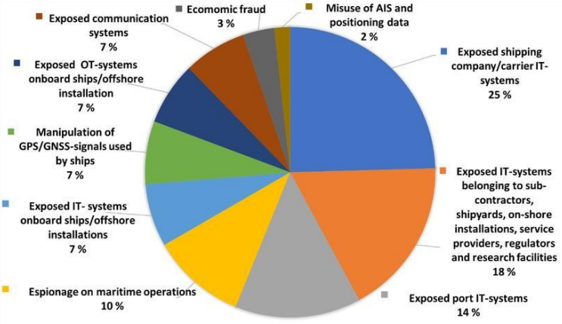***Fig 1: Percentage Distribution of different Cybersecurity Risks***

**What Happens Without Cybersecurity?**

Without proper cybersecurity measures:

* Personal and financial data can be stolen or misused.
* Businesses may suffer data loss, legal trouble, or reputation damage.
* Hackers could take control of critical infrastructure or systems.
* Online services and platforms could be disrupted or brought down.

**Common Cyber Threats**

* **Malware**: Harmful software like viruses or ransomware.
* **Phishing:** Fake emails or messages tricking users into revealing information.
* **Data Breaches:** Unauthorized access to confidential information.
* **DDoS Attacks:** Flooding a system with traffic to make it unavailable.

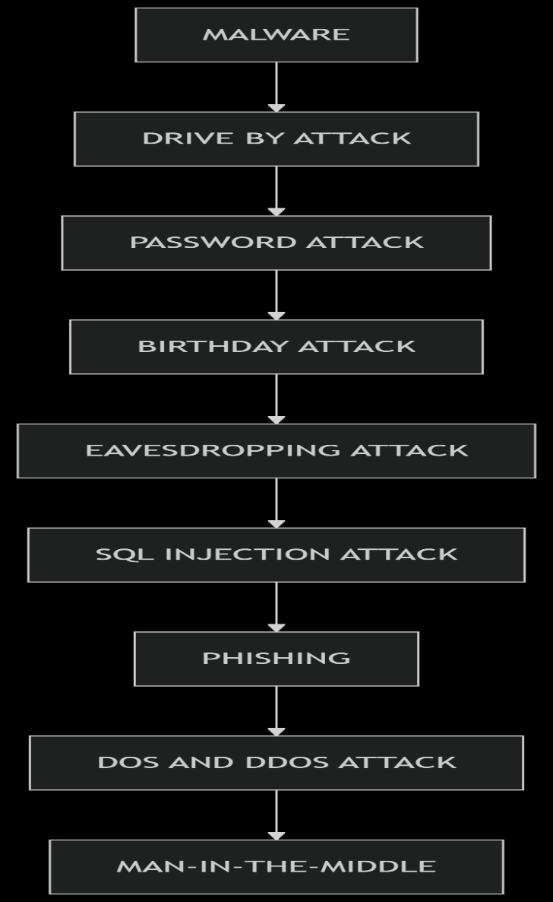   ***Fig 2: Different Cyber Attacks***

**9.4 AI Aware Cybersecurity Policies and Regulations**

AI-aware cybersecurity policies and regulations refer to rules, guidelines, and frameworks that explicitly take into account the unique challenges and threats introduced by Artificial Intelligence (AI) systems—both those used in cyberattacks and those deployed to defend against them. These policies aim to ensure the secure development, deployment, and usage of AI technologies in a rapidly evolving digital landscape.

Here’s an overview of the current state and core elements of AI-aware cybersecurity policies and regulations:

### **1. Core Principles of AI-Aware Cybersecurity Policies**

#### **a. Risk-Based Security Approach**

* Assess AI systems for potential vulnerabilities and risks.
* Include AI in threat modeling and cybersecurity planning.

#### **b. Secure AI Development**

* Ensure security is embedded throughout the AI lifecycle (design, training, testing, deployment).
* Mandate secure coding practices and regular vulnerability assessments.

#### **c. Robust Data Protection**

* Protect training and operational data from poisoning or manipulation.
* Ensure data privacy through techniques like federated learning and differential privacy.

#### **d. Auditability and Transparency**

* AI decisions should be explainable and traceable, especially in sensitive domains.
* Logs and audit trails must be maintained to investigate misuse or failures.

### **2. Regulatory Landscape (International)**

#### **a. European Union**

* AI Act (upcoming): Includes cybersecurity obligations for high-risk AI systems.
* NIS2 Directive: Requires critical infrastructure sectors to manage cyber risks, including those related to AI systems.

#### **b. United States**

* Executive Order 14110 on Safe, Secure, and Trustworthy AI (2023): Directs NIST and other agencies to issue AI security guidelines.
* NIST AI Risk Management Framework (2023): Provides guidance for managing AI-related risks including cybersecurity.

#### **c. United Kingdom**

* UK AI Regulation
* White Paper (2023): Encourages a context-based regulatory approach with a focus on safe AI deployment.

#### **d. OECD AI Principles**

* Promote inclusive growth, human-centered values, transparency, robustness, and accountability in AI development and deployment.

### **3. AI-Specific Cyber Threats Considered**

* Adversarial Attacks: Input manipulations to deceive AI models (e.g., in facial recognition or malware detection).
* Data Poisoning: Corrupting training data to mislead models.
* Model Extraction and Inversion: Reconstructing or stealing models/data.
* AI-powered Malware and Phishing: Using generative AI for social engineering attacks.

### **4. Emerging Best Practices in AI-Cybersecurity Regulation**

* Mandatory AI model testing and red teaming before deployment.
* Threat-sharing alliances that include AI-specific incident reporting.
* Requirements for certification and labeling of AI systems with verified security standards.
* Regulations promoting Human-in-the-loop oversight for critical systems (e.g., defense, healthcare).
* Alignment with zero trust architectures when integrating AI into enterprise IT systems.

### **5. Challenges and Ongoing Gaps**

* Global policy fragmentation – lack of standardization.
* Difficulty in regulating open-source AI models.
* Balancing innovation and security—especially for startups and SMEs.
* Rapid evolution of threats outpacing regulatory agility.

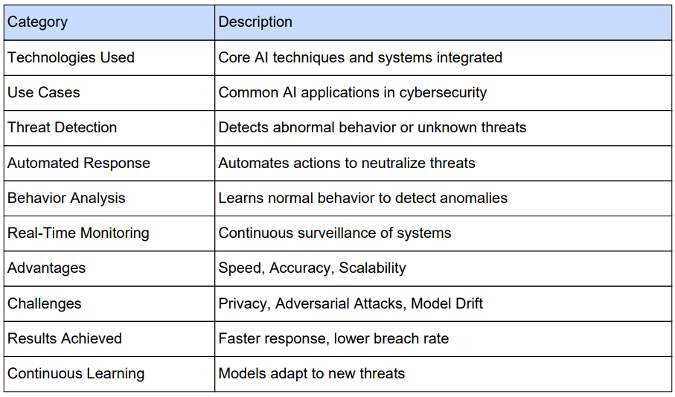***Fig 3: Cybersecurity Key Aspects Overview***

***9.5 Real World Case-Studies on Cyber Security Incidents***

* ***Yahoo Attack***

Another of the most massive security attacks and data breaches in history is the Yahoo attack which resulted in the hacking of nearly 500 million Yahoo accounts. It was reported as a state-sponsored attack when the hacker breached into Yahoo's systems and extracted data. This comprised Yahoo account holders' names, phone numbers, birth dates, email addresses, security questions, etc. While Yahoo had realized the breach in 2014 they never made the breach public and many identity thefts and phishing attempts ensued. A case study into such security breaches reveals the requirement of swift security response and compliance with security guidelines.

* **WannaCry Ransomware**

Another well-known cybersecurity attack that affected globally, is the WannaCry Ransomware that brought huge devastation and disruption, infecting Windows computer systems globally, and affecting more than 230,000 computers in more than 150 nations in 2017. The hackers exploited the vulnerability in the Windows called EternalBlue. Though Microsoft had issued a security patch prior to the attack to fix the vulnerability, numerous users had not installed it. This attack halted operations in numerous institutions like Hospitals, Government agencies and businesses across the globe. As a counter-measure, a "Kill Switch" was found by a security expert, however, numerous had already paid the hackers the ransom to bring their computers back online, with the hackers having made an estimated billions of dollars. Once again, case studies on such incidents prove the necessity of having any new updated version of cybersecurity installed and to update one's system periodically.**The Sony Pictures Hack**

Took place in 2014, hackers managed to infiltrate the network of Sony Pictures and release confidential data and other critical information including private communications between executives and employees' personal details. This led to a massive setback for Sony causing huge financial loss and reputational damage. Sony Pictures incurred heavy investments in improving its cybersecurity measures and making numerous legal settlements.

Cybersecurity case studies for incidents like this highlight the importance of improving a company's network security and more careful management, handling and protection of data.

* **The Equifax Breach**

One of the largest data breaches in the world is the huge one in 2017 in which hackers targeted the web application of Equifax, an international consumer credit reporting agency. The breach saw 147 million consumers' personal data lost almost in an approximate manner. It inflicted immense harm to the credit bureau financially as well as reputationally. This huge breach was made possible since Equifax committed the error of failing to patch a vulnerability in their web application Apache Struts that led to the compromise of personal IDs and information to malicious actors who are able to use this information even for future thefts. The hackers were able to obtain approximately 209,000 credit card information and social security numbers of the British and Canadian clients. Case studies in a cyber security breach such as Equifax reveal the urgent necessity of maintaining the company's software/applications up to date and regularly conducting ethical hacking to maintain their vulnerability under control. It emphasizes the need for effective vulnerability management and puts strong solutions and controls in place to avoid such breaches from happening.

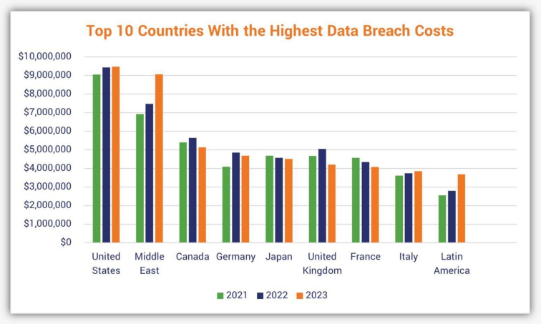***Fig 4: Countries with highest data breach costs***

**9.6 Conclusion**

Cybersecurity is no longer a choice—it’s a must for everyone, from web browsers to corporations handling millions of sensitive information. With increasing threats such as phishing, ransomware, data breaches, and AI-driven cyber-attacks, surfing online without protection can be risky.

Global cybercrime losses in 2023 totaled more than $8 trillion. That figure is projected to reach approximately $9.5 trillion in 2024, and could approach $10.5 trillion in 2025. These statistics easily demonstrate the need to lock down your devices, guard your personal and financial information, and employ sound cybersecurity software and methodologies.

Whether it’s preventing phishing scams, securing cloud storage, or blocking malware, cybersecurity plays a key role in ensuring a safe digital environment. By staying informed, using robust security tools, and following best practices, individuals and businesses can reduce risks and enhance overall cyber protection.

**9.7 Future Scope**

The future horizon of cybersecurity is enormous and ever-growing because of the ever-growing complexity and  
frequency of cyber attacks. With the increasing interconnectedness of the world and dependence on digital  
technologies, the demand for strong cybersecurity practices and professionals will only grow.

**Major Trends Defining the Future of Cybersecurity:**  
Growing Sophistication of Threats: Cyberattacks are becoming more sophisticated, utilizing technologies  
such as Artificial Intelligence (AI) to automate and increase their effectiveness. These include AI-based  
malware, phishing, and social engineering techniques.

**Increasing Attack Surfaces:**

The increased use of Internet of Things (IoT) devices, cloud computing, and  
remote working environments presents a larger set of vulnerabilities to be exploited by cybercriminals. Protecting  
these various and interconnected systems will be one of the primary areas of focus.

**Expanding Regulatory Environment:**

Governments globally are putting in place tighter data protection and privacy laws, like GDPR.Organizations will require cybersecurity experts to remain compliant and navigating this complicated legal environment.

**The Emergence of AI and Machine Learning in Defense:**

 AI is a threat but also presents tremendous opportunities for strengthening cybersecurity defenses. AI-based tools will be vital in detecting threats,anomaly inspection, predictive security, and automated incident response.

**Quantum Computing Threats and Countermeasures:**

The advent of quantum computing is a potential threat to present day encryption practices. Creation and implementation of quantum-resistant encryption techniques will be of paramount importance in the years to come.

**9.8 References**

**1. Musser, B., Muñoz-González, L., Carnerero-Cano, J., & Lupu, E. C. (2023).** Adversarial machine learning in cybersecurity: Legal implications and technical challenges. *arXiv preprint arXiv:[2305.14553]*.

**2. Hariyanti, D., Djunaidy, D., & Siahaan, R. (2023).** The impact of artificial intelligence on organizational cybersecurity. *Journal of King Saud University - Computer and Information Sciences*. [ScienceDirect](https://www.sciencedirect.com/science/article/pii/S2543925123000372?utm_source=chatgpt.com)

**3. Li, Y. (2024).** Application and challenges of artificial intelligence in cybersecurity. *International Journal of Computer Science and Information Security (IJCSIS)*

**4. Pasupuleti, R. (2023).** Cybersecurity issues and challenges related to generative AI and ChatGPT. *University of Miami IDSC Reports*.

**5. Falade, P. V. (2023).** Decoding the threat landscape: ChatGPT, FraudGPT, and WormGPT in social engineering attacks. *arXiv preprint arXiv:[2310.05595]*. [arXiv](https://arxiv.org/abs/2310.05595?utm_source=chatgpt.com%22%20\t%20%22_blank)

**6. Starnes, R. (2023).** Impact, risks, and examples of AI in cybersecurity. *IS Partners, LLC*. [I.S. Partners](https://www.ispartnersllc.com/blog/ai-cybersecurity-examples/?utm_source=chatgpt.com)

**7. Chakraborty, A., Biswas, A., & Khan, A. K. (2022).** Artificial intelligence for cybersecurity: Threats, attacks, and mitigation. *arXiv preprint arXiv:[2209.13454]*. [arXiv](https://arxiv.org/abs/2209.13454?utm_source=chatgpt.com%22%20\t%20%22_blank)

**8. https://www.geeksforgeeks.org/ai-in-cybersecurity/**

**9. World Economic Forum. (2025).** Artificial intelligence and cybersecurity: Balancing risks and rewards. *WEF Reports*. [World Economic Forum Reports](https://reports.weforum.org/docs/WEF_Artificial_Intelligence_and_Cybersecurity_Balancing_Risks_and_Rewards_2025.pdf?utm_source=chatgpt.com)

**10. National Institute of Standards and Technology (NIST). (2024).** Managing cybersecurity and privacy risks in the age of artificial intelligence. *NIST Cybersecurity Insights Blog*.

**11. Brundage et al. (2018). "The Malicious Use of Artificial Intelligence: Forecasting, Prevention, and Mitigation.",** URL: https://arxiv.org/abs/1802.07228

**12. Cath, C. (2018). "Governing Artificial Intelligence: Ethical, Legal and Technical Opportunities and Challenges.",** Philosophical Transactions of the Royal Society A., DOI: [10.1098/rsta.2018.0080]

**13. U.S. National Institute of Standards and Technology (NIST) – AI Risk Management Framework (2023)**, URL: https://www.nist.gov/itl/ai-risk-management-framework

**14. EU Artificial Intelligence Act (AI Act),** **“Proposed regulation addressing trustworthy AI, includes cybersecurity and risk classification”.**, URL: https://artificialintelligenceact.eu/

**15. OECD Principles on Artificial Intelligence (2019),** **“Emphasizes AI robustness and security, including resilience to adversarial attacks”,** URL: <https://oecd.ai/en/ai-principles>