The Role of Biofire in Bone Infection
Diagnosis and Treatment

Author
Dr Reham Abdelmonem
MBBCh, MPH, MBA, DipRCPath, PhD, D (ABMM)
Consultant in Medical Microbiology and Public Health
Senior clinical fellow- Lancashire Teaching Hospitals NHS Foundation Trust- Royal Preston Hospital
Sharoe Green Lane
Fulwood- Preston- Lancashire
PR2 9HT
Reham.h.e@hotmail.com
ABSTRACT
The evolution of diagnostics in recent decades, has been of a great importance in laboratory medicine, especially the Microbiology laboratory. The accurate diagnosis of pathogen standing behind the acute or chronic infections, is the corner stone of the proper management of infections. In bone infections, such as septic arthritis, osteomyelitis, diabetic foot infections, spinal infections, and periprosthetic joint infections, the diagnosis of causative organisms is challenging while using the conventional methods. Modern diagnostics such as BIOFIRE JI panel can add a great benefit not only in identifying the causative organisms but also in specifying the antimicrobial resistance genes which can help in tailoring effective empirical antimicrobial treatment plan.

Keywords: BIOFIRE, Bone, Infection, Diagnostics, conventional, culture, antimicrobial, empirical, resistance, genes.

- INTRODUCTION

Bone and joint infections, including osteomyelitis, septic arthritis, and prosthetic joint infections, represent a significant clinical challenge due to their complexity, potential for severe complications, and the need for timely and accurate diagnosis. Traditional diagnostic methods, such as culture-based techniques, often require extended timeframes, ranging from 48 hours to several days, and may yield false-negative results, especially when patients have received prior antibiotic therapy. These limitations can delay the initiation of targeted treatment, increasing the risk of poor outcomes, including chronic infection, amputation, or the need for repeated surgeries. The introduction of advanced molecular diagnostic tools, such as the BIOFIRE Joint Infection (JI) Panel, has revolutionized the approach to diagnosing and treating these infections.
The BIOFIRE JI Panel is a multiplex polymerase chain reaction (PCR) assay designed to rapidly identify a comprehensive array of pathogens and key antimicrobial resistance (AMR) genes directly from synovial fluid. This cutting-edge technology offers results in approximately one hour, significantly shortening the diagnostic timeline compared to traditional methods. By detecting up to 39 targets, including bacteria such as Staphylococcus aureus and Pseudomonas aeruginosa, fungi like Candida species, and critical resistance markers such as mecA and vanA/B, the panel provides a detailed microbiological profile essential for tailoring therapy.
One of the panel’s primary advantages is its utility in situations where standard culture methods are insufficient. For instance, it excels in detecting fastidious organisms or polymicrobial infections, which are often missed due to the limitations of culture techniques. This feature is particularly important in cases of chronic or complex infections, where multiple pathogens may coexist, or in patients who have been pre-treated with antibiotics that suppress bacterial growth in cultures. Furthermore, the BIOFIRE JI Panel’s ability to identify resistance genes facilitates the early administration of appropriate antibiotics, reducing reliance on broad-spectrum empiric therapy and promoting antimicrobial stewardship.
The clinical impact of the BIOFIRE JI Panel extends beyond rapid diagnostics. Its implementation has been shown to improve patient outcomes by enabling timely and targeted intervention, which reduces the risk of prolonged infections and associated complications. Additionally, it enhances the efficiency of healthcare delivery by decreasing hospital stays, minimizing unnecessary procedures, and reducing overall healthcare costs. By integrating this tool into diagnostic workflows, clinicians can address bone and joint infections more effectively, ensuring that patients receive optimal care based on precise and actionable data. In conclusion, the BIOFIRE JI Panel represents a paradigm shift in the management of bone infections, bridging the gap between microbiological diagnostics and clinical decision-making. Its rapid, accurate, and comprehensive detection capabilities are indispensable in modern infectious disease management, providing significant benefits for both patients and healthcare systems.

- TOPICS

- What is the bone infection?
- What are the different diagnostics used for the diagnosis of bone infection?
- What is the Biofire technology?
- What is the role of Biofire in diagnosis of bone infection?
- What is the role of Biofire in treatment of bone infection?
- Case scenarios representing the value of the BIOFIRE JI panel in diagnosis and treatment of bone infections.
- Recommendations for Biofire use in bone infection management.

- What is the bone infection?

Bone infection is one of the most serious complaints among all ages of patients. It has a wide range of signs and symptoms based on the type, site and complications caused by this infection. Serious morbidities and mortalities can be caused by bone infections especially that it has management challenges starting from the need for proper diagnosis passing through surgical and medical management of this infection. Bone infection might be native or caused by external factors such as trauma, or surgical intervention. Different clinical forms of bone infection include septic arthritis, osteomyelitis, spinal infections, diabetic foot infection, fracture related infection, and implant related infections.
A very big challenge in management of chronic bone infection, is the evolvement and reversion of infection due to the ability of bacteria to persist like in Staphylococcus aureus which endures through several mechanisms such as small colony variants, intracellular survival, biofilm formation, invasion of lacunocanalicular network of the bone osteocytes, in addition to collection and abscess formation. (1) Many factors have been contributing to the deep understanding of the of the Microbiology of bone infection, these factors include the evolution in Microbiology diagnostics, especially the molecular techniques. It helps in identifying organisms that might be hard to be isolated through conventional methodologies, in addition to detection of wide range of genes that stand behind antibiotic resistance which also plays a role in improving the management of infections. (2)
Septic arthritis almost affect 4-10/ 100.000 patients each year, this incidence increase to 30-60 individual per 100.000 in patients with underlying joint diseases. (3) The average incidence of chronic multifocal osteomyelitis is 0.65/ 100.000 among children and adolescence in the UK and Republic of Ireland. (4) Among musculoskeletal infections, the spinal infections occurrence ranges from 2-7 % and although its low incidence rate in some areas like developed countries (1/100.000 to 1/250.000), its has a 2-4% mortality rate. (5) On the other hand, PJI incidence ranges from 2-2.4% in primary joint arthroplasty and up to 20% in revision surgeries. (6)

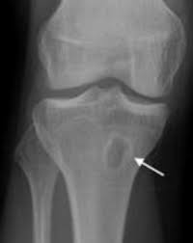 | 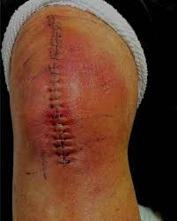 | 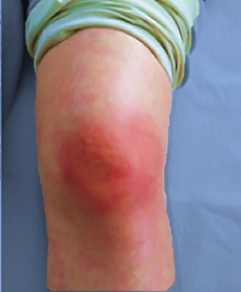
Figure (1) Different types of bone infection
- knee Osteomyelitis | - Knee post-surgical infection | - Septic artheritis

- What are the different diagnostics used for the diagnosis of bone infection?

Conventional Microbiology diagnostics such as routine culture, and analytic profile index (API) are still the gold standard although their limitations, and they should not be replaced by the advanced molecular techniques, but they can complement the role of each other. Conventional Microbiology cultures have the advantage of providing antibiotic sensitivity, but it has a long turnaround time. On the other hand, the molecular techniques have the advantage of identifying organisms in false negative culture results, which caused by multiple reasons such as infections caused by fastidious organisms like Kingella kingae, which is on top causes of septic arthritis in children and Neisseria gonorrhoeae which causes septic arthritis in sexually active individuals. (7,8) Persistence of antibiotics in specimens which hinder the ability of conventional cultures to isolate organisms is also one of the reasons behind false negative culture results. However, Molecular diagnostics are still having limitations to detect organisms in some situations such as low inoculum or polymicrobial infections, or even identifying nucleic acid of non-viable organisms. Variable molecular techniques can be used, for example; specific, multiplex and universal PCR, and whole genome sequencing (WGS). (9)

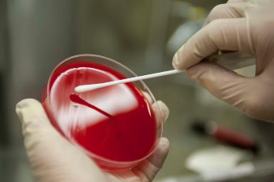 | 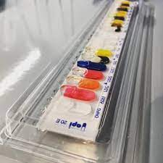 | 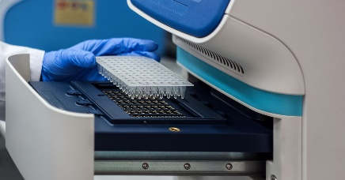 | 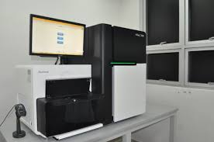
Figure (2): Different diagnostics used in Microbiology laboratory
- Routine culture | - API | - PCR | - WGS

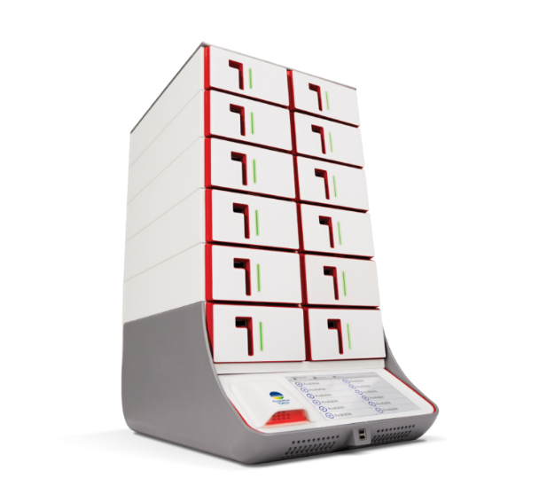
- What is the Biofire technology?

The BIOFIRE® FILMARRAY® Pouch is based on multiplex PCR, which is performed through three simple steps: (a) Setup through injection of hydration solution and sample, followed by (b) Inserting the pouch into the instrument figure (3). Then finally (c) ended by software reporting the results. Biofire cycle of identification starts with extraction and purification of nucleic acids from the suitable sample. Thereafter, two steps of multiplex PCR are commenced, starting with single multiplexed reaction followed by individual single-plex reactions to detect the target either an organism or an antimicrobial resistant gene.
This technology and its simple performance give many advantages to the BIOFIRE over the conventional culture methos used in the Microbiology Laboratories. These advantages include the faster turnaround time and cost effectiveness, which help in identifying causative organisms and their mechanism of antimicrobial resistance which can guide the physicians in developing an early efficient antimicrobial plan.
In 2022, Food and Drug Administration (FDA) approved the BIOFIRE Joint JI panel, which is targeting 39 clinically relevant targets including Gram-positive bacteria, Gram-negative bacteria, yeast, and antimicrobial resistance genes Table (1). (10) The sample used for this panel is 200 μL of synovial fluid, with minimal hands on and short turnaround time nearly one hour.
Figure (3): BIOFIRE FILMARRAY

Table (1): Clinically relevant targets identified by the BIOFIRE JI Panel:

Gram positive bacteria | Anaerococcus prevotii/vaginalis
 | Clostridium perfringens
 | Cutibacterium avidum/granulosum
 | Enterococcus faecalis
 | Enterococcus faecium
 | Finegoldia magna
 | Parvimonas micra
 | Peptoniphilus
 | Peptostreptococcus anaerobius
 | Staphylococcus aureus
 | Staphylococcus lugdunensis
 | Streptococcus agalactiae
 | Streptococcus pneumoniae
 | Streptococcus pyogenes
Gram negative bacteria | Bacteroides fragilis
 | Citrobacter
 | Enterobacter cloacae complex
 | Escherichia coli
 | Haemophilus influenzae
 | Kingella kingae
 | Haemophilus influenzae
 | Kingella kingae
 | Klebsiella aerogenes
 | Klebsiella pneumoniae group
 | Morganella morganii
 | Neisseria gonorrhoeae
 | Proteus spp.
 | Pseudomonas aeruginosa
 | Salmonella spp.
 | Serratia marcescens
Yeast | Candida albicans
Antimicrobial resistance genes | CTX-M
 | KPC
 | NDM
 | IMP
 | VIM
 | OXA-48-like
 | mecA/C and MREJ (MRSA)
 | vanA/B

- What is the role of Biofire in diagnosis of bone infection?

Many studies assessed the role of BIOFIRE joint infection panel, in the diagnosis of periprosthetic joint infections. The BIOFIRE technology added an advantage of identifying some difficult to grow organisms specially in cases of unexpected negative cultures.(11) The role of BIOFIRE in diagnosing bone infection is much higher in native acute septic arthritis rather than post- surgical joint infections. This is because the BIOFIRE JI panel lacks some organisms, which are commonly isolated in post-surgical PJI. These organisms such as staphylococcus epidermidis and cutibacterium acne. Their absence from the BIOFIRE JI panel, probably takes aim to minimize false-positive results, because the isolation of these organisms is still debatable because they might be part of the normal skin flora.
Several studies have compared the performance of BIOFIRE JI panel with the routine culture, the gold standard method and although the high agreement between BIOFIRE and conventional culture results, there were a percentage of discrepancy which requires proper clinical assessment. (12)

Table (2): Overall agreement between BIOFIRE JI panel and routine culture in
native and prosthetic joint infections

In native joint infections
Overall agreement between BIOFIRE JI panel, and routine culture is 88.4 %
Both positive | Both negative | Positive BIOFIRE JI panel only | Positive routine culture only
147 samples | 641 samples | 73 samples | 12 samples
In prosthetic joint infection
Overall agreement between BIOFIRE JI panel, and routine culture is 85.7 %
Both positive | Both negative | Positive BIOFIRE JI panel only | Positive routine culture only
138 | 210 | 38 | 12

These results in table (2) mean that the positivity rate results gained by (positive routine culture only) is much lower than that obtained by the (positive BIOFIRE JI panel only). (13) This was attributed to the organisms of the JI panel such as Finegoldia magna, Peptoniphilus, and other anaerobic organisms which were only identified by BIOFIRE JI panel but not by the routine culture. This has a big role in modifying the epidemiology of anaerobic organisms as a cause of bone infection. Consequently, this identification should modify the empirical and targeted antibiotics, which is considered a big role to play by the BIOFIRE JI panel.
On the other hand, most of the organisms which were detected by (routine culture only) but not by BIOFIRE JI panel, are not included in the BIOFIRE JI panel which means; it is not due to a limitation in the technology, these organisms such as coagulase negative Staphylococci (except staphylococcus lugdunensis) and Cutibacterium acenes. Many studies have assessed the sensitivity and specificity of BIOFIRE JI panel table (3).

Table (3): BIOFIRE JI panel, sensitivity and specificity assessment.

 | Sensitivity | Specificity
Biomerieux (14) | 91.7% | 99.8%
Berinson B st al. (15) | 100% | 100%
Hoffman et al. (16) | 92% | 100%
Saeed et al. (17) | 91.6% | 93%
Esteban J et al. (18) | 90.5% | 99.6%
Gaillard et al. (19) | 84.9% | 100%
Schaenmakers et. al. (20) | 80.6% | 100%
Salar-Vidal et al. (21) | 69% | 91.9%
Gardete-Hartmann et al. (11) | 41.4% | 91.1%

- What is the role of Biofire in treatment of bone infection?

BIOFIRE technology has a crucial antimicrobial stewardship role in the initiation of empirical antimicrobials. This role is achieved through de-escalation of the usually used empirical broad-spectrum antimicrobials, to a narrower spectrum covering only the isolated organism and at the same time to be effective against the detected antimicrobial resistance gene. This can be an excellent tool for applying regulations of antimicrobial stewardship. (16)

Table (4): comparison between BIOFIRE JI panel and routine culture
in detection of resistance genes.
In native joint infections
 | Both positive | Detection only by BIOFIRE JI panel | Detection only by Routine culture | Total detection by BIOFIRE JI panel | Total detection by routine culture
Gram positive resistance genes | 4 | 6 | 2 | 10 | 6
Gram negative resistance genes | 0 | 5 | 0 | 5 | 0
In prosthetic joint infection
 | Both positive | BIOFIRE JI panel only is positive | Routine culture only is positive | Total detection by JI panel | Total detection by routine culture
Gram positive resistance genes | 6 | 5 | 0 | 11 | 6
Gram negative resistance genes | 3 | 13 | 0 | 16 | 3

Results shown in table (4), confirms the superiority of the BIOFIRE JI panel to the routine culture, in detection of resistance genes especially in gram negative organisms.(13) This is considered a big advantage which can modify the antimicrobial plan in the empirical phase to ensure the most effective treatment plan for the patient. BIOFIRE JI panel can guide antimicrobial management plan in cases of polymicrobial infection where cultures cannot detect, which is one of the top reasons behind failure of joint revision surgeries. (22)

- Case scenarios representing the value of the BIOFIRE JI panel in diagnosis and treatment of bone infections.

Case 1: Rapid Diagnosis in PJI:
- Scenario:
A 70-year-old male undergoes a total knee arthroplasty and presents two weeks later with swelling, warmth, and pain in the surgical area. Routine cultures from synovial fluid yield no growth after 48 hours, and the patient's condition deteriorates.
- How the BIOFIRE JI Panel Helps:
- The BIOFIRE Joint Infection (JI) Panel provides results in approximately one hour, identifying Staphylococcus aureus with mecA resistance gene (indicating methicillin resistance).
- Rapid identification allows clinicians to switch from empiric vancomycin to a targeted regimen with daptomycin, reducing the risk of antibiotic resistance and improving outcomes.
- Early, targeted treatment prevents prosthetic failure and reduces the need for revision surgery.

Case 2: Identification of Polymicrobial Infections in Osteomyelitis
- Scenario:
A 42-year-old diabetic patient presents with chronic foot ulceration and signs of osteomyelitis. Imaging confirms bone involvement, but routine cultures identify only Escherichia coli. Despite appropriate treatment, the infection persists.
- How the BIOFIRE JI Panel Helps:
- The panel identifies additional pathogens (Pseudomonas aeruginosa and Streptococcus agalactiae) within an hour, which were missed in standard culture due to prior antibiotic use.
- The broad detection enables the adjustment of antibiotics to cover all implicated organisms, resolving the infection effectively.
- Faster diagnosis prevents unnecessary delays in initiating comprehensive therapy, lowering the risk of amputation.

Case 3: Differentiation Between Contaminants and True Pathogens in Joint Infection
- Scenario:
A 30-year-old male with a history of intravenous drug use presents with septic arthritis. Initial synovial fluid culture detects Corynebacterium species, but it is unclear if the finding represents a contaminant or a true pathogen.
- How the BIOFIRE JI Panel Helps:
- The BIOFIRE JI Panel confirms the presence of Corynebacterium striatum and its antimicrobial resistance profile, differentiating it as a significant pathogen.
- Targeted treatment is initiated based on susceptibility data, avoiding overuse of broad-spectrum antibiotics.
- Rapid results prevent delays and support better antimicrobial stewardship.

- Recommendations for Biofire use in bone infection management.

The BIOFIRE JI Panel is a rapid multiplex PCR assay designed to detect a broad spectrum of pathogens and AMR genes associated with joint infections. Its implementation in clinical settings has been evaluated in several studies, leading to recommendations for its use in diagnosing and managing bone and joint infections.

- Enhanced Diagnostic Accuracy and Speed
- Improved Sensitivity and Specificity:
The BIOFIRE JI Panel has shown high sensitivity and specificity for detecting pathogens in joint infections, outperforming traditional culture methods.
- Rapid Turnaround Time:
Results are available in about one hour, significantly reducing diagnostic time compared to conventional culture methods, which can take days.
- Utility in Clinical Decision-Making
- Timely Antimicrobial Therapy:
Rapid identification of pathogens and antimicrobial resistance genes enables early, targeted treatment, improving patient outcomes.
- Detection of Polymicrobial Infections:
The panel's ability to identify multiple pathogens in a single test is beneficial for recognizing complex polymicrobial infections.
- Considerations for Use
- Complementary to Traditional Methods:
The panel enhances diagnostic capabilities but should be used alongside culture methods for susceptibility testing and epidemiological purposes.
- Specimen Selection:
The panel is validated primarily for synovial fluid. Its performance with other sample types, such as bone or periprosthetic tissue, requires further study.
- Clinical Implementation Guidelines
- Interdisciplinary Collaboration:
Decisions to use the BIOFIRE JI Panel in prosthetic joint infections should involve input from orthopaedic and infectious disease specialists.
- Integration into Diagnostic Algorithms:
The panel should be incorporated into diagnostic workflows while considering its limitations and the need for complementary diagnostics.
.

- REFERENCES

1. Masters EA, Ricciardi BF, Bentley KL de M, Moriarty TF, Schwarz EM, Muthukrishnan G. Skeletal infections: microbial pathogenesis, immunity and clinical management. Nat Rev Microbiol. 2022 Jul;20(7):385–400.
2. Murillo O, Grau I, Lora-Tamayo J, Gomez-Junyent J, Ribera A, Tubau F, et al. The changing epidemiology of bacteraemic osteoarticular infections in the early 21st century. Clinical Microbiology and Infection [Internet]. 2015 Mar 1 [cited 2024 Dec 21];21(3):254.e1-254.e8. Available from: https://www.clinicalmicrobiologyandinfection.com/article/S1198-743X(14)00038-X/fulltext
3. Geirsson AJ, Statkevicius S, Víkingsson A. Septic arthritis in Iceland 1990-2002: increasing incidence due to iatrogenic infections. Ann Rheum Dis. 2008 May;67(5):638–43.
4. Chia DT, Toms AP, Sanghrajka A, Ramanan AV, Killeen OG, Ilea C, et al. Incidence of chronic recurrent multifocal osteomyelitis in children and adolescents in the UK and Republic of Ireland. Rheumatology [Internet]. 2024 Aug 21 [cited 2025 Jan 4];keae447. Available from: https://doi.org/10.1093/rheumatology/keae447
5. Goubran A, Tomlinson J. Spinal infection – an overview.
6. Signore A, Sconfienza LM, Borens O, Glaudemans AWJM, Cassar-Pullicino V, Trampuz A, et al. Consensus document for the diagnosis of prosthetic joint infections: a joint paper by the EANM, EBJIS, and ESR (with ESCMID endorsement). Eur J Nucl Med Mol Imaging [Internet]. 2019 [cited 2024 Dec 24];46(4):971–88. Available from: https://www.ncbi.nlm.nih.gov/pmc/articles/PMC6450843/
7. Hunter S, Chan H, Baker JF. Global epidemiology of childhood bone and joint infection: a systematic review. Infection. 2022 Apr;50(2):329–41.
8. Moussiegt A, François C, Belmonte O, Jaubert J, Traversier N, Picot S, et al. Gonococcal arthritis: case series of 58 hospital cases. Clin Rheumatol. 2022 Sep;41(9):2855–62.
9. Dupieux C, Laurent F. Diagnostic des infections ostéo-articulaires. Revue Francophone des Laboratoires [Internet]. 2016 Mar 1 [cited 2024 Dec 21];2016(480):47–53. Available from: https://www.sciencedirect.com/science/article/pii/S1773035X16300879
10. bioMérieux Website [Internet]. [cited 2024 Dec 22]. BIOFIRE® Joint Infection Panel. Available from: https://www.biomerieux.com/corp/en/our-offer/clinical-products/biofire-joint-infection-panel.html
11. Gardete-Hartmann S, Mitterer JA, Sebastian S, Frank BJH, Simon S, Huber S, et al. The role of BioFire Joint Infection Panel in diagnosing periprosthetic hip and knee joint infections in patients with unclear conventional microbiological results. Bone Joint Res. 2024 Jul 10;13(7):353–61.
12. Moran A, Arellano J, Bregman K, McElvania E. Evaluation of a BioFire multiplex PCR panel for detection of joint infections using retrospective and prospectively collected specimens. J Clin Microbiol. 2024 Aug 14;62(8):e0018224.
13. Pascual S, Noble B, Ahmad-Saeed N, Aldridge C, Ambretti S, Amit S, et al. Potential value of a rapid syndromic multiplex PCR for the diagnosis of native and prosthetic joint infections: a real-world evidence study. J Bone Jt Infect. 2024;9(1):87–97.
14. bioMérieux Website [Internet]. [cited 2025 Jan 4]. BIOFIRE® Joint Infection (JI) Panel. Available from: https://www.biomerieux.com/us/en/our-offer/clinical-products/biofire-joint-infection-panel.html
15. Berinson B, Spenke L, Krivec L, Tanida K, Both A, Keller J, et al. Performance and Hypothetical Impact on Joint Infection Management of the BioFire Joint Infection Panel: a Retrospective Analysis. J Clin Microbiol [Internet]. [cited 2025 Jan 4];61(8):e00592-23. Available from: https://www.ncbi.nlm.nih.gov/pmc/articles/PMC10446873/
16. Real-Life Experience and Diagnostic Utility of the BioFire Joint Infection PCR Panel in Bone and Joint Infections: Analysis of a Prospective Validation Study - PubMed [Internet]. [cited 2024 Dec 24]. Available from: https://pubmed.ncbi.nlm.nih.gov/37129850/
17. Saeed K, Ahmad-Saeed N, Annett R, Barlow G, Barrett L, Boyd SE, et al. A multicentre evaluation and expert recommendations of use of the newly developed BioFire Joint Infection polymerase chain reaction panel. Eur J Clin Microbiol Infect Dis [Internet]. 2023 Feb 1 [cited 2025 Jan 4];42(2):169–76. Available from: https://doi.org/10.1007/s10096-022-04538-w
18. Esteban J, Salar-Vidal L, Schmitt BH, Waggoner A, Laurent F, Abad L, et al. Multicenter evaluation of the BIOFIRE Joint Infection Panel for the detection of bacteria, yeast, and AMR genes in synovial fluid samples. J Clin Microbiol [Internet]. [cited 2025 Jan 4];61(11):e00357-23. Available from: https://www.ncbi.nlm.nih.gov/pmc/articles/PMC10662359/
19. Gaillard T, Dupieux-Chabert C, Roux AL, Tessier E, Boutet-Dubois A, Courboulès C, et al. A prospective multicentre evaluation of BioFire® Joint Infection Panel for the rapid microbiological documentation of acute arthritis. Clinical Microbiology and Infection [Internet]. 2024 Jul 1 [cited 2025 Jan 4];30(7):905–10. Available from: https://www.sciencedirect.com/science/article/pii/S1198743X24001538
20. Schoenmakers JWA, de Boer R, Gard L, Kampinga GA, van Oosten M, van Dijl JM, et al. First evaluation of a commercial multiplex PCR panel for rapid detection of pathogens associated with acute joint infections. J Bone Jt Infect. 2023;8(1):45–50.
21. Salar-Vidal L, Chaves C, Dianzo-Delgado IT, Favier P, Giner-Almaraz S, Gómez-Gómez MJ, et al. Multicenter evaluation of BioFire JI panel related to improved microbiological diagnostics on acute osteoarticular infections. International Journal of Medical Microbiology [Internet]. 2023 Nov 1 [cited 2025 Jan 4];313(6):151588. Available from: https://www.sciencedirect.com/science/article/pii/S1438422123000164
22. Frank BJH, Aichmair A, Simon S, Schwarz GM, Dominkus M, Hofstaetter JG. Analysis of Culture Positive First and Second Stage Procedures in Periprosthetic Knee and Hip Joint Infections. J Arthroplasty. 2021 Jun;36(6):2158–64.

