**Current trends in Agricultural Nitrous Oxide Emissions: Drivers, Impacts, and Mitigation**

Nisha Khatri, Chaukha Ram Riya K.R., Devanshi M.

Division of Integrated Farming System Kerala Agricultural University

ICAR- Central Arid Zone Research Institute Thrissur-680656, Kerala, India

Jodhpur-342003, Rajasthan, India

[nishakhatri780@gmail.com](mailto:nishakhatri780@gmail.com), [c.ram4298@gmail.com](mailto:c.ram4298@gmail.com)

**ABSTRACT**

Nitrous oxide (N₂O) is a potent greenhouse gas with a global warming potential 273 times that of carbon dioxide over a 100-year period, making its emissions a critical environmental challenge. Agricultural practices, particularly nitrogen fertilization, are the primary anthropogenic source of rising N₂O emissions, contributing significantly to global warming and ozone depletion. N₂O emissions in agriculture primarily originate from microbe-mediated soil processes, including nitrification and denitrification, influenced by soil physico-chemical properties such as pH, moisture, and oxygen availability. Additionally, fertilizer type and application methods, manure management, crop residue incorporation, and land-use changes significantly affect emission levels. Climate change further exacerbates N₂O fluxes, with rising temperatures and altered precipitation patterns influencing soil microbial activity and nitrogen transformations. Mitigation strategies for reducing N₂O emissions involve optimizing nitrogen use efficiency through the 4R nutrient management approach (right source, rate, time, and placement), integrating nitrification and denitrification inhibitors, adopting controlled-release fertilizers, and enhancing soil carbon sequestration via biochar application. Moreover, climate-smart agricultural practices, including precision irrigation, reduced tillage, and microbial inoculation, have shown promise in reducing emissions while maintaining crop productivity. Addressing this issue requires a holistic approach that integrates scientific advancements, policy frameworks, and farmer participation to achieve sustainable agricultural intensification while minimizing environmental impacts.

**Keywords:** Climate change; greenhouse gas; nitrogen cycling; soil microbiology; sustainable agriculture

1. **INTRODUCTION**

Nitrous oxide (N₂O) is a significant greenhouse gas with a global warming potential (GWP) of 273 times than carbon dioxide over a period of 100 years. It is a long living greenhouse gas (GHG) in the atmosphere making its emissions a pressing environmental concern. Thus, understanding its dynamics and source of emission can help in the formulation of effective mitigation strategies and contribute to sustainable development goals. Nitrogen fertilization in agriculture integrated with intensive agricultural practices is the primary source of rising levels of N₂O in the atmosphere [1], [2]. It is the third largest contributor to anthropogenic radiative forcing, exacerbating global warming and ozone depletion [3]. Total N2O emissions due to anthropogenic factors have surged in the country by 40% from 1980 to 2020 with majority accounting to 3.9 Tg N year-1 in 2020 from direct agricultural emission [4]. Despite these alarming trends, some regions such as Europe have made success in reducing emissions by 31% since 1980, by adapting effective mitigation strategies [4]. However, the overall increase in global N2O emissions underscores the urgent need for comprehensive monitoring and reduction efforts.

1. **SOURCES AND MECHANISMS OF N₂O EMISSION IN AGRICULTURE**

The mechanisms of N₂O production are complex, involving biological processes such as nitrification and denitrification, which are influenced by various environmental factors (Figure 1).

**A. Soil Microbial Processes: -**

The process of microbe-mediated N₂O emissions from agricultural soils are mainly nitrification and denitrification. Some of the reported key genes which are mainly responsible for N₂O production are *amoA*, *narG*, *nirS*, *nirK*, and *nosZ*, through different pathways such as ammonia oxidation, nitrate reduction, and denitrification [5]. Such processes are influenced by different soil physico-chemical and biological characteristics such as soil pH, EC, moisture, temperature, oxygen availability, nitrogen content and substrate availability for the microbes [6]. In addition to these factors, environmental conditions and agronomic practices could also significantly affect the amount and frequency of N₂O emissions. The increasing atmospheric CO2 concentration, resulting to global warming, is expected to increase N₂O emissions by 40.6% and 159.7% respectively [5]. Both nitrification and denitrification may involve the bacterial and fungal population available in the soil [7], [8].

**B. Contribution of Fertilizers and Manure: -**

Agriculture is one of the primary contributors to N₂O emissions, mainly due to the use of fertilizers and manure as well as the higher emission of N₂O from untreated liquid manure as compared to conventional inorganic fertilizers and decomposed slurry [6], [9]. Additionally, Sarkodie-Addo et al.[10]highlighted the integrated use of inorganic fertilizers with green manure residues could aggravate the emission. Nitrogen fertilization increases N₂O emissions by 153.2%, while biochar application reduces these emissions by 15.8% [5]. For example, Zhang et al.[11]reported that urea is the world's most widely used synthetic nitrogen fertilizer and a significant source of N₂O emissions in agriculture.

**C. Role of Crop Residues and Land Use Changes: -**

The incorporation of crop residues has a substantial impact on N₂O emissions from agricultural soils. The magnitude and duration of N₂O emissions are determined by factors such as residue quality, soil characteristics, and management practices. Residues with low C:N ratio and high soluble fractions generally lead to higher N₂O emissions [12], [13]. Crop rotation along with conventional tillage practices can result in higher emissions when compared to no-till systems [14]. The impact of residue addition on N2O emissions was comparative or even higher when compared to the emissions due to the use of synthetic fertilizers, whereas the impact on emissions after assimilation of residue in the soil is influenced by soil parameters such as pH, texture, and moisture content [15].

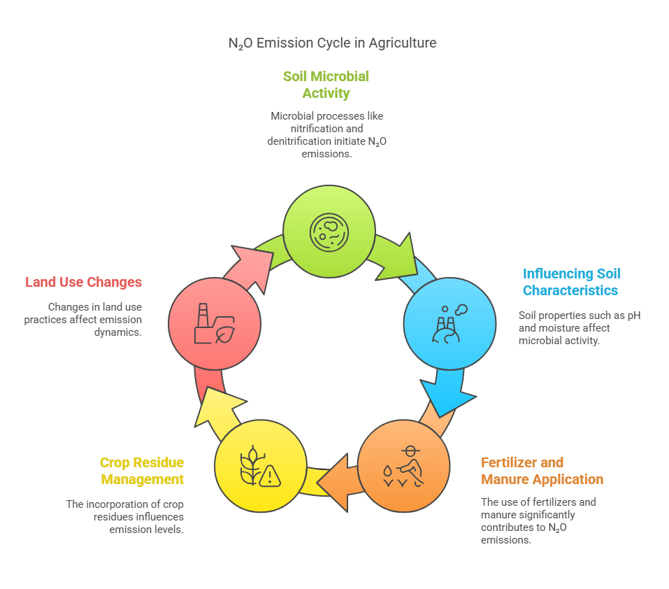

## Figure 1: Factors responsible and the underlying mechanisms for N₂O emissions from agricultural land

1. **KEY DRIVERS OF RISING AGRICULTURAL N₂O EMISSIONS**

TheN2O emissions from agriculture is mainly due to the use of nitrogenous fertilizers and its emission is affected by several interrelated factors such as different agricultural practices, land management, and changing climatic conditions etc. (Figure 2). Hence to effectively mitigate the emissions it is essential to understand the driving mechanism which leads to the emissions.

1. **Intensification of Agricultural Practices: -**

A major factor in the increase in N2O emissions has been agricultural intensification, including increased fertilizer application, soil moisture, temperature, and nitrogen content [16], [17]. Seasons and crops have a significant impact on emissions, with grasslands frequently generating more emissions than cereals [16].

1. **Climate Change and Soil Conditions: -**

Agricultural N₂O emissions are affected by various factors of soil such as moisture conditions playing a crucial role, temperature, and nitrate levels [18]. Both NO and N2O emissions are significantly increased by nitrogen application rates, with higher emissions occurring in soils with higher levels of organic carbon [19]. Coarse-textured soils with good drainage encourage NO emissions, whereas fine-textured soils with poor drainage and slightly acidic conditions promote N₂O emissions [19]. Iron has been recognized as a frequently overlooked contributor to N₂O production, surpassing other soil properties in explaining emissions under specific conditions [7]. Emission factors range from 0.4% to 6.5% of applied nitrogen, with variations seen among crop varieties, and they change significantly between sites and years [18]. These factors should be considered while developing emission models and inventories.

1. **Land Management and Irrigation Effects: -**

Research shows that irrigation control has a major effect on N2O emissions from agriculture. The timing and intensity of irrigation have a significant impact on N2O fluxes [20] and more water application typically results in greater emissions [20], [21]. However, when compared to traditional ways, deficit irrigation and low-volume techniques such as drip irrigation and zero tillage system can successfully minimize N₂O emissions [22], [23]. Large-scale shifts towards water-efficient irrigation practices can lead to significant reductions in regional N2O emissions [23].

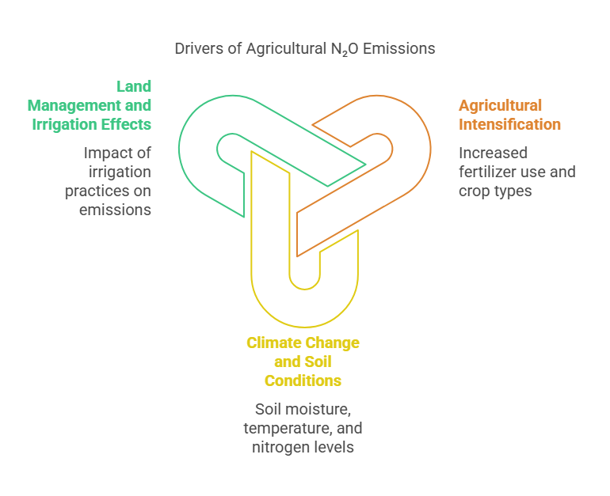

**Figure 2: Agricultural practices, land management factors, and changing climatic conditions affecting soil chemistry resulting in elevated N2O emissions**

1. **ENVIRONMENTAL AND CLIMATIC IMPACTS OF N₂O EMISSIONS**
2. **Contribution to Global Warming Potential and Ozone Depletion: -**

N₂O is a powerful greenhouse gas with a global warming potential 273 times greater than CO₂, playing a major role in climate change and ozone layer depletion [24], [25]. As the primary ozone-depleting agent of the 21st century, it has become a serious threat to ozone layer [26]. Stratospheric cooling and changes in air circulation, which reduce NOx output from N2O, have an impact on how successful N2O will be in destroying ozone [27]. Furthermore, the quantification of N2O’s effects on ozone is complicated by interacting with other gases, such as CO2, CH4, and halo carbons [28]. Both radiative and chemical variables in the higher stratosphere influence how N2O affects ozone, emphasizing the necessity of complete emission reduction methods [27]. However, efforts to reduce N2O emissions are severely hampered by climatic criticism. Climate has a significant impact on these emissions, with wet and hotter climates increasing the production of N2O [25].

1. **Soil Health and Ecosystem Implications: -**

Air quality, human health, and climate change are all greatly impacted by N₂O emissions from agricultural soils [29]. The nitrogen cycle has been accelerated by anthropogenic activity, which has affected soil health and carbon sequestration and raised N2O emissions [30]. Soil N₂O emissions are significantly influenced by the diversity and abundance of nosZ genes, which encode N₂O reductase. Soil N₂O emissions are also influenced by non-prokaryotic sources, including chemo-denitrification and fungal denitrification [31].

1. **POLICY AND GLOBAL INITIATIVES TO ADDRESS N₂O EMISSIONS**

In order to achieve long-term reductions in N2O emission, an integrated approach of scientific innovation, advanced mitigation technologies, and adaptive policy frameworks with stakeholder engagement needs to be adopted. Global initiatives and policies have been framed in several countries to emphasize sustainable agricultural practices while reducing N2O emissions from agriculture. For example, the Paris Agreement, signed in 2016, aims to reduce GHG emissions from agriculture through financial and technological support, carbon market mechanisms, and international research collaboration, etc. Additionally, several countries have been advocating certain agricultural practices that enhance nitrogen use efficiencies and incorporating N2O reduction targets into their Nationally Determined Contributions. The Intergovernmental Panel on Climate Change (IPCC) plays a crucial role in the estimation of GHG emissions and national inventory preparation. It provides standardized methodologies and guidelines to be adopted by countries for emission calculation thus ensuring consistency and accuracy in estimation [32]. It also provides refined and updated methodologies as per scientific advancements hence reducing uncertainty and improving the accuracy of inventories [33]. The Tier I methodology of IPCC is based on empirical methods while the updated Tier II and Tier III methodologies are based on climatic and land use impacts and hence provide more specific emission estimates [34]. The reduction of N2O emissions is also linked with various SDGs accomplishments. For example, reduction in N2O emission enhances human health, positively contributes to better ecosystem services, and helps combat climate change. Therefore, this indicates that it is essential to focus on both economic as well as socio-economic balance while achieving N2O emission reduction. Gu et al.[35]suggested that implementing cost-effective nitrogen control could reduce 72% of the financial burden. Government support mechanisms, incentives, and direct investments further encourage the adoption of sustainable practices, organic farming, etc. [36], [37].

1. **MITIGATION STRATEGIES FOR REDUCING N₂O EMISSIONS**

Davidsion and Kanter [38]reported **t**hat agriculture contributes 66% of the total N2O emission from anthropogenic activities. Keeping in mind the possible negative effects of climate change, mitigation of N2O emission is crucial. In regard to mitigation strategies, there are several strategies and novel technologies are identified and tested. Some of the climate-smart agricultural practices that can reduce N2O emissions are discussed below:

(A) Integrated use of nitrification and denitrification inhibitors such as 3,4-dimethyl pyrazole phosphate, controlled release fertilizers, and specific microbial consortium [39] with conventional nitrogen fertilizer application are reported to be effective in reducing N2O emissions. For example**,** Xue et al.[40]reported that nitrification inhibitors can substantially reduce N2O emissions up to 60% while reducing reactive nitrogen compounds (HONO and NO) by 90%. Similarly, Lam et al.[41]reported 8-57% reduced emissions with such nitrification inhibitors due to improved nitrogen use efficiency (NUE). However, they noticed that there has been an increased trend of ammonia volatilization (3-65%), thus raising doubt on the benefits of increased NUE. Effectiveness of such inhibitors depends upon various factors such as application techniques, climate, and land use. Therefore, to ensure the economic and ecological benefits of such strategies, a careful analysis must be performed before advocating to general masses [42].

(B) Optimum application of fertilizer by following 4R approach which is right source, rate, time, and placement which reduces N₂O emissions by optimizing NUE [43]. Since,the key source of N₂O emissions are urea based fertilizers in agriculture [11], Hassan et al.[44]suggested that by application of amendments such as biochar and slow-release fertilizer with nitrification inhibitors can reduce N₂O emissions up to 80% and 50% respectively The application of such amendments does not compromise with the crop yield simultaneously the use of biochar can also aid in carbon sequestration. The carbon loss of biochar over 60 days range between 0.8 to 9.4%, its stability is found to be higher than feedstock materials [45]. Its effectiveness depends on factors such as feedstock properties, soil, climatic conditions, and application rates [46], [47].

(C) Adoption of Climate-Smart Agricultural Practices like implementing Climate-Smart Agricultural Practices such as using organic fertilizer and reducing tillage may have different impacts on N2O emissions [48]. Future mitigation measures could benefit from biological approaches such microbial inoculation with arbuscular mycorrhizal fungus [11].

**CONCLUSION**

Agriculture is a significant contributor of nitrous oxide (N₂O) emissions thus influences climate change, soil health, and sustainable food production to a certain extent. Due to increasing temperature, intensive cultivation, and rigorous use of nitrogenous fertilizers the problem of N₂O emissions have aggravated leading to depletion of the ozone layer and global warming. To address this challenge, an integrated approach of scientific innovation, policy frameworks, and sustainable agricultural practices needs to be incorporated.

Several mitigation strategies for reducing N₂O emissions such as the use of nitrification and denitrification inhibitors, biochar amendments, precision fertilization (4R approach), and climate-smart agricultural techniques were found excellent. These strategies are competent in reducing emissions without compromising with crop productivity. Furthermore, agreements and global initiatives such as the Paris Agreement and IPCC guidelines, are crucial to keep a check on emissions, policy formulations, and plan and promote emission reduction strategies at the national and international levels. In this context, research must continue to refine emission models, develop cost-effective mitigation technologies, and enhance NUE in agricultural systems. By integrating scientific advancements with policy and stakeholder engagement, the agricultural sector can significantly contribute to global efforts in mitigating N₂O emissions, ensuring both environmental sustainability and food security. While the focus on N2O emissions is critical for climate mitigation, it is also essential to consider the broader context of greenhouse gas emissions and their interrelated effects on global warming and environmental health.

**REFERENCES**

[1] X. Huang, “The Impact of Nitrous Oxide Produced by Agricultural Products on Global Warming,” *HSET*, vol. 99, pp. 161–165, Jun. 2024, doi: 10.54097/jqj0jh52.

[2] C. Kiemle, C. Fruck, and A. Fix, “Nitrous Oxide, N2O: Spectroscopic Investigations for Future Lidar Applications.” Accessed: Feb. 17, 2025. [Online]. Available: https://meetingorganizer.copernicus.org/EGU23/EGU23-7065.html

[3] P. A. Barker, G. Allen, M. Flynn, S. Riddick, and J. R. Pitt, “Measurement of recreational N2O emissions from an urban environment in Manchester, UK,” *Urban Climate*, vol. 46, p. 101282, Dec. 2022, doi: 10.1016/j.uclim.2022.101282.

[4] H. Tian *et al.*, “Global nitrous oxide budget (1980–2020),” *Earth Syst. Sci. Data*, vol. 16, no. 6, Art. no. 6, Jun. 2024, doi: 10.5194/essd-16-2543-2024.

[5] D. Hui, A. Ray, L. Kasrija, and J. Christian, “Impacts of Climate Change and Agricultural Practices on Nitrogen Processes, Genes, and Soil Nitrous Oxide Emissions: A Quantitative Review of Meta-Analyses,” *Agriculture*, vol. 14, no. 2, p. 240, Feb. 2024, doi: 10.3390/agriculture14020240.

[6] D. Signor and C. E. P. Cerri, “Nitrous oxide emissions in agricultural soils: a review,” *Pesqui. Agropecu. Trop.*, vol. 43, no. 3, pp. 322–338, Sep. 2013, doi: 10.1590/S1983-40632013000300014.

[7] X. Zhu, L. C. R. Silva, T. A. Doane, and W. R. Horwath, “Iron: The Forgotten Driver of Nitrous Oxide Production in Agricultural Soil,” *PLoS ONE*, vol. 8, no. 3, p. e60146, Mar. 2013, doi: 10.1371/journal.pone.0060146.

[8] M. J. Torres *et al.*, “Nitrous Oxide Metabolism in Nitrate-Reducing Bacteria,” in *Advances in Microbial Physiology*, vol. 68, Elsevier, 2016, pp. 353–432. doi: 10.1016/bs.ampbs.2016.02.007.

[9] S. O. Petersen, “Nitrous Oxide Emissions from Manure and Inorganic Fertilizers Applied to Spring Barley,” *J of Env Quality*, vol. 28, no. 5, pp. 1610–1618, Sep. 1999, doi: 10.2134/jeq1999.00472425002800050027x.

[10] J. Sarkodie‐Addo, H. C. Lee, and E. M. Baggs, “Nitrous oxide emissions after application of inorganic fertilizer and incorporation of green manure residues,” *Soil Use and Management*, vol. 19, no. 4, pp. 331–339, Dec. 2003, doi: 10.1111/j.1475-2743.2003.tb00323.x.

[11] Y. Zhang, W. Wang, and H. Yao, “Urea-based nitrogen fertilization in agriculture: a key source of N2 O emissions and recent development in mitigating strategies,” *Archives of Agronomy and Soil Science*, vol. 69, no. 5, pp. 663–678, Apr. 2023, doi: 10.1080/03650340.2022.2025588.

[12] E. M. Baggs, R. M. Rees, K. A. Smith, and A. J. A. Vinten, “Nitrous oxide emission from soils after incorporating crop residues,” *Soil Use and Management*, vol. 16, no. 2, pp. 82–87, Jun. 2000, doi: 10.1111/j.1475-2743.2000.tb00179.x.

[13] G. Lashermes *et al.*, “N2O emissions from decomposing crop residues are strongly linked to their initial soluble fraction and early C mineralization,” *Science of The Total Environment*, vol. 806, p. 150883, Feb. 2022, doi: 10.1016/j.scitotenv.2021.150883.

[14] P. V. F. Machado, R. E. Farrell, W. Deen, R. P. Voroney, K. A. Congreves, and C. Wagner-Riddle, “Contribution of crop residue, soil, and fertilizer nitrogen to nitrous oxide emissions varies with long-term crop rotation and tillage,” *Science of The Total Environment*, vol. 767, p. 145107, May 2021, doi: 10.1016/j.scitotenv.2021.145107.

[15] H. Chen, X. Li, F. Hu, and W. Shi, “Soil nitrous oxide emissions following crop residue addition: a meta‐analysis,” *Global Change Biology*, vol. 19, no. 10, pp. 2956–2964, Oct. 2013, doi: 10.1111/gcb.12274.

[16] K. E. Dobbie, I. P. McTaggart, and K. A. Smith, “Nitrous oxide emissions from intensive agricultural systems: Variations between crops and seasons, key driving variables, and mean emission factors,” *J. Geophys. Res.*, vol. 104, no. D21, pp. 26891–26899, Nov. 1999, doi: 10.1029/1999JD900378.

[17] M. Zaman *et al.*, “Emissions of Nitrous Oxide (N2O) and Di-Nitrogen (N2) from the Agricultural Landscapes, Sources, Sinks, and Factors Affecting N2O and N2 Ratios,” in *Greenhouse Gases - Emission, Measurement and Management*, G. Liu, Ed., InTech, 2012. doi: 10.5772/32781.

[18] K. E. Dobbie and K. A. Smith, “Nitrous oxide emission factors for agricultural soils in Great Britain: the impact of soil water‐filled pore space and other controlling variables,” *Global Change Biology*, vol. 9, no. 2, pp. 204–218, Feb. 2003, doi: 10.1046/j.1365-2486.2003.00563.x.

[19] A. F. Bouwman, L. J. M. Boumans, and N. H. Batjes, “Emissions of N2 O and NO from fertilized fields: Summary of available measurement data,” *Global Biogeochemical Cycles*, vol. 16, no. 4, Dec. 2002, doi: 10.1029/2001GB001811.

[20] L. Ottaiano, I. Di Mola, P. Di Tommasi, M. Mori, V. Magliulo, and L. Vitale, “Effects of Irrigation on N2O Emissions in a Maize Crop Grown on Different Soil Types in Two Contrasting Seasons,” *Agriculture*, vol. 10, no. 12, p. 623, Dec. 2020, doi: 10.3390/agriculture10120623.

[21] C. Scheer, P. R. Grace, D. W. Rowlings, and J. Payero, “Nitrous oxide emissions from irrigated wheat in Australia: impact of irrigation management,” *Plant Soil*, vol. 359, no. 1–2, pp. 351–362, Oct. 2012, doi: 10.1007/s11104-012-1197-4.

[22] R. M. Carbonell-Bojollo, Ó. Veroz-González, E. J. González-Sánchez, R. Ordóñez-Fernández, M. Moreno-García, and M. A. Repullo-Ruibérriz De Torres, “Soil Management, Irrigation and Fertilisation Strategies for N2O Emissions Mitigation in Mediterranean Agricultural Systems,” *Agronomy*, vol. 12, no. 6, p. 1349, Jun. 2022, doi: 10.3390/agronomy12061349.

[23] J. Deng *et al.*, “Changes in Irrigation Practices Likely Mitigate Nitrous Oxide Emissions From California Cropland,” *Global Biogeochemical Cycles*, vol. 32, no. 10, pp. 1514–1527, Oct. 2018, doi: 10.1029/2018GB005961.

[24] S. J. Del Grosso, T. Wirth, S. M. Ogle, and W. J. Parton, “Estimating Agricultural Nitrous Oxide Emissions,” *EoS Transactions*, vol. 89, no. 51, pp. 529–529, Dec. 2008, doi: 10.1029/2008EO510001.

[25] T. J. Griffis *et al.*, “Nitrous oxide emissions are enhanced in a warmer and wetter world,” *Proc. Natl. Acad. Sci. U.S.A.*, vol. 114, no. 45, pp. 12081–12085, Nov. 2017, doi: 10.1073/pnas.1704552114.

[26] A. R. Ravishankara, J. S. Daniel, and R. W. Portmann, “Nitrous Oxide (N2 O): The Dominant Ozone-Depleting Substance Emitted in the 21st Century,” *Science*, vol. 326, no. 5949, pp. 123–125, Oct. 2009, doi: 10.1126/science.1176985.

[27] L. E. Revell *et al.*, “The effectiveness of N2 O in depleting stratospheric ozone,” *Geophysical Research Letters*, vol. 39, no. 15, p. 2012GL052143, Aug. 2012, doi: 10.1029/2012GL052143.

[28] R. W. Portmann, J. S. Daniel, and A. R. Ravishankara, “Stratospheric ozone depletion due to nitrous oxide: influences of other gases,” *Phil. Trans. R. Soc. B*, vol. 367, no. 1593, pp. 1256–1264, May 2012, doi: 10.1098/rstb.2011.0377.

[29] L. Luo, L. Ran, Q. Z. Rasool, and D. S. Cohan, “Integrated Modeling of U.S. Agricultural Soil Emissions of Reactive Nitrogen and Associated Impacts on Air Pollution, Health, and Climate,” *Environ. Sci. Technol.*, vol. 56, no. 13, pp. 9265–9276, Jul. 2022, doi: 10.1021/acs.est.1c08660.

[30] Bijay-Singh, “The Nitrogen Cycle: Implications for Management, Soil Health, and Climate Change,” in *Soil Health and Climate Change*, vol. 29, B. P. Singh, A. L. Cowie, and K. Y. Chan, Eds., in Soil Biology, vol. 29. , Berlin, Heidelberg: Springer Berlin Heidelberg, 2011, pp. 107–129. doi: 10.1007/978-3-642-20256-8_6.

[31] S. Yoon, B. Song, R. L. Phillips, J. Chang, and M. J. Song, “Ecological and physiological implications of nitrogen oxide reduction pathways on greenhouse gas emissions in agroecosystems,” *FEMS Microbiology Ecology*, vol. 95, no. 6, p. fiz066, Jun. 2019, doi: 10.1093/femsec/fiz066.

[32] S. Zhu, B. Cai, S. Fang, J. Zhu, and Q. Gao, “The Development and Influence of IPCC Guidelines for National Greenhouse Gas Inventories,” in *Annual Report on Actions to Address Climate Change (2019)*, G. Zhuang, Q. Chao, G. Hu, and J. Pan, Eds., in Research Series on the Chinese Dream and China’s Development Path. , Singapore: Springer Nature Singapore, 2023, pp. 233–246. doi: 10.1007/978-981-19-7738-1_16.

[33] K. Hergoualc’h, N. Mueller, M. Bernoux, Ä. Kasimir, T. J. Van Der Weerden, and S. M. Ogle, “Improved accuracy and reduced uncertainty in greenhouse gas inventories by refining the IPCC emission factor for direct N2 O emissions from nitrogen inputs to managed soils,” *Global Change Biology*, vol. 27, no. 24, Art. no. 24, Dec. 2021, doi: 10.1111/gcb.15884.

[34] O. Obi-Njoku *et al.*, “A comparison of Tier 1, 2, and 3 methods for quantifying nitrous oxide emissions from soils amended with biosolids,” *Science of The Total Environment*, vol. 915, p. 169639, Mar. 2024, doi: 10.1016/j.scitotenv.2023.169639.

[35] B. Gu *et al.*, “Halving nitrogen waste for global sustainable development goals,” Dec. 05, 2023, *In Review*. doi: 10.21203/rs.3.rs-3522193/v1.

[36] M. W. Barbosa, “Government Support Mechanisms for Sustainable Agriculture: A Systematic Literature Review and Future Research Agenda,” *Sustainability*, vol. 16, no. 5, Art. no. 5, Mar. 2024, doi: 10.3390/su16052185.

[37] L. Tou, J. Wang, and M. Chu, “From intention to action: Enabling sustainable agriculture in emerging economies through decentralized regulations for manure management,” *Public Admin & Development*, vol. 44, no. 5, Art. no. 5, Dec. 2024, doi: 10.1002/pad.2066.

[38] E. A. Davidson and D. Kanter, “Inventories and scenarios of nitrous oxide emissions,” *Environ. Res. Lett.*, vol. 9, no. 10, p. 105012, Oct. 2014, doi: 10.1088/1748-9326/9/10/105012.

[39] X. Wang *et al.*, “Using adaptive and aggressive N2O-reducing bacteria to augment digestate fertilizer for mitigating N2O emissions from agricultural soils,” *Science of The Total Environment*, vol. 903, p. 166284, Dec. 2023, doi: 10.1016/j.scitotenv.2023.166284.

[40] C. Xue *et al.*, “Reducing Soil-Emitted Nitrous Acid as a Feasible Strategy for Tackling Ozone Pollution,” *Environ. Sci. Technol.*, vol. 58, no. 21, Art. no. 21, May 2024, doi: 10.1021/acs.est.4c01070.

[41] S. K. Lam, H. Suter, A. R. Mosier, and D. Chen, “Using nitrification inhibitors to mitigate agricultural N2 O emission: a double‐edged sword?,” *Global Change Biology*, vol. 23, no. 2, pp. 485–489, Feb. 2017, doi: 10.1111/gcb.13338.

[42] Y. Uchida and I. Von Rein, “Mitigation of Nitrous Oxide Emissions during Nitrification and Denitrification Processes in Agricultural Soils Using Enhanced Efficiency Fertilizers,” in *Soil Contamination and Alternatives for Sustainable Development*, D. Vázquez-Luna and M. Del Carmen Cuevas-Díaz, Eds., IntechOpen, 2019. doi: 10.5772/intechopen.81548.

[43] R. T. Venterea, J. A. Coulter, and M. S. Dolan, “Evaluation of Intensive ‘4R’ Strategies for Decreasing Nitrous Oxide Emissions and Nitrogen Surplus in Rainfed Corn,” *J of Env Quality*, vol. 45, no. 4, pp. 1186–1195, Jul. 2016, doi: 10.2134/jeq2016.01.0024.

[44] M. U. Hassan *et al.*, “Management Strategies to Mitigate N2O Emissions in Agriculture,” *Life*, vol. 12, no. 3, p. 439, Mar. 2022, doi: 10.3390/life12030439.

[45] P. Grutzmacher, A. P. Puga, M. P. S. Bibar, A. R. Coscione, A. P. Packer, and C. A. De Andrade, “Carbon stability and mitigation of fertilizer induced N2O emissions in soil amended with biochar,” *Science of The Total Environment*, vol. 625, pp. 1459–1466, Jun. 2018, doi: 10.1016/j.scitotenv.2017.12.196.

[46] H. Azad, J. I. A. Bhat, and S. A. Shameem, “Potential of Biochar to Sequester Carbon and Mitigate Greenhouse Gas Emissions,” *CJAST*, vol. 42, no. 4, pp. 24–31, Mar. 2023, doi: 10.9734/cjast/2023/v42i44064.

[47] E. Valkama, D. Tzemi, U. R. Esparza‐Robles, A. Syp, A. O’Toole, and P. Maenhout, “Effectiveness of soil management strategies for mitigation of N2 O emissions in European arable land: A meta‐analysis,” *European J Soil Science*, vol. 75, no. 3, p. e13488, May 2024, doi: 10.1111/ejss.13488.

[48] D. Grados *et al.*, “Synthesizing the evidence of nitrous oxide mitigation practices in agroecosystems,” *Environ. Res. Lett.*, vol. 17, no. 11, p. 114024, Nov. 2022, doi: 10.1088/1748-9326/ac9b50.