**Effect of isovalent ion (Co2+) substitution on Structural Properties of ZnFe2O4**

**Gulab Singh1, Avinash Chand Yadav2, Pravin kumar3, Ajaz Hussain4, Pradip Kumar Priya4**

1Department of Physics, Feroze Gandhi College, Raebareli -229001, UP, India

2Department of Physics S G N Government P G College Muhammadabad Gohana Mau-276403 UP, India

3College of Technology, Sardar Vallabhbhai Patel University of Agriculture and technology Meerut -250110 (U.P) India

4Department of Physics, Ewing Christian College, Prayagraj -211002, India

**Abstract**

This research work describes the synthesis process of cobalt substituted zinc ferrite (Co-doped ZnFe2O4) nano-composite systems via Solution-Gelation method which undergoes the process with self ignition employed by auto-combustion using nitrate precursors. The prepared material samples were characterized by X-ray diffraction (XRD) technique for structural properties. Further Match3! and VESTA software were employed for the observations of structural properties of the synthesized nanomaterials Co-doped ZnFe2O4.

**Keywords:** Zinc ferrite, Nano-composites materials, X-ray diffraction.

1. **Introduction**

In general, ferrite is a ceramic class material that includes iron oxide as a core ingredient and metallic element such as Mn, Co, Ni, Mg, and Zn in small scale [1-3]. It has been investigated that the properties of the bulk materials get changed when their dimensions reduce. These significant changes are caused to an increase in surface area to volume ratio. The similar reports have been considered for the case of magnetic materials also. In recent years due to vital applications and effectiveness of spinel ferrites structure like memory storage, high frequency power supply, biomedicines a number of approaches has been found to synthesis and investigate for their functional utilization in information storage systems, actuators, sensors, magnetic fluid, microwave absorbers and medical diagnostics. Therefore, attention has been focused on the sample preparation and characterization of spinel ferrites [4, 5]. The spinel structure is abbreviated in form of AB2O4, where A and B are tetrahedral and octahedral interstitial sites respectively. AB2O4 structure possess a larger unit cell which consists of 8 small unit cells having face centered cubic structure with tetrahedral(A) site and octahedral(B) site in each. There are 64 A sites and 32 B sites in total and 32 oxygen atoms build a unit cell of closed packed structure [6]. In spinel ferrite systems, A is represented by divalent metal ions like Mn2+,Co2+,Ni2+, Mg2+,Cd2+ etc. and that of B by Fe3+ ions. In Mn-Zn ferrites Zn2+ ions located on A sites while Mn2+ and Fe3+ ions could be positioned on B sites. Mainly, zinc ferrite adopts the simple spinel group possessing no net magnetic moment by its unit cell due to d0[Zn2+] and d5,d5[Fe3+,Fe3+] while on the other hand manganese ferrite attributes to inverse spinel group that is composed of two magnetic sub lattices are antiferromagnetically aligned[7].

1. **Experimental section**

**2.1. Material synthesis process**

A series of the system MnxZn(1–x)Fe2O4(for x=0.0, 0.1, 0.2, 0.3) was synthesized via Solution-Gelation process employed by auto combustion route using nitrate precursors. Metal nitrates were utilized as starting chemical regents, Ferric nitrate Nona hydrate [FeN3O9.9H2O] 98+% (metals basis) crystalline from Alfa Aesar, Zinc nitrate hexahydrate [Zn(NO3)2.6H2O] 99% (metals basis) crystalline from Alfa Aesar, Manganese(II) nitrate tetra hydrate [Co(NO3)2.4H2O]98% (Alfa Aesar, metals basis) crystalline from and citric acid Anhydrous[C6H8O7.H2O] 99.8% Fizmerk India, for the synthesis of Co-Zn ferrite nanomaterial. The Mn-Zn ferrites nano particles were synthesized by Solution-Gelation techniques utilized by auto combustion. In this route, a mixture of [Fe(NO3)3.9H2O], Mn(NO3)2.6H2O, Zn(NO3)2.6H2O salts were dissolved in 100 ml de-ionized water for distinct composition and 6.3042 gm of citric acid was added as a fuel to manage the ratio of the fuel to the oxidizer *ϕ* = 1.35[8]. The mix solution was stirred in beaker on hot plate for two hours at 80 0C to get a homogeneous solution. The pH was maintained up to 7 by adding drop wise the ammonia solution (NH4OH). Further the temperature of the hot plate was increased to 235-240 °C and prepared solution was gradually evaporated and gel form could be obtained. Later this gel was auto ignited and converted into ash powder. After cooling at normal temperature, the ash formed was ground using agate mortar and pestle to obtain homogeneous mixing of powder sample. The powder was calcined in furnace at 600 °C for 4 hours.

**2.2 Characterizations**

The X-ray diffraction patterns of system MnxZn(1–x)Fe2O4 (for x=0.0, 0.1, 0.2, 0.3) were recorded at room temperature employing Miniflex II, Rigaku, Japan with Cu-Kα radiation (λ≈1.5406 Å , 20° ≤ 2θ ≤ 80° and step size of Δ2θ=0.02˚) and Ni filter at a scanning rate of 2°C/min. Further all these structures were optimized using crystallography open database and Material Project**.** VESTA software (OpenGL version: 3.3.0, Tsukuba, Japan) was utilized for simulation studies**.** Additionally, Match3! Software was used for theoretical studies of the polycrystalline composite structure**.**

**3. Results and Discussion**

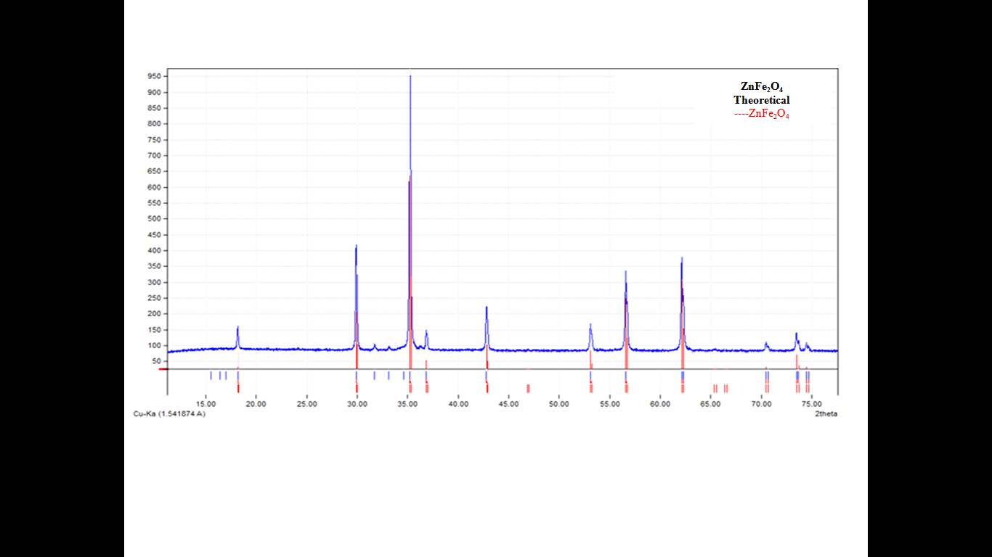

Figure 1. Theoretical XRD pattern of ZnFe2O4

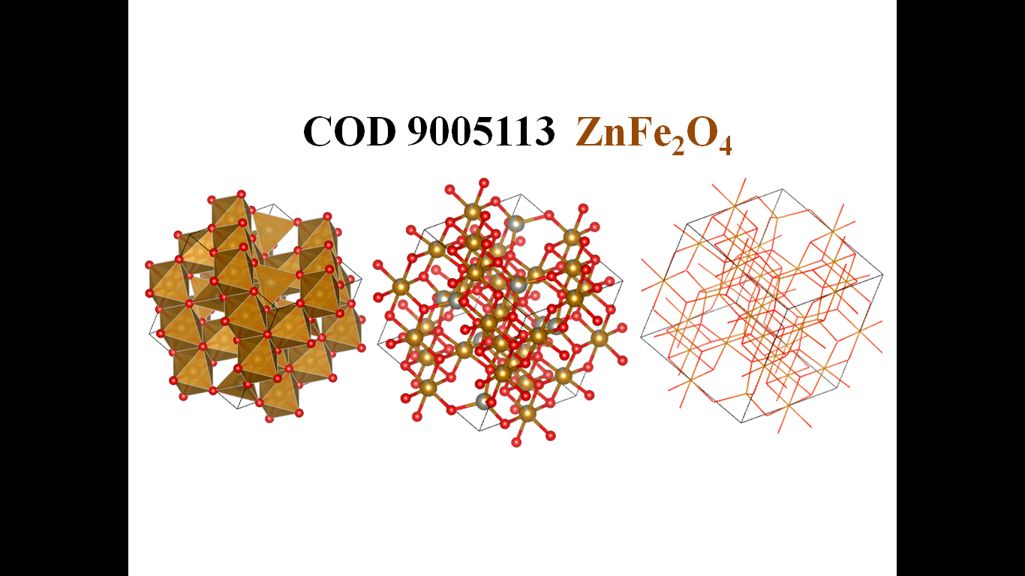

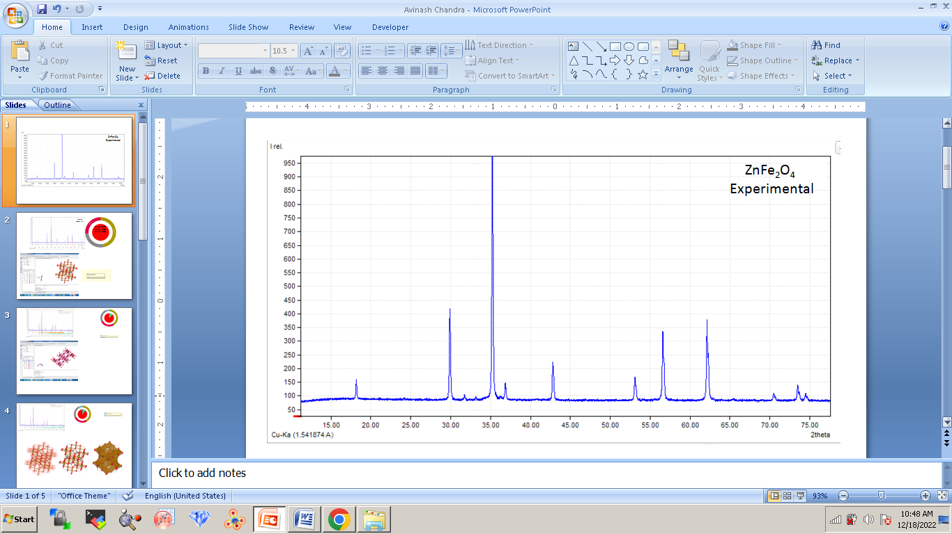

Figure 2. Experimental XRD pattern of ZnFe2O4

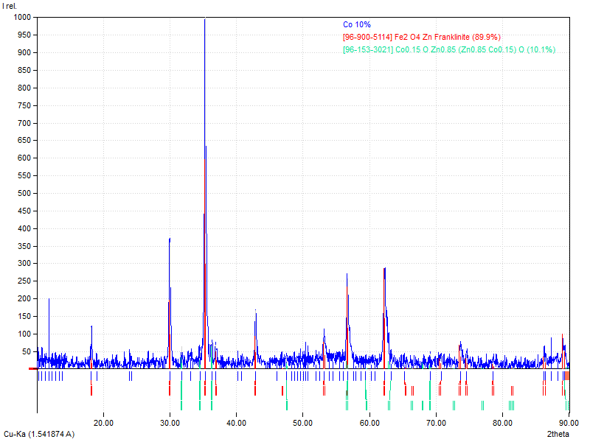

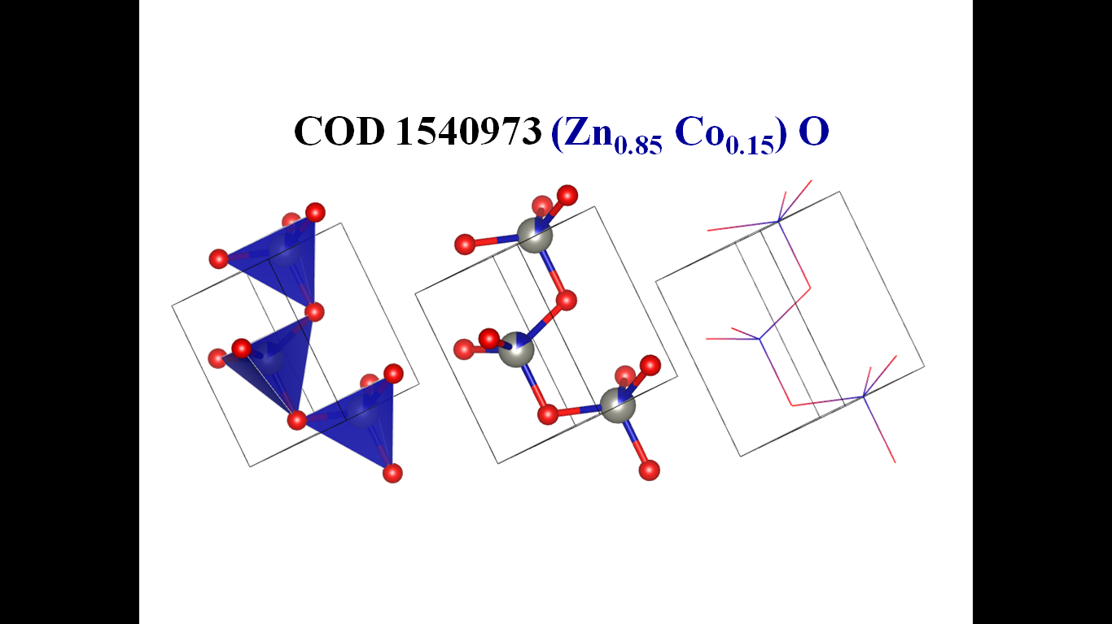

Figure3. Theoretical XRD pattern of 10% Cobalt in ZnFe2O4

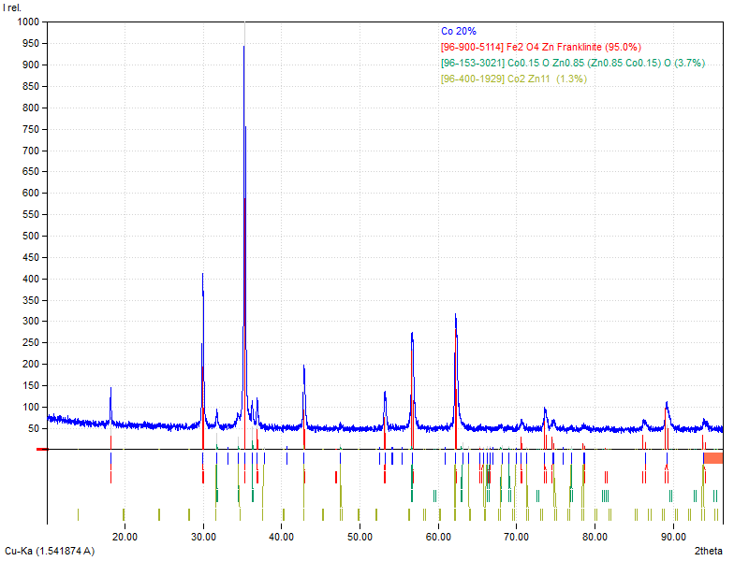

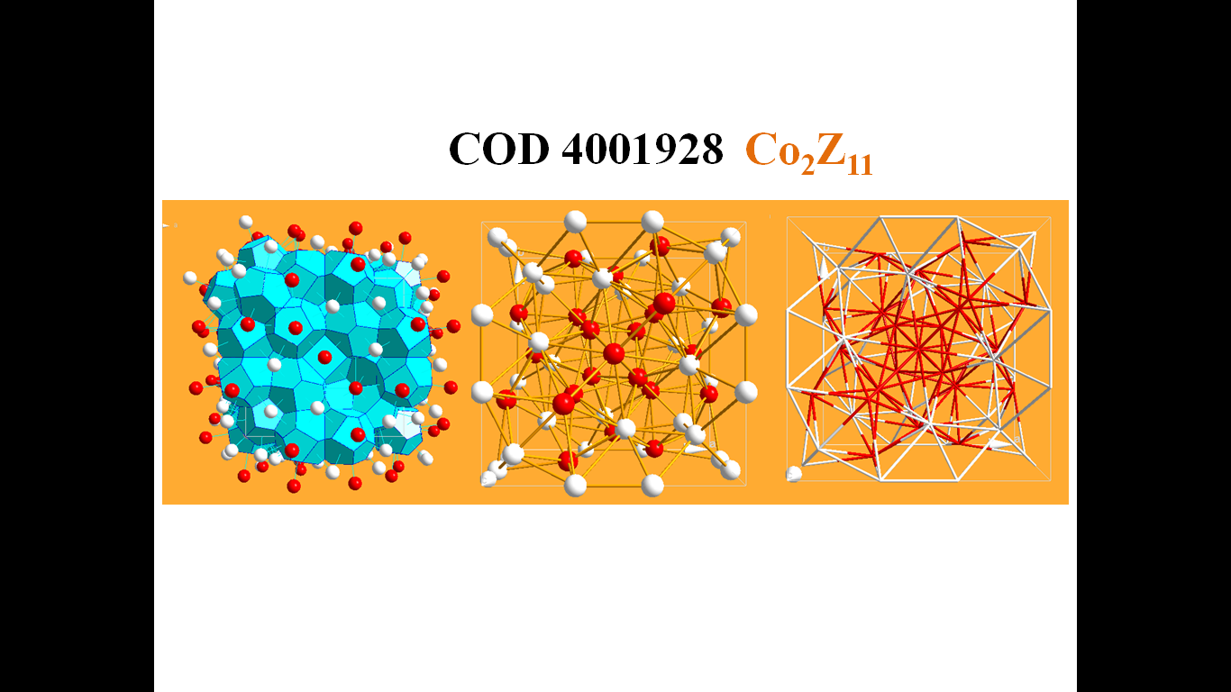

Figure4. Theoretical XRD pattern of 20% Cobalt in ZnFe2O4

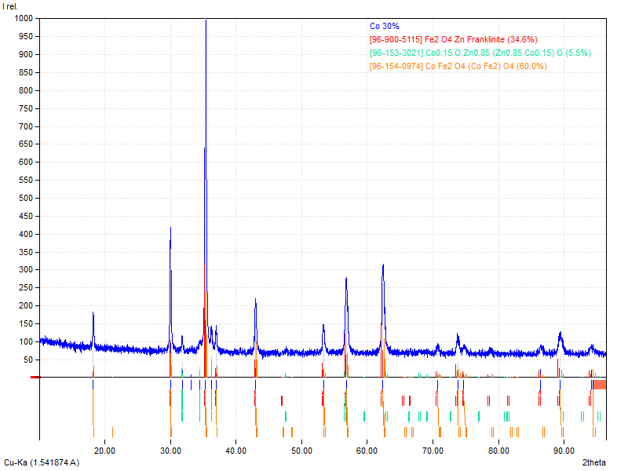

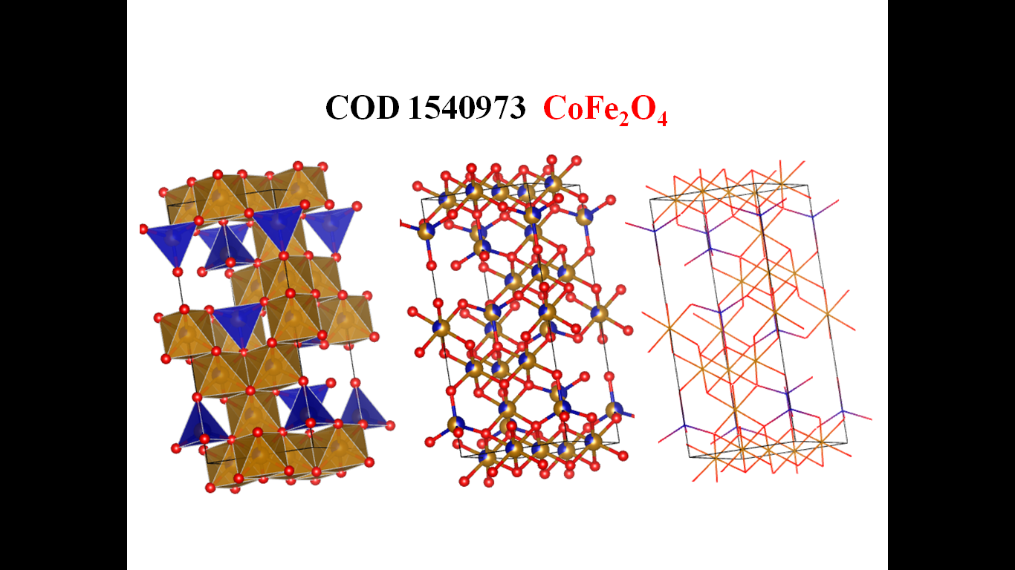

Figure5. Theoretical XRD pattern of 30% Cobalt in ZnFe2O4

Theoretical simulation of ZnFe2O4 exhibited cubic system zinc ferrite ZnFe2O4 (COD - 900511), with lattice type F, space groupFd-3m with space group number 227 and setting number two. Inside the unit cell of ZnFe2O4, a=b=c= 8.4420 Å, and α=β=γ= 90°. The unit cell volume of the system ZnFe2O4 was calculated ⁓601.660396 $Å^{3}$. The experimental XRD pattern was perfectly in agreement with simulation pattern of the composite which further confirmed the single phase formation of base materials ZnFe2O4. VESTA (Open GL version: 3.3.0, Tsukuba, Japan), Material Project, and Endeavor software were utilized for polyhedral, ball-stick and wireframe representation of different phases obtained in simulation studies[9]. All theoretical structures were optimized using crystallography open database[10]. Furthermore, thorough investigations of the polycrystalline composite systems were performed by utilizing experimental XRD diffraction pattern and Match3! Software [9-13].

Theoretical simulation of base materials (ZnFe2O4) exhibited cubic system zinc ferrite ZnFe2O4 (COD - 900513), with lattice type F, space group *Fd-3m* with space group number 227 and setting number two. For the unit cell of ZnFe2O4, a = b = c = 8.44210 Å, and α = β = γ = 90°. The unit cell volume of the system ZnFe2O4 was determined to be 601.660376 Å^3. The experimental XRD diffraction pattern was perfectly in good agreement with simulation pattern of the composite which confirmed the single phase formation of base materials ZnFe2O4.

When 10% of Co was added in pure base material ZnFe2O4 then one new phase was appeared to be hexagonal Zn0.85Co0.15 as a minor phase with lattice type P, space group *P 63 m c* with space group number 186 and setting number one. Inside the unit cell of Zn0.85Co0.15, a = b = 3.25380, while c = 5.20440 Å, and α = β = 90°, with γ = 120°. The unit cell volume of the system ZnFe2O4 was found to be 601.660376Å^3.

At rising proportion of Co to be 20%, two minor phases appeared to be Zn0.85Co0.15 and Co2Zn11 respectively. The crystal Co2Zn11 emerged due to increasing percentage of Cobalt in base material ZnFe2O4. Theoretical simulation exhibited Co2Zn11, to be cubic system with lattice type I, space group *I-43 m* with space group number 217. Inside the unit cell of ZnFe2O4, a = b = c = 8.96540 Å, and α = β = γ = 90°. The unit cell volume of the system ZnFe2O4 was found to be 720.624420 Å^3.

When the entitlement of Co is further increased to be 30%, the major phase ZnFe2O4 was replaced by CoFe2O4, which indicate that Zn was probably replaced by Co for the crystal system ZnFe2O4 while other minor phase was appeared to be Zn0.85Co0.15. Additionally, theoretical simulation exhibited CoFe2O4 to be trigonal system with lattice type R, space group *R-3m*, space group number 166 with setting number one (with hexagonal axes). Inside the unit cell of CoFe2O4, a = b = 5.93660, c = 14.54300 Å, and α = β = 90°, while γ = 120°. The unit cell volume of the system ZnFe2O4 was found to be 443.874553Å^3.

Bulk ZnFe2O4 possesses a typical cubic spinel X-Y2-O4 atomic arrangement, in which oxygen anions occupy 32e Wyckoff sites and form a distorted face-centered cubic (FCC) lattice as well as large interstices between O2− are partially occupied by iron and zinc cations. One eighth of the tetrahedral positions are occupied by divalent Zn2+ cations, whereas half of the octahedral positions are engaged by trivalent Fe3+ cations, leading to the formula [Zn2+]A[Fe3+2]BO2−4[11]. Moreover, the spinel structure is relatively “open”, and various vacant crystallographic sites can ease the intercalation of dopant, which in turn can enlarge the number of applications of such material [11, 14, 15]. In the crystal system ZnFe2O4 depicts Zn and Fe is surrounded by Oxygens with potential bonding between Zn-O, Fe-O, Zn-O-Zn or Fe-O-Fe.

1. **Conclusion**

Cobalt-doped nano zinc ferrites were synthesized by the sol-gel method followed by auto-combustion. XRD, Match3! And VESTAwasusedas the characterization techniques for the structural properties of the synthesized nanoparticles. The XRD pattern reveals that the synthesized nanoparticles have a cubic spinel ferrite phase with space group *Fd3m*. The experimental XRD diffraction pattern was perfectly in agreement with simulation pattern of the composite which further confirmed the single phase formation of base materials ZnFe2O4. It was seen that some minor phases Zn0.85Co0.15 for 10% Co, Zn0.85Co0.15 and Co2Zn11 for 20% Co were found along with major phase of Zinc Ferrites. When Co is further increased to be 30%, the major phase ZnFe2O4 was replaced by CoFe2O4. These minor phases definitely will affect the Vibrational and Magnetic properties of the synthesized nanomaterials.

**Acknowledgement**

Although we have used freely available Match3! And VESTA software but authors are sincerely thankful to the developer of Match3! And VESTA software and to make it freely available for worldwide researchers.

**References:**

1. Sugimoto, M., *The Past, Present, and Future of Ferrites.* Journal of the American Ceramic Society, 1999. **82**(2): p. 269-280.

2. Song, Q. and Z.J. Zhang, *Controlled synthesis and magnetic properties of bimagnetic spinel ferrite CoFe2O4 and MnFe2O4 nanocrystals with core-shell architecture.* J Am Chem Soc, 2012. **134**(24): p. 10182-90.

3. Skołyszewska, B., et al., *Preparation and magnetic properties of MgZn and MnZn ferrites.* Physica C: Superconductivity, 2003. **387**(1-2): p. 290-294.

4. König, U., *Substitutions in manganese zinc ferrites.* Applied physics, 1974. **4**: p. 237-242.

5. Gadkari, A., T. Shinde, and P. Vasambekar, *Structural analysis of Y3+-doped Mg–Cd ferrites prepared by oxalate co-precipitation method.* Materials Chemistry and Physics, 2009. **114**(2-3): p. 505-510.

6. LAMBEBO, T.Y., *SUBSTITUTION EFFECT ON THE STRUCTURE, MORPHOLOGY, ELECTRICAL AND DIELECTRIC PROPERTIES OF.* 2018.

7. Mazen, S., N.I. Abu-Elsaad, and A.S. Nawara, *The Influence of Various Divalent Metal Ions (Mn2+, Co2+, and Cu2+) Substitution on the Structural and Magnetic Properties of Nickel–Zinc Spinel Ferrite.* Physics of the Solid State, 2020. **62**(7): p. 1183-1194.

8. Feng, J., et al., *Preparation of cobalt substituted zinc ferrite nanopowders via auto-combustion route: an investigation to their structural and magnetic properties.* Journal of Materials Science: Materials in Electronics, 2018. **29**(21): p. 18358-18371.

9. Vaitkus, A., A. Merkys, and S. Gražulis, *Validation of the crystallography open database using the crystallographic information framework.* Journal of applied crystallography, 2021. **54**(2): p. 661-672.

10. Jain, A., et al., *Commentary: The Materials Project: A materials genome approach to accelerating materials innovation.* APL Materials, 2013. **1**(1).

11. Momma, K. and F. Izumi, *VESTA 3 for three-dimensional visualization of crystal, volumetric and morphology data.* Journal of applied crystallography, 2011. **44**(6): p. 1272-1276.

12. Momma, K. and F. Izumi, *VESTA: a three-dimensional visualization system for electronic and structural analysis.* Journal of Applied crystallography, 2008. **41**(3): p. 653-658.

13. Avinashi, S.K., et al., *Morphological, mechanical, and biological evolution of pure hydroxyapatite and its composites with titanium carbide for biomedical applications.* Ceramics International, 2022. **48**(13): p. 18475-18489.

14. Bohra, M., V. Alman, and R. Arras, *Nanostructured ZnFe2O4: an exotic energy material.* Nanomaterials, 2021. **11**(5): p. 1286.

15. Bohra, M., V. Alman, and R. Arras, *Nanostructured ZnFe2O4: An Exotic Energy Material. Nanomaterials 2021, 11, 1286*. 2021, s Note: MDPI stays neu-tral with regard to jurisdictional claims in ….