CHAPTER 11. RAPID SUSCEPTIBILITY TESTING

MARGARET ORDÓÑEZ SMITH DE DANIES. MSc. PhD

Microbiologist and Bacteriologist from Los Andes University (Universidad de Los Andes), Colombia. Specialization in Microbiology and Immunology from Federal University of Rio de Janeiro, Brazil (Universidade Federal do Río de Janeiro, Brazil), Master in Microbiology from Pontificia Universidad Javeriana, Colombia. PhD in Biology from Atlantic International University of United States. Member: Emeritus of the American Society for Microbiology United States (UA) Member of: the Anaerobe Society of the Americas, UA, Clinical Laboratory Standards Institute (CLSI) of UUA, Association on for Diagnostic and Laboratory Medicine (ADLM) UA, Medicine Academy of Colombia, Bacteriology National College of Colombia, Colombian Infectious Diseases Association (ACIN), Colombia. Director of the Microbiology Institute of Colombia IMICOL since 1982.

**Introduction:**

In order to have rapid sensitivity results in Clinical Microbiology Laboratories, Microbiology Institute of Colombia IMICOL, did a research with many different samples to help physicians in their right treatment to improve patient’s health (1,2,3). The most useful result of a Clinical Microbiology Laboratory is to provide the most appropriate specific antibiotic for its treatment. In most laboratories a urine culture takes from 3 to 5 days to give the sensitivity tests, because it needs to have pure cultures to do the Antibiotic Sensitivity Tests (AST). This is a consequence in many cases a need to stay more days in the hospital and therefore, it increases the cost of their illness, plus the deterioration of their health. (4)

The new manual rapid techniques: Direct and Enrichment AST MOS. So, called MOS because they have been proposed and implemented by Margaret Ordonez Smith. These techniques are a modification of the standard disk diffusion technique described by Kirby-Bauer and Barry (5,6) and it was reconfirmed after 18 hours of incubation (7, 8, 9), as approved by CLSI (Clinical Laboratory Standards Institute) and EUCAST (European Committee on Antimicrobial Susceptibility Testing) (10, 11). These manual techniques are very useful for urgent cases, easy, economic, reliable and they don´t need special equipment’s only an incubator to put the Petri dishes in a 37°C temperature. Thefore, they can be standardized by any kind of laboratory in the world. (Figure 1).

1. **Standard Disk Diffusion Test by Kirby-Bauer**

This technique has been the golden standard disk diffusion test for many years (5). The sample needs to be a pure culture in order to be done. If the sample has two bacterias, each one should be isolated and incubation is done at 37°C. In the first day the sample is smeared in an enrichment media, example, a blood agar (BA), MacConkey (Mac) agar and/or Eosin Methylene Blue agar (EMB). In the second day, the Kirby-Bauer technique is done with the bacterium isolated in order to do the identification (ID) and AST test. To do the AST the microorganism is smeared onto an enrichment broth, such as Tryptone Soya Broth (TSB) and when the inoculum has a turbidity of the MacFarland No. 0.5 it is smeared onto a dried AST media Mueller Hinton Agar (MHA). The inoculum should streak back-and-forth motion, rotate the Petri dish three times every 60°, in order to have an even distribution of inoculum and with a confluent lawn of grown. After 18 hours of incubation the zones of inhibition are interpreted with the breakpoints tables as CLSI or EUCAST (10,11). If the sample has only one bacterium on the third day the result can be given. But, If the sample has more bacterias it can last even 5 days., the result of the AST is ready to have the interpretation of the discs (Figure 1).

**Novel Manual Techniques:**

Specific Objectives:

These techniques are a modification of Kirby-Bauer Disk Diffusion Test. They can be done with any sample and the great advantage is to have a reliable rapid result. The most important is to **know just in hours which is the reliable antibiotic for the patient’s treatment.** The principle of the AST MOS tests is for a suitable therapeutic agent to be used *in vivo*. AST discs can be used with filter paper discs impregnated with specified concentrations of antimicrobial agents placed on the surface of a suitable test medium. Direct AST MOS is done with direct samples and Enrichment AST MOS with an inoculum as MacFarland No.0.5 of the samples. Both techniques are inoculated onto the sensitivity test media and they are incubated at 37°C with AST discs. The discs diffuse into the agar in 16 to 18 hours. After incubation at human corporal temperature, the zones of inhibition around the discs are measured and compared against recognized zone diameter ranges for the specific antimicrobial agents/organisms with CLSI or EUCAST breakpoints tables. Example, if the sample has an *Escherichia coli* infection, AST test can be read in 4 to 8 hours as a preliminary test and after 16 to 18 hours the reconfirmation of the data.

Advantages of these novel techniques

The most important and relevant issue is that the AST MOS techniques can be used in any laboratory, because they are very economic, easy and rapid tests. Both Direct MOS and Enrichment MOS can be read after 4 to 8 hours of reception of the sample as Barry (6) describes it, and it can be reconfirmed after 18 hours (7,8,9). The great advantage is to have the reliable antibiotic for the patient´s treatment, in order to reduce days of hospitalization, tests and/or medicines, plus the deterioration of their health (4). Any of the AST tests: manual or automated takes at least 3 to 8 days, to give the antibiotic information. The automated system needs a pure culture and the physician has to start an empiric treatment that maybe is helpful or not. This situation can increase the bacterial resistance to antibiotics.

Samples:

In the Direct AST MOS samples must have an inoculum with a high concentration, example, in urines with a concentration of 10ᵔ8; also, it is very helpful for vaginal (12), sputum, feces (13), abscess samples, the samples are smeared directly onto the Petri dish. In the Enrichment technique AST MOS, any sample can be used, because the sample is enriched in a tryptone soya broth (TSB) or any broth until it has a concentration of 10ᵔ8 (MacFarland No.0. 5). It can be done on eye or wound secretions, semen.

Materials required:

Petri dishes with special media to do the AST, such as Mueller Hinton Agar, ISO Sensitivity Agar, Diagnostic Sensitivity Test Agar can be used. An inoculum suspension with pure culture of the samples, sterile loops, swabs, sterile forceps, McFarland turbidity No.0.5 tube, incubator at 37°C, modified atmosphere environments. For quality control of the discs must be used strains with ATCC (American Type Culture Collection) or NCTC (National Collection of Type Culture), millimeter (mm) measuring ruler to read the zone sizes and interpretative criteria by Kirby-Bauer method of susceptibility testing with CLSI or EUCAST breakpoint tables.

Storage and Handling:

AST discs must be stored at -20°C to 8°C until required. Allow to reach room temperature when they are going to be used. Once opened, the discs should be stored within a dispenser in a container with desiccant to protect the discs from moisture. And the media in a refrigerator at approximately 8°C and the Petri dish should have 4 mm deep, usually each dish has 25 mL of media.

Statistical studies:

These novel techniques were compared with other laboratories and automated equipment. Giving a p>0.09 for Direct MOS and p>0.09 for the Enrichment MOS method, an accuracy of 99 %.

**2. Procedures for the Novel techniques:**

**2.1**. **Direct technique MOS.** It is very useful when the sample has a high concentration of bacteria, such as: feces, vaginal, throat, sputum, abdominal abscess, urine when it has abundant bacteria in a urine analysis with a urine culture of >100.000 CFU/mL. Figure 1. There is no problem to have a mixed inoculum, usually the bacteria causing the infection is in a higher amount. If there are two inhibition zones, a Gram stain and isolation must be done and compared with the cultures used to do the ID.

Urine samples are smeared onto the Petri dish with a sterile loop of 0.01 mL, twelve loops. Then three streaks are done with a sterile swab every 60° to have an even inoculum in a 90mm dish with any AST media, as, an Iso-Sensitest agar and incubated at 37°C. (1). The Direct AST MOS method is done as the gold standard technique is described by CLSI (10). In urgent cases, Barry (6) describes a preliminary reading in case the inhibition zone can be read after 4 to 8 hours. However, it is better to subtract 4 mm to have a reliable data, the interpretation is accurate between both techniques. There is no other method that can help the physician in 4 to 6 hours after reception of the sample.

,

Table 1

______________________________________________________

|  |  |  |  |  |  |  |  |  |  |  |
| --- | --- | --- | --- | --- | --- | --- | --- | --- | --- | --- |
| |  | | --- | | Inhibition zones in millimeters (mm) between Direct AST MOS and Standard Disk Diffusion Test | | | | | | | | | | |
| ANTIBIOTIC | FIM | SXT | AMC | SAM | ATM | CL | CIP | CAZ |
| Direct AST MOS | 20=S | 27=S | 21=S | 20=S | 29=S | 19=S | 0=R | 26=S |
| Standard DF | 19=S | 21=S | 19=S | 18=S | 26=S | 17=I | 0=R | 22=S |
| Interpretation | S | S | S | S | S | Subtract 4mm = I | R | S |

FIM= Nitrofurantoin, SXT= Sulphamethoxazole/Trimethoprim, AMC= Amoxycillin/Claulonic Acid, SAM= Ampicillin/Sulbactam, ATM= Aztreonam,  CL= Cephalexin, CIP= Ciprofloxacin, CAZ= Ceftazidime, TSB =Tryptone Soya Broth, McF = MacFarland Scale No. 0.5, S=Susceptible, I= intermediate, R= Resistant

The sample of feces are inoculated onto EMB agar and MacConkey Agar for the identification (ID) of the microorganisms, and at the same time the sample is inoculated to the MHA with the discs. All the Petri dishes must be incubated at 37°C. For the ID the incubation is for 1 to 3 days (if necessary), the AST can be read in 4 to 8 hours in order to give a preliminary AST result for the patient´s treatment and in 18 hours of incubation after reception of the sample the AST result can be given. If the zones of Inhibition have a mixed culture do a Gram stain and isolate the bacteria or fungus.

For coprocultures the container should be sterile to receive the feces, most common study of enteropathogens are, *Shigella, Salmonella, Yersinia, Campylobacter, Proteus* (13). Usually in a diarrhea, there is only one bacterium and this Direct AST MOS test can give the same day of recollection the reliable antibiotic for the treatment.

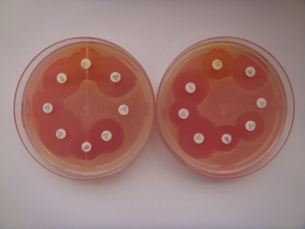

Figure 2 It shows a coproculture with *Proteus mirabilis* and *Escherichia coli.* This method also helps to isolate the bacteria and between 8 to 18 hours the laboratory can give the AST reliable result. (3,7).

This Direct AST MOS method can help in vaginal secretions, specially it is useful with fastidious bacteria as *Mobiluncus* and *Gardnerella vaginalis.* In sputum with pneumonia can give a preliminary result with Gram negative bacterias as *Klebsiella pneumoniae.*

**2.2.** **Enrichment technique MOS**.

The procedure is to smear the sample onto a tube with TSB, and must be incubated at 37°C and every hour, the tube has to be checked until it has the turbidity of MacFarland No.0.5. Immediately it can be smeared onto the MHA media or the sensitivity test media that the laboratory uses. Put the antimicrobial susceptibility test discs and incube at 37 ˚C for 4 to 18 hours then read the zones of inhibition and give the reliable AST result. The AST inhibition zones can be read as Barry described after 4 to 8 hours of incubation (1,2,3,6,7,8,9).

The great advantage of this Enrichment AST MOS technique is that it can be used **with any sample**, for example, eyes secretions that are very difficult to grow, because the inoculum is very tiny. Its interpretation is as accurate as the standard disk diffusion of Kirby Bauer (5,3,7,8). The procedure with urine sample: 1 mL (one milliliter) smeared onto 2 mL (two milliliter) of broth (TSB) and every hour the turbidity must be checked until it has the turbidity of MacFarland No.0.5. In table 2 all the zones were the same as the standard disk diffusion test. Gram positive bacteria grow slower than Gram negative. Figure No. 1

Table 2

|  |  |  |  |  |  |  |  |  |  |  |
| --- | --- | --- | --- | --- | --- | --- | --- | --- | --- | --- |
| |  | | --- | | Inhibition zones in millimeters (mm) between Enrichment AST MOS and Standard Disk Diffusion Test | | | | | | | | | | |
| ANTIBIOTIC | FIM | SXT | AMC | SAM | ATM | CL | CIP | CAZ |
| Enrichment AST MOS  TSB= McF | 20=S | 22=S | 18=S | 19=S | 27=S | 17=I | 0=R | 24=S |
| Enrichment AST MOS with urine at 37C | 21=S | 24=S | 19=S | 20=S | 27=S | 17=I | 0=R | 22=S |
| Standard D F | 19=S | 21=S | 19=S | 18=S | 26=S | 17=I | 0=R | 22=S |
| Interpretation | S | S | S | S | S | I | R | S |

FIM= Nitrofurantoin, SXT= Sulphamethoxazole/Trimethoprim, AMC= Amoxycillin/Clavulonic Acid, SAM= Ampicillin/Sulbactam, ATM= Aztreonam,  CL= Cephalexin, CIP= Ciprofloxacin, CAZ= Ceftazidime, TSB =Tryptone Soya Broth, McF = MacFarland Scale No. 0.5, S=Susceptible, I= intermediate, R= Resistant

Figure No.1. Procedures in: Standard Diffusion Disk Test, Direct AST MOS, Enrichment AST MOS techniques

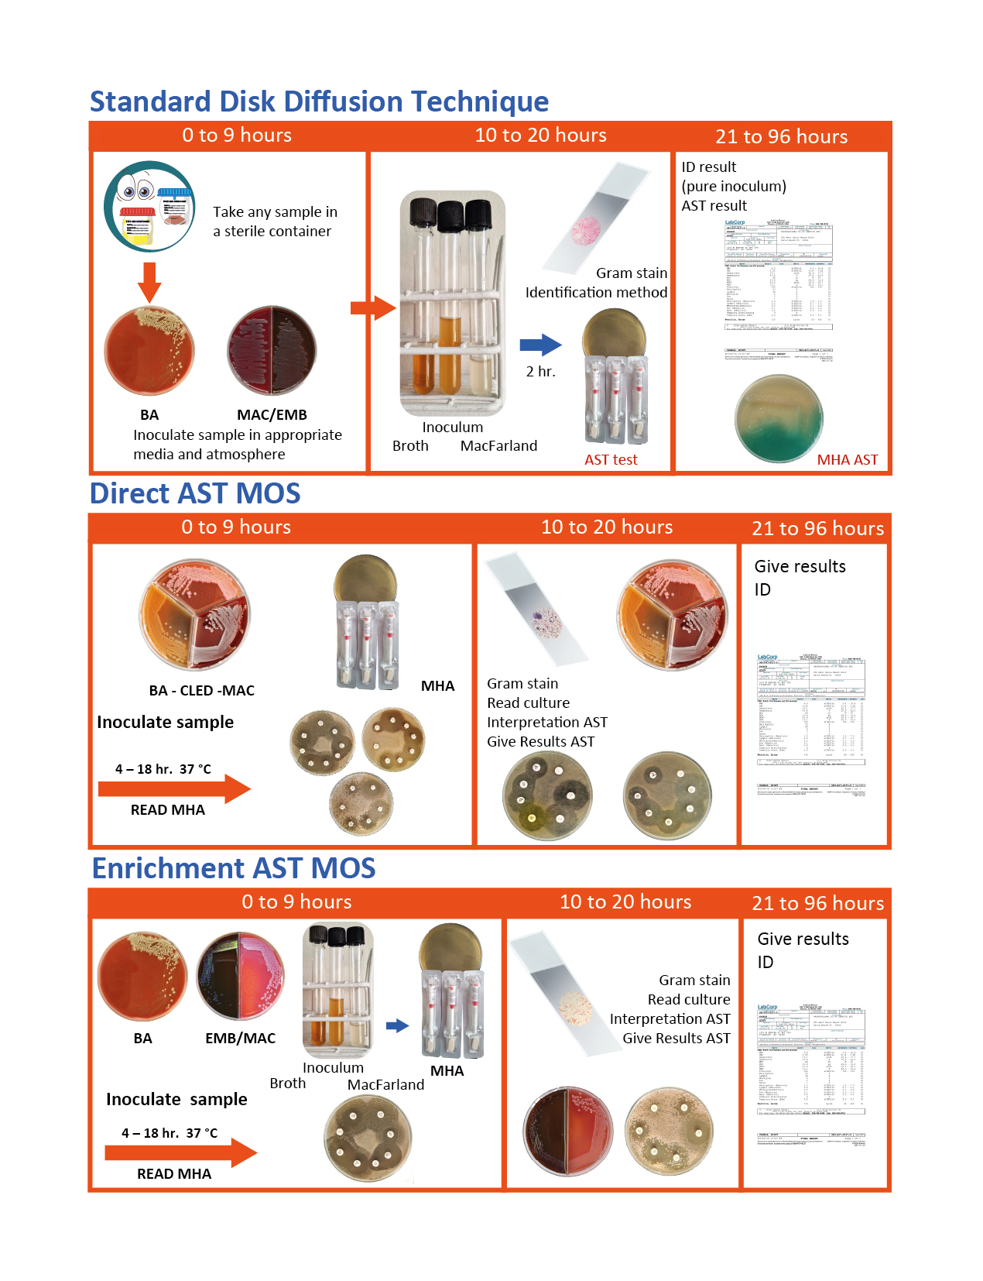

BA= Blood Agar, EMB= Eosin Methylene Blue Agar, CLED = Cysteine Lactose Electrolyte Deficient medium with Andrade Indicator, MHA= Mueller-Hinton Agar, Broth= Tryptone Soy Broth, MacFarland No. 0.5, AST= Antibiotic Susceptibility Test, ID= Identification

<https://drive.google.com/file/d/1s3hl0_y5E-nWzB4ObM1hotdrChqSULHA/view?usp=sharing>

**2.3. New transport media tube**

This method is a modification of the Enrichment AST MOS technique, it is a new way to recover the bacteria from any infectious disease and can be done in any place of the world. The only requirement is to have the Transport Media Tube (TMT) MOS when the sample is taken.

Procedure: As the Enrichment AST MOS, the great advantage is that the patient puts the sample immediately onto the TMT MOS (figure 2). The tube is placed in a "kangaroo" style for 2 to 3 hours or more, in order, to keep the sample at a corporal temperature. Then the TMT MOS is sent to the laboratory by airplane or personally. This method has a recovery of 100%, compared with Cary Blair transport media of 67.9%. (14,15,16)

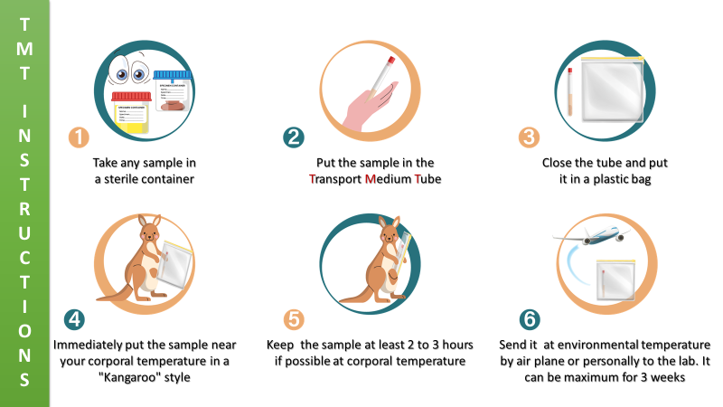

Figure 2. Transport Medium Tube MOS instruction for the patient to take the sample.

**3. Automated AST test compared with novel manual MOS techniques**

62 samples were analyzed with urines >100.000CFU/mL with the Direct MOS AST with the automated system MIC (Minimum Inhibitory Concentration) and statistically comparative there was no difference p>0.09. The sensitivity was 97.9%, specificity 81.8%, positive predictive value (PPV) 99.5% and negative predictive value (NVP) 44.4% (2). Therefore, the Direct MOS AST is of great value because can give in urgent cases the reliable antibiotic in 4 to 18 hours after the recollection of the sample, and it can be confirmed by Disk Diffusion Test or automated MIC system as CLSI or EUCAST approvals (2).

**4. Blood Direct Standard**

Blood cultures are among the most delicate tests to be done. A rapid AST result is always needed, because sepsis or bacteremia are critical health conditions. With this modification the hospitalization time was shortened between 28 to 40 hours. It is a simple, reliable, economic and very useful method (2,10,17,18).

Procedure: the blood is inoculated into an enrichment broth or a blood culture bottle, when the systematized equipment indicates bacterial growth, 0.3 mL is immediately taken to inoculate on a Mueller Hinton Agar Petri dish with the discs with an even inoculum as described in the Standard Disk Diffusion Test and then incubated at 37°C for 18 hours. This technique can be performed in any Clinical Microbiology Laboratory (2,17,18,19).

CONCLUSION:

There are many automated systems to know which bacteria is causing the infectious disease as Maldi Tof MS System and other equipments can give the bacteria identification, but not the same day of sample reception is given the AST information (20). In a health service the most important is to know the reliable treatment, not the name of the bacteria, in order to give as soon as possible the antibiotic for the patient´s treatment. Most of the cases the physician has to start with an empirical medicine.

All these rapid MOS methods reduces the hospitalization time, costs on tests or medicine unnecessary. It is the aim to publish so that many laboratories in the whole world can start to process them. Since they are very rapid, simple, economic, and **reliable.**

**5. Gram Stain with Blood Sample**

This technique is not used with blood sample, but it is very useful in just only 4 to 6 minutes the laboratory can give the physician the cause of an infectious disease: if it is a bacteria Gram negative or Gram positive or a fungus. In the Microbiology Institute of Colombia IMICOL is used for all the samples, but blood is not use as a standard technique and it is very useful (2). A drop of blood is just what you need; it is very economic, easy and rapid to give guidance in a treatment. Since many years ago, a sepsis is caused mostly by bacteria Gram positive or negative and fungi as *Candida* (21,22,23)*.*

Procedure: Put a drop of the blood in a slide, dry the sample and stained it with Gram. Dry it and read with immersion oil and see it at the microscope at 100x. The laboratory can give a preliminary result and it helps to the physician for a reliable treatment. This improves the way of life of the patients and avoids unnecessary medicines and days of hospitalization. Usually when a patient has sepsis or bacteremia a deterioration is done; therefore, knowing the type of bacteria or fungus the treatment is faster, because the hemocultures takes from 2 to 5 days to have a result.

In 2013, Stoneking et al (24) studied that 55.7% of the treatments can be changed to narrower spectrum antimicrobials if the AST result is done in the same day. Some places or laboratories don’t have expensive equipments so we suggest to use a direct smeared of the blood sample onto a blood agar or chocolate agar to have the bacterium or a Sabouraud agar to recover fungi.

REFERENCES

1. Ordóñez Smith M. Dos nuevas técnicas manuales rápidas

para antibiogramas urinarias en 6 a 18 horas. Medicina.

1994; 35(2):36-42.

1. Ordóñez Smith M. Guías prácticas para los laboratorios de Bacteriología clínica. 1ª ed. Editorial Médica Panamericana 20214. P 173-197. ISBN 978-958-8442-47-8.
2. Ordóñez Smith M. Nuevos métodos manuales rápidos de pruebas de sensibilidad empleando muestras directas: resultados en 8 a 20 horas. Infectio. 2006;10(2):112.
3. Micek S et al. An institutional perspective on the impact of

recent antibiotic exposure on length of stay and hospital

costs for patients with Gram-negative sepsis. BMC Infectious

Diseases. 2012; 12:56.

1. Bauer A W, et al. Antibiotic susceptibility testing by a standardized single disk method. American Journal Clinical Pathology. 1966; 45(4):493-496.
2. Barry A L. The agar overlay for disc susceptibility testing.

In Balows A ed: Current technique for antibiotic susceptibility

testing. Spring Field: III. Charles C Thomas; 1974. p.17-25.

1. Ordóñez Smith M. New techniques to avoid bacterial resistance. Atlantic International University Research for PhD program in Biology; 2012.
2. Ordóñez Smith M. Nuevos métodos bacteriológicos para detectar y evitar la resistencia bacteriana. Medicina. 2003;25(2):101-110.
3. Ordóñez Smith M. Muestras directas en el diagnóstico de urgencias clínicas. Tribuna Médica.2005;105(1):24-27.
4. CLSI M100 Performance Standards for Antimicrobial Susceptibility Testing, 35th Edition/standards/products/microbiology/documents/m100/2024
5. EUCAST European Committee on Antimicrobial Susceptibility Testing. 2024 https://www.eucast.org/publications-and-documents/consultations
6. Ordóñez Smith M, Gruntoradova de Franco Y. *Staphy-*

*lococcus aureus* en infecciones genitales. Tribuna

Médica.1999;99(2):71-85.

1. Ordóñez Smith, M. Agentes causales de la enteritis humanas. Incidencia del *Proteus mirabilis.* Tribuna Médica. 1995;92(5):282-291.
2. Ordonez Smith M. New transport Medium Tube (TMT) to preserve viable parasites, bacteria and fungus. 2024 ADLM (Association for Diagnostic & Laboratory Medicine) Meeting.Clinical Chemistry 70(Suplement_1) DOI:10.1093/clinchem/have106.292
3. Ordonez Smith M. New Transport Medium Tube MOS compared with Cary Blair in feces samples. To be published
4. Ordóñez Smith M. A Change In Preanalytical Procedures is Needed to Recover Positive Cultures. Poster presentation in American Society for Microbiology in Chicago. 2020.
5. Ordóñez Smith de Danies, M. et al. Muestra técnica rápida: prueba de sensibilidad antimicrobiana enriquecida (PSEA) con muestras de Hemocultivos. Laboratorio Actual. 2012; 43:29-32.
6. M23 Development of *In Vitro* Susceptibility Methods, breakpoints, and Quality Parameters. 6th ed. CLSI (Clinical and Laboratory Standards Institute) guideline M23 (ISBN 978-1-68440-186-4). CLSI. 2023.
7. Becker, K, Lupetti. MALDI-TOF MS in microbiological diagnostics: future applications beyond identification. Front Microbiol Sec Antimicrobials, Resistance and Chemotherapy Vol. 14 -2023 <https://doi.org/10.3389/fmicb.2023.1204452>
8. Uehara Y, Yagoshi M, Tanimichi Y, et al. Impact of reporting Gram stain results from blood culture bottles on the selection of antimicrobial agents. Am J Clin Pathol. 2009;132(1):18-25.
9. Wong RCW, Heung SSY. Evaluation of PREVI color Gram automated staining system on positive blood samples. Lab Med. 2011;42:414-418.
10. Froom P, Havis R, Barak M. The rate of manual peripheral blood smear reviews in outpatients. Clin Chem Lab Med. 2009;47(11):1401-1405.
11. Ikegaya S, Tai K, Shigemi H et al. Fulminant candidemia diagnosed by prompt detection of pseudohyphae in a peripheral blood smear. Am J Med Sci. 2012;343(5):419-420.
12. Stoneking LR, Patanwala AE, Winkler JP et al. Would earlier microbe identification alter antibiotic therapy in bacteremic emergency department patients? J Emerg Med. 2013;44(1):1-8.