Modeling of Gauss Elimination Method for Linear and Fractional Programming Problem

Sanjay Jain¹ and Adarsh Mangal^{2*}

¹Principal, Government College Nand (Ajmer)

²Department of Mathematics, Engineering College, Ajmer.

drjainsanjay@gmail.com

dradarshmangal1@gmail.com

1. INTRODUCTION
Decision making play a vital role in any administration, politics, industry, business, education and many more sectors. Most favorable decision is to be taken by the higher management personnel / stakeholders in the process of decision making. Mathematical Programming is the mathematical technique used for taking the most favorable (optimal) decisions in case of many problems involved in business, industry, administration, politics, education etc. Mathematical Programming Problem (MPP) or an Optimization Problem is defined as a problem which seeks to minimize or maximize a numerical function of one or more variables when the variables can be independent or related in some way through the specification of certain constraints. The function which is to be optimized is said to be an objective function or cost function. In particular, when the objective function and constraints both are linear, the problem is called a Linear Programming Problem (LPP).
Mathematical Programming Problem (MPP) can be classified broadly in two categories:
- Linear Programming Problem (LPP)
- Non-linear Programming Problem (NLPP)
If all the terms involved in the MPP are linear in nature, then the corresponding MPP is termed as Linear Programming Problem (LPP). For example,
Max. Z = 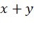
Subject to, 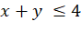
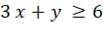
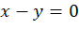
and 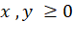
Here two decision variables 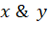 are being used which is involved linearly in objective function, restrictions and non-negative conditions.
In this chapter, we’ll discuss modeling of Gauss elimination technique for different kinds of Mathematical Programming Problems viz. Linear Programming Problem (LPP) and Linear Fractional Programming Problem (FPP).
Gauss Elimination Method for linear algebraic equations
Gauss elimination method proposes a systematic strategy for reducing the system of equations to the upper triangular form using the forward elimination approach and then for obtaining values of unknowns using the back substitution process. Let us consider the system :-
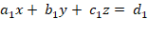 …………………….(1)
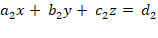 …………………….(2)
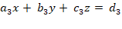 …………………….(3)
Step I :- Elimination of from equations (2) and (3)
Assuming 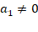, we eliminate from equation (2) by subtracting times the equation (1) from the equation (2). Similarly, we eliminate from equation (3) by subtracting times the equation (1). Thus, we get the new system as given below :-
……………….……(4)
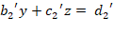 ……………………(5)
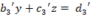 ……………………(6)
Equation (4) is known as pivotal equation and is said to be first pivot.
Step II :- Elimination of from equation (6)
To eliminate from the equation (6), we multiply the equation (5) by and subtract it from the equation (6). Thus, we get the new system as :-
……………….……(7)
……………………(8)
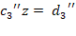 ……………………(9)
Step III :- Now, we can find the values of unknowns 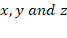 from an upper triangular system defined by equations (7), (8) and (9) obtained above by using back substitution.
Gauss elimination method for inequalities
The solution of an inequality provides possibility of many solutions in bounded form. One has to select minimum or maximum value out of the solutions obtained above as per the requirement of the problem under consideration. This is the basic theme of this method for inequalities. Maximum or minimum value of an objective function (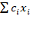,where all 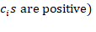depends upon the maximum or minimum values of the decision variables.
We are applying Gauss elimination method on the system of linear inequalities of the same sign in nature i.e., either ≤ or ≥. The process of elimination is done by combining the inequalities in such a way that at each iteration one variable and an inequality are eliminated. At the end of the process, there remains only one inequality with one variable remains. The last inequality thus obtained gives the value of last variable in bounded form. One can select the value of that particular variable as per requirement of the objective function. At the end, we can obtain the values of remaining variables by the methos of back substitution. Let us consider the system of m inequalities and n variables:-
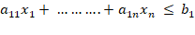 …………………………………..(10)
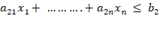 ………………………….(11)
……………………………………
……………………………………
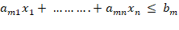……………………..(12)
Elimination of
Assuming 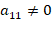, we multiply the first row by corresponding factors and then subtract them as laid down in case of linear simultaneous equations stated earlier. Thus, we get the new system as given below :-
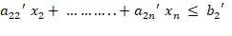
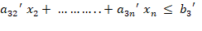
…………………………………………………
…………………………………………………
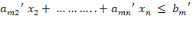
where = - 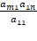
There remain (n-1) variables as well as inequalities at the end of first iteration. There remains only one variable after repeating this process to (n-1) iterations. One can easily obtain the value of the last variable. There may be some redundant constraints present in the system.
Algorithm of Gauss elimination method
The steps to apply Gauss elimination method are as follows:
- One has to reformulate the given problem as per requirement of the method. In this method, an objective function of the problem under consideration is also considered as constraint. The nature of all inequalities including constraint inequalities and an objective function inequality must be same either ≤ or ≥.
- The process of elimination is done by combining the inequalities in such a way that at each iteration one variable and an inequality are eliminated. If an absurd inequality appears like 0 where is not a positive number at any step, then one can easily conclude that the given problem has an infeasible solution otherwise a feasible solution.
- One has to form the following pairwise disjoint sets as given below.
=
=
= ; i = 1,2, …….., m and j = 1,2,…..,n
- If the set or comes out as an empty set for a variable at any step, then it indicates that the given problem has an unbounded solution.
6. Problem Formulation

- Linear Programming Problem (LPP)
Max. Z = 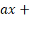α
subject to, 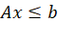
and 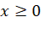
Above problem can be reduced to the following form as follows :-
Max. Z
Z – 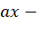α 0
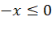
- Fractional Programming Problem (FPP)
Max. Z = 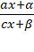
subject to
and
Above problem can be reduced to the following form as follows :-

Max. Z
(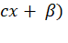Z – 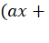α) 0
Numerical examples based on LPP and FPP are being solved here by the Gauss elimination method.
7. Numerical Examples
- Solve the LPP given below:-
Max. Z =
Subject to,
and
Standard form for applying the proposed method, we have
Max Z
Z - ≤ 0 ………(1)
………(2)
………(3)
………(4)
………(5)
If we suppose that variable x is to be eliminated first, then

Since, here non-empty sets of 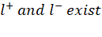, hence an optimal solution of above LPP can be obtained.
Now, (1) multiplied by - , we have
– 3 - 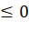 ……….(6)
Adding (6) to (2), we get
+ 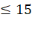 ………(7)
Multiplied (1) by -1, we have
Z – 5 - 3 …………(8)
Adding (8) to (3), we get
Z – 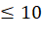 …………(9)
Multiplied (1) by , we have
– – …………..(10)
Subtracting (10) from (4), we get
- + …………..(11)
Hence, after first stage of elimination, we have
Max Z
+ or 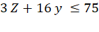 ………………(12)
Z – …………………..(13)
- + or -Z + 3 ………………….(14)
-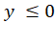 …………………..(15)
In the second stage of Gauss elimination, to eliminate the variable , multiplying (12) by - , we have
+ 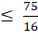 ………………….(16)
Adding (16) to (13), we get
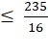 ………………..(17)
Multiplied (12) by , we have
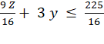 …………………(18)
Subtracting (18) from (14), we get
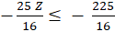 …………………..(19)
Multiplied (12) by - , we have
+ ……………….(20)
Adding (15) to (20), we get
………………(21)
Hence, after second stage of elimination, we have
Max Z
Z 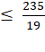
Z 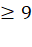
Z 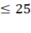
We are getting more than one values of Z and we have to choose an optimal (Maximum) value of Z that satisfies all the inequalities altogether.
Hence, Max. Z = 9.
On putting Z = 9 into (12) , we have
16 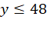 or 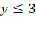
On putting Z = 9 into (13) , we have
-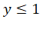 or 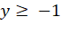
On putting Z = 9 into (14) , we have
3 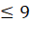 or
It can be easily stated that for Z = 9, we can have different bounded values of 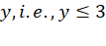, and 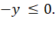 Out of these, 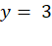 is the only value that satisfies all the inequalities altogether.
On putting Z = 9 and in (1), we get
-5 or
On putting Z = 9 and in (2), we get
3 or 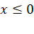
Now putting Z = 9 and in (3), we get
5 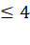 or 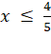
It can be seen that with the help of the values of Z and y which when substituted into the system (1) to (5), we can have various bounded values of x. i.e., , and . Out of these, 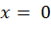 is the only candidate for an optimal solution. Hence, .
Hence, an optimal solution of above LPP is, , and Z = 9.

- Solve the LFPP given below:-
Max. Z = 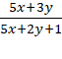
Subject to, 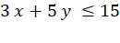
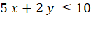
and 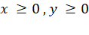
Standard form for applying the proposed method, we have
Max Z
≤ 0 ………(22)
………(23)
………(24)
………(25)
………(26)
Our aim is to obtain the maximum value of an objective function. Let 1< z < .
If we suppose that variable x is to be eliminated first, then
Since, here non-empty sets of , hence an optimal solution of above LFPP can be obtained.
Now, (22) multiplied by 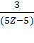 , we have
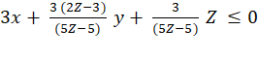 …………………….(27)
On subtracting (27) from (23), we have
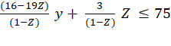 ……........................(28)
Now, (22) multiplied by 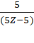 , we have
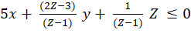 …………………….(29)
On subtracting (29) from (24), we have
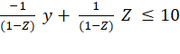 ……........................(30)
Now, (22) multiplied by 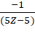 , we have
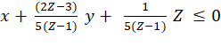 …………………….(31)
Adding (31) and (25), we have
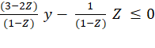 ……........................(32)
Hence after first stage of elimination, we have
Max. Z
……........................(33)
…........................(34)
……........................(35)
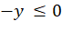 …………………(36)
In the second stage of Gauss elimination, to eliminate the variable , multiplying (33) by -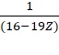 , we have
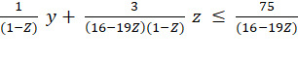 …………………….(37)
Adding (37) and (34), we get
-209 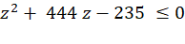 ………………………………(38)
Now, (33) multiplied by 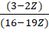, we have
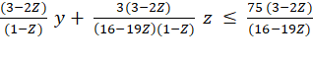 ……………………….(39)
Subtracting (39) from (35), we get
7 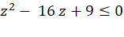 …………………………(40)
Now, multiplied (33) by 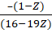 , we have
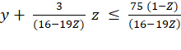 …………………………..(41)
Adding (41) and (36), we get
78 z – 75 ≤ 0 …………………..(42)
Hence, after second stage of elimination, we have
-209 …………………………………(43)
7 …………………………………(44)
78 z – 75 ≤ 0 ………………………..(45)
After this step, two quadratic inequalities and a linear inequality can be found. Quadratic inequality may provide solutions containing only real, only imaginery or real and imaginery both roots. But as per our requirement, we have to choose only real values of the variable. If there exists no such real value for a variable, then there is no possibility of existence of a feasible solution of LFPP. We can have bounded values of Z by using quadratic root method
( 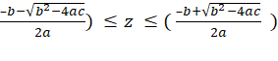 or by graphical method. Values of z from inequalities (43), (44) and (45) are
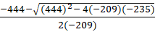 ≤ z ≤ 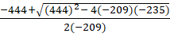
Hence Max. Z = { 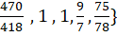 =
On putting Z = into (33) to (36) respectively, we obtain different bounded values for the variable y as y ≤ 3, y ≤ , y ≥ 3 along with –y ≤ 0. Out of these y = 3 is the only candidate that satisfies (33) to (36) altogether. Hence y = 3.
On putting Z = and y = 3 into the (22) to (26) respectively, we obtain different bounded values for the variable as ≤ 0, 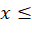 and – ≤ 0. Out of these, 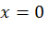is the only candidate that satisfies (22) to (26) altogether. Hence 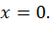
Therefore an optimal solution of the above linear fractional programming problem is 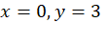and Z = .

