**Chapter:7. Sustainable pharmaceuticals**

**INTRODUCTION**:

The pharmaceutical sector is essential to enhancing global health because it creates and produces treatments and medications that can save lives. However, the production of hazardous waste, high energy usage, and greenhouse gas emissions are just a few of the major environmental effects that occur from typical pharmaceutical manufacturing procedures. As environmental concerns and regulatory demands increase, the need to promote sustainability in pharmaceutical manufacturing is becoming more widely acknowledged. This introduction gives a broad overview of the subject, emphasizing the significance of sustainable practices in the pharmaceutical sector as well as the main research fields targeted at lessening its environmental impact. For a thorough examination of different research stances and projects aimed at advancing sustainability in pharmaceutical production, it provides the necessary context. The introduction highlights how urgently creative solutions are needed to solve environmental issues while maintaining access to safe and efficient medications. In moving the pharmaceutical sector closer to a more sustainable future, it emphasizes the need of research and teamwork[1].

**History**

Thank to several pre-existing theories and research initiatives, green chemistry came into being in the years before the 1990s as public awareness of chemical pollution and resource depletion increased[2]. Green chemistry developed in the US and Europe in the years leading up to the 1990s when environmental challenges were being tackled in new ways and public awareness of resource depletion and chemical contamination increased. The collection of concepts now known as "green chemistry" began to take shape in the mid- to late-1990s, and the term's acceptance grew. of taking the effort to develop advanced manufacturing technologies in order to reduce pollution The collection of concepts now known as "green chemistry" first appeared in the mid- to late-1990s, and the word swiftly gained traction, outstripping rival terms like "clean" and "environmental." Through its funding, programming, and expert coordination in pollution reduction, the Environmental Protection Agency played a significant role in the early development of green chemistry in the United States[3].

**Green chemistry in pharmaceutical development**

The design of chemical products and processes that minimize or eliminate the production of hazardous substances is known as "green chemistry" (GC); it incorporates techniques like using fewer solvents, switching to aqueous conditions, catalytic variants, microwave irradiation, ultrasound facilitation, and photochemical routes as seen in the pharmaceutical context [4]. Simple solvent use, particularly with volatile or poisonous organic solvents, can seriously pollute the environment.

**BASIC PRINCIPLES OF GREEN CHEMISTRY**

One of the primary objectives of green chemistry is the removal of hazardous substances from the process. Consequently, the usage of chemicals that are bad for the environment and people's health is reduced or eliminated. While it is challenging to compile all of the method principles' needs at once while developing a GC process, attempts should be made to apply certain principles as hoped throughout particular synthesis phases.

**12 principles of green chemistry**

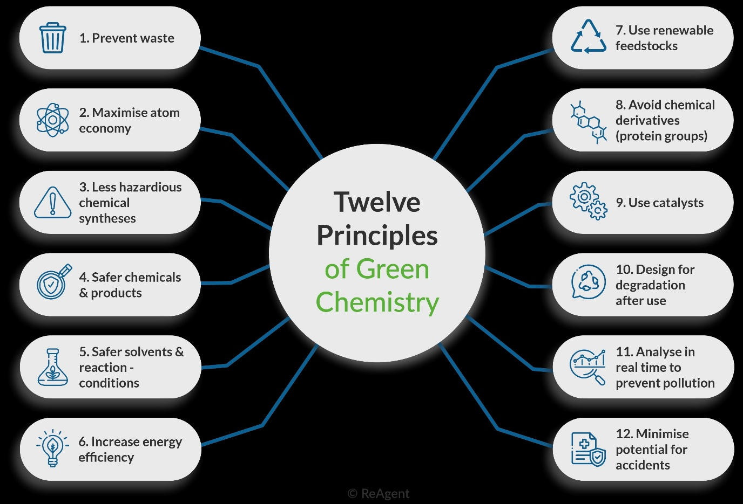

**Figure: The 12 principle’s of green chemistry**

**One Principle:**

While it is possible to mitigate the negative effects of essentially harmful chemicals, doing so requires a substantial time, financial, material, and energetic commitment. As a first step towards a sustainable product, process, or system, designers should assess the basic nature of the selected material and energy inputs to ensure that they are as benign as is practicable. The objective of molecular designers is to create materials and energy sources that are fundamentally safe. If risks are eliminated from the final product during the production process due to improved operating conditions, they will need to be transferred to an off-site storage and disposal facility[5].

**Two Principle:**

This concept, known as "atom economy" at the molecular level and "material economy" at larger design levels, is exemplified by the architecture of contemporary fossil fuel-based power production systems, which naturally generate waste at every stage of their life cycles. Waste generation mostly comes from consumption, even when garbage is produced during mining and processing. Fossil fuel combustion releases greenhouse gasses. Power generation methods don't have to generate waste, unlike fusion energy. Fusion energy has the potential to advance energy systems toward sustainability, even though it hasn't been accomplished yet. Since fusion eliminates the need for fossil fuels, it will stop the creation of products from chemical combustion. Moreover, unlike nuclear energy, fusion energy does not produce hazardous fission products. This technique's application in energy systems serves as an example of how basic design ideas can be applied to develop processes, systems, and other components that reduce waste production[6].

**Three principle :**

Separation is the goal. In many production processes, the most energy and resources are used in product separation and purification. Some conventional separation methods heavily rely on energy in the form of heat or pressure, while others heavily rely on potentially hazardous substances. Separation and purification are taken into consideration in advance to reduce harvesting time and expenses. Techniques for separation and purification, such as distillation and column chromatography, are generally ineffective at the molecular level. For separation and repurposing, polymers can be employed to change the solubility of labels, catalysts, and substrates. Separation and purification are taken into account early in the design process to prevent wasting energy and resources [7].

**Four principle :**

Increase the efficiency of mass, energy, time, and space. Since processes and systems typically require more time, space, energy, and materials than necessary, the implications could be classified as "inefficiencies" even though they are widely distributed throughout the product and process life cycles. If a system is designed, implemented, or operated inefficiently, resources are squandered during its lifetime. Massive batch reactors are usually only used partially during the reaction time in chemical manufacturing, often at dilution levels that are significantly higher than required. High productivity can be produced from small amounts of material by using process intensification techniques, such as microreactors that operate continuously at very low volumes with effective mixing[8].

**Five principle :**

During the reaction time, large batch reactors are usually only partially used in chemical manufacturing, often at dilution levels that are significantly higher than required. Small amounts of material can produce high productivity through the use of process intensification techniques, such as micro reactors that operate continuously at very low volumes with effective mixing. Molecular, product, and process methods that have been optimized for optimal intensity and efficiency can be used. When water is removed from the product stream to "pull" the process to completion, this occurs at the molecular level in chemical transformations such as condensation reactions[9].

**Six principle :**

Maintain the complexity. A product's complexity, whether at the macro, micro, or molecular level, is usually influenced by the amount of money spent on resources, energy, and time. Reuse should be associated with high complexity, while positive disposal or recycling that preserves value should be associated with low complexity. Recognizing that natural systems offer advantages in complexity that shouldn't be unduly lost in processing or manufacturing transformation is also crucial. It might not be cost-effective to recycle a silicon chip in order to recoup the value of the original materials due to the high level of intricacy involved[10].

**Seven principle :**

Environmental issues including persistence, bioaccumulation, and solid waste management are typically associated with products that last far past their useful economic life. To keep dangerous compounds from becoming immortal in the environment, it is imperative to create chemicals with a specific lifespan. Designing for durability rather than immortality reduces the risk to human and environmental health. The quality of life is considerably diminished at the end of life. Even after its brief useful life, this product still poses a significant environmental concern. One substitute is Eco-fill, a novel starch-based packaging material that rivals traditional polystyrene packing and is composed of food-grade ingredients that readily dissolve in household or commercial water systems when the product reaches the end of its useful life. This product's endurance, but not immortality, allows Eco-fill to fulfil its original purpose without committing to long-term environmental responsibilities[11].

**Eight principle :**

But since some disinfection compounds lose their potency over time, the concentrations of disinfection products in water farther away from the drinking water treatment plant in the system will be at higher than needed levels. For instance, it may be possible to replace more reactive reagents with less reactive ones as with enzyme catalysts. The water closest to the drinking water treatment plant in the system will have more than is necessary of disinfection by products, as some of it evaporates while in the pipes. Water closer to where the drinking water treatment plant is in the system will have elevated disinfection by products because some of it evaporates. The resulting tri-halo methane, while it does not use a chlorine-free disinfection method, is still worthy of evaluation -- and if it can be taken up again with respect to a general system, it would be a gradual but remarkable improvement on the current system. This reduces the hazards that chlorine generation and subsequent chemical chlorination pose to the environment and public health[12].

**Nine principle :**

Cars, food packaging, computers, and paint are just a few examples of the many items that have multiple components. Certain plastics employ chemical additives like flame retardants, plasticizers, colors, and thermal stabilizers. At the product level, some auto designers are reducing the amount of plastic needed by developing novel polymer shapes that are easier to decompose and recycle. These days, layered parts like instrument panels and doors are made using this method. For instance, components, such as metal-licenced polyolefins, can be constructed from a single material that possesses all the required design properties. This mono-material design idea eliminates the need to disassemble the instrument panel or door in order to recycle or recover it[13]

**Ten principle :**

A unit operation, production line, manufacturing facility, industrial park, or neighborhood should be the design location for products, processes, and systems in order to capitalize on the existing framework of energy and material flows. This makes it possible to collect energy and "waste" materials everywhere. These systems reverse the electric motor by trapping the heat generated by braking, which is usually an energy waste. A variety of sources, including waste heat from adjacent activities and recyclable materials, provide energy inputs[14].

**Eleven principle :**

All human activity affects the environment, but by eliminating those behaviours, we can produce more environmentally friendly products, processes and systems. It is more a sign of immaturity than a little flaw of product quality. Mobile phones, laptop computers and PDAs frequently are retired with the rapid advance of technology and changing fashions, but the actual components of the device still work completely well, thus the value.Examples of renewably sustainable features & technologies include bio-based polymers, utilizing natural ecosystems for wastewater treatment, and recovering biomass feedstock. This reduces duplicate components in subsequent product generations and reduces end-of-life costs as components incorporated can be recovered during end-of-life process. For example, Xerox equipment is made to be remanufactured 90% of the time. Converting industrial buildings into places to live, for instance, is a systems approach[15].

**Twelve principle :**

Instead of being depleted, renewable resources are used. Determining whether a chemical or energy supply is renewable or declining has significant implications. The term "renewable" is often used to describe biological materials. However, from a sustainability standpoint, if a process's waste output can be collected and used as a different feedstock or recyclable input that maintains its value, it would undoubtedly be seen as renewable. Renewable energy is used in place of finite resources. Examples include the recovery of biomass feedstock, wastewater treatment using natural ecosystems, and bio-based polymers[16].

**Benefits of green chemistry for the pharmaceutical sector include:**

**Human health:** Cleaner air: Reduced pulmonary damage from toxic chemical emissions into the atmosphere. Less harmful chemical waste is discharged into the environment, leading to cleaner drinking and recreational water. The chemical industry has made it safer for workers, reducing the risk of accidents, using less dangerous substances, and requiring less protective equipment. Many more safe consumer goods will become available — few will replace a few[17].

**Reduced Environment:** The region referred to as the "less environment" is characterized by the introduction of a large number of waste chemicals into the environment, either intentionally (e.g., pesticides), inadvertently (e.g., emissions from production), and/or as waste. Yet environmentally friendly chemicals are recycled or break down into harmless compounds. There is less potential for smog, ozone depletion or global warming; less environmental pollutants that damage plants and animals and fewer chemical disruptions of ecosystems.” Especially for hazardous waste, there is reduced dependency on landfills[18].

**Eco- Friendly Packaging in Pharmaceutical**

Eco-friendly packaging, also known as green or nature-friendly packaging, is created from materials that are safe for the environment and aim to minimize harm. To highlight these materials used in pharmaceutical packaging, eco-labels are often displayed. There are many projects focused on developing and using biodegradable and environmentally friendly packaging options. These materials need to be designed to fulfill current needs while either replacing or improving existing packaging solutions.

A few examples of suitable eco-friendly options include recycled or sustainably sourced paper and biodegradable corn starch. Corn starch is a fantastic alternative to plastic, offering similar strength and versatility for products like bags, trays, and boxes. Considering environmental impact early on in the design process is essential because it’s tough to make a product more sustainable once it hits the market. In the pharmaceutical industry, packaging design is complex, and it must tackle today’s environmental challenges effectively[19].

Another goal of these designs is to reduce the amount of waste generated. Greener packaging solutions aim to satisfy the needs of the pharmaceutical industry without causing harm to the environment, leading to a variety of new eco-friendly packaging materials. To support this, equipment and packaging are created with a low calorific value, which helps maximize energy recovery or allows for recycling a certain weight proportion. Eco-friendly packaging should be simple, biodegradable, and easy to recycle or reuse.

The pharmaceutical industry is increasingly turning to reusable materials to tackle the challenges of the twenty-first century. Thanks to advancements in technology and rising consumer demand, biodegradable packaging has become more cost-effective, allowing many businesses to boost their sales by making this switch. Since eco-friendly pharmaceutical packaging is an emerging ethical trend globally, brands in the cosmetics and natural health sectors are also refreshing their image with these sustainable options, adding value to their products. For this reason, equipment and packaging are made and engineered to have a minimum calorific value to maximize energy recovery or to allow recycling of a specific proportion by weight. Eco-friendly packaging should have a clean, simple design, be biodegradable, and be readily recyclable or reusable . The pharmaceutical business is also moving toward the usage of these reusable materials to face the increasing problems of the twenty-first century.

New technology and rising customer demand have made biodegradable packaging more accessible, and many companies are seeing an increase in sales as a result of making the switch. Nowadays, cosmetics and natural health products are embracing environmentally friendly pharmaceutical packaging to improve their brand image since it is one of the newest ethical trends in the world. It also adds extra brand value to a certain product[20].

**Features of environmentally friendly materials for pharmaceutical packaging**

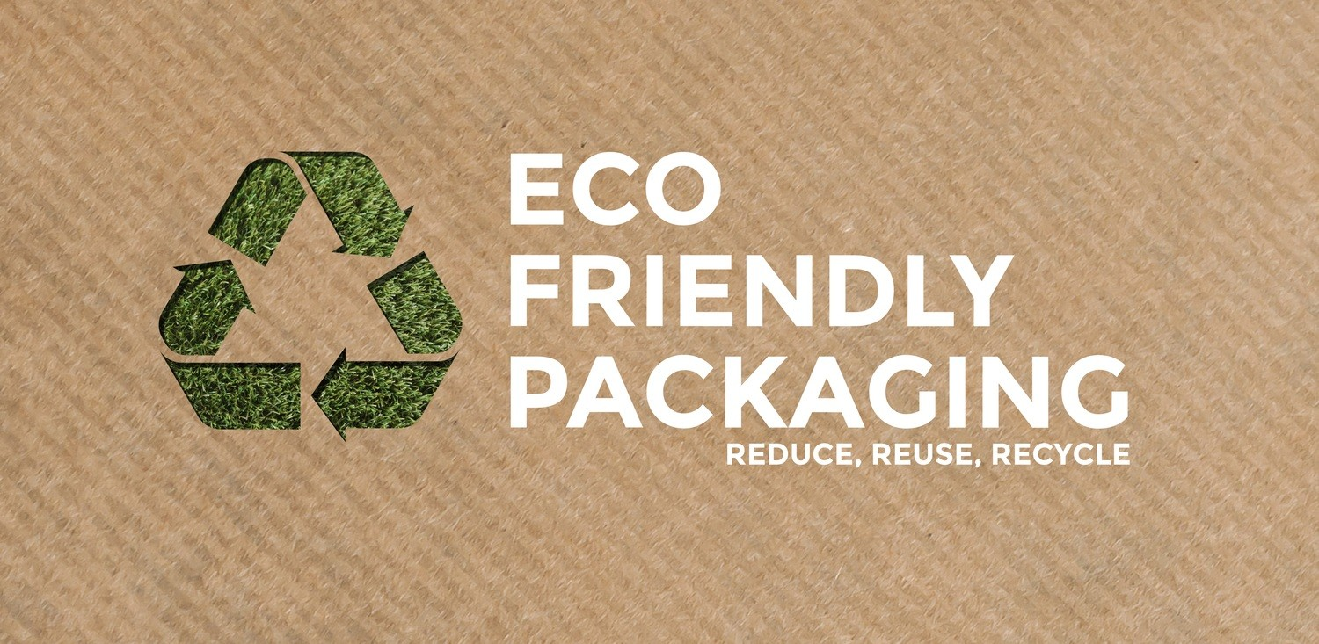

Figure: 2 **Eco-friendly pharmaceuticals packaging**

**Reduce:** The ability to reduce package volume is a feature of environmentally friendly packaging materials. The needless disposal of degradation products is decreased as a result. Additionally, some formulations are not overpackaged due to specific legal requirements. One large bottle of formulation is preferable to several small bottles, and multiple dosage containers are preferable to single-use containers.

**Recycle:** Reusing packaging materials to create newer packaging is a feature of eco-friendly packaging materials. Examples of recyclable, environmentally friendly packaging materials include paper, cardboard, metal, glass, and thermoplastic. Additionally, the microbes found in materials recovered through glass and metal recycling are far safer[21].

**Reuse:** Reuse is the ability of environmentally friendly packaging materials to be used repeatedly. Using packaging material in its original form is part of this attribute. For instance, several cleaning solutions and products from The Body Shop are offered in reusable or returnable containers. Likewise, purchasing milk in reusable containers helps prevent the production of plastic waste.

**Renew:** It is the ability of environmentally friendly packaging materials, like thermoplastic, made from renewable natural resources to be recycled into new packaging.

**Repurpose:** This feature of environmentally friendly packaging materials allows them to be shaped into new shapes with different medicinal uses in mind [22].

**supply chain management in sustainable pharmaceuticals**

Supply chain management is the integration of essential business operations throughout the supply chain with the goal of creating value for stakeholders and customers. It is true that supply chain management effectively combines supply and demand both within and across businesses.[23]Supply chain management involves the planning and administration of all sourcing, procurement, conversion, and logistics-related activities, according to the Council of Supply Chain Management Professionals. The evaluation of the supply chain involves many different aspects. Some of the most important ones are the removal of bottlenecks, the optimization of manufacturing flow, the maintenance of the proper mix and location of factories and warehouses, dynamic programming, vehicle routing analysis, and the efficient use of capacities, inventories, and labor. The proper setup and flexibility must be implemented by all investors in order to establish best practices and get beyond the challenges in a constantly shifting environment. The pharmaceutical supply chain should provide medications in the appropriate amount, with acceptable quality, at the appropriate location and clients, at the appropriate time, and at the best possible price in order to support the goals of the health system and to profit its investors. The participants, procedures, data, and resources that move raw materials and components into completed goods and services and deliver them to clients make up the supply chain. It consists of customers, suppliers, middlemen, and outside service providers. 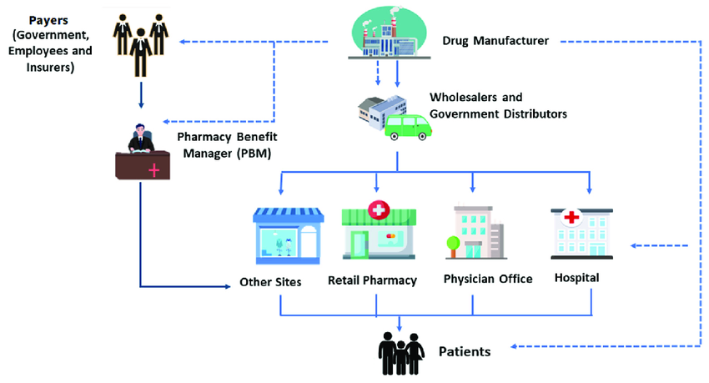

**Figure:3. Supply chain management system for manufacturing**

**Advantages of supply chain management**

Within the pharmaceutical industry, supply chain management can modernize the business to make better use of assets and resources, create income, raise shareholder value, and optimistically meet customer demand. Effective supply chain management has the potential to influence and enhance nearly every business activity, including data integrity, operational complexity reduction, supplier selection, purchasing, warehousing, and distribution. Additional benefits include[24].

* Higher fulfillment rates and faster customer response
* Reduced lead time
* Reduced costs and increased production
* decreased supply of merchandise across the board
* Reduced vendors and a shorter planning period
* Increased accuracy in forecasting

**pharmaceutical waste management**

Wastes can take many different forms, such as sewage, sludge, packaging materials, industrial garbage, discarded automobiles, old televisions, garden debris, paint containers, and home trash. As a result, everyday activities might result in a wide range of waste products from many sources. This could be created by homes, businesses, industry, agriculture, building and demolition projects, mining and quarrying operations, and energy production. It is crucial that garbage be managed in a way that does not negatively impact the environment or human health, given the enormous amounts of waste produced. There are various kinds of pharmaceutical waste, primarily hazardous and non-hazardous wastes[25].

**Pharmaceutical Wastes**

Syringes are one of several possible sources of pharmaceutical waste in the healthcare system; they are not just produced during intravenous (IV) preparation.

Typically, pharmaceutical waste may include:

* Drugs that have expired
* Personal drugs that patients have thrown away
* Waste products with extra medications (syringes, IV bags, tubing, vials, etc.);
* Waste products with traces of chemotherapeutic drugs;
* Drug vials that are open and unusable;
* Containers for acute hazardous waste medications;
* Medications that are thrown away; and
* Spill cleanup supplies, absorbents, and contaminated clothing.

Three categories are used to further classify pharmaceutical waste:

1. Hazardous waste,
2. Non-hazardous waste,
3. Chemo waste

**Social Responsibility in Sustainable Pharmaceuticals**

The 2005 paper "Who cares wins" is credited with coining the term Environmental, Social, and Governance (Knoepfel, 2005). Stakeholder and institutional theory make up the majority of the theoretical underpinnings of Environmental, Social, and Governance research. Several distinct Environmental, Social, and Governance frameworks concentrate on the most important subset of elements in their setting, depending on the assessment's industrial or regional focus. An overview of relevant Environmental, Social, and Governance elements that businesses may take into account when improving their operations for sustainability is provided in(Table 1)[26].

|  |  |
| --- | --- |
| **Dimension** | **Factors** |
| Environmental (E) | * gGHG and additional emissions to soil, water, and air |
|  | * Efficiency and use of energy and raw materials |
|  | * Fossil fuel exposure |
|  | * Deforestation, soil sealing, desertification, and land degradation |
|  | * Water use, management, and recycling |
|  | * Production and management of waste |
|  | * Impact on and reliance on ecosystems and biodiversity |
|  | * Development of eco-friendly goods, services, and technologies |
| Social (S) | * Human rights policies and the application of basic ILO conventions: child labor, forced and coercive labor, and human trafficking |
|  | * Workplace health and safety: mishaps, illnesses, injuries, or deaths |
|  | * HR management and employee relations: freedom of association, equal opportunity, diversity, inclusion, and protection for whistleblowers |
|  | * Education and training, as well as human capital investment |
|  | * Impact of poverty on communities |
|  | * Seeing contentious weapons |
|  | * Supply chain management |
|  | * Consumer safety, health, and privacy |
|  | * Excellent and creative customer service, as well as consumers' rights to learn about environmental issue |
|  | * Personal data security |
|  | * Access to credit and financial inclusion |
|  | * Breaking the Principles of the UN Global Compact |
| Governance (G) | * Business principles and conduct codes |
|  | * Accountability |
|  | * Openness and disclosure |
|  | * Gender pay gap and executive compensation |
|  | * Diversity, structure, and independence of the board of directors |
|  | * Both corruption and bribery |
|  | * A set of guidelines or precepts outlining the rights, obligations, and expectations of various stakeholders in the entity's or sovereign's governance |
|  | * Rights of shareholders |

**Conclusion**

In summary, improving pharmaceutical manufacturing's sustainability is a complex undertaking that calls for coordinated research efforts from a range of academic fields. In order to lessen the environmental impact of medicine development and manufacture, researchers are looking into creative solutions ranging from energy-efficient processes, waste management, green packaging, green analytics, green chemistry, and solvent selection. While meeting the increasing demand for life-saving drugs, the pharmaceutical industry can reduce its environmental impact by implementing sustainable practices like reducing waste production, maximizing energy use, and encouraging the use of renewable resources. To further advance and create standards and guidelines for sustainable medicine manufacturing, cooperation and knowledge exchange among academic institutions, business, and regulatory bodies are crucial. Pharmaceutical manufacturers can show their dedication to environmental stewardship and corporate social responsibility in addition to cutting expenses and improving operational efficiency by adopting sustainability as a fundamental tenet. In the end, promoting sustainability in pharmaceutical production is important for public health, future generations, and the sustainability of the world.

**References**

[1] Mrs, K., Nimse, Gadge, M., Jadhav, M.S., & Jawarkar, M.P. “Advancing Sustainability In Pharmaceutical Manufacturing: Research Perspectives”.

[2] Amiard-Triquet C, Amiard JC, Mouneyrac C. Aquatic ecotoxicology. Advancing tools for dealing with emerging risks. 1st ed. Academic Press; 2015.

[3] Gamarra JS Jr, Godoi AF, de Vasconcelos EC, de Souza KM, de Oliviera CM. Environmental Risk Assessment (ERA) of diclofenac and ibuprofen: a public health perspective. Chemosphere. 2015;120:462–469.

[4] Sageer Ahmad, Rahul Jaiswal, Reetu Yadav, Sarita Verma,Recent advances in green chemistry approaches for pharmaceutical synthesis,Sustainable Chemistry One World,Volume 4,2024,100029,ISSN2950-3574,

https://doi.org/10.1016/j.scowo.2024.100029.

[5] Bu Q, Wang B, Huang J, Deng S, Yu G. Pharmaceuticals and personal care products in the aquatic environment in China: a review. J Hazard Mater. 2013;262:189–211.

[6] Oldenkamp R, Huijbregts MA, Hollander A, Ragas AM. Environmental impact assessment of pharmaceutical prescriptions: Does location matter? Chemosphere. 2014;115:88–94.

[7] Eissen M, Backhaus D. Pharmaceuticals in the environment: an educational perspective. Environ Sci Pollut Res Int. 2011;18:1555–1566.

[8] Brown KD, Kulis J, Thomson B, Chapman TH, Mawhinney DB. Occurrence of antibiotics in hospital, residential, and dairy effluent, municipal wastewater, and the Rio Grande in New Mexico. Sci Total Environ. 2006;366(2-3):772–783.

[9] Agunbiade FO, Moodley B. Occurrence and distribution pattern of acidic pharmaceuticals in surface water, wastewater, and sediment of the Msunduzi River, Kwazulu-Natal, South Africa. Environ Toxicol Chem. 2016;35(1):36–46.

[10] Al-Khazrajy OS, Boxall AB. Risk-based prioritization of pharmaceuticals in the natural environment in Iraq. Environ Sci Pollut Res Int. 2016;23(15):15712–15726.

[11] Calisto V, Esteves VI. Psychiatric pharmaceuticals in the environment. Chemosphere. 2009;77:1257–1274.

[12] Chen Y, Yu G, Cao Q, Zhang H, Lin Q, Hong Y. Occurrence and environmental implications of pharmaceuticals in Chinese municipal sewage sludge. Chemosphere. 2013;93:1765–1772.

[13] Chitescu CL, Kaklamanos G, Nicolau AI, Stolker AA. High sensitive multiresidue analysis of pharmaceuticals and antifungals in surface water using U-HPLC-Q Exactive Orbitrap HRMS. Application to the Danube river basin on the Romanian territory. Sci Total Environ. 2015;532:501–511.

[14] Evans S, Bagnall J, Kasprzyk-Hordern B. Enantiomeric profiling of a chemically diverse mixture of chiral pharmaceuticals in urban water. Environ Pollut. 2017;230:368–377.

[15]Fent K, Weston AA, Caminada D. Ecotoxicology of human pharmaceuticals. Aquat Toxicol. 2006;76:122–159.

[16] Isidori M, Lavorgna M, Nardelli A, Parrella A, Previtera L, Rubino M. Ecotoxicity of naproxen and its phototransformation products. Sci Total Environ. 2005;348:93–101.

[17] Kasprzyk-Hordern B, Dinsdale RM, Guwy AJ. Illicit drugs and pharmaceuticals in the environment--forensic applications of environmental data. Part 1: Estimation of the usage of drugs in local communities. Environ Pollut. 2009;157:1773–1777.

[18] Kasprzyk-Hordern B, Dinsdale RM, Guwy AJ. Illicit drugs and pharmaceuticals in the environment--forensic applications of environmental data, Part 2: Pharmaceuticals as chemical markers of faecal water contamination. Environ Pollut. 2009;157:1778–1786.

[19] Bird, K., 2009. Green Packaging is more about improving recycling than new materials. http://www.cosmeticsdesign.com/On-your- radar/Green-packaging/Green-packaging-is-more-I about-improving-recycling-than-new-materials.

[20] http://www.Product Packaging.html

[21] http://www.Eco Friendly Packaging News You Can Use.html.

[22] http://www.recycling packaging.html.

[23] Rossetti CL, Handfield R, Dooley KJ (2011) Forces, trends, and decisions in pharmaceutical supply chain management. Int J Phys Distr Log 41: 601-622.

[24]Deisingh AK (2005) Pharmaceutical counterfeiting. Analyst 130(3): 271-279.

[25] Pratyusha K, Nikita M, Gaikwad AA, Phatak PD, Chaudhari. Review On: Waste Material Management In Pharmaceutical Industry. Int. J Pharm. Sci. Rev. Res. 2012; 16(2):nᵒ 27, 121-129

[26]Azarow, R. C., Walsh, E., Grey, S., & Nabhan, P. (2021). ESG and banking: The disclosure debate. The Banking Law Journal, 138(10), 554–561