**Buck Converter Based CSI Fed BLDC Motor Drive**

**Kiruthiga B,***Department of EEE,Velammal College of Engineering and Technology, Madurai, Tamil Nadu ,India;* [*kirthiice@gmail.com*](mailto:kirthiice@gmail.com)

**Om Prakash A ,** *Government Polytechnic College, Usilampatti, Madurai, Tamil Nadu ,India;* [*omprakashgptu@gmail.com*](mailto:omprakashgptu@gmail.com)

***Abstract*-** **The full simulation model of a CSI-fed BLDC motor based on a Buck Converter is created in this article. A BLDC motor, six IGBTs, a speed sensor, a PI controller, and a second-order low pass filter make up the simulation model. The inductance value in the CSI-fed BLDC drive-controlled rectifier is very high. The method mentioned earlier is used to lower the inductance value. A three-phase current source inverter and Buck converter supply power to the BLDC motor. The inverter operates in six pulses by using the Hall Effect position sensor signals as gating signals. A PI controller and a greater switching frequency are used to control the speed. The SIMVIEW was used to get these results. It is also possible to obtain the results of other parameters, such as gate pulses and Hall Effect sensor pulses, by adding them to SIMVIEW.With this kit, we can build the Buck converter circuit. At 20 KHz, the switching frequency is fixed. By comparing the triangular wave with the DC line, the pulse can be produced. By adjusting the potentiometer, the duty cycle may be adjusted from 0% to 100% and hardware results can be obtained.**

**Index terms: Current source inverter (CSI), BLDC Motor, PI Controller, IGBT, Duty Cycle.**

**I. INTRODUCTION**

Switch-mode electronic By temporarily holding the input energy and releasing it to the output of a different voltage, DC to DC converters change the DC voltage level. For the input control circuit, there are several kinds of DC-DC converters available. Buck, boost, and buck-boost converters are the three fundamental types of DC-DC converter circuits. A power device serves as a switch in each of these circuits.There are several uses for the DC-DC single switch buck converter [1].These converters' primary goal is to increase efficiency while lowering size, weight, and cost. In order to attain compact size, weight, and cost, switch-mode power sources must use smaller magnetic elements [2]. High frequency switching is necessary to do this. Conversely, switching loss rises with increasing switching frequency, negatively impacting overall efficiency and size.The switching frequency can be changed to control these converters. To regulate the voltage and current in the converters, small inductor values are selected [3–4].A CSI-based BLDC motor is used to operate the buck converter, and the speed will change depending on the operating conditions [5-8]. In variable speed, the pulse width modulation signal is used for both operating and running conditions [9–12].use this document.Low switching stress and low voltage stress values are obtained in the results by using the pulse signal in the buck converter.

**II. INVERTERS**

In the field of power electronics, an inverter is a type of circuit that converts DC voltage or current into AC voltage or current. It is sometimes referred to as a power conditioning circuit. Referring to AC to DC converters, the inverter performs the opposite function of the AC—DC converter. Additionally, an inverter circuit's input is a DC source; using an AC source, such as the AC supply system, to obtain this DC is not inequitable. For instance, an AC to DC converter may be used to convert the AC supply voltage output to DC, and an inverter circuit may be used to reverse the conversion back to AC. This would be the main source of input power. In this case, the utility supply system's input AC and the final AC output can have different frequencies and magnitudes.

***A. Current Source Inverter (CSI)***

The process of moving current from one phase to another in accordance with the intended current and voltage pattern is known as "commutation." There should ideally be no glitches in the current transfer process, but due to flaws, the current waveform may exhibit a "dip" at the middle of a 120° conduction interval. Torque ripple results from this dip because it reduces the amount of torque produced during commutation. Phase "A" in Figure 1 is conducting, and a current transfer from phase "B" to phase "C"—that is, thyristor T4 turning off and thyristor T6 turning on—is expected to occur if the phase currents lead the corresponding motor back EMFs. Assuming that current ia is equal to the DC link current, natural commutation of the thyristor is possible, provided that the commutation interval (μ) is minor compared to the conduction interval.It is expected that the current moves from T4 to T6 as soon as T6 is turned on. Phase I was the other phase that was carried out prior to the commutation interval. This utilizes the fact that a thyristor shuts off if its cathode potential is greater than its anode potential, and the BLDC motor's back-EMF enables commutation. At low speeds, the motor's back-EMF might not be enough to commutate the thyristors because it is proportional to the motor speed. In order for commutation to occur, the DC link current might need to be driven to zero. Put another way, the DC voltage (which may have ripples) is seen at the rectifier's output while the CSI is operating in the rectifier mode, which switches the gating signals of the upper and lower thyristors. This serves as a test to ensure that the drive logic operates correctly in the open-loop without endangering the system [13].

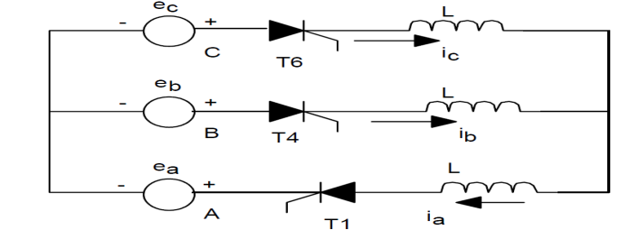

*Fig.1 Circuit during commutation in CSI*

**III. CONVERTER**

With a single inductor and capacitor used for both converters, a non-inverting buck-boost converter—a cascaded combination of a buck converter and a boost converter—is regarded as the converter model. The input polarity of this converter is not the opposite of the output voltage polarity [5]. This converter uses a single switch to combine the designs of a buck converter and a boost converter into a single topology.

***A.Converter Selection***

For low-voltage converter applications, single-phase buck controllers perform admirably at currents up to around 25A; but, at greater currents, power consumption and efficiency start to become problems. A multi-phase buck controller is one appropriate method. Throughout the comparison investigation, it is assumed that the converters are functioning in the DCM mode. Here, an alternative method of operation is used [1-2].

***B. Buck Converter***

The output voltage of a buck converter is smaller than the input voltage. To change the direction of current, a power switch is utilized. Additionally, when the switch is off, a diode—also known as a freewheeling diode—allows the load current to pass through it.



*Fig.2 Buck Converter*

This circuit is called as a step-down device; as the output voltage is normally lower than the input voltage. *A.*

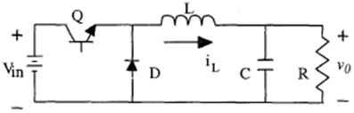

*Fig.3 DC-DC Buck Converter*

**IV. BLDC MOTOR**

In order to excite the motor stator windings, the BLDC motor uses an electronic device, like a VSC, rather of brushes [6]. Therefore, removing this source of wear, tear, and power loss—which is caused by heating—improves the motor's dependability and efficiency. Moreover, BLDC motors have several other benefits over brushed DC and induction motors, such as improved dynamic response, noiseless operation, greater speed ranges, and superior speed/torque characteristics. Additionally, the torque delivered in relation to the motor's size is higher, making it a viable choice for applications where higher power is required but portability and light weight are crucial factors, including electric automobiles and washing machines [7]. Because the magnetic fields produced by the rotor and stator rotate at the same frequency, BLDC motors are referred to as synchronous types. One benefit of this configuration is that, unlike induction motors, BLDC motors do not slide. The most popular kind of motors are three-phase, though they can be one-, two-, or three-phase. Additionally, the stator construction is comparable. The BLDC motor drive's cross-section is shown in Fig. 4 below. In order to accommodate an even number of windings along the inner circumference construction in Figure 4, the stator of a BLDC motor is made up of steel laminations that are slotted axially. Although the stator of a BLDC motor is similar to that of an induction motor, the winding arrangement is different.

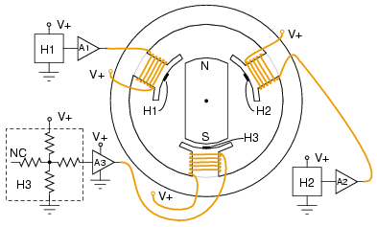

*Fig.4 Cross-section of the BLDC motor*

***A. Fundamentals of Operation***

The BLDC motor's electronic commutator turns on the stator coils, creating a revolving electric field that draws the rotor along with it. Depending on the number of magnetic pairings, a few electrical revolutions are equivalent to one mechanical rotation. Three Hall-effect sensors are mounted in the stator of a 3ϕ motor to assess the rotor's location in relation to the stator. In order for the controller to activate the windings in the proper order and at the appropriate time, the data is fed into it. Figure 3 displays the Hall sensors that are installed on the unit's non-driving end.

***B. Control of a BLDC motor***

A reversed DC commutator motor is the same as a BLDC motor. It appears as though the conductors stay in their fixed states as the magnetic rotates. The location of the commutator and brushes in the DC commutator motor determines the polarity of the current. However, polarity reversal in brushless DC motors is accomplished by means of power switches that are synchronized with the motor's rotor position. In order to sense the real rotor position, BLDC motors use either internal or external position sensors [8–9]. It is also possible to determine the position without the usage of sensors.The sensor's operation is depicted in Fig. 5 below.

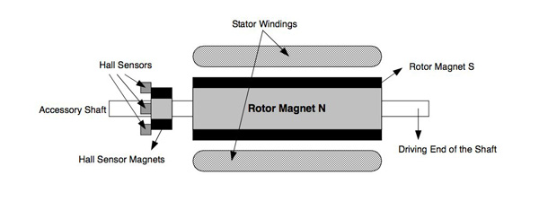

*Fig.5 Hall sensor arrangement in the BLDC shaft*

***C. Commutation of the BLDC motor***

To create a rotating magnetic field, commutation is necessary. If there is a 90° angle between the stator and rotor fluxes, the BLDC motor runs correctly. Six stator flux sequences are needed for a six-step control. It is necessary to adjust the stator flux vector for every rotor position. Hall sensors are used to detect the rotor position. Signals with six states are produced by the Hall sensors [10]. Every condition of a Hall sensor is associated with a specific stator flux vector, as indicated in table I.

**TABLE I:COMMUTATION SEQUENCE FOR CLOCKWISE ROTATION**

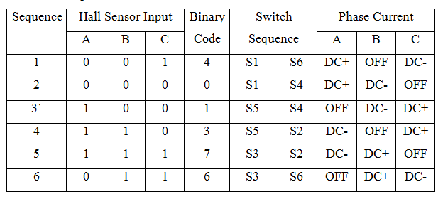

**V. SIMULATION RESULTS**

BLDC motor fed by a CSI based on a Buck Converter. A BLDC motor, six IGBTs, a speed sensor, a PI controller, and a second-order low pass filter make up the simulation model. The inductance value in the CSI-fed BLDC drive-controlled rectifier is very high. The aforementioned technique is used to lower the inductance value. A three-phase current source inverter and Buck converter supply power to the BLDC motor. The inverter operates in six pulses by using the Hall Effect position sensor signals as gating signals. A PI controller and a greater switching frequency are used to control the speed. The SIMVIEW in Fig. 6 was used to get these results.

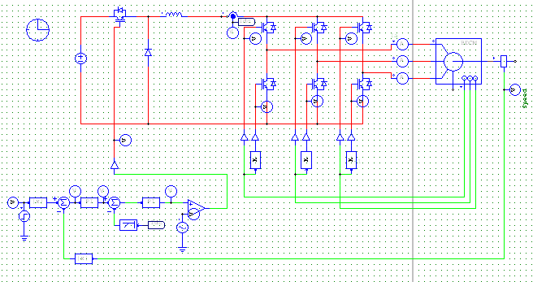

*Fig.6 Simulation diagram of proposed SYtsem*

The two different speeds of CSI fed BLDC motor speed output is simulated,

*A. Buck Converter Based CSI Fed BLDC Drive(Rated Speed:10000):*

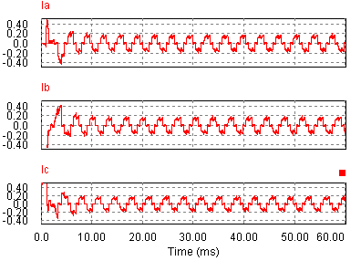

*Fig.7 Phase Current Waveforms*

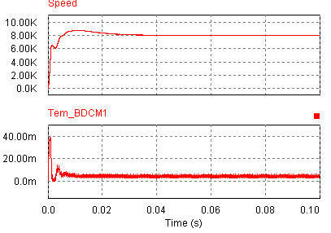

*Fig.8 Speed and Torque Waveform*

*B. Buck Converter Based CSI Fed BLDC Drive(Rated speed:15000)*



*Fig.9 Phase Current Waveforms*

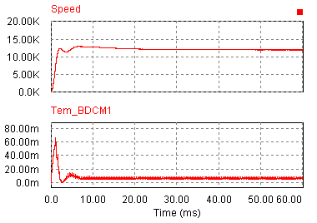

*Fig.10 Speed and Torque Waveform*

In DC voltage, phase current ,speed,electromagnetic torque and reference speed will be improved compared to table II for 15000 RPM speed.

**VI. HARDWARE DESIGN AND RESULTS**

The conventional method speed control of BLDC motor diagram is shown in Figure 11. The block diagram contains DC supply, Inverter circuit, BLDC motor controller IC (MC 33035), PIC Controller (PIC 16F877A), BLDC motor and LED display. The MC33035 IC is designed to operate efficiently control of BLDC motor. The program is embedded in the PIC controller and it is given to the motor controller board to control the speed of the BLDC motor drive [14]. The LED display is used to display the speed of the BLDC motor. Figure 11 shows the hardware circuit of the conventional model of BLDC motor controller.

We have constructed the DC-DC converter kit for testing the simulation results. The block diagram of DC-DC converter kit is used. We can construct the circuit for Buck converter, Boost converter, Buck boost converter, Cuk converter and Sepic converter using this kit. The switching frequency is fixed at 20 KHz. The pulse can be generated by comparing the triangular wave with the DC line. The duty cycle can be changed from 0-100% by varying the potentiometer.The hardware circuit model of DC-DC converter designed. Figure 12 shows the DC-DC Converter Hardware circuit model with CRO & Multimeter.

The buck converter is designed and the values are listed below at Vin = 12 V, L = 250 µH, C = 100 µF, Fs = 20 KHz Load Resistance R=18Ω.

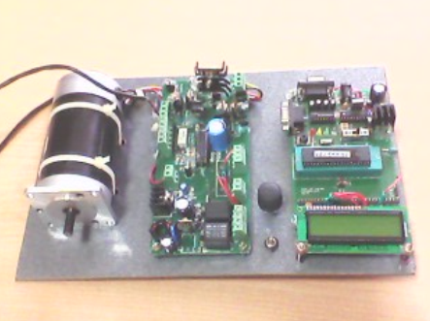

*Fig. 11 Hardware Circuit of Conventional model of BLDC motor controller*

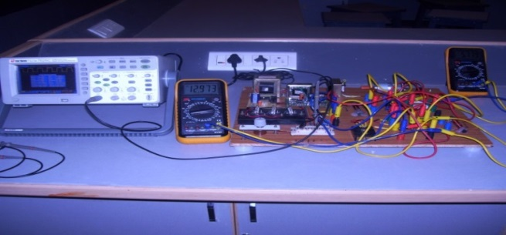

*Fig. 12 DC-DC Converter Hardware circuit model with CRO & Multimeter*

TABLE II MOTOR PARAMETER SPECIFICATIONS

|  |  |
| --- | --- |
| **Parameters** | **Range** |
| Rated Voltage in Volts | 24 |
| Rated Power in Watts | 150 |
| Rated speed in RPM | 5500 |
| Stator winding resistance | 5.3 Ohms |
| Inductance of the winding | 6.6*10-µH |
| Rated Torque in NM | 0.89 |
| Rotor inertia in Kgm | 1.014*10-3 Kgm2 |
| Number of pole pairs | 4 (8poles) |

The software and hardware results described clearly in the below sections ,

***A. Hardware Results***

**TABLE III:R LOAD**

|  |  |
| --- | --- |
| Input VoltageVin = 12V | |
| Duty Ratio | Output Voltage Vo |
| 0.2 (20%) | 2.84 |
| 0.4 (40%) | 4.84 |
| 0.5 (50%) | 5.70 |
| 0.6 (60%) | 6.79 |
| 0.8 (80%) | 9.13 |
| 0.9 (90%) | 10.25 |

**TABLE IV:RL LOAD**

|  |  |
| --- | --- |
| Input Voltage Vin = 12V | |
| Duty Ratio | Output Voltage Vo |
| 0.2 (20%) | .85 |
| 0.4 (40%) | 4.92 |
| 0.5 (50%) | 5.68 |
| 0.6 (60%) | 6.81 |
| 0.8 (80%) | 9.10 |
| 0.9 (90%) | 10.21 |

The buck converter is designed and the values are listed below at Vin = 12 V, L = 250 µH, C = 100 µF, Fs = 20 KHz Load Resistance R=18Ω, Load Inductance L = 7mH.

**TABLE V:MOTOR LOAD**

|  |  |  |
| --- | --- | --- |
| Input Voltage Vin = 12V | | |
| Duty Ratio | Output Voltage Vo | Speed (RPM) |
| 18.2% | 2 | 400 |
| 35% | 4 | 785 |
| 54.67% | 6 | 1195 |
| 71.5% | 8 | 1610 |
| 88% | 10 | 2020 |

Rated Speed of DC motor = 2450 RPM

Rated Voltage of DC motor = 12V

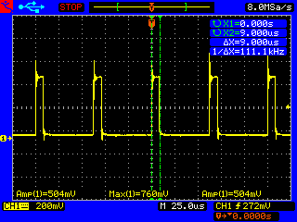

*Fig.13PWM pulse during buck operation*

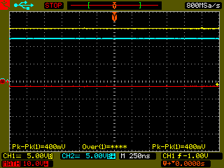

*Fig.14 Output During Buck Operation*

***B. Description***

By using a Current Source Inverter (CSI) to replace hard switching with natural turn-off, heat sinks and hefty DC link capacitors are eliminated. The current source is a big inductor and a regulated rectifier. The sole drawback is the DC link inductor's high value, which results in significant resistive losses due to the enormous number of turns required to reach these inductance values. A appropriate DC-DC converter based current source switching at high frequencies and a considerably smaller value of the DC link inductor can be used in place of the controlled rectifier and the big inductor.It is feasible to lower the DC link inductor value without raising the current ripple by switching at high frequencies.

**TABLE VI: RESULT COMPARISON FOR VARIOUS SPEED**

|  |  |  |
| --- | --- | --- |
| Parameter | Rated Speed  (10000 RPM) | Rated Speed  (15000 RPM) |
| Phase current | 0.2A | 0.5A |
| Speed | 8000rpm | 12000rpm |
| Electromagnetic Torque | 0.004N-m | 0.007N-m |
| Switching frequency | 25khz | 25khz |
| Inductance | 30Mh | 30mH |
| Reference speed | 8000 RPM | 12000 RPM |

By using a Current Source Inverter (CSI) to replace hard switching with natural turn-off, heat sinks and hefty DC link capacitors are eliminated. The current source is a big inductor and a regulated rectifier. The sole drawback is the DC link inductor's high value, which results in significant resistive losses due to the enormous number of turns required to reach these inductance values. A appropriate DC-DC converter based current source switching at high frequencies and a considerably smaller value of the DC link inductor can be used in place of the controlled rectifier and the big inductor.It is feasible to lower the DC link inductor value without raising the current ripple by switching at high frequencies.

**IX. CONCLUSION**

The drive system's speed and efficiency are increased by the CSI-fed BLDC motor based on a Buck converter, which also dramatically lowers inductance and current ripples.As signals are switched, the strain on voltage and current will be lessened. The motor speed will be run at the prescribed speed under the control of the hall signals. Phase current, speed, electromagnetic torque, and reference speed will all increase in tandem with the motor's rated speed. Duty cycle will be used to confirm that the output voltage is as required. Buck converters have been used in the majority of applications.To implement the two switch tri state buck boost power factor corrected with FPGA and compare with conventional results and To implement the same scheme with sensor less methods.

**REFERENCES**

[1] Mohammad Reza Amini, HoseinFarzanehfardSwitched resonator DC/DC converter with a single switch and small inductors IET Power Electron., 2014, Vol. 7, Iss. 6, pp. 1331–1339.

[2] Urgun, S.: ‘Zero-voltage transition–zero-current transition pulse width modulation DC–DC buck converter with zero-voltage switching zero-current switching auxiliary circuit’, IET Power Electron., 2012,5, (5), pp. 627–634.

[3]. Bodur, H., Cetin, S., Yanik, G.: ‘A new zero-voltage transition pulse width modulated boost converter’, IET Power Electron., 2011, 4, (7), pp. 827–834.

[4] Adib, E., Farzanehfard, H.: ‘Family of zero-voltage transition pulse width modulation converters with low auxiliary switch voltage stress’, IET Power Electron., 2011, 4, (4), pp. 447–453.

[5].Cho, J.G., Cho, G.H.: ‘Single-cycle resonant converters: a new group of quasi-resonant converters suitable for high-performance DC/DC and AC/AC conversion applications’, IEEE Trans. Ind. Electron., 1991,38, (4), pp. 260–267.

[6].Amini, M.R., Farzanehfard, H.: ‘Switched resonator buck converter with a single switch’. 2012 Int. Conf. Applied Electronics, 5–7 September 2012, pp. 13–16.

[7] Chang Liang Xia, Permanent Magnet Brushless DC Motor Drives and Controls, Wiley Press, Beijing, 2012.

[8] J. Moreno, M. E. Ortuzar and J.W. Dixon, “Energy-management system for a hybrid electric vehicle, using ultracapacitors and neural networks,” IEEE Trans. Ind. Electron., vol.53, no.2, pp. 614- 623, April 2006.

[9] Y. Chen, C. Chiu, Y. Jhang, Z. Tang and R. Liang, “A Driver for the Single-Phase Brushless DC Fan Motor with Hybrid Winding Structure,” IEEE Trans. Ind. Electron., vol.60, no.10, pp.4369-4375, Oct. 2013.

[10] Xiaoyan Huang, A. Goodman, C. Gerada, Youtong Fang and Qinfen Lu, “A Single Sided Matrix Converter Drive for a Brushless DC Motor in Aerospace Applications,” IEEE Trans. Ind. Electron., vol.59, no.9, pp.3542-3552, Sept. 2012.

[11].Wiechmann, E, and Rodriguez J.," Efficiency of Voltage Source and Current Source Inverters for High-Power Drives", Industrial Electronics, IEEE Transactions on April 2008 Volume: 55 PP 1771-82.

[12].Al-nabi, and Jingya Dai, "High power CSI-fed IPM drive system control with minimum dc-link current",IEEE Conference on Nov. 2010 PP 857-63.

[13].J. Karthikeyan and R. D. Sekaran , "DC-DC Converter CSI fed BLDC Motor for Defence Applications" ,  International Conference on Recent Advancements in Electrical, Electronics and Control Engineering

[14].H. C. Chen and H. H. Huang , "Design of buck-type current source inverter fed brushless DC motor drive and its application to position sensorless control with square-wave current" ,  lET Electric Power Applications , 2013.